
Artwork posted by u/woke0rthadox
r/Superstonk DD Mega Back Up
Archived DD, with most attention, in no particular order.
Archive provided by u/onlyfuturehuman
Table of Contents – Click titles to jump to that section. Click usernames to jump directly to OP.
A House of Cards - Part 1 - Posted by u/atobitt
House of Cards - Part 2 - Posted by u/atobitt
House of Cards - Part 3 - Posted by u/atobitt
Peek-a-boo! I see you 79M hidden shorts! - Posted by u/WhatCanIMakeToday
Peek-a-boo! I see 103M hidden shorts! (Part Deux) - Posted by u/WhatCanIMakeToday
TL:DR – I believe inflation is the match that has been lit that will light the fuse of our rocket. Part 2 - Posted by
u/Dismal-Jellyfish
The Anatomy of the MOASS - Part 1/3: The Key Market Concepts that Make the MOASS Possible and Other
Important Terminology - Posted by u/HCMF_MaceFace
wen moon 10 : Endgame ■ Final TA - Posted by u/MOSfriedeggs
The Sun Never Sets On Citadel -- Part 1 - Posted by u/swede_child_of_mine
The Sun Never Sets on Citadel -- Part 2 - Posted by u/swede_child_of_mine
New OCC rule passed to fuck the large financial institutions out of using derivatives to pass their tests. -
Posted by u/laflammaster
The DTCC (Depository That Clears Counterfeits) is finished. They covered up the fraud that enables naked
short selling and are why we will MOASS to epic proportions. - Posted by u/JustBeingPunny
Elliott Waves and The Top Of The Market, Is This THE TOP? - Posted by u/possibly6
The MOASS Preparation Guide 2.0 - Posted by u/socrates6210
The NYSE threshold list: collapsing shorts and launching the MOASS - Posted by u/Bladeace
Infinity Pool: How GME Will Break the Laws of Supply and Demand and Enable the Money Glitch - Posted by
u/Hemoglobin_trotter
Where and how Citadel/other hedge funds have been hiding their short positions, and a true estimate of how
many short shares are currently being hidden. - Posted by u/AcedVector
Dark Pools, Price Discovery and Short Selling/Marking - Posted by u/dlauer
Hi All, It's Ryan Cohen T+21 Tweet Guy. I'm losing my shit - Posted by u/Nalifi
Elliot Waves And GME, The Return Of The Uptrend 🚀 - Posted by u/possibly6
Ryan Cohen Started Chewy with $15m in Investments. He is Starting Off at GME with $1bn. This Interview is
the Only DD I Need. Possible Blue Prints for GME? - Posted by u/tendieful
Hyperinflation is Coming- The Dollar Endgame: PART 1, “A New Rome” - Posted by u/peruvian_bull
The Fed is pinned into a corner from the 2008 can-kick utilizing QE, and the economic effects of COVID. They
are stuck battling a collateral crisis AND a liquidity crisis. The Fed is currently fudging the numbers of
treasuries to hide a collateral…- Posted by u/Criand
Reverse Repos, DTC-2021-005, SR-NSCC-2021-002, Banks, and the C-Market: How it's all connected and how
we might be on the verge of the House of Cards falling. - Posted by u/AcedVector
GME, Banks Falling Off a Cliff, The Movie Stock, Elliot Waves, WUT Mean For This Week? 🚀 - Posted by
u/possibly6
DEBUNKING THE 20% INFLATION DDs! IT IS CRUCIAL TO FACT-CHECK BEFORE UPVOTING DDs WITH WILDLY
ABSURD CLAIMS! - Posted by u/hikurashi83
AnnihilationGod presents: The Big Short Data Collection for Everyone - Or: How to data proof irregularities in
GMEs trading history for everyone (AGods GME Mastersheet + Full collection Download link at the end) -
Posted by u/AnnihilationGod
I think the Fed just accidentally proved us right - Posted by u/leisure_rules
Reverse Repo Operations - Explaining Their Purpose - Posted by u/Kintsugi2
I processed 16 years of data across 8 stocks to prove something no one cares about: GME's price is ending in
.00 10X more than it should be. - Posted by u/LongTimeGamer
The OBV does not lie. The price is WRONG!💎🙌HODL!🚀 - Posted by u/_Badtothebone_
T+35 is the one true "cycle" [Evidence to back my theory up plus a step-by-step guide on how to follow along
at home] - Posted by u/dentisttft
The Bigger Short. How 2008 is repeating, at a much greater magnitude, and COVID ignited the fuse. GME is
not the reason for the market crash. GME was the fatal flaw of Wall Street in their infinite money cheat that
they did not expect. - Posted by u/Criand
Elliot Waves, GME, The S&P 500, Wen Market Peak and GME Boom? - Posted by u/possibly6
Why big name banks like Bank of America, JP Morgan Chase, Citigroup and more were excluded from bonds
sales in the EU, and what banks have been doing for YEARS to manipulate the market to fuck everyone else
over - Posted by u/AcedVector
Riding Elliot Waves to the Moon, Why GME from a Technical Standpoint Alone is Better Than Gold 🚀 -
Posted by u/possibly6
Cohen has reached the same conclusion as u/Criand's T+21 Net Capital thesis: An analysis of tweet activity
and corporate announcements - Posted by u/Nalifi
A revisit to Net Capital. What is truly driving these T+21 loops, the March and June gamma runs, and how
skyrocketing ETF FTDs might cause big price movements in the coming weeks. - Posted by u/Criand
Clarification of when GameStop will issue a press release stating the ATM Offering is complete, sale price
max, maximum offering, update on outstanding shares, the reason why MarketWatch and Ortex differ, and
other Form 424B5 goodies… - Posted by u/Squashua1982
Elliot Waves and GME, Why I'm Jacked To Infinity With Today's 82 Point Drop 🚀 - Posted by u/possibly6
Danger Zone Part 2 - Shorts are terrified of a $310+ close. Projected price movement for the next few months
based on T+21, ever-increasing, and poking harder at the first domino just waiting for it to fall. - Posted by
u/Criand
IMPORTANT: This is why they mentioned "more than a majority represented" at the meeting. It's simple.
Read this. Please. - Posted by u/greysweatseveryday
What's happening today - 6/8/2021 - Posted by u/atobitt
THE MOTHER OF ALL WEDGES: AN ENDGAME DD. Technical and Fundamental Analysis with Warden. Where
we are now, where we are headed. When might the MOASS begin? - Posted by u/WardenElite
Looks like the recent RobinHood Class Action SI Report just proved /u/broccaaa's data. That the shorts
haven't covered, that they hid SI% through Deep ITM CALLs, and SI% is a minimum of 226.42%. - Posted by
u/Criand
Why We're STILL Trading Sideways and Why We Haven't Launched - Posted by u/c-digs
Holy shit. I was skeptical of all the high ceilings being thrown out until I put the pieces together. I honestly
think GME is priceless, and the most valuable stock you will ever buy. Here's the full picture, as I understand
it... - Posted by u/missing_the_point_
$GME - The Mother of All Short Squeezes (MOASS) Thesis. Summarized and broken down in a way for all (or
most) to understand. We are in the end-game everyone, and this rocket is taking off with or without you. If
you want … - Posted by u/HCMF_MaceFace
The flurry of rules before the storm. DTC, ICC, OCC are prepared. GME might be hitting T+35 and T+21
crossover next week, pulling the house of cards down. - Posted by u/Criand
Wait... Is NSCC-002 about to turn the T+21/T+35 loop into a death spiral of T+0 as we approach Q2 end? -
Posted by u/Criand
Things are shockingly similar to the February 24th and March 10th runup so far. Gamma squeeze indicators
from the previous T+21/T+35 have returned. Their doom approaches. - Posted by u/Criand
Hank's Big Bang: Quant Apes Glitch the Simulation - Posted by u/HomeDepotHank69
The naked shorting scam in numbers: AI detection of 140M hidden FTDs, up to 400M naked shorts in married
puts and massive dark pool activity by Shitadel and the shorts - Posted by u/broccaaa
Hank's Definitive GME Theory of Everything - Posted by u/HomeDepotHank69
Actually useful info you might have missed, 23/04/21 - Posted by u/HPADude
Walkin' like a duck. Talkin' like a duck - Posted by u/atobitt
I've estimated the current SI% based on the SI Report Cycle and Deep ITM CALL purchases. - Posted by
u/Criand
Glacier Capital Exists - And It's Much Spicer Than You Thought - Posted by u/MrMadium
All Shorts Must Cover. They're Entering The Danger Zone. The SI Report Loop Consistently Brings Us Ever
Closer To The Squeeze. - Posted by u/Criand
Tombstone Tweet Confirms Reverse Merger? Reposted Reverse Merger DD - Posted by u/Alert_Piano341
If you STILL dont understand why today we went red again after we were big green yesterday and WHY you
should get a hold of yourself and stop fucking caring. - Posted by u/Damsellindistress
🚀 Time to expose the shell game. FTDs can be "reset" through borrowing from ETFs. Read the Truth. -
Posted by u/augrr
I Got What You Quant - 6/2/21 Trading Analysis and a Deeper Dive Into Today's Tape - Posted by
u/myplayprofile
The end has begun. (IMPORTANT INFO INSIDE) - Posted by u/Kitchen-Rain-9986
The March to Zero Liquidity: Volume or Bust - Posted by u/Suspicious-Singer243
SR-DTC-2021-004, The DTCC and J.P Morgan. They're getting ready for defaults and bankruptcies, they've just
opened THREE additional netting accounts. - Posted by u/JustBeingPunny
CITADEL, MARGIN CALL, 1M MISSING SHARES & THE TRADING HALT - Posted by u/Rugby97
Major Deep ITM CALL Option Dates. A Massive Net Capital BOMB Might Explode This Week. - Posted by
u/Criand
Another GME DD dump from Hank - Posted by u/HomeDepotHank69
CHAOS THEORY - The FINAL Connection - Posted by u/sharkbaitlol
SEC Filing: Merger with brokarage, detailing lawssuit, mentions 30 brokerages engaging in coordinated
conspiracy - Posted by u/jamiegirl21
a followup to the HoC DD- the "everything" in Everything Short. I present, RAGNAROK - Posted by
u/mybustersword
I've been scraping data used by hedge funds for over a year now to make it freely available to everyone. I
think I might start doing regular data reports on $GME on here if there's interest, let me know if you have any
feedback on the report below. - Posted by u/pdwp90
[UPDATED] DD: I did the math, there is literally NO DOUBT that we own >100% of the remaining float.
[including updated remaining float from GME's proxy statement] 🚀🚀🚀 - Posted by u/InForTheSqueeze
PROOF of Artificial Price Movement: Spreadsheets with Statistics to Soothe the Soul - Posted by u/G_KG
It's Just a Pyramid Scheme Part 1: The Missing Cornerstone - Posted by u/hell-mitc
Dance of Darkness: The SEC and Dark Pools - Posted by u/umu68
[Final Update] Superstonk users ALONE hold between 27 million and 35 million shares. No, really. - Posted by
u/TheCaptainCog
The MOASS is not a straight line up, do not paper hand at a minor dip - Posted by u/Magistricide
The Complete Bank of America Gamestop DD - Posted by u/gfountyyc
Elliott Waves, GME, WEN THE F*CK MOON!? 🚀 - Posted by u/possibly6
SRO Filings - Posted by u/dlauer
Infinity War: The Final Exit DD Compilation - Posted by u/gherkinit
AndrewMoMoney Used My DD In A Live Stream Ft. Shill Sniffing Dog And Deleted My Comment, So I
Analyzed His Channel - Posted by u/itsdaynotdave
OBV and Beta definitively show that the price is heavily suppressed and that GME is the ultimate hedge
against market volatility - Posted by u/OverlordHippo
Over 30% of GME bananas are missing from Bloomberg Terminal. Over 69% of GME is trading off exchanges
or in an unreported Dark Pool? It's National Banana Day - Do you know where your GME bananas are? -
Posted by u/nayboyer2
Citadel has hostages: explaining why the MOASS is taking so long, how the January spike was stopped, Robinhood's
motives for the trading halt, and the mysterious silence of the SEC - Posted by u/Bladeace
A House of Cards parts I, II, & III in PDF - Posted by u/atobitt (LINK ONLY:
https://pdfhost.io/v/lRQ4HqpG0_House_of_Cards_Atobitt.pdf)
There will be DD that I have missed. This should get you through the MOASS regardless of Reddit or r/Superstonk
fuckery we may see. See you apes on the other side! 🚀

Peek-a-boo! I see you 79M hidden shorts!
DD 👨‍🔬
tl;dr: I found around 79M can kicked shares in Jan 2021 using the married put approach. We can see
those cans kicked out 1, 2, 3, 6, 12, and 24 months from Jan 2021 at various options expirations.
After poking around in ToS, I found that I can see exactly when Puts where opened by tracking the daily
Open Interest for a put. See my previous post
here: https://www.reddit.com/r/Superstonk/comments/ocen11/historical_gme_71421_options_oi_to_s
ee_how_many/
I needed the data in CSV format so I could play with it. So I bought the GME Options Data (surprisingly
cheap, about $21) from https://www.historicaloptiondata.com/ for 2021 up to end of June.
I then filtered out the lowest strike Put option for each of the major options expirations (Feb, March,
April, Jan 2022 leap, and Jan 2023 leap) during that time and charted the daily Open Interest Change.
Daily OI Change for Lowest Strike Puts
Guess what? Most of these low strike puts were opened around GME's Jan run up!
Wut mean? Superstonk has been discussing how married puts are used to hide naked shorts in deep
OTM puts so this data shows us exactly how far out they kicked those Jan naked short cans down the
road AND we can see which expirations have them. We can see pretty much every major options
expiration has a ton of new openings in Jan so those cans were kicked 1, 2, 3, 6, 12, and 24 months out
(Feb ,March, April, July, Jan 2022, and Jan 2023, respectively).
Option As of 1/4/2021 As of 2/1/2021
Feb $1 Put 0 52,193
March 0 (n/a) 32,907
April $0.50 Put 510 43,892
July $0.50 Put 168 71,709
Jan 2022 $0.50 Put 2,441 106,082
Jan 2023 $2 Put 105 16,585
Total 3,224 323,368
Do you see what I see? There's about 320,000 options opened in Jan 2021 to hide naked shorts and kick
those cans just at the cheapest strike! That's the equivalent of 32,000,000 (32M) shares!
Wut about other low strikes? I filtered the options data for two snapshots in time: Jan 4, 2021 (before can
kicking) and Feb 1, 2021 (after can kicking). Out of those snapshots, I summed the total open interest for
all options with a strike price less than or equal to $20. Here's the results:
1/4/2021 2/1/2021
Total Put OI for all strikes <= $20 309,563 1,101,826
The difference there is 792,263 OI. Basically just shy of 800k new put open interest at super low OTM
strikes representing over 79M shares kicked down the road in Jan 2021! Half of those are hidden in the
lowest strike alone.
Happy July 4th! We're gonna have a blast!
EDIT: Wowza! Thanks everyone! I’ve never had this many upvotes or awards before! You are all
amazing! I learned more in the past 6 months about trading and markets from Superstonk than in
decades of trading. I’m happy I can give back to the community!
Back to Table of Contents
Peek-a-boo! I see 103M hidden shorts! (Part
Deux)
DD 👨‍🔬
Part Uno (you might want to read it first for
background): https://www.reddit.com/r/Superstonk/comments/odsded/peekaboo_i_see_you_79m_hid
den_shorts/
I'm BAAACK!
After finding 79M hidden shorts in married puts, I asked myself "Can I do better?" I didn't disappoint.
Don't get me wrong, I'm disappointed (yet also happy) that I found more shorts.
In Part Uno, I searched for new deep OTM Put Options that have no business being opened and found
79M shares worth of options (about 792k opened Put options) opened during the Jan GME spike. I used
a rather crude approach which was assuming worthless options are at the deepest OTM Put strike and
then expanded that to strikes <= $5. Crude, but it worked fairly well.
Here in Part Deux, I've improved on it by growing a wrinkle about options greeks.
Using the same GME Options Data set I bought for about $21
from https://www.historicaloptiondata.com/ for 2021 up to end of June, I did the following:
1. Filtered the data set down to get two snapshots in time: Jan 19th, 2021 and Feb 1st,
2021. This is effectively bracketing the week before and week of the huge GME Jan spike.
Whatever happens in here should 100% be tied to that crazy spike. (I just realized I'm
undercounting a bit because the spike, T, was Jan 28th and Feb 1 is only T+2. I'm too
lazy to rerun the process right now to expand out and you'll get the picture.)
2. Filtered out only for Puts (duh) because we're looking for Married Puts.
3. (NEW for Part Deux!) Filtered by delta which is an option greek that represents how
much the option value changes per $1 change in the underlying stock price. I filtered
for delta < 0.01 which means if the stock price moves by $1, the price of these options
moves by a penny ($0.01) or less. These options are literally worthless.
Grow wrinkles about option greeks
here: https://www.investopedia.com/terms/g/greeks.asp
4. Summed up the total Open Interest for all remaining Puts.
Total Open Interest for Puts with delta <= 0.01:
As of Jan 19, 2021 As of Feb 1, 2021
58,970 1,096,066
Wut mean? Over 1M worthless junk put options were opened in the 2 weeks (from Jan 19th to Feb 1st,
10 trading days) of our January spike. 1,037,096 worthless put options were opened. Sink that in
because those brand spanking, newly opened, absolutely worthless options are capable of hiding
over 103,700,000 (103M) shares.
Updates:
1. Why worthless puts?
See https://www.reddit.com/r/GME/comments/mgj0j1/the_naked_shorting_scam_rev
ealed_lending_of/
2. The prior 79M is a subset of this 103M. This approach is a more accurate way to count
worthless options.
Back to Table of Contents
TL:DR – I believe inflation is the match that has
been lit that will light the fuse of our rocket.
Part 2
DD 👨‍🔬
Good morning r/Superstonk, neighborhood jellyfish here!
I would like to revisit some more data recently released and posted and continue trying to tie this all
together as the situation continues to evolve.
Posts being referenced: 1st Inflation Post, Existing Home Sales May, New Home sales May, Fed Balance
Sheet through 6/16, It’s not just manufacturing supply shortages, manufacturers can’t get people for
work, 6.4% annualized inflation (PCE, excluding food and energy the most conservative inflation measure US
government releases and the Fed relies on)
I want to start by revisiting the Fed’s balance sheet. The last time we talked about it (6/17), it stood at a
then RECORD $8.064 trillion. Let’s write this one out: $8,064,000,000,000.As of July 1st, that number
stands at a NEW RECORD $8,078,544,000,000—an increase of $14,544,000,000.
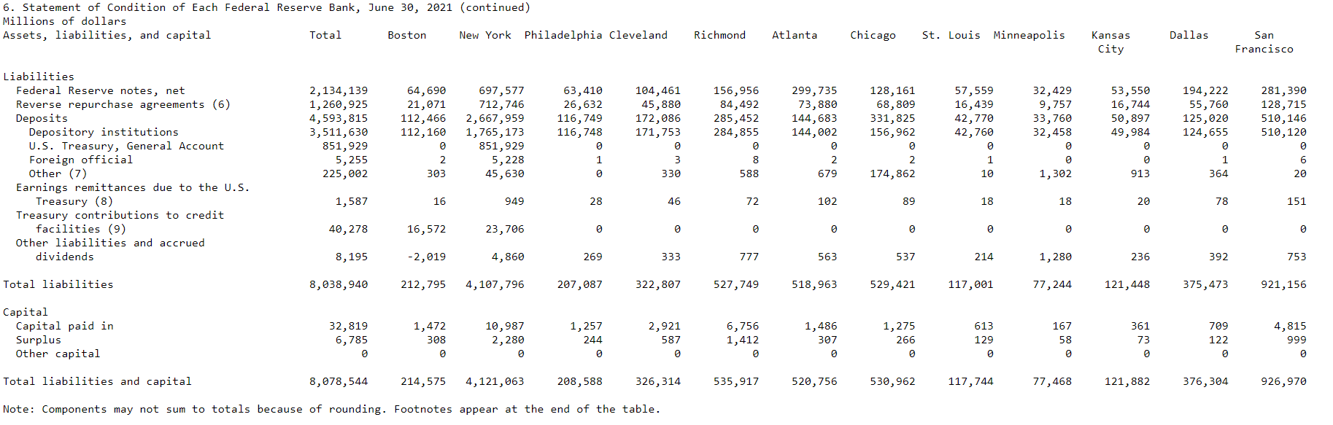
$8,078,544,000,000
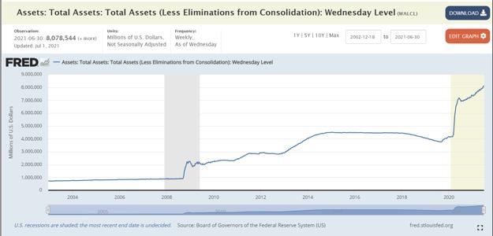
Look at that triangle that has started at $7 trillion!
So what caused the jump in the balance sheet?
The Treasury General Account (TGA), which Yellen said in February she wanted to get to $500 billion by
the end of June, actually increased by $86.815 Billion to $851 Billion.
Federal Reserve Notes, net jumped $4,594 million.
The Fed’s balance sheet is jumping while we are watching the
housing bubble inflate in front of us.
The rate of sales continues to trend downward, but median home prices for existing homes are up
23.6% year-over-year to an all-time high of $350,300 with May rising at the greatest year-over-year
pace since at least 1999, up from $283,500 last year and $340,600 in April.
So, months’ supply is increasing (supply taking longer to move), sales are beginning to decrease (.9%)
(demand), and median existing-home price across all housing types hit a record high of $350,300 in
May, an increase of 23.6% from the year before (price).
Despite supply increasing for months, single-family home sales by homebuilders to the public in May
fell 6% from the prior month to a seasonally adjusted annual rate of 769,000 houses, down 23% from
the recent high in January. This steep decline in sales occurred amid rising prices.
The median price of new single-family houses rose 2.5% from the previous month, and spiked 18.1%
year-over-year, to a record $374,400:
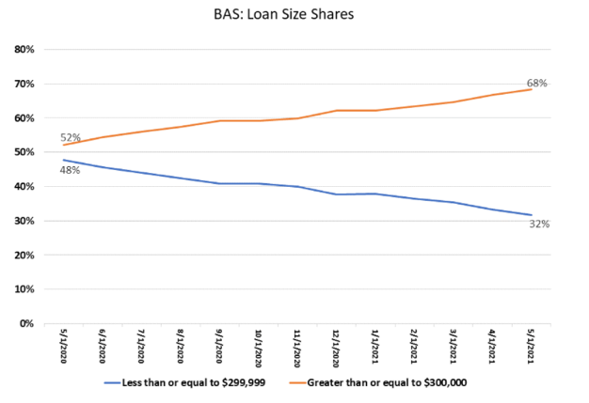
The drop in sales of new homes in the past months brought sales back to about pre-pandemic levels. On
the other end of our equation, inventory really is rising!
Unsold speculative houses rose for the fifth month in a row to 330,000 houses and months’ supply rose
to 5.1 months.
New single-family homes completed since Jan 2021 :
1,328,000+1,347,000+1,497,000+1,426,000+1,368,000 = 6,966,000 homes
New single-family homes sold since Jan 2021 : 993,000 +823,000+886,000+817,000+ 769,000 =
4,288,000 homes
Supply is up +2,678,000 homes in 2021 so far.
Stated another way:
The current supply is steadying with current inventory not moving at the current prices and is
increasing as more homes come online (census bureau has it at ~ 4-8 months in 2020 to build from start
to finish, projects started during the pandemic will be coming online), Demand is decreasing, Median
Prices has increased to an all-time high.
With the conditions of the housing market above, I believe we are entering ‘textbook’ bubble
territory.
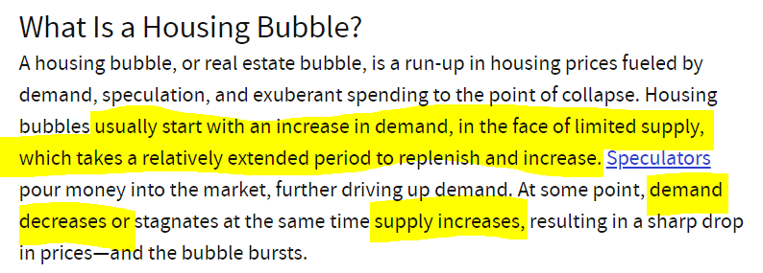
Source: https://www.investopedia.com/terms/h/housing_bubble.asp
Ok, as we covered above, demand had been through the roof, but the supply is back on the rise and
current stock is taking longer to move. At the same time, demand for new mortgages is decreasing as the
supply continues to hold and increase—but prices continue to go up!
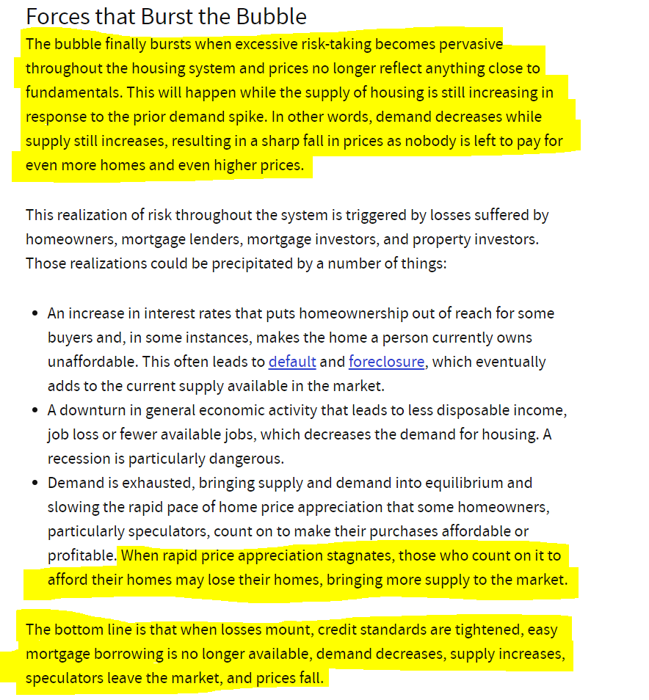
But what about delinquency rates? This can be a source to the supply...
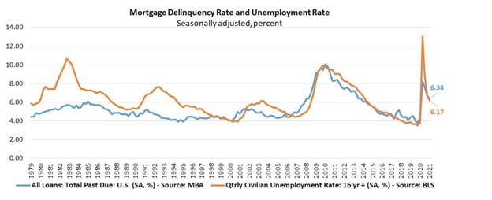
https://www.mba.org/2021-press-releases/may/mortgage-delinquencies-decrease-in-the-first-quarter-of-2021
On a year-over-year basis, total mortgage delinquencies increased for all loans outstanding. The
delinquency rate increased by 141 basis points for conventional loans, increased 498 basis points for
FHA loans, and increased 297 basis points for VA loans.The delinquency rate includes loans that are at
least one payment past due but does not include loans in the process of foreclosure. The percentage of
loans on which foreclosure actions were started in the first quarter rose by 1 basis point to 0.04 percent.
The percentage of loans in the foreclosure process at the end of the first quarter was 0.54 percent, down
2 basis points from the fourth quarter of 2020 and 19 basis points from one year ago. This is the lowest
foreclosure inventory rate since the first quarter of 1982.The seriously delinquent rate, the percentage
of loans that are 90 days or more past due or in the process of foreclosure, was 4.70 percent. It
decreased by 33 basis points from last quarter and increased by 303 basis points from last year. From
the previous quarter, the seriously delinquent rate decreased 34 basis points for conventional loans,
decreased 19 basis points for FHA loans, and decreased 37 basis points for VA loans. Compared to a year
ago, the seriously delinquent rate increased by 205 basis points for conventional loans, increased 771
basis points for FHA loans, and increased 379 basis points for VA loans.
Then there are those still in or coming out of forbearance with the likely expiration and non-
renewal of these Covid rules at the end of the month:
The Mortgage Bankers Association's (MBA) latest Forbearance and Call Volume Survey revealed that the total
number of loans now in forbearance decreased by 2 basis points from 4.18% of servicers' portfolio volume in
the prior week to 4.16% as of May 30, 2021. According to MBA's estimate, 2.1 million homeowners are in
forbearance plans.
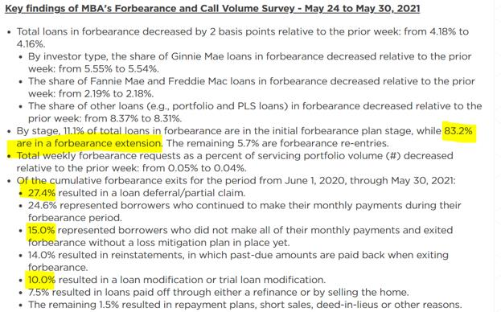
While it is great to see people come out of forbearance, if I am reading the numbers correctly, more than
half of folks coming out are still going to have amounts that still need to be paid back. Budgets are
already stretched tight, wage growth is decreasing, and inflation is making everything else more
expensive.
So, the central-bank asset purchases that continue chugging along ($120 billion per month) continue to
help directly inflate this bubble! The music on inflating home prices is going to stop!
This brings me back to a comment from earlier this week I made in the RRP’s post:
Inflation is blowing up as they have a full-blown liquidity crisis on their hands!
The Fed has backed themselves & the banks in a corner after letting the printer run brrrrr. High Reverse
Repo Purchase usage signals that the banks simply don't have the balance sheets to accept the excess
reserves. Even accounting for end-of-quarter use spiking, $991.939 billion to 90 participants is
absolutely bonkers!!!
Thus, they are forced to park them right back with the Fed using the Overnight Reverse Repo Purchase
and 0.05% lending.
This has created a dangerous game of chicken in the market. Currently, the liquidity in the market is
entirely artificial because of the aforementioned brrrrr. If the Fed lets up the slightest bit on the central-
bank asset purchases ($120 billion per month currently), it could shut down the entire game. However, if
JPow keeps letting the printer run, he risks hyperinflation and further cracks in support from his members.
It's turned into either no more liquidity for anyone or so much liquidity that the value of USD becomes
near worthless and we see Weimar Republic levels of hyperinflation.
For GME, I believe the thought is that no liquidity means institutions will have to sell off other assets to
increase their capital supply. This will continue until they can no longer increase their capital supply to
meet margin requirements.
When/if institutions cannot meet their margin requirements (aka prove liquidity to be able to cover
positions), DTCC will forcibly close all of their positions and MOASS takes flight
This is the game of chicken the Fed is caught up in—demand for housing (as we covered above) is
going down, supply is increasing, yet prices continue to inflate—I believe this is in large part
because of the $120 billion per month central bank MBS is allowing prices to continue to increase
and build this bubble!
Let’s revisit the rate of inflation from my first post. The CPI report had inflation at 5% and we reviewed
ICE BofA Single-B US High Yield Index Effective Yield @ 4.47% -.53% adjusted for inflation (Highly
Speculative) and ICE BofA CCC & Lower US High Yield Index Effective Yield @ 6.83% 1.83% adjusted for
inflation (“extremely speculative” to “default is imminent with little prospect for recovery”).
Annualizing the Personal Consumption Expenditures, excluding food and energy (PCE), again the most
conservative inflation number the government offers, from the BEA report the other day, inflation is at
6.4%--inflation is at least 28% higher than the first time we examined this at 5%!!!
Looking at the bonds again, adjusted for inflation, things are worse!
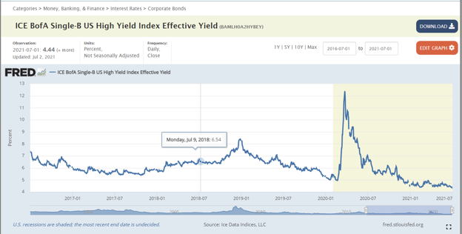
ICE BofA Single-B US High Yield Index Effective Yield @ 4.44% -1.93% adjusted for PCE inflation (Highly Speculative)
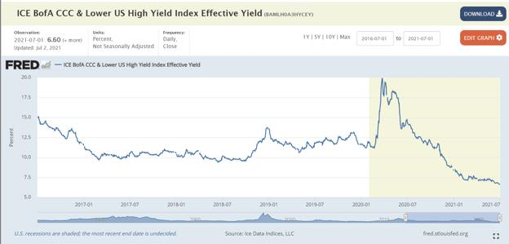
ICE BofA CCC & Lower US High Yield Index Effective Yield @ 6.60% .2% adjusted for inflation (“extremely speculative” to “default
is imminent with little prospect for recovery”)
Can we let that sink in again for a moment? To get any sort of positive yield an investor must expose
themselves to bonds rated “extremely speculative” to “default is imminent with little prospect for
recovery”. If they invest in the Single-B ‘Highly Speculative’ they lose principal capital to inflation!
Remember, they can’t just sit on this cash as the dollar is losing buying power (as we have covered
before), the cash would get eaten by inflation, and it is a liability for them—since they must pay interest
on client cash. (This is where having too much cash is considered a liquidity crisis! There isn’t enough
good debt to place it in!). No wonder the Reverse Repo Markets are so heavily used!
Before we go any further, let’s do some quick level setting on bonds and their risk descriptions:
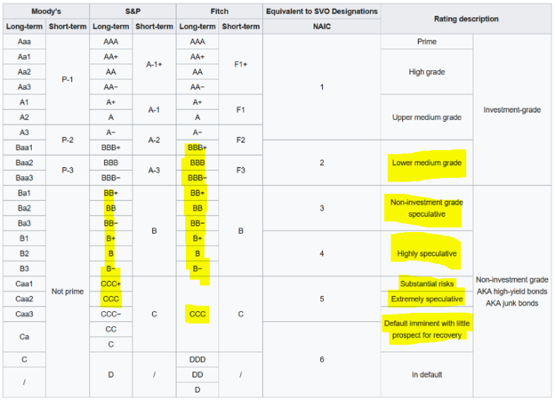
How the Credit Rating Agencies Classify Corporate Bonds and Loans by Credit Risk or the Risk of Default.
0:00
3:44
Any excuse to use this clip again makes my day...
Again, JPow believes this inflation is transitory and will drop back down to 2%. The Fed has been 2 steps
behind on inflation and I think they are severely underplaying a new wild dynamic in this inflation
madness—people and businesses are willing to pay these increased prices!
We have looked extensively at the record median prices in homes, but let’s consider cars for a minute.
This is why I think the inflation game has changed! According to data from the Bureau of Economic
Analysis June sales for autos fell to 1.30 million vehicles, down 14.2% from June 2019, after a strong
March, April, and May.
Vehicle sales picture
The Seasonally Adjusted Annual Rate (SAAR) of sales,(takes the number of selling days and other
seasonal factors into account and then annualizes the result), vehicle sales look:
June: 15.4 million SAAR, -9.5% from June 2019; the lowest for any month since January 2014.
May: 17.0 million SAAR, -1.0% from May 2019.
April: 18.6 million SAAR, the highest total for any month in 16 years, +7.4% from April 2019.
March: 17.9 million SAAR, +7.9% from March 2019.
Carmakers and dealers are making money hand over fist though! Dealers by and large don’t produce
‘economy’ cars and trucks anymore. Everything is has shifted to high profit-margin vehicles—for
example, Ford (except for the Mustang) doesn’t produce cars anymore!
Because of this and shifting to have ‘on-demand' inventories, the average transaction price for cars is at
record highs, so is average gross profits per unit—the average transaction price (ATP) of new vehicles in
June jumped 14.9% from a year ago, to $40,206, a joint forecast from J.D. Power and LMC Automotive—a
record surge,
The combination of strong retail volumes and higher prices means that consumers are on track to spend
$45.6 billion on new vehicles this month, the highest on record for the month of June. Consumer
expenditures on new vehicles are expected to reach a Q2 record of $149.7 billion, up 60.7% from 2020
and up 27.9% from 2019.
Total retailer profit per unit, inclusive of grosses and finance & insurance income, is on pace to reach an
all-time high of $3,908, an increase of $2,061 from a year ago. Grosses have been above $2,000 for 11 of
the past 12 months. Coupled with the strong retail sales pace, total aggregate retailer profits from new-
vehicle sales will be $4.4 billion, the highest ever for the month of June and up an astounding 175% from
June 2019.
The combination of strong retail volumes and higher prices means that consumer expenditures on new
vehicles are expected to reach a first-half record of $270.8 billion, up 47.8% from 2020 and up 24.7%
from 2019.
Retailer profits from new-vehicle sales will reach first-half record levels on both, a per unit, and total
basis. Profit per unit for the first half of 2021 will reach $2,844, up $1,310 from the same period in 2020
and up $1,457 from 2019, while total profits will reach $20.2 billion, up $12.1 billion from 2020 and up
$11.2 billion from 2019.
The trade-in market is also nuts! The chip shortage and covid have set the secondary market on fire.
Normally, it is tempered through rental car companies and the like offloading their fleets. Covid has
thrown a huge wrench into that, and add in the chip shortage in new vehicles, has led to what I believe
is the fairy dust on this inflation fire, reports of low-mileage used vehicles costing more than the new
model would cost if it were available.
(timeout, I do hope RC and the GameStop team are reading up on how Toyota is killing this chip
shortage since they had this sort of risk already identified in their Business Continuity Plan
because of what happened with Fukushima in 2011!)
A study by iSeeCars, which combed through over 470,000 new vehicles and “lightly used” 2019 and 2020
model-year vehicles, found that the gap between new and slightly used had “drastically narrowed”
across the board, and it found that 16 hot models were selling for more money as used vehicles than
their equivalent new versions, that were not in stock.
On top of this list is the Kia Telluride, it would sell for $44,166 as new vehicle sold for $47,730 as a
slightly used vehicle. The first six on the list were either pickups (GMC Sierra 1500, Toyota Tacoma,
Toyota Tundra) or SUVs (Telluride, Mercedes-Benz G-Class, Toyota RAV4 Hybrid).
Rather than haggle till they get the price down, or just not buy as they had done for a couple of
years of the Great Recession, consumers are buying are paying whatever it takes to get a new or
used vehicle or new or used home as their whole mindset about inflation has changed!
The brakes on inflation have been cut! This beast is going to keep running!
OK, so to try and wrap this up again:
· More cash is going to continue to pour in that needs to be placed.
· Inflation is going to make it impossible to earn positive rates on assets after being adjusted for inflation
on anything but “extremely speculative” to “default is imminent with little prospect for recovery” risks.
· Cash can be stashed with the Fed @ 0.05% currently
· Previous collateral (zombie CMBS as an example) is considered junk and may be losing value due to
being mistakenly rated/valued to begin, with yield rates, which had been used to secure the balance
sheet now also being eaten by inflation. (Washington Prime Group and certain of its subsidiaries filed for
Chapter 11 bankruptcy protection since the last time)
· Their cash can’t be used as collateral because it is a liability, and even if used, will suffer a loss of value
from inflation.
Opinion: Because of inflation, the shorts are going to drown in their cash. There is no place for it to go to
earn a positive yield greater than what inflation will eat, or should be acceptable for the level of risk of
default.
With nowhere to park this cash to generate positive yields and while having to contend with balance
sheets that are having assets eaten away, participants will continue to use the Reverse Repo to buy time
until:
Being down in real terms because of inflation is something that cannot be made back up to service the
debt and will weigh on balance sheets as they try to protect from margin calls.
Their existing collateral on the balance sheet can get re-rated lower, re-appraised lower, or just eaten by
inflation to the point even what they are borrowing in treasuries can’t meet the requirements to hold off
a margin call.
They hit the 80 billion Reverse Repo limit because of nowhere else to place cash, are tapped out on
treasuries, and no longer able to post acceptable collateral to meet their margin requirements.
Finally, GameStop now faces inflation concerns because of that
fat stack of cash they have ready to deploy!
I am sure RC and company have plans to deploy that capital in ways that will earn more than the rate of
inflation, but I would like to propose they consider setting at least 1% of that cash aside to hedge the
company against inflation moving forward to invest in b I t c o I n and e t h e r e u m.
I know this investment suggestion is probably controversial! However, I've been in crypto longer than
GameStop (and DFV has been in GameStop), and it was understanding these fundamentals that helped
make his explanations and some of the DD here click for me to ape into GameStop when I learned about
it.
I am happy to touch on these subjects in the comments further (but I do want to keep this on the topic as
much as possible and try and wrap up), but in short, I believe in PlanB’s Stock-to-Flow hypothesis on b I t
c o I n.
I think GameStop could benefit some cash to this asset that cannot be inflated away, and as Elon proved,
can be turned from cash-b I t c o I n-cash instantly.
More importantly, though, I think the company should allocate a portion of that to staking e t h e r e u m
and offering the ability to stake to GameStop’s user base.
In the future, I believe GME values decentralization of ownership of our digital assets, which is why we
should buy and mint NFT’s on GameStop’s Blockchain.
For the less blockchain familiar GameStop users, I think GameStop should open up the protocol to allow
ETH2 staking with GME? Empower the players to secure the metaverse?
For the balance sheet though, if you're staking on E t h e r e u m 2.0, E t h e r e u m 's parallel PoS
network, your operations are earning you a roughly 8% annual percentage return (APR). This number
is higher than the rate of inflation that we covered as well! Yes, E t h e r e u m fluctuates in price,
but as we covered above, staking will also further secure and make the network stronger, which
in turn does the same for the metaverse!
EIP-1559 is in flight. What this means is that net "issuance" of new coins minted is going to be
dramatically lowered. To put it in perspective, the issuance rate right now is 4.5% per year, the
estimates for the issuance rate after EIP 1559 is implemented are .5 - 1%. Why does this matter?
So b I t c o in issuance halves every 4 years right? (this is what makes the stock-to-flow model tick) Well,
an issuance drop from 4.5% is the equivalent of 3 halvenings happening at one time. (4.5 cut in half to
2.25 again to 1.125 and again to .56). E t h e r e u m is already at a multi-year low supply on exchanges,
once this happens E t h e r e u m will become more instantly scarce. People have dubbed this the
"Cliffening".
I believe this increasingly scarce asset that will also secure the metaverse would be a great place
to place cash to avoid inflation!
EDIT 1: Many in the comments are viewing the crypto turn to fight inflation as me turning to shilling
crypto. My response to that is:
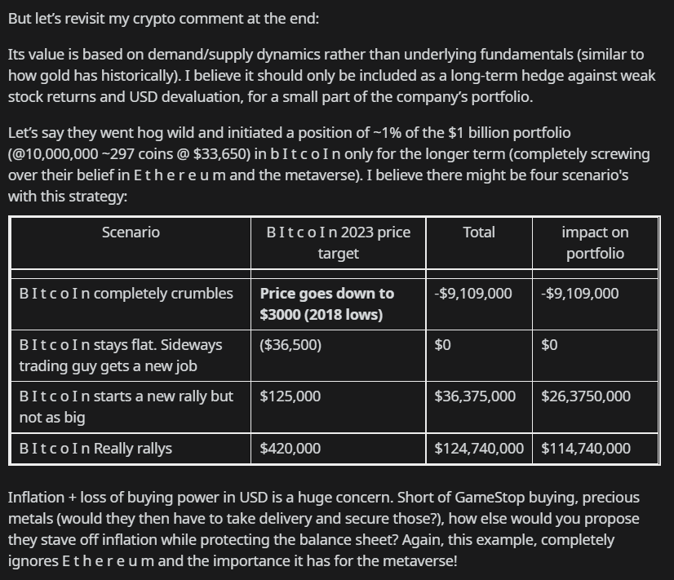
Again, I understand that RC and company are going to be deploying a lot of that war chest but how do we best protect the cash
war chest in the interim?!?!

Elon has done it and seen this technique make his company more money than they have by actually selling cars? RC and
GameStop bring the metaverse fire!
TL:DR – I believe inflation is the match that has been lit that will light the fuse of our rocket.
Back to Table of Contents
The Anatomy of the MOASS - Part 1/3: The Key
Market Concepts that Make the MOASS
Possible and Other Important Terminology
DD 👨‍🔬
Disclaimer: Not Financial Advice, I am not a Financial Advisor .
BEFORE READING
IMPORTANT LINKS FOR NEW MEMBERS TO r/superstonk
• APE Security Protocol (how to secure and protect yourself online)
• DD Beginners Guide Page
• Wiki
Feel free to use the contents of this post however you want
• Don't worry about asking for permission to:
o Copy it / cross-post it / translate it / refine it / Use it in your own posts
o Do whatever you want
Leave a comment if you have any questions
• If you prefer Chat or do not meet karma requirements, you can hit me up on chat as well
I have found myself more active on Twitter than I ever really expected to be and do what I can to support
the SuperStonk and the broader Ape Community, so feel free to follow me if you want to see things like
the below:
• Future DD Notifications, and sharing of DD from other contributors and other important
SuperStonk Info
• Shit-posting with the other Apes in the community
• Antagonizing Market Adversaries, MSM Shills, etc.
• Weaponization of Social Media
SERIES PREFACE
WIP portions will be linked in the future, but I have included the high-level frame of what will be
covered (subject to change)
Part 1 - The Key Market Concepts that Make The MOASS Possible
and Other Important Terminology - YOU ARE HERE
• Stock/Securities Concepts
• Trade Positions
• Market Participants
• Important Market/Trade Mechanics
• MOASS Breakdown of "How"
This Part overlaps a lot with content in The MOASS Thesis Summary DD (The MOASS Summary goes into
a little more depth on the GME Thesis so it may be a good read if you have not checked it out in the DD
Beginners Guide Menu), but includes some refinements
Part 2 (WIP) - MOASS Mechanics, Landscape, Atmosphere, and
Tactics: What "Normal" Looks Like in the Months/Weeks Leading to
MOASS
• Tactics
o MSM Propaganda
o Community Infiltration
o Price Manipulation
o Steganography
• Mechanics
o Loopholes
o Patterns and Cycles
• What does Normal Look Like (Expectations to set)
o Price Movement
o MSM Content
o Shill Activity
Part 3 (WIP) - MOASS Mindset and Ways to Navigate
• Think Critically
• Understand "Why" You Believe in Your Thesis and the Basics "How" the Thesis is Possible
• Don't be afraid to ask questions to become learned
INTRODUCTION / INTENTION OF POST - PART 1
Part 1 of this DD series is intended to break down the main market concepts that make the MOASS
possible. These are all Fundamental Concepts that are not unique to GME.
These terms are key to understanding the MOASS Thesis and speculated value of a GME investment.
Hyperlinks to Investopedia, "the world's leading source of financial content on the web", have been
included for most market terms and concepts and it is recommended to check them out if they are not
clear. We will be breaking down some of the more complex terms and concepts within the post and
framing them within the context of GME.
Table of Contents for Key Concepts
1. Stocks Concepts
a. Share/Stock
b. Synthetic Shares
c. Outstanding Shares
d. Restricted Shares
e. The Float
2. Trade Positions
a. Long Position - Buying/Selling Stock
b. Short Position - Shorting/Covering Stock
c. Naked Short Position - Naked Shorting/Covering Stock
3. Market Participants
a. Retail Investors
b. Institutional Investors
c. Market Makers
d. Prime Brokers (Broker Dealers) and Brokers
e. Clearinghouses
f. Mainstream Media (MSM)
4. IMPORTANT MARKET/TRADE MECHANICS
a. Fails to Deliver (FTD)
b. Margin
c. Margin Calls
d. Margin Calls Who Calls Who
e. Short Squeeze
5. MOASS Order of Operations
1 - STOCKS CONCEPTS
1.1 - Shares/Stock
Shares are the smallest unit of a Companies Stock
• Stocks and Shares are often used interchangeably
• Technically "shares" would represent how many of a specific company's stock, where
buying multiple "stocks" would main that shares of multiple company's were bought
o ex. I bought 2 stocks; 10 shares of GME, and 60 shares of CHWY
• There are different classes of shares that are distinguished on their voting rights, sales
charges, and other factors
o Classes of shares have relatively complex dynamics, but I will not go
further into them here, as it is not as relevant to GME
1. 2 - Synthetic Shares
Synthetic Shares are the financial instruments that get produced through Naked Shorting
• Not to be confused with synthetic options positions, which are legal/legitimate trade
strategies that "simulate" the profits/losses as if the trader actually held those shares
• Synthetic shares entitle the owner to all of the same rights as an investor owning a non-
synthetic share
• Cases where there is an excessive amount of synthetic shares point to the possibility that
a stock is being abused or manipulated
• Cannot be easily measured due to limited public transparency at the Market Maker and
Prime Broker level
1.3 - Outstanding Shares
The number of Outstanding shares encompasses the amount of issued shares held by all shareholders
(both private and public)
• It is possible for there to be more shares outstanding through Naked shorting, which
produces Synthetic shares
• The number of issued AND synthetic shares outstanding is very difficult to measure, as
they are only recorded on the books of the market makers generating synthetic shares
and the prime-brokers they trade through
o These parties are not incentivized to be transparent and actively obscure
these numbers, as the practice of naked shorting excessively is fraudulent
and illegal
1.4 - Restricted Shares
Restricted shares include the number of issued shares held by insiders of the company
• These shares are not publicly traded on the stock market
1.5 - The Float
The Float, or Floating Stock is the number of shares of stock that are available to be publicly traded (the
number of Outstanding shares minus the amount of Restricted shares that are owned by insiders).
• In theory, the number of shares owned by retail investors and institutional investors should
not exceed the float
• GME’s float total is currently ~56.89 Million shares (as of 6/10/21)
2 - TRADE POSITIONS
2.1 - Long Position - Buying/Selling Stock
When an investor buys a stock they are considered long on it (this is the type of position most people
associate with trading stocks)
• Not to be confused with a long-term investment
• In other words, holders of long positions have a positive number of shares
• To close a long position the owner would sell their shares on the stock market
Basic flow of obtaining/closing a long position is:
1. Buy the stock
2. Hold it until the price of it increases to a desired amount
3. Sell it for a profit
2.2 - Short Position - Shorting/Covering Stock
When a short seller shorts a stock they hold a short position on the stock, or owe the party they
borrowed from however many shares they shorted
• Not to be confused with a short-term investment
• Investors with short positions effectively are in debt or owe the number of shares that
they have shorted and can be considered negative on the stock
• To close that position, short-sellers must buy a number of shares equal to the size of their
short position (buying to close a short position is known as covering)
• Short positions must be reported to regulators (unlike naked short sales)
Basic flow of obtaining/closing a short position:
1. Borrow a share owned by a lender
2. Sell the stock that was borrowed
3. Gaining the cash based on the price it was at the time it was “shorted”
4. Pay interest as a percentage of the stock's value
5. Since this is a percentage the cost of interest increases if the stock's value increases
6. Hold the position until the price has dropped to a desired price
7. Buy the stock on the open market
8. Ideally the stock is bought back at a lower price than originally borrowed for so the
investor can pocket the difference
9. Return the share back to the lender
2.3 - Naked Short Position - Naked Shorting/Covering Stock
Naked Shorting effectively allows a Short Seller, working with a market maker, to short a stock using a
without having a borrowed share like normal short selling
• Naked short sales do NOT have to be reported the same way as normal "Short Sales" and
can be "hidden"
o Failures to Deliver the shares that were "fake-borrowed" to the buyer are
on of the main ways to find evidence of naked shorting
• Due to a loophole and lack of oversight by regulation, Naked short selling can be used to
manipulate the price of certain stocks
o This type of trade illegal outside of specific situations involving Market
Makers
• Naked shorting was targeted for tighter regulation during the financial crisis of 2008 but
enforcement has unfortunately not been effective in preventing it from manipulating the
market
Basic flow of obtaining/closing a naked short position (kind of complex and involves two specific parties
for 2 initial trades called a married put)
1. A Short Seller "A" buys 100 shares from a Market Maker "Z" who can technically sell them
without locating them
a. Market Maker is Naked Shorting the stock, and the Short Seller is receiving
100 synthetic shares
2. Short Seller "A" now buys a Put Option (1 options contract is worth 100 shares) from
Market Maker "Z" who is the writer of the put (Writing a put does not require the writer
to have the shares on hand)
a. Writing/selling a put nets +100 shares to the Market Maker, which results
in the -100 shares that were naked shorted to be neutralized, so the
Market Maker no is at a neutral position (Market Makers generally try to
remain net 0 on trades
b. Short Seller "A" now has 100 shares that can be short sold (they
"borrowing" the synthetic shares the Market Maker effectively printed out
of thin air), and one put contract that they can make money on as long as
the price goes down
3. The steps or the short seller are basically the same as a normal short sale now (2.2 steps
2-8), however, interest from the Short seller does not need to be paid to a lender (no one
is formally lending it)
a. The premium from the put being purchased from the Market Maker is how
they benefit
b. Short Seller "A" now has a short position that they can cover simply by
buying 100 shares, which would cancel out the synthetic short position
3 - MARKET PARTICIPANTS
3.1 - Retail Investors
• Retail Investors, also known as individual investors, are your average investors (not a
company or organization)
• Referred to as the "Dumb Money" by Wall Street and the "professional" financial
community
• Reddit communities
• u/DeepFuckingValue (@TheRoaringKitty on Twitter)
3.2 - Institutional Investors
Institutional Investors are organizations that invest on individuals' behalf
• Examples of Institutional Investors
o Endowment Funds
o Commercial Banks
o Mutual Funds
o Hedge funds
o Pension funds
o Insurance companies
Notable institutional Investors involved in the GME Saga so far
• RC Ventures LLC (LONG)
o To Apes: Ryan "Buckle Up" Cohen, AKA GameStop Chairman, AKA Bringer
of SHF Tears 🥰
o To SHFs and Market Manipulators: Doom
• BlackRock (Long)
• Vanguard Group (Long)
• Fidelity (Long) - May not have an active position on GME Specifically
• Melvin Capital (Short)
• Shitadel Advisors (Short)
• Point72 (Short)
3.3 - Market Makers
Market Makers can be Hedge Funds, Brokers, or Prime Brokers, who, rather than investing and holding
long or short positions, they profit by ensuring there is liquidity in the market buy simultaneously
submitting buy AND sell orders close to the current price (they play both sides of the market and must
always have shares to buy and sell)
• Market Makers ensure that if some another investor wants to buy or sell shares near the
current price of a stock, there is a corresponding buyer/seller on the other side of the
trade offering to trade (for availability essentially)
o They will normally offer to buy at an amount that is a bit lower (generally
fractions of a percent away) than the last price a share was sold for, or sell
at a price that was a bit higher than the last price a share was sold for
Ex. Lets say current share price is $200$; A Market Maker
might have a buy order for 100 shares at $199.75, and have
sell orders for 100 shares at $200.25, so assuming both of
those trades execute, they net $50 on those 100 shares
($0.50 * 100 shares)
o Generally, Market Makers intend to remain Net Neutral on their positions,
making money based on volume traded, rather than holding positions long
enough for them to increase or decrease
o They employ High Frequency Trading systems (computers) and algorithms
to facilitate trading
• When you buy and sell stock those trades are often trading between you and a market
maker
• Market makers get "special rules" that enable them to keep liquidity in the market when
there is low liquidity
o Naked shorting is one of the options Market Makers have when navigating
a trade that other investors do not have
Notable Market Makers
• Shitadel Securities
o While part of "Shitadel" this organization is separate from the Hedge Fund
(Shitadel Advisors)
• Virtu Financial
• Credit Suisse Securities
• Deutsche Bank Securities
• Goldman Sachs and Company
3.4 - Prime Brokers (Broker Dealers) and Brokers
A Prime-Broker is a bundled group of services that investment banks and other financial institutions
offer to hedge funds and other large investment clients that need to be able to borrow securities or cash
in order to engage in netting to achieve absolute returns
• Broker vs Prime-Broker
o A broker is an individual or entity that facilitates the purchase or sale of
securities, such as the buying or selling of stocks and bonds for an
investment account. A prime broker is a large institution that provides a
multitude of services, from cash management to securities lending to risk
management for other large institutions.
• While Brokers often route trades through Market Makers, MMs also through and receive
margin from Prime Brokers
o The Prime Broker is who would Margin Call Shitadel if their short position
gets too large or they bleed too much capital
• Retail investors trade through and receive margin from Brokers (not Prime Brokers)
3.5 - Clearing Houses
Clearinghouses are intermediaries between buyers and sellers
• Finalize transactions
• Regulates delivery of assets
• Reports on trading data
3.6 - MSM (Mainstream Media)
Though not a traditional market participant (as in they are not trade/financial entities) the MSM is
worth noting due to its role in influencing the financial atmosphere and landscape
• The MSM (specifically the Financial Media in this case) overall is motivated through
sponsors and through ratings
o They often cover topics based on what their sponsors want them to cover,
and/or those that are more likely to draw many viewers
• The Financial Mainstream media comes in many forms
o News Articles
o Blogs
o Television
o Newspaper
4 - IMPORTANT MARKET/TRADE MECHANICS
4.1 - Failures to Deliver (FTD)
FTDs occur when a buyer of a stock ends up not having the money to purchase the stock that they traded
for OR, when a short seller does not own the stock at the time of settlement
• FTDs are one of the main check-balances to naked shorting, so very high amounts of
Failures to Deliver are indicative of this
o Spoiler: GME has tons of FTDs reported
• FTDs are supposed to be covered within a specific time period in order to avoid violation
of regulatory rules
Cycles
Our understanding regarding the "rules" of T+21 and T+35 Cycles was constructed in The SECs Key Points
About Regulation SHO
T+21 Cycle
When there are Failures to Delivery that are not satisfied by the required time period (T+4 for Short
Sales and T+6 for Long Sales, a Market Maker must satisfy the FTD within 13 days following the T+4/6
• If it was for a long sale that Failed to Deliver, T+6 (7 Days including the trade day) plus
another 13 consecutive days (14 Days including the failed settlement day), amounts to 21
days (this is where the T+21 Cycle comes From)
T+35 Cycle
If a FTD passes through T+21, there is a maximum time of 35 calendar days after the initial trade date
that the firm clearing the trade must pre-borrow (purchase) the share to satisfy the FTD
• In theory, to avoid breaking the rules, Failures to Deliver must be satisfied some time
within 35 Calendar Days of the trade date
4.2 - Margin
• Margin is basically credit that that an investor can use to buy more stock
• When you buy on margin you must stake the assets you have already purchased with
your own cash as collateral
• The amount of Margin you can have depends on the value of your collateral
• The value of your collateral and cash but meet the margin requirements in order to
continue to buy on margin
• Keep in mind the value of your collateral can change if the price goes up or down and if
the value of your collateral/cash drops below the margin requirement you will received
a Margin CallAnother way to think about it:
1. Imagine I have $1,000 in stock
2. You obtain a personal loan for another $1000
3. To get the credit you stake your $1000 in stock (if you default it goes to the lender to
cover your debt)
4. You buy $1000 more stock with that loan (you now own $2000 in stocks, half in cash half
on margin)
5. You will pay interest on the $1000 on margin but if your investment makes more money
than the interest then you are still profiting
6. If your investment turns bad (lets say the price of your stock falls 50% and you are left
with $1000) your lender can forcibly close out your positions (everything you bought in
cash and staked as collateral along with what you bought on margin so that they can get
the $1000 they loaned you back)
4.3 - Margin Call
• A Margin Call is a notice indicating you have a specific amount of time to deposit enough
of your own funds to meet your margin requirement (if you cannot meet the requirement
the lender is entitled to sell all of your holdings to recover what you borrowed
Margin Examples:
This is a slightly complicated scenario that can be a little hard to follow. Give it a few reads if it doesn't
make sense the first time, but basically, Margin is a credit line that you can use to buy more assets
(effectively a loan backed by collateral and cash in your own account). If you buy assets with it, you have
to pay back what you borrowed, whether the value of your investment goes up or down (if the
investment goes up in value, you make more than you normally would, but if the investment goes down
in value, you lose more than you otherwise would have without margin).
This gets even more (or less maybe) complicated when you have short positions AND long positions, like
most institutional investors. To have short positions, I still need to have margin, but I do not need to use
it to buy stocks, It can act as a buffer if I have a short position on a stock that is increasing in value (with
a short position, if the price of something I short goes up, I am losing money), and if it gets too high, it
can run against my margin line, causing a margin call.
GAIN: Long Positions
1. Imagine I have $1000 in stock XXX (let's say 10 shares worth $100 each)
2. My broker may lend me margin credit line equal to the value of my assets (so $1000 in
margin), and let's say they give me a margin requirement of $800, meaning that the value
of my non-margin assets (the ones I bought with my money) must be above $800 in order
to keep using margin (so as long as stock XXX stays above $80 a share, then I will not get a
margin call for being below the requirement)
3. I then choose to use the margin, buying 10 more shares of stock XXX for $100 each, so I
now have 20 shares of stock XXX, valued at 100$ a piece
4. If the price of stock XXX goes up to %25 per share, and I sell all 20 shares, I just profited
$500 (+$25 on 20 shares)
a. In this case, closing the position clears me from the margin debt, as I am no
longer using it in an open position
b. If I had not used margin, I would have only walked away with $250 in
profit ($25 per share on 10 shares), but instead I made $500, and paid
back the credit, plus a little bit of interest.
5. Yay.
LOSS: Long Positions
1. Imagine I have $1000 in stock XXX (let's say 10 shares worth $100 each)
2. My broker may lend me margin credit line equal to the value of my assets (so $1000 in
margin), and let's say they give me a margin requirement of $800, meaning that the value
of my non-margin assets (the ones I bought with my money) must be above $800 in order
to keep using margin (so as long as stock XXX stays above $80 a share, then I will not get a
margin call for being below the requirement)
3. I then choose to use the margin, buying 10 more shares of stock XXX for $100 each, so I
now have 20 shares of stock XXX, valued at 100$ a piece
4. If the price of stock XXX goes down %25, bringing the value per share down to $75 a
share, the value of my total position is now $1500, and the value of my non-margin assets
is $750, which is below the margin requirement (keep in mind, I borrowed $1000, so that
is still the amount I have to pay back)
5. My lender will give me a margin call, indicating I have two business days to deposit 50$
into my account in order to meet the margin requirement
a. If I have the cash to deposit the extra $50 would take my assets to $800
($750 in stock XXX + 50$ cash)
i. If the price of stock XXX recovered to above $80 per share, it
could also satisfy the requirement
b. If I do not have the cash to deposit, then I am in trouble, as after two days,
they are allowed to liquidate (sell) the assets I bought with my own money,
as well as the assets I bought on margin
i. Let's say this happens, all my borrowed assets are sold first
to cover my $1000 loan (since the price of stock XXX was
only $750, it only covers $750 of my $1000 margin line
ii. I now have $750 left in assets of Stock X, but I still owe
money from margin, so my lender is entitled to sell $250
work of my shares in order to get their full $1000 back
iii. I am now left with $500 total ($750 in 10 shares of stock
XXX - $250)
6. Not Yay
LOSS: Short and Long Positions
THIS IS THE RELEVANT ONE TO GME
1. Imagine I have $1000 in stock XXX (let's say 10 shares worth $100 each)
2. My broker may lend me margin credit line equal to the value of my assets (so $1000 in
margin), and let's say they give me a margin requirement of $800, meaning that the value
of my non-margin assets (the ones I bought with my money) must be above $800 in order
to keep using margin
3. Instead of using the margin to buy more, I instead short 10 shares of stock YYY which is at
$50 a share currently (giving me $500 in extra cash), which I use to buy 5 more shares of
stock X
a. I am now long 15 shares of stock XXX valued at $1500 and short 10 shares
of stock YYY valued at -$500 (negative $500) for a net value of $1000
b. No margin is actively committed to open positions, and I am still using my
$1000
4. Now, lets say a short squeeze happens involving stock Y, causing the price to skyrocket to
$200 per share
a. My short position is now -$2000 (10 shares of -$200 each)
5. My net account value is now $-500 ($1500 - $2000) which is now using my margin, and
because my account's value is no longer above $800, I no longer meet margin
requirements so I get a margin call
6. If I cannot balance my account, the lender will liquidate my $1500 in stock XXX in order
to pay the -$2000 I owe, leaving me with -$500 left in debt
a. I have now defaulted, as I cannot pay the $500
7. Now that I have defaulted, the lender who gave me margin owns my short positions,
meaning they are now short whatever was left
a. The lender can now navigate the short positions however they want (they
can hold them and hope the price goes down, and cover to close them, or
they can close them immediately, costing them the whole $500 I still
owed)
8. GUH!
4.4 - Margin Calls Who Calls Who
Margin calls happen at levels 1-4 when the cell to the left cannot meet margin requirements
• Broker Margin Calls Retail Traders
• Prime Brokers Margin Call Brokers, Hedge Funds, and Market Makers
• The NSCC Margin Calls Prime Brokers
• Defaults roll up left to right
o If Retail Trader defaults, Broker must take on their leftover positions
o If Broker, Hedge Fund, or Market Maker defaults, the Prime Broker must
take on their leftover positions
o If Prime Broker Defaults, the NSCC must take on Position
o If the NSCC Defaults, the Fed must take on the position
Level 1 Level 2 Level 3 Level 4 Level 4
Retail Trader Broker Prime Broker NSCC (DTCC) Fed (JPOW)
x Market Maker Prime Broker NSCC (DTCC) Fed (JPOW)
x Hedge Fund Prime Broker NSCC (DTCC) Fed (JPOW)
4.5 - Short Squeeze
A Short Squeeze is a market event that occurs when there is a large short position on a stock whose price
rapidly increases higher than expected, normally due to a catalyst
• During the short squeeze, the losses of those who have short positions continue to
increase higher it goes
o Since they owe shares, the cost to cover their position increases depending
on how high the price goes (there is theoretically no limit on how high a
stock can go)
• As market participants who are short on the stock buy to cover, supply decreases and
demand increases, causing the price to increase even more rapidly
• While short sellers are scrambling to cover their positions, the rapid price change may
entice investors who are not short on the stock to buy it in order to make a quick profit
o Again, lowering supply and increasing demand
TL;DR
Obligatory TL;DR (Closest thing to one is section 5)
5 - MOASS Breakdown of "How"
The main point of the post is to read and understand section V, but here is section IV to act as a TL:DR
1. Toxic Market Participants have built up massive short positions made through Naked
Shorting
2. Retail caught on to this strategy and discovered it can backfire if the company being
shorted does not go bankrupt, especially if shares are bought and held indefinitely
3. Rules and regulations have implemented by the DTCC and its subsidiaries have been
geared towards preventing market collapse, as well as to minimize the ability to perform
illegal trades (naked shorting)
4. The SEC is also doing more to enforce compliance with the "rules"
5. The manipulators are at the mercy of a vicious trade cycle (T+21/35 FTD Cycle) that is
forcing those with naked short positions to perform actions to cover (buy back shares that
are short), or risk regulatory consequences
6. This act of rapid covering drives up the price, making it more expensive to cover during
the next cycle if the share price continues to increase week over week
7. Eventually, the prices of GME will get so high that prime brokers will have no choice but
to Margin Call these participants which most likely will not be meetable due to the nature
of Short Squeezes, causing them to default and be forcibly liquidated
8. The Prime-Brokers will then take on the position, and if the Prime Brokers cannot cover
them and also defaults, the NSCC will be next to attempt to settle all positions left over
based on their Recovery and Wind-down Plan (p42)
9. If NSCC cannot afford to close everything with the money reserved for this type of
situation, they the Fed must navigate the remaining positions (potentially via printing
money/bailout)
Stay Tuned for Parts 2 and 3
Back to Table of Contents
wen moon 10 : Endgame ■ Final TA
DD 👨‍🔬
Hello everyone 🦍, this DD will be the last one I publish untill the squeeze hence the title Endgame.The
reason is simple ; I strongly believe we are in the final stage of the battle with the crooked hedge funds
and their agents.
In my humble opinion there is no reason for me to provide more technical analysis in the near future ,
or perhaps evidence for a squeeze. Hundreds of DD, countless data and hours of interview with some of
the most brilliant mind and expert out there should be enough to convince you that ---
The things set in motion cannot be stopped.
🚀
It's been one hell of a journey from DFV first YOLO post to the recent and exciting development with the
company and every crazy event 🍌 that happened in between.
I've had the time of my life sharing these DD and shitposting with you guys.
I'm ZEN as can be and I hope everyone else is.
at this point I think our hands are nothing but pure diamonds. 💎
🍻
without further ado, let's dive in...
PART 1 - Basic charting 🌙
Without using any indicators whatsover and just by looking at our daily chart things seem to be
progressing well.
u/chayse1984 pointed out in his DD that GME are currently about to break out of a cup and handle
while being inside of a bullish pennant.
For my smooth 🧠 out there it means we have roughly a 66% chance of breaking out on the upside to a
bare minimum of about 450$.
(measurement from the bottom to the top of the cup on the log chart).
What's also interesting to note; it would bring us exactly where Elliot Wave guy told us the 3rd wave
would bring us. 👨‍💻 (This was also double checked by Youtuber Trading Sciences; Source)
When two different analysis made by numerous people point in a direction it's best to assume that these
speculation have a very good chance of happening for the simple fact that it plays a key factor in the
psychology of trading in individuals.
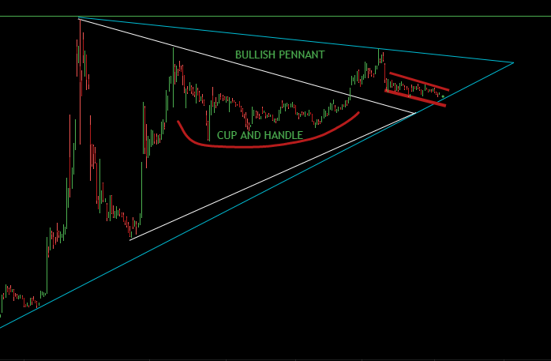
Chart as analyzed by chayse and myself , cup and handle insine a bullish pennant supported by a trendline.
SOLVING THE CUP AND HANDLE
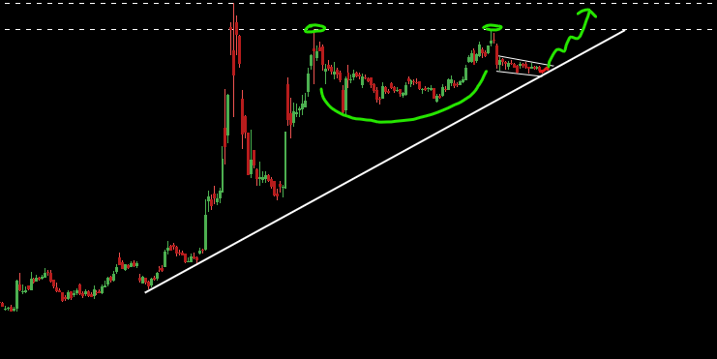
The first thing we need to find out is how the cup and handle will play out.
It's pretty normal for a cup and handle to retrace as much as 50% from their initial high before a blue
sky breakout or in our case a trip to the moon. As illustrated below this would be the most possible
scenario in my opinion, this would also trap bears causing even more buying pressure if the trend
changes rapidly.
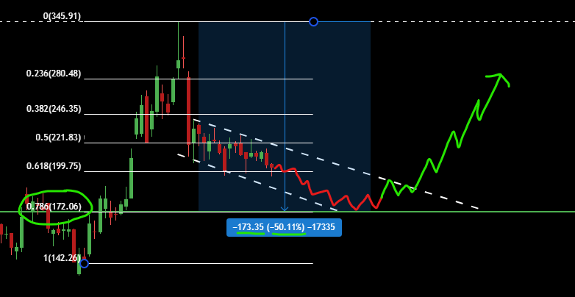
GME could go as low as 172$/173$ before breaking out.
This to me is another scenario also bullish but less probable, we could see the trend reverse itself as
soon as monday and we would resume our journey to the top. Such a weak downtrend would indicate
that shorts and bears are now completly powerless, they don't even believe in their own thesis anymore.
If GME remains above 200$ and start to break out by the end of the week, HOLY MOLY.
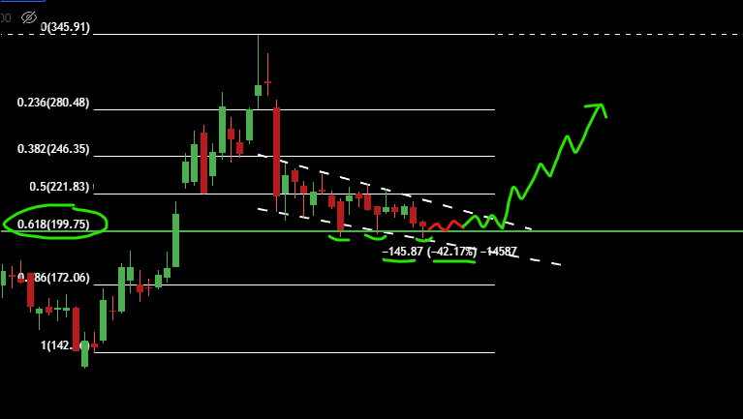
Hedgies are fucked
If you wish to understand more about Elliot Wave theory I recommend reading Elliot Wave Guy DD or
watching this video.
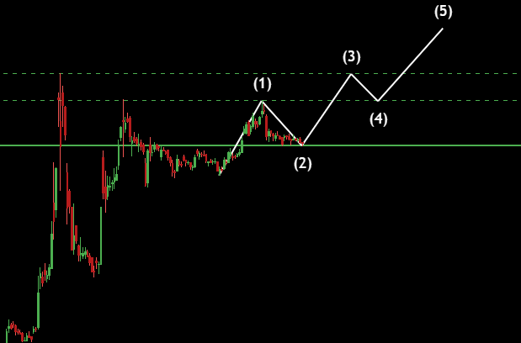
Elliot Wave theory applied to GME
Now we can put all the pieces of the puzzle togheter and it look something like this, two different
technique ; same result. Very bullish but also realistic and works perfectly in accordance with William
O'Neil trading strategy about the cup and handle theory and Elliot Wave theory.
HODL 🚀
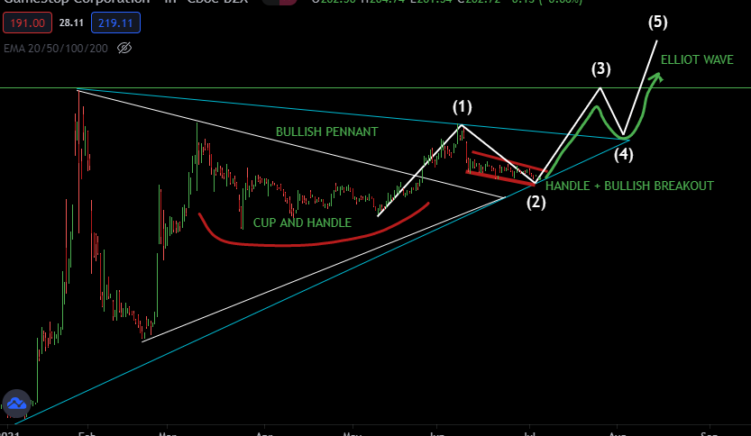
O'neil + Elliot theory applied to $GME
If this is not enough to confirm your bias check out the next section. 😎
Part 2 - In depth T.A 🌙
MACD
Downtrend is getting weaker and weaker, bears are fucked. Just give it a little more time and this baby is
gonna crossover like it always did in the past, as you can see everytime is crosses-over we raise our floor
a little bit.
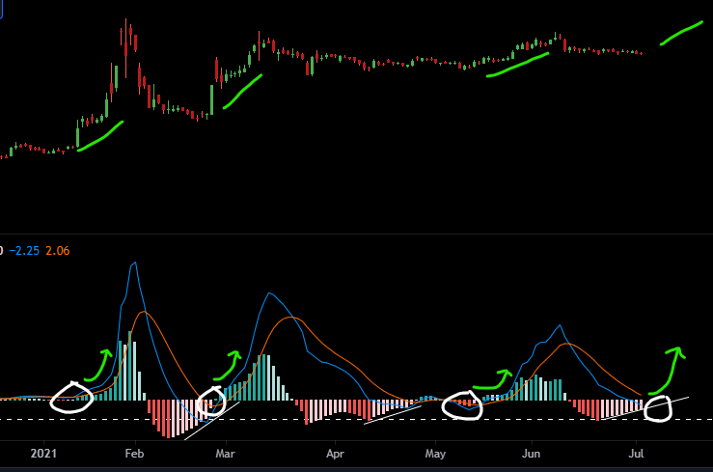
MACDADDY GETTING READY TO 🌊💧🍾
RSI
RSI on GME has a tendency to bounce of the median line (GREEN) and explode back up, right now we're
consolidating but as you can see it's just a matter of time until it breaks out again, we can also confirm
that the current downtrend is very weak and that APES are in control.
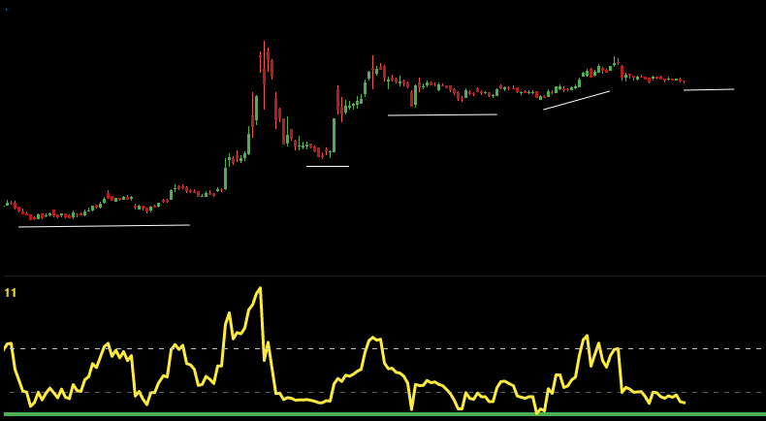
Wow Kenny ! Is that the best you could do ?
EMA
The exponential moving average (EMA) is a technical chart indicator that tracks the price of an investment
(like a stock or commodity) over time. The EMA is a type of weighted moving average (WMA) that gives
more weighting or importance to recent price data.
The EMA on the weekly timeframe is looking great, the EMA on the daily timeframe reminds me of the
way we traded back in march. Consolidating before a break out. Also BOOLISH LFGGGGG
WEEKLY EMA
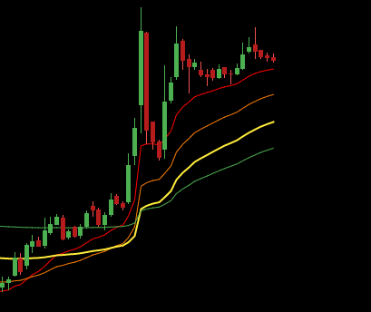
Weekly EMA looking stunning.
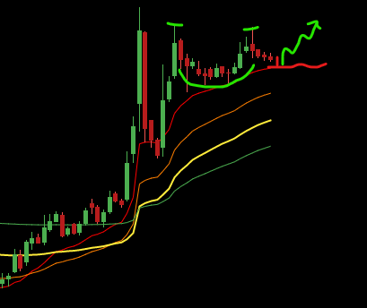
GME will most likely bounce off the 20 EMA on the WEEKLY and RIP
DAILY EMA
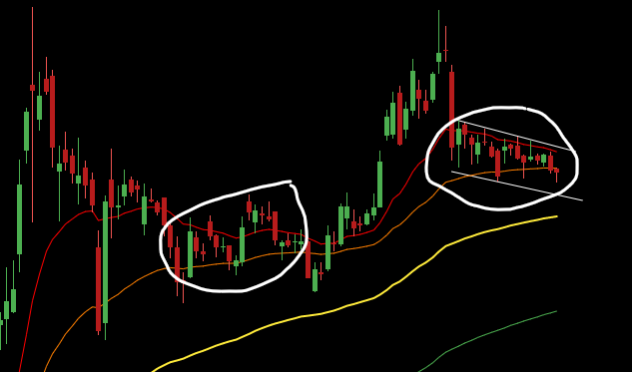
Last time we traded in between the 20/50 EMA things went crazy afterward.
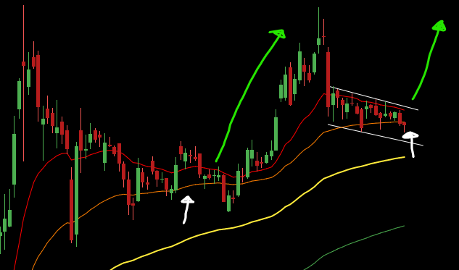
Huu guys.. 🚀
VOLUME
Well I think everyone has noticed by now that the volume is drier than the Sahara desert. But fear not,
this is very similar to what happened back in July.
Low volume pullback like this are very attractive to investors as they present low risk high rewards
scenario.
In simple term FOMO will be kicking in soon, and the people who didn't buy this will be mad because it's
pretty much the last chance you've got at buying GME at a some ''reasonable price''.
I'm sure if you could bo back in time and buy at 4$ / 40$ you would go all in, don't miss out
again.Because you might never see the low 200's ever.
Also I'd like to point out how similar the chart is looking to the previous run up to 75$ from last summer.
This isn't financial advice, just common sense.
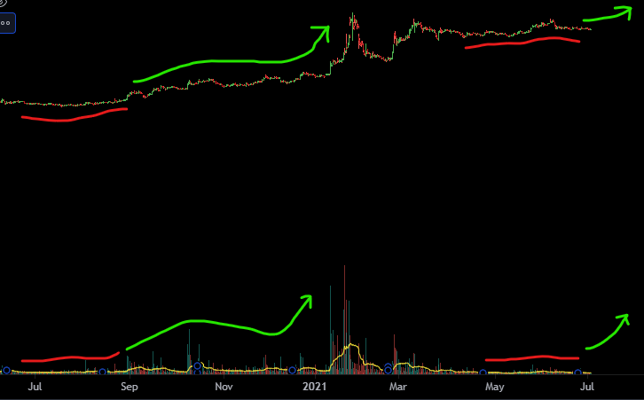
''awww man.. I wish I would have bought at 200$ but I wasn't sure I mean GME is a dying company on paper, right guys ? '' -
Some fundamental investor
BOLLINGER BANDS
Bollinger bands help determine whether prices are high or low on a relative basis. They are used in pairs,
both upper and lower bands and in conjunction with a moving average.
The Squeeze
The squeeze is the central concept of Bollinger Bands®. When the bands come close together,
constricting the moving average, it is called a squeeze. A squeeze signals a period of low volatility and is
considered by traders to be a potential sign of future increased volatility and possible trading
opportunities.
The superstonk is about to go BRRRRRRRRRRRRRRRRRR , the chart is screaming BUY ME alot of
people will miss out on life changing money because ''mUh DyInG BrIcK aNd MoRtaR StorE'' .
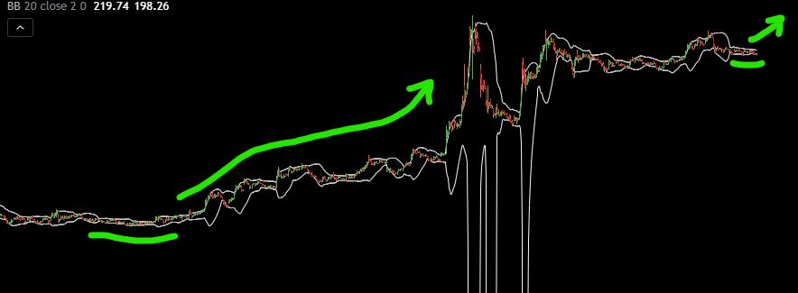
HVP by Bali Purr (Historical Volatility Percentile)
It's my theory that DFV and many big traders used this signal as a confirmation to buy Gamestop last
summer, it rarely gives a signal so when it happens it's huge.
it gave a signal last month !!!!!!! , usually it takes a few weeks to breakout add a few more weeks for
volatility to reach a peak. As we know volatility is key for us. We broke out!!!! SO.. in a few weeks we
will MOST LIKELY SEE a HUGE SPIKE in volatility A.K.A TENDIES. 🍗🍗🍗🍗
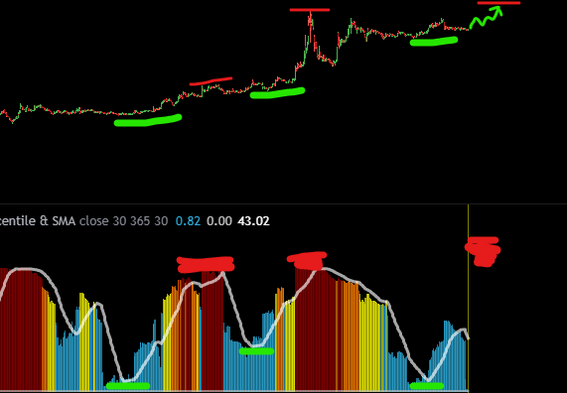
HOLY FUCKING MOLY, this is it. Cherry on top of the sundae :D
PART 3 : FINAL WORD AND TLDR 🌙
If you are doubting Techical Analysis let me give you a quote from the book trading in the
zone by Mark Douglas :
'' Individuals develop behavior patterns, and a group of individuals interacting with one another on a
consistent basis form collective behavior patterns. These behaviors are observable and quantifiable and
they repeat themselves with statistical reliability. -- in a sense technical analysis allow you get into the
mind of the market. As a method for projecting future price movement, technical analysis as turned out to
be far superior to a purely fundamental approach. ''
----
EVERY INDICATOR IS SCREAMING BUYYYYYYYYYYYYYYYYY
Like I said in the intro I feel like everything is going as it should right now. If you are anxious or feeling
fudy, just know that everything is gearing for a move that is gonna literally break the space-time
continuum. 🚀
Everything is a buy right now, EVERYTHING. We're past the point (I THINK) where we'll ever
get GME at a cheap price . Buy if you can HODL if you can't.
If I could go back in time and tell my past self to buy more at 40$ trust I would but I won't have the
regret of not going all in at 200$ , I just maxed out.
XX hodler till infinity. 🚀
I will see ya'll on the moon very soon. 🚀
❤️
EGGS out -
EDIT : I want to thank everyone from the bottom of my heart 💖 X to XXXX hodlers for all the work you
guys have put in to build-up this amazing community.
Back to Table of Contents
The Sun Never Sets On Citadel -- Part 1
DD 👨‍🔬
Hello Superstonk
Preface
I became bothered by a question a few months ago. The GME saga started with MAJOR fight in the
financial landscape between Team Citadel vs. Team Other (Blackrock, Vanguard, etc.), and Superstonk is
here now because of Team Other getting Ryan Cohen on the board at GME, then “retail” landed on the
scene, now Apes, etc. But this ONE question always bothered me:
What did Citadel do to piss everyone off? WHY would they want to give Citadel the most epic beat
down in financial history?
So I spent some time looking into that because it must be good and...
HO BOY, GET YOUR POPCORN, I’VE GOT SOME GOODS TO SHARE WITH YOU AND IT’S GONNA BE
JUICY
Note: this is a strategy post. u/atobitt and u/criand focus on macro topics about Citadel’s structure in the
overall market, but this series is going to be about financial industry strategy. I have a master’s degree in
business and specialize in strategy and operations. While I don’t have direct experience in finance per se,
I really enjoy finding the “hows” and “whys” behind what businesses do.
Also, I’ll give shout outs to the Apes who did relevant DD before this. Parts of this are my own discovery,
parts are building on the work of those who came before :) This is an overall picture.
Symbol indicators:
• [] - request for link to relevant DD (r/Superstonk DD posts or legitimate sources)
1.0: Introduction
The Price of $GME is artificial. Prior posts (1, 2) have covered how Citadel and other players in the
market have greedily, illegally conspired to change the price of stocks for their own profit. While
Citadel’s criminal price manipulation of GME represents a failed scheme to fabricate shares for profit,
this was only a small corner of a much larger body of activity. Citadel’s overall activity shows a plan to
monopolize markets worldwide and control securities transactions at the exchange level.
Yep.
Buckle up :)
Key Term
Market Maker (or “MM”) – a special role in a stock exchanges around the world. An MM’s primary role
is to provide liquidity, or “to make sure there are shares available to buy if people want them” as well as
“make sure there is a buyer if people want to sell.” Exchanges need it: liquidity makes for easy buying
and selling.
• A MM is the intermediary for almost any securities transaction. It is positioned between
the exchange and the brokers/dealers/funds that do not have access to the exchange, or
they use the MM to do the buying work for them, lol. Or the MM is positioned on the other
side of a transaction, supplying the securities in demand.
• A MM is always in a position of risk. They are constantly in a place to be on the losing side
of a transaction if they “guess” wrong.
• Note: Citadel has many branches, but it’s two major branches are its hedge fund and its
MM. I will be referring only to its MM activity.
1.1: Plus Ultra
Take a moment to marvel at how Citadel has installed themselves in so many markets around the
world. They are Market Makers and/or liquidity providers in nearly every major exchange on
earth: (Note: my undersrtanding of a liquidity provider is that it’s a bit like a less-powerful MM)
Citadel Securities own splash page
• US/North America: NYSE, NASDAQ, CBOE (not even going to bother with links here, you
know they’re there), Toronto
• Europe: London/Ireland, Amsterdam[], Frankfurt[]
• Asia/Pacific: Hong Kong, Singapore, Sydney [], Shanghai []
• (Apologies on missing links, I’ve saved so many links through this whole drama that I
can’t find some of my sources anymore. And this is not the full list, this is only what I
could put together for this post.)
Citadel is truly an intmidating company based on the position it occupies in markets worldwide.
1.2: E Pluribus Unum
So WHY has Citadel strived to achieve such a large footprint across the globe?
Because there is a flaw in the markets across the world: it depends on Market Makers.
• Exchanges are set up to have several Market Makers providing liquidity.
• So the Market Maker has responsibilities for supply and demand of a given security.
• It’s an essential service so exchanges empower MMs with exclusive powers and
responsibilities.
Take a look at the exclusive powers the NYSE gives its DMMs (like a “Super” Market Maker): From the
NYSE DMM page
• MMs have Superpowers and wield immense control over securities.
• Exchanges rely on incentives for winning bids (coupons) as a way of creating competition
and fair prices at the exchange.
MMs are intended to be balanced by competing against each other
• ...so that the customers (brokers) can get the best value, and the Market Makers are
financially rewarded for their service...
• …but that means the MMs are competing for as many transactions as possible on the
exchange. As much as their risk can allow.
So the better the MMs are at managing risk, the more control they have over the exchange
(because they capture more of the transactions)
• And there are advantages for MMs who perform better and capture more volume – they
can leverage the volume to achieve better prices and capture even more transactions.
• You’ve probably seen this chart, but it shows the size that MMs have become: Citadel is
almost as big as the CBOE – the main options exchange for the US
• (Citadel, Virtu, and G1 are all MMs.)
• The important part about that graphic is the NYSE, NASDAQ, and CBOE volumes include
the transactions with Citadel and Virtu.
The MMs are becoming (or already are) bigger than the exchanges themselves. And the
exchanges depend on them.
• Furthermore, the exchange is limited – to a certain location, structure, set of regluations,
list of securities, etc. Almost all exchanges are for profit.
• But if the exchange provides no security that can’t be bought on another exchange, then
the exchange needs to compete on best price - or else it's revenue goes away.
• And exactly who at the exchange offers the best price?
• But a Market Maker is free to engage in multiple exchanges. So if a financial product is
available in one exchange, but not another, and an MM is in both exchanges, then the
Market Maker can offer it because it a separate entity (if it legally can).
• And the Market Maker is free offer their best price at multiple exchanges, or even directly.
What advantage does the exchange itself have? They can’t provide anything that the Market
Makers themselves can’t/don’t provide.
• As an analogy, if you are used to shopping for separate items across several stores – food at
the farmers market, clothes at the mall, etc. – a company like Amazon or WalMart will have
an advantage by selling the same items for a comparable price in one convenient place.
It’s “malls” vs. “Target/WalMart/Amazon/Costco” all over. We all know who won that one.
1.3: Man o' War
I mentioned “volume” earlier – that is going to be key here.
• Market Making is already very risky, but the size of the established players make it
prohibitive for new entrants. A new MM would need significant advantages to compete
against Citadel, Susquehanna, and Virtu who will have superior positioning, expertise,
technology, market understanding, funding, risk tolerance…
“The way to think about Citadel is as the Amazon of trading,” says Spencer Mindlin, a capital markets
technology analyst at Aite Group. In an industry that relies heavily on technology, Citadel has forged
ahead by playing “a game of scale. You reach a point where it’s impossible for others to compete,”
he says. [emphasis mine] - Quartz
Backstory:
• In the early 2010’s Ken tired to make Citadel an investment bank and failed (lol)....
• ...but it ended up being one of those “lemons to lemonade” things for him. Because Ken
realized that other MMs were banks, which were a major disadvantage. You
see, Banks were encumbered with “regulations”, “capital requirements” and stupid
“investors”. But Market Makers didn’t need a bank, so they didn't need to have those
pesky constraints.
• Then Ken stopped trying to be a bank. Which meant he could capture the MM market.
• Citadel went on to buy out competing Market Maker assets from Citi, Goldman Sachs/IMC,
and KCG to grow his market share and reduce compeition.
• And now, the Market Maker field is NOT competitive. The number of DMMs in NYSE
has decreased over the years.
• Citadel has heavily “leveled-up” and is bar none THE biggest player on the field.
This is why Citadel is in so many exchanges. Successful practices can be copied from one
exchange to the next, with market advantages and rewards that scale. Why shouldn’t Citadel be a
MM in every major exchange on earth?
• But you realize what this means, right?
The exchanges have become commodities. They are necessary for fulfilling their role as a securites
selling venue, but have no unique value to themselves.
”We already have 16 stock exchanges, over 30 ATSs and handful of market maker SDPs, do we
really need the banks to further fragment liquidity?” [emphasis mine] - Themis Trading
The TRUE value to the market is a firm that spans multiple exchanges and offers the breadth of
securities available at competitive prices.
1.4: The Commonwealth
But, but -- what about compeition? What about Virtu, G1, and the MMs in other countries? I thought
you said this was a cOmPEtITivE field.
It’s true, Virtu & G1 do “compete” against Citadel. But they have an... “interesting” relationship which
prompts some theories and requires further investigation.
• First, Citadel needs to maintain the appearance of a free market to avoid antitrust
lawsuits. They also need other Market Makers to offload the transactions that they are
unwilling to take. A duopoloy or even triopoly is fine as long as they control the market.
• Second, from Virtu’s perspective (they’re the largest competitor so I’ll use them here), it
doesn’t make sense to go head-to-head directly with Citadel on transactions – Citadel has
better positioning and a technological edge.
• And directly competing with a superior opponent would be expensive for Virtu. However,
they would stand to profit from joining with Citadel if they took the same positions as
them.
• And wouldn’t you know it, Apes have discovered that Virtu and Citadel are doing
the exact same things across many tickers. Here are 2 famous ones: MAX-D, GME [Any
more Apes want to do asset comparison between Citadel & Virtu? CALLING
SUPERSTONKS MOST QUANTED] (s/o to u/BadassTrader, u/JustBeingPunny, u/Sti8man7)
• That said, Virtu could still compete indirectly - they would need to find a niche where they
could gain an advantage and separate themselves from Citadel…
• ...and oh look Virtu seems very focused on client experience, where Citadel is focused on
product and market position.
So Virtu is disincentivized to directly compete against Citadel, and is incentivized to coordinate
with and complement Citadel.
Monopoly much?
1.5: The Crown Jewel
If you STILL believe that being a Market Maker IS competitive and that exchanges are NOT
commoditized, and that Virtu and Citadel are taking the same positions for non-collusive reasons
(“Exchanges are the pumping heart of a free economy! Of course EXCHANGES have control and NOT the
Market Makers, the Market Makers are just making the plays they see are winners”), and you need even
more convincing… I have bad news.
About 9 months ago the MEMX exchange opened.
Why is that a big deal? Who opened the exchange? Let’s check the MEMX website...
• Oh.
• Citadel and Virtu (and some other players you might recognize) OPENED THEIR OWN
EXCHANGE.
• Yeah.
“But, but – they wouldn’t open their own exchange to profit at the expense of the market, would they?”
• On the MEMX own splash page
• “MEMX will represent the interests of its founders” - MEMX.com
• So, founders first, everybody else after. FROM. THEIR. OWN. FUCKING. SPLASH. PAGE.
“But, but – maybe it’s just a small side thing and it’s not really going anywhere?”
• Right. Yeah. Sure.
“But, but – wouldn’t that piss off the other exchanges? They would want to attack the MEMX founders in
some way, right?”
• Yup.
Exchanges have become so commoditized and Market Makers have such an entrenched
advantage that the dominant Market Makers have opened their own exchange, MEMX, whose
primary purpose is to serve their interests at the expense of other exchanges.
"Free market."
TL;DR
Citadel is/was moving to monopolize securities transactions at the exchange level.
• Market Makers have the most control over transactions at exchanges.
• Citadel is the largest Market Maker across exchanges worldwide (can't find the sauce []).
• Citadel has more power than the exchanges do, offering more products, more ways to
purchase them, in more venues than the exchanges.
• Citadel has even started its own exchange in September 2020, which is growing rapidly.
• MM Competition is deterred from directly competing with Citadel - they have too much
influence, and competitors are incentivized to coordinate with Citadel, not compete.
• The number of MMs have decreased in major exchanges while Citadel's market share is
growing.
Structurally speaking, Citadel is in a position to directly control the price of many securities and
transactions at the exchange level.
And that's not even all of it. Part 2 coming soon...
Back to Table of Contents
The Sun Never Sets on Citadel -- Part 2
DD 👨‍🔬
Part 1
Apes, I’m stunned. I’ve rewritten this post several times because of what I’ve
discovered. I haven’t seen it anywhere else on Superstonk.
All of this is intertwined. I won’t be able to get to all of the pieces of Citadel in this part so this DD will
continue… and build… into Part 3.
This is a fucking ride.
Preface, part 1: Kudos
First I’d like to follow up on some key critiques from Part 1 and give kudos:.
• EU MMs – MAJOR kudos to u/NoughtyNought who did digging on finding the list of EU
MMs.
• DE markets – MAJOR kudos to u/LNhamburg who has been looking into European markets
since February and even followed up on my post with an awesome post of their own.
But first, I need to apologize. I erroneously said Citadel was an MM across the EU in Part 1. I found
conflicting sources, and Citadel is an MM in Ireland, but I should have clarified. I’ll explain more on
“how” and “why” I missed this later, but props to these Apes above who did their Due Due Diligience, I
am in your debt. (“To err is human...”)
• Several users also pointed out: MEMX lists several “friendly” institutions, including
BlackRock and Fidelity, as founders, not just Citadel and Virtu.
• This is true! Kudos to the several users who broght this
up: u/mattlukinhapilydrunk, u/Robin_Squeeze
So what should we make of Citadel being at MEMX? Does Citadel really control MEMX – or even
monopolize the market – if Blackrock, Virtu, and Fidelity are there too?
2.0: Introduction
The price of $GME is artificial. Prior posts have shown how $GME is being illegally manipulated by key
players to the financial system, namely Citadel. These companies abuse their legitimate privileges to
profit themselves at the expense of the market and investors. But it goes much deeper: Citadel is now
positioned to do more than just monopolize securities transactions. Citadel is positioned to BE
the market for securities transactions.
Wait, what?
Buckle up.
2.1: KING, I
Citadel’s influence on the market is all due to one quality: Volume.
Volume is king.
• There is no way to understate it. Remember this chart? Citadel and Virtu’s combined
volume being larger than ANY exchange is only the beginning, it’s our starting point.
Do you want to know why it’s taking so long to MOASS?
• Look at this tweet estimating the fees the MMs make off of volume. - sauce
• MMs made an estimated $350M+ in four days. January 27 (the “sneeze”) volume was 24.8
billion equities traded for a single day.
• (we now know the MMs also took the full income of the shares they sold since they were
selling pledged shares and never delivered)
• This illustrates how the MMs generate revenue off of any volume. They do this with
nearly any security or transaction they make a market for.
So the same activities that empower Apes to create the MOASS also provide the MMs with more
resources to prolong the arrival of MOASS.
What a fuckin’ paradox.
2.2: Kneel before the crown
Volume is king. Once a firm hits a critical mass of transactions, it become impossible NOT to deal with
that firm. For example:
Exchanges
• The NYSE & Nasdaq view Citadel/MEMX as a threat. Look at this article posted on the
Nasdaq website regarding MEMX:
“MEMX will provide market makers with the ability to bypass the exchanges entirely.” (lol, so pissy)
(credit to u/Fantasybroke for their awesome comment)
• As much as these exchanges might be “frenemies” with Citadel, they still need to function
as businesses.
• This pandemic posed a major issue for the NYSE: how could they do IPOs – a critical
function for exchanges – when all traders were remote?
• They relied on Citadel. Nine times.
• There was no other firm that had the capability to execute. Only Citadel.
Brokers
• Awhile back there was a post about how a broker sent notice to clients saying in effect
that they wouldn’t know how to source their transactions in the event of Citadel
defaulting. Users should expect delays in transactions if that happened.
• (eToro? WeBull? Schwab? TDA? Superstonk I need the source, help![])
• If confirmed, this implies major brokerages are becoming or already are reliant on Citadel
for basic, essential functions.
WHAT. THE. FUCK.
Let me it say again another way: we are at a point where MAJOR
BROKERAGES AND EVEN EXCHANGES DO NOT KNOW HOW TO
FUNCTION WITHOUT CITADEL.
But it’s bigger than that – it’s not just key players in the market that are reliant on Citadel.
But first.
2.3: The Four Corners
We... manufacture money.
– Ken Griffin
That Ken Griffin quote stood out to me, I have a background in operations with experience in
manufacturing & logistics. “Manufacture” implies certainty of output, given the correct inputs. Looking
at Citadel’s actions in the context of manufacturing - supply and demand – we can reverse engineer the
strategy. Understand how we got here. Let's go. (This is important groundwork, but if you need to skip
you can jump to "2.4: Corner 3: Buyer")
Overview
You can think of the financial industry as one that manufactures “transactions”, in the same way that the
automotive industry manufactures “vehicles” of all varieties.
To manufacture a transaction requires a buyer, a seller, a product,
and is produced in a venue (a.k.a. a “Transaction factory”).
• The national “supply” comes from the collection of the different “factories”: exchanges,
ATS’s (Dark Pools), SDP’s (single-company terminals), etc. Each of the venues produces a
slice of the overall Transactions pie chart.
• Supply of “raw materials” (lol) - buyers and sellers with products - flow into the various
factories. Exchanges have been the primary “Transaction factories” for centuries. NYSE
and Nasdaq still produce a large portion of US transactions every year.
• These exchanges employ Market Makers as a permanent stand-in buyer, seller, or
provider of products at the exchanges – whatever is needed. Exchanges charter MMs to
provide the missing pieces to complete the transactions, and provide the MMs with
special abilities to do so. Because exchanges benefit from having MMs.
So...
if you were a Market Maker, and you already provide the raw materials for
buyer, seller, and product pieces of “production,” what would you want to do
next if you wanted to grow?
You would want a venue. Then you could manufacture transactions independently.
So guess what Citadel wants to do?
But – is Citadel is ready? Do they really have enough Products, Sellers, and Buyers to supply a
“factory” of their own?
2.2: Corner 1: PRODUCT
Product is about range. Range of available products is CRITICAL feature demanded by clients, as well
as the necessary volume.
Storytime:
• A few months back a reddit user commented about their experience working at a
financial firm (for the love of everything I can’t find the comment now – Superstonk
help again!?[]). I don’t remember the username, probably something like
“stocksniffer42” or whatevs, lol. Let’s call him “Greg.”
• Greg would occasionally need to make securities transactions at a nearby terminal, a
couple times a week. Price wasn’t really important to Greg.
• But what WAS significant was availability. Greg had providers he preferred because they
had what he needed. When they didn’t it was super inconvenient for him because THEN
Greg would have to search through enough providers to find what he needed. The more
“availability” that a certain provider offered, the more likely Greg used them.
• This is pretty much the Amazon/WalMart/Target strategy. You’re more likely to buy from
them since they have everything. Even if it’s not the lowest price.
Exchanges have a limited offering – CBOE doesn’t offer the same products as NYSE and vice-versa.
Huh, look at that. Citadel is a MM for multiple exchanges - CBOE, NYSE, and
NASDAQ. Looks like Citadel can offer options, securities, bonds, swaps, and
pretty much any product under the sun.
Seems like they have “Product” pretty well sorted. What about the other pieces?
2.3: Corner 2: SELLER
Generally, Sellers are interested in only PRICE. However, price is the LEAST important aspect of all
demand, believe it or not. (Note: we’ll assume some interests overlap between buyer and seller because the
same party can alternate roles.)
Price is supported market-wide by a sense of trust and pre-arranged transaction costs:
• Price is set nationally by the NBBO – the National Best Bid and Offer. A national price
range that establishes trust with buyers and sellers. Everybody abides by it. Nobody will
be scamming anyone on price in the NBBO. Because...
• Venues (like exchanges) don’t make money off price, they make it from member fees, or
sub-penny fees.
• Product prices can vary quickly, so it’s somewhat relative. Precision pricing isn’t a
concern for the vast majority of non-HFT trades.
• Buyers will proceed if the price is within their acceptable range and doesn’t have an
undue markup.
• Market Makers make very little money on individual transactions, usually.
• (We individual retail investors may want maximum profit through a single transaction
(*cough* DIAMOND HANDS *cough*)... but not Market Makers.)
However, institutional sellers have an additional price agenda:
• Volume sellers don’t want to flood the market of their given security, dropping the price
right as they sell. They want to offload the asset in a price-friendly way.
• Strategic sellers don’t want the marketplace to know that they changed a position, they
want to keep their transactions private.
These sellers would want a venue that won’t affect the public price and remains private.
So price agenda is relative - it’s up to each party to decide their interests. At the point of
transaction price is either pre-negotiated (for volume sells), or else precise price does not matter
for non-HFT transactions. (Would you sell $XYZ at $220.05 but NOT at $220.02?)
Strategically, if Citadel wanted to increase its volume of sellers it would need:
• the ability to absorb large volumes of securities (i.e. buy a lot at a competitive price)
• source a large volume of buyers to match with the sellers.
• have a private transaction venue to attract sellers of any volume
Interesting. Seems like Citadel is probably already doing a lot of this activity
through the exchanges or Dark Pools they might be connected to.
How about the last piece?
2.4: Corner 3: BUYER
A Buyer is interested in one thing: EASE OF ACCESS.
Like Greg, a buyer wants easy access to a range of securities, acceptable prices, and easy access to
to sellers.
Citadel can be all of these and/or provide them, but, wait –
How exactly can clients BUY from Citadel?
Maybe clients can buy from Citadel on the public exchanges?
• True, but Citadel could still lose the bid. Or pay additional fees, or lose on the bid-ask
spread.
• Also, that’s no good for Citadel. It means the clients are coming to the exchanges, which
are the venues Citadel is trying to compete against.
Perhaps their target clients are institutions that want the kind of lower-cost, lower-visibility option that a
Dark Pool offers? Can clients buy from Citadel on one of the many Dark Pools/ATSs?
• Yes, but the Dark Pools can be “pinged” by HFTs to reveal positions and interest. Someone
else could front run the transaction.
• And again, the venue would be making the transaction, not Citadel.
So why doesn’t Citadel do their own Dark Pool then? Why should the US’s largest Market Maker pay to use
someone else’s Dark Pool?
• Okay, let’s check if Citadel Has their own ATS. Hmmm… that’s weird. There is no ATS
registered to Citadel. Anywhere.
• (Dark Pools have to register through form ATS-N due to SEC regulation ATS)
So if Citadel has to compete for buyers in exchanges, and they pay to go through Dark Pools, then
why, or how, do clients buy from Citadel? How does Citadel get its volume?
Easy.
Citadel Connect.
Wait, what?
Citadel Connect.
That’s right. You’ve been in these subs for 6 months and you haven’t heard of Citadel Connect? Citadel’s
“not a Dark Pool” Dark Pool? (That’s not by coincidence, btw).
MOTHERFUCKER WHAT?!?!
Citadel Connect is an SDP, not an ATS. The difference is the reporting requirements. SDPs do not have to
make the disclosures that either the exchanges or even the ATSs (a.k.a. Dark Pools) have to.
• (FINRA once took a look at regulating SDPs, but decided not to).
Yep.
There is a laughable amount of search results for Citadel Connect on Google. There are no images of it
that I could find. I believe it is an API-type feed that plugs into existing order systems. But I couldn’t tell
you based on searches. I found no documentation – just allusions to its features.
• So when the SEC regulated ATSs in 2015, Ken shut down Citadel’s actual Dark
Pool, Apogee, in order to avoid visibility altogether. Citadel started routing
transactions through Citadel Connectinstead.
• Citadel Connect doesn’t meet the definition of an ATS. There is no competition – no bids,
no intent of interest, no disclosures – nothing. It is one order type from one company.
• Order type is IOC (Immediate Or Cancel), and the output is binary – a type of “yes” or
“no”. You deal only with Citadel.
• “Citadel, here’s 420 shares of $DOOK, will you buy at $6.969?”
• “YES” --> transaction complete, or
• “NO” --> end transaction
• Since it’s private, the only information that comes out of the transaction is what’s
reported to the tape, 10 seconds after the transaction.
Okay, so you’re just buying from a single company, that doesn’t seem like a big deal. And aren’t there are a
lot of other SDPs? So why is this a problem?
By itself? Not a problem. Buyers and sellers love it, I’m sure.
However…
2.5: KING, II
Volume is king.
Citadel does such volume that it is considered a “securities wholesaler”, one of only a few in the US.
Like Costco, or any wholesale business, it deals in bulk. But Citadel can deal in small transactions, too.
Citadel has a massive network of sales connections through its Market Maker presence at US exchanges.
It capitalizes on the relationships through Citadel Connect, turning them into clients.
• Citadel has a market advantage with its volume of clients.
Citadel Connect integrates into existing ATSs and client dashboards (here’s an example from BNP
Paribas - sauce). Like Greg’s testimonial, I suspect it’s easy for just about any financial firm to deal
directly with Citadel.
• Citadel has an ease of access advantage.
And given Citadel’s wide range of products it conducts business in and is a Market Maker for, I’m sure
Citadel is an attractive option for just about anyone in the financial industry who wants to buy or sell a
financial product of any kind. Competitive prices. Whether in bulk or in small batches. Whether privately
or publicly. However frequently, or whatever the dollar amount might be.
• Citadel has a privacy and pricing advantage.
Like Amazon, WalMart, and Target, Citadel is offering everything: a wide range of products, nearly any
volume, effortless ease of access, the additional powers of an MM, and a nearly ubiquitous presence.
Doing so lets Citadel capture a massive amount of market share. So much that it is prohibitive to other
players, relegating them to smaller niche offerings and/or a smaller footprint.
• Citadel has market presence advantage.
2.6: The Final Piece: VENUE
So guess what Citadel wants to do?
But… do you get it? Have you figured it out?
Citadel doesn’t need to get a venue.
Citadel IS the venue.
Citadel is internalizing a substantial volume of transactions from the marketplace. It’s conducting the
transactions inside its own walls, acting AS the venue in itself.
Said another way, Citadel is “black box”-ing the transaction market, and it’s
doing so at a massive volume - sauce.
• Okay, so it sounds like Citadel is just buying and selling from multiple parties, and making a
profit off the spread. Every firm does that, though, right? It’s just arbitrage, it doesn’t make
them an exchange.
Citadel is offering the features of an exchange, or even benefiting from existing exchanges (i.e. the NBBO,
MM powers across multiple exchanges) without any of the regulations of an exchange. It can offer more
products, more easily, more quickly, more cheaply, and more privately than an exchange could. It’s so
non-competitive that IEX - yeah, the exchange - wrote about the decline of exchanges:
“...trends of the past decade have seen a sharp increase in costs to trade on exchanges, a sharp decrease
in the number of exchange broker members, and a steady erosion in the ability of smaller or new firms
to compete for business.”
It is doing this at the same time that brokers and even exchanges are relying on Citadel more and more.
And, by the way - why are they so reliant on Citadel in the first place? Glad you asked.
Volume is limited. So the more volume Citadel takes...
• ...the less volume there is for the competition.
• ...the more reliant the other players are on Citadel for buying and selling.
• ...the less profit for competitors, so the more expensive their services have to be.
This “rich-get-richer” advantage is known as a “virtuous cycle” (hah – “virtuous”) – one of the most
sought-after business advantages.
Citadel is capturing and internalizing more and more transactions, driving up costs for
exchanges and making the competition smaller and smaller while also making them more
dependent on Citadel to conduct critical business operations.
“Free market”
2.7: “...to forgive, devine.”
Apes, I told you I would follow up on “how” and “why” I missed on Citadel not being an MM across the
EU.
The EU marketplace is structured differently than the American markets, with different rules and roles. I
knew Citadel had a massive presence in the EU, I just missed the role. I think you can put together why.
2.8: TL;DR
Citadel is moving beyond monopolizing the MM role, it has captured a massive portion of all
securities transactions and is moving them off-exchange. For an undisclosed portion of
transactions, Citadel IS the market.
• Citadel positioned itself to provide every piece required to provide transactions – buyers,
sellers, product – at an unrivaled scale, allowing it to be a wholesale internalizer.
• (“Internalizing” here is shorthand for “one company acting as a private exchange without
exchange regulations or oversight”).
• Citadel does this through an SDP called “Citadel Connect,” which is a type of Dark Pool
that doesn’t require disclosure.
• Citadel's overall volume and market position are prohibitive to new competition and also
drives away all but the largest competitors.
• Even exchanges are losing volume to Citadel's OTC market share, threatening the
exchanges’ position in the market.
Citadel is capturing more and more of the transactions market, experiencing less competition, as
it enjoys more and more entrenched advantages, at the expense of the market and the investor.
This is the groundwork that will set us up for Part 3.
Part 3 coming soon...
EPILOGUE: Dieu et mon droit
"But it’s bigger than that – it’s not just key players in the market that are reliant on Citadel."
Including this after the TL;DR for all to see. This is why I was delayed.
This is a 2 minute video from Citadel’s own page. Watch it. It blew me away when I saw it, and I'll
explain why below. Transcription mine (streamlined version):
Mary Erodes: That’s a really important shift. The groups that used to make markets, i.e. step in when no
one else was there, were the banks. They have shrunk by law. So when we need liquidity in the future…
[points at Ken] He’s has a fiduciary obligation to care only about his shareholders and his investors. He
doesn’t have an obligation to step in to make markets for the sake of making markets. It will be a
very different playbook when we go through the liquidity crunch that eventually will come.
Ken Griffin: I think this is very interesting, ”what is the role [Citadel] will play in the next great market
correction?” …[In financial crashes] no one buys the asset that represents the falling knife. The role of
the market maker is to maximize the availability of liquidity to all participants. Because the perception
and reality that you create liquidity helps to calm the markets. We worked with NYSE and the SEC to re-
architect trading protocols… The role of large investment banks has been supplanted by not only
Citadel Securities, but by a whole ecosystem of statistical arbitrage that will absorb risk that
comes to market quickly.
[emphasis mine]
Let me summarize. Mary and Ken commented that:
• The old way of stabilizing financial crises was through multiple banks negotiating a
solution to stabilize the economy.
• Banks can no longer do this due to regulations and their position in the market.
• Citadel (Ken) sees a Market Maker’s role as a stabilizer, to make sure there are no violent
price swings.
• Citadel worked with NYSE and SEC to re-architect the markets/economy on this belief
that MMs will stablize and calm markets.
IF this is true, and IF what Ken spoke of is an accurate reflection of how the
market is now structured, then here is the subtext and implications:
• Market Makers, specifically Citadel and Virtu, are now the ECONOMY’S “immune system,”
they are the first and best line of defense against catastrophic collapse.
• Their function is to make sure that no single security or asset class can expose the market
to overwhelming risk.
• They manage this risk through statistical arbitrage and coordination with authorities
(NYSE & SEC) on behalf of the market.
• Citadel worked with the oversight organizations to influence the structure of the overall
market.
Going deeper:
Everyone in this room knew about naked shorting. And that Citadel was a primary culprit.
Which implies that somewhere, at some point, a deal was reached, tacitly or explicitly. The NYSE and
SEC were in on it (at the time):
Citadel/MM’s get to control securities prices with relative impunity. Naked shorting and all.
And in return, Citadel is responsible for making sure that no more crashes happen.
WHAT THE FUCK. I have no words.
IF this is true, the implications for the MOASS are...
• Citadel defaulting is the equivalent of the entire economy getting full blown AIDS and
spinal cancer at the same time. Knocking out the immune system and the functional
response chain of the market.
• This leaves the market vulnerable to violent price swings that can instantly bankrupt
other players
• ...which is why the DTCC is so concerned about member defaulting and transferring of
assets…
• ...and another reason why the MOASS is taking so long: every player in the economy
needs Citadel’s assets need to remain intact, to stabilize the market and continue acting as
the immune system.
This video is from 2018. It has been over 2 years since then, at the time of this writing.
Buy. Hodl.
Note 1: u/dlauer if you're reading this I'd like to connect re:part 3 - HMU with chat (DMs are off)
Note 2: If you guys find the links I couldn't find (i.e. "Greg", and the brokerage letter saying Citadel
defaulting would delay their transactions) - comment and I'll update!
Note 3: Apes, I've seen responses to part one that end in despair. Be encouraged - regulators (NYSE,
SEC, et. al) don't seem to like the current setup anymore. Gary Gensler's speech last month was laser-
focused on Citadel and Virtu (and also confirms this DD):
Further, wholesalers have many advantages when it comes to pricing compared to exchange market
makers. The two types of market makers are operating under very different rules. [...]
Within the off-exchange market maker space, we are seeing concentration. One firm has publicly stated
that it executes nearly half of all retail volume.[2] There are many reasons behind this market
concentration — from payment for order flow to the growing impact of data, both of which I’ll discuss.
Market concentration can deter healthy competition and limit innovation. It also can increase potential
system-wide risks, should any single incumbent with significant size or market share fail.
I don't think the guy likes Citadel very much lol
Edit: I'm seeing some responses that think this post implies Citadel is all powerful or controls
everything. Very much not the case. Apes have them by the balls. Buy and Hodl, as always. But it helps to
know exactly what we are up against, and why the MOASS is taking time. Also, we don't really want
Citadel to just change the name on the building and get a new CEO - that doesn't really solve the
problem, does it?
Back to Table of Contents
New OCC rule passed to fuck the large
financial institutions out of using derivatives to
pass their tests.
DD 👨‍🔬
u/leisure_rules has pointed me to the OCC - something that I should have been taking a look at since the
beginning of my journey into the workings of the Fed.
So I decided to look deeper.
OP: https://www.reddit.com/r/Superstonk/comments/ocfcfi/occ_rule_in_effect_7121_net_stable_fundi
ng_ratio/
TLDR start - and this is not short, as the document is close to 10k pages, with this section of 102 pages
alone;
After the recent test, it looks like the Fed shat themselves. A new rule was rushed to be introduced by
the self-regulating fucks for the banks and split NFSR into 4 categories of application. Despite the rule
having been in plan since 2016 and kind of in play, but has a ton of mentions of ‘08 crash.

the Fed looking back at the '08 crash - I'll fucking do it again!
Only the Category II of the banks have submitted a comment that the fucks in Category II will have a fire
sale with such strict requirements. Rule passed for more stringent reporting just after the Fed passed
the stress test for the banks, allowing them to buy back shares ($12Bn worth, likely the $12Bn that they
got from gouging their customers on overdraft fees - no joke ($11Bn in 2019)).
Because it is instituted on July 1st, 2021 - allowing the banks to have 10 business days to provide a
response/plan on how to deal with their shitty NFSR ratio - we are likely looking at a few weeks if the
NFSR ration is rated as bad in some of the banks. But we can expect some movement in the market next
week - real movement.
Now these agencies are no longer going to count derivatives towards a positive ASF (Available Stable
Funding) factor. Further, RSF (Required Stable Funding) factor is set to 100% for the derivatives. This is
a double-banana worthy of Rick!
Look at the equation (sauce to u/leisure_rules) :
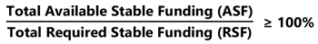
NSFR Ratio calculation
What is ASF:
• Sum of carrying values of the banking organization’s liabilities and regulatory capital,
each multiplied by a standardized weighting (ASF factor) ranging from 0 to 100%.
Here’s the chart of proposed ASF factors: https://www.federalregister.gov/d/2020-26546/p-363
What is RSF:
• Sum of the carrying values of its assets, each multiplied by a standardized weighting
(RSF factor) ranging from 0 to 100% to reflect the relative need for funding over a 1
year horizon based on liquidity characteristics of the asset
• PLUS RSF amounts based on the banking organization’s committed facilities and
derivatives exposure (CRIAND!!!)
Here’s the chart of the RSF factors: https://www.federalregister.gov/d/2020-26546/p-481
TLDR end;
I’d like to put together a summary of what the fuck is going on - its all in plain English, and I suggest to
read it yourself to gain more wrinkles:
Introduction
The OCC, the Fed, and OCC (agencies) are looking into a 2016 rule to establish NSFR (net stable funding
ratio) for any institution with >=$10Bn of consolidated assets.
Another two proposals that were being looked into are:
• scope of NSFR
• Complex Institution Liquidity Monitoring Report (FR 2052a) - to basically get self-
regulating information from the banks (Smells like Goldman’s F3 to anyone?)
Background
In the ‘08 crash, the banks had issues with risk management, specifically how the banks managed their
liabilities to fund their assets.
Further, there was an overreliance on short-term, less-stable funding - no shit, they were leveraged to
shits.
In response, Basel Committee on Banking Supervision (BCBS) created 2 liquidity standards:
1. Liquidity Coverage Ratio (LCR) - for high net cash outflows in a period of stress
2. NFSR - for banks to not be taking handies behind Wendy's after using their credit cards
to play the casino
Part of the LCR rule was for the banks to hold a specific amount of unencumbered high-quality liquid
assets (HQLA) that can be easily converted into cash to meet payments for a 30-day stress period.
Along with the “poorly done” Dodd-Frank Act, the board (Fed) decided to adopt an “enhanced prudential
standards rule, which established general risk management, liquidity risk management, and stress
testing requirements for certain bank holding companies and foreign banking organizations.”
PROBLEM: The framework never addressed the relationship
between a banking organization’s funding profile and its
composition of assets and off-balance commitments. NO SHIT!
ANOTHER PROBLEM: The fucking rule was passed AFTER
the recent stress test!
Here’s where the margin debt comes in - being 2x that of ‘00 and ‘08 crashes. Coupled with u/CriandDD -
means the OCC is realizing how big of a shitshow it has become, and was never dealt with until Retail
started making money and exposing their shit.
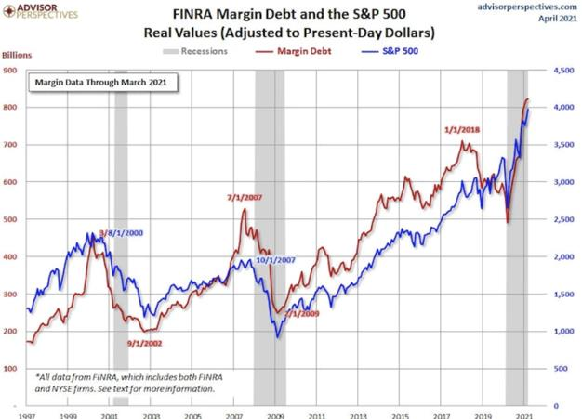
Margin Debt w/ S&P500
Overview of the Proposed Rule and Proposed Scope of Application
• The Proposed Stable Funding Requirement
1. In June ‘16, comments were invited on the rule
2. Rule was generally consistent with the Basel NSFR, but has some characteristics of U.S.
market
3. Proposed rule: maintaining ratio of ASF equal or greater than the minimum funding
needs (RSF) over a 1 year horizon to be minimum 1.0.
The Final Rule
• The final rule assigns a zero percent RSF factor to unencumbered level 1 liquid asset
securities and certain short-term secured lending transactions backed by level 1 liquid
asset securities
• The final rule provides more favorable treatment for certain affiliate sweep deposits and
non-deposit retail funding
• The final rule permits cash variation margin to be eligible to offset a covered company's
current exposures under its derivatives transactions even if it does not meet all of the
criteria in the agencies' supplementary leverage ratio rule (SLR rule). In addition,
variation margin received in the form of rehypothecatable level 1 liquid asset securities
also would be eligible to offset a covered company's current exposures
• The final rule reduces the amount of a covered company's gross derivatives liabilities
that will be assigned a 100 percent RSF factor
Application of the final rule.
The agencies have decided to break down the application/companies into 4 categories:
• Category I: US global systemically important banks (GSIBs) and any of their depository
institution subsidiaries with >=$10Bn in consolidated assets
• Category II: Top-tier banking organizations, other than US GSIBs, with >=$700Bn in
consolidated assets of >=$75Bn in average cross-jurisdiction activity, and to their
depository institutions with >=$10Bn in consolidated assets.
• Category III: Top-tier banking organizations that have >=$250Bn in consolidated
assets, or that have >$100Bn in consolidated assets and also have >=$75Bn or more in:
o Average nonbank assets
o Average weighted short-term wholesale funding
o Average off-balance sheet exposure (not in Category I or II)
• Category IV: Top-tier depository institutions holding companies or US intermediate
holding companies that in each case have >=$100Bn in consolidated assets and
>=$50Bn average weighted short-term wholesale funding (not in Category I, II, or III)
NFSR Requirements by Category
1. Category I: 100%
2. Category II: 100%
3. Category III: 85%
4. Category IV: 70%
Short Sales - I SUGGEST YOU READ THE WHOLE SECTION (IT IS GOLD)
(https://www.federalregister.gov/d/2020-26546/p-810)
Back to Table of Contents
The DTCC (Depository That Clears
Counterfeits) is finished. They covered up the
fraud that enables naked short selling and
are why we will MOASS to epic proportions.
DD 👨‍🔬
Edit - Due to my misunderstanding of crypto, NFT dividend has been changed to 'Non-standard'.
The point I'm conveying is that a dividend that can't easily be obtained by short sellers to cover.
TL;DR - The naked shorting scandal is much worse than you may have first believed. The 'real'
shares in your account hold the exact same rights as any other, but behind the curtain, the DTCC
has historically covered up the FTDs and mass naked shorting using CEBE (Counterfeit Electronic
Book Entries). This is the DTCC's way of maintaining this reverse Ponzi scheme. This is why a
'non-standard' dividend would ruin them, as they can’t ‘cook the books’ for everyone to get one.
The DTCC is fuk.
Edit - If the DTCC wasn't royally fucked...why would they be passing so many rules to push the
blame on to the participants? Tits = Jacqued
Docs link
House of Cards was an extraordinary insight to the inner workings of the DTCC. If you haven't read it by
now, you should before you read this post, as it assumes a fundamental knowledge of them. I have also
obtained much data here from the naked short selling expert Jim DeCosta. If you haven't read his letters
to the SEC, I urge you too. They're long but they were dumbed down so even the SEC could understand
them.
I ain't no financial advisor.
________________________________________________________________________________________________________________________
________
A brief history -
For ease of typing I will be using NSS to refer to Naked Short Selling.
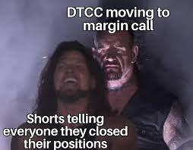
NSS has been as systemic issue YEARS before the financial crash of 2008. There were warnings of this to
the SEC back in 2006 and of course, they did nothing. The small changes they did implement were
miniscule in effect, which continued to enable predatory short sellers to cause financial 'death spirals' to
bankruptcy.
Do you know how institutions defended NSS as a necessary evil in the markets? Pump and dumps.
NSS was meant to 'curb the fraud' and 'protect investors'. It was argued that pump and dumps would
run riot without the ability to sell shares they couldn't borrow. Collectively, these 'shareholder
advocates' are generously offering their services in the fight back against pump and dumps.
They're offering to step up and volunteer to become a pseudo-sheriff and sell non-existent stocks into
the hands of 'about to become victims'. They don't own the shares, nor did they check the 'borrowability'
of them. They're generously volunteering to take the investors money in exchange for a
CEBE, artificially raising the supply. This of course, immediately does damage to the investment, the
company and existing shareholders.
After the naked short has been done, what now? Well the 'would be victim' and the 'shareholder
advocate' now fundamentally have goals that are polar opposite. The buyer wants the stock to go to the
moon. The naked short seller wants the business to bankrupt. It begs the question; why would an
entity volunteering to protect against fraud, still take the money of the investor?
Wouldn't you agree that pump and dumps and NSS go hand in hand? Pump up a stock and then
bear raid it into the ground? It was a way to maximize profit on the DOWN in the dump phase.
________________________________________________________________________________________________________________________
_____
1+1 = 3
The maximum amount of shares that can LEGALLY be sold short is governed by the number shares that
can LEGALLY be borrowed. NSS ignores this fundamental basic mechanism. In fact, the DTCC enables
this further due to the fact a single share can be lent out in multiple directions. This is the reason for
FTDs in the hundreds of percent.
So how does this play into GameStop? How do you know your share is a real share and not a
CEBE?
Answer : YOU DON'T, AND IT DOESN’T FUCKING MATTER.
ONE. BIT.
To the general public, your share is as good as my share. It holds the same rights as any other. If I hold
100 shares of the same 1 share, it doesn’t matter one bit. I have the legal rights to 100 shares.
You know who it does matter to? The DTCC and its’ participants. They have an accounting nightmare on
their hands.
Imagine the DTCC selling the same lambo 100 times? Those 100 buyers believe they own a lambo, can
sell the title to the lambo, heck they can even use the car as collateral! Well, what happens when
Lamborghini decide to issue every single owner with a special keychain?
The DTCC can’t replicate this keychain and you as an owner are still legally entitled to receive it.
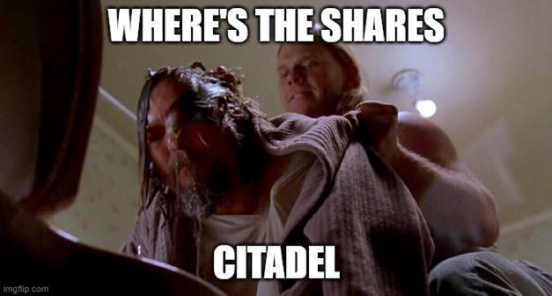
This is the same situation as GameStop. You thought you were buying shares from a 'real shareholder'.
You see a number of shares in your brokerage account. Why would you even think for one second that
the shares aren't even there? You see no reason to ask for the validity of the delivery of certificated
shares. It's also why brokers strongly advocate against clients demanding paper certificates of their
shares. One firm in 1999 urged fellow DTCC participants to hike up fees for share certificates to hinder
investors demanding proof of purchase.
So you bought some shares. You see the number. Where are they? Well, they’re 'conveniently' held in an
anonymous 'pool' of all of the other shares. It's like taking a bunch of green skittles (real shares) and red
skittles (naked shares) and throwing them into a bag, mixing em' up and asking a colorblind person to
pick one out?
To them? It’s any old skittle.
Now what if all the red skittles all needed to be taken back?
What if the bag was FULL of red skittles.
The only person who knew what color went where was the person holding the bag (The DTCC).
(wow irony)
________________________________________________________________________________________________________________________
________
The CEBEs at the DTCC do not represent what you think of as 'shares'. Shares are a 'package of rights'
attached to a public company. I hate to break it but this doesn't include the other millions of shares
(beyond the public float) that are counterfeit in the system. Real shares also hold the right to any
dividends distributed.
So say a company issued dividends that were shares to all shareholders? You hold one share? You get
another one! The float is 100 million shares. The transfer agent would send a 'real' certificate made out
to Cede and Co. for another 100 million shares to give to each and every share holder. What happens
when an extra 400 million show up as being 'delivered' to shareholders?
Because the DTCC are complicit in ensuring that this fraud is covered up every time a
shareholder tries to exercise of the rights attached to only 'real' shares. These CEBEs at the DTCC
are NOT real shares and do not have the rights attached with them. HOWEVER, THEY HAVE TO
MAINTAIN THE ILLUSION THAT THEY HAVE THESE RIGHTS TO NOT EXPOSE THIS FRAUD.
Why would they do this? THEY HAD TO. Otherwise, they would have to inform the owners of these
other 300 million shares that what they had was:
· non-existent
· not actually real
· no rights to the dividend
· their money in the pockets of the seller
What happens if you want to sell your share. The DTCC won't turn around and say, 'you can't sell that
because we never got good delivery of your purchase'. The broker would have normally just sold your
counterfeit shares to the next naïve investor. Have you ever heard of an investor who got a proxy
solicitation statement that indicated that he or she can't vote his or her shares because they are
counterfeit and there never were any voting rights attached? The DTCC has to maintain this illusion
otherwise the reverse ponzi scheme will be revealed.
So what happens if a non-standard dividend is issued? The DTCC can’t ‘cook the books’ and are
forced to reconcile the float back down to its’ issued amount.
Shorts HAVE to close their positions. They need everyone to sell to cancel out their ‘fake borrow’.
What if no one sells? YOU GET THE FUCKING MOASS.
________________________________________________________________________________________________________________________
______
So what did you actually buy?'
You bought the right to sell a Counterfeit Electronic Book Entry.
You bought a put option with no expiry date.
You were conned.
Does it matter? Not a fucking bit. You are entitled to the rights just as much as anyone else and the
DTCC are going to have a really hard time getting you a dividend that isn’t cash or stock.
And if they can’t, they have to buy back your share at a price YOU STATE AND THERE IS NOTHING
THEY CAN DO ABOUT IT.

The irony? For them to cover, you're going to have to sell something that doesn't exist. That is...if
you ever sell...
________________________________________________________________________________________________________________________
________
Part two?- How T+0 is the best case for the DTCC, naked short selling and outright fraud
Back to Table of Contents
Elliott Waves and The Top Of The Market, Is
This THE TOP?
DD 👨‍🔬
Sup Apes
not financial advice
super brief post, I've received so many pings this AM I wanted to address it in a formal post.
the original post is
here: https://www.reddit.com/r/Superstonk/comments/o02fnr/elliot_waves_gme_the_sp_500_wen_m
arket_peak_and/?utm_source=share&utm_medium=web2x&context=3
I've seen a lot of chatter regarding my post saying SPY would peak around 430, and I wanted to add a
few more targets for your viewing pleasure.
In that post, I believe I gave a target of around high 429, though there are multiple levels to watch out
for. Remember, Elliott Wave gives us multiple targets, as we are analyzing many different time frames.
Outlined for your convenience:
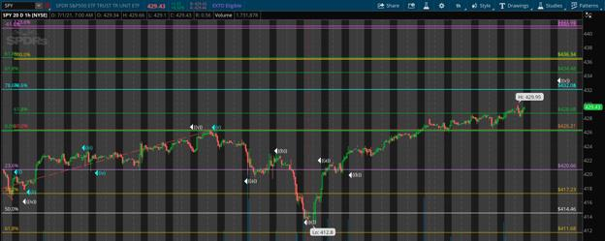
1hr
I'm gonna zoom out so you can see the super cycle 5 target, as I believe this to be the most
valid/important level. I got this target by measure waves 1-3 and bringing the extension down to the
low of 4 (covid flash crash).
First level is the .618 level, next target being the .786.
The .618 level was passed long ago, narrowing our top end super cycle target at 432.08 (blue line):
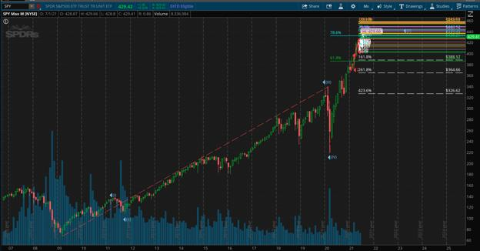
super cycle from end of 08
clearly, even though i have a shit ton of borderline aneurism inducing levels, it looks like we are running
out of steam.
Just for fun, I went and analyzed the grand super cycle of SPX, as the grand super cycle dates back to the
low of the great depression (roaring twenties)
super briefly, just look and take from the image what you will.
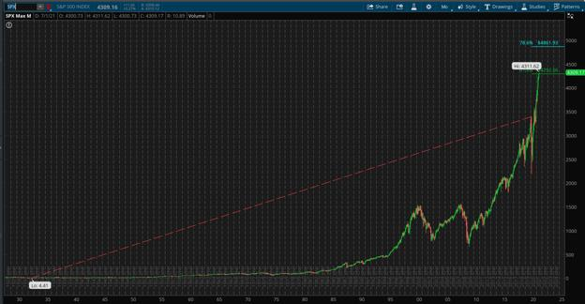
monthly
IDK about you, but me thinks the music is about to stop.
in the first image, I provided a few targets as I am measure multiple different "cycles" if you will, all of
which are point to a high around low to mid 430s.
There is no "magic level" per se, but fibs are not wrong. They are nature in essence, the golden ratio is
everywhere.
After hitting our peak, my guess is around 432 should the peak not be today (nothing surprises me
anymore) we begin our slow bleed. I do believe Gamestop among many other catalyst will cause a
relatively harsh "A" wave if you will, on SPY it will likely drop to at least 345 before any significant buy
pressure comes back, though this point would be the "B" wave. the fakeout. media will likely say the
crash is over and its okay to buy. SPY won't dip that hard. come on. be realistic.
LIES!
I believe SPY will come back to at least 250, timeframe for this is really hard to gauge, but based on
previous bear markets, I'd guess at least a 2 year bear market.
Though we also haven't had an event quite like this before, so as to how long the bear market will ensue,
that's anyone's guess.
Given this is our Grand Super cycle completing from the low of the roaring twenties, it really is not crazy
to think that we can (and likely will) correct 50% of that move.
IE, it is TOTALLY POSSIBLE for SPX (not spy) to drop down to around 2200 before beginning to recover.
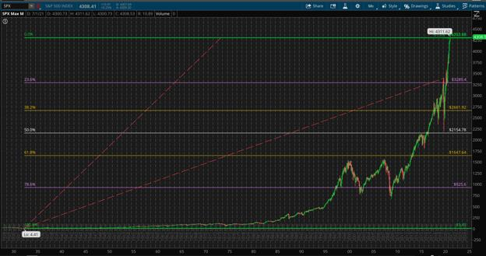
SPX
I'll leave you with this. I won't theorize too much on the events that will cause this, I believe everyone
has a pretty solid idea of whats about to happen. I just want to lay out the technicals, and how I
PERSONALLY believe this will play out. I can be 100% wrong as can anyone else.
Be well.
It's cynical, but I'm jacked.
TLDR: market peak close, market will fall hard soon. Media will likely say crash is over at the "B" phase
of the correction wherein we rebound a bit. Don't fall for it. GME go BOOM soon 🚀
Back to Table of Contents
The MOASS Preparation Guide 2.0
DD 👨‍🔬
*******************************************************
I'm just gonna start off by saying that this is a sequel to The MOASS Preparation Guide, a post I wrote a few
months ago. I felt it deserved an updated version considering so much that has happened recently, also i've
learned a lot since then. This guide will be pretty in depth but don't worry, my view is that when you're
explaining something, always imagine you're talking to a 5 year old (ELI5). So make yourself a cup of
coffee, and grab a tasty crayola and enjoy.
The subsequent sections are as follows:
• Pre-liftoff preparation
• D-Day
• During the MOASS
• Immediate Aftermath
• Long term aftermath
*******************************************************
Please read though this as i believe it is important that we all have an understanding on the game plan
🚀
Pre-liftoff Preparation

• Brokers preparation - I think everyone should take the time to understand the nuances
and rules that the broker applies on trading. Some brokers may have some sneaky fine
prints. So you should make sure that nothing can get in the way of you and your tendies.
o Take note of the brokers that previous placed trade restrictions here.
o some brokers (Trading212 for example) have decided to restrict buying if
you do not agree to their share lending program (Do NOT agree to this.)
o If you have all your shares in one of these bad brokers and can't transfer,
don't sweat it too much. JUST DO NOT SELL YOUR SHARES. The message
was clear as crystal in January: if they prevent free trade like Robinhood
did then that means they will lose customers and face litigation, so
i hope for their sake that they have prepared for this.
o It also wouldn't hurt to email your brokers customer service and ask them
"will you prevent me from selling if the price goes to X amount?".
Additionally, i would recommend keeping documentation, screenshots and
recordings of your positions just incase f*ckery arises. It's good to create a
paper trail just incase you need to bring them to court.
• Back up broker - If you can, open up an account as soon as possible on a reputable
broker and buy at least 1 share. Don't aim to maximize gains but to minimize the regret of
missing out just in case your broker decides to f*ck you. The rule of thumb is usually that
commission based boomer brokers with horrible user interfaces are the most
trustworthy. See the "good brokers" in the link above.
• Diversify Brokers - if you can, spread out your holdings across multiple brokers. Also
take note of what clearing house they use. You don't want to be caught up in some f*ckery
where both brokers wont let you sell because they share the same clearing house. A
solution to this could be to transfer shares. Some brokers allow you to transfer shares to
others, but small "shit" brokers like eToro for example, do not. If thats the case
then hold tight and buy on a different broker, if you wanna buy more shares.
o Here is a list of some brokerages and the respective clearing houses they
use.
o Here is a list of brokers who placed restrictions in a follow up post i made.
o Trading212 for example: they're becoming Robinhood 2.0 now as they
decided to place buy restrictions if you don't agree to their share lending
program. Admittedly, I am a Trading212 customer. So this is why you
should diversify brokers, you never know when they are going to pull
some shady shit.
o side-note: I would stay away from brokers that use Apex Clearing, they're
shady as shit.
• Order Routing - Order routing is when an order to buy or sell a stock is sent from your
broker to an exchange. There are two kinds of exchanges: Lit pools and Dark pools.
o Dark pools do not display prices at which participants are willing to trade
(ie; in the dark), whereas lit pools do show these various bids and offers
in a stocks. It's been said that the naked shorting gang pay millions to
brokers to have millions of orders routed through their own dark pools, to
which they can perform shady business (skimming cents off the spread of
every order, suppressing buying pressure etc).
o This brings me to my point: If you are thinking about buying some
shares, you should route it through IEX, which is an exchange that was
made in order to mitigate the affects of high frequency trading. Oh hey,
look! Our friends at Citadel don't like IEX.
• Cash account, not margin - if you haven't already, request your broker to change your
account from a margin account to a cash account. This way your shares are entirely your
own and aren't being lent out to short sellers. Note that you need to have no options or
short positions active with your account before you do this. If you are reluctant to
switching your account then make sure that you have no withstanding deficits in your
account so you don't get margin called and your broker automatically closes positions
without your consent. Yes, this has happened to people before.
• Online Security - If you have learned anything from all this it's that you should not trust
anyone. Take the time to enable two-factor authentication on your bank/broker accounts.
Also you should have a different password for each account, preferably 20+ characters
with a mixture of alphanumeric characters and symbols.
o Do not use public wifi to log into your broker account.
o Use a VPN when possible.
• Taxes - It is crucial that you learn about your countries capital gains taxes. I would go
deeper into this, However different tax rates apply in different countries depending on
how long you are holding the stock. To keep this general for all users i will say Just google
"what are the tax laws for stocks in <my country>?". (If you're a smooth brain, dont worry.
I have the solution for you in immediate aftermath section)
• Prepare a personal balance sheet - It may be a good idea to prepare a balance sheet. A
balance sheet is a snapshot of net worth and lists all your assets, liabilities, cash etc. This
will make your life (and your accountants life) easier when you need an accountant. If you
need a better understanding of balance sheets see this video here.
• Mental preparation - This one isn't so obvious, but please prepare yourself for seeing
life changing money in your possession. Have a long think what you are going to do with
this money. And as a side note: try to not tell too people you're invested, the less people
know the easier your life will be.
D-Day
0:00
0:08
• Take care of your health - Firstly, on the day of lift off you will definitely feel
overwhelmed with emotions and anxiety. You're probably going to feel a little dizzy
seeing the price increase exponentially. Please sit down when you are checking the price.
The last thing i want to hear is that a fellow ape fainted and cracked their head because of
being overwhelmed with emotions. In my opinion, deep slow diaphragmatic
breathing really helps to slow down your heart rate and reduce anxiety.
• Expect Trading Halts - There is a difference between trading suspension and trading
halt. Securities exchanges have the power to temporarily halt, in the middle of the trading
day, or delay, at the beginning of the trading day, trading on a stock. halts and delays
usually last less than one hour. As opposed to suspensions, which can last two weeks.
Suspensions are enforced by the SEC
o In the case of trading halt: The NYSE may stop trading if the price rises
too quickly. This is usually done to prevent massive impulse waves and let
people calm down for a few minutes. But this is futile in the setting of a
short squeeze, because all shorts must cover regardless. You can also
check when GME is halted here. Do not freak out if the graph flatlines.
o In the case of trading suspension: I believe that if the infinity pool
happens, meaning shorts literally will not be able to cover the potentially
billions of synthetic shares they have created, driving the price to literally
infinity, that the SEC most likely implement a trading suspension. We
won't know unless it happens. But, who knows? They might not. You can
read about trading suspensions here.
• BOTS, BOTS EVERYWHERE - This could go two ways: either the shorts don't have
anymore money to pay shills or we will have a massive influx of bots/shills on here and
<other stonk subs> trying to nudge people to sell. They will say something like "wow i sold
my 3 shares for 30K" and try to create a narrative that below 100K is the peak. 100K is
not the peak. don't listen to it. we set the price.
• Reddit might be down - during the rally from $40 to $90 in February Reddit inexplicably
went offline. It happened a couple of other times before when the price rose considerably.
This could be due to a DDOS attack or just too much traffic to the site. Either way, if
Reddit does go down don't worry. We are all still here.
o The only call to action would be to go to the SuperStonk youtube channel,
which the mods said they will do an emergency broadcast when things
kick off. So go there for communication.
o Backup places to check out would be the mods twitter pages
https://twitter.com/rensole
https://twitter.com/RedChessQueen99
https://twitter.com/PinkCatsOnAcid
During the MOASS
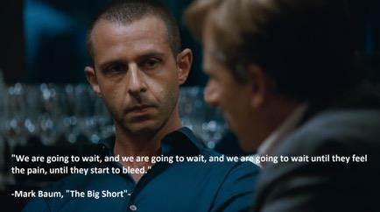
• Diamond hands - This one i cannot stress enough, the mantra is clear: HOLD! If you sell
early you creating downward pressure against the MOASS. If the short position is in the
billions of shares (which has been theorized) then this shouldn't be too much of a
problem, but regardless - KEEP THOSE HANDS DIAMOND! The squeeze could last a few
days, week or indefinitely. At this point no one knows. Don't feel pressure to sell when it
goes $100K+, if the DD is correct (and it has been so far) then we are not stopping add
measly hundreds of thousands.
o A forced buy-back differs from a Margin call, in which a margin call is
just a notice to "increase the amount of money in your account before we
close your positions, because you won't be able pay us if this goes any higher"
o Prime brokers will implement forced buy-back of hedge funds to cover
their short positions. This means they will go the open market and buy
them for what ever someone is will to sell them for.
o The stock price = the last price it sold for. If the only sells available were
asking for 1 million, then that means the price will be 1 million. And since
it's likely there aren't enough shares in existence to cover the amount of
shorting that went on then theoretically this ape filled rocket could blast
through the moon and land on Alpha centauri B.
• Whats an exit strategy? - This one isn't so obvious because the we don't know what the
peak will be, but you should have an exit strategy: Plan out what you need on the day of
selling, where do you need to be? think about that day and visualize it so you aren't
overwhelmed with anxiety when it actually happens. As for selling: all i can say on this
matter is do not sell on the way up as it's a bad idea. () Use this exit strategy instead
by u/gherkinit:
• Understand the different types of orders - Limit Order, Market Order, Stop Limit Order
and Stop Loss Order, explanations on the pro's and cons of each can also be found here
o Some people have noted that certain brokers have limits on the amount
you can place an order for online (in terms of dollar value). Just to be safe
make sure you have phone credit and the number for your broker ready to
contact them to execute an order if this applies to you.
o Also, some brokers may not even limit orders (Revolut as far as i know).
Don't sweat it, this is beyond your control. Just sell on the way down, or
don't. I don't care this is not financial advice.
• Sit down when you decide to take gains - When the dust has settled and you decide to
take gains, again, sit down and drink some water and breath.. because you may faint or
possibly get sick from seeing that you have sold a single share for an ungodly amount.
• Don't publish your realised gains publicly - Obvious one, don't be that person who
flaunts the gains online. You are going to cause a lot of fair-weather friends and family to
crawl out of the woodwork trying to get their hands on your tendies. It may be tempting
to rub it in the faces of the people who doubted you, but just don't. It's not worth it.
• T+2 settlement - When you sell a share, it actually doesn't get settled until 2 days after
it's executed, meaning you don't actually have the money in your brokerage until 2 days
later. Learn about the settlement violations here before you start going off buying other
stocks with your gains. This T+2 settlement also gives the SEC the power to reverse any
transactions they seem fit due to violations. Not meant to be FUD, i just thought its useful
to know. I doubt they will start reversing transactions during the MOASS, but if it does
occur. Hold tight, again: we set the price.
• WHAT DO WITH MONEY? - It should be known that your regular current/checking
account is only insured up to $250,000 if you're in the US under the FDIC and €100,000 if
you are in the European Union. So its not advised to dump all your money into your bank
account straight away. I would wait for T+2 settlement to clear then invest in value
stocks, so you're money isn't tied to your broker, should they have issues. This brings me
to the next section...
Immediate Aftermath
0:02
0:02
• Assemble a team of legal and financial advisers:
o Lawyer up - Hire a tax attorney to deal with any problems that may arise
from all of this. Hire a family law or estate planning attorney that can
arrange a Will for your family immediately.
side note: do NOT sign anything, from your
broker/bank/crayon dealer or anyone if you do not
understand it. Make sure you have an attorney read
anything you may or may not be asked to sign.
o Get an accountant - Get certified public accountant who helps wealthy
families organize their finances and guide you through your finances.
o Hire a financial advisor - Make sure you hire a financial advisor that is
sworn to act as a fiduciary (acting in your best financial interests, not
theirs), preferably with experience managing significant wealth. Make sure
you check their certifications and that they aren't trying to push you to buy
some insurance policy. The requirements to be a FA aren't concrete so
there are a lot of snake oil salesmen that really don't have your best
interests at heart. Make sure how you ask how they profit from you being
their client and make sure they aren't trying to make commissions. Also,
look out for high fees. Minimum advisor fees based on AUM should not be
over 1% unless they can justify it with amazing historical returns.
• Expect to vilified by MSM - In the case of a financial crisis, i can nearly guarantee that
they will try to blame us rather than the hedgies and regulators who caused it. Pay no
mind to mainstream media and stand your ground.
o Expect people to say you just got lucky, expect them to speak as though we
are ones who caused this. They will lie, twist and corrupt the truth. Expect
your friend who paper-handed a few months back and still think's
GameStop is dying brick-and-mortar resent you. You don't need to justify
yourself. All of our research has been documented, archived and literally
shouted from the rooftops for months. As Michael brrry would say "I
warned, but no one listened".
o They may also try and backtrack to a pro-GME narrative now that it's not
financial in their interest to side with SHFs. Just remember: MSM is not
your friend, these people are allows pushing the narrative that they
are paid push. It's literally their business model.
• Do nothing with the money - this kind of piggy backs off the first point about
assembling a team of advisors, but please don't just cash out and go crazy with the
money. Sit and think about it for some time. Let reality settle in and decide how are you
going to use this money to help yourself and the people around you. Lambos are great but
they won't bring you happiness forever. Don't blow that money down the drain. Educate
yourself on how wealthy people maintain their wealth.
Longer Term aftermath
• Expect turbulence in the economy - this wont be just contained to the world of GME.
This is going to have a ripple affect across the world economy as the powers-that-be, who
have been taking advantage of the system loops holes, finally pay their debt. Here is some
essentials you should check out (in order) if you haven't already, this is 2008 continued:
1. Inside Job (Full movie) - by Charles Ferguson
2. The Bigger Short. How 2008 is repeating - by u/Criand
3. A House of Cards - by u/atobitt
4. The EVERYTHING Short - by u/atobitt
High/hyper Inflation - We need to talk about inflation. In v1.0 of this guide I mentioned a possibility of
inflation, but as more news has come out it's pretty much a guarantee. Also, I didn't give much
recommendations on what to do about it. So, i learned a bit about inflation so you don't have to:
• The What?
o Since governments have moved away from the gold standard, countries
have the power to create money out of thin air through quantitative easing.
o Inflation is the annual percentage rise in the cost of living. Okay so what
does that really mean? Here is smooth brain explanation: If you have $1 in
2020, and inflation rises 10% in 2021, you still have your $1 but you only
have the buying power of $0.90 relative to last year. This is why holding
onto cash is not good in a high inflationary economy.
• The How?
o Everyone always says its from over-printing of money, but in reality this is
just a symptom of a failing economy, and a byproduct of the citizens lack of
confidence in the currency.
o In order to counter these rise in prices, the FED (or central bank) will raise
interest rates, essentially reducing the amount of money in circulation.
o The chair of the Fed, JPOW himself, said interest rates won't be raised until
2023. However, fear is arising in the stock market as many speculate we
have high inflation because the massive amount of "free money" initiatives
to help the country get back on its feet, but it's just not being seen due to
COVID-19.
o I think it is also noteworthy to say there is a difference between high
inflation and hyperinflation. Hyperinflation is a term to describe rapid,
excessive, and out-of-control general price increases in an economy. While
inflation is a measure of the pace of rising prices for goods and services,
hyperinflation is rapidly rising inflation, typically measuring more than
50% per month.
• How to protect yourself?
o Well firstly I'd like to note assets to avoid during high inflation:
Fixed rate bonds
Growth stocks
Cash (yes, that includes the money in your savings account)
o The best investments during high inflation:
Real estate/land
Commodities (Gold, oil etc.)
Boomer Value Stocks
• How about crypt-0?
o I can't name certain coins here because of auto-mod, but you know of the
big ones I'm talking about.
o It is assumed that anything with a limited supply will inevitably move with
inflation. the loss in confidence people have in fiat currency is prevented
with crypt-0-currency as it has an immutable finite supply.
o However, you also need to bear in mind the utility of the asset. Just because
something has a limited supply does not mean it's valuable (The 2021 shit-
coin craze being evidence of this)
o In a financial nuclear winter event, it may a case that some coins may
become too expensive to mine due to rise in electricity prices, leading to a
disinterest/disincentivization in holding the asset and thus reducing it's
value.
o Be careful if you decide to hedge with these assets as they are yet to be
stress-tested during a financial crisis, some might succeed and many will
fail.
• side-note: One silver lining i learned about inflation is that the burden of any debt you
may have will be softened as the nominal value of the debt stays the same even as the
value of the currency decreases. What does this mean? if you owe money, lets say a
mortgage or student loan, it is easier to pay of that debt as it is assumed you wages will
increase, while the number of dollars you owe stays the same. (not that you will have a job
after the MOASS anyway ( ͡° ͜ʖ ͡°) )

Taken during the 2011 Ocupy Wallstreet March (At National i
If there is anything else you think should be in here let me know in the comments. This is just my opinion
and not financial advice. I am just an ape who eats crayons for fun. This will probably be my last DD before
valhalla (financially speaking), I'll finish by leaving you with this image (above ^). Remember what
happened in 2008 and don't show any mercy. HOLD.
- Socrates ( ͡° ͜ʖ ͡°)
🚀🚀🚀🚀🚀🚀🚀🚀🚀🚀🚀🚀
TLDR: no tldr you lazy ape, go read it. Its important
_____________________________________________
- edits 1: Diamond hands section typo : "**aren't enough shares", not "are enough shares"
- edits 2: removed WardenElites exit strategy, added the gherkinit's exit strategy
- edits 3: added mods twitters in Reddit going down section
Back to Table of Contents
The NYSE threshold list: collapsing shorts and
launching the MOASS
DD 👨‍🔬
TA;DR: threshold list killed small shorts in January. Big shorts took on their positions. Threshold list
restrictions coming for big shorts too. Watch for GME being added to the threshold list.
TL;DR: restrictions associated with extended periods of failures to deliver inform the past six months of
GME shenanigans. These restrictions killed the small players who were short GME in January and
allowed big players to take on their position. Big players assumed they could use their powers and
resources to turn this losing hand into a big win. Apes stopped them. Now, finally, the big players are
going to find these same restrictions applied to them - watch for GME being added to the threshold list.
Background
The New York Stock Exchange provides a list of ‘threshold securities’, which are securities that are
regarded as difficult to borrow due to a large number of recent failures to deliver. When a security is on
this list, there are limits on a market maker's ability to short sell the security in question and obligations
regarding delivery requirements. These restrictions and obligations can increase the longer the security
stays on the list. For further information and some relevant links, please see this comment by u/Criand.
There is currently some discussion of this topic because moviestock has been added to the threshold list
recently, this post by u/OrwellsWarning presents tweets by u/dlauer and Susanne Trimbath which is a
good place to look for discussion of the significance of the threshold list (see the comments).
In short, the ability to perform fucketry is diminished when a security is on the threshold
list. u/dlauertweets that it might be unusual for companies like GME to make it onto this list (usually it’s
small companies). This rather underappreciated post by u/mlebjerg provides graphs of the price of
moviestock and GME in relation to their being on the threshold list. Notice that the price of moviestock
does not appear to be related to their being on the threshold list. Neither does the price of GME, with a
notable exception.
Key point
Given the restrictions that come with being on the threshold list and its relationship with the historical
prices of the two securities, I suspect the effect of being on the threshold list do not translate to price
changes until the security has been on the list for long enough to compromise the ability of those with
short positions to manipulate the price. On the below graph I compare the price of GME with the number
of concurrent days it has been on the threshold list:
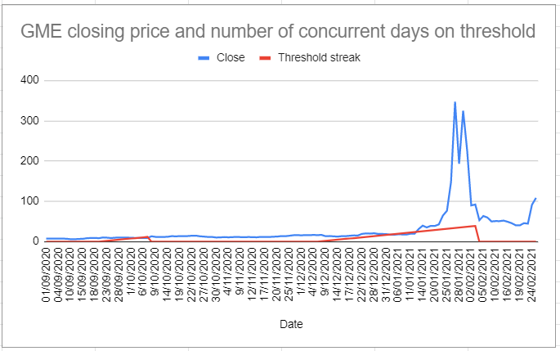
From the end of December 2020 and into the beginning of February 2021 GME was on the threshold list
for 39 market days. I believe that this answers an important question that has been outstanding since
February: it explains why they needed to resort to a market halt to stop the January spike but not the
February gamma.
The difference between January and February
In this post from April I argue that the unusual market activity during February, the ‘gamma swarm’ or
‘gamma squeeze’, was an attempt to launch the MOASS that failed due to those shorting GME flooding
the market with ever more short positions, which mitigated attempts to rapidly rise the price. In this
post from May I argue that the changes in order flow indicate that the market center Citadel Securities
was used to open a large short position in January and the NASDAQ market center was used to
manipulate the price in February. These two arguments leave an unanswered question: if the spike in
February was prevented by manipulation involving inter-market-center fucketry, why did they need to
resort to a trading halt to prevent the January spike?
I think the threshold list answers that question: trading was halted in January because GME had been on
the threshold list for weeks prior to the spike, which prevented the other methods of price restricting
manipulation available to those shorting GME. After weeks on the threshold list, and in the face of
massive buying pressure, they had no winning play left - so they halted trading. I suspect that, with
trading halted, they then brought the minimum number of GME shares required to cover the
outstanding failures to deliver which then removed GME from the threshold list. I expect that this
actually left them with an even bigger outstanding short position, considering how much it would have
expanded during the January spike: they opened a bigger position due tomorrow, to close the positions
keeping GME on the list today. I think this led to the game they’ve been playing since February.
The story so far
Notice that GME has not returned to the threshold list since early February. I think that this is because
the parties shorting GME since then have been more competent, better resourced, and more powerful. I
suspect that GME went onto the threshold list in December 2020 because a smaller player, perhaps
Melvin Capital, was failing to cover or defer their short positions. Ultimately, this led to the January spike
and a more powerful institution capable of the manipulation required to stop the spike stepping in.
Essentially, I think at least one smaller player who was short GME collapsed in December and January
which undermined the ability of the larger players to control the situation. In response, I suspect that
the larger players with market maker privileges and influence over market centers took over these
collapsing players.
This is why I think that the short position was expanded in January even though I also think some
positions were covered. As I discuss in my post regarding the 605 data (also linked earlier, the may post),
it appears that the market center Citadel Securities was used to expand a short position during the
January spike. Notice that the restrictions associated with a security being on the threshold list are not
applied to all parties equally. This is how shorting took place in January, despite GME having been on the
list for weeks - it was one of the smaller players failing to deliver that got GME on the list, so the big
players were not suffering all of the related restrictions (especially those with influence over their own
market center). I suspect that the short position was expanded dramatically in the leadup to the January
spike and then, after the trading halt, the oldest positions were covered to resolve those failures to
deliver that were keeping GME on the threshold list. In this manner, the short position was moved from
small players to the big ones and the overall short position expanded while the reported short position
lowered substantially.
With their short position bigger than ever, I suspect that they attempted to crash the price in February
to convince everyone that it’s time to sell their GME shares. At this point, their position is likely looking
quite strong - the short positions opened in January were at a high price per share, which means they’ve
received more money from buyers than the current share price. So, on paper anway, they are in a strong
position - yes, they owe an insane amount of GME shares, but the price of GME is now much lower. As
long as they can eventually convince everyone this is over, they’ll likely come out of this stronger than
ever. If they can keep issuing more short positions that they eventually cover at a much lower price,
after shareholders give up and move on, they’ll actually have profited over this debacle and gobbled up
smaller players. Provided the apes stop buying and move on, they’ve turned an infinite loss position into
a huge win. Masterstroke.
This is a bold plan, it will turn a massive loss into a huge win. So, they go all in and do an excellent job of
it. The trading halt works by allowing them to consolidate the short positions into only those players big
enough to pull this strategy off. Expanding the short position provides an influx of cash from buyers.
Further shorting after the trading halt drops the price in early February. The political fallout allows
them to announce very publicly that they’ve closed their positions. The media narrative fits perfectly to
what they need to portray. For the first few weeks of February, it’s working.
Except, it doesn’t work. It’s an excellent play and they executed it well. Regardless, two factors prevent
their success. Firstly, millions of weirdos from the internet appear to have disregarded all traditionally
authoritative sources of information and keep buying more shares. Given the complete lack of any
evidence to justify this behaviour, it’s understandable that this caught the shorts off guard. At this point,
it’s too late - they’re beyond fully committed to this play, they’ve gambled everything they have and the
health of the entire financial markets on this. So, they do what they can to undermine this bizarre online
resistance. Unfortunately, for them, they are also facing resistance from other big players who, for
whatever reason, are not willing to allow them this victory. This resistance from other big players comes
in the form of the February gamma, which attempts to launch the squeeze that was prevented with the
trading halt (link to my April post on this, also linked earlier).
This sets the stage for everything that follows, March onwards. In January and early February the shorts
win the battles. Smaller players die and cause a massive mess, but this allows the big-shorts to take over
their positions and expand their short positions at a favorable price point while doing so. They gamble
on an extreme play, a trading halt, to crash the price and it works. However, Apes pervert their attempts
to motivate selloffs and realize they are being targeted with misinformation - so, they gather together to
defend themselves. Ultimately, this becomes r/SuperStonk. Other big players, perhaps fearing what the
big-shorts have become and are doing, instigate the February gamma which reverses a large portion of
the price crash and exposes the ongoing manipulation. As February draws to a close, the gamma has
failed to launch the rocket and the Apes have only a vague understanding of what is happening. It’s a
stalemate.
I think the battles fought in January and February have informed everything that followed. The big
players short GME have used their power, influence, and resources to avoid any further restrictions on
their GME activities. The big players opposing them have done what they can, but can’t launch the
rocket. Apes’ might be described as the wildcard, but I think they’re better understood as the
battleground. As the months drag on, they grow in sophistication, numbers, and power. Six months into
this mess, they’re the ones holding the winning hand. It’s the Apes’ whose shares need to be brought: the
shorts always needed retail shares, but after six months of endless shorting they now need a lot of retail
shares and, much worse, the retail holders know it.
If my outline, story I guess, is correct, then the outcome is inevitable. At least, assuming Apes hold.
Eventually, especially in the face of tightening restrictions, GME is going to end up back on that
threshold list. Once it does, the powers and privileges allowing those short GME to fight will be steadily
stripped away until they can’t do anything except watch as their obligations to the NSCC kick in and the
attempt to close the infinite loss position they have burdened their peers with begins. I suspect this is
why the new restrictions are finishing off with ‘rules clarifications’ that limit rehypothecation and
prevent a borrowed share from being used to ‘deliver’ an earlier position. Once the failures to deliver
can no longer be hidden, GME is going to end up back on that threshold list. Once it’s there, those with
outstanding failures to deliver will have their ability to short GME restricted and the big-shorts will be
caught in the same trap they ‘saved’ the little shorts from in January.
Finally, please note a recent by u/Feeling_Point_5978 yesterday (I can't link, it's on a different subreddit)
for discussion of this in the context of Moviestock. For what it’s worth, I think that Moviestock is our
canary in the coal mines on this issue. I suspect that the new restrictions, finally in effect from last week,
will result in the failures to deliver GME to being piling up quite soon. If this happens, expect to see GME
on the threshold list soon after. Once it’s there, the restrictions escalate until it’s off the list. I suspect
that there is only one way GME is getting off that list once it’s back on it, and that’s the MOASS.
(Please note that my incompetence limits the reliability of any of the above. I argue, think, and suspect
many things; my saying it doesn’t mean much regardless of how I phrase it - read with caution!)
Back to Table of Contents
Infinity Pool: How GME Will Break the Laws of
Supply and Demand and Enable the Money
Glitch
DD 👨‍🔬
Introduction
Welcome to Theoretical Microeconomics for Apes.
This post will discuss the interactions of fundamental microeconomic principles of supply, demand,
price, and quantity during the MOASS, pose a theoretical example based on a hypothetical Short Interest,
and discuss the possible impact of an Infinity Pool depending on its size. One of many reasons that GME
will be studied for centuries is because it will stretch fundamentals of supply and demand to their
theoretical limits. There are a handful of terms used repetitively throughout this post, so put your
wrinkle-caps on and do some word learnin'. Fortunately, there is no quiz or attendance record.
• Section 1: Microeconomic Principles
• Section 2: Microeconomic Principles Applied to the MOASS
• Section 3: Key Takeaways
Disclaimer: I am by no means an expert, nor am I giving advice. My goal here is to understand and discuss
theoretical microeconomic principles in relation to the MOASS due to my interest in the underlying
mechanics of supply and demand at play. Please refute any incorrect assumptions in the comments and I
will amend the post as necessary.
ta;dr: GME is a fascinating experiment of Supply and Demand. Diamond-handed Ape names price
for banana
SECTION 1: MICROECONOMIC PRINCIPLES
I will provide a brief overview of each concept, with links. It is worthwhile to read the entirety of each
article if you are interested in the topic(s).
If you are already familiar with these principles, you can skip to the next section.
1.1 Theory of Price - Link to Article
The theory of price—also referred to as "price theory"—is a microeconomic principle that uses the
concept of supply and demand to determine the appropriate price point for a given good or service [or
in the case of GME, a security].
The goal is to achieve the equilibrium where the quantity of the goods or services provided matches the
demand of the corresponding market and its ability to acquire the good or service. The concept of price
theory allows for price adjustments as market conditions change.
Ape Speak: In general, price will go up when demand exceeds supply. When supply = demand, price stay
same. When supply exceeds demand, price go down.
1.2 The Laws of Supply and Demand
Law of Supply - Link to Article
The law of supply is the microeconomic law that states that, all other factors being equal, as the price of
a good or service increases, the quantity of goods or services that suppliers offer will increase, and vice
versa. The law of supply says that as the price of an item goes up, suppliers will attempt to maximize
their profits by increasing the quantity offered for sale.
SUPPLY CURVE: Supply in a market can be depicted as an upward sloping supply curve that shows how
the quantity supplied will respond to various prices over a period of time.
Ape Speak: higher prices gradually convince more Apes to sell over time.
Law of Demand - Link to Article
The law of demand states that quantity purchased varies inversely with price. In other words, the higher
the price, the lower the quantity demanded.
DEMAND CURVE: A market demand curve expresses the sum of quantity demanded at each price across
all consumers in the market.
Changes in price can be reflected in movement along a demand curve, but do not by themselves increase
or decrease demand.
Ape Speak: Typically, higher prices make people buy fewer of something.
1.3 Supply and Demand Curves - Link to Article
Pic#1: Example Supply and Demand Curves plotted together.
The demand curve shows the quantities of a particular good or service that buyers will be willing and
able to purchase at each price during a specified period. The supply curve shows the quantities that
sellers will offer for sale at each price during that same period. By putting the two curves together, we
should be able to find a price at which the quantity buyers are willing and able to purchase equals the
quantity sellers will offer for sale.
Any individual point along the Supply or Demand Curve identifies the quantity that will be supplied or
demanded at a particular price (i.e., Quantity Supplied & Quantity Demanded). When supply exceeds
demand, there is a surplus. When demand exceeds supply, there is a shortage.
Ape Speak: Typically, demand and supply move in opposite directions in relation to price. When you put
the two lines on a graph, they intersect at a specific price and quantity - these graphs are useful for
analyzing prices.
1.4 Equilibrium - Link to Article
Equilibrium (artificial or otherwise) is something GME users have come to know intimately over the last
month. During the MOASS, the price of GME will begin moving wildly towards a new market equilibrium
(extreme rising and dipping), after which prices will stabilize and return to earth.
Equilibrium is the state in which market supply and demand balance each other, and as a result prices
become stable. Generally, an over-supply of goods or services causes prices to go down, which results in
higher demand—while an under-supply or shortage causes prices to go up resulting in less demand. The
balancing effect of supply and demand results in a state of equilibrium.
Because Equilibrium is a singular point on a standard graph where two curves intersect, it produces an
Equilibrium Price (the Y axis), and an Equilibrium Quantity (the X axis).
A market in equilibrium demonstrates three characteristics: the behavior of agents is consistent, there
are no incentives for agents to change behavior, and a dynamic process governs equilibrium outcome.
This is where Apes combined with astronomical Short Interest throw a wrench into the market machinery
and stretch the mechanics of supply and demand to the limit.
Ape Speak: Equilibrium is reached when quantity supplied = quantity demanded. Equilibrium produces
a measurable Equilibrium Price and Equilibrium Quantity. Equilibrium = market harmony.
1.5 Price Elasticity of Supply and Price Elasticity of Demand
Elasticity vs. Inelasticity - Perfect Elasticity and Zero Elasticity - Inelastic Supply Explained
Elasticity: In this context, elasticity is another way of saying "rate of change" of a curve. Both Supply and
Demand Curves have their own elasticity, which determines exactly how steep the curve is on the graph.
See Pic#1. Determining the elasticity of each curve is helpful for understanding where the curves might
intersect to create market equilibrium price and quantity.
Elasticity, expressed mathematically, is: E = (% Change in Quantity (Supplied or Demanded) / % Change
in Price). It expresses the relationship of how many units become available from sellers or are
demanded by buyers in response to changes in price. In theory, Demand and Supply Curves can reach
extremes of elasticity - either perfect elasticity, or zero elasticity. It is important to note that elasticity is
subject to market conditions, and changes over time - this means that Supply and Demand Curves can
have different slopes at different quantities/prices. (Hint: supply being held by a diamond-handed Ape is
a market condition that impacts elasticity of supply!)
• Perfect elasticity means that your Supply or Demand Curve is completely flat, and that
Quantity Supplied or Demanded changes by an infinite amount in response to any
change in price. (We don't really care about this in the context of GME, except to the
extent that it helps us understand the flip-side, zero elasticity).
• Zero elasticity (E = 0), which is what we care about in our GME example, refers to
extreme cases where a % change in price, no matter how large, results in zero change in
Quantity Supplied or Demanded. When elasticity is zero, supply and demand are
irresponsive to any change in price, no matter how large.
Ape Speak: Elasticity determines the slope of the Supply and Demand Curves. Low Elasticity of
Supplymeans that a big change in price has a small impact on the quantity of shares supplied to the
market. Low/zero Elasticity of Demand means that a big change in price does not impact demand (in this
case, the requirement to close a fixed quantity of short positions).
SECTION 2: MICROECONOMIC PRINCIPLES APPLIED TO THE MOASS
Disclaimer: This is the point of the post at which my understanding of the material presented above collides
with my understanding of the last few months of DD. In other words, the proceeding sections could be most
accurately classified as an opinion or educated guess.
We're gonna hypothetical them hedgies' clavicles!
Here, I will apply the above-reference microeconomic principles to a MOASS that uses hypothetical
numbers. Short Interest is critical here because it represents the number of shares at which the
QUANTITY DEMANDED WILL BE FIXED. (Note: this is not a discussion about the possible short interest.
I personally believe that the real SI is much higher than in the example I am about to pose.)
Pic#2: Money Glitch Activated: A Hypothetical GME MOASS Supply & Demand Curve
Important Numbers for this example:
• Short Interest: ~400% (280m shares)
• Float: 25m (for ease of calculation)
• Float repurchases to cover shorted shares: 11.2 float repurchases (the last ~25m shares
- the final whole float repurchase - is important later on)
2.1. GME Demand Curve and Price Elasticity of Demand - Fixed Demand Enables Infinite Losses
GME Demand Curve
• When shorts must cover and close their positions, they will require a fixed quantity of
shares to do so.
• This fixed Quantity Demanded means that shorts must cover at any price until
the Quantity Supplied reaches the Quantity Demanded.
GME Price Elasticity of Demand
• Because Quantity Demanded is fixed, Price Elasticity of Demand is ZERO - the Demand
Curve is VERTICAL.
• Quantity Demanded will not change NO MATTER THE CHANGE IN PRICE.
2.2. GME Supply Curve and Price Elasticity of Supply - The Ceiling is Your Imagination
GME Supply Curve
• The GME Supply Curve is the single most important factor for determining the "price
ceiling" of the MOASS.
• Because the Demand Curve is a vertical line, Equilibrium Price is determined by
whatever point the Supply Curve intersects the Demand Curve (in other terms,
when Quantity Supplied equals Quantity Demanded).
• The steeper the slope of the Supply Curve, the higher the "price ceiling" of the MOASS
GME Price Elasticity of Supply (PES)
• In practice, GME PES (the slope of the Supply Curve) will change over time and according
to market conditions.
• Paperhands lead to higher PES and flatter Supply Curves, whereas Diamond hands lead
to near-zero PES and more vertical Supply Curves (Remember when I said that having
diamond hands is a market condition?)
• When PES is high, more shares will trade between trading halts. When PES is low, fewer
shares will be exchanged between trading halts. (Theoretically, as little as a single share
could be traded between trading halts).
• At the beginning of the MOASS, PES will be higher as paperhands are tempted to sell in
the 3-6 figure range. (Smaller changes in price will cause higher quantities to become
available)
• The real squeeze begins when Diamond hands begin setting/lowering the PES, enabling
share prices to exceed 7 figures. (Larger changes in price cause very low quantities to
become available)
2.3. GME Theory of Price and Equilibrium - Ape Names Price
Bringing it back to this graphic: Pic#2: Hypothetical GME MOASS Supply & Demand Curve, you can see
that a hypothetical Equilibrium Price has been established.
Disclaimer: This example does not account for the fact that some amount of the final ~25m shares (the final
float once rehypothecated shares are gone) will be re-circulated and change the Price Elasticity of Supply
as the Supply Curve approaches the Demand Curve. In other words, the Supply Curve could begin to flatten
once Quantity Supplied is one whole float away from Quantity Demanded.
• In this example, a price somewhere between $10m-$100m is sufficient to convince
Diamond-Handed Apes to provide enough supply of shares to meet the demand created
by Marge's call and create the required liquidity to close all of the outstanding short
positions.
• When the short positions are closed, Equilibrium has been achieved, Quantity
Supplied equals Quantity Demanded, and the price begins to stabilize (crash). This does
not imply that the peak occurs exactly at the moment that the last short position is
closed. I believe that the peak will occur sometime shortly after the first of the real
shares enter the market, and liquidity begins to normalize.
2.4. GME MOASS, Infinity Pool Edition - The Forever Shorts
But what happens if the Quantity Supplied never reaches the Quantity Demanded?
It would look something like this: Pic#3: GME MOASS Supply & Demand Curve: INFINITY POOL EDITION
• An Infinity Pool of any size will reduce Price Elasticity of Supply, thus maintaining a more
vertical Supply Curve even as real shares enter the market for re-circulation.
• If there is an Infinity Pool that equals or exceeds one whole float (~25m shares +1
share), then the Price Elasticity of Supply becomes ZERO, the Supply Curve becomes
COMPLETELY VERTICAL and never intersects the Demand Curve, and Apes can truly
name whatever price their broker allows them to enter at the time. There is an
absolute Shortage of shares.
SECTION 3: KEY TAKEAWAYS
I believe these key takeaways are reasonable given the information already known and presented here, but
these are best classified as opinions/ educated guesses:
• Current State of Relative Equilibrium: Currently, so long as shorts create artificial
equilibrium by meeting demand with artificial supply, the market will remain in a state
of pseudo-equilibrium. When the downward price pressure of artificial supply inverts
itself into upward price pressure from buying to cover, a wormhole opens. (This is
nothing new, but I have yet to hear it expressed in these terms)
• Real-time Supply & Demand Curve: Monitoring activity on the bid/ask spread and
volume between trading halts during the MOASS will provide insight into the current
state of Price Elasticity of Supply. At times, the bid/ask spread will be as wide as
brokerage maximum-price limits allow.
• When is the Infinity Squeeze phase of the MOASS truly getting started? When
the Price Elasticity of Supply is stupidly low and getting lower. Assuming that Diamond
Handed Apes own the float, the real squeeze hasn't started until GME is trading over 7-8
digits. Apes will be some of the last sellers to get in line, so any price action prior to Apes
getting in line to name their price is only a buildup to the Infinity Squeeze.
• Utility of Volume During MOASS as a Predictor of a Potential Peak: In all likelihood,
total volume is not a reliable indicator of a squeeze peak. You would have to possess a
relatively accurate idea of the true size of the short position (a.k.a. Quantity Demanded),
know that there is no additional volume being created by new short positions that open
during the MOASS, and know the impact of real shares beginning to re-circulate.
• Infinity Pool Can Create a True Infinity Squeeze: Suppose that Apes own the float
two-times over. If each Ape placed half of their shares into the Infinity Pool, then the
final ~25m shares will be inaccessible by the market, and the short positions can't be
closed until other sources of liquidity become available. In that scenario, Apes can name
their price for the half of their shares that do not go into the Infinity Pool. I cannot
personally fathom what would happen to the price if the entire current float could not
re-enter circulation - perhaps institutional sellers would provide liquidity to stabilize
the price later-on, but I do not know the details of how or how long it would take.
• Dips on the way up: No matter how far the price crashes down on the way up, I will not
be convinced that the squeeze has started until the price is rocketing past $100k-$1m
and very few shares are exchanging hands between the trading halts. IMO, any dip
between $1m-$10m cannot be the true peak, because by that point it is clear that Apes
are diamond handing enough shares to allow Apes to name their own price if they
continue to hold.
• Closing the Last Short Position vs. Timing of the Peak: When the short positions are
closed, Equilibrium has been momentarily achieved, Quantity Supplied equals Quantity
Demanded, and the price begins to move towards a new Equilibrium with different
market conditions. This does not imply that the peak or crash occurs exactly at the
moment that the last short position is closed. I believe that the peak will occur sometime
shortly after the first of the real shares enter the market, but IDK though.
• USE LIMIT ORDERS: How can an Ape name their price if they let the market name the
price for them?
As many have said, if everyone waits until backside of the MOASS to sell, there will be no
backside.
My personal opinion on the matter, which is obviously not financial advice, is that holding all but 1 share
would be the optimal way to assure an Infinity Pool is achieved!
ta;dr: GME is a fascinating experiment of Supply and Demand. Diamond-handed Ape names price
for banana
Pic #1: Ordinary Supply and Demand Curves
Pic #2: Money Glitch Activated: A Hypothetical GME MOASS Supply & Demand Curve
Pic #3: GME MOASS Supply & Demand Curve: INFINITY POOL EDITION
This is a repost of my content from a month ago. [Further reading on Infinity Pool concept
by /u/bluprince can be found here.]
(https://www.reddit.com/r/Superstonk/comments/mpvx9n/the_infinity_pool_naming_a_theoretical_p
osit_for). This is a case of two people independently arriving at the same conclusion using different
methodologies, which ought to jack your tits that much more.
Back to Table of Contents
Where and how Citadel/other hedge funds
have been hiding their short positions, and a
true estimate of how many short shares are
currently being hidden.
DD 👨‍🔬
Hello there fellow apes! I have an interesting theory to share with you today, that if plausible, would be
able to explain how Citadel (and maybe even other hedge funds with massively overleveraged positions
against GME) have been hiding the true extent of their short position, as well as give a good estimate of
how many shorts they have truly been hiding.
In order to properly explain this, we need to look at another entity that was in a similarly overleveraged
position (suffering heavy losses as a result), and who other to perfectly fit the bill than Archegos
Capital Management.
The Archegos Capital Management Fiasco:
Archegos, just like Citadel, suffered massive exposure in their positions in the stock market and ended
up collapsing with billions in dollars of losses. But what exactly were they doing that lead them on this
path to utter destruction? Well, according to a WSJ article, total return swaps played a large role in how
overleverged they were in their positions.
So what in the goddamn is a total return swap? I'm glad you asked. A total return swap is basically a
contract between two parties (such as a hedgefund and a bank) , where one party makes a series of
payments to the other, and in exchange they are receiving the full return of the assets being held by the
other party. In essence, one party is paying another to hold assets for them in exchange for the returns
the asset would give them, as if they had owned it themselves. WSJ has a nice graphic of the process
behind it here, given that this is happening between a hedgefund and a bank:
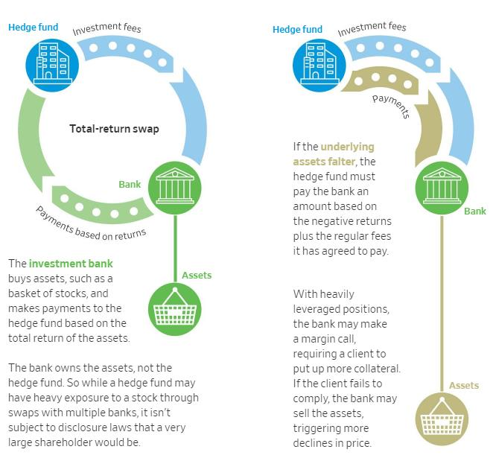
In this demographic, the hedgefund pays fees to the bank to buy assets for them and gets returns based on the returns of the
assets. If the position is highly leveraged, the bank can margin call them and sell their positions if they fail the call.
In Archegos' case, they were EXTREMELY overleveraged (as a lot of their positions were concentrated
on certain stocks like blue chip stocks), and when they got margin called and couldn't put up the
collateral the banks they paid to hold their assets for them sold them into the market, causing market
wide sell offs in the positions that they held billions of dollars in. This lead to their downfall, and shows
why so many people are against total return swaps, especially if you don't even have to disclose you have
them like Citadel and other hedge funds can.
How does this connect with Citadel and friends?
It doesn't make sense to say that Citadel or Melvin Capital or any other hedge fund that shorted
GameStop had total return swaps, because they actually were in ownership of their short positions.
However, as I was scouring the sub, I came across a post (its worth checking out) that had a nice
comment by u/taimpeng that goes into detail on how there could be the exact EQUIVALENT of a short
position using synthetic return swaps: return swaps between a synthetic prime brokerage and a hedge
fund that hedge funds can use to gain massive leverage (similar to Archegos using total return swaps to
gain massive leverage on their positions) , that would effectively allow them to have a short position
without actually owning the short position.
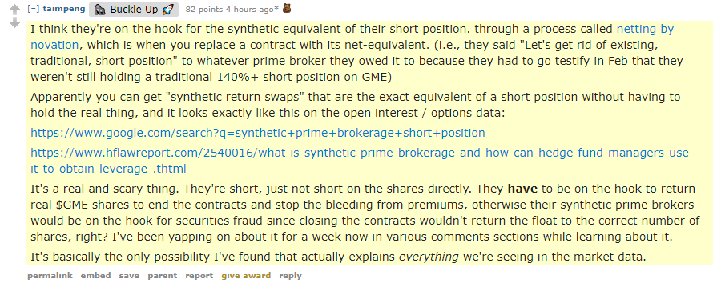
Seriously, give this man an award! This is gold.
Taimpeng here basically states that through netting by novation, its possible that hedge funds like
Citadel, Melvin Capital, and other hedge funds can essentially say that they have "closed their short
positions", but effectively just create an equivalent of the short position by entering into a contract with
a synthetic prime broker to say, "hey, we want you to swap our short shares with OTM put contracts.
We'll hold the OTM puts and we'll pay you to keep hold of our short shares." This would, in effect explain
how those 0.5$ strike July 16th puts appear in the options chain, and why it looks like GME isn't as
shorted as it actually is. It helps to explain the FTDs to some extent too as a lot of these shares could
have been nakedly shorted, but put under the veil of these put contracts that makes it look like the
shares actually exist. If this is the case, then we can go down the options chain to all OTM puts of the like
and find an estimate of the equivalent accumulation of short shares that the hedge funds have worked
together to hide through these OTM put contracts (at least the ones in the option chain that haven't
expired) , so l took the liberty of finding where most of these are (this is using yahoo finance options
data):
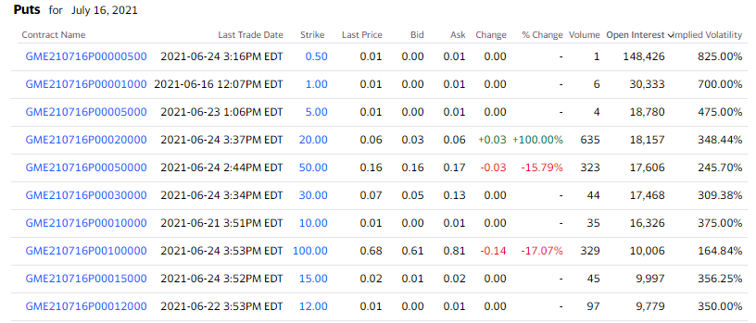
This is for July 16th. Basically what I'm doing is sorting by open interest and adding up the highest ones (as in thousands of open
interest) on expirations that have suspicious OTM low strikes like there are here.
For reference, here is what the puts on a options expiration date is supposed to look like:
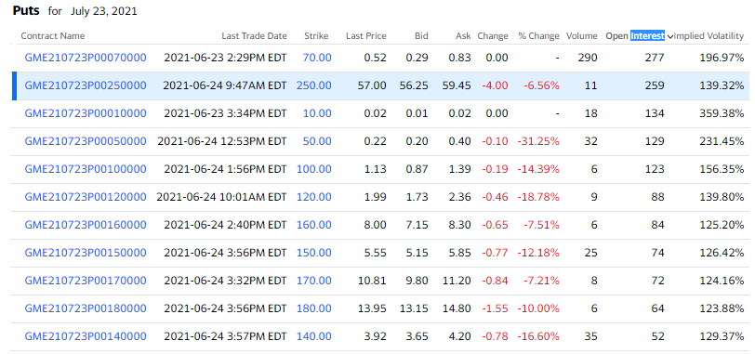
Here, the open interest shows up low overall on strikes OTM like 10$ and 50$ which don't signify much suspicious activity at
play.
I will now show you the rest of the dates that these suspicious OTM put open interest appears:
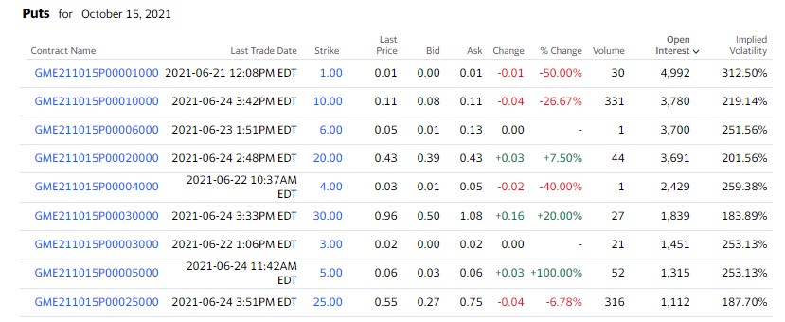
October 15th, 2021
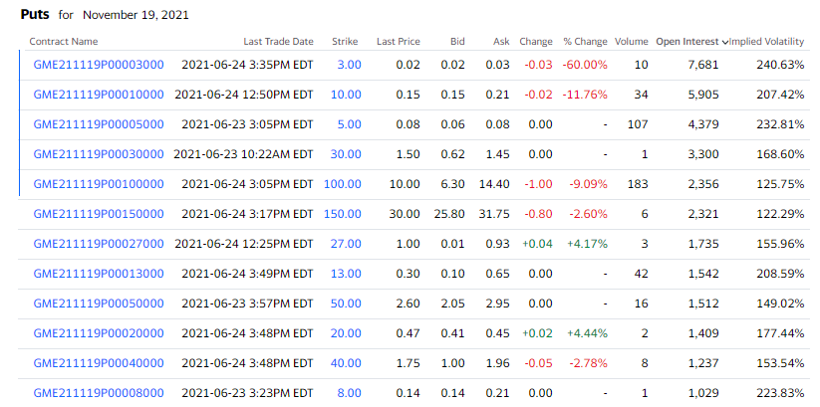
November 19th, 2021
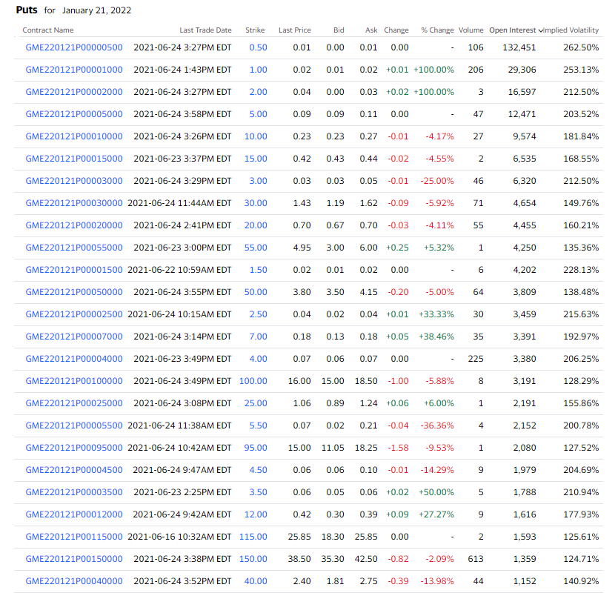
BIG one for January 21, 2022
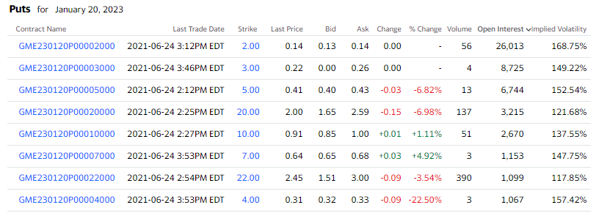
January 20, 2023
After crunching the numbers, here is a table of what I found:
Options Expiration Approximate Suspicious OTM Put Open Interest Total
July 16th, 2021 408,746 put contracts
October 15th, 2021 27,433 put contracts
November 19th, 2021 35,689 put contracts
January 21, 2022 267,336 put contracts
January 20, 2023 56,776 put contracts
Total: 795,980 put contracts
HOLY SMACKEROOS that's a lot of put contracts, and that's just the ones that I could find! There could be
a lot more put contracts they spread out that I couldn't find over other expiration dates, these are just
the put contracts where the put open interest stands out suspiciously on low strikes. For the grand total
number suspicious put contracts being at approximately 795,980 put contracts, in terms of shares that
would be... 79,598,000 shares short. Not as high as you would think, but also keep in mind that this does
NOT include the shorts they have covered already through FTD buy ins in the FTD cycle, as well as
shares short they could be hiding through other means that we don't know about. If we were to calculate
the short interest based on current data, we would have:
79,598,000 shares short / 70,800,000 shares outstanding ≈ 112% short interest
Quick edit: This is the short interest based on OTM Put data ALONE. If you were to add the short shares
currently reported (9.67M according to Finra data) on top of this, the revised calculation would be:
89,268,000 shares short / 70,800,000 shares outstanding ≈ 126% short interest
AND THIS IS STILL EXCLUDING GOD KNOWS HOW MANY SYNTHETICALLY CREATED SHORTS
EXIST.
QUICK EDIT AGAIN: I've recently just
read u/criand 's post that goes into depth on the deep ITM
CALL side of options (Side Note: I find it weird that these
contracts were around the same strike prices too for both puts
and calls, makes me think we can get an idea of the strike
prices of their short position based off that, just some food for
thought), and I think everyone should take a look at THAT as
well as it is most definitely a good read. Just for shits and
giggles, I've decided to include the call side of the shares
shorted based on his post to grab a good estimate of the
synthetic shares overall.
According to his post, approximately 1,100,000 calls in open interest were present (this is during
January) , or ≈ 110,000,000 shares overall on the call side regarding suspicious deep ITM calls. SO,
to add that on top of the already existing shares short we have:
199,268,000 shares short / 70,800,000 shares outstanding ≈
281% Short Interest
Edit: saw some comments asking to do short % of float so here
it is
79,598,000 shares short / 55,480,000 float ≈ 143% of float shorted
Revised calculation:
89,268,000 shares short / 55,480,000 float ≈ 160% of float shorted
Calculation including the deep ITM CALL side from
criand's post:
199,268,000 shares short/ 55,480,000 float ≈ 359% of float
shorted
That is a MASSIVE amount of short interest, and shows that GME is still very much being manipulated
even if we can't see it on the surface. If they have to buy all of these shares at once when we quite
possibly own the float MULTIPLE times over, they would have to buy approximately 199,268,000
shares MULTIPLE TIMES. The share price would definitely go into the millions in that circumstance (at
least in my opinion), and we KNOW the hedgies can pay it too. BUY AND HODL.
Post DD Message:
Thank you guys again for reading my DD! :) On this DD I felt motivated to find out what the hedgies were
hiding in terms of short shares, as I felt left in the dark as to what was happening overall and there was a
lack of explanation for a lot of things in my mind. This theory only manages to explain a little, but I hope
what I found was helpful to you guys and maybe give you a little confirmation bias going forward. It's
hard going against the grain, where there are so many people around you that think "oh GameStop is
done" and "the squeeze has been over for months now", so I truly applaud each and every one of you
that have been hodling with those diamond fucking hands of yours. Anyways, it's getting pretty late right
about now, so I think that's gonna be about it for this DD. I'll try to hang in the comments before going to
bed but I hope you guys have a nice rest of your day!
EDIT 2: I've been seeing in the comments that yahoo finance seems to regularly have this phenomenon
with their data at night (open interest data resetting). I've removed the images just so the post is a little
cleaner now and doesn't stir confusion regarding the data.
Back to Table of Contents
Dark Pools, Price Discovery and Short
Selling/Marking
DD 👨‍🔬
Recently, and since I've joined this sub-reddit, there have been a ton of questions around the role that
Dark Pools play in US equity market structure. I wanted to put together a post to clarify some things
about how they operate, what they do, and what they cannot do.
Dark pools were created as part of Regulation ATS (Alternative Trading System) in 1998. Originally they
were predominantly ECNs (Electronic Crossing Networks), including ones you're familiar with today as
exchanges such as Arca and Direct Edge. Ultimately though, most dark pools after Reg NMS was
implemented in 2007 were either broker-owned (such as UBS, Goldman, Credit Suisse and JP Morgan, to
name the top 4 DPs today) or independent block trading facilities, such as Liquidnet. Note that I am not
discussing OTC trading, which is what Citadel and Virtu do to internalize retail trades. I'll talk about that
in a bit.
To understand Dark Pools, and what makes them different from exchanges, you need to understand
some regulatory nuances, and some market data characteristics. From a regulatory perspective, it is
easier to get approval for a dark pool (regulated by FINRA), than an exchange (regulated by the SEC).
This is on purpose - ATSs are supposed to be a way to foster competition and innovation. Unfortunately,
that has resulted in 40+ dark pools and extreme off-exchange fragmentation.
Most dark pools are there ostensibly to allow institutional asset managers to post large orders that they
do not want to be visible on an exchange. This is the fundamental difference between dark pools and
exchanges - no orders are visible on dark pools (hence "dark"), whereas you can have visible orders on
exchanges. Now, you can also have hidden orders on exchanges. And there's nothing preventing an ATS
from posting quotes (Bloomberg used to do this on the FINRA ADF). However, generally speaking, today,
there aren't dark pools that show any posted orders.
So what about trades? All trades in the national market system have to be printed to a SIP feed. It
does not matter where they happen. And all trades during regular trading hours (9:30am - 4pm)
MUST be within the NBBO. These are hard and fast rules that cannot be violated. All trades on
exchanges are reported to the regular SIP. All trades that happen off exchange (ATS or OTC) are
reported to the Trade Reporting Facility (TRF) run by NYSE, Nasdaq or FINRA (there are 3 of them). All
trades have to be reported to the TRF within 10 seconds of being executed, though the reality is that
they are reported nearly instantaneously:
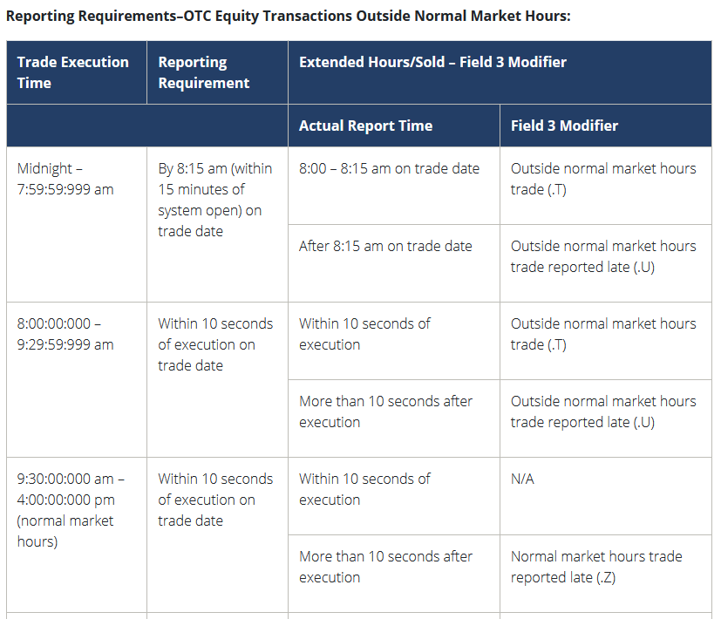
There was a question on FOX and Twitter yesterday - can hedge funds "go short" in dark pools and not
need to report it? I did not mean to be flippant in my tweet about how that is non-sensical, but I had a
long day yesterday and had no brain power left. But such a statement is non-sensical. That's not how
dark pools work.
There is practically no difference at all between trades executed on-exchange or off-exchange, especially
when you're talking about reporting short positions or short sale marking. The rules are identical,
regardless. Short-sale marking is not dependent on whether you trade on-exchange or off-exchange. I'm
not trying to make a statement as to whether firms are doing it adequately or accurately, but there is no
nexus with dark pools here. I also have never heard of this idea that firms will choose whether to
execute on-exchange or off-exchange based on where they want "buying pressure" or "selling pressure"
to show up. Every sophisticated trading firm out there is watching the TRF and categorizing every trade
that takes place relative to the NBBO. Every time a trade happens at the ask (or near it) they
characterize that as a buy. Every time a trade happens at the bid (or near it) they characterize it as a
sell. You cannot hide what you are doing in dark pools or through OTC internalization - it cannot
be done. All trades are public and reported within 10 seconds.
Here's what I think was trying to be said. If trades are taking place OTC, such as retail orders that are
being internalized by Citadel or Virtu, both of those firms qualify as Market Makers. Market Makers DO
have an exemption for short selling - they are allowed to do so without having located the shares first.
However, they still have to mark those sales as "short" and they are still, under standard rules, required
to ultimately locate those shares. Again, I'm not trying to get into whether there is naked shorting taking
place, or whether these rules are being followed - that's a different conversation. I'm just trying to help
you understand that dark pools are not nefarious, and that there is very little difference between dark
pools and exchanges from a trading, position marking and reporting perspective.
Ok, so finally, to get to the meat of this - can you use dark pools and off-exchange trading to artificially
hold down the price of a stock? I struggle to see the mechanism by which this can be done. I've never
heard of it, other than here. As I've said several times, every trade needs to be reported. Every single
retail trade that buys GME at the ask is reported to the tape. There's no hiding that. The only market
manipulation I've ever studied and measured, and that has been subject to enforcement action by the
SEC, has been on exchanges. That is done with layer and spoofing, or other manipulative practices such
as banging the close. Retail buying pressure OTC will be picked up on by firms watching the tape, and it
will also find its way on to exchanges as the internalizers need to lay off their inventory (they will
accumulate shorts, and want to close out those positions). You might claim that this is where naked
shorting comes in, but again that's a speculative leap, and really hard to imagine that firms that excel at
risk management would put themselves in such a position. I'm not saying it doesn't happen -
enforcement actions and lawsuits make it clear that this is an issue. But even if it does happen, the
trades to open those short positions were printed to the tape for everyone to see - they cannot be
hidden.
tldr; The only difference between dark pools and exchanges is that dark pools don't display quotes,
where exchanges do. Dark pool trades are all publicly reported within 10 seconds. You cannot get
around short sale marking and position reporting requirements based on where you trade (dark pool or
exchange). I don't believe you can suppress the price of a stock through manipulation that only involves
dark pools or off-exchange trading, as it is all publicly reported.
EDIT: Let me clear on something: There is WAY too much off-exchange trading. This harms markets. It
acts as a disincentive to market makers on lit exchanges. I want market makers on exchanges to make
money, and I want open competition for order flow. Off exchange trading is antithetical to those aims. It
has its place for institutional orders. But the level of off exchange trading, especially in stocks traded
heavily by retail such as GME is a symptom of a broken market structure with intractable conflicts-of-
interest, such as PFOF. When the head of NYSE says that the NBBO isn't doing its job for price discovery,
this is what she is referring to. If I, as a market maker, post a better bid on-exchange, and then suddenly
a bunch of off-exchange trades happen at the price level I just created, then the off-exchange trades are
free-riding my quote. They are taking no risk, and reaping the reward, while I take all the risk on-
exchange and do not get the trade. That's a real problem in markets, and it's why I have pushed hard for
rules to limit dark pool trading, such as you find in Canada, UK, Europe and other markets.
Back to Table of Contents
Hi All, It's Ryan Cohen T+21 Tweet Guy. I'm
losing my shit
DD 👨‍🔬
This is not financial advice.
------
Edit: So we are clear that T+21 did not happen Thursday, and probably not Friday either (due to the
Juneteenth speculation). I reiterate that the main purpose of the post is to demonstrate that Cohen is
aware of the mechanics behind this situation and price movement, and that shareholders are in good
hands. However, I am inclined to present two main alternatives theses:
A) SHF were able to reach the 100% net capital requirement, moving payment to T+28;
https://www.reddit.com/r/Superstonk/comments/o7g9mn/net_capital_and_t21/
Speculating that injection of 5 million shares through the offering allowed shorts to have enough money
to pass the 75% net capital requirement. Personally, I don't think dates are an issue. The public has a
limited amount of information to work with and this is the best apes can do. Up until now, this has been
accurate.
B) SHF covered not only the previous cycle, but also the current cycle in the runup to 340.
The fact is, apes are going to buy and hodl anyways; many are immune to the dips at this point. I've
already gotten hateful comments from gme_meltdown users trying to spread FUD in this forum. Apes
give constructive feedback, alternative theories, and support; remember this. And there is plenty of good
news to come out of this week - especially solid evidence that the SI is above 200%!
------
And to the original post:
Hey all, if anyone doesn't remember me, earlier I made a DD on Ryan Cohen's Tweet timing:
https://www.reddit.com/r/Superstonk/comments/nycuk4/cohen_has_reached_the_same_conclusion_a
s_ucriands/
Observing that RC has tweeted seemingly meaningless tweets on T+21 days. I honestly don't think they
have any deeper meaning other than signaling the T+21 day, but there is some speculation on the
meanings of them.
Anyways, in this previous post, I calculated that Cohen had an objectively, statistically
significanttrend of tweeting on T+21 days. Back then, the chance that his tweets were "randomly" on
T+21 days was 0.0339%.
Ryan Cohen has tweeted again, the night before a T+21 day!
https://twitter.com/ryancohen/status/1407896835096678402
With the introduction of this 5th tweet, he has now placed tweets on 5/6 T+21 days (missing only the
first one, when he might have not even known about the trend). Including his father's day tweet and also
this most recent one,
The probability that these tweets are random is 0.0069543%************. 0.00707%
That doesn't look very random to me.
For those interested: I used a hypergeometric law in which 173 days since 1/1/2021 (It's probably actually even higher than this as he entered the GME situation earlier than this. 20 Tweets out of 173 days means 20
"successes" in a population of 173. Then, 6 samples (T+21 days had 5 successes in samples (Ryan Cohen Tweets on T+21 days, leading to a hypergeometric probability of 0.000069543; multiplied by 100 to convert to
the percent. Statisticians please correct me if I am wrong and I will edit the post. Evidently, it is better to use the chance of picking exactly 5 dates, rather than 5 out of 6 possible; this would be somewhat higher at
0.00707%, but still quite low (hence the edit.)
Another subjective assumption I made in my last post was that, because Cohen was well aware of this
T+21 net capital cycle, he also timed the 5 million ATM share offering to coincide with a period in which
Hedge Funds would want to drive the price down. In doing so, diamond handed apes would simply
attribute lowered prices to the share offering, as many of us did.
He gave us FUD immunity.
Surely enough, Gamestop sold 5 million shares and raised 1.6 billion dollars, barely making a dent in the
price at least in the eyes of a December ape like myself, and announced the completion of the offering
leading up to the T+21 days.
I think we can be excited if the price goes up tomorrow (there's some real weird fuckery going on with
OTM Puts, crypt0, and other shit right now) but honestly I'm kinda shook he tweeted at all considering
DFV has gone quiet. That being said I have no doubt that he's got a team that knows far more than I do
about law (nothing) and is covered on this end. Either way, it shows that
Cohen and Co. know what's going on.
They could even read Superstonk DD. Maybe they realized before us. Regardless, I hope my message
with these posts can be:
GME Shareholders are in good hands. Buy if you have the means. HODL. HODL till you pass out and
then HODL some more. I have no doubt that this stonk will go: Just Up. (Not financial advice)
Things to be jacked for:
Apparently 002 is enforced/officially published 6/24
T+21 is on 6/24
Russel 1000 reconstitution 6/25
$750B in longer term RRP (not overnight) also due by counterparties on Friday, June 25th?
(thanks u/Criand)
Quarter end inc, with RRP already at an all time high?
Just Up
This is not financial advice. Although I was able to finally time my bananas correctly to eat them fresh,
quickly following this accomplishment I also ate something I'm very allergic to like a complete idiot.
Needless to say, my desire to Diamond Hand led me to the hospital safely. I ain't goin out until I see this shit
explode.
Edit: Also, I flaired this as DD just because the last one was, and it still leads with an objective statistical
analysis of the tweet timing, but I may change it to Discussion/Possible DD as there isn't that much to
add in terms of the statistics, just an update.
Edit 2: formatting, I'm a dumbass
Edit 3: Instead of picking exactly 5 days out of 6 possible days (T+21 days), it is evidently more relevant
to use a different equation picking 5 specific days that are nonrandom; this lands a revised probability of
0.00707%.
Back to Table of Contents
Elliot Waves And GME, The Return Of The
Uptrend
DD 👨‍🔬
Sup Apes
Not financial advice. Seriously. Do NOT listen to me, I am most definitely not a financial advisor. Just an
ape who want 🍌
Bump this shit now. not a request: https://www.youtube.com/watch?v=X2LTL8KgKv8
This is gonna be a pretty short post, just giving a brief overview of what I expect/would like to see
tomorrow.
Please remember this is a PREDICTION and in no way a guarantee, I take crayons from restaurants and
draw on my computer screen.
I know y'all are JACKED after today, and so am I. I'm so jacked that I'm getting high and drunk as we
speak (mothafuckin cheers you glorious degenerate bastards, porsche or food stamps )
CHEEERS
Okay so everyone knows the ATM offering is complete. AND everyone knows what happened last time it
was complete. Yesterday we finally touched the .618 level that I outlined in this post (see final
edit) https://www.reddit.com/r/Superstonk/comments/nwyj77/elliot_waves_and_gme_why_im_jacked_to_
infinity/
"holy fuck, just another reason why you shouldn't listen to me, im so retarded (I was probably high in all
honesty) when I wrote this and i looked at my fibs as 213 being the 61.8 level to watch... but i am
retarded... the proper level is 201... so keep a strong eye on that for a
bounce: https://imgur.com/dmywYOA (okay now im acc leaving, the TA wasn't sitting right with me so i
took a closer look, and voila... user error smh. Sorry for confusion, I'm just an ape (look CLOSELY at how
the retracemnt is drawn, from the low on 3/24 to the high on 6/8... these are the PROPER ratios to
reference, Irdk how I missed that yesterday"
So we hit that yesterday and bounced at 197. The levels don't need to be hit perfectly by any means, but
when the level IS hit, we have greater confirmation that the move is complete. Remember wave 2
typically targets at least 50% retracement of 1, though often times it hits the .618 level, or the .786 level.
What's important is the LOW IS IN MOTHAFUCKAS (so it seems, i'd love more cheapies), AND we had a
seemingly definitive wave 1 on a smaller scale complete. Identifying a wave 1 is often times the hardest
part of EW, but the trick is to look for the end of a downtrend. It is imperative that the wave 2 does not
cross below the low of wave 1, or the move is invalidated.
Here's a view of what I see:
4hr
My brain is playing tricks on me as I'm writing this, there are a few possible counts when looking
intraday but I'm just gonna lay out the one that makes the most sense to me:
30m
So my thinking in this analysis is that the move after the morning dip to a high of 225.8 as a 1 and not
the pre market move on news of the ATM offering being complete. The ALT count would be the move in
pre market is the (i), but this doesn't really change much, just alters targets by a few points.
So assuming the move to 225.8 was a (i), remember were looking for at least a 50% correction of said
move as validation of a (ii). Low and behold, price crossed below the 50% level (white line), so the move
is valid thus far.
Do note, the .618 level was not hit, so I'm not ruling that possibility out just yet. Assuming our low of the
day at 209.3 was our (ii), that puts the next (smaller timeframe) upside targets at 238.18 (1:1 extension
of (i) ), remember (iii) can't be the shortest. thus, a minimum extension of 1:1 of (i) is expected, though
typically 1.618:1.
The 1.618 level comes out to 256, which ironically is the exact same as the 38.2% retracement level of
our cycle wave 1 (run from 113 to 344). This is why I'm more inclined to go with this wave count. Fib is
nature, when targets overlap I'm more convinced my count is correct.
The drop to 197 yesterday does not change the overarching 3 within a 3 within a 3 setup at all, all it does
is lowers original cycle 3 targets by the respective difference of the previous extension drawings (so like
$9 or so). This put minimum CYCLE 3 target at 423 (This overlaps the bigger wave 3 initial target, see
below and look at the 100% level, yellow)
target (say it like tarzyay)
okay maybe i shouldn't have gotten drunk for this i'm really losing my train of thought lol, bear with me
almost done
in short, the move thus far is valid unless we break below 197, which idk about you, but I don't see that
happening any time soon, if ever. Within this current wave subset, the highest we should go (assuming
we dont see a hyperextension to 1160, personally I think moves of that scale will come a bit later, but I
could be very wrong) is around 565 before a bit of retracement action.
However, if you saw my recent post going over the (seemingly) correlation between eyyyy emm see,
when that ticker did its thang, it actually hit the 1.618 level of its JANUARY run up. using that same
philosophy with GME, that puts GME at...
get ready for it...
are you ready...?
no you're not.
862.16
We shall see.
I don't really care about the intraday action. Just look for higher highs/lows relative to 197 and were
looking good.
Will re evaluate when I must, but it's reallllly hard not to be jacked.
Before I sign off, here's the 1.618 target of the january move... enjoy:
GME
Will show you eyy emm see too just so you can see this shit really did happen, and I have reason to
believe it will replicate on GME:
movie stonk
TLDR: I CAN FEEL IT COMING 🚀also not saying 862 happens tomorrow lol, soon enough 😈
edit: interestingly enough, if we use fib time extensions, .5 level comes to 6/28 (drawing from GME's
lowest low ever to the high of january. this doesn't really mean anything but It's interesting how it all
ties into outside factors going on... this doesn't mean we squeeze 6/28 lol. Just something interesting)
edit 2: probably nothing but noticed a tiny $.50 gap around the 200 level, worth noting. Its minuscule
and doesn't show up on a daily chart, only hourly but you have to squint to see it. This is normal in
stocks
Edit: I’m going insane so I dug deeper . I’ll probably make a new dd tonight or tomorrow morning 🥴
Back to Table of Contents
Ryan Cohen Started Chewy with $15m in
Investments. He is Starting Off at GME with
$1bn. This Interview is the Only DD I Need.
Possible Blue Prints for GME?
DD 👨‍🔬
I have added commentary to the interview and bolded what I think are the important takeaways. If you
want to read the un-adultured full interview you can find it here. I cut out the end part where he
answers some questions about his dad. While very insightful information into the life of RC, I didn't feel
like analyzing that particular part as it relates to investing.
Over 7 years RC and Chewy raised around $350m in investments. He sold to PetSmart for 3.5bn. He has
already raised $550m + 1.126bn = $1.676bn for GameStop**.** The difference is this isn't private
money. These monies were acquired by selling to long term devoted investors. He is starting off at
GameStop in a significantly better capital position than he did at Chewy. GME is and is not a meme.
Cohen also served as CEO of Chewy, which PetSmart acquired in 2017 for $3.35 billion, which at the
time was the largest e-commerce acquisition ever.
Zack Friedman: Why did you see a need for Chewy that didn’t exist with Petco, PetSmart, Amazon and
other online retailers?
Ryan Cohen: I was going to the neighborhood pet store for my dog food but because I was busy building
a business, I didn’t always have the time to make the trip. I tried Amazon and the big box retailers, but
they were all missing the specialized experience and their customer service sucked. Try calling
them.
With Chewy, I combined the best from all of them. I saw an opportunity to differentiate from the pack
and convert fanatical pet parents, like myself, into die-hard customers. Our customers got the local
pet store experience with the convenience of shopping online.
You can see that RC really believes in what he does. It's a mentality like this why some people would say
"Invest in the man, not the company". You see a similar aspect with someone like Elon Musk. Not to put
anyone on a pedestal but many investors put a lot of blind faith into him because they believe in his
vision. It's great when you get the combination of a great company and a visionary behind the wheel. It's
the cherry on top of a sound investment. You can see he built the business because he identified a major
flaw in the existing market and sought to remedy it with controversial and groundbreaking business
ideas. Some of it was against the grain as he elaborates to further on. You can see a mirror premiss in his
investment in GME.
I focused on bringing a human element to e-commerce. We provided 24/7 US-based customer
service and included small touches like handwritten holiday cards and personalized pet portraits.
These were ways we could connect with customers and build loyalty over time, optimizing for
a lifetime relationship, not a single transaction. Chewy’s relationship with customers was
the secret sauce.
This is the main reason why Microsoft, and likely Sony, have commission based sales relationships with
GameStop. Both companies have the ability to create decreased Customer Acquisition costs though
GameStop vs Amazon or WalMart and create longer LifeTime Revenue and increase their Total
Addressable Market. GameStop does have the largest digital magazine subscription in the world.
Someone like Ryan Cohen will be able to capitalize on this aspect by focusing on Customer Service and
Customer Experience. You can tell he as a huge inclination towards his customer loyalty. Another great
article in the link at the top of this paragraph.
Friedman: You were rejected by 100 different investors. What did you learn from the process? What
made you keep going when you kept hearing no?
Cohen: For me, each no sounded like they just didn’t understand my vision. It was frustrating at times,
but never discouraging. Those “no”s never made me doubt my strategy – it was the opposite. I
was motivated by all the rejections and they just got me fired up.
Buy and fucking hold. Don't worry about the noise.
Most investors couldn’t get past two hurdles: competing head-on with Amazon and
the pets.com failure during the dot com bubble. But I was convinced being focused on the pet
category along with high-touch customer service gave Chewy unique competitive
advantages.Pets.com was a good idea but a decade too soon and without sufficient scale to cover
their costs.These two hurdles didn’t scare me. I never considered changing my business plan. One
highly respected venture capitalist told me he would be more interested if we were selling live pets over
the internet rather than pet supplies. Like most investors, he believed running into Amazon’s teeth was
suicidal.
I understood that thinking big was likely going to be misunderstood along the way. I’m contrarian by
nature, so being misunderstood often validates what I’m doing. It wasn’t until Chewy boxes were on
doorsteps across the country that the bulk of investors started to recognize our formula.
How many times has Ryan and GameStop shown they have a hidden edge that no one expected? That
sentiment will only continue to grow.
Friedman: Let’s talk about execution and scale. You’ve said that you used Zappos as a model. You also
were inspired by Jeff Bezos and Amazon’s growth and model. How do you go from idea to platform to
scale? What was the process and how did you scale so quickly?
Cohen: In just three months we built a website, found a distributor and partnered with a third-
party logistics company.
What has GameStop done in the last three months? Raised almost 2bn in cash. Made a ton of new hires.
Expanded their product offering. Completely changed their board. Increased revenues and online sales.
Got rid of the drift wood, thank you for your service Sherman. Revamped their online presence.
Sustained insane valuations compared to where they were last year.
In June of 2011 we launched. I focused on four pillars and we did them better than anyone else.
We started with the value proposition of delighting our customers, which we did through amazing
customer service, low prices, fast shipping, and selection. The onus was on us to create the most
efficient supply chain to support that business model.
This is where we start getting into some more serious DD on RC's comments. Anyone who has ever
worked for a multi billion dollar corporation recognizes what RC means when he starts talking about
building pillars. Pillar systems are some of the most cliche corporate business strategy foundations that
exist. What this tells me is this guy is familiar and in the know with running a multi-billion dollar
company. He obviously has experience with Chewy but this jargon validates that he was actually doing
something while he was there. Those who have been following along know that he has made a major
shift towards delighting customers and offering a better value proposition. Anyone in the USA who has
experienced the Door Dash same day delivery knows what I'm talking about.
When we reached $200 million in sales, we had to insource fulfillment to be able scale to the next
level. We opened our first two warehouses in 2014. By 2018 we had seven warehousesaround the
country and 4.7 million square feet of space. Each is the size of 13 football fields and four stories high.
GameStop, like I just said is using DoorDash for fulfilment along with pickup in store. Covid is probably
presenting a lot of challenges for this right now, and no doubt every industry is either going to adapt or
die though these times. Maybe RC intends to insource this as well for GameStop. I also do not know what
they currently do for warehousing and distribution but I would imagine this would be one of the first
things RC would intent to overhaul if he saw fit. Will be curious to see if we can get any insight into these
plans, if any. To give you reference 4.7 million square feet is about 3x3 city blocks or it would take about
6km by 6km of property to fit warehouses of that size. Roughly peaking. It's large though. So he is
capable of managing logistics of a large scale. This is the scale of multi billion dollar operations.
Edit: A good spot to add u/thechaoschicken 's contribution about GameStop expanding their fulfillment
capabilities with a new 700k+ sq.ft facility.
I needed to hire the best people and delegate into their areas of expertise. Each employee we hired
had a strong bias for action and were excited about the opportunity to disrupt the pet industry. We
always hired for will over skill. One you can teach, the other you can’t. Everyone and everything
revolved around being customer obsessed. We scaled from 3 employees in 2011 to over 9000
Chewtopians by 2018.
I specialize in labor management for large corporations. I also ran a small business with several
employees. These are the fundamental aspects of managing people. You could literally be entirely
unqualified in your field, as long as you delegate to qualified people and hire people based on their
attitude vs their qualifications, then you will build a very strong culture and worker base. Most skills can
be taught to most people, especially the motivated ones. But only the motivated ones can help you drive
business forward. They will grow as much as you nurture them. One of my largest concerns with
GameStop is that, judging by their subreddit, they have a ton of disgruntled employees. Sounds like they
are often driven to quitting through unreasonable growth and sales expectations and competing with
stores that manipulate figures. Among other problems. To see Ryan call his employees "Chewtopians"
really signifies that he has a personal relationship with his workers. I would like to see that type of
culture expanded in GameStop.
We prioritized long term growth over short term profitability. The last thing you want to be is
a subscale e-commerce company. You’re a dead man walking, and Amazon will crush you. We rapidly
expanded our product offering to include all pet food and supplies so there was never a reason to
shop elsewhere.
Expect the same thing with GME. Sustained growth. Long term investment. He knows what it takes to
take on Amazon. We know this. We've seen it before in Chewy. Maybe Bezos will be smart enough to
partner this time. Only time will tell. They have already expanded their product offering in the USA.
Expect that to continue.
By 2018, 90% of our revenue was from repeat customers.
This is easier to achieve with something like pet food, but holy smokes that is an insane figure.
We raised six rounds of financing and more than $350 million over seven years. We grew sales
from $2 million in 2011 to $3.5 billion by 2018, a 190% annual growth rate.
190% ANNUAL growth? Jesus christ those kind of returns are practically unheard of on a continued
basis. Applying that to GME sends it to a trillion dollar valuation in less than 5 years. Here's a video of
Anne Hand, CEO of Super League Gaming talking about the potential market for the gaming industry.
Friedman: What’s the most misunderstood thing about entrepreneurship?
Cohen: Don’t let the pictures or magazines mislead you, it’s not at all glamorous. Negotiating with
vendors, reading long contracts, conducting nonstop interviews, convincing investors to give you
money, combined with a constant stream of everyday problems, is not fun.
The Type A in me is competitive and loves to win, but the day-to-day feels like you’re losing. If you
think you’re winning you’re probably not doing a great job building your company. Even as
our sales grew into the billions, I always felt behind. Whether that’s the right mentality or not, that’s
how I’m wired.
Friedman: What are three pieces of advice you would give to an aspiring entrepreneur?
Cohen:
I’d be remiss to say my way is the ‘right’ way. It’s simply what worked for me. My dad had a glassware
importing business, and he told me about how he was talking with his dad one day. His dad had pointed
at two trucks. “You see those trucks there?” he’d said. “If what’s in one of those trucks will make you
more money, and what’s in the other truck will make your customers happier, choose the one that
makes your customers happier, even if you make less money.” That served as the guiding premise for
Chewy.
Second, I was never afraid to say no. I was constantly bombarded with new ideas, and when you’re
growing quickly it’s critical to stay focused, so I said no to almost everything. There’s a time and place
for ideation, but in the early days when resources are finite, it’s important to choose a handful of things
and do them extremely well.
This just provides some insight into his business strategy. Out of the box thinking can be a great thing, so
don't be worried if you see some un-orthodox moves come from RC.
Third, my biggest risk would have been not taking risk. The risk of going head-to-
head against Amazon. The risk of insourcing fulfillment. The risk of building a company in Florida
rather than a popular tech hub. The risk of spending $3 million a month on TV ads, more than Home
Depot HD +1.6%'s budget. The risk of hiring expensive executives even though we weren’t
profitable.These decisions were some of the most controversial and required me being comfortable
betting against conventional wisdom, and were often contrary to the advice of my board. Suffice it
to say, I was not the most popular board member.
This is basically where I stopped analyzing the interview. Like i said, he goes on to answer some
questions about his dad. Which I believe lend a lot of insight into his personality and life but I didn't
really feel comfortable commenting on it. I have no doubt his dad would be pretty proud of what he is
doing now. As a father myself I would be completely blown away if my kids were doing what he's doing.
Based on what RC says here I believe you can get a feel for what to expect next. TV/Social Media ads are
probably coming. So much meme potential for them. Hiring expensive execs has already started. If
anyone could share the DD on that I would love to link it here. The next piece of the puzzle will be what
they plan to do with the over 1bn in cash on their books right now. Expecting some type of acquisition or
major business expansion.
Tl;Dr: You guys really need to put more blind faith into this guy
Back to Table of Contents
Hyperinflation is Coming- The Dollar Endgame:
PART 1, “A New Rome”
DD 👨‍🔬
I am getting increasingly worried about the amount of warning signals that are flashing red for
hyperinflation- I believe the process has already begun, as I will lay out in this paper. The first stages of
hyperinflation begin slowly, and as this is an exponential process, most people will not grasp the true
extent of it until it is too late. I know I’m going to gloss over a lot of stuff going over this, sorry about this
but I need to fit it all into four posts without giving everyone a 400 page treatise on macro-economics to
read. Counter-DDs and opinions welcome. This is going to be a lot longer than a normal DD, but I
promise the pay-off is worth it, knowing the history is key to understanding where we are today.
SERIES TL/DR (PARTS 1-4): We are at the end of a MASSIVE debt supercycle. This 80-100 year
pattern always ends in one of two scenarios- default/restructuring (deflation a la Great Depression) or
inflation( hyperinflation in severe cases (a la Weimar Republic). The United States has been abusing it’s
privilege as the World Reserve Currency holder to enforce its political and economic hegemony onto the
Third World, specifically by creating massive artificial demand for treasuries/US Dollars, allowing the
US to borrow extraordinary amounts of money at extremely low rates for decades, creating a Sword of
Damocles that hangs over the global financial system. The massive debt loads have been transferred
worldwide, and sovereigns are starting to call our bluff. Systemic risk within the US financial system
(from derivatives) has built up to the point that collapse is all but inevitable, and the Federal Reserve
has demonstrated it will do whatever it takes to defend legacy finance (banks, broker/dealers, etc) and
government solvency, even at the expense of everything else (The US Dollar).
I’ll break this down into four parts. ALL of this is interconnected, so please read these in order:
• Part One: The Global Monetary System- “A New Rome” < (YOU ARE HERE)
• Part Two: Derivatives, Systemic Risk, & Nitroglycerin- “The Ouroboros” <
• Part Three: Banks, Debt Cycles & Avalanches- “The Money Machine” <
• Part Four: Financial Gravity & the Fed’s Dilemma- “At World’s End” <
Preface:
Some terms you need to know:
Inflation: Commonly refers to increase in prices (per Keynesian thinking). However, Inflation in the
truest sense is inflation (growth) of the money supply- higher prices are just the RESULT of monetary
inflation. (Think, in normal terms, prices really only rise/fall, same with temperatures. (ie Housing
prices rose today). The word Inflation refers to a growth in multiple directions (quantity and velocity).
Deflation means a contraction of the money supply, which results in falling prices.
Dollarization (Weaponization of the Dollar): The process by which the US government, IMF, World Bank,
and other elite organizations force countries to adopt dollar systems and therefore create indirect
demand for dollars, supporting its value. (Think Petrodollars).
Central Banks: Generally these are banks that control/monitor the monetary policy of the country they
reside in. They are usually owned by private financial institutions (large banks/bank holding firms).
They utilize open market operations to stabilize and set market rates. They are called the “Lender of
Last Resort” as they are supposed to LEND (not bailout/buy assets) to other banks in a crisis and help
defend their currency’s value in international forex markets. CBs are beholden to the “dual mandate” of
maintaining price stability (low inflation) and a strong job market (low unemployment)
Monetary Policy: The set of tools that central bankers have to adjust how money moves through the
financial system. The main tool they use is quantitative tightening/easing, which basically means selling
treasuries or buying treasuries, respectively. *A quick note- bond prices and interest rates move
inversely to one another, so when Central banks buy bonds (easing), they lower interest rates; and when
they sell bonds (tightening), they increase interest rates.
Fiscal Policy: The actions taken by the government (mainly spending and taxing) to influence
macroeconomic conditions. Fiscal policy and monetary policy are supposed to be enacted
independently, so as not to allow massive mismanagement of the money supply to lead to extreme
conditions (aka high inflation/hyperinflation or deflation) *cough Yellen cough*
Part One: The Global Monetary System- A New Rome

Allegory of the Prisoner's Dilemma
Prologue:
In their masterwork tapestry entitled “Allegory of the Prisoner’s Dilemma” (pictured in the title image of
this post) the artists Diaz Hope and Roth visually depict a great tower of civilization that rests upon a
bedrock of human cooperation and competition across history. The artists force us to confront the fact
that after 10,000 years of human civilization we are now at a cross-roads. Today we have the highest
living standards in human history that co-exists with an ability to destroy our planet ecologically and
ourselves through nuclear war. We are in the greatest period of stability with the largest probabilistic
tail risk ever. The majority of Americans have lived their entire lives without ever experiencing a direct
war and this is, by all accounts, rare in the history of humankind. Does this mean we are safe? Or does
the risk exist in some other form, transmuted and changed by time and space, unseen by most
political pundits who brazenly tout perpetual American dominance across our screens?(Pulled
from Artemis Capital Research Paper)
The Bretton Woods Agreement
Money, in and of itself, might have actual value; it can be a shell, a metal coin, or a piece of paper. Its
value depends on the importance that people place on it—traditionally, money functions as a medium of
exchange, a unit of measurement, and a storehouse for wealth (what is called the three factor definition
of money). Money allows people to trade goods and services indirectly, it helps communicate the price
of goods (prices written in dollar and cents correspond to a numerical amount in your possession, i.e. in
your pocket, purse, or wallet), and it provides individuals with a way to store their wealth in the long-
term.
Since the inception of world trade, merchants have attempted to use a single form of money for
international settlement. In the 1500s-1700s, the Spanish silver peso (where we derive the $ sign) was
the standard- by the 1800s and early 1900s, the British rose to prominence and the Pound (under a gold
standard) became the de facto world reserve currency, helping to boost the UK’s military and economic
dominance over much of the world. After World War 1, geopolitical power started to shift to the US, and
this was cemented in 1944 at Bretton Woods, where the US was designated as the WRC (World Reserve
Currency) holder.

Bretton Woods
In the early fall of 1939, the world had watched in horror as the German blitzkrieg raced through
Poland, and combined with a simultaneous Russian invasion, had conquered the entire territory in 35
days. This was no easy task, as the Polish army numbered more than 1,500,000 men, and was thought by
military tacticians to be a tough adversary, even for the industrious German war machine. As WWII
continued to heat up and country after country fell to the German onslaught, European countries,
fretting over possible invasions of their countries and annexation of their gold, started sending massive
amounts of their Gold Reserves to the US. At one point, the Federal Reserve held over 50% of all above-
ground reserves in the world.
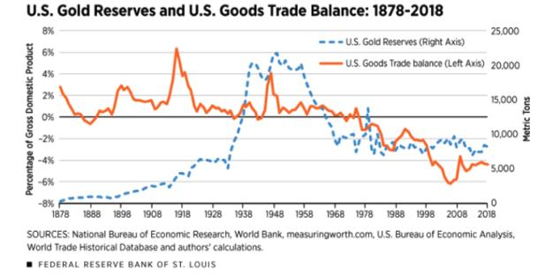
US Trade Balance
In a global monetary system restrained by a Gold Standard, countries HAVE to have gold reserves in
their vaults in order to issue paper currency. The Western European powers all exited the Gold standard
via executive acts in the during the dark days of the Great Depression (in Germany’s case, immediately
after WW1) and build up to War by their respective finance ministers, but the understanding was they
would return back to the Gold standard, or at least some form of it, after the chaos had subsided. As the
war wound down, and it became clear that the Allies would win, the Western Powers understood that
they would need to come to a new consensus on the creation of a new global monetary and economic
system. Britain, the previous world superpower, was marred by the war, and had seen most of her
industrial cities in ruin from the Blitz. France was basically in tatters, with most industrial infrastructure
completely obliterated by German and American shelling during various points of the war. The leaders
of the Western world looked ahead to a long road of rebuilding and recovery. The new threat of the
USSR loomed heavy on the horizon, as the Iron Curtain was already taking shape within the territories
re-conquered by the hordes of Red Army. Realizing that it was unsafe to send the gold back from the US,
they understood that a post-war economic system would need a new World Reserve Currency. The US
was the de-facto choice as it had massive reserves and huge lending capacity due to its untouched
infrastructure and incredibly productive economy.
At Bretton Woods, the consortium of nations assented to an agreement whereby the Dollar would
become the WRC and the participating nations would synchronize monetary policy to avoid competitive
devaluation. In summary, they could still redeem dollars for Gold at a fixed rate of $35 an oz, a hard
redemption peg which the U.S would defend. Thus they entered into a quasi- Gold standard, where
citizens and private corporations could NOT redeem dollars for Gold (due to the Gold Reserve Act , c.
1934), but sovereign governments (Central banks) could still redeem dollars for gold. Since their
currencies (like the Franc and Pound) were pegged to the Dollar, and the Dollar pegged to gold, all
countries remained connected indirectly to a gold standard, stabilizing their currency conversion rate to
each other and limiting local governments’ ability to print and spend recklessly.
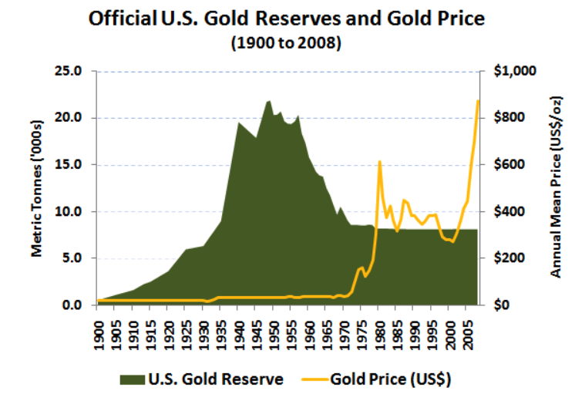
US Gold Reserves
For a few decades, this system worked well enough. US economic growth spurred European rebuilding,
and world trade continued to increase. Cracks started to appear during the Guns and Butter era of the
1960’s, when Vietnam War spending and Johnson’s Great Society programs spurred a new era of
fiscal profligacy. The US started borrowing massively, and dollars in the form of Treasuries started
stacking up in foreign Central Banks reserve accounts.
Then-French President Charles De Gaulle did the calculus and realized in 1965 that the US had issued far
too many dollars, even considering the massive gold reserves they had, to ever redeem all dollars for
gold (remember naked shorting more shares than exist? -same idea here). He laid out this argument in
his infamous Criterion Speech and began aggressively redeeming dollars for gold. The global “run on the
dollar” had already begun, but the process accelerated after his seminal address, as every large
sovereign turned in their dollars for bullion, and the US Treasury was forced to start massively
exporting gold. Backing the sovereign government's actions were fiscal and monetary strategists getting
more and more worried that the US would not have enough gold to redeem their dollars, and they would
be left holding a bag of worthless paper dollars, backed by nothing but promises. The outward flow of
gold quickly became a deluge, and policymakers at all levels of Treasury and the State department
started to worry.
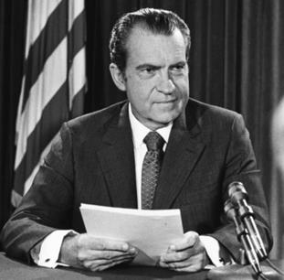
Nixon ends Bretton Woods
Nearing a coming dollar solvency crisis, Richard Nixon announced on August 15th, 1971 that he was
closing the gold window, effectively barring all countries from current and future gold redemptions.
Money ceased to be based on the gold in the Treasury vaults, and instead was now completely unbacked,
based solely on government decree, or fiat. Fixed wage and price controls were created, inflation
skyrocketed, and unemployment spiked.
Nixon’s speech was not received as well internationally as it was in the United States. Many in the
international community interpreted Nixon’s plan as a unilateral act. In response, the Group of Ten (G-
10) industrialized democracies decided on new exchange rates that centered on a devalued dollar in
what became known as the Smithsonian Agreement. That plan went into effect in Dec. 1971, but it
proved unsuccessful. Beginning in Feb. 1973, speculative market pressure caused the USD to devalue
and led to a series of exchange parities.
Amid still-heavy pressure on the dollar in March of that year, the G–10 implemented a strategy that
called for six European members to tie their currencies together and jointly float them against the dollar.
That decision essentially brought an end to the fixed exchange rate system established by Bretton
Woods. This crisis came to be known as the “Nixon Shock” and the DXY (US dollar index) began to fall in
global markets.
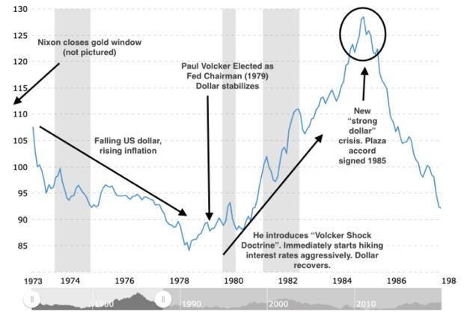
DXY
This crisis came out of the blue for most members of the administration. According
to Keynesianeconomists, stagflation was literally impossible, as it was a violation of the Philips
Curve principle, where Unemployment and Inflation were inversely correlated, thus inflation
should theoretically be decreasing as the recession worsened and unemployment climbed
through 1973-1975.
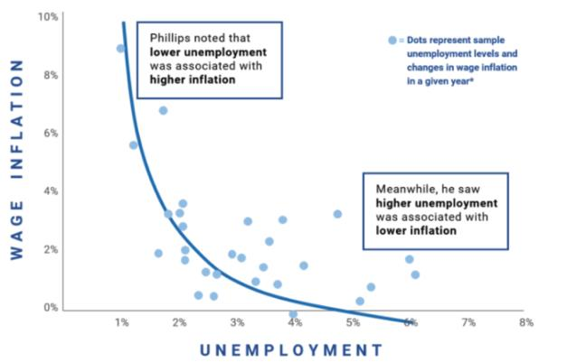
Phillips Curve
MONKE-SPEK: Philips Curve Explained
• Low Unemployment>Lots of jobs/high demand for labor.
• Thus, more workers are employed, and wages rise>putting more money in more
people’s pockets.
• These people go out and buy beanie babies, toasters, and bananas (what economist John
Maynard Keynes called aggregate demand) and this higher demand leads to higher
prices for goods and services. This shows up as inflation.
• Consider the opposite- high unemployment>fewer jobs>less money for people
• Less demand for goods and services> lower inflation
Keynesian economists treated this curve as a law of nature, rather than a general rule. We see
exceptions to this rule everywhere- Argentina is a prime example, where they have persistently high
unemployment AND high inflation. This phenomenon is called stagflation, and is evidence of inflationary
pressures so strong that they overcome the deflationary force of high unemployment. These economists
were utterly blindsided by the emergence of stagflation.
After the closing of the gold window in 1971, the crisis spread, inflation kept climbing, and other
sovereigns began contemplating devaluing their currencies as their only peg, the US dollar, was now
unmoored and looked to be heading to disaster. US exports started climbing (cheaper dollar, foreigners
could now import stuff to their countries), straining export economies and sparking talks of a currency
war. Knowing they had to do something to stop the bleeding, the Nixon administration, at the direction
of Henry Kissinger, made a secret deal with OPEC, creating what is now called the Petrodollar system.
This article summarizes it best:
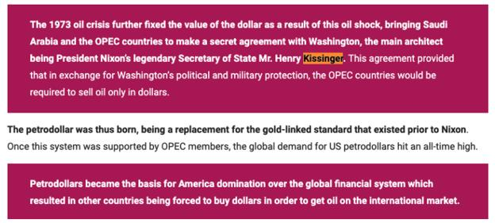
PetroDollar system
Petrodollars had been around since the late 1940s, but only with a few suppliers. Petrodollars are U.S.
dollars paid to an oil-exporting country for the sale of the commodity. Put simply, the petrodollar system
is an exchange of oil for U.S. dollars between countries that buy oil and those that produce it. By forcing
the majority of the oil producers in the world to price contracts in dollars, it created artificial demand
for dollars, helping to support US dollar value on foreign exchange markets. The petrodollar system
creates surpluses for oil producers, which lead to large U.S. dollar reserves for oil exporters, which need
to be recycled, meaning they can be channeled into loans or direct investment back in the United States.
It still wasn’t enough. Inflation, like many things, had inertia, and the oil shocks caused by the Yom
Kippur War and other geo-political events continued to strain the economy through the 1970’s.
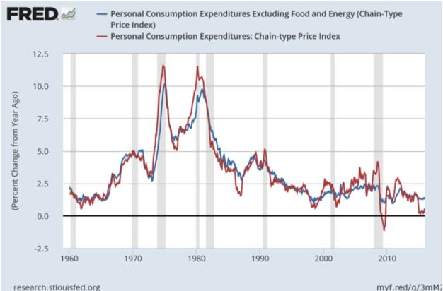
PCE Index
Running out of road, monetary policymakers finally decided to employ the nuclear option. Paul Volcker,
the new Federal Reserve Chairman selected in 1979, knew that it was imperative to break the back of
inflation to preserve the global economic system. That year, inflation was spiking well above 10%, with
no end in sight. He decided to do something about it.
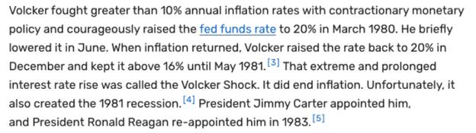
Volcker Doctrine
By hiking interest rates aggressively, consumer credit lending slowed, mortgages became more
expensive to finance, and corporate debt became more expensive to borrow. Foreign companies that
had been dumping US dollar holdings as inflation had risen now had good reason to keep their funds
vested in US accounts. When the Petrodollar system, which had started taking shape in ‘73 was
completed in March 1979 under the US-Saudi Joint Commission, the dollar finally began to stabilize. The
worst of the crisis was over.
Volcker had to keep interest rates elevated well above 8% for most of the decade, to shore up support
for the dollar and assure foreign creditors that the Fed would do whatever it takes to defend the value of
the dollar in the future. These absurdly high interest rates put a brake to US government borrowing, at
least for a few years. Foreign creditors breathed a sigh of relief as they saw that the Fed would go to
extreme lengths to preserve the value of the dollar and ensure that Treasury bonds paid back their
principal + interest in real terms.
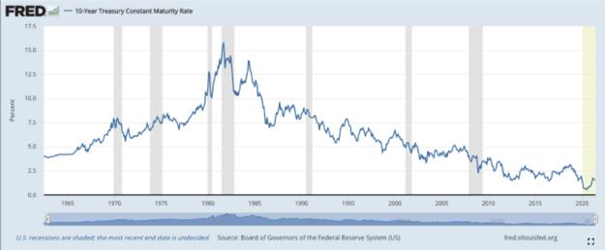
10yr US treasury yields
Over the next 40 years, the United States and most of the developed world saw a prolonged period of
economic growth and global trade. Fiat money became the norm, and creditors accepted the new
paradigm, with it’s new risk of inflation/devaluation (under the gold standard, current account deficits,
and thus inflation risk, was self-stabilizing). The Global Monetary system now consisted of free-floating
fiat currencies, liberated from the fetters of the gold system.
(I had to break this post up into two sections due to the character limit, here is second half of Pt 1): /
Back to Table of Contents
The Fed is pinned into a corner from the 2008
can-kick utilizing QE, and the economic effects
of COVID. They are stuck battling a collateral
crisis AND a liquidity crisis. The Fed is currently
fudging the numbers of treasuries to hide a
collateral shortage and to try to prop the
economy up.
DD 👨‍🔬
0. Preface
I am not a financial advisor. I do not provide financial advice. Many thoughts here are my opinion, and
others can be speculative.
I'm personally happy to see that there is a shift from GME DD to macro-economics DD. Because it
provides a much wider insight into how the market is behaving, and how GME would NOT be the cause
of a market crash. Everything has been a pressure cooker over the past decade, ready to burst, and the
new DD provides insight on when things might go down.
The new DD also diverges from the expectations of things to shoot up in price every week, where
everyone is watching T+21/T+35/Net Capital cycles. It gives a general "MOASS will most likely occur
when everything falls due to liquidation of defaulting Banks / Hedge Funds / Financial Institutions".
It gives me peace of mind, because I do not watch for specific dates around GME to cause the surge. I
watch the economy at the macro scale to understand when things could blow.
And to any skeptics - yes, it is possible that GME could never blow up. Do I think it will blow up?
Sure I do. But I encourage YOU to read this post, disregarding GME, and to instead understand
what is going on with the economy on the macro scale.
Even if the GME play is wrong in your eyes, it is good to understand how the economy could crash
harder than it did in 2008. I don't care if you don't believe in GME. I care about you, and don't
want YOU to be hurt.

Me IRL - Maybe - Sometime
1. Before We Begin: An Overview of Repo And Reverse Repo
Repo and Reverse Repo might be a bit confusing. You probably saw on this subreddit or in news that the
reverse repo market has been blowing up, and it's a bit concerning.
It's not too complicated if you just imagine it between two entities: the Federal Reserve and Banks.
For both Repo and Reverse Repo, it is an agreement between two parties for one of them to sell some
security for a price, and they agree to buy that security back at a later date at a higher price based on
some interest rate (usually). This is called a "Repurchase Agreement", where "Repo" is a standard
"Repurchase Agreement" and the "Reverse Repo" is a "Reverse Repurchase Agreement", the inverse of a
"Repo".
The length of these Repurchase Agreements can be various lengths. Such as overnight, one month, three
month, etc.. But what we're seeing is short-term overnight Reverse Repos. The parties swap, and then
the next trading day they swap back. It is not a permanent extraction of the underlying security. It is
an overnight swap. A permanent extraction comes from Quantitative Easing or Quantitative
Tightening, both of which I will discuss later.
• Repo (Repurchase Agreement) - This is where the bank swaps collateral (such as US
Treasuries) for cash. This is used when the banks have too much collateral and not
enough cash, or when the banks want to generate profit off of giving loans to other
parties in the repo market.
• Reverse Repo (Reverse Repurchase Agreement) - This is where the bank swaps cash
(liquidity) for collateral (such as US Treasuries). This is used when the banks have too
much cash (liquidity) and not enough collateral. The main reason behind this behavior is
to pump balance sheets for the night.
Below is a diagram I made which might make this more clear. It is between the Fed (left) and Banks
(right):
Edit: I have a typo here. QT and QE should be flipped in the diagram. QT is permanent extraction
of liquidity. QE is permanent extraction of collateral.
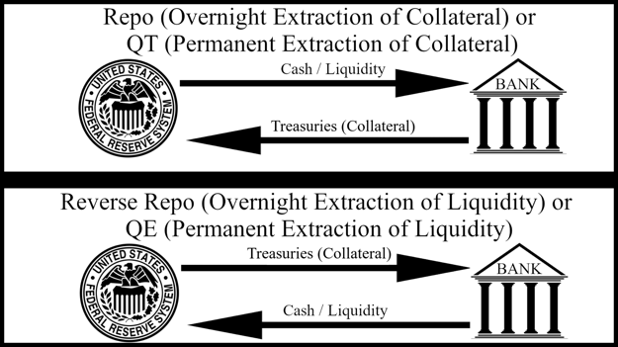
Repo and QT Versus Reverse Repo and QE
2. Quantitative Easing Can-Kick of 2008, Slowly Draining
Collateral From The Market
Note: If you want an overview of what led to the 2008 crash, check out my previous post which has a
summary of the documentary "Inside Job (2010)". It also describes where we're probably headed based
on SLR, the DTC, ICC, OCC, NSCC rules, and mortgage default protections expiring June 30th, 2021.
Zoom back in time to 2008. The economy took a massive dump due to Wall Street's abuse of derivatives
and leverage. They created a bunch of toxic CDOs mostly consisting of subprime Mortgages to create an
economic apocalyptic scenario around Mortgage Backed Securities (MBS). Everything was
overleveraged and was a massive balloon of bets based on the performance of the MBS's.
Currently, there's evidence of Wall Street doing the same abuse of toxic CDO's but this time with
Commercial Mortgage-Backed Securities (CMBS). [See above linked post for this detail]
The economy was hurting pretty bad from the 2008 crash, and it was going to continue going into a
complete death spiral until the Federal Reserve (Fed) introduced Quantitative Easing (QE):
The Fed announced QE1 on November 25, 2008. Fed Chairman Ben Bernanke announced an aggressive
attack on the financial crisis of 2008. The Fed began buying $500 billion in mortgage-backed
securities and $100 billion in other debt. QE supported the housing market that the subprime
mortgage crisis had devastated. - Source
If you're still scratching your head on what QE is, here's the Wikipedia overview definition, as well as
(hopefully) a more simplified definition.
Quantitative Easing (QE) - is a monetary policy whereby a central bank purchases at scale government
bonds or other financial assets in order to inject money into the economy to expand economic activity.
• This is what the Fed will do to extract collateral (including US Treasuries) from the
economy in order to push in liquidity. The Fed started doing this in 2008 to extract toxic
collateral from the market and encourage economic growth because it allowed more
cash flow in the economy.
• This pulls out collateral from the economy, and pushes cash (liquidity) in.
• It was a ticking timebomb ever since it started, because it extracts collateral from
the market, slowly creating a collateral shortage issue.
Check out the effects of QE on the Dow Jones Industrial Average ($DJI):
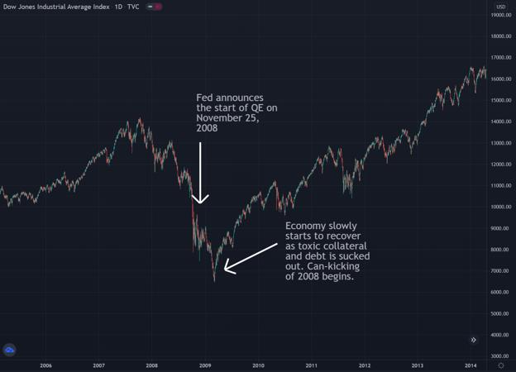
DJI Before And After Quantitative Easing Begins
It was helping the economy reverse the death spiral, and it has been pumping the economy ever since
the introduction of QE. The problem is, of course, that collateral would continue to be sucked out of the
market through the mechanics of QE.
And QE can't continue forever, because collateral is a fundamental part of the repo market which
allows cash to flow in the economy. When you don't have collateral, you can't post the collateral in the
market for cash from banks, and thus the flow of cash basically shuts down. You cannot perform a
normal repo transaction between a Bank / Hedge Fund / Financial Institution.
The Fed tried to stop QE after a while. Instead of pulling collateral out of the economy, they needed to
try to push collateral back into the economy. In order to stop QE, they tried what was, in essence, the
"reverse" of QE called Quantitative Tightening (QT).
Quantitative Tightening (QT) - (or quantitative hardening) is a contractionary monetary policy applied
by a central bank to decrease the amount of liquidity within the economy. The policy is the reverse
ofquantitative easing (QE), aimed to increase money supply in order to "stimulate" the economy.
• This is what the Fed will do to extract liquidity from the economy in order to push in
collateral. It is used to attempt to reverse the effects of QE, to try to regain balance in the
economy.
• This pulls out cash (liquidity) from the economy, and pushes collateral in.
• The Fed attempted QT in 2018, but it proved to have very bad consequences on
the economy. So, they went back to QE in 2019, continuing to can-kick the effects
of the 2008 crash.
This is a chart showing the Fed's "Total Assets", where collateral is an asset for the Fed. So when
collateral was extracted from the economy through QE, it went onto their "Assets" side of their balance
sheet. When collateral was pushed back into the economy through QT, it was extracted from their
"Assets" side of their balance sheet.
1. At the start of QE in 2008, there is a surge of assets due to the buying up of MBS's and
treasuries.
2. Around 2018 the assets began to decline because the Fed attempted QT by pushing
collateral back into the economy and sucking liquidity out.
3. Around September 2019 the assets began to increase again because the Fed went back
to QE after realizing the negative effects it was having on the economy due to causing a
liquidity shortage.
So... what happened in September of 2019? Why did QT fail after a decade of QE?
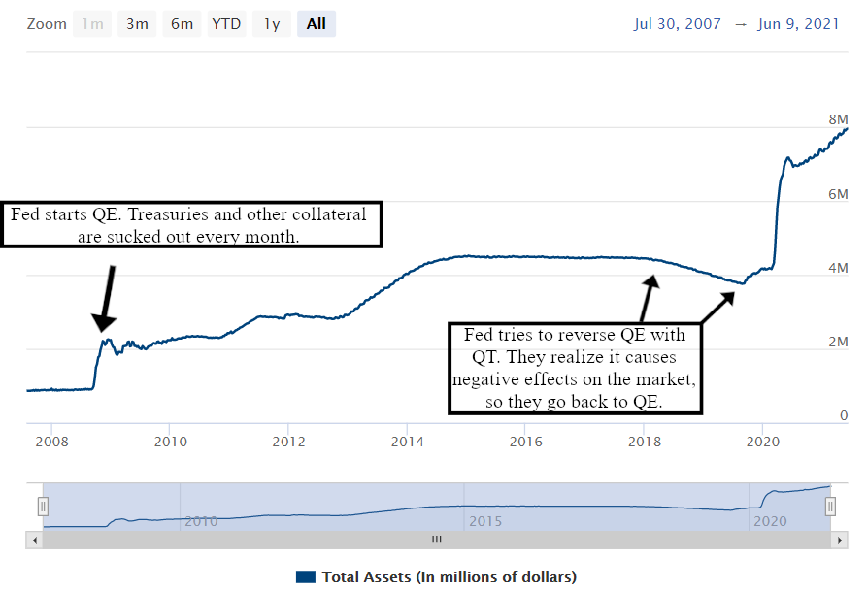
https://www.federalreserve.gov/monetarypolicy/bst_recenttrends.htm
3. Quantitative Easing Cannot Be Reversed. The Can-Kick
Continues Until The Economy Crashes
Despite pumping in a bunch of liquidity into the market through QE, the economy was still lacking
liquidity. When the Fed started to reverse QE through QT, the liquidity in the market tightened and thus
the negative effects on the economy began to surface in September of 2019.
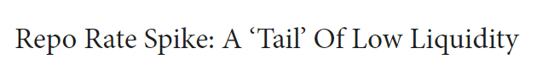
https://blog.pimco.com/en/2019/09/repo-rate-spike-a-tail-of-low-liquidity
Less than a year after starting QT, a liquidity crisis emerged on September 15th, 2019, when the repo
rate spiked up severely. This was a clash of events surrounding the lower liquidity issue.
Banks’ “reporting” dates are known inflection points in the short-term funding markets and typically fall
at the end of the month, quarter, and of course the year. But periodically, the 15th of the month is
also a pressure point. Such was the case this past Monday when a short-term funding rate that had
been hovering around 2.21% soared as high as 10%.
The funding market succumbed to a trifecta of pressures:
1. Payments on corporate taxes were due on 15 September, leading to high redemptions of
more than $35 billion in money market funds.
2. Cash balances increased by an additional $83 billion in the U.S. Treasury general
account, which reduces excess reserves and simultaneously acts to reduce the aggregate
supply of overnight liquidity available in funding markets.
3. Dealers needed an additional $20 billion in funding to finance the settlement of recent
scheduled U.S. Treasury issuance.
...
...
On September 15, as so many institutions needed funding, repo rates climbed well above the fed
funds upper-end target at the time of 2.25% to briefly touch 5%. The following day, cash repo
markets traded as high as 10% for those looking to finance agency mortgage positions
overnight. Later that morning, the Federal Reserve Bank of New York acknowledged the
pressures and conducted its first Open Market Operation (OMO) in more than a decade to add
reserves to the funding markets that were clearly in need of the liquidity. Subsequently, after its
meeting Wednesday, the Federal Open Market Committee (FOMC) announced a cut in the interest on
excess reserves (IOER) of 0.30% – five basis points more than its cut in the fed funds rate – providing
some relief to the upper bound of money-market yields. - Source
Due to the reduced liquidity from QT, because it sucks out liquidity and pushes in collateral, the markets
hit a critical point where there was too much cash that was needed and not enough to supply those who
needed the cash. There was huge amounts of strain on the economy.
This was most likely due to continued large leverage + derivatives abuse stemming from what led to the
2000-2007 Housing Market Bubble. The Fed realized that QT could not continue because of the liquidity
shortage that was arising. They had to stop QT and continue QE in order to continue to pull out
collateral and pump in liquidity. And thus, the collateral shortage time bomb continued ticking.
Below is the figure of when the repo rate shot up to ~10% within a day. This was awful, because it was
much more expensive for loans to go out. The repo market would have shut down from nobody wanting
to spend 10% on a repurchase agreement to get cash for the day. How would ANYONE get 10%
return overnight to pay for these loans? The flow of cash was about to halt.
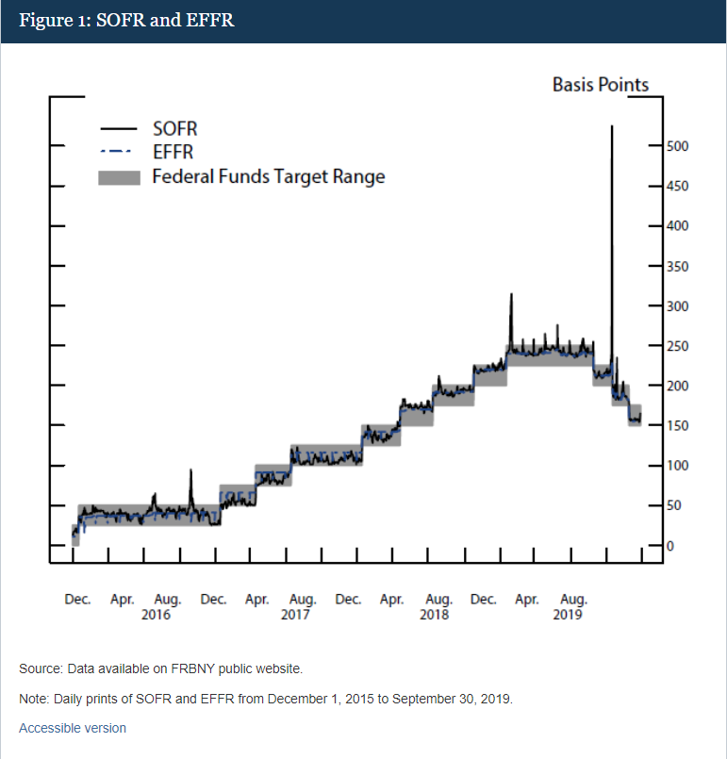
https://www.federalreserve.gov/econres/notes/feds-notes/what-happened-in-money-markets-in-september-2019-
20200227.htm
4. COVID Initiated A Liquidity Crisis In The Banks, Which Now
Fights With The Collateral Shortage
QE continued on until 2020, when suddenly, COVID came in. Nobody expected it.
And boy, oh boy, did COVID wreak havoc on the economy and the financial world. While the Fed was
slowly approaching a collateral crisis through QE, COVID exacerbated the issue due to the sudden impact
it had on liquidity. COVID increased liquidity, and when you have a sudden surge of liquidity, you need
to balance it with collateral. The economic balance was tipping as of March of 2020.
This does not even take into account the effects of many people losing their jobs, being unable to pay
rent/mortgages, and other issues that arose from COVID. Those all apply to another ticking time bomb:
the CMBS issue, equivalent to the MBS bubble of 2000-2007, which I discussed in my other post.
The COVID pandemic caused a surge of money being printed from stimulus packages in the US. When
you print a bunch of money into the economy on a whim, you risk driving inflation of the currency itself.
What does inflation encourage? Less spending from companies, due to the higher price. This leads to less
loaning of cash in the repo market, and banks obtaining an ever-surplus of cash.
COVID caused a sudden surge of trillions of dollars worth that the economy couldn't handle naturally.
Compare the treasury balance versus the deposits over time, and the surge that occurred in 2020 in
response to the pandemic. The COVID stimulus bills pumped in a massive amount of money into the
economy at the risk of inflation. And we're already seeing the effects of inflation occur on the supply
chain:
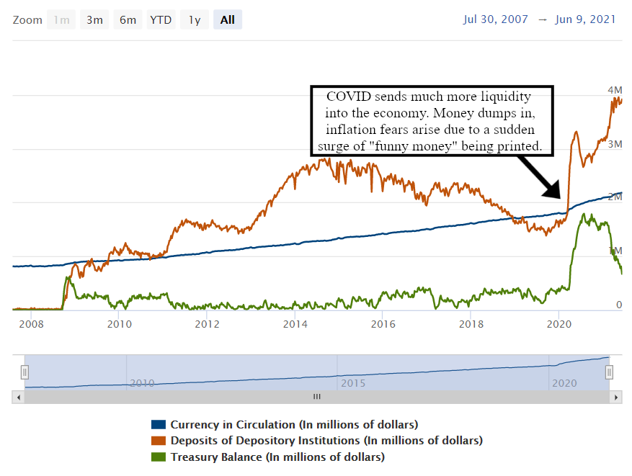
https://www.federalreserve.gov/monetarypolicy/bst_recenttrends.htm
Stimulus checks were sent out to retail. Companies were bailed out. Unemployment increased, resulting
in more unemployment benefits going out due to the relief bills. More money printed. More money
deposited at banks.
There was a ton of cash (liquidity) being pumped into the economy over the past year from March 2020
to June 2021. Because of this, due to inflation and an excess of cash, banks began to get a surplus of cash
deposited. People had more cash. They didn't need to spend money on rent/mortages. Companies didn't
want to spend more due to fears of inflation. So, bank deposits went up.
The main problem with this is that the cash deposited with the banks became a liability on their
balance sheets. When you have a surplus of liabilities on your balance sheet, you need to
'balance' it out with assets, such as US Treasuries.
The banks were now in trouble because they had way, way too many deposits. They were at risk of
defaulting due to their SLR requirements. Here is a figure showing how deposits (liabilities) of banks
increased over time. It mushroomed during the COVID pandemic:
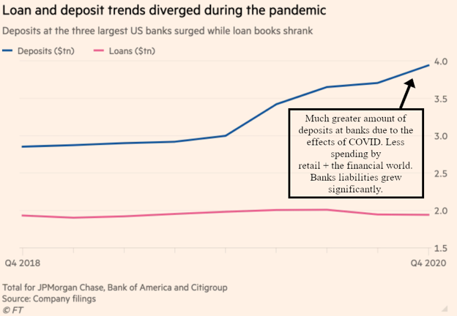
https://www.ft.com/content/a5e165f7-a524-4b5b-9939-de689b6a1687
To combat this issue, the Fed decided to introduce a relief program for banks regarding SLR because of
the massive increase of liquidity due to the uppercut that COVID created on the financial world.
The supplementary leverage ratio (SLR) is the US implementation of the Basel III Tier 1 leverage
ratio, with which banks calculate the amount of common equity capital they must hold relative to
their total leverage exposure. Large US banks must hold 3%. Top-tier bank holding companies must
also hold an extra 2% buffer, for a total of 5%. The SLR, which does not distinguish between assets based
on risk, is conceived as a backstop to risk-weighted capital requirements. - Source
In more of a simplified summary, SLR is a requirement of total equity that a bank must hold compared to
their total leverage exposure. If they are exposed to leverage, they need to hold enough capital for that
position otherwise they are at risk of defaulting. In this case, they only need to hold a measly 3%-5%,
dependent on how large of a bank they are. Just like in 2008 - these banks can have massive leverage
and SLR is to "help protect the economy" from them abusing leverage.
But hey, the Fed put in place some protections for the year to help these banks since they were
obviously overleveraged to begin with. These protections expired on March 31st, 2021.
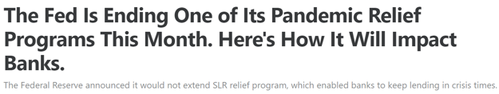
https://www.fool.com/investing/2021/03/29/the-fed-is-ending-one-of-its-pandemic-relief-progr/
The Fed's relief program last year allowed banks to exclude U.S. Treasuries and central bank
reserves from the SLR calculation. The relief program was a response to the many non-banking
institutions selling Treasuries to raise cash, and coincided with other measures, including the $2.2
trillion CARES Act, which resulted in even more Treasuries being sold into the market. - Source
Right after the expiration of the protection plans of SLR, the Reverse Repo market began to blow
up because the banks had way too much liquidity and not enough treasuries on their balance
sheets.
The argument that the banks were "parking their money at the Fed" was a reasonable explanation at
first. Though, with 0% ROI from the RRP at the time, the banks would literally get no return on their
investments. So for that argument, all of their other investments would have had to yield negative in
order for RRP to be more enticing. Does this make sense to you that they'd use 0% RRP to be an
'investment'?
The fact that the RRP began to ramp up and then explode after the SLR protections lifted makes this look
like a collateral shortage issue. And of course, with QE occurring over the past decade, makes it more
likely, because collateral was sucked out of the economy and onto the Fed's balance sheet over the years.
That was of course questionable on whether it was a liquidity or collateral issue, until, the RRP
rate dropped negative in March of 2021, as well as in April of 2021.
5. Reverse Repo Rate Flips Negative; Warnings Of Collateral
Shortage
Think about it quite simply in a supply/demand factor and the reverse repo when the RRP rate dropped
negative.
You are a bank. You want to get Collateral from the Fed to balance your sheets. The Fed says they'll give
you a small amount of interest for borrowing their collateral overnight. But now, imagine that the supply
of collateral is too low and demand is too high. The Fed will no longer want to pay you for borrowing its
collateral so it will shift the interest rate down. If demand really outweighs supply, then the Fed would
then want cash from YOU in order for YOU to borrow the collateral.
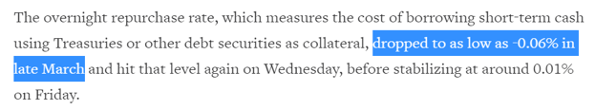
https://www.reuters.com/article/us-usa-bonds-repo-explainer/explainer-u-s-repo-market-flirts-with-negative-rates-as-fed-
seeks-to-absorb-excess-cash-idUSKBN2C32AI
This was just one of the warning signs that a collateral issue was arising. The RRP rates were already at
0%, so the only way for them to move was either up or down. An increase in treasury demand could
shift it down, into the negatives, which it did.
6. The Fed Is Fudging The Numbers And Hiding A Collateral
Shortage
The drop in RRP interest rates to the negative came after the Fed increased the total borrowing amount
of counterparties in the RRP from $30 Billion to $80 Billion.
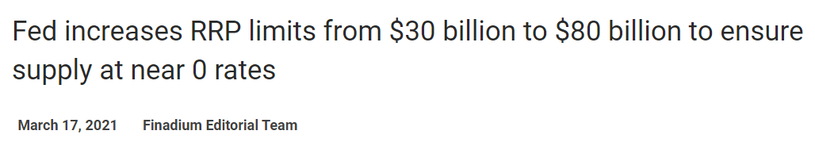
https://finadium.com/fed-increases-rrp-limits-from-30-billion-to-80-billion-to-ensure-supply-at-near-0-rates/
Why did they do this? Think of it again as a supply versus demand issue. For simple math, imagine the
Fed has 50 members.
• At a limit of $30 Billion per member, that is a total of $30B * 50 = $1.5 Trillion that can
be borrowed.
• At a limit of $80 Billion per member, that is a total of $80B * 50 = $4 Trillion that can be
borrowed.
What is this doing? Why did the Fed increase the limit?
It's artificially inflating the total "supply" of treasuries that can be borrowed by counterparties in
the RRP. It is attempting to keep the interest rate positive because there is so much demand for
collateral and not enough supply in the markets and on the Fed's balance sheet. The RRP was
already at 0%, there was nowhere for it to go besides negative, which as you know implies a
shortage of collateral and a red flag for the financial world.
Not only did they artificially inflate the total supply to combat the demand by increasing the total
borrow amount, the Fed decided to not affect the assets side of its balance sheet during these RRP
transactions. This effectively leaves the supply of treasuries on the Fed's balance sheet the
same. This is another method to can-kick to avoid interest rates going negative and flashing a collateral
issue.
When the Desk conducts RRP open market operations, it sells securities held in the System Open Market
Account (SOMA) to eligible RRP counterparties, with an agreement to buy the assets back on the RRP’s
specified maturity date. This leaves the SOMA portfolio the same size, as securities sold temporarily
under repurchase agreements continue to be shown as assets held by the SOMA in accordance with
generally accepted accounting principles, but the transaction shifts some of the liabilities on the Federal
Reserve’s balance sheet from deposits held by depository institutions (also known as bank reserves) to
reverse repos while the trade is outstanding. - Source
We can see this visually from the Fed's balance sheet that they're not affecting their assets during the
RRP. They're allowing counterparties to borrow treasuries WITHOUT affecting the supply - desperately
trying to get away from the rising demand for treasuries and avoid treasury yields from snapping down
(and likewise the price of treasuries up):
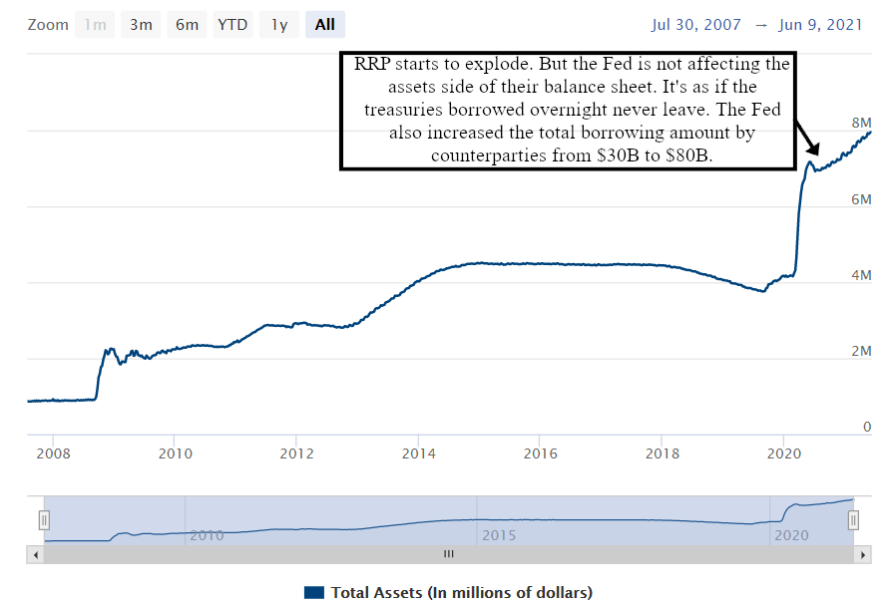
https://www.federalreserve.gov/monetarypolicy/bst_recenttrends.htm
On top of this, the Fed showed their hand ONCE AGAIN of fudging the numbers on June 16th when
they bumped up the RRP rate to 0.05%. The short-term treasury yields briefly went BELOW the
RRP interest amount of 0.05% on June 17th when the new RRP ROI was in effect.
This is a BAD sign because now overnight RRP had a higher return than 2-month and 3-month
treasury bonds.
The Fed is fudging the numbers trying to hide the treasury bond shortage.
The Fed cannot keep this up. They're trying to keep the T-bill yield curve propped up despite the
treasury shortage. They're not affecting their balance sheet, and they also artificially increased the
amount of treasuries in their "supply" by increasing the counterparty borrow limit from $30 Billion to
$80 Billion.
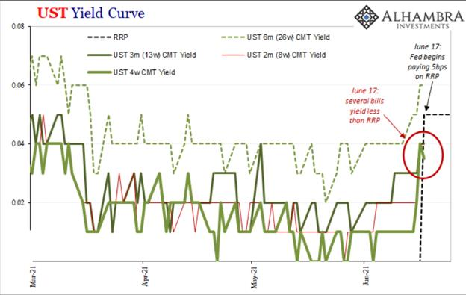
https://alhambrapartners.com/2021/06/17/the-fomc-accidentally-exposes-itself-reverse-repo-style/
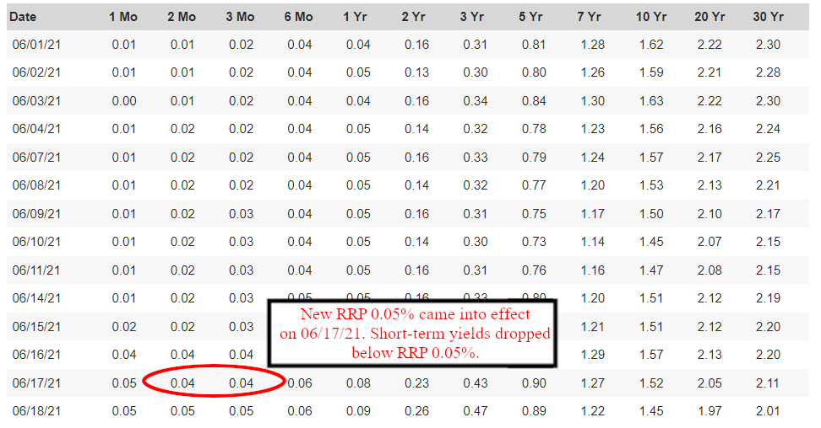
https://www.treasury.gov/resource-center/data-chart-center/interest-rates/Pages/TextView.aspx?data=yield
The Fed is also planning on increasing interest rates. This starts to scare the economy, which is most
likely why we're now seeing the dump of the stock market over the past few days and the dump leading
into the week of June 21st. This is bad for the markets because it means it's going to cost more for the
economy to function (e.g. what happened in 2019 when Repo Rates spiked to 10%). Companies have to
spend more to hire, produce, etc. It costs the economy more to function.
The Fed is pinned between a collateral issue from QE sucking out collateral, and a liquidity issue
and COVID pumping in too much liquidity for the banks to handle.
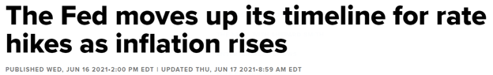
https://www.cnbc.com/2021/06/16/fed-holds-rates-steady-but-raises-inflation-expectations-sharply-and-makes-no-mention-
of-taper.html
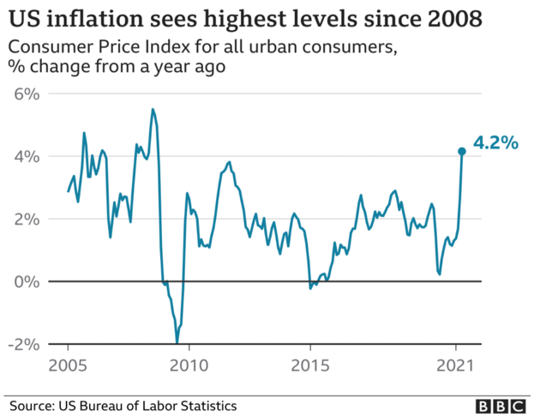
https://www.bbc.com/news/business-57090421
7. Quarter Ends Explode The Reverse Repo. The Next Quarter
End Is June 30th, 2021.
This is not a date to look forward to for GME potentially rising. This is a date of "Holy shit. The RRP
could explode to the point where treasury supply vs demand is unable to take it any more".
About 3-4 days prior to quarter ends, the RRP explodes up in the amount of collateral that is borrowed
from the Fed. This is because of the underlying plumbing of the financial markets, identified in Section 3
above, causes additional strain on the financial markets. The banks need more collateral to prop up their
balance sheets for the night of the quarter-ends.
The RRP borrowed amount can shoot up almost 2-4x the current levels. The amount of RRP at the
moment is $747 Billion. The RRP could explode 2-4x the amount it is at upon June 25th, 2021. What
if it's $1 Trillion by then due to the massive amount of collateral needed by the banks? More?
Can the Fed handle it?
Can they still prop the yield curve up?
Will the short-term treasuries dip below the RRP amount once more due to this shortage and
flash red flags to the world of financial instability in the US?
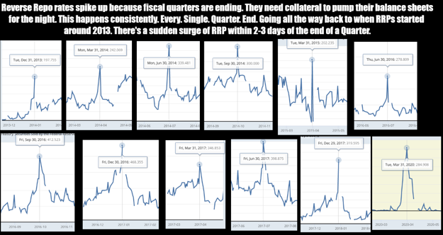
https://www.reddit.com/r/Superstonk/comments/nylihz/previous_rrp_behavior_on_quarter_ends_massive/
If the US Treasury yield curve snaps down from this instability and the Fed no longer able to prop up the
yield curve, then it can drive treasury prices up.
If /u/atobitt's "Everything Short" is true and they're actually shorting treasuries, then that can lead to
banks defaulting due to the price of treasuries shooting up. When they default, they'll be forced to buy
up all the treasuries that they've shorted into the market.
And it is very possible that they are shorting treasuries.
When performing RRP of 0%, the repo market was most likely shut down due to nobody needing cash
loaned out. The banks only profitable move was to perform the RRP with the Fed and
then shorttreasuries into the market, rehypothecating the treasuries to other parties. This would have
also helped prop up the market by artificially increasing the supply of treasuries (collateral) in the
market.
If it's true, and they have truly been performing the "Everything Short", then it could initiate a Global
Financial Crisis equivalent to The Great Depression.
Do I want that to happen? No. But is there a chance? Yes, there is.
Is GME going to squeeze? Is the DD just false hopium? I don't think it's just hopium. I believe in the DD.
But some users might think otherwise and not believe in GME or the DD. Hello users outside
of r/superstonk! If you're reading this, check out the DD on the subreddit!
Even if there's a slight chance of a GME squeeze in your eyes, and all of these signs are pointing to a
market crash...
Why not give it a shot?
Back to Table of Contents
Reverse Repos, DTC-2021-005, SR-NSCC-2021-
002, Banks, and the C-Market: How it's all
connected and how we might be on the verge
of the House of Cards falling.
DD 👨‍🔬
EDIT: 002 is not coming into effect tommorow as a fellow
redditor has pointed out to me in the comments. It is going to
get approved or denied, then implemented either same day or
up to 10 days after approval(as far as I am aware)
EDIT 2: Fixed some minor formatting and phrasing issues to
make the post a little cleaner to look at. (editing on mobile
removes the images for some reason)
Hello fellow apes! So the reason I'm writing this right now, as you might imagine, is because reverse
repos have gone haywire. I mean, take a look at this:
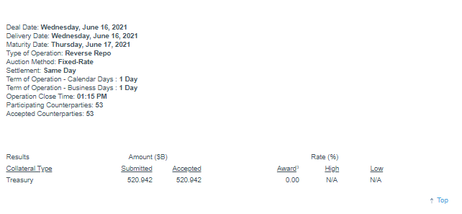
ON RRP last Wednesday
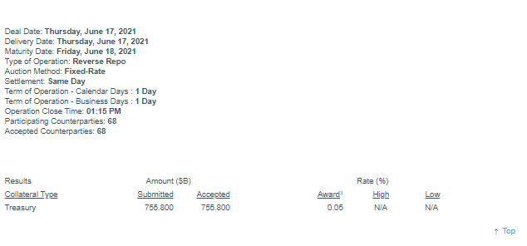
ON RRP the day AFTER
So, what gives? Why did all of these counterparties decide to throw money at the FED like they were at a
strip club getting the greatest performance of their goddamn lives? That's a 200 BILLION increase in a
day. Well, if you look under "Rate (%)" you'll see the award amount has changed to 0.05. That's right
folks, banks and other counterparties are now getting paid for borrowing treasury collateral as the
reverse repo rate isn't 0 anymore. This basically does 2 things:
1. Incentivizes more counterparties to throw money into reverse repos
2. Incentivizes said counterparties to be more loosey goosey with how much treasury
collateral they are borrowing
Hence, we have the sudden jump in both counterparties as well as the total reverse repo $ amount. For
such a large jump in a day, however, shows that there is a lot of demand for treasury collateral. This
proves to me how bad this collateral crisis truly is, and how desperate banks and other counterparties
are to get a hold of meaningful collateral. What's weird to me, is the timing of all this though. I mean,
don't you find it weird that around the same time that 005 gets put into effect, counterparties are
incentivized to borrow more treasury collateral? To understand this connection, we need to understand
what 005 does.
Quick Rundown on 005:
For some of the newer apes around here, or if you are still a little confused about the recent 005 rule
enacted by the DTCC, what DTC-2021-005 does (other than soft doxxing people, shame on you DTCC) is
essentially making it so if you are borrowing/lending a share, the share being lent is still in the hands of
the lender (used to be it goes to the borrower), but is marked as "borrowed".
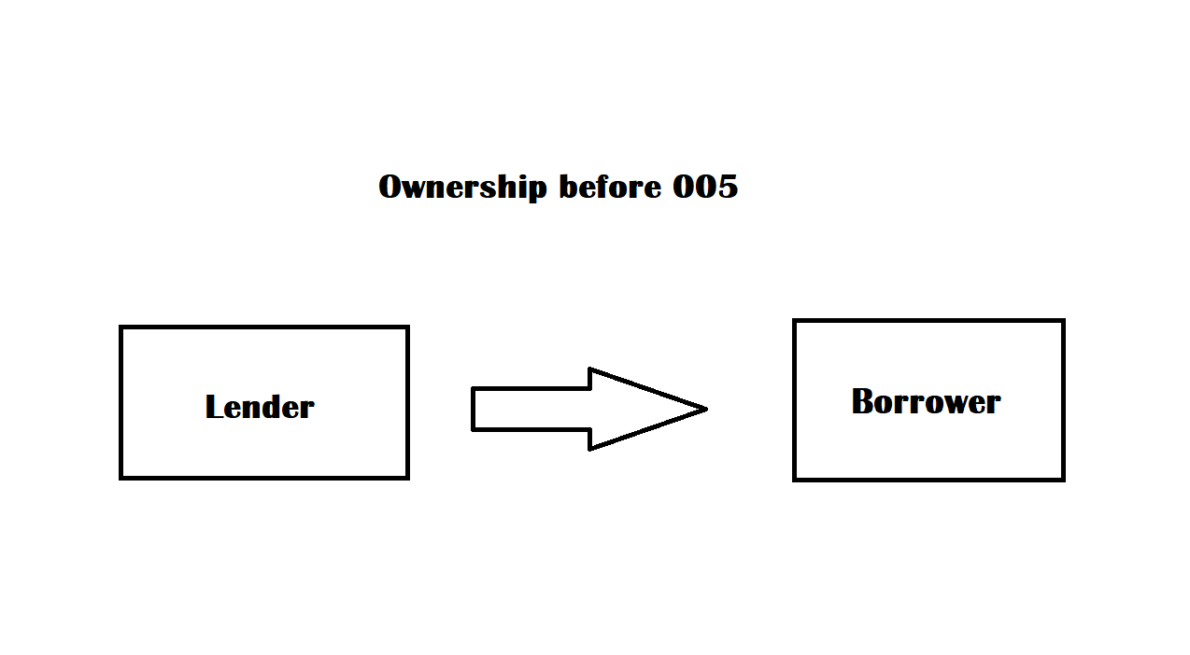
(Apologies for the bad image) Before 005, when a share was lent, ownership of the share went from the lender to the borrower,
with the lender often in the dark as to what was happening with their shares; this gave openings for rehypothecation and other
shenanigans the borrower could do.
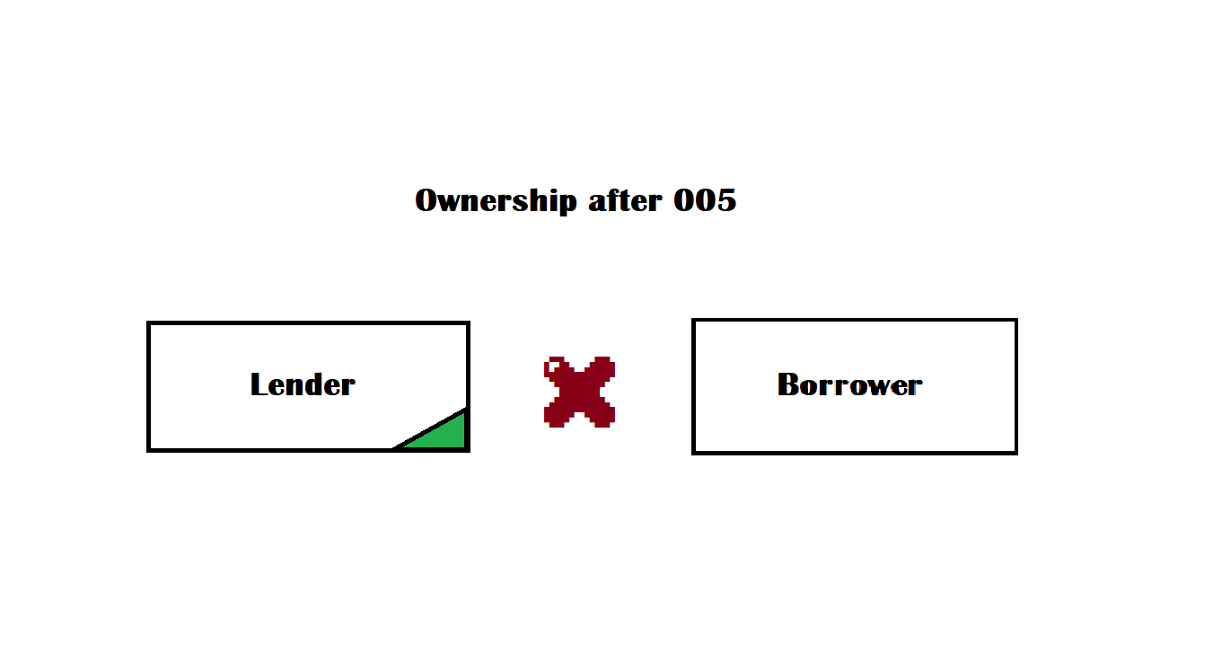
With 005 now in effect, when a share is loaned, the ownership is still in the hands of the lender, the borrower gets the share, and
the share is marked as "borrowed".
Through this, you basically can't borrow the same share more than once as well as rehypothecate the
shares (meaning you can't re-use the collateral you put up to borrow the share until the share is
returned). There's a well written and in depth post that explains it better than I could here that you
should also look into if you want a better understanding of 005.
The Connection:
So now that we have a gist of 005, we can begin to connect some dots:
• 005, a rule that is designed to stop a lot of rehypothecation as well as reborrowing of
shares more than once, comes into effect.
• The FED ups the reverse repo rate, causing a flood of counterparties looking for treasury
collateral to dump a butt load of money into ON RRP, raising the total reverse repo $
amount by over 200 billion.
Correlation does not equal causation of course, and this is a loose connection, so we need further proof
of anything substantial. Well, take a look at this:
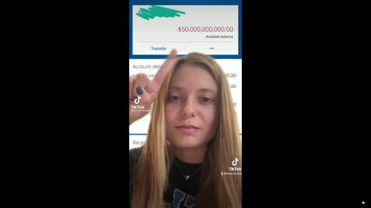
Several Chase customers have started reporting that they have -50 BILLION$ in debt. Ridiculous.
At first I was skeptical that this was a true value and that it could have just been a glitch, but here is
what u/jaybaumyo had to say regarding this in the comments:
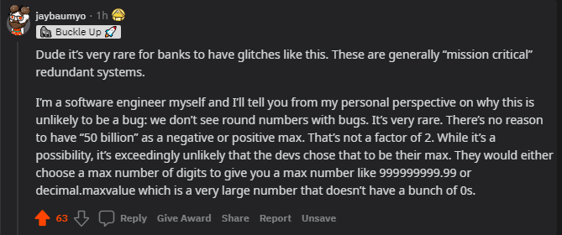
So, 50 billion is a specific number to have as a max number in coding, one so specific that it is highly unlikely to be a glitch in this
circumstance and likely the result of something else, such as Chase's debt leaking into their customers bank accounts.
With Chase customers suddenly reporting -50 billion in debt in their BANK accounts, and with BANKS
being some of the primary counterparties of FED ON RRP agreements, my theory is that banks have
started getting desperate to hide their debt in any way possible so that they can still stay afloat, even if it
means putting their customers in danger. 005 being in place REALLY put banks in fear for a couple of
reasons:
1. How overleveraged they are
2. How overleveraged hedge funds like Citadel are, that we have been theorizing for a while
now have been rehypothecating borrowed shares to help reset FTD cycles.
If a large hedge fund like Citadel goes down(who massively shorted the treasury bonds market BTW),
the banks know it won't be long before they become next, so this incentive to use reverse repos helped
the demand for treasury collateral become more visible to the public than it already was and helped
crystalize what we have been saying for months now.
But why is all this coming about now, to the extent that it has other than just the incentive? For them to
be this desperate about it, they have to be afraid of something that isn't just DTC-2021-005 (which is
already bad enough) . Well, what special certain rule *cough* SR-NSCC-2021-002 is possibly coming into
effect TOMMOROW that automates margin calls, and is asking for supplemental liquidity deposits DAILY
to NSCC's clearing fund from its members for their overleveraged positions?
If 002 comes into play, it won't take long before the house of cards comes falling down. They're so
desperate in fact, their debt has not only started to leak through their customer's bank accounts, but in
other avenues as well.
The C-Market Connection:
Banks, hedge funds, hell the whole house of cards are truly on the brink of destruction right now in my
opinion. To truly send this point home, I would like for you to have a look at this as well:
Quick Edit: changed the source that reported on this story to a more reputable source
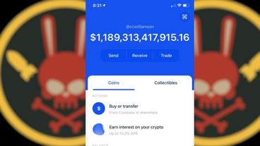
You're seeing that right: a Georgia man woke up to 1 TRILLION in his account, after investing only 20 dollars in a random C-coin
called Rocket Bunny.
Now obviously, he's probably not gonna get to take out all 1 trillion dollars, but something is definitely
suspicious here regarding the timing of all of this. I mean, do you know how much money 1 fucking
trillion dollars is? Who the hell is capable of inflating a random C.C. to the extent that a random guy that
put 20 dollars into it got 1 TRILLION out of it? There's only two entities that I believe are capable of such
feat, and they are ALSO the ones in massively overleveraged positions:
1. Banks
2. Hedge funds
But first: Why use the c-market as a way to hide debt, and how?
1. The c-market is massively unregulated at the moment which is the perfect place to take
advantage of to hide a bunch of money.
2. By inflating random C.Cs, when they take profits it could be used to hide the true value of
the debt itself.
Let me explain that second point. Right now, as far as we know the overleveraged positions of these
entities are unrealized losses. They don't become real losses until they exit their positions. So, by inflating
random C.C.s , they're using the profits they gain to report larger assets overall on the books vs liabilities
(not reporting on what they did in the C-market specifically of course, they really aren't required to
report that). Since their losses are unrealized, we have the illusion on the accounting front that they are
thriving and don't have much debt when they are actually on the verge of collapse and are probably using
these profits to help cover their losses when they become realized.
For the c-market, the manipulation could honestly be a combination of both banks, hedge funds and
other entities we may not even know of that are also really overleveraged in the market right now. I just
think it makes more sense with banks and the hedgies because:
In terms of banks:
• The FED is basically hoarding treasury collateral at this point, so banks and other
counterparties can only use so much treasury collateral through ON RRP to report less
losses on the books.
In terms of hedge funds:
• Hedge funds aren't qualified counterparties (to my knowledge) for reverse repos, so
inflating random C.Cs is one of the only ways (besides resetting FTD cycles infinitely
through rehypothecation/options fuckery, which we know with DTC-2021-005 in effect is
next to impossible to keep doing forever now) that they can continue to stay afloat and
give the illusion on the books that they have outstanding financial performance.
Conclusion/TLDR:
I think DTC-005 coming into effect was the trigger for the house of cards to finally come down, and with
NSCC-002 coming into effect after approval, we could see some potentially catastrophic effects in the
market in the near future. We've already been seeing some debt being leaked into customers bank
accounts, as well as in the c-market. Banks, hedge funds, and any other massive financial entity in an
extremely overleveraged position are probably shitting themselves right now because they KNOW they
don't have the money to support supplemental liquidity deposits DAILY as well as the possibility of an
automatic margin call, when they are most likely BILLIONS in debt. If I were Kenny boy, I would grab my
mayo and start running for the hills.
Post DD Message:
Again guys, I just want to thank all of you for reading through my DD! :) The messages and support you
guys have given me on my last post as well made me genuinely very happy to see, and it made me more
motivated to continue to try to make some DD! Hopefully you guys have enjoyed reading through it, and
as for me I might hang out in the comments for a bit before going to sleep soon because its about
midnight right now where I live. As always, I will try to continue to improve my DD in the future and this
DD, as with any, isn't perfect; I am glad this community helps to chizzle my DD into something closer and
closer to it though with every post.
Back to Table of Contents
GME, Banks Falling Off a Cliff, The Movie
Stock, Elliot Waves, WUT Mean For This Week?
DD 👨‍🔬
Sup Apes
Elliot waves guy here doing my best to give you your daily dose of confirmation bias before the market
opens!
Not financial advice, I do unimaginable things with the crayons I get when I ask for a kid's menu at
restaurants.
NON NEGOTIABLE: PLAY THIS AS YOU READ (This song slowly builds, idk the vibes feel
right https://www.youtube.com/watch?v=bvBfiRWLj_0)
HAPPY FUCKING FATHERS DAY TO ALL YOU PAPA SILVERBACKS OUT THERE!!! If you're drunk from
the day's festivities, this read will be even better.
This might be a shorter post, I don't have too much to say as of yet other than I'm FUCKING JACKED 🚀
First off, I'm sure you all have seen the posts regarding bank stocks following and how we can
potentially use that as a predictive indicator in terms of GME stock price. Great work here if you missed
the
post: https://www.reddit.com/r/Superstonk/comments/o42bfm/big_banks_lost_a_lot_of_value_on_jan
uary_14th_but/
Let's take a look at the banks last week:
OOOOF
This might be one of my favorite screenshots of all time. Let's take a look at the banks back in the middle
of january and see if that had any correlation to GME goin bananas at the end of January.
death to big banks
Given that GME's run peaked in the end of January, the conclusions that I draw from that are the banks
hit a low around GME's peak. Granted, there were many outside factors at play back then, so this is all
speculative. However, Let's look at GME in january now, pay close attention to the dates on the bottom
and compare those to the banks above:
squeeze for ants
just from eyeballing, we can see that the banks seem to find their "bottom" as GME begins to lift off. Does
this mean the banks will go to zero before GME squeezes? absolutely not, please don't think that will be
the case. HOWEVER, we can assume that the financial sector and GME have some sort of inverse
relationship, simply based on the erratic price action between the pairs.
This time around, I'm expecting banks to continue to fall as GME rises. Can't halt buying this time
around!
I haven't charted out the bank stocks because frankly I don't really care, I want the major banks at 0
personally, wouldn't pay a penny more to hold that garbage (all my homies hate the financials sector)
Alright, so we can seemingly use the falling stock price of banks as a predictive indicator for upwards
GME price action. Do note, I didn't conduct any significance tests or anything, this is all simply from
comparing candle charts and looking for similarities/differences.
Speaking of comparing candle charts, something super interesting was brought to my attention in a
group discussion, big shoutout to u/roman_axt for the hard work you ultra wrinkly brained primate.
Below are images of GME and the movie company, courtesy of u/roman_axt as the arrows are drawn so
the smoothest of brains can interpret what tf is going on. Do note, these are from about a week ago, so
not all candles are up to date (if it even matters)
movie company
GME
The reason I bring this up is because some of my friends in the trading world (that only trade off price
action mind you, they don't really understand the whole GME saga) noticed this as well. It APPEARS that
the movie company and GME not only move in a somewhat similar/predictable pattern, but GME seems
to be lagging behind by about 2 or so weeks. Do note, this is just an approximation from eyeballing,
please take this all with a grain of salt and remember I am retarded.
Here is a view sent to me by one of my good friends who noticed the same fishiness occurring (from
mobile thinkorswim):
moveee stonk
gAmEsToNk
now what REALLY has me jacked is the pattern lines up from a few weeks ago, when the movie stock
was trading for sub $16/share. It then ran to upwards of 70+. I was able to predict the movie stock's
relative high's and low's using EW as well, which I've gotta say is actually super exciting. I own none,
BUT it worked on a seemingly "impossible" to time stock. Idk about you, but I don't believe in
coincidences.
Disclaimer, I hodl ZERO of the movie stock, I have always believed it was a distraction. the fact that the
media is talking about it should tell you enough.
Now let's tie this assumption into my GME elliot waves analysis, try not to get too jacked:
4hr
As stated time and time again, we are in a 3 within a 3 within a 3, which is quite literally an elliot wave
trader's wet dream. This setup is valid down to about 113, so I wouldn't worry about "is the structure
still valid?" yes. yes it is.
This is literally as bullish a setup you can get, all we need is a match to light the fuse. Our cycle 3 (white
line) is targeting at the MINIMUM 440, though I would love to see the 1.618:1 ratio hit, as is most
common for wave 3. This puts GME at roughly 582, though remember this is all pre squeeze.
As always, the motto is simple. Buy hodl, sell for life changing money (not no 10k/share bullshit, 8
figures/share is life changing in my eyes, and that's just my floor).
I'm not saying we will break into the 400+ range this week by any means, but man the stars are aligning
for some crazy shit to go down. I'm fookin jacked m8.
Lastly, let's take a look at SPY and the VIX, as we can use each as a tool to gauge not only sentiment, but
potential fuckery before it happens. In my post regarding the SP500 and GME, I brought up how In the
January squeeze, SPY took a fucking HIT as GME broke into the hundreds for the first time ever. Here's
my view of SPY:
4hr
NGL, SPY is kind of in no man's land right now. I'll have to see how we open to have a better idea of
where it's going. By all means this COULD be the beginning of our long awaited bear market, but it could
very well form an impulsive wave 1 to the upside to make for a final push to around 430 before shit hits
the fan
My OWN PERSONAL THESIS is that we will see the markets pumped to valhalla 1 last time to try and
draw as many "suckers" in so wall street can offload the bag at the peak. Put yourself in their shoes,
seems like a logical play to strike fear into everyone, then prop the markets up a bit longer to make
everyone think its okay, then proceed to dump the bag on them
Lastly, the VIX, the fear/volatility indicator:
VIX
Finished up 16% on friday? spicy. In one of my posts I mentioned how we can use the VIX to gauge when
GME will potentially do something erratic. just compare the spikes of the VIX and GME, you'll see there's
at least some correlation there. I mean shit, end of january? Clear as kenny's "for sale" sign on his
marked down penthouse that he suddenly is in a rush to sell. wonder why? (I think it sold actually lol,
even funnier).
I'm preparing for the best while always expecting the worst. I'm never disappointed this way and always
excited, 10/10 would recommend.
June 30 is the end of the grace period for banks, worth noting. I'm expecting the VIX to FLY when that
happens, though again, pure speculation.
TLDR: worth the read. Banks falling is a potential indicator that GME will do some crazy shit, GME
also appears to be lagging behind the movie stock. That part is pure speculation, but speculation is part
of the fun part no? (Sorry the song doesn't fit perfectly, you'd be surprised how much time i spend trying
to link a fitting song lol. as long as you're jacked, i consider this a job well done)
Now Imma go get high af so I'm well rested for MONDAY🚀 🚀 🚀
edit: funny story cause y'all are fam, I went to the porsche dealer yesterday to test drive my post-moass
whip, and the salesman googled me before I came in to make sure I wasn't some degenerate looking to
crash their pristine GT4. I get there, and the salesman said he googled me and knew me as the elliot
wave guy. Simulation confirmed. during the drive we talked about trading, I showed him my wave count,
hopefully he got some GME. idk, random. Thought I'd share cause I thought it's a nice story. This
movement is bigger than we can comprehend. EW guy is in the bio of my socials, so he put 2 and 2
together after googling my real name.
Edit 2: proof I went and they let me drive the gt4: https://imgur.com/a/uzTn3OR
Back to Table of Contents
DEBUNKING THE 20% INFLATION DDs! IT IS
CRUCIAL TO FACT-CHECK BEFORE UPVOTING
DDs WITH WILDLY ABSURD CLAIMS!
DD 👨‍🔬
I've seen multiple posts (Post 1and Post 2) rise to the top this weekend regarding true inflation
estimated to 19-20% which I am here to explain why this is wildly incorrect.
TADR: The math to arrive at the 19-20% true inflation is wrong. OP from Post 1 incorrectly used current
velocity of M2 rather than the growth (rate of change) in the velocity of M2.
OP from Post 2 straight up used the wrong equation. The equation he used was for nominal GDP, and
NOT inflation.
Debunking Post 1:
https://www.reddit.com/r/Superstonk/comments/o2dw45/thoughts_on_the_feds_balance_sheet_after
_todays/
When asked about the source of the equation for the first post, OP links us to here:
https://saylordotorg.github.io/text_macroeconomics-theory-through-applications/s15-01-the-
quantity-theory-of-money.html
Long-Run Inflation
We now use the quantity equation to provide us with a theory of long-run inflation. To do so, we use the
rules of growth rates. One of these rules is as follows: if you have two variables, x and y, then the growth
rate of the product (x × y) is the sum of the growth rate of x and the growth rate of y. We can apply this to
the quantity equation:
money supply × velocity of money = price level × real GDP.
The left side of this equation is the product of two variables, the money supply and the velocity of
money. The right side is likewise the product of two variables. So we obtain
growth rate of the money supply + growth rate of the velocity of money = inflation rate + growth
rate of output.
We have used the fact that the growth rate of the price level is, by definition, the inflation rate.
The equation is growth rate of the money supply + growth rate of the velocity of money = inflation rate +
growth rate of output.
Let growth rate of the money supply be M, growth rate of the velocity of money be P, inflation rate be I,
and growth rate of output (growth in GDP) be Q.
Rearranging for I, we get:
I = M + P - Q
From OP's news article source on projected M2 growth, M = 25%, however OP mistakenly used the
static Q1 2021 velocity of money instead of the growth rate of the velocity of money. Unless someone
can find a reliable article on velocity of M2 forecast, I will use the growth from the past year which
would be the % change from Q1 2020 to Q1 2021 which is -18.6%, NOT 1.122%.
From OP's news article source on projected GDP growth, Q = 6.5%
Now plugging everything back into the equation:
I = 25% + (-18.6%) - 6.5%
= -0.1%
I know this result is kind of odd as surely inflation should not be this low, but just by using the sources
for the equations provided by OP, this is the correct conclusion.
Debunking Post 2:
https://www.reddit.com/r/Superstonk/comments/o42ftz/theres_been_a_lot_of_talk_about_inflation_w
hat/
I'm fairly certain OP wrote this DD based on the DD from post 1 but when asked about the source of
their equation, OP provides us with a new link (it's in edit 2 of OP's post):
https://thismatter.com/money/banking/money-growth-money-velocity-inflation.htm
Nominal GDP = Quantity of Money × Velocity of Money
But yet, the equation OP used in their DD is:
What follows is a sort of explainer into the basics of inflation. Are you ready? Here we go: Inflation=
(money supply) * (money velocity).
...which as you can see is completely different from the equation of his source.
Nominal GDP = Quantity of Money (aka money supply) * Velocity of Money (aka money velocity)
NOMINAL GDP DOES NOT EQUAL INFLATION
If we look deeper in OP's source, it actually shows the correct equation to find inflation:
If money velocity is constant, then:
Money Growth = Real GDP Growth + Inflation
or, rearranged:
Inflation = Money Growth – Real GDP Growth
or
Inflation = ΔP = ΔM – ΔY
The key phrase here is if money velocity is constant which we know is not.
Now if we include the growth of money velocity, we end up with the equation from the source of post 1's
OP.
growth rate of the money supply + growth rate of the velocity of money = inflation rate + growth
rate of output.
Again, rearranged for inflation rate:
Inflation rate = Money Growth + Money Velocity Growth – Real GDP Growth
which is the same equation as above (I = M + P - Q)
Conclusion
I understand we wants our tits jacked but it's important to fact check DDs, especially if they contain
hugely absurd claims. I know many apes might upvote posts without checking the math for themselves
especially if OP makes these huge claims sound convincing. I find it ironic how OP from Post 2 titles his
DD.
Theres been a lot of talk about inflation. What you don't realise is that you can calculate it and view it on
Trading View. Do it for yourself and see. The Math Doesn't Lie. 20% + inflation this year.
but is incapable of explaining his numbers when challenged in the comments (turns out the math DOES
lie when done incorrectly).
I do believe both OP's wrote their DDs in good faith but again, it is crucial that DDs (especially ones that
reach the top) have been reviewed and fact checked to avoid spreading misinformation whether or not
they please Jacques Tits, especially if OPs are non-receptive when clearly debunked or given valid
criticism.
Also, I think we really need a DEBUNKED (or Counter-DD) flair which will encourage wrinkled apes to
debunk or atleast challenge top DDs ultimately increasing their reliability and quality.
🚀🚀🚀
Edit: For those asking if the -0.1% inflation is accurate based on this equation, I would be very skeptical.
Personally, I don't think this equation is an accurate way to find inflation because although Q2 2021
M2V data has yet to be released, if we were to use the growth of M2V from Q2 2020 to Q2 2021 (variable
P) I am quite confident P would be much closer to 0% because there was a very steep drop in M2V from
Q1 and Q2 of 2020.
Back to Table of Contents
AnnihilationGod presents: The Big Short Data
Collection for Everyone - Or: How to data
proof irregularities in GMEs trading history for
everyone (AGods GME Mastersheet + Full
collection Download link at the end)
DD 👨‍🔬
!NEW CHARTS AT THE END OF THE POST - Updated 21.06.2021 01:42 CET!
Hey everyone,
time is running out for some people in the market and it's neither GME nor retail.
A big issue in this whole GME situation is a lack of data. Retails just have access to limited informations,
sometimes non, but in generall not enough.
I spend the last month learning everything I could about data, what data is available and how to get this
free data.

Thx to u/hamzah604 for this great meme! :D
Yeah, RegSho. Everyone knows RegSho. But the data just goes back as far as 1 year and thats it.
Really?
On the visible level - Yes.
On smart brain level - No.
I realised that the useable timeframe is moving on with the time passing by. So I asked myself - do they
delete the files the moment they disappear on the webside?
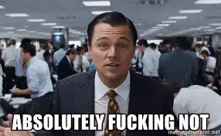
So I merged ALOT links in Excel, threw them into JDownloader and VOILA:11.551 Files - and a way more
accurate data collection then Apes ever had!
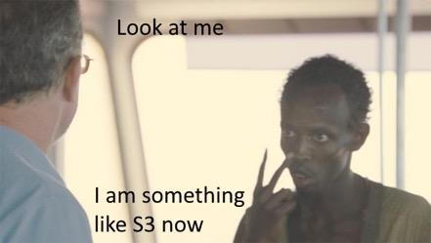
I extracted all available GME data and all available CBOE Data back to 2010, merged them with Historical
Data provided by Yahoo, Nasdaq and Fail To Delivery and made on big MasterSheet for every GME
retail.
The overall accuracy is around 45%. Means, 45% 50,37% (recalculation at the end) of all shares
traded between 2010 and 2021 are displayed in the data. Its lower at the beginning of the timeframe,
but gets better over time.
I already produced some charts for people with the excel-level ape.
I further organised my whole data collection, zipped it and uploaded it on Mega so that EVERY
FUCKING RETAIL has access to better data for free, totally unrelated to GME. Its a shame that retails
are getting no support - so we have to help each other!
One chart from the Mastersheet shall be displayed here to raise your attention for data:
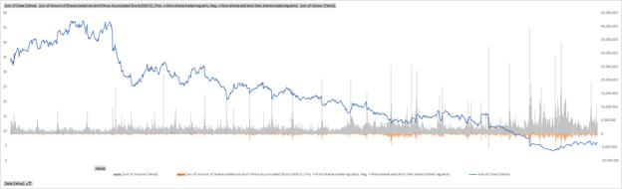
Timeframe 2015-2020 - Does anyone else see a pattern? (Source: Mastersheet)
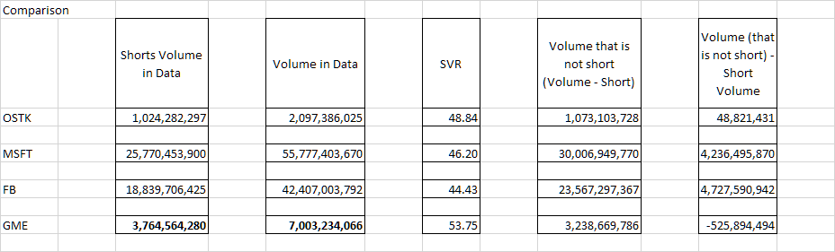
Because my first calculation was like: WTF GME? This doesnt make any sense - Should compare! (thx to the discord dudes giving
me this stock names for a comparison). The results are - interesting - And like: WTF?
I dont know if this data set is enough to proof naked short selling with data, but if this is the case, I really
would like this SEC Award! :D SEC pls?
You can download the Mastersheet here:
https://easyupload.io/ogovzr
Contains all Information I could find for GME in the data sets. Contains prebuild charts and comparisons.
You can download the whole fkn collection ( 1,4 GB zipped, 4 GB unzipped - 22.734 Files)
https://mega.nz/file/ikgUUCRC#HxOl0afMatKWpmmWrYOBMwQgQwVU2MHgGSoG0p1uRQk
Contains my entire data collection - have fun! And pls, share it with every community that could have
use for this information. The data collection is about ALL stocks - and I think alot retails rely their
investment on bad data atm. If you want to work with the raw data on your own, get Notepad ++ - makes
it way more easier to work with this amount of data.

To the Moon!!!
Thats the part a youtuber would ask for your financial support, but I have another request:If you make
money because of this data collection, you already made a fortune in stocks and you are happy to finally
have some quality data - give some money to charity.
I worked 4 month to get this done - and you would make me happy if your donation would be for
a Children's hospice - because this is something that should be supported more. And I am pretty sure
they would love to play some Mario or have a nice stuffed animal of their favorite character.
Let's take care of each other and support people who need our help.
Let's change the world.
Gamers and Retails United!
Best wishes and have a great Weekend!
Your
AnnihilationGod
PS: I'll publish the link to the updated versions of the collection and mastersheet on my Twitter:@
Annihil4tionGod or here at r/Superstonk . If you got any questions regarding the data and so on, pls
reach out.
Usefull links to get daily data about shorting:http://regsho.finra.org/regsho-June.html
https://www.cboe.com/us/equities/market_statistics/short_sale/?mkt=bzx
https://www.cboe.com/us/equities/market_statistics/short_sale/?mkt=byx
https://www.cboe.com/us/equities/market_statistics/short_sale/?mkt=edga
https://www.cboe.com/us/equities/market_statistics/short_sale/?mkt=edgx
Historical Data (open, high, low, close, volume:):
https://de.finance.yahoo.com/quote/GME/history?p=GME
https://www.nasdaq.com/de/market-activity/stocks/gme/historical
SEC Search Edgar (better
then Sec.report):https://www.sec.gov/edgar/search/?r=el#/dateRange=all&category=form-cat0
Add: I wanna thank SC - he helped me alot over the past months - this collection would not exist
without his advice and support whenever I could not solve a problem!
Thx SC!;) I owe you a beer!
Update 22:50 CET
**Add2:**I couldnt accept that i couldnt find any stock so far with a negative quote like GME - so I made
another research. I decided to choose the stock mentioned in this article I had read back in Feb 2021:
https://www.securitiesfinancetimes.com/securitieslendingnews/industryarticle.php?article_id=22454
8&navigationaction=industrynews&newssection=industry
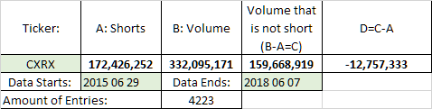
Perhaps someone who already downloaded the collection could crosscheck this pls?
Add3: 20. June 2021:I have to admit that I did a mistake while calculating the accuracy of the data. It is
50.37% instead of 45% like i wrote before.
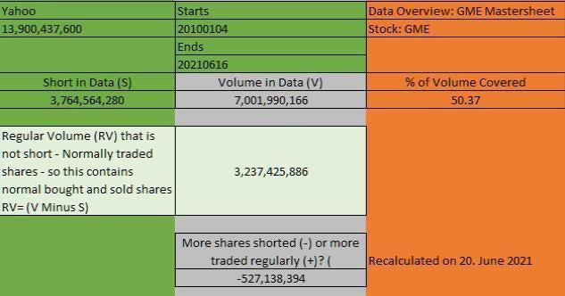
I looked deeper into the data to understand the relationship between regular volume and short volume
better. This is the result for the Timeframe 2010-2021. I am trying to increase my data collection tonight
and will try to find out, if the balance had been positiv before 2010.
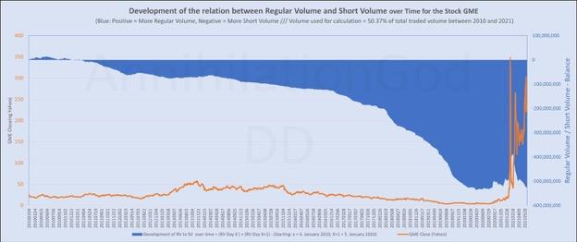
Chart GME
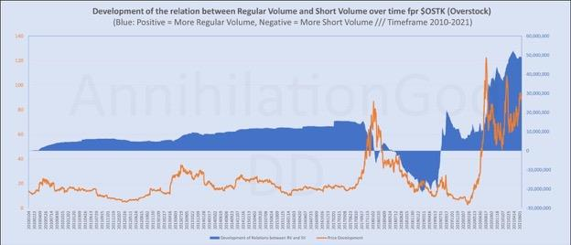
Chart OSTK - I though it would be a good idea to use OSTK again because i already compared it above with GME.
Back to Table of Contents
I think the Fed just accidentally proved us right
DD 👨‍🔬
Some background reading: Detailed & Simplified
As we all know, usage of the ON RRP Facility just jumped up over $200B, setting a new record at $755.8
billion from now 68 counterparties. Why?
Well, during the FOMC meetings, the Fed announced a few things around QE that are circulating through
MSM, freaking everyone out about there being 'too much money' and risks of inflation - but a key change
that isn't getting as much attention is their decision to raise the IOR and ON RRP rate 5 basis points
(.05%), effectively trying to raise the 'floor' of the FFR. (If this doesn't make sense to you, please
read this explanation)
Long story short, the Fed is now incentivizing more usage of the facility in its efforts to raise the interest
rates away from negative territory, by offering to pay counterparties 5 basis points instead of 0 to park
cash every night. This seems counterintuitive right, since continued QE is pumping cash into the system,
and now the Fed is paying to take it back out at the end of each day - but it actually makes sense when
you look at the affect it has (or should have) on short-term interest rates in the open market.
While the ON RRP rate was still 0, we could all assume that the 'too much money' narrative was in fact
the issue. However, something interesting happened to short-term T-bill yields yesterday when the ON
RRP rate was lifted:
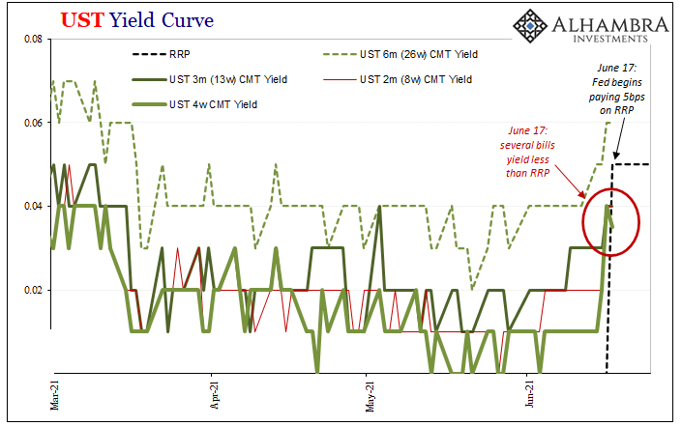
short-term yields went the WRONG DIRECTION
What does this mean? Well, the goal was to start easing yields back up from near-zero or potentially
negative levels by lifting the 'floor' of the ON RRP. If the issue was purely due to too much money being
in the system, it would've worked. Banks, MMFs, GSEs, etc. would take the 5 basis points from the Fed
and not bother parking their excess cash elsewhere for less interest.
So the reverse repo is now at 5, yet bill yields at the 4-, 8-, and 3-month maturities are all less than this.
Why? It can only mean this one thing, there is a stark and very dire need for high-quality collateral,
otherwise nothing would ever yield below this secured alternative with the Federal Reserve. Who would
buy a 4- or 8-week UST bill returning one and a half maybe two basis points less than lending to the Fed
secured by the same instrument? They're giving up guaranteed profit
This all points to the true underlying issue that we collectively have been yelling about here - there is a
MAJOR collateral liquidity issue in the money markets. I WONDER WHY....
edit:
TL;DR
The Fed just inadvertently showed us that the liquidity issue around ON RRP usage isn't 'too much cash'
- it's too little collateral.
from u/scamiran:
There's plenty of liquidity in the market.
Solvency? Not so much. But everyone wants to pretend that if there is sufficient liquidity, there must be
solvency.
That's how you get zombie banks and stagflation.
e2: if anyone wants to further learn about this stuff, I highly recommend looking into Jeff Snider as a
great place to start - his research into this is the basis of this whole
post https://alhambrapartners.com/author/jsnider/ or Alhambra Investments
Back to Table of Contents
Reverse Repo Operations - Explaining Their
Purpose
DD 👨‍🔬
There seems to be a lot of misinformation regarding Reverse Repo Operations so I figured I would try to
explain it so we can understand why it's happening and how it may effect us.
First off, Why does RRP exist? Reverse Repo Programs work to control Short Term Interest Rates, and
thereby liquidity in those markets
When SHORT TERM rates threaten to turn negative, the Fed steps in to set the floor. Why are short term
rates pushing downward? People are moving into short term fixed income because they don't want to go
into longer dated securities that could depreciate in value if inflation continues.
I'll try to describe this in fairly simple terms, but know that it is much more complicated than how I
describe it below.
Think of it like this:
1. Inflation worries kick in. Prices will be higher in the future than they are now, so fixed income
investors want more yield to compensate. That way their real returns aren't negative.
2. 30 Year Treasury Bond Holders see their treasuries market value drop and their YTM increase
as new issuance rates trend higher. New treasuries entering the market have better yield so the old
treasuries that were issued at lower yield drop in price as they effectively are paying less annually.
3. The Fed buys bonds and distressed debt They do this to set a "floor of sorts" on the price of these
assets. If the price of these assets drop substantially, there could be a sell off, which would only
compound the demand for higher yields to assume the risk with these fixed income assets. By
purchasing these longer dated assets, they are introducing money into the system, inflating asset values,
increasing liquidity across the spectrum and weakening the dollar. This in conjunction with 0 reserve
requirements means there is a lot of CASH floating around.
4. Investors Don't Want to Assume Risk Cash Hoarding is apparent, which goes against the idea of
inflation. Yet, this is directly a result of the Monetary AND Fiscal Expansionary Policy. Lower taxes,
stimulus checks, asset purchase programs, reduced reserve requirements, low Fed Fund Rate. All being
used to prop up the market. So investors are okay with LOSING money (holding cash) to not assume risk.
This would, depending on your school of thought, infer that asset values are inflated and inflation will
not continue. Asset values should decrease. But they aren't, why?
5. Where to go? Short Term FI The Fed recognize that much of this inflation is their own actions. These
actions force people to assume less risk. Investors know that long term FI is inflated AND not paying
enough to deal with inflation, so why not just assume 0 risk and deal with losing a little more in the short
term? Treasury issuance is down and the Fed is trying to unwind their balance sheet, so, once again,
short term rates trend negative. This places a lot of demand on the short term FI market. People are
buying up Money Markets, Treasuries low in duration, etc. Fannie Mae and Freddie Mac are only allowed
to invest their cash in short terms markets backed by government securities, demand being high in that
area places added pressure. Simply put, investors have fewer places to park their cash short term, and
rates run the risk of going negative.
6. Fed Sets the Floor The Fed comes in and sets the floor at 0% with their Reverse Repo Program.
Essentially they tell these banks, MMs, etc. We can ensure you're not Paying others to hold your cash,
we'll hold it and pay you nothing, but at least it will be worth the same tomorrow (nominally, not in real
value). But there's only so much demand for this. Optimally, investors want their cash to be worth the
same tomorrow as it is today, in real terms (factoring inflation). This has not been the situation since
pre-covid.
7. What's the goal? Now, the Fed have upped the RRP to .05%. They want to drive up the floor slowly.
Doing this will add demand for short term securities and reduce liquidity in the market as cash is being
used rather than going to risky assets that have inflated values (which would only serve to put more
pressure on inflation). The hope is that investors will utilize RRP until the deemed riskiness of other
assets subsides post covid and inflation expectations subside. The Fed are going all in on managing
expectations of inflation while hoping the economy recovers. Once riskier assets are deemed safer, the
Fed can unwind their risky assets at fairer value, the liquidity doesn't return until the Fed reduce theirs,
and inflation worries are subsided.
How much is .05%? Who's getting paid? If a bank places 1 Billion in the RRP, they'll receive 1,388.89
daily on their placement. This is what they would receive from the Fed for placing their cash with them.
A lot of the investors utilizing the RRP are Money Market Funds looking to keep their yield high enough
so that retail/institutional investors stay in the funds.
EDIT (to show the calculation on interest):
Repos are done on a 360 calendar year along with being done on a yield basis
Reverse principal + Interest = Reverse principal *( 1 + (y * t / 360)) where y is the yield or REPO rate, t is
maturity of the reverse REPO
Therefore, to solve for interest,
1,000,000,000 + INT = 1,000,000,000*(1+(.0005*1/360))
1,000,000,000 + INT = $1,000,001,388.89
INT = 1,388.89
These are done as an agreement of repurchase. The Fed gives bank a "security" with the promise to
repurchase later at the higher price.
What does this mean for apes and GME? Decreased liquidity is only applicable for risky assets that
investors have the option to avoid. If a hedge fund is margin called, they will want to unwind other non-
risky, uncorrelated positions first. They'll attempt to keep correlated positions (like AMC on a GME
squeeze) so that they can capture some of the upside. So they'll first utilize cash-like securities if
possible. This is why one could reasonably make the connection that increased RRPs means more
gunpowder for covering their assets during a squeeze. While it's possible, it likely won't be a catalyst,
only a possible sign that the market is deeming there is more risk "somewhere" in the market. That
could be anywhere: in treasuries, other equity, ABS, MBS etc.
The other issue arises if investors deem the banks as risky. THIS IS THE MAJOR THING TO WATCH. It's
important to keep an eye on the relation between the RRP rate and the IOER (rate the feds pay bank
reserves). Bank disintermediation essentially means investors seek parking their assets in MMMFs
(Money Market Mutual Funds) over the banks themselves who are subject to deposit insurance. Banks
losing consumer cash due to withdrawals, means reduced liquidity, lower revenues and increased
expenses. They can't leverage as much, and then borrowers aren't able to receive the loans they may
require (especially post covid). Corp rates, MBS and CREs especially see higher rates which could lead to
lower profit expectations or even bankruptcies.
Unfortunately, there are so many pieces, all interrelated that it's hard to discern exactly what will
happen, let alone, could happen. What is clear is that we are near a ledge that is very susceptible to
falling off the edge. The RRP is good to look at, but it likely won't be the catalyst to a squeeze, just a
implication of what is happening on a more macro scale. Expecting RPPs to be correlated to GME price is
FUD. I know all I have to do is hold. There are many possible ways we could take off, but relying on the
idea that any particular catalyst is the ONE, and only ONE, is damaging.
tldr; RRPs may not be the catalyst we are after and it's correlation with GME should not imply
causation. It does imply a lot of other issues in the economy and is definitely something
important to keep an eye on.
Back to Table of Contents
I processed 16 years of data across 8 stocks to
prove something no one cares about: GME's
price is ending in .00 10X more than it should
be.
DD 👨‍🔬
I’m back and so is my fondness of the .00. I spent all week trying to shake the thought of it... but just as
the return of 005 was, the return of .00 is inevitable.
Speaking of .00, Did you know in June that 29% of our open, close, high, and low prices have ended in
.00? 48 data points, 14 being .00 price points, 29%. That’s up from 15% in May and 13% in April. I didn’t
know either until I gave up sleep for this.
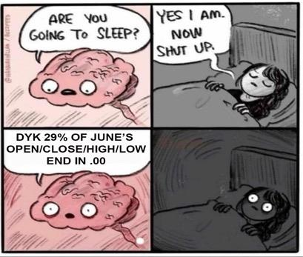
Now, before you come at me with why the frequency of .00 price points are increasing with reasoning
such as "as prices increase so do chances of .00 price points"... I know! This whole post will be dedicated
to proving that even with certain understandings of why a stock might end in .00, GME is a true
outlier (and you know what that means 🚀🚀🚀).
Earlier this week I succumbed to my madness and had to see if my own noticing of .00 key (open, close,
high, and low) price points was frequency illusions or fact. Frequency illusion, or Baader-Meinhof
Phenomenon, is your internal bias that causes something to appear more often only after learning or
noticing that thing for the first time.
Before now, I thought I was simply seeing what I wanted to see. You can check out my previous post to
see what started it all, but a quick recap is that in 2021 GME has a 61.06% rate of having a key price
point during a trading day end in .00. The average for the 18 prior years is 9.25%, last year was 5.14%.
GME is seeing key price points at .00 more often, and the rate is increasing.
I appreciate the love my first post on .00 received. I also appreciate the perspective that other apes were
able to provide as my brain is smoother than the gelato my wife treats me to once a month. Since then,
I’ve quadrupled my research in an attempt to directly address some of the top reasonings for .00 price
points to determine if GME is following a trend that exists across all stocks or is a 1.00-of-a-kindin just
another way.
TL;DR: Buy & Hold. Read the title again too. I predict we will continue to see an abundance of .00
key price points as we approach the MOASS. GME is a true outlier and in my next post, I will be
mapping GME’s .00 price point frequency to the FTD cycles.
This post is broken into sections each starting with a quick summary.
.00 | The Data
I’ve exported all my data from Yahoo's historic price exports. I love transparency.
I am going to cover the following in this post.GME historical data from January 2002 to June 15, 2021
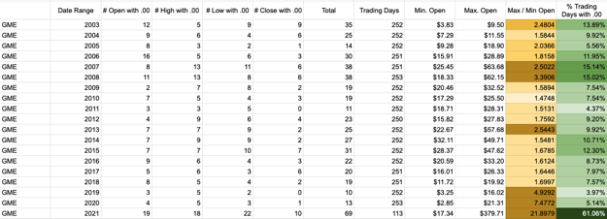
And the following stocks for comparisons and baselines.AMC historical data from January 2014 to June
15, 2021
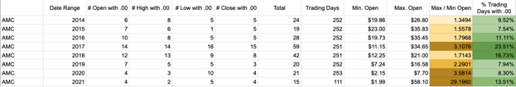
TSLA historical data from June 29, 2010 to June 15, 2021
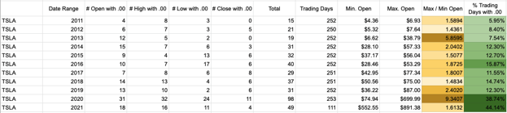
AMZN historical data from January 2005 to June 15, 2021
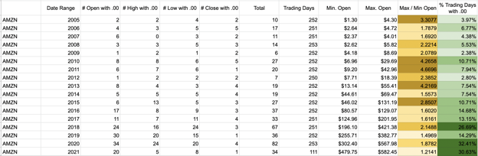
OSTK historical data from January 2005 to June 15, 2021
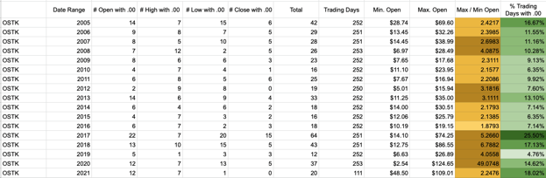
AAPL historical data from January 2005 to June 15, 2021
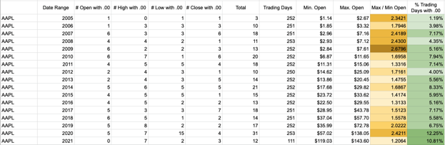
GOOG historical data from January 2005 to June 15, 2021
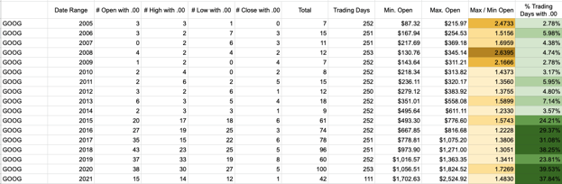
NFLX historical data from January 2005 to June 15, 2021
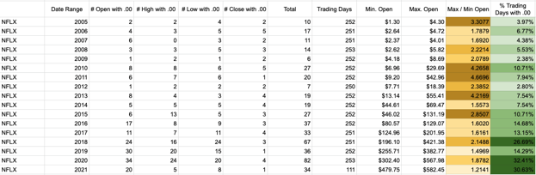
Reason for .00 #1.00 | As a stock price increases, .00 key price points are more common.
Is the statement backed by data: Yes. See below.
GME Myth or Fact: Myth. Although the rate of .00 key price points has increased with the stock’s price,
GME is trending 5-10x higher than the average stock for .00 appearances at price points greater than
$100.
Before I go into the numbers, I want to take a second to explain why this statement is reasonable to
believe without first checking the data. If a stock is $1.50 it would require a 33% movement to hit a .00
key price point. If a stock is $15.50 it would only require a 3.2% movement. Therefore, it’s safe to believe
that as a stock price increases that the occurrence of .00 key price points will also increase.
That simple understanding wasn’t enough for this smooth brain of mine. I wanted to see just how
common these .00 key price points were within different price brackets. I'm a simple ape that likes
patterns and nice flat numbers. My TV volume is at a flat 20 and my stock will be at a flat 20,000,000.00
soon too, and I'll love every short moment of it before the rocket continues rising.
For this experiment, I deemed testing and verifying using only the Open Price of GME and the stocks in
my data pool would suffice.
I tallied the occurrence of how many times each stock opened in my set price ranges and also tallied how
many times each stock opened at .00 within my set range. This can be used to tell us the percentage of
times my data pool opened at .00 within each price range. There were no surprises here:
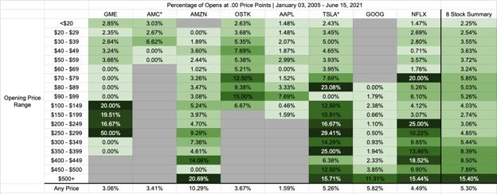
Looking across all eight stocks, the percentage of time a stock opened at .00 increases pretty steadily as
the stock price increases.
This confirms the original believed statement that as the price increases so does the appearance of .00
key price points. However, we can see that GME is a clear outlier. Once the price broke $100, we’ve
seen an increase in .00 appearances that is unlike any other stock. This tells us that we are not just
seeing more .00 appearances in 2021 than previously, but also that GME is trending in more .00 at this
price level than normal.
Reason for .00 #2.00 | Retail is more likely to place orders at .00 and GME is THE retail
movement.
Is the statement backed by data: No. I was not able to find data on retail orders and if orders ending in
.00 are more common.
GME Myth or Fact: Myth. There is a lack of quantitative data on retail orders and there is no correlation
between the percentage of .00 appearances in 2021 of GME (61.06%) and AMC (13.51%).
Before we go further, I think it's important to understand the reasoning. The idea here is twofold: First,
retail is more likely to place orders ending in .00, and second retail’s tremendous support of GME leads
to a larger influence of the .00 price point. There is no exact data that I was able to find on the first point,
and the second is conjecture based on the first. It’s tough to tackle this directly.
First, for retail placing orders ending in .00, It’s unreasonable for me to come to any conclusion on this. I
do see a large number of posts educating users on limit orders versus market orders. That tells me that
the number of retail investors that are purchasing stock at .00 price points may be smaller than
anticipated. There is also an affinity for .69 and 4.20 tail ends as well. Since I can't prove or disprove this,
let's tackle the second part.
For the second part, I would assume the same trend of greater .00 appearances due to increased retail
support would also be seen in the movie stock. That wasn’t the case.
A recap of GME's % of trading days with .00 appearances:
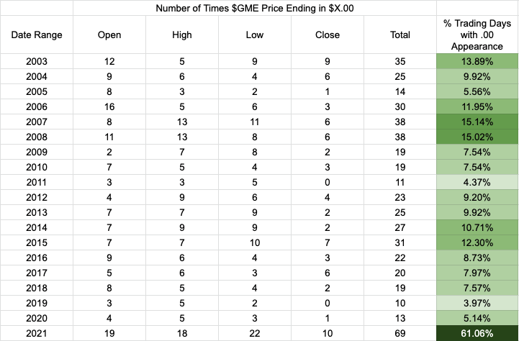
And the other stock's rate of .00 appearances:
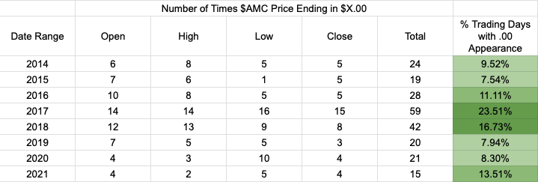
For 2021, it currently sits at 13.51% appearance of .00 key price points, an increase of only +2% on the
8-year average. Even with recent movements, there has not been an increase in .00 appearances.
This wasn’t enough for me. We all know GME is the real play, so this didn’t seem like a fair comparison. I
wanted to take it a step further and attempt to track how much retail interest or hype around a stock
would play into the appearance of .00 price points.
Reason for .00 #3.00 | Large movements in a stock’s price lead to more .00 appearances.
Is the statement backed by data: No. I compiled a total of 106 trading years and tracked the spread of
Minimum Open Price and Maximum Open Price for each year compared to that year’s percentage of .00
appearances and see no relation.
GME Myth or Fact: Myth. Although GME’s stock price is rising as we approach the MOASS and we are
seeing an increase of .00 price points, it appears to only be a coincidence.
This was a fun one to tackle. How do I compare GME, a once-in-a-ever opportunity, to other stocks?
I felt that the larger the spread between Min. Open Price and Max Open Price in a given year would
provide a good telling of a stock’s movement and potential retail hype. I believe that the larger the
spread, the more retail hype there would be. I then compared the spread to the percent of trading days
with a .00 appearance.
I uncovered that the appearance of .00s doesn’t appear to relate to a more volatile stock.
Years with the lowest spread of Min Open price to Max Open Price:
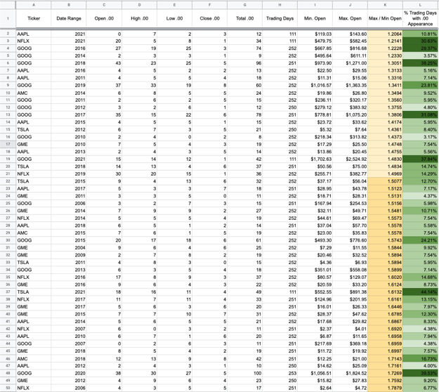
Years with the highest spread of Min Open Price to Max Open Price.
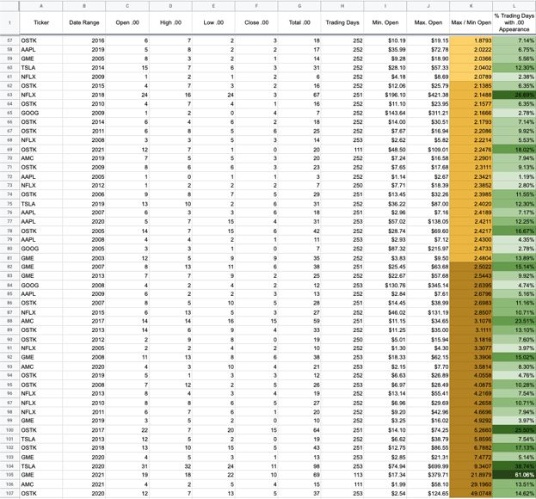
Across the board, there is a pretty flat rate of 12% of trading days seeing a .00 key price point.
In 2021, GME saw a minimum open price of $17.34 and a maximum open price of $379.71, an increase
of 21X. And what is GME’s percentage of days in 2021 with a .00 key price point? 61.06%.
The largest one-year spread (until GME has its way with me) I found was in OSTK in 2020. I saw a low of
$2.54 and a high of $124.65, an increase of 49X. Yet, OSTK’s percentage of days in 2020 with a .00 key
price point was only 14.62%.
While reason #2.00 was more inconclusive because of a lack of data, reason #3.00 can clearly be
dismissed as false. There is no relation between a stock's open spread in a given year with the
percentage of trading days with .00 appearances.
------------------------------
That's all I have for now. There are no dates or prices this data allows us to spectate on, but it does show
that something is fishy.
I applaud you for making it through this data-heavy DD. As I mentioned at the start of my post, I'm not
done yet. I think there is more here as the frequency of these .00s is steadily increasing. In my next post,
I will be mapping GME’s .00 price point frequency to the FTD cycle.
Now I look to you, ape. Please help me out by providing further reasoning as to why GME might be
seeing .00 price points. I'm happy to do further research, discuss, and add another wrinkle to this
smooth brain of mine. I want every piece to this .00 puzzle.
Back to Table of Contents
The OBV does not lie. The price is
WRONG! HODL!
DD 👨‍🔬
Hello Apes, Bones here, im going to explain what exactly the OBV is, what it does and how it pertains to
GME.🚀

So what is the OBV? Well OBV stands for “On Balance Volume”
•On Balance Volume (OBV) measures buying and selling pressure as a cumulative indicator that adds
volume on up days and subtracts volume on down days.
⚠️The actual value of the OBV is unimportant; concentrate on its direction.⚠️
• When both price and OBV are making higher peaks and higher troughs, the upward
trend is likely to continue.
• When both price and OBV are making lower peaks and lower troughs, the downward
trend is likely to continue.
• During a trading range, if the OBV is rising, accumulation may be taking place—a
warning of an upward breakout.
• During a trading range, if the OBV is falling, distribution may be taking place—a warning
of a downward breakout.
• When price continues to make higher peaks and OBV fails to make higher peaks, the
upward trend is likely to stall or fail. This is called a negative divergence.
• When price continues to make lower troughs and OBV fails to make lower troughs, the
downward trend is likely to stall or fail. This is called a positive divergence.
https://www.fidelity.com/learning-center/trading-investing/technical-analysis/technical-indicator-
guide/OBV
Now that you have a brief idea of what OBV stands for and how its used in technical analysis i will
present how to use it as an indicator for GME price action.
So if you look at the (180/1 day) chart for GME you will see that the price of GME is going down (at the
moment).... BUT, the OBV is staying flat and actually continuing its upward pattern ever so slightly.
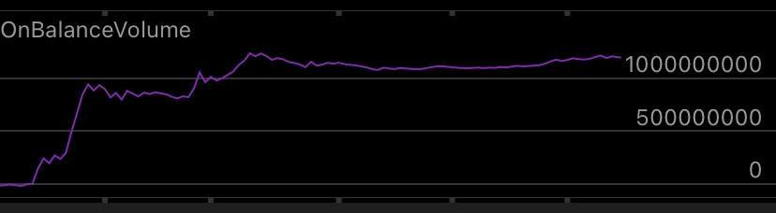
(GME OBV 180 day chart)
“But why would the price go down if the OBV is going up or staying flat?”
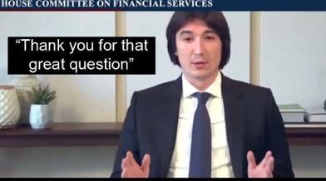
Vlad the stock impaler
Thats because there is actually buying pressure outweighing the selling pressure or coming damn near
close to being even!
-There are many great DDs out there explaining how hedgies use ETFs to short gamestop. In my opinion
I believe the OBV is indicating that YOU, the Diamond Handed Apes are HODLING your shares and
buying more that the OBV is staying up do to holding and buying pressure, and it proves that the price is
indeed WRONG!
Hedgies are shorting gamestop through ETFs/ Dark Pools to artificially deflate the price, this keeps the
price of GME down temporarily until they stop, once they stop shorting ETFs, GME begins uptrending
because of buying pressure. There are no more shares available to short Gamestop (GME), so they resort
to shorting ETFs that contain GME like XRT which is a big one. this does not effect the volume on GME
because the hedgies are shorting ETFs, not GME directly, therefore the price of GME deflates but the OBV
is showing otherwise. This is only a temporary fix for the hedgies. They are FUK either way.
This leads me to believe the price is 100% WRONG! Hedgies are trying to get Apes to paper hand and
sell. And Apes are proving that it takes nothing to HOLD, and costs them everything to kick the can down
the road.

Listen here hedgies, you cant kick the can down the road forever, DIAMOND HANDS got you beat. It
costs nothing to hodl these shares to the moon and it will cost you everything to try and make apes
paper hand.

Diamond Hands (APES OWN THE FLOAT....and then some)
📈As for me, I like the stock📈
🐻Hedies R Fuk🐻
🚀🦍See you on the moon Apes 🦍 🚀
-Boner out✌️
(If i missed something or if anyone has info to add please leave it in the comments or DM me and i can
add it)
❌Obligatory: *not financial advise*❌
Back to Table of Contents
T+35 is the one true "cycle" [Evidence to back
my theory up plus a step-by-step guide on how
to follow along at home]
DD 👨‍🔬
This post is for educational purposes only. Do your own research and make your own decisions before
acting on them. Just because this information is correct now, doesn’t mean it will be correct every other day.
HFs have a lot of tricks. No one knows what will come next...
EDIT10 (6/21): It is more clear to me now that ETF FTD's do not behave the same as the GME
FTDs that I use as examples. The ETF FTDs are a work in progress. The ETF FTDs should be
weighted as well. If you find a pattern in the ETF FTDs, I'm open to hearing it!
--------------------------------------------------------------------------------------
TL;DR:
• Every spike that is seen can be traced back to T+35.
• I show 1 min spikes to back this claim up
• I provide a guide on how to setup this data yourself.
Preface
Almost 2 weeks ago, I posted some DD about T+35.
T+21 is NOT actually a thing! [Counter DD]
I claim that T+35 is the only T+X that is important, and other T+X “cycles” are actually just from T+35.
This concept goes against the general consensus, so as expected... I got mixed reviews. Since then I have
seen a different T+X, T+Y, T+Z theory every day, but there is always a catch or some sort of guessing
applied. Or the cycle is T+21 one month, but T+19 the other month. As you may imagine, this has gotten
frustrating for me. There is no shade being thrown at other DD writers. I just want everyone to realize
how simple this is so we can all be on the same page.
My T+35 theory doesn’t have guess work. It works every time and it’s based on free data that
anyone can get. In this post, I will show you how. (I know this is starting to sound like an infomercial,
but stick with me)
Where my T+35 theory comes from...
Reg SHO Rule 204 (https://www.law.cornell.edu/cfr/text/17/242.204) states HFs need to cover their
FTDs “before regular trading hours on the 35th day after the FTD date”. My T+35 theory shows they
wait until the last possible day to cover, so the 34th day after the FTD date (this is why our third column
formula was “=A1 + 34”). If the 34th day lands on a weekend or holiday, bump it forward to the next
business day.
Reg SHO states that you cannot short a stock if you have FTDs open. Once the FTDs get covered on that
day, GME’s price will not return to that point.
That’s it. That’s all you need.
It’s as simple as…
1. Get the FTD data
2. Count 34 calendar days (FTDs need to be covered BEFORE the 35th day)
3. Those FTDs will be bought all at once on that trading day.
Oh, you want to see an example?
Okay, sure.
I have picked out days from April because the FTDs are large and the volume was small. It is very easy to
pick them out.
How about… April 21. 32,220 FTDs need to be covered. The day’s volume was low, but there was a 1m
volume spike at 12:23 EST of 39,000. GME’s price never came back afterward.
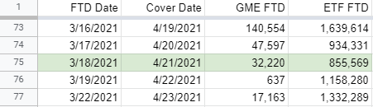
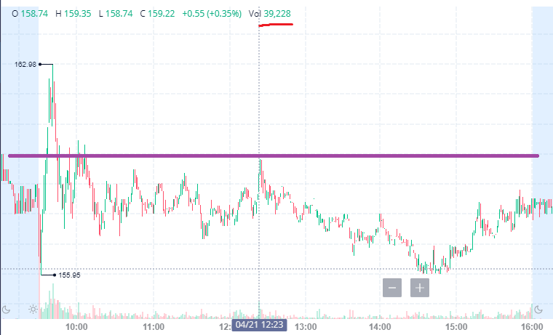
April 19. 140,554 FTDs need to be covered. GME was rising quite fast on it’s own. Remember, they can’t
short a stock when they have FTDs that need to be covered. So at 10:25 EST, There was a big jump in
volume up to 160k and then the price dropped for the rest of the day.
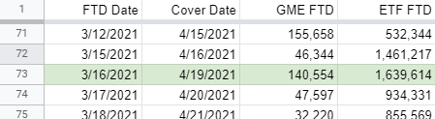
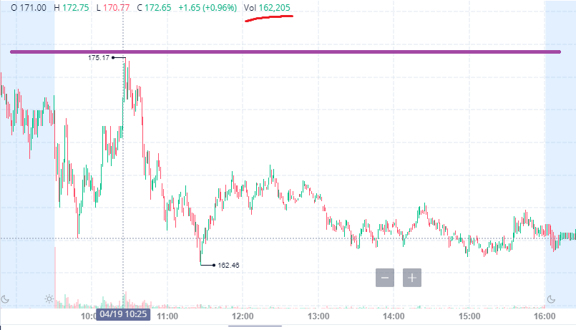
You see? It's that easy!
Meh... this seems like a coincidence
Okay, fine... I'll keep going.
April 16 - 46,344 FTDs
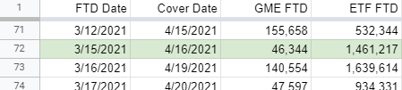
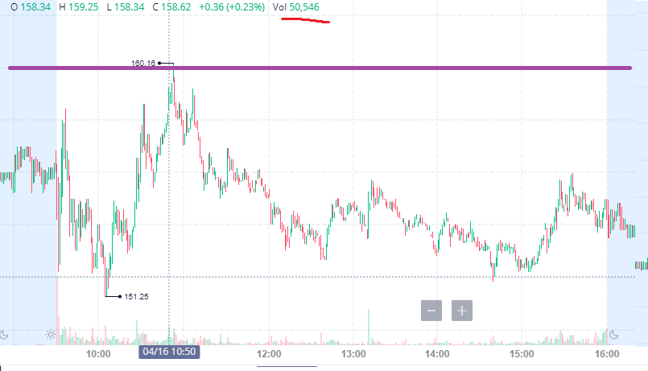
April 15 - 155,658 FTDs
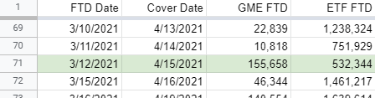
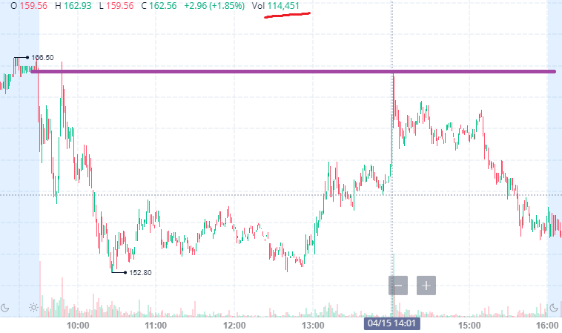
April 1 - Two days needed to be covered this day because 4/4 was a weekend. At 1:25, there was an 83k
volume spike followed by a couple 100k-150k volume candles.
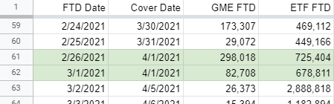
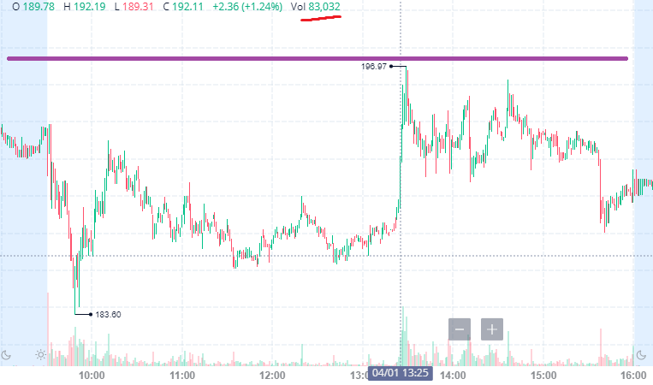
April 30 - 86,859 FTDs. This one got split between two minutes on my chart. The average 1m volume
was between 30k-40k shares. And then there are two 70k-80k volume candles at 9:50-9:51 am.
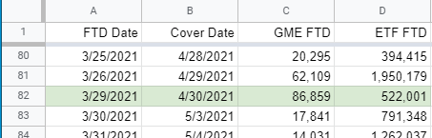
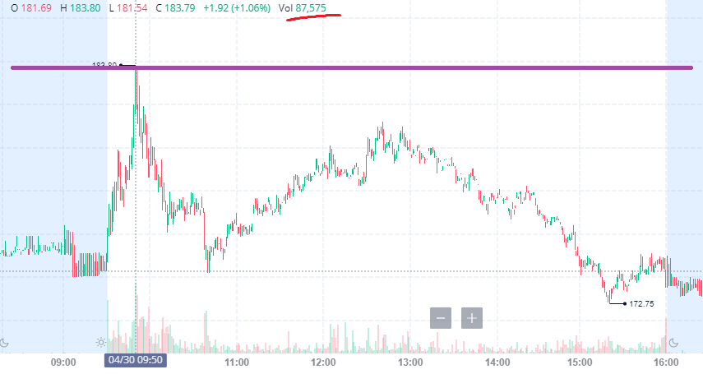
I can keep going. These are the easy ones to spot just in April.
So what about ETF FTDs?
Days with large ETF FTDs also see spikes like this. But it doesn’t convert well enough to show. For
instance, 1.9 million ETF FTDs might convert to a 120,000 share GME spike. If someone wants to
continue this research and find a way to convert the ETF FTD count into GME shares, go ahead.
Why do some days lead to large gains and some days drop
immediately after the FTD cover?
I wrote about that in my last DD:
SLD DD [A predictable monthly pinch on capital leading to GME gains]
But here’s what you need to know if you can’t read two DDs in a row:
• There is a period that starts on Wednesday before monthly options expiration
and extends to 9 days after monthly options expiration where the 30 largest financial
companies need to make large deposits to the NSCC.
• During those days, they have less money and need to be careful not to spend more or
they will get liquidity called.
• Meaning T+35’s with large FTD days that fall in the SLD period will increase GME’s price
a lot more than large FTD days that fall out of the SLD period. Once the price of GME
rises within the SLD period, it does not come back down until 2 days before the end
of SLD.
I even mapped out the SLD periods:
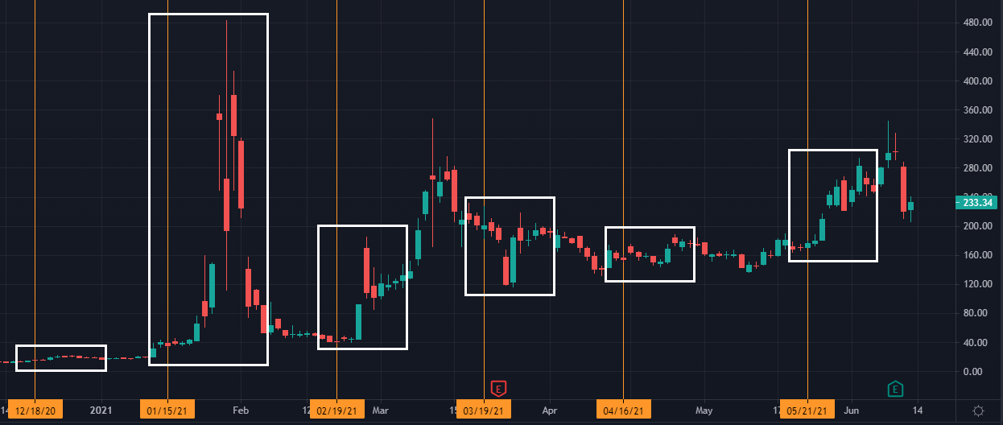
March 5-10 is the biggest spike outside of SLD. Those can be associated with ETF FTDs.
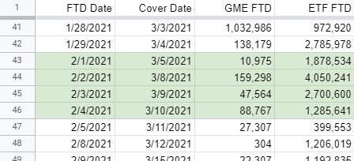
How do I see this for myself?
Download the FTD data from the SEC: https://www.sec.gov/data/foiadocsfailsdatahtm and pull out
every line with GME and every line of the ETFs GME are in. But that’s a lot of work. Luckily, a lovely ape
by the name of u/nequin made a website to do this all for you.
Get the FTD data:
1. Go to https://failedtodeliver.com/?symbols=GME
2. Make a spreadsheet.
a. Column A is the FTD date.
b. Column B is “=A1+34” and fill down.
c. Column C is the number of GME FTDs
d. Column D is the number of ETF FTDs
ETFs with GME
https://failedtodeliver.com/?symbols=GAMR,XRT,RETL,XSVM,VIOV,RWJ,VIOO,PSCD,VIOG,VTWV,IUSS,V
CR,VTWO,SFYF,IWC,EWSC,SYLD,PRF,RALS,FNDX,FNDB,VBR,IJS,XJR,NUSC,SLYV,IJR,SPSM,SLY,FLQS,IJT,G
SSC,SLYG,VXF,NVQ,IWN,ESML,VB,SAA,DMRS,BBSC,OMFS,FDIS,STSB,SSLY,IWM,SCHA,PBSM,UWM,VTHR,
URTY,VTI,TILT,VLU,HDG,AVUS,MMTM,DSI,SPTM,IWV,SCHB,ITOT,DFAU
EDIT 7: I posted my dataset for the people who want to
compare. https://www.reddit.com/user/dentisttft/comments/o1k5s4/t35_dataset/
EDIT 9: There were some issues brought up in the data. But they shouldn't be issues. Trust the files
or failedtodeliver.com, they are the same.
EDIT 6: IT HAS BEEN BROUGHT TO MY ATTENTION THAT THE WEBSITE IS OFF BY ONE DAY
STARTING IN APRIL. PROBABLY BECAUSE OF THE HOLIDAY. I HAVE TAGGED THE PERSON WHO
CREATED IT. SO MAKE SURE YOU DOUBLE CHECK SOME DAYS WITH THE FILES UNTIL ITS FIXED.
EDIT 8: APPARENTLY THE WEBSITE USES THE FILES, SO EDIT 6 IS NOT COMPLETELY CORRECT.
THERE IS A DISCREPENCY BETWEEN THE FILES/FAILEDTODELIVER.COM AND THE SEC'S FTD
GRAPH.https://sec.report/fails.php?tc=gme
THE FILES SKIP APRIL 21 (WHICH IN MY OPINION MEANS ZERO) AND HAVE APRIL 30, THE
GRAPH WEBSITE HAS APRIL 21 AND SKIPS APRIL 30. SO I THINK THE GRAPH WEBSITE MIGHT BE
INCORRECT.
Important Notes:
• Column A is the settlement date when the share officially becomes an FTD.
• Column B is the last possible day to cover the FTD
Your spreadsheet looks like this…
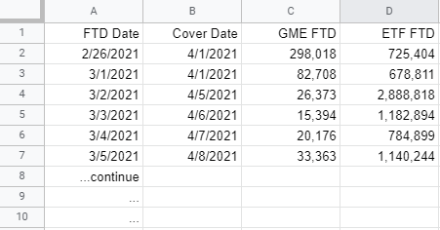
Now what?
1. Google search “what is today’s date”
2. Find that date in column 2 (the +34 day)
3. Follow this flow chart.
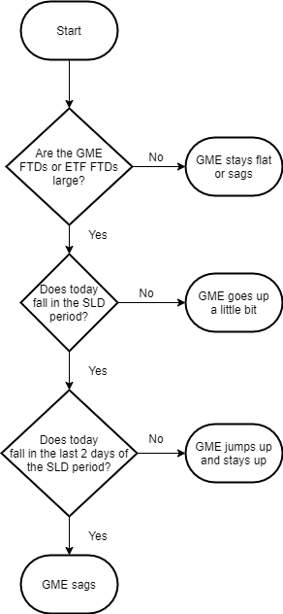
In my experience, a “large number of FTDs” is 70,000+ for GME FTDs or 1-1.5 million FTDs for ETFs.
Again, this is not guaranteed. This is just based on patterns I’ve seen. There are plenty of tricks that
probably have not been shown. Don’t do something stupid based on this data, its for education purposes
only.
Should my tits be jacked!?
Here's the new data for this next week... Use your new knowledge from this post and you decide!
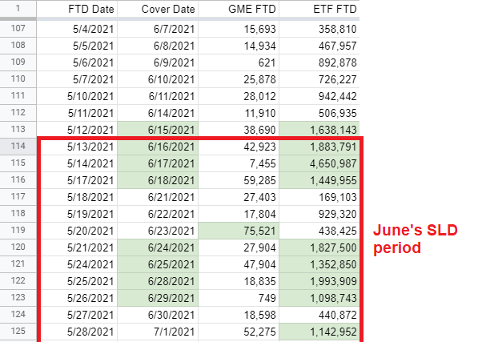
EDIT5: Fixed the hightlighted section. Accidentally had June 15th in there when it shouldn't be.
FAQ
New FTD data just came out yesterday. So what about June?
The ETF FTDs are quite large for the next 5-7 trading days. Combine that with SLD starting on June
16 17, things look good.
EDIT5: Accidentally had the wrong date typed here and the wrong dates highlighted in the photo.
Why do the last two days of SLD not behave the same as the other days?
Not sure. My guess is that HFs have 2 days to pay a liquidity call. So there’s no point in liquidity calling
them when they are about to get their money back. It also usually is at the end of the week when option
premiums get extremely high, less calls are bought, and gamma ramp slows down.
How long does it take before GME/ETFs show up as FTDs?
They become FTDs when the trade settles. So for GME FTDs, its T+2. For ETF’s, its T+6. (shoutout
to u/karasuuchiha for pointing out the ETF settlement time to me)
What causes GME FTDs?
This is where the idea of “cycles” comes from. When FTDs fall in SLD and GME spikes, it creates a lot of
ITM call options. When those call options are exercised on Friday, they become FTDs upon settling (T+2
settlement). Note: Buying and selling option contracts settle in T+1, but exercising contracts is T+2. This
causes a lot of new FTDs that need to be covered in 34 more days. Thus creating an obsession with
“cycles” and why other “T+X cycle” theories fall short. It’s literally just ITM options from the last SLD
+ FTD spike price increase will create new FTDs on Tuesday (or Wednesday with a holiday).
What causes ETF FTDs?
SSR!!! Remember all those days when SSR didn’t stop GME from going down? It’s because GME is
shorted through the ETFs causing ETF FTDs 6 days later when they settle. It did something, it’s just not
immediately seen.
I’m still not buying it. There are definitely spikes every 21 days!
Well, I tried. Erase what you know about T+21 cycles and try to understand and apply this post. And
maybe you will eventually see what I see.
What about Net Capital?
I don’t know. I avoid FINRA things because in the end… it’s just FINRA. This is based off of NSCC rules.
I’ve found enough correlation in only using FTDs and SLD that I didn’t think I needed to look into Net
Capital too much. They could definitely both be happening, but in the end, I don’t think it’s too
important. I’m open to someone changing my mind on this if you can show me the data (not the rules) to
support that Net Capital has more correlation than SLD.
What else should I know?
Rule 204 says the 35 day exception applies when you have a long position on the stock. If they’re
shorting, how do they get to say they have a long position? I have a theory, but nothing concrete.
TL;DR: The TL;DR is at the top of the post you sweet, tender, smooth-brained ape.
Now that I have more eyes on my posts, I’m hoping this theory sticks better than the first time. In my
opinion, getting distracted on other types of cycles is diluting focus.
pce~~
u/dentisttft
----------------------------------------
Shoutout to u/wJFq6aE7-zv44wa__gHq for letting me bounce ideas off of them!
EDIT1-3: formatting fixes
EDIT4: Added "Should my tits be jacked!?" section
EDIT5: Fixed the dates on my new section. I rushed it and highlighted June 15 on accident.
Bonus Round!
I posted my SLD DD on June 13th at 6:23 PM EST. 6 hours later at 12:02, Elon Musk posted this on
Twitter.

Is it about my DD? No idea, probably not. But it’s fun to think about. If any of the RC Tweet analyzers can
find a definite connection, that would make my day.
Back to Table of Contents
The Bigger Short. How 2008 is repeating, at a
much greater magnitude, and COVID ignited
the fuse. GME is not the reason for the market
crash. GME was the fatal flaw of Wall Street in
their infinite money cheat that they did not
expect.
DD 👨‍🔬
0. Preface
I am not a financial advisor, and I do not provide financial advice. Many thoughts here are my opinion,
and others can be speculative.
TL;DR - (Though I think you REALLY should consider reading because it is important to
understand what is going on):
• The market crash of 2008 never finished. It was can-kicked and the same people who
caused the crash have still been running rampant doing the same bullshit in the
derivatives market as that market continues to be unregulated. They're profiting off of
short-term gains at the risk of killing their institutions and potentially the global
economy. Only this time it is much, much worse.
• The bankers abused smaller amounts of leverage for the 2008 bubble and have since
abused much higher amounts of leverage - creating an even larger speculative bubble.
Not just in the stock market and derivatives market, but also in the crypt0 market,
upwards of 100x leverage.
• COVID came in and rocked the economy to the point where the Fed is now pinned
between a rock and a hard place. In order to buy more time, the government triggered a
flurry of protective measures, such as mortgage forbearance, expiring end of Q2 on June
30th, 2021, and SLR exemptions, which expired March 31, 2021. The market was going
to crash regardless. GME was and never will be the reason for the market
crashing.
• The rich made a fatal error in way overshorting stocks. There is a potential for their
decades of sucking money out of taxpayers to be taken back. The derivatives market is
potentially a $1 Quadrillion market. "Meme prices" are not meme prices. There is so
much money in the world, and you are just accustomed to thinking the "meme prices"
are too high to feasibly reach.
• The DTC, ICC, OCC have been passing rules and regulations (auction and wind-down
plans) so that they can easily eat up competition and consolidate power once again like
in 2008. The people in charge, including Gary Gensler, are not your friends.
• The DTC, ICC, OCC are also passing rules to make sure that retail will never be able to to
do this again. These rules are for the future market (post market crash) and they
never want anyone to have a chance to take their game away from them again.
These rules are not to start the MOASS. They are indirectly regulating retail so that a
short squeeze condition can never occur after GME.
• The COVID pandemic exposed a lot of banks through the Supplementary Leverage Ratio
(SLR) where mass borrowing (leverage) almost made many banks default. Banks have
account 'blocks' on the Fed's balance sheet which holds their treasuries and
deposits. The SLR exemption made it so that these treasuries and deposits of the
banks 'accounts' on the Fed's balance sheet were not calculated into SLR, which
allowed them to boost their SLR until March 31, 2021 and avoid defaulting. Now,
they must extract treasuries from the Fed in reverse repo to avoid defaulting from
SLR requirements. This results in the reverse repo market explosion as they are
scrambling to survive due to their mass leverage.
• This is not a "retail vs. Melvin/Point72/Citadel" issue. This is a "retail vs. Mega Banks"
issue. The rich, and I mean all of Wall Street, are trying desperately to shut GameStop
down because it has the chance to suck out trillions if not hundreds of trillions from the
game they've played for decades. They've rigged this game since the 1990's when
derivatives were first introduced. Do you really think they, including the Fed,
wouldn't pull all the stops now to try to get you to sell?
End TL;DR
A ton of the information provided in this post is from the movie Inside Job (2010). I am paraphrasing
from the movie as well as taking direct quotes, so please understand that a bunch of this information is a
summary of that film.
I understand that The Big Short (2015) is much more popular here, due to it being a more Hollywood
style movie, but it does not go into such great detail of the conditions that led to the crash - and how
things haven't even changed. But in fact, got worse, and led us to where we are now.
Seriously. Go. Watch. Inside Job. It is a documentary with interviews of many people, including those
who were involved in the Ponzi Scheme of the derivative market bomb that led to the crash of 2008, and
their continued lobbying to influence the Government to keep regulations at bay.
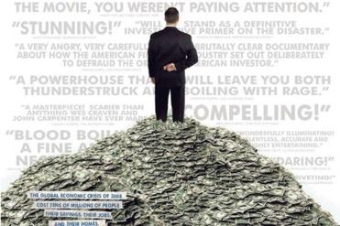
Inside Job (2010) Promotional
1. The Market Crash Of 2008
1.1 The Casino Of The Financial World: The Derivatives Market
It all started back in the 1990's when the Derivative Market was created. This was the opening of the
literal Casino in the financial world. These are bets placed upon an underlying asset, index, or entity, and
are very risky. Derivatives are contracts between two or more parties that derives its value from the
performance of the underlying asset, index, or entity.
One such derivative many are familiar with are options (CALLs and PUTs). Other examples of
derivatives are fowards, futures, swaps, and variations of those such as Collateralized Debt
Obligations (CDOs), and Credit Default Swaps (CDS).
The potential to make money off of these trades is insane. Take your regular CALL option for example.
You no longer take home a 1:1 return when the underlying stock rises or falls $1. Your returns can be
amplified by magnitudes more. Sometimes you might make a 10:1 return on your investment, or 20:1,
and so forth.
Not only this, you can grab leverage by borrowing cash from some other entity. This allows your bets to
potentially return that much more money. You can see how this gets out of hand really fast, because the
amount of cash that can be gained absolutely skyrockets versus traditional investments.
Attempts were made to regulate the derivatives market, but due to mass lobbying from Wall Street,
regulations were continuously shut down. People continued to try to pass regulations, until in 2000,
the Commodity Futures Modernization Act banned the regulation of derivatives outright.
And of course, once the Derivatives Market was left unchecked, it was off to the races for Wall Street to
begin making tons of risky bets and surging their profits.
The Derivative Market exploded in size once regulation was banned and de-regulation of the financial
world continued. You can see as of 2000, the cumulative derivatives market was already out of control.
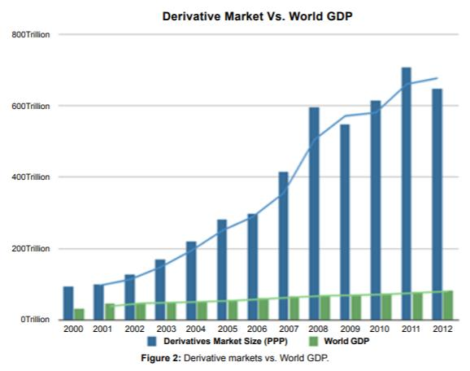
https://www.hilarispublisher.com/open-access/investment-banks-and-credit-institutions-the-ignored-and-
unregulateddiversity-2151-6219-1000224.pdf
The Derivatives Market is big. Insanely big. Look at how it compares to Global Wealth.
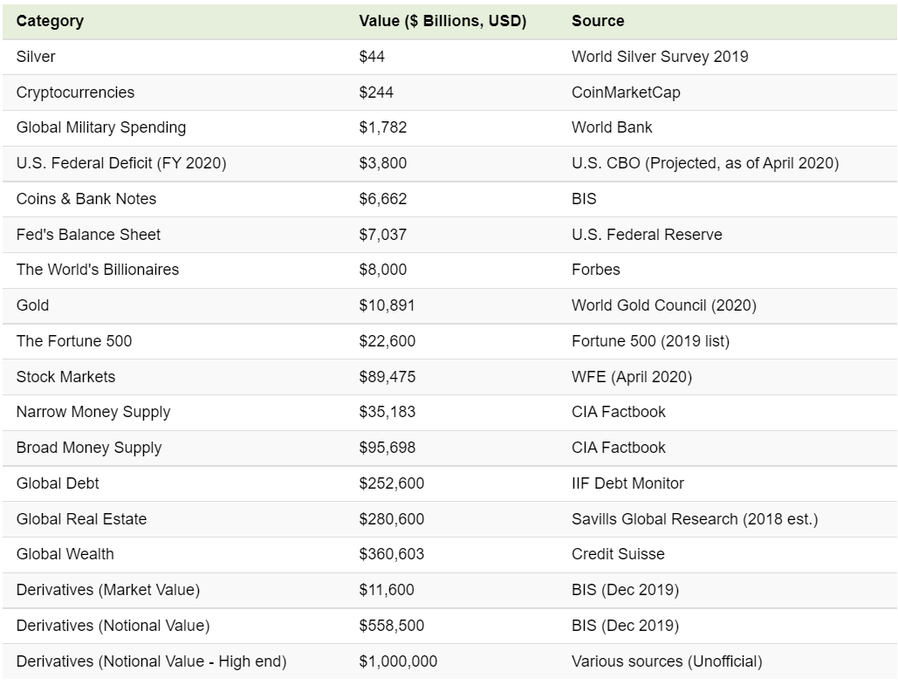
https://www.visualcapitalist.com/all-of-the-worlds-money-and-markets-in-one-visualization-2020/
At the bottom of the list are three derivatives entries, with "Market Value" and "Notional Value" called
out.
The "Market Value" is the value of the derivative at its current trading price.
The "Notional Value" is the value of the derivative if it was at the strike price.
E.g. A CALL option (a derivative) represents 100 shares of ABC stock with a strike of $50. Perhaps it is
trading in the market at $1 per contract right now.
• Market Value = 100 shares * $1.00 per contract = $100
• Notional Value = 100 shares * $50 strike price = $5,000
Visual Capitalist estimates that the cumulative Notional Value of derivatives is between $558
Trillion and $1 Quadrillion. So yeah. You are not going to cause a market crash if GME sells for
millions per share. The rich are already priming the market crash through the Derivatives Market.
1.2 CDOs And Mortgage Backed Securities
Decades ago, the system of paying mortgages used to be between two parties. The buyer, and the loaner.
Since the movement of money was between the buyer and the loaner, the loaner was very careful to
ensure that the buyer would be able to pay off their loan and not miss payments.
But now, it's a chain.
1. Home buyers will buy a loan from the lenders.
2. The lenders will then sell those loans to Investment Banks.
3. The Investment Banks then combine thousands of mortgages and other loans, including
car loans, student loans, and credit card debt to create complex derivatives called
"Collateralized Debt Obligations (CDO's)".
4. The Investment Banks then pay Rating Agencies to rate their CDO's. This can be on a
scale of "AAA", the best possible rating, equivalent to government-backed securities, all
the way down to C/D, which are junk bonds and very risky. Many of these CDO's were
given AAA ratings despite being filled with junk.
5. The Investment Banks then take these CDO's and sell them to investors, including
retirement funds, because that was the rating required for retirement funds as they
would only purchase highly rated securities.
6. Now when the homeowner pays their mortgage, the money flows directly into the
investors. The investors are the main ones who will be hurt if the CDO's containing the
mortgages begin to fail.
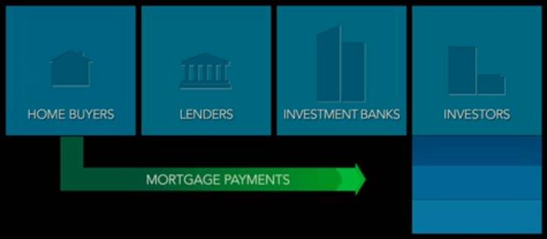
Inside Job (2010) - Flow Of Money For Mortgage Payments
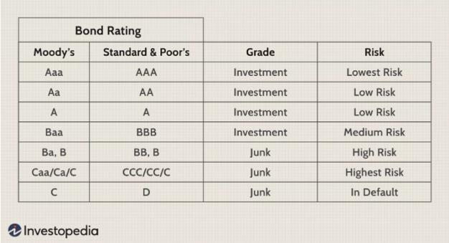
https://www.investopedia.com/ask/answers/09/bond-rating.asp
1.3 The Bubble of Subprime Loans Packed In CDOs
This system became a ticking timebomb due to this potential of free short-term gain cash. Lenders didn't
care if a borrower could repay, so they would start handing out riskier loans. The investment banks
didn't care if there were riskier loans, because the more CDO's sold to investors resulted in more profit.
And the Rating Agencies didn't care because there were no regulatory constraints and there was no
liability if their ratings of the CDO's proved to be wrong.
So they went wild and pumped out more and more loans, and more and more CDOs. Between 2000 and
2003, the number of mortgage loans made each year nearly quadrupled. They didn’t care about the
quality of the mortgage - they cared about maximizing the volume and getting profit out of it.
In the early 2000s there was a huge increase in the riskiest loans - “Subprime Loans”. These are loans
given to people who have low income, limited credit history, poor credit, etc. They are very at risk to not
pay their mortgages. It was predatory lending, because it hunted for potential home buyers who would
never be able to pay back their mortgages so that they could continue to pack these up into CDO's.
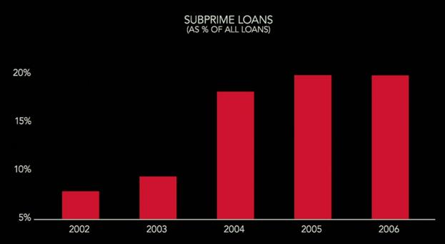
Inside Job (2010) - % Of Subprime Loans
In fact, the investment banks preferred subprime loans, because they carried higher interest rates and
more profit for them.
So the Investment Banks took these subprime loans, packaged the subprime loans up into CDO's,
and many of them still received AAA ratings. These can be considered "toxic CDO's" because of
their high ability to default and fail despite their ratings.
Pretty much anyone could get a home now. Purchases of homes and housing prices skyrocketed. It
didn't matter because everyone in the chain was making money in an unregulated market.
1.4 Short Term Greed At The Risk Of Institutional And
Economic Failure
In Wall Street, annual cash bonuses started to spike. Traders and CEOs became extremely wealthy in this
bubble as they continued to pump more toxic CDO's into the market. Lehman Bros. was one of the top
underwriters of subprime lending and their CEO alone took home over $485 million in bonuses.
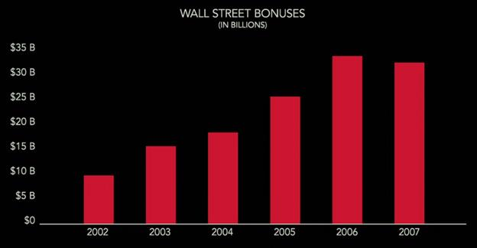
Inside Job (2010) Wall Street Bonuses
And it was all short-term gain, high risk, with no worries about the potential failure of your institution or
the economy. When things collapsed, they would not need to pay back their bonuses and gains. They
were literally risking the entire world economy for the sake of short-term profits.
AND THEY EVEN TOOK IT FURTHER WITH LEVERAGE TO MAXIMIZE PROFITS.
During the bubble from 2000 to 2007, the investment banks were borrowing heavily to buy more loans
and to create more CDO's. The ratio of banks borrowed money and their own money was their leverage.
The more they borrowed, the higher their leverage. They abused leverage to continue churning profits.
And are still abusing massive leverage to this day. It might even be much higher leverage today than
what it was back in the Housing Market Bubble.
In 2004, Henry Paulson, the CEO of Goldman Sachs, helped lobby the SEC to relax limits on leverage,
allowing the banks to sharply increase their borrowing. Basically, the SEC allowed investment banks to
gamble a lot more. Investment banks would go up to about 33-to-1 leverage at the time of the 2008
crash. Which means if a 3% decrease occurred in their asset base, it would leave them insolvent. Henry
Paulson would later become the Secretary Of The Treasury from 2006 to 2009. He was just one of
many Wall Street executives to eventually make it into Government positions. Including the infamous
Gary Gensler, the current SEC chairman, who helped block derivative market regulations.
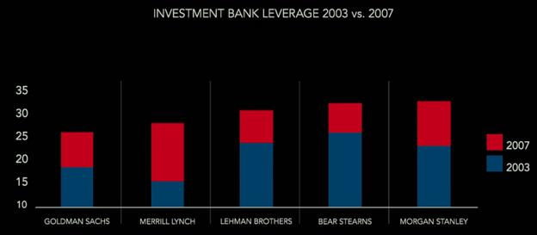
Inside Job (2010) Leverage Abuse of 2008
The borrowing exploded, the profits exploded, and it was all at the risk of obliterating their institutions
and possibly the global economy. Some of these banks knew that they were "too big to fail" and could
push for bailouts at the expense of taxpayers. Especially when they began planting their own executives
in positions of power.
1.5 Credit Default Swaps (CDS)
To add another ticking bomb to the system, AIG, the worlds largest insurance company, got into the
game with another type of derivative. They began selling Credit Default Swaps (CDS).
For investors who owned CDO's, CDS's worked like an insurance policy. An investor who purchased a
CDS paid AIG a quarterly premium. If the CDO went bad, AIG promised to pay the investor for their
losses. Think of it like insuring a car. You're paying premiums, but if you get into an accident, the
insurance will pay up (some of the time at least).
But unlike regular insurance, where you can only insure your car once, speculators could also
purchase CDS's from AIG in order to bet against CDO's they didn't own. You could suddenly have a
sense of rehypothecation where fifty, one hundred entities might now have insurance against a CDO.
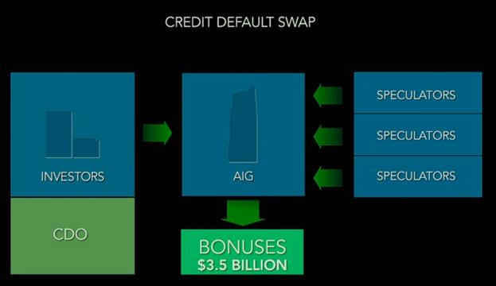
Inside Job (2010) Payment Flow of CDS's
If you've watched The Big Short (2015), you might remember the Credit Default Swaps, because those
are what Michael Burry and others purchased to bet against the Subprime Mortgage CDO's.
CDS's were unregulated, so AIG didn’t have to set aside any money to cover potential losses.
Instead, AIG paid its employees huge cash bonuses as soon as contracts were signed in order to
incentivize the sales of these derivatives. But if the CDO's later went bad, AIG would be on the hook. It
paid everyone short-term gains while pushing the bill to the company itself without worrying about
footing the bill if shit hit the fan. People once again were being rewarded with short-term profit to take
these massive risks.
AIG’s Financial Products division in London issued over $500B worth of CDS's during the bubble. Many
of these CDS's were for CDO's backed by subprime mortgages.
The 400 employees of AIGFP made $3.5B between 2000 and 2007. And the head of AIGFP personally
made $315M.
1.6 The Crash And Consumption Of Banks To Consolidate
Power
By late 2006, Goldman Sachs took it one step further. It didn’t just sell toxic CDO's, it started actively
betting against them at the same time it was telling customers that they were high-quality investments.
Goldman Sachs would purchase CDS's from AIG and bet against CDO's it didn’t own, and got paid when
those CDO's failed. Goldman bought at least $22B in CDS's from AIG, and it was so much that Goldman
realized AIG itself might go bankrupt (which later on it would and the Government had to bail them out).
So Goldman spent $150M insuring themselves against AIG’s potential collapse. They purchased CDS's
against AIG.
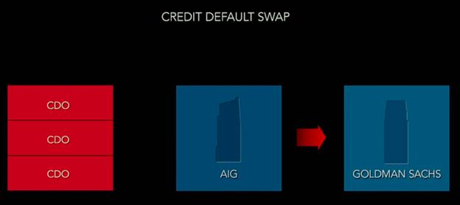
Inside Job (2010) Payment From AIG To Goldman Sachs If CDO's Failed
Then in 2007, Goldman went even further. They started selling CDO's specifically designed so that the
more money their customers lost, the more Goldman Sachs made.
Many other banks did the same. They created shitty CDO's, sold them, while simultaneously bet that they
would fail with CDS's. All of these CDO's were sold to customers as “safe” investments because of the
complicit Rating Agencies.
The three rating agencies, Moody’s, S&P and Fitch, made billions of dollars giving high ratings to these
risky securities. Moody’s, the largest ratings agency, quadrupled its profits between 2000 and 2007. The
more AAA's they gave out, the higher their compensation and earnings were for the quarter. AAA ratings
mushroomed from a handful in 2000 to thousands by 2006. Hundreds of billions of dollars worth of
CDO's were being rated AAA per year. When it all collapsed and the ratings agencies were called before
Congress, the rating agencies expressed that it was “their opinion” of the rating in order to weasel their
way out of blame. Despite knowing that they were toxic and did not deserve anything above 'junk'
rating.
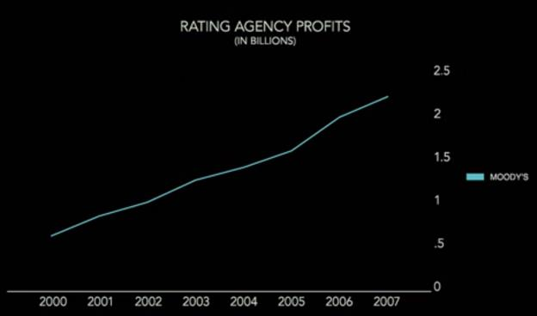
Inside Job (2010) Ratings Agencies Profits
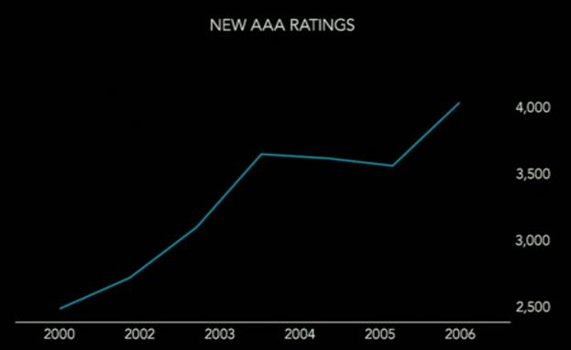
Inside Job (2010) - Insane Increase of AAA Rated CDOs
By 2008, home foreclosures were skyrocketing. Home buyers in the subprime loans were defaulting on
their payments. Lenders could no longer sell their loans to the investment banks. And as the loans went
bad, dozens of lenders failed. The market for CDO's collapsed, leaving the investment banks holding
hundreds of billions of dollars in loans, CDO's, and real estate they couldn’t sell. Meanwhile, those who
purchased up CDS's were knocking at the door to be paid.
In March 2008, Bear Stearns ran out of cash and was acquired for $2 a share by JPMorgan Chase. The
deal was backed by $30B in emergency guarantees by the Fed Reserve. This was just one instance of a
bank getting consumed by a larger entity.
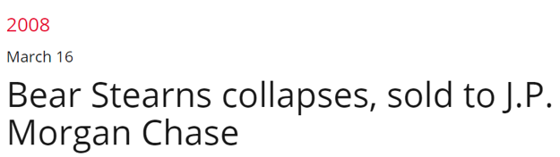
https://www.history.com/this-day-in-history/bear-stearns-sold-to-j-p-morgan-chase
AIG, Bear Stearns, Lehman Bros, Fannie Mae, and Freddie Mac, were all AA or above rating days before
either collapsing or being bailed out. Meaning they were 'very secure', yet they failed.
The Fed Reserve and Big Banks met together in order to discuss bailouts for different banks, and they
decided to let Lehman Brothers fail as well.
The Government also then took over AIG, and a day after the takeover, asked the Government for $700B
in bailouts for big banks. At this point in time, the person in charge of handling the financial crisis,
Henry Paulson, former CEO of Goldman Sachs, worked with the chairman of the Federal Reserve to
force AIG to pay Goldman Sachs some of its bailout money at 100-cents on the dollar. Meaning there was
no negotiation of lower prices. Conflict of interest much?
The Fed and Henry Paulson also forced AIG to surrender their right to sue Goldman Sachs and other
banks for fraud.
This is but a small glimpse of the consolidation of power in big banks from the 2008 crash. They
let others fail and scooped up their assets in the crisis.
After the crash of 2008, big banks are more powerful and more consolidated than ever before.
And the DTC, ICC, OCC rules are planning on making that worse through the auction and wind-
down plans where big banks can once again consume other entities that default.
1.7 The Can-Kick To Continue The Game Of Derivative Market
Greed
After the crisis, the financial industry worked harder than ever to fight reform. The financial sector, as of
2010, employed over 3000 lobbyists. More than five for each member of Congress. Between 1998 and
2008 the financial industry spent over $5B on lobbying and campaign contributions. And ever since the
crisis, they’re spending even more money.
President Barack Obama campaigned heavily on "Change" and "Reform" of Wall Street, but when in
office, nothing substantial was passed. But this goes back for decades - the Government has been in the
pocket of the rich for a long time, both parties, both sides, and their influence through lobbying
undoubtedly prevented any actual change from occurring.
So their game of playing the derivative market was green-lit to still run rampant following the 2008
crash and mass bailouts from the Government at the expense of taxpayers.
There's now more consolidation of banks, more consolidation of power, more years of deregulation, and
over a decade that they used to continue the game. And just like in 2008, it's happening again. We're on
the brink of another market crash and potentially a global financial crisis.
2. The New CDO Game, And How COVID Uppercut To The
System
2.1 Abuse Of Commercial Mortgage Backed Securities
It's not just /u/atobitt's "House Of Cards" where the US Treasury Market has been abused. It is abuse of
many forms of collateral and securities this time around.
It's the same thing as 2008, but much worse due to even higher amounts of leverage in the system on
top of massive amounts of liquidity and potential inflation from stimulus money of the COVID crisis.
Here's an excerpt from The Bigger Short: Wall Street's Cooked Books Fueled The Financial Crisis of
2008. It's Happening Again:
A longtime industry analyst has uncovered creative accounting on a startling scale in the commercial
real estate market, in ways similar to the “liar loans” handed out during the mid-2000s for residential
real estate, according to financial records examined by the analyst and reviewed by The Intercept. A
recent, large-scale academic study backs up his conclusion, finding that banks such as Goldman Sachs
and Citigroup have systematically reported erroneously inflated income data that compromises
the integrity of the resulting securities.
...
The analyst’s findings, first reported by ProPublica last year, are the subject of a whistleblower
complaint he filed in 2019 with the Securities and Exchange Commission. Moreover, the analyst has
identified complex financial machinations by one financial institution, one that both issues loans and
manages a real estate trust, that may ultimately help one of its top tenants — the low-cost, low-wage
store Dollar General — flourish while devastating smaller retailers.
This time, the issue is not a bubble in the housing market, but apparent widespread inflation of the
value of commercial businesses, on which loans are based.
...
Now it may be happening again — this time not with residential mortgage-backed securities, based on
loans for homes, but commercial mortgage-backed securities, or CMBS, based on loans for
businesses. And this industrywide scheme is colliding with a collapse of the commercial real estate
market amid the pandemic, which has business tenants across the country unable to make their
payments.
They've been abusing Commercial Mortgage Backed Securities (CMBS) this time around, and potentially
have still been abusing other forms of collateral - they might still be hitting MBS as well as treasury
bonds per /u/atobitt's DD.
John M. Griffin and Alex Priest released a study last November. They sampled almost 40,000 CMBS loans
with a market capitalization of $650 billion underwritten from the beginning of 2013 to the end of
2019. Their findings were that large banks had 35% or more loans exhibiting 5% or greater
income overstatements.
The below chart shows the overstatements of the biggest problem-making banks. The difference in bars
is between samples taken from data between 2013-2015, and then data between 2016-2019. Almost
every single bank experienced a positive move up over time of overstatements.
Unintentional overstatement should have occurred at random times. Or if lenders were assiduous and
the overstatement was unwitting, one might expect it to diminish over time as the lenders discovered
their mistakes. Instead, with almost every lender, the overstatement increased as time went on.
- Source
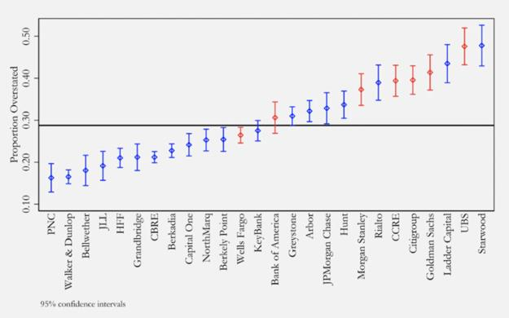
https://theintercept.com/2021/04/20/wall-street-cmbs-dollar-general-ladder-capital/
So what does this mean? It means they've once again been handing out subprime loans (predatory
loans). But this time to businesses through Commercial Mortgage Backed Securities.
Just like Mortgage-Backed Securities from 2000 to 2007, the loaners will go around, hand out loans to
businesses, and rake in the profits while having no concern over the potential for the subprime loans
failing.
2.2 COVID's Uppercut Sent Them Scrambling
The system was propped up to fail just like from the 2000-2007 Housing Market Bubble. Now we are in
a speculative bubble of the entire market along with the Commercial Market Bubble due to continued
mass leverage abuse of the world.
Hell - also in Crypt0currencies that were introduced after the 2008 crash. Did you know that you can
get over 100x leverage in crypt0 right now? Imagine how terrifying that crash could be if the
other markets fail.
There is SO. MUCH. LEVERAGE. ABUSE. IN. THE. WORLD. All it takes is one fatal blow to bring it all down
- and it sure as hell looks like COVID was that uppercut to send everything into a death spiral.
When COVID hit, many people were left without jobs. Others had less pay from the jobs they kept. It
rocked the financial world and it was so unexpected. Apartment residents would now become
delinquent, causing the apartment complexes to become delinquent. Business owners would be hurting
for cash to pay their mortgages as well due to lack of business. The subprime loans all started to become
a really big issue.
Delinquency rates of Commercial Mortgages started to skyrocket when the COVID crisis hit. They even
surpassed 2008 levels in March of 2020. Remember what happened in 2008 when this occurred? When
delinquency rates went up on mortgages in 2008, the CDO's of those mortgages began to fail. But,
this time, they can-kicked it because COVID caught them all off guard.
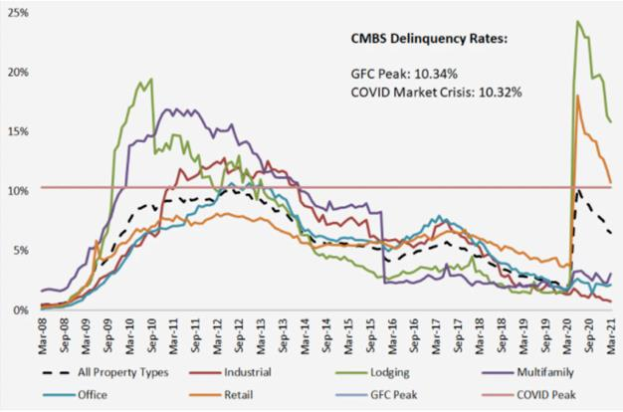
https://theintercept.com/2021/04/20/wall-street-cmbs-dollar-general-ladder-capital/
2.3 Can-Kick Of COVID To Prevent CDO's From Defaulting
Before Being Ready
COVID sent them Scrambling. They could not allow these CDO's to fail just yet, because they wanted to
get their rules in place to help them consume other failing entities at a whim.
Like in 2008, they wanted to not only protect themselves when the nuke went off from these decades of
derivatives abuse, they wanted to be able to scoop up the competition easily. That is when the DTC, ICC,
and OCC began drafting their auction and wind-down plans.
In order to buy time, they began tossing out emergency relief "protections" for the economy. Such as
preventing mortgage defaults which would send their CDO's tumbling. This protection ends on June
30th, 2021.
And guess what? Many people are still at risk of being delinquent. This article was posted
just yesterday. The moment these protection plans lift, we can see a surge in foreclosures as delinquent
payments have accumulated over the past year.
When everyone, including small business owners who were attacked with predatory loans, begin to
default from these emergency plans expiring, it can lead to the CDO's themselves collapsing. Which is
exactly what triggered the 2008 recession.
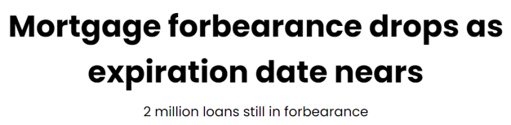
https://www.housingwire.com/articles/mortgage-forbearance-drops-as-expiration-date-nears/
2.4 SLR Requirement Exemption - Why The Reverse Repo Is
Blowing Up
Another big issue exposed from COVID is when SLR requirements were leaned during the pandemic.
They had to pass a quick measure to protect the banks from defaulting in April of 2020.
In a brief announcement, the Fed said it would allow a change to the supplementary leverage ratio to
expire March 31. The initial move, announced April 1, 2020, allowed banks to exclude Treasurys
and deposits with Fed banks from the calculation of the leverage ratio. - Source
What can you take from the above?
SLR is based on the banks deposits with the Fed itself. It is the treasuries and deposits that the
banks have on the Fed's balance sheet. Banks have an 'account block' on the Fed's balance sheet
that holds treasuries and deposits. The SLR pandemic rule allowed them to neglect these
treasuries and deposits from their SLR calculation, and it boosted their SLR value, allowing them
to survive defaults.
This is a big, big, BIG sign that the banks are way overleveraged by borrowing tons of money just
like in 2008.
The SLR is the "Supplementary Leverage Ratio" and they enacted quick to allow it so banks wouldn't fail
under mass leverage for failing to maintain enough equity.
The supplementary leverage ratio is the US implementation of the Basel III Tier 1 leverage ratio, with
which banks calculate the amount of common equity capital they must hold relative to their total
leverage exposure. Large US banks must hold 3%. Top-tier bank holding companies must also
hold an extra 2% buffer, for a total of 5%. The SLR, which does not distinguish between assets based
on risk, is conceived as a backstop to risk-weighted capital requirements. - Source
Here is an exposure of their SLR from earlier this year. The key is to have high SLR, above 5%, as a top-
tier bank:
Bank Supplementary Leverage Ratio (SLR)
JP Morgan Chase 6.8%
Bank Of America 7%
Citigroup 6.7%
Goldman Sachs 6.7%
Morgan Stanley 7.3%
Bank of New York Mellon 8.2%
State Street 8.3%
The SLR protection ended on March 31, 2021. Guess what started to happen just after?
The reverse repo market started to explode. This is VERY unusual behavior because it is not at a
quarter-end where quarter-ends have significant strain on the economy. The build-up over time
implies that there is significant strain on the market AS OF ENTERING Q2 (April 1st - June 30th).
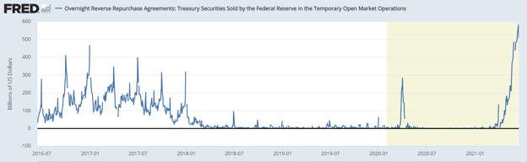
https://fred.stlouisfed.org/series/RRPONTSYD
Speculation: SLR IS DEPENDENT ON THEIR DEPOSITS WITH THE FED ITSELF. THEY NEED TO
EXTRACT TREASURIES OVER NIGHT TO KEEP THEM OFF THE FED'S BALANCE SHEETS TO
PREVENT THEMSELVES FROM FAILING SLR REQUIREMENTS AND DEFAULTING DUE TO MASS
OVERLEVERAGE. EACH BANK HAS AN ACCOUNT ON THE FED'S BALANCE SHEET, WHICH IS WHAT
SLR IS CALCULATED AGAINST. THIS IS WHY IT IS EXPLODING. THEY ARE ALL STRUGGLING TO
MEET SLR REQUIREMENTS.
2.5 DTC, ICC, OCC Wind-Down and Auction Plans; Preparing
For More Consolidation Of Power
We've seen some interesting rules from the DTC, ICC, and OCC. For the longest time we thought this was
all surrounding GameStop. Guess what. They aren't all about GameStop. Some of them are, but not all
of them.
They are furiously passing these rules because the COVID can-kick can't last forever. The Fed is
dealing with the potential of runaway inflation from COVID stimulus and they can't allow the
overleveraged banks to can-kick any more. They need to resolve this as soon as possible. June
30th could be the deadline because of the potential for CDO's to begin collapsing.
Let's revisit a few of these rules. The most important ones, in my opinion, because they shed light on the
bullshit they're trying to do once again: Scoop up competitors at the cheap, and protect themselves from
defaulting as well.
• DTC-004: Wind-down and auction plan. - Link
• ICC-005: Wind-down and auction plan. - Link
• OCC-004: Auction plan. Allows third parties to join in. - Link
• OCC-003: Shielding plan. Protects the OCC. - Link
Each of these plans, in brief summary, allows each branch of the market to protect themselves in the
event of major defaults of members. They also allow members to scoop up assets of defaulting
members.
What was that? Scooping up assets? In other words it is more concentration of power. Less
competition.
I would not be surprised if many small and large Banks, Hedge Funds, and Financial Institutions
evaporate and get consumed after this crash and we're left with just a select few massive entities. That
is, after all, exactly what they're planning for.
They could not allow the COVID crash to pop their massive speculative derivative bubble so soon. It
came too sudden for them to not all collapse instead of just a few of them. It would have obliterated the
entire economy even more so than it will once this bomb is finally let off. They needed more time to
prepare so that they could feast when it all comes crashing down.
2.6 Signs Of Collapse Coming - ICC-014 - Incentives For Credit
Default Swaps
A comment on this subreddit made me revisit a rule passed by the ICC. It flew under the radar and is
another sign for a crash coming.
This is ICC-014. Passed and effective as of June 1st, 2021.
Seems boring at first. Right? That's why it flew under the radar?
But now that you know the causes of the 2008 market crash and how toxic CDO's were packaged
together, and then CDS's were used to bet against those CDO's, check out what ICC-014 is doing as of
June 1st.
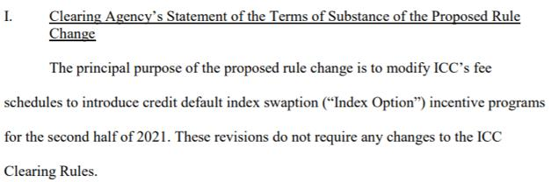
ICC-014 Proposed Discounts On Credit Default Index Swaptions
They are providing incentive programs to purchase Credit Default Swap Indexes. These are like
standard CDS's, but packaged together like an index. Think of it like an index fund.
This is allowing them to bet against a wide range of CDO's or other entities at a cheaper rate.
Buyers can now bet against a wide range of failures in the market. They are allowing upwards of
25% discounts.
There's many more indicators that are pointing to a market collapse. But I will leave that to you to
investigate more. Here is quite a scary compilation of charts relating the current market trends to the
crashes of Black Monday, The Internet Bubble, The 2008 Housing Market Crash, and Today.
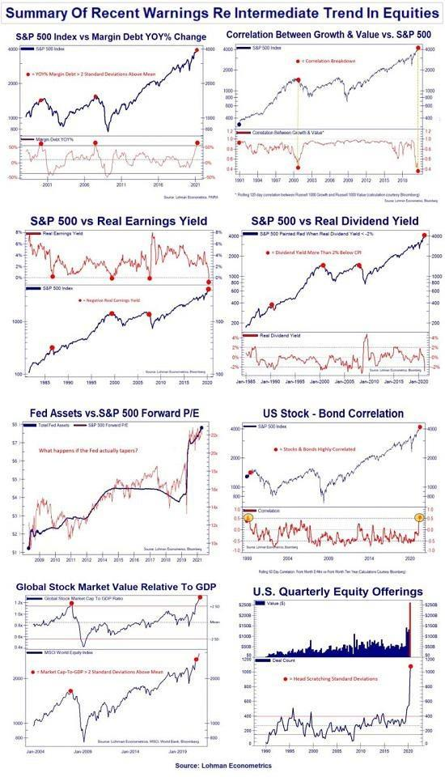
Summary of Recent Warnings Re Intermediate Trend In Equities
3. The Failure Of The 1% - How GameStop Can Deal A Fatal
Blow To Wealth Inequality
3.1 GameStop Was Never Going To Cause The Market Crash
GameStop was meant to die off. The rich bet against it many folds over, and it was on the brink of
Bankruptcy before many conditions led it to where it is today.
It was never going to cause the market crash. And it never will cause the crash. The short squeeze is a
result of high abuse of the derivatives market over the past decade, where Wall Street's abuse of this
market has primed the economy for another market crash on their own.
We can see this because when COVID hit, GameStop was a non-issue in the market. The CDO market
around CMBS was about to collapse on its own because of the instantaneous recession which left
mortgage owners delinquent.
If anyone, be it the media, the US Government, or others, try to blame this crash on GameStop or
anything other than the Banks and Wall Street, they are WRONG.
3.2 The Rich Are Trying To Kill GameStop. They Are Terrified
In January, the SI% was reported to be 140%. But it is very likely that it was underreported at that
time. Maybe it was 200% back then. 400%. 800%. Who knows. From the above you can hopefully gather
that Wall Street takes on massive risks all the time, they do not care as long as it churns them
short-term profits. There is loads of evidence pointing to shorts never covering by hiding their SI%
through malicious options practices, and manipulating the price every step of the way.
The conditions that led GameStop to where it is today is a miracle in itself, and the support of retail
traders has led to expose a fatal mistake of the rich. Because a short position has infinite loss
potential. There is SO much money in the world, especially in the derivatives market.
This should scream to you that any price target that you think is low, could very well be extremely low
in YOUR perspective. You might just be accustomed to thinking "$X price floor is too much money.
There's no way it can hit that". I used to think that too, until I dove deep into this bullshit.
The market crashing no longer was a matter of simply scooping up defaulters, their assets, and
consolidating power. The rich now have to worry about the potential of infinite losses from GameStop
and possibly other meme stocks with high price floor targets some retail have.
It's not a fight against Melvin / Citadel / Point72. It's a battle against the entire financial world. There
is even speculation from multiple people that the Fed is even being complicit right now in helping
suppress GameStop. Their whole game is at risk here.
Don't you think they'd fight tooth-and-nail to suppress this and try to get everyone to sell?
That they'd pull every trick in the book to make you think that they've covered?
The amount of money they could lose is unfathomable.
With the collapsing SI%, it is mathematically impossible for the squeeze to have happened - its
mathematically impossible for them to have covered. /u/atobitt also discusses this in House of Cards
Part 2.
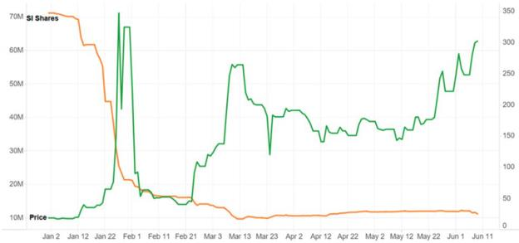
https://www.thebharatexpressnews.com/short-squeeze-could-save-gamestop-investors-a-third-time/
And in regards to all the other rules that look good for the MOASS - I see them in a negative light.
They are passing NSCC-002/801, DTC-005, and others, in order to prevent a GameStop situation
from ever occurring again.
They realized how much power retail could have from piling into a short squeeze play. These new rules
will snap new emerging short squeezes instantly if the conditions of a short squeeze ever occur again.
There will never be a GameStop situation after this.
It's their game after all. They've been abusing the derivative market game for decades and GameStop is a
huge threat. It was supposed to be, "crash the economy and run with the money". Not "crash the
economy and pay up to retail". But GameStop was a flaw exposed by their greed, the COVID crash, and
the quick turn-around of the company to take it away from the brink of bankruptcy.
The rich are now at risk of losing that money and insane amounts of cash that they've accumulated over
the years from causing the Internet Bubble Crash of 2000, and the Housing Market Crash of 2008.
So, yeah, I'm going to be fucking greedy.
Back to Table of Contents
Elliot Waves, GME, The S&P 500, Wen Market
Peak and GME Boom?
DD 👨‍🔬
Sup Apes
Not Financial Advice
I'm so honored to finally have the Elliot Wave Guy flair!!! I post on twitter pretty consistently now, if you
wanna see snippets of analysis and whatnot intraday (also in the event my reddit gets
hacked) https://twitter.com/gavinmayreal
Please remember this is all just my theory, I can very well be wrong. I’m just an ape who want banana
🍌
This post isn't gonna be talking about GME's wave's as much, rather the broader market, and how we
can use SPX (I'm gonna be referencing $SPY in this post, ETF that tracks the SP500, SPYDER GANG) as a
gauge of when to expect some erratic GME movement.
I have one request before I begin, please blast this song while reading, it sets the
mood: https://youtu.be/MN3x-kAbgFU
Okay then, hope everyone is having an amazing evening! I think it's a pretty safe assumption to assume
that the majority of apes here understand the GME situation pretty well. What I'm gonna be focusing on
in this post is how we can use elliot waves on SPY to not only predict the top of this absurd, seemingly
endless bull market, but more importantly, how we can use these targets on the broader market in
relation to GME.
We all know by now that GME is a negative beta stock. Simply put, Beta is a numeric value that
measures the fluctuations of a stock to changes in the overall stock market. Beta measures the
responsiveness of a stock's price to changes in the overall stock market. ... The volatility of the stock and
systematic risk can be judged by calculating beta.
normal stocks have a positive beta, usually around 1.0, meaning if the market (SPY) drops 1 point, we
can assume said ticker will drop 1 point as well. idk what GME's beta is as of now, though it's probably
something ridiculously negative (anyone with a bloomberg terminal wanna lmk the actual beta?). I've
seen numbers ranging from -5 to -40... needless to say, GME does indeed have a negative beta.
wut mean?
There have been many great thesis's drafted regarding GME boom = market crash, which I think are
completely true. In short, the market crash makes GME moon, or GME moon causes the market crash.
why? I know people have noticed the wild crip toe fluctuations and drops, this is partly attributed to
capital requirements, meaning if shorts don't post collateral by x time on x date, marge comes a calling.
But think about the stock market. It's no secret that hedgies are also long certain stocks, after all they
manage billions and billions of dollars. Citadel recent 13f: https://whalewisdom.com/filer/citadel-advisors-
llc#tabholdings_tab_link
Do note the last reported 13f is 3/31, reported quarterly.
Interesting how their largest position reported is short SPY huh? Anyways, not much of a point digging
through their holdings, you can if you want but I don't see it as a super useful way to spend your time.
if (when) the market takes a turn and enters a bear market, needless to say their long positions lose
value. What happens when their long positions are suddenly worth less and they need to post collateral
to avoid marge calling in... See where I'm going with this?
onto the wavvveeeesssssss
Below is a monthly view of SPY:
monthly
This is our SUPER CYCLE, starting from the low of the 08 fin crisis. Now let's zoom in and see where
we're at on a smaller scale:
4 hr compressed
Remember, the order for wave cycles is grand super cycle, super cycle, cycle, primary, intermediate, and
so on. What's important is you can distinguish where we are at in any cycle. For SPY, we are actually in
the 5th wave of our 5th wave of our 5th wave... can anyone tell me what that means?
I'll wait...
come on...
I know you know...
Okay fine I'll tell you. Using EW, we can clearly see that we are nearing the tippy top of this raging bull
market. From a grand super cycle standpoint alone, my next target comes out to 428.5, and my cycle 5
(not super cycle, too lazy to draw a bunch of lines lol) target comes out to 429.69 (nice).
now, this under no circumstances is saying SPY will peak at exactly 429.69 and begin to trend
downward (though that would be pretty fucking funny right, i mean 69? come on, doesn't get any better
than that). However, what we DO know is that GME and the rest of the market are correlated.
So, my working thesis is that the top of the stock market is not only predictable, but imminent. Tying this
into GME, well, you know the rest.
Speaking of GME, a little update on the waaavvveees:
4hr
1hr
Do note, we have not actually hit the 61.8% retracement of our cycle 1 (201), we under no
circumstances have to hit that for the structure to be valid. In fact, the structure is valid unless we break
under 112.83 (bottom of cycle 1), so I wouldn't worry about that at all haha. I'm still waiting for a
significant move to give updated GME upside targets, tis a waiting game for now. What's new? Wish I
had more time, need more shares.
Regarding SPY, because this is our super cycle, and we are nearing the peak, that means that we must
then correct that entire move via an ABC correction, targeting minimum 50% of that entire move. Where
does that put SPY when all is said and done?
SHEEEEEEESH
50% of the entire 5 wave super cycle puts SPY at 247.67 (assuming ~ 429 is the top). It could go higher
than 429 without a doubt, though i doubt much higher in all honesty.
Alright, I think I covered everything. Thanks for reading and have a great rest of your night!
TLDR: The top of the market is imminent, using EW, we are literally at the tippy top with only a few
points till bear market ensues. GME moves inverse the market for a variety of reasons... the market is
near the top, GME moves inverse the market, the market is near the top............ mmm yes it's all coming
together...
JACKED TO INFINITY!!! BUY AND HODL!!! 🚀
edit: okay, maybe let's dance isn't the best song to listen to for this, remember the big shorts' "dont
fucking dance?" my bad, gme exciting, rest of market for everyone not in GME, not so much. Have
updated with another banger, also sets the mood :)
edit 2: Just for reference, here is SPY vs GME at the end of January:
SPY: https://imgur.com/BaQ1cu1
GME: https://imgur.com/oYtGCgc
Back to Table of Contents
Why big name banks like Bank of America, JP
Morgan Chase, Citigroup and more were
excluded from bonds sales in the EU, and what
banks have been doing for YEARS to
manipulate the market to fuck everyone else
over
DD 👨‍🔬
Edit: I just want to thank everyone for the support you guys
have been giving me in the comments! I truly appreciate it and I
am greatful that this community is a really nice and caring one. I
wouldn't want to go to the moon any other way, this sub is really
something else. :)
Hello fellow apes! Its been difficult finding something to properly write up about lately, but I think I've
got some right now all things considered.
By now, you may have seen posts like this floating around on reddit:
https://www.reddit.com/r/Superstonk/comments/o0ctw1/eu_freezes_10_banks_out_of_bond_sales_ov
er/?utm_medium=android_app&utm_source=share
Here is a quote that I think helps effectively summarize an alternative article the OP of the post provided
regarding this topic:
"A spokesperson for the European Commission, which handles debt issuance on behalf of the European
Union, said that banks found to have violated EU competition rules “will not be invited to bid for
individual syndicated transactions. "
Wut mean?
Basically, the articles were saying that the EU had to literally FORCEFULLY stop banks from
participating in their bonds sales because of how ridiculous their borrowing has gotten, along with their
history of market manipulation in the past. The fact that a lot of these banks are common names here in
the US: JP Morgan Chase, Bank of America, Citigroup, etc. speaks volumes to how bad the fuckery has
really gotten.
I want to just elaborate a bit: these banks are trying to not just borrow bonds from the US, but ALSO
from the EU just to try to fix their balance sheet and make their debt look a little bit more reasonable.
The EU saw ahead of the disaster and took IMMEDIATE action to stop it, as they didn't want the fire to
spread to them and screw them as well.
Its quite clear at this point that they have fucked the system, but what have they been DOING exactly to
fuck the system, and fuck EVERYONE except themselves just to keep themselves afloat?
I refrence another article in the following paragraph, from this source:
https://ec.europa.eu/commission/presscorner/detail/en/ip_21_2004
Here is exactly what they have been doing, according to a European article speaking on the European
commission fining banks like these for violating EU anti-trust laws (keep in mind, this was from April of
2021 and are regarding different bonds but multiple big name banks are probably still doing this
overall):
1. Logged onto multilateral/ bi-lateral chat rooms on Bloomberg terminals and knew each
other suspiciously well despite being in "direct competition".
2. Because of how well they knew each other, they updated each other frequently on their
trading activities.
3. They had at times agreed to hold back on bidding and offering in the market if it meant
they would come into competition with each other.
4. They had split trades between each other to either combine or reduce their positions to
meet a specific customer's request (the article doesn't specify on what customer in
particular) without the customer themselves knowing they were dealing with more than
one entity and thus in theory the customer's choices were limited.
Conclusion/TLDR:
Basically, Bank of America, Merrill Lynch, Crédit Agricole, and Credit Suisse all aligned their trading
activities in such a way that they acted as a SINGLE entity to manipulate the bonds market in April 2021
and got caught for it and fined. But remember, these were just the banks that GOT CAUGHT doing this.
With the EU recently barring more big banks like JP Morgan & Chase and Citigroup from participating in
their bonds sales it looks like they are suspicious of them as well in corroborating in market collusion to
a similar degree.
How many more banks are in on this collusion, acting as one big entity to further their own agenda in
the market and fuck everyone else over, that has been happening for MULTIPLE years now? Is their debt
so big now that they are preying on EU bonds and the EU realizes what could happen if these big name
banks colluded in bonds sales together and spread their debt amongst themselves so they don't all go
down together? I feel like when the whole truth comes out and more gets revealed regarding this it will
possibly be the absolute WORST case of financial corruption in this "free market" in history.
Post DD Message
And as always guys, thanks for reading my posts! :) I know I haven't posted as much lately regarding DD
and in all honesty the reasoning for that was because a lot of my DD would get debunked, and I felt
discouraged to continue making more without stronger sources to back up my claims. I tried to make my
DD a little stronger today, and I hope you guys have enjoyed reading it! Hopefully I can continue to
improve more with DD in the future and make something really good in quality.
Sources:
https://ec.europa.eu/commission/presscorner/detail/en/ip_21_2004
https://quebecnewstribune.com/news/business/eu-freezes-bond-sales-of-10-banks-for-violating-
antitrust-laws-18190/
Back to Table of Contents
Riding Elliot Waves to the Moon, Why GME
from a Technical Standpoint Alone is Better
Than Gold
DD 👨‍🔬
Sup apes, Elliot Waves guy here.
I wanted to write this post because for one, my last post blew up way more than I ever expected, so I
have a lot of new readers now. If you missed my previous post, you can check it out here (seriously, I
can't thank this community enough for all your love and
support) https://www.reddit.com/r/Superstonk/comments/nwyj77/elliot_waves_and_gme_why_im_ja
cked_to_infinity/
This post isn't gonna be going over technical levels as much, rather a general overview of why I believe
the stock price is about to take off from a technical perspective only, and how it all ties into the bigger
picture. I also noticed on my last post, there was an issue with the images loading when I added them
directly to the post, so from now on I'll just be linking everything via imgur.com
I had to make a small edit in my recent post as I didn't analyze the proper fib ratio when saying 213
appeared to be the bottom. In EW theory, wave 2 typically retraces 61.8% of wave 1, though the 61.8%
level I used in that analysis was actually from the start of a 5 wave impulse within the cycle, not the
actual cycle. I have circled the proper fib ratios for the apparent Cycle 1 and 2 that appear to have
completed:
https://imgur.com/r9UEkkr
Hopefully you caught my edit in my recent post, but if you didn't, this puts our bottom of cycle 2 at 201.
We did not hit this level to the T, though given the nature of the rebound from the lows yesterday, I'm
inclined to say that we will not see us hit 201... though if we do, expect a bounce:
https://imgur.com/3CVBUu5
Wave 3 is often the longest and strongest of the 5 wave impulse, but what I want you to note that is
specifically interesting about this specific situation with GME, we are in a 3 within a 3 within a 3, just
starting the Cycle 3 (the order is grand super cycle, super cycle, cycle, primary, intermediate, and so on)
In the image I'm about to link, do note just because a price target based on the line I drew is on a certain
date, do not bank on anything happening by said date. This is solely for visualization purposes. For
reference our cycle 1 took over 2 months to pan out, though this can be attributed to many outside
factors causing us to trade sideways for a considerable amount of time (circled, March 24 to June 8).
Grand super cycle is illustrated in blue, super cycle in yellow, and cycle in white:
https://imgur.com/PJfbmCL
Just for reference: I'm gonna link a car/truck company and a company that does electricity generally
(boomer stocks are great examples of EW in action, also automod doesn’t let me use other tickers lol)
note how wave 3 is the strongest for both:
Cars and trucks that starts with eff: https://imgur.com/yG6itXH
Electricity, generally : https://imgur.com/FLfk2Xy
Granted, these were not a 3 within a 3 within a 3, but even from a visual standpoint on boring ass stocks,
you can see Elliot Wave theory come to fruition.
As for GME short term, I can't quite give short term upside targets yet, as I am yet to see a primary 1 and
2 complete. To verify this action, I'm looking for a strong ish move to the upside followed by a 50%-
61.8% correction of that move.
This is THE time to really be loading up, to be honest, from an EW standpoint, this is about as good a
setup you can dream of, the risk/reward from a technical standpoint is worth drooling over, and this
isn't even factoring in a short squeeze.
Do note, when the rocket really kicks off, and I mean well above 5 figures, this is when I'll have to take
out my big crayon and draw that whole movement set as a 1, if that makes sense. Worrying about that
later haha, for now all i know is buy, hodl, buy some more, okay maybe some more, and hodl for 8
figures or more.
Will try to post every day of the trading week by popular demand, in the event my account gets attacked
(as has happened to previous well known DD creators in the past), check out my
twitter: https://twitter.com/gavinmayreal Much easier to do small updates on their as well 🚀
I just started posting my analysis on twitter, disregard the follower count hahaha I used to be a youtuber
back in the day, sort of retired cause I don't really like where it's gone, but if people would like I can start
posting genuine tutorials on my Youtube.
GME? bullish af. Shorts? fuk. Tits? Jacked.
My Cycle 3 targets are as follows: https://imgur.com/g80KXrX
Please remember, these are CYCLE 3 targets, not intermediate or primary, meaning don't be upset if we
dont break 500 this week... It is inevitable that we will in due time, and the ball is really about to start
rolling. Can it just be Monday already?
also note, quad witching comes up this Friday:
https://preview.redd.it/mkvwok0vpw471.png?width=859&format=png&auto=webp&s=86bdbd4d9c9f
50b398d683185efd316542da47c6
TLDR: GME is at the bottom of a cycle 3, within a super cycle 3, within a grand super cycle 3. this is the
most bullish EW trading setup possible, and EW traders dream of finding this setup. These low prices
won't last 🚀 Hopefully Automod doesn't block it this time 🤞
Edit: lol super random, I bought assassins creed Valhalla from my local GameStop recently, if you know,
what are the best weapons? 🤣
Back to Table of Contents
Cohen has reached the same conclusion as
u/Criand's T+21 Net Capital thesis: An analysis
of tweet activity and corporate
announcements
DD 👨‍🔬
This is not financial advice. I am a retard who always lets one banana in the bunch he buys go bad because
I can’t time eating the bananas correctly.
UPDATE WITH LATEST RC TWEET:
https://www.reddit.com/r/Superstonk/comments/o6tax3/hi_all_its_ryan_cohen_t21_tweet_guy_im_los
ing_my/
TL;DR: CHANCE THAT THIS IS RANDOM IS NOW 0.0069543%!
And another edit now that June 24th has passed:
So we are clear that T+21 did not happen Thursday, and probably not Friday either (due to the
Juneteenth speculation). I reiterate that the main purpose of the post is to demonstrate that Cohen is
aware of the mechanics behind this situation and price movement, and that shareholders are in good
hands. However, I am inclined to present two main alternatives theses:
A) SHF were able to reach the 100% net capital requirement, moving payment to T+28;
https://www.reddit.com/r/Superstonk/comments/o7g9mn/net_capital_and_t21/
Speculating that injection of 5 million shares through the offering allowed shorts to have enough money
to pass the 75% net capital requirement. If that is the case we will see on July 5th/6th (Mon/Tues,
depending on Juneteenth). Personally, I don't think dates are an issue. The public has a limited amount
of information to work with and this is the best apes can do. Up until now, net capital cycles have been
the best way to predict price movements, aside from T+35 day-per-day FTD's (refer to u/dentisttft 's
posts)
B) SHF covered not only the previous cycle, but also the current cycle in the runup to 340.
The fact is, apes are going to buy and hodl anyways; many are immune to the dips at this point. I've
already gotten hateful comments from gme_meltdown users trying to spread FUD in this forum (talk
about brigading, huh?). Apes give constructive feedback, alternative theories, and support; remember
this. And there is plenty of good news to come out of this week - I mean, Cohen did make the tweet on
supposed T+21. And the price didn't go up; that's proof enough that the price movements are not due to
his tweets but due to underlying mechanisms.
And the original post ---
This post will re-analyze Cohen's tweets and Gamestop's positive price movements in relation
tou/Criand's new T+21 net capital thesis.
First of all I would like to lead you to Criand’s new post, “Revisit to Net Capital”.
https://www.reddit.com/r/Superstonk/comments/ny2ov4/a_revisit_to_net_capital_what_is_truly_drivi
ng/
I believe that TA does not apply to our favorite stock (but look forward to Elliot Wave guys proving me
wrong), but the initial T+21/T+35 cycles were unique in that they don’t rely on normal stock behavior,
and instead analyze the unique situation GME is in (excessive shorting, FTD’s). Additionally, it has had
almost a 100% success rate at predicting price movements.
I believe the net capital requirement thesis ties this together by eliminating loose ends in the previous
theory, such as the shaky T+35 price movements, in addition to providing a solid explanation as
to whythese movements occur.
I decided to take this opportunity to revisit speculation on Cohen’s tweets/Gamestop major
news, their timing, and analyze if these were the causes of price movements (and thus not the actual
cycles). I decided to investigate by going full retard on my only day off and investigating each news
report compared to the net capital cycle. The result has my tits absolutely, indescribably jacked**:**
If you’d like to follow along, let’s open Criand’s beautiful chart -
https://preview.redd.it/xh4u2ugmfs471.png?width=1438&format=png&auto=webp&s=85188eccc2bf3
841bb98e37e5be98b8badcc01c7
and take a look with some positive Gamestop news catalysts and tweets from our favorite Ryan Cohen.
I’ll keep this area to data only and leave speculations for the end.
1. The Ice Cream Cone
https://twitter.com/ryancohen/status/1364650709669601289
Ryan Cohen tweets the famous ice cream cone on Feb 24, lining up perfectly with the T+21 net capital
requirement date. The price rockets that day. Edit: The tweet was at 1:57PM. A large influx of buying
volume began in the morning (9:30, 10:30), and the spike came at 2:30PM. The tweet may have
exacerbated the T+21 cycle, but did not cause it.
2. Voluntary redemption of senior notes is announced.
https://news.gamestop.com/news-releases/news-release-details/gamestop-announces-voluntary-
early-redemption-senior-notes-0
GME announces a voluntary early redemption of senior notes on April 13th. Price spike is April 13 AH –
T+14 date is April 15th. The positive news does not correlate with price movement.
Side note: DFV Final Yolo update: April 16th
3. Cohen train tweet.
https://twitter.com/ryancohen/status/1386485746916380673
April 25th: Cohen tweets a train coming. South Park. This is one day before the T+21 or 75% Net
capital cycle. Additionally:
4. Gamestop announces completion of the At-The-Market
equity offering program.
https://news.gamestop.com/news-releases/news-release-details/gamestop-completes-market-equity-
offering-
program#:~:text=GameStop%20disclosed%20on%20April%205,time%20through%20the%20ATM%2
0Offering.
This news is placed directly on the T+21 date. Price spikes.
May 3rd; Gamestop completes voluntary early redemption of senior notes, leading them out of debt.
T+7 is May 5th, no price movement on this announcement. They also announce acquisition of a 700,000
sq. ft fulfillment center, resulting in no price movement.
May 11; Gamestop tweets man on the moon, T+14 is May 14th,
May 12, Gamestop Esports twitter profile is launched.
None of these announcements result in significant price movement. Neither do Cohen's tweets in
between T+21 dates. These should go to show that his tweets are not the cause of the price movements.
May 25, Ryan Cohen tweets “Don’t try this at home” at 12:32
AM, midnight before market open on the T+21 cycle the next
day.
https://twitter.com/ryancohen/status/1397047791889879041
Price spike.
Later that day, the Gamestop NFT is found. It has a launch date of July 14, 1 day before June 24 T+14
cycle.
May 29, Cohen tweets “R.I.P. dumb ass”, noting that the T+21 cycle has been figured out and the Hedgies.
Are. Fuk.
Speculation:
Cohen is fully aware of the T+21 net capital loop that the hedge funds are trapped in. Given that both
good news and hype tweets are clearly insufficient to result in a positive price movement (See: May 3rd,
May 11, May 12, April 13), I am highly doubtful that an ice cream cone tweet is enough to drive up the
price by over 100%.
I believe that Cohen has had this figured out since very early on, and that’s clear in his tweet behavior on
later T+21 dates.
This can also explain why Gamestop made the choice to conduct a share offering on 6/9 -
6/9, the Gamestop shareholder meeting, as meme of a date as it may be, is not on a significant net capital
requirement date, and thus Cohen and friends were well aware that the price would fall again. To
counteract negative sentiment, he announces the share offering; effectively, FUD immunity, because any
negative movement can be attributed to it. Additionally, it provides 1 billion dollars in capital for future
positive announcements, which he can place on the T+21 dates; for example, the June 24 T+21, which is
in close proximity to the Russel rebalancing. Note: So far, only Cohen tweets have lined up with T+21
dates. If positive Gamestop news; an acquisition, a dividend, NFT’s, esports deals lines up… oh god. No
dates, but those with shares have nothing to worry about - they're in good hands. Only up.
Tl;dr: Cohen is well aware of the T+21 dates and has lined up his own tweets in clear indication of it. The
6/9 ATM market offering, although I know many apes including myself were disappointed by, is
basically FUD immunity as the price falls in between T+21 cycles. Furthermore, it raises capital for
positive corporate announcements which can be lined up with T+21 dates, which so far, only Cohen
tweets have lined up with. Positive news and RC tweets that are not on T+21 dates do not result in price
movement, indicating that they are not the catalyst themselves, but may compound them.
We’re in good hands. If you hodl shares, there’s nothing to worry about. HODL!
Edit: formatting. If anyone has criticisms, announcements, or additional news that I missed, please
comment below.
Not financial advice.
EDIT: Guys I fucking missed one.
On March 25, Cohen tweets our smoky teddy,
https://twitter.com/ryancohen/status/1375159657166209031
Lining up with the T+21 date on March 25th.
With this, out of 18 Cohen tweets since his activity in Gamestop, 4 of them line up with the 5 T+21 cycle
days thus far, missing only the first one on January. While it is possible that this is a coincidence, given
that there's about 180 days since the beginning of all this I don't think it's very likely. If anyone is a
statistics legend and could calculate the probability that this is random it would be much appreciated.
Also, I don't think there's much of another reason why he would tweet an ice cream cone.
edit: Reached out to friend who is a statistics major. He just graduated and doesn't want to do math but
his response was - "Pretty sure though just from inspection it'll be statistically significant".
edit 2: Update - math wrinkle brain messaged me with:
"I can't post bc of karma but the probability of having at least 4 right dates on 5 while picking 18 out of
180 is 0.0339% It's an hypergeometric law."
In basically any statistical research model this is significant. As always if anyone has any corrections to
this please comment or message me. Tits jacked!
FAQ: When is the next T+21?
June 24 (it says in chart)
Back to Table of Contents
A revisit to Net Capital. What is truly driving
these T+21 loops, the March and June gamma
runs, and how skyrocketing ETF FTDs might
cause big price movements in the coming
weeks.
DD 👨‍🔬
0. Preface
Well well, I think it's time to revisit an old topic. Net Capital. I posted about this in the past and for some
reason gave up on it. I can now provide counter DD to my own T+21/T+35 theory.
Remember - I am not a financial advisor and I do not provide financial advice! Everything in here is
based on research and discussion with others on the topics. As always, do your own research and
criticize. Take my opinions with a grain of salt.
Wanting to revisit the Net Capital topic was a few things. There were posts about ETF FTDs
spiking severely as of May 12th - even more than the highest peaks of January. I had my own doubts
over time of how we could possibly have multiple cycles overlapping, when it felt more like there would
be only a single cycle. And of course, some people commented and/or posted counter DD! Which I think
is awesome, it's always good to provide counter DD.
Kenny and his gang love to continue digging a hole for themselves - while the whole financial world tries
desperately to contain this potential market crash from coming to fruition.
GME shorts and Reverse Repo Market go brrrrrrrr.
TLDR: Sorry I'm too lazy right now. About to post this and go to sleep. 😎
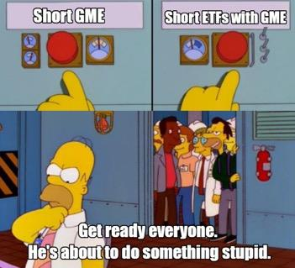
Kenny And The Boys
My previous post about Net Capital was thinking that we'd see significant price movement T+14 days
after April 16th options expirations. That didn't happen, so I tossed it out of the window. (Criand, you
dumb bitch)
Which then led me down the path of the T+21 Loop Missing Link. It got pretty popular. It's the whole
T+21/T+35 conjunction theory that occurred May 24th and May 25th. While it definitely appears to be
right, I have been doubting it ever since May 24th. Especially after a courageous
ape u/dentisttftposted the Counter DD to T+21 theory. T+35 (May 24th) didn't have significant enough
price movement. If it truly was a new T+35 initiating a loop, then it should have exploded up in price on
May
24th. And for that, I think it's time to put that theory to bed.
The counter DD that /u/dentisttft posted is excellent and you should definitely take a look. If my
post is wrong, /u/dentisttft still proposes another possibility: that T+35 from the FTD spike could
initiate buy pressure around June 17th.
Ever since the counter DD, I decided to revisit Net Capital since that is what /u/keijikage brought to my
attention so many weeks ago. Very smart guy by the way! Always very knowledgeable and provides
amazing discussion!
Looking back on Net Capital now, especially with the ETF FTD spike that occurred on May 12th, it might
finally paint the picture as to what has been going on this whole time with the "T+21 cycle", the March
Gamma Ramp, and the June Gamma Ramp.
1. GME FTDs, ETF FTDs, Massive Resurgence Started May 12
First, I want to discuss ETF FTDs, as something absolutely wild occurred in May. Note that we
do nothave the full months FTD data yet. The SEC releases the data in first half and second half of the
month reports. So, it cuts off quite conveniently when FTDs began to go haywire.
For a while now it's been theorized (with some pretty damn good evidence) that ETFs containing GME
have been heavily shorted. Supposedly they will short the ETF, buy up all of the other stocks in the ETF
that were shorted, but leave GME alone. There's a net 0 effect on the other stocks but a net short on
GME. This then starts to cause ETF FTD anomalies which they also try to suppress, but they can't hide
forever. Because it appears that as of May 12th, these FTDs have begun to spill out of hiding.
u/basketas87 posted about this surge of ETF FTDs in "New data shows a large increase of ETF FTDs":
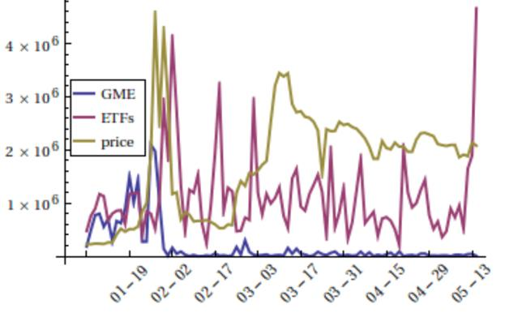
GME Price Vs. GME FTDs and ETF FTDs (which contain GME); Source: /u/basketas87
You can immediately see the ETF FTDs absolutely SKYROCKETED just before the cutoff of the SEC FTD
bi-monthly report. We don't even know how high this has gone in the following days or if its come
crashing back down. Remember - these are aggregate. We don't sum up the FTDs between dates.
Whatever the number is upon a date is the current total of FTDs reported.
For a date-by-date tracking for these FTDs between January and the end of March, /u/broccaaaprovided
an excellent chart in "The naked shorting scam using ETFs: mass shifting of FTDs from GME to 20+ ETFs
& 27+ billion dollars still owed in remaining SI". This gives us an easier look at the exact dates when
FTDs spiked earlier in the year.
I selected GME and 19 ETFs containing GME. I chose to only look at the ETFs that contain the most GME
shares and had large numbers of FTDs in 2021. - /u/broccaaa
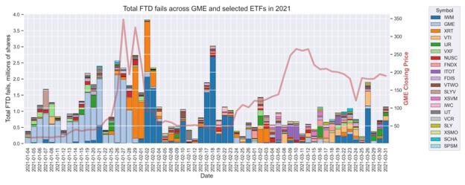
Aggregate FTDs for GME; GME and ETFs; Source: /u/broccaaa
Some notable aggregate FTD dates from this chart:
1. January 29th
2. February 2nd
3. February 18th
And of course, the latest absolutely insane May 12th. Once again, we don't even know what the FTD
numbers are for the second half of May. It could very well be much higher.
2. Net Capital And Market Makers; Citadel's Can-Kicked Bag
Net Capital is detailed out in this post but I will do a quick summary. It revolves around Net Capital
Requirements For Brokers or Dealers - 240.15c3-1:
...is designed to ensure that a broker-dealer holds, at all times, more than one dollar of highly liquid
assets for each dollar of liabilities (e.g., money owed to customers and counterparties), excluding
liabilities that are subordinated to all other creditors by contractual agreement. The premise underlying
the net capital rule is that if a broker-dealer fails, it should be in a position to meet all unsubordinated
obligations to customers and counterparties and generate resources sufficient to wind down its
operations in an orderly manner without the need of a formal proceeding...
...A broker-dealer must ensure that its actual net capital exceeds its required minimum net
capital at all times. - Source
Or in other words, you must have enough capital to not be "margin-called". In this case, Citadel is a
prime victim to this rule as they are a Market Maker and must sustain enough net capital to not go bust.
If they do not, they're a risk to their customers and counterparties. This rule tries to ensure that they
have enough money to pay up in the event of a default.
The very interesting part of this rule comes down to how they're calculating Net Capital in regards to
short securities:
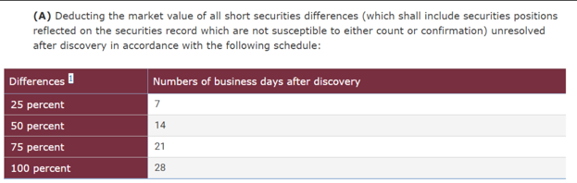
Net Capital Rule; Short Securities Deduction From Net Capital Per "Days After Discovery"
What this basically means is that after the short security difference is found to be unresolved after
discovery (think FTD popping up is the "discovery"), then it's going to slowly start eating away at their
net capital the longer it remains unresolved/undelivered:
• Day 0 after discovery = 0% of the unresolved short security is calculated into their net
capital
• Day 7 after discovery = 25% of the unresolved short security is calculated into their net
capital
• Day 14 after discovery = 50% of the unresolved short security is calculated into their net
capital
• Day 21 after discovery = 75% of the unresolved short security is calculated into their net
capital
• Day 28 after discovery = 100% of the unresolved short security is calculated into their
net capital
When you have these debts accounted for into your net capital, it is taking away that value, because it is
a short difference you owe. As the days go by, net capital starts chunking down. So, if you have a rather
large short security difference discovered one day (such as May 12th) then you want to resolve it
quickly or risk defaulting.
Do you find a way to stuff the unresolved shorts back under the rug? Do you deliver and force buy-ins?
Both? That appears to be the loop they've been stuck in, which slowly bumps the price floor upward.
You'll notice that there's a familiar number in there. Day 21. T+21? Oooh. Tasty. Here we go.
The total timeframe for Net Capital is 28 days, but Citadel most likely cannot allow the Net Capital
threshold to go past 75%. They must kick-the-can and force buy-ins on or before T+7, T+14, T+21 but
complete the entire process by the net 75% threshold of T+21. They can't risk it going to 100% or else
they'll most likely default.
Wham, bam, the T+21 loop ignites itself continuously.
3. Plotting The Net Capital Loop - The Counter of T+21 and
T+35
The major option dates still play a big role. But I don't think T+35 theory is what's really applying here.
What are "major options"? These are the only options that were available for the year 2021 back in
early 2020. These are the option dates that were most likely opened up initially by shorters at the start
of COVID. Perfect time to place bets and start their kill shot on GameStop:
• January 15, 2021
• April 16, 2021
• July 16, 2021
Upon expiration, unrealized losses now became realized losses, and their overall capital receives a dent.
It most likely gets harder to hide FTDs and hide them under the rug.
You know the most curious thing?
Posts about Citadel working the night-shift started just after April 16th options expirations.
That's also right around when Bank of America shut down a bunch of their locations. I won't buy
their excuses. Bank of America looks like they're a bag holder and is freaking out too.
Something big had to of happened as of April 16th, and it's most likely that they had a huge dent in their
capital that is now causing a slow bleed-out of FTDs that they've hidden, which then must be satisfied
within the Net Capital timeframe of T+7, T+14, T+21, T+28, or else they can go net negative and default.
And of course, following April 16 options expirations, the ETF FTDs start to skyrocket on May 12th. My
main intuition is that they were unable to hide these any more and they have started to spill out. Ruh-
roh.
First, I'll plot out the T+21 Net Capital loop so that it isn't too cluttered:
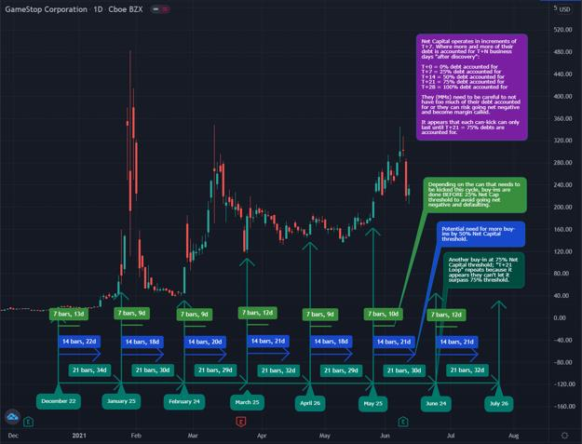
Plotted Net Capital "T+21" Cycle, December 22 to July 26
Upon December 22, the clock starts ticking. It's possible that at this point the price was too high for them
to NOT worry about Net Capital any more, and they had to start can-kicking and forced buy-ins.
Each loop is separated T+21 because it appears that they cannot sustain higher than the 75% threshold
each time. You can see the T+21 loop we're familiar with, starting December 22, and then traveling
through January 25, February 24, March 25, April 26, May 25. And potentially continuing on to June 24
and July 26. [The next two dates if any apes are curious].
To get a closer look of the potential effects of the various Threshold amounts (T+7 (25%), T+14 (50%),
T+21 (75%)) I've zoomed in on March 25th to May 25th. ENHANCE!
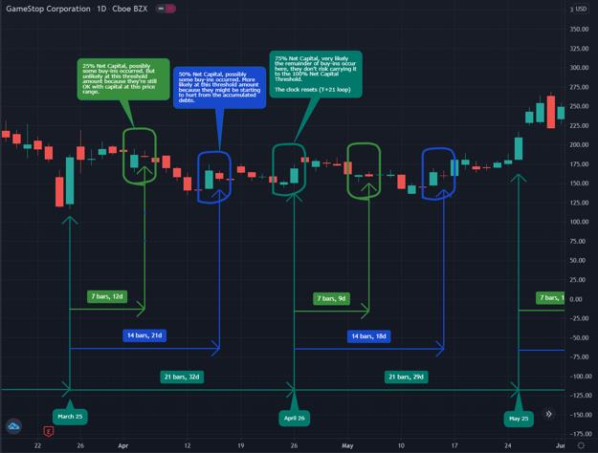
Plotted Net Capital "T+21" Cycle, March 25 to May 25, Price Spikes Prior to Each Threshold (T+7, T+14) Date
In the above it's unlikely but there is a chance that they have too many FTDs to shuffle around by the
time Net Capital 25% (T+7) Threshold hits. This could initiate some buy-in pressure on or before that
date, typically the day before, as outlined in the light green circle. The day before because they don't
want those positions to be 50% upon the next day. They must be resolved BEFORE.
It is also unlikely but a greater chance that they have too many FTDs to shuffle around by the time Net
Capital 50% (T+14) Threshold hits. This again could initiate some buy-in pressure on or before that
date, typically the day before, as outlined in the blue circle.
And of course upon Net Capital 75% (T+21) Threshold, they must complete their rug-hiding and/or buy-
ins to avoid going Net Negative. It is possible that the rug-hiding and buy-ins are in conjunction with one
another, slowly increasing the price floor, and that between each threshold they try to short the
stock more to push down the price.
Looping back to Section 1 when we identified the major FTD dates:
1. January 29th
2. February 2nd
3. February 18th
4. May 12th
There's a potential relationship to be seen with these insane FTD dates. Now this chart I'm about to
show is highly speculative. I'm unsure if the Net Capital loop initiates upon the FTD spikes (though it
certainly should, per Net Capital rule, because that would be when they are "discovered").
I say I'm unsure because I only see one data point here so far and somewhat of a second data point from
the price run-up we've been seeing the past few days.
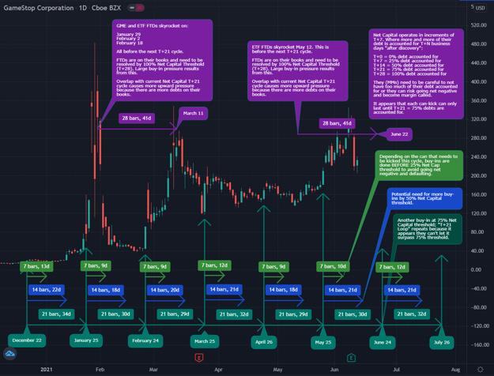
Plotted Net Capital "T+21" Cycle, December 22 to July 26, and FTD Spike Relationship
In the above picture, look at January 29th's FTD spike. Plotting the full 28 days of Net Capital out where
100% of the debts would be accounted for, that lands it on March 11th. They want to resolve
this before March 11th, while the debts are still 75% accounted for. Remember that date? March 10th? I
sure do. This could be why we saw the price spike, and why T+35 is incorrect in theory. But, it appears
the major option dates still play a role, because of the May 12th FTD spike that just occurred, which
followed April 16th options. Likewise, the January 15th options may have initiated the FTD spikes
around January 29th and February 2nd.
If the same situation occurs due to the May 12th FTDs, then plotting out the full 28 days of Net Capital
lands us on June 22nd. If these FTDs initiated Net Capital T+0 upon May 12th, then things could get
crazy on or before June 22nd.
It is very possible that the run-up from May 25th to June 8th was all due to this new set of FTDs, and
they had to start buy-ins on or before T+14 and T+21 from May 12th due to the sheer amount of
unresolved shorts that were eating away at their Net Capital. If the FTDs aren't fully hidden again or all
the buy-ins aren't complete, there's still T+28 to look towards, which lands on June 22nd. They would
need to hide these FTDs again and/or buy-in on or before June 22nd. This would keep in line with the
March 10th squeeze.
This could also very well explain what was going on with AMC. (Don't freak out on me yet, I love looking
at AMC because it's very good analysis to track. It's been following the same exact T+21 pattern as
GME)
4. AMC Behavior - Given Up On By Shorts? Too Expensive To
Juggle With GME?
AMC has gone on an absolute RUN. It increased nearly 70% in one day. Take a look at the following chart
now that you know about Net Capital and the different T+7, T+14, T+21, T+28 Thresholds:
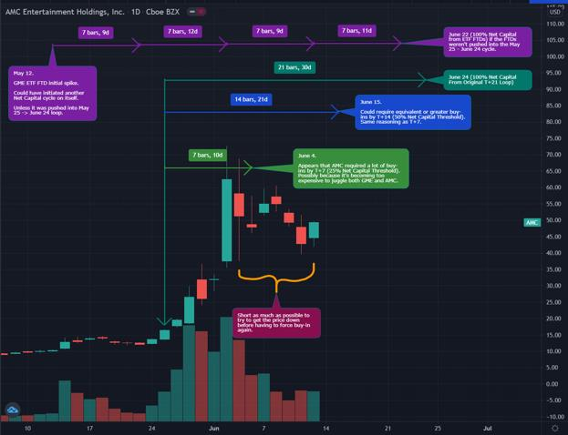
AMC Behavior from May 12th to June 24th
Damn. Did they just GIVE UP on AMC and decide that it's too much to deal with? Do they not have
enough capital to deal with both GME and AMC (and possibly other short meme stocks)? I think so,
because this lines up quite well. They had to fix Net Capital for AMC by T+7 (25%) Threshold on June 4th
probably because it was too expensive to handle alongside GME, and GME is the one they really need to
keep their ammo for.
Between T+7 and T+14, they of course short some more, trying to pull the price down in preparation of
the next Threshold cycle of T+14, which will probably cause an equivalent or greater amount of buy-ins.
This lands on... June 15th. And if it's like previous cycles, that would imply that they want to do the buy-
ins by June 14th (next Monday) to avoid those unresolved shorts hitting the next threshold amount. Big
price spike coming again?
Even then, the current T+21 cycle isn't over. The threshold of 75% doesn't land until June 24th, where
things very likely will continue to spike upward with an equivalent or greater spike of the run before
T+7 (25%) Threshold.
I truly think that they've put all of their effort into containing GME and have more or less "given up" on
AMC because it's not as big of a deal to them. That's why it's mooning like crazy while GME is taking a
little time to wake up.
5. GME Behavior - Shorts Holding On As Long As They Can
With the same exact timeframe of AMC, let's finally look at GME and the current cycle going on. The ETF
FTDs from May 12th line up T+28 (100% Net Capital Threshold) on June 22nd. Again, if the Net Capital
loop initiated upon that FTD spike, then things could get absolutely wild on or just before June 22nd.
Otherwise, it might just be the standard T+21 Net Capital loop, which has that extra pressure from the
ETF FTDs, where the Net Capital loop initiated on May 25th, and ends on June 24th.
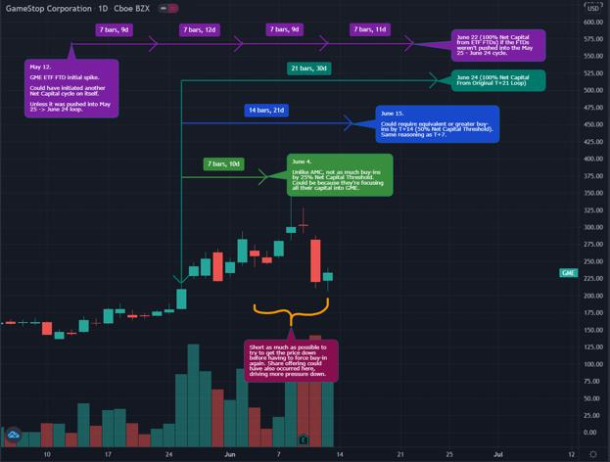
GME Behavior from May 12th to June 24th
By the time of T+7 (25% Threshold), it appears that they really needed to apply some buy-ins, and the
price started to rise quite significantly. Just like AMC, but not as extreme, because they want to put all of
their energy into keeping this bad boy from popping off.
Once again... take a look when T+14 (50% Threshold) will hit. June 15th. From the above analysis, the
buy-ins would occur on or before this threshold date, typically right before. Know where that lands?
Next Monday. June 14th.
It's possible that they won't be able to sustain to the 75% threshold any more, but now must sustain the
50% threshold of T+14 where they need to resolve their unresolved shorts by.
Maybe there will be a big price spike next Monday. Otherwise, keep an eye out for the T+28 date of the
ETF FTDs, landing June 22nd, or the original T+21 date, landing June 24th.
I believe we're also waiting for the Russell 1000 change the week of June 24th. ;)
Back to Table of Contents
Clarification of when GameStop will issue a
press release stating the ATM Offering is
complete, sale price max, maximum offering,
update on outstanding shares, the reason why
MarketWatch and Ortex differ, and other Form
424B5 goodies with highlighted pictures!
DD 👨‍🔬
Hey there! This comes straight from the 424B5 Form! Here is the link for reference.
https://gamestop.gcs-web.com/sec-filings/sec-filing/424b5/0001193125-21-186796
We will not receive any update about the completion of the ATM offering today. The earliest an
announcement could be made is Monday. This is based off of T+2 settlement. Also, based on past press
releases, this will not happen until after market close on any given day.
https://i.imgur.com/tuz8Nhh.jpg
GameStop is updated before the market opens every day on how many shares were sold the previous
day. Which also points to any announcement of the completion of the offering happening after market
close.
https://i.imgur.com/sr8Undy.jpg
$255.39 is not the max sell price. This was the average share price on June 4th and they used it for
calculating the fee projections of this offering.
$1,276,950,000 is not the maximum amount of funds GameStop can raise from this offering. Again, they
used this for calculating the fee projections of this offering. This was understandably confusing because
the last offering had a maximum amount allowable to raise.
https://i.imgur.com/5cljjEg.jpg
As of June 1st 2021 Outstanding Shares numbered 71,815,131 shares. If I am reading this correctly, that
number includes 2,435,881 restricted shares.
https://i.imgur.com/dPp6A21.jpg
Edit 1: If GameStop sells all 5 million shares then the new Outstanding Shares will be 76,815,131.
Thanks to /u/Cspawn for the image!
https://i.imgur.com/Dvnq05P.jpg
BTW the restricted shares is why MarketWatch and Ortex Outstanding Shares differ.
Ortex is adding the restricted shares to the 71,815,131 number which brings them to 74,251,012.
https://i.imgur.com/0EX7jDx.jpg
MarketWatch is including the restricted shares in the 71,815,131.
https://i.imgur.com/9VCvtvS.jpg
MarketWatch and Ortex updated their Outstanding Shares numbers based on the 424B5 form and not
because they saw new shares enter the market. This makes sense, because if they could do that then
they would account for all the synthetic shares on the market as well….
Edit 2: thank you to /u/Dclaw504 for finding this info! The 10-Q release specifically says that restricted
shares are included in the number of outstanding shares!!
https://i.imgur.com/7dowX8b.jpg
Hers is the link to the 10-Q released June 9th 2021. the info on restricted shares os located on page 13.
https://gamestop.gcs-web.com/sec-filings/sec-filing/10-q/0001326380-21-000066
I hope this helps clarify some things!
Back to Table of Contents
Elliot Waves and GME, Why I'm Jacked To
Infinity With Today's 82 Point Drop
DD 👨‍🔬
Sup apes, (refer to edit 8 for updated downside target, i looked at my levels wrong, and want you to have
accurate information)
hooooollllyyyy fuck what a day
Lower your pitchforks please, I know we broke below the "impossible" 219. First of all, this isn't
financial advice, I'm quite literally retarded and use crayons to predict where a stock will go.
Here's yesterday's prediction if you missed
it: https://www.reddit.com/r/Superstonk/comments/nw84nw/elliot_waves_and_gme_why_tomorrow_
should_be/
Buckle up, this isn't gonna be short, I'm going super in depth for you guys cause I've never been more
jacked...
I'm not gonna lie, the drop caught me off guard a bit, but its because I wasn't looking big enough... Here's
a view of my previous charting, where you can visualize the "cycle" waves with the white lines (SS from
yesterday as I already drew new waves):
&#x200B;
previous wave cycle deemed invalid
So why am I excited? Originally I was looking at the previous movements as cycle movements, where i
thought the move from our low on 3/24 (last earnings) was a 5 wave CYCLE, but todays price action
showed be that that whole move to 344 was actually just a wave 1 within that cycle, and today was wave
2..... completed...
wave 3 is the longest and most explosive wave of the 5, and were about to fucking start it...
So how do we verify all of this? First of all, really quick, here are basic EW rules (just inserting a
screenshot from wikipedia cause It's way better than my explanation)
&#x200B;
RULES
I want you to look at wave 4 specifically, as this is why I am redrawing. notice how 4 can't retrace into
the territory of 1? Well the top of my previous 1 was at 218.93, which is why I said it should
theoretically be impossible to break below this. HOWEVER, since we did indeed break below (hit a low
of 211), this invalidates that wave structure, forcing me to tHiNk OuTsIdE tHe bOx here...
Just so you know, the price targets I outlined (to the upside at least) are invalid now, as I had to redraw
the cycle set. that being said, the new price targets to the upside are so fucking juicy you might just kiss
me...
&#x200B;
Also, I'm gonna be referencing the rules of the waves pretty frequently in this post, so feel free to
reference the rules above^
&#x200B;
Try not to get too jacked, this is just the 3rd cycle wave illustrated, just take a look...
&#x200B;
you done fucked up kenny g
I believe that Gamestop did indeed start their 5m share offering today, or at least some of it, but im not
gonna speculate on that, I'm just the waves guy. So how can we confirm that today was a cycle 2? Let's
take a look...
Remember how wave 2 targets 61.8% of the entire wave 1 right? Here are the fib targets from the
bottom to the top of my newly drawn cycle 1:
for reference, the 61.8 level here is 213.24
BAM!!! WAVE 2 CONFIRMED! Now refer back to EW rules, or if you're a good ape and did your
homework, you already know that wave 3 can't be the shortest wave, and often is the longest and most
powerful of the 5 wave impulse...
So, assuming that 213 is the bottom of our cycle 2 (pretty confident in this, possible we retrace to
177.51 but super fucking unlikely imo, given the nature of the bounce at 213)
Okay, so wave 3 can't be the shortest, what happens if it doesn't hit the 1.618:1 target? (in this case it is
586.1)
It has to hit, at the minimum 1:1 of wave 1. If it doesn't reach this target, the wave is not finished. This
means at the very minimum, this cycle 3 should target 442.83.
&#x200B;
100, 123.6, and 161.8 are initial targets, could go even higher depending on wtf happens
Do note though, these are CYCLE targets, I am in no way saying that we will see 442 or 586 tomorrow,
BUT these are the bigger targets to watch for as of now. To give more precise targets for the waves
within this cycle (intermediate, minor etc) I will need for at least an intermediate "1" to complete, so
likely by tomorrow I'll be able to pinpoint more precise intraday/daily/weekly targets for your viewing
(and buying) pleasure.
disregarding EW, another reason why I'm excited about today's drop is a GAP UP from 6/1. If you've
been following me for a while, I always point out gaps, and their significance. You can visualize the gap
below by the green box.
GAP
If you've been following me since march, this is how I was able to predict the 350 to 180 drop, but that
was before I knew EW theory. now that this gap is filled (we have one on the daily chart as well that was
also filled today, doesn't matter as much as that "gap" only appears on the daily, meaning the price
action filled the areas in the after hours/pre market. We can determine this by looking on a 4hr chart.
You can compare the daily and the 4hr below:
&#x200B;
&#x200B;
daily
4hr
See the difference?
Anyways, not too significant, just worth noting. In any scenario, a gap fill is a great indicator to switch
direction and play the reversal.
alright, you should be jacked now. Not only do we (appear) to have confirmation of cycle wave 2
completion (61.8% of wave 1), but this newly drawn cycle fits into my super cycle target a lotttttt
better...
for reference, my super cycle is visualized by the yellow lines. Given that this is the beginning of our 3,
the price targets seem to line up a lot better with the original super cycle drawing... If anything, the
super cycle wave 3 will finish even higher than initially predicted:
&#x200B;
&#x200B;
jacked to da max
I dont even really trade technical patterns anymore, but I couldn't ignore this beautiful cup and handle
forming...
&#x200B;
checks out
This lines up with the wave 2 bottom, cup and handle patterns are very bullish, bias confirmed.
If you want me to update this post tomorrow in real time let me know, I had fun nonetheless, it was cool
adapting in real time and reconstructing an analysis. I feel super privileged to be learning this theory on
such an erratic situation, and to all the haters, you can't argue with human nature. This shit works.
Oki I think I'm done. Thanks for trusting me and giving me a platform to try and spread a skill I've been
trying to put into action. I'm no expert by any means, to be completely honest I've only been studying
this theory for about 3 months, and am nowhere near an expert.
TLDR: 213 looks like the very bottom, hard to deny that today was a cycle wave 2. It was rough to watch,
but when you take a step back and look at where we are, it's really hard not to be bullish. I have trader
friends that absolutely hate GME and have zero faith in it, even they said they're buying today...Buckle up
my friends, we all know what happened after the last earnings call... to be completely honest, if price
action is as similar to march 25 (which mind you was also the bottom of a "2") tomorrow should be face
ripping 🚀
BUY AND HODL!!! I emptied the rest of my ammo in at 238 today and couldn't be more jacked!
Edit: holy shit I made the front page of all of Reddit… thank you all so much for the love ❤️❤️ to the
fucking moon 🚀
Edit 2: great comment by u/ricecooker8055BH
“((1)) Apr13 low 132=>((2))=>((3))=>((4))=>((5)) Jun8 hi 344 ==> MINUTE ((i))
The drop from Jun8 hi 344 to Jun10 low 211 ==> MINUTE ((i))
The next wave MINUTE ((iii)) is considerably/extremely bullish.
Why?
Elliottician dream is to identify this wave known as THIRD OF THIRD IMPULSIVE RALLY (within MINOR
WAVE 3). This is the DEADLY TSUNAMI WAVE that hit Sumatra, Indonesia; Phuket, Thailand in 2004
and Fukushima, Japan 2011. You don't want to go against this KILLER WAVE.
There will be a lot of ARCHEGOS body bag when this unfold. Really? Based on DD we read, and with the
measured objective 555/766/978, I don't know how many HF can survive it if MARGIE CALLING.
What's gonna trigger it? Probably SEC, DTC I don't know.
I know it's confusing...LONG STORY SHORT...this is fking BUUUUULLISH! BUY&HOLD 💎🙌🏻🦍💪🏻
🚀🚀🚀🚀🚀🚀🚀🚀🚀”
edit 3: Morning, looks like I was correct in this analysis, 213 does seem to be the bottom of our cycle 2...
confirmation in that alone is enough for me to be happy with today.I'm still waiting for a bigger
intermedia movement to really have an idea of the targets, but based off this mornings price action, this
is what I'm watching as of now: https://imgur.com/auYvUMj also thank you all so much for the support
on this post, really does mean the world <3
edit 4: lol im literally dead broke, but i deposited another $80 into my TD (i hold xxx on fidelity, only x
on td) to buy my last (till i get paid) share at 231... these prices won't last!
edit 5: I feel like there were a few misconceptions from my post, first of all, In no way do i expect to hit
500+ today. The targets outlined are CYCLE 3 targets, but I haven't seen enough movement to draft
intermediate waves and so on... ALL I CARE ABOUT is that 213 is the bottom of wave 3 (within 3 within
3, uber bullish), that in itself is huge.
Edit 6: there’s no truer pain than watching your favorite stock dip and not having liquid funds to buy the
dip 🥲 give em hell for me
edit 7: about to hit the gym, probably not gonna update for a bit... we seem to be holding above 213,
though for clarify, if we do happen to break below, its not the end of the world by any means. EW theory
here is valid so long as we dont drop below like 110 ish (bottom of cycle 1) in this subset, so anything
under 213 would be ideal to buy.making an ASSUMPTION here in that GME isn't done with their 5m
offering (I believe i read somewhere the offering has to be under 255/share? someone correct me if im
wrong)... Just remember that every short piling onto this mess is gonna get squeezed out very, very soon.
Technical indicators are probably gonna trigger algo buys soon, as we are nearing oversold territory
edit 8: holy fuck, just another reason why you shouldn't listen to me, im so retarded (I was probably high
in all honesty) when I wrote this and i looked at my fibs as 213 being the 61.8 level to watch... but i am
retarded... the proper level is 201... so keep a strong eye on that for a
bounce: https://imgur.com/dmywYOA (okay now im acc leaving, the TA wasn't sitting right with me so i
took a closer look, and voila... user error smh. Sorry for confusion, I'm just an ape (look CLOSELY at how
the retracemnt is drawn, from the low on 3/24 to the high on 6/8... these are the PROPER ratios to
reference, Irdk how I missed that yesterday
Back to Table of Contents
Danger Zone Part 2 - Shorts are terrified of a
$310+ close. Projected price movement for the
next few months based on T+21, ever-
increasing, and poking harder at the first
domino just waiting for it to fall.
DD 👨‍🔬
0. Preface
Welcome. WELCOME. More patterns. More dates (T+21 dates).
I'm not a financial advisor - I don't provide financial advice. Also, you must be pretty nuts to be listening
to a Pomeranian.
I made a post before about the price entering the DANGER ZONE and thought it was above $160. Well,
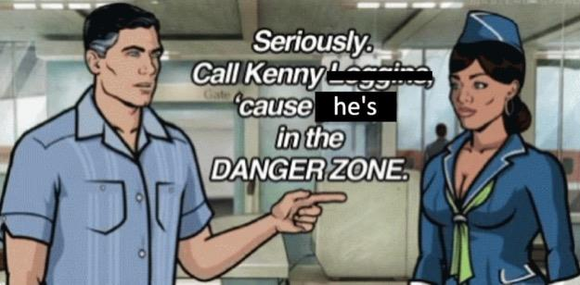
let's revisit that topic because of the interesting price movement we have been getting.
Somebody. PLEASE call Kenny. Marge? You there?
TLDR: Danger Zone part 2
• The price floor continues to rise each T+21 cycle.
• Price goes on a Crabby Move 🦀on normal T+21 dates - floor rises about $30 each
time.
• Price goes on a Parabolic Move 🚀between T+21 dates where major options come
into play (January 15, April 16, July 16) - floor rises about $80 each time.
• If the price pattern continues, we should see a $500 floor by January 2022.
• Shorts haven't covered. They post unrealized losses and unrealized gains to mess
with you.
• Retail average base cost is (probably) around $156.57. This is most likely the
shorter average short price.
• Shorts with an average price of $156.57 would experience 100% loss around
$313.14. (Speculative based on data - the real cost could be around $350).
• Shorters are terrified of $300+, there's been a big battle here for a few days,
hinting that small short positions are about to hit margin call territory (the
Danger Zone).
• The current price momentum in this gamma is much stronger than the previous
two gammas of January and March. They're trying desperately to not let it take off.
• The moment one shorter falls, the dominos fall.
• I like the stock. I also like you. 😉
1. Ever-Rising Price Floor And Projection For The Next Few
Cycles
I've been getting pinged a lot on the next T+21 dates and when the next possible parabolic move could
be coming. You might say "Past performance is no guarantee of future results" and generally I would
agree. But with T+21 consistently occurring and the parabolic moves so far looking like they were
triggered by major option dates, I'd say it's a pretty good bet that past performance will guarantee
future results.
• Every 21 trading days a price spike occurs. Upon each spike, the clock resets to 0, and
you count up 21 trading days following. Note that you must ignore holidays.
• Major options dates appear to drive parabolic moves upward. "Major dates" are the only
option dates which were available early last year for the 2021 trading year.
o January 15 --> February 24 - March 10; Parabolic Move
o April 16 --> May 25 - June 9; Parabolic Move (Maybe more movement to
come)
o July 16 --> August 24 - September 8; Parabolic Move (Projected)
I will say, the only thing that could make this crap the bed is if DTC-2021-009 somehow affects T+21.
Guess we'll have to see what happens on June 24th, the next T+21. I'm thinking it does not, since T+21 is
most likely not caused by a DTC rule, and therefore the DTC can't mess with that timeframe.
On another note, there is speculation that T+21 is not actually a thing. It could be due to other mechanics
we don't fully understand (T+35 rule or Net Capital for example). That being said, we're consistently in
this loop so far. So, for the sake of making it easy to understand the loop, I think it's safe to continue
calling it T+21.
Without further ado, here you go! Projection of price movements with T+21 dates labeled for the next
few months.
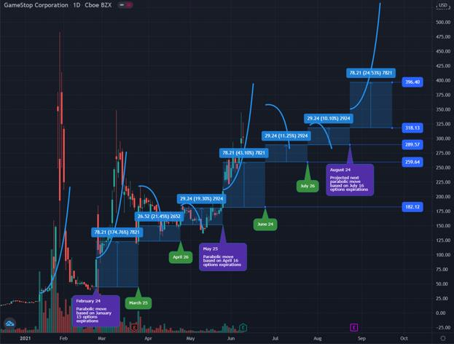
Price Projection Based On Rising Floor Every T+21 Days And Major Option Expirations
It's a bit of a wild chart, so I'm sorry if it's cluttered. I've plotted with curvy lines the parabolic
momentum that we see, and the crabby moves we get dependent on the different factors at play that
cycle:
1. February 24 -> March 25: Parabolic Move 🚀 (January 15 options)
2. March 25 -> April 26: Crabby Move 🦀
3. April 26 -> May 25: Crabby Move 🦀
4. May 25 -> June 24: Parabolic Move 🚀 (April 16 options)
5. June 24 -> July 26: Crabby Move 🦀
6. July 26 -> August 24: Crabby Move 🦀
7. August 24 -> September 8: Parabolic Move 🚀 (July 16 options)
In the chart, there's blue boxes starting at the floor of the previous cycle and ending at the floor of the
next cycle. I drew them very roughly, so the numbers on the graph aren't exact. Sorry. I'm moving a bit
quick.
You'll see that the floor has continued to rise. Although I'm sure many have already seen that from the
exponential floor posts! This is expanding on those posts and is a visualization to show that the floor
rises every T+21 day cycle. So far, it looks like it rises at a very nice rate, even with the crabby cycles:
• Crabby Moves 🦀 increase the floor roughly $30 each time.
• Parabolic Moves 🚀 increase the floor roughly $80 each time.
If the patterns follow, we could see the following price floors. Note that between April 26 and May 25
that the price broke below the previous floor. That's ok and expected. They can short a hell of a lot more
shares to try to pull the price down between these cycles, but the floor continues to rise upon each T+21
date, despite this trickery.
Price Floor $ Increase From % Increase From
T+21 Date (Roughly) Previous Previous (Rounded)
February 24 $45 - -
March 25 $116 $71 157%
April 26 $148 $32 28%
May 25 $182 $34 23%
June 24 $259 $77 42%
July 26
(Projected) $289 $30 12%
August 24
(Projected) $318 $29 10%
September 8
(Projected) $396 $78 25%
After September 8 I don't think we'll see another parabolic move for a while, since that would be due to
the last "major option date" of 2021 (July 16 options). The next "major option date" would be for
January 2022. But, if the pattern continues, then the price floor would be around $500 by January 2022.
Ooftah. Think they could last that long?
2. Short Position "Gains" And "Losses" Are Unrealized. They
Averaged Up.
I want to bring your attention to another matter that has popped up a lot, and there's a lot of celebration
around it. The articles about short sellers "losing" billions of dollars in short positions on meme stocks.
Horray!!! Shorts are bleeding money! Right? I don't think so. They're bleeding, but not for this reason.
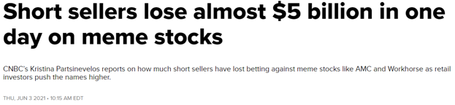
https://www.cnbc.com/video/2021/06/03/short-sellers-lose-almost-5-billion-in-one-day-on-meme-
stocks.html#:~:text=CNBC's%20Kristina%20Partsinevelos%20reports%20on,investors%20push%20the%20names%20higher.
I've always thought these articles being posted were interesting.... almost as if they wanted to convey
that the shorters "covered". (A few small shorters, like new retail shorters, might have covered. But not
the big ones).
Hint hint. They haven't covered. They do not plan to cover. The margin call Thanos snap when they get
liquidated will finally make them cover.
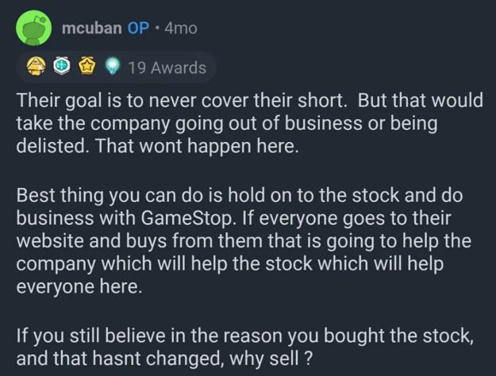
https://www.reddit.com/r/wallstreetbets/comments/lawubt/hey_everyone_its_mark_cuban_jumping_on_to_do_an/
I always look back at the total PUT OI going on an absolute tear in January when they hid SI% and think
to myself, "Damn. That's totally not normal."
Take a look at this. PUT OI spikes to 2e6 OI = 200m shares worth in PUTs. These PUTs were spread far
and wide to many options expiring from February 5 all the way to January 2023. What in the hell?
Totally normal hedge move, yup. Totally normal.
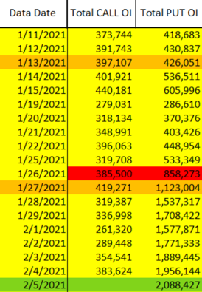
CALL and PUT OI Comparison; Data from /u/yelyah2
They're not covering. They're hiding their shorts and trying everything they can to scare you off.
So in my eyes these articles are all bull. Especially this one from the start of March:
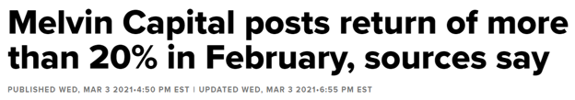
https://www.cnbc.com/2021/03/03/melvin-capital-posts-return-of-more-than-20percent-in-february-sources-say.html
I remember getting pinged about this article and being told that Melvin won, shorters exited, blah blah
blah, that was the FUD back then.
How could they possibly gain 20% in February after getting obliterated in January? Well... they, and
other shorters, must have averaged up their short position price. Anyone who took advantage of the
GME peak price in January was able to have a fun time with gains.
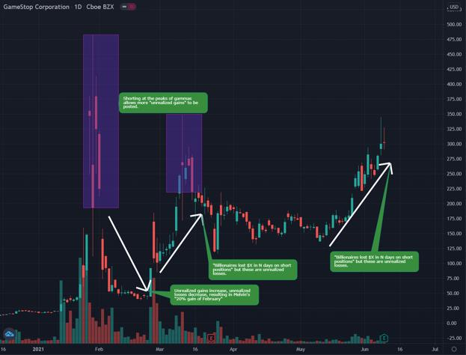
Short Position Unrealized Gains / Losses Based On Opening New Shorts
Their overall short position price went up, so they could post that they had returns/gains on that
massive downward momentum in February. But these gains are all unrealized. They aren't covering,
they're just digging a deeper hole because that's all they can do.
3. Average Retail Buy Price; Average Short Position Price
It's an absolute WARZONE right now. The price is so desperately trying to go on a run upward.
Last week I was noticing how similar this run was to February, and I was predicting that we'd
see another Gamma Neutral spike on June 4th. BUT IT SPIKED UP TWO DAYS EARLIER THAN
EXPECTED ON JUNE 2nd. [Data courtesy of /u/yelyah2]
That was a big, "Wait. What?" moment for me because it implied this gamma was ready to take off much
sooner than the previous gamma run of February 24 - March 10. I should have noticed earlier at how
much stronger this run was compared to the previous two gammas. Check out this comparison of the
price hammers for January, March, and June gamma runs. Big shout out to /u/sharp717 for
identifying the similarities to the January run as well.
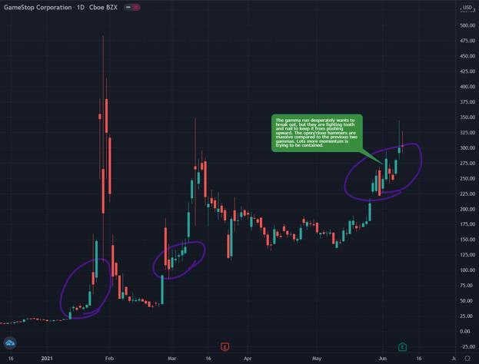
Price Momentum Being Contained. January, March, and June Gamma Squeezes
There's huuuuge momentum that they have been trying to contain ever since May 25th. The price has
been swinging up and down massively each day in this parabolic cycle🚀.
Have they succeeded with suppressing the gamma squeeze? I mean, time will tell. June 9th is when I
expected it to either start to go parabolic or be flash crashed down. But it's a goddamn battlefield right
now! And this parabolic run is much different and stronger than the previous one. I personally think this
run isn't over with. Their attacks are weaker every time, and there's so much strength still in this
parabolic cycle🚀.
There's so much ammunition being thrown because it truly is getting close to margin call territory, and
they're most likely hurting even more in captial from January 15 and April 16 options expiring.
Did I say margin call territory? I mean - the DANGER ZONE. Marge, call Kenny. Please.
Some big brain apes discussed this Webull chart and the implications of it relating to their "Danger Zone
price". It truly is a goldmine. With how popular Webull is it's probably safe to use this as a baseline for
retail (and indirectly a baseline for shorters).
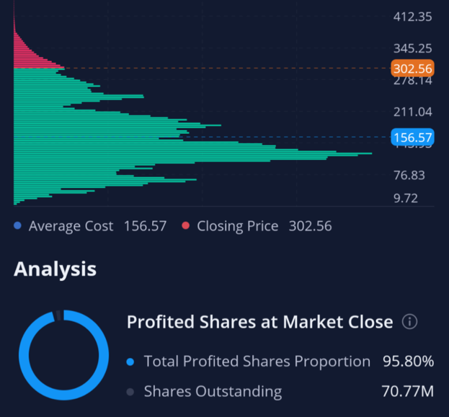
Webull GME Statistics. Average share cost of $156.57
What is this telling us?
1. Each horizontal bar represents a cluster of cost basis for retail shares. For example you
can see a huge cluster between $76.83 and $156.57. There's way more retail that own
shares at that price point than anything above $302.56.
2. The red indicates that the shares owned above $302.56 (price point when this
screenshot was captured) currently have unrealized losses. "They're in the red"
3. Likewise, the green indicates that the shares owned below $302.56 currently have
unrealized gains. "They're in the green".
4. The blue price point of $156.57 is the average ownership price.
Seems fair. We can most likely assume that retail's average base cost is around $156.57. Most retail
probably started buying in around December, because that's when the news of a GME short squeeze
started to really take off. We can now indirectly say that this is also the average short position price.
GME was over 100% shorted in December:
• You have to have naked shorts to get over 100% in the first place.
• OBV implies that barely anyone is selling.
• This signifies a liquidity issue where synthetics are created, ever-increasing the SI%.
• Any retail buy was most likely a new short position that was opened or a swap between
paper hands and diamond hands.
Our dear shorties might have an average short position of around $156.57. Give or take a little bit.
If you have a long position that you opened up at $156.57, and the price goes down to $78.28, you'll be
down 50%. If it continues down to $39.14, you'll be down 75%.
If you have a short position that you opened up at $156.57, and the price goes up to $234.855, you'll be
down 50% on margin. If it continues up to $313.14, you'll be down 100% on margin. BOOM. Marge
starts calling.
Assumptions per a big brain ape who discussed this:
1. Generally the margin requirements on short positions is 100% cash value of the position
a. When you hit 100% loss, marge starts to call. Example of $156.57 short
hitting $313.14. You need $156.57 posted to cover your margin
requirement.
2. WeBull is a large enough broker to likely be considered a representative sample of all
GME holders.
3. This is assuming the positions are unlevered - levering would reduce the margin call
point.
4. This is assuming additional capital was not raised against the positions [Such as shill
stock tickers pumped and dumped / Crypto / etc].
4. Danger Zone Part 2
They dun goofed. Their FUD attack today (which we expected) was fruitless. All their tricks have been
found out lmao.
Guess what, Ken? Here's my trick. It's crayons showing the goddamn Danger Zone you're entering and
so desperately trying to stay out of.
The new and improved danger zone is based on the average short price of $156.57 which would trigger
100% losses at $313.14 assuming 100% margin requirements.
[Note: Speculative based on Webull data. This could very well be $350 or higher, but the battle at
$300 signals that this is a very rough place for the shorters to be].
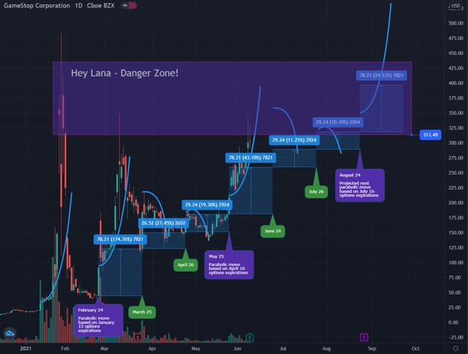
Danger Zone Visualization
Is this why there's such a huge battle around $300 right now? And why the price is SEVERELY smacked
down when it tries to reach above $350? It's probably because this danger zone is when small
HedgeFunds / shorters begin to fall, and it's getting so close to closing in the zone.
When one of the small shorters fall, it becomes a domino effect. Not only would they initiate buy
pressure from covering their short positions, but the banks which are connected to the shorters might
get upper-cut just enough to also send the banks defaulting with the ICC.
This would then cascade to all the other shorters under that bank because their swaps with the bank for
assets/liabilities to pump their balance sheets would get rug-pulled. Not just that... but everyone else on
the brink of defaulting in the entire financial world connected to that bank would start to fall.
You've all seen the reverse repo market. Things are bad bad BAD in the market. The amount has already
reached an all-time high above $500 Billion in a non-quarter end. This is abnormal because quarter-
ends are usually the time when banks would take advantage of the repo market to adjust their balance
sheets.
Other than high levels immediately before a quarter-end, these levels of sustained reverse repo activity
in excess of $300 Billion have not been seen since the Great Recession. - Source
Everyone in the repo market is terrified of the 2008 bomb that wasn't allowed to finish going off.
They're most likely colluding to prop each other up because of the absolute insanity that could follow.
Not just in the stock market. But the repo market, the crypto market, the treasury market, every market
potentially.
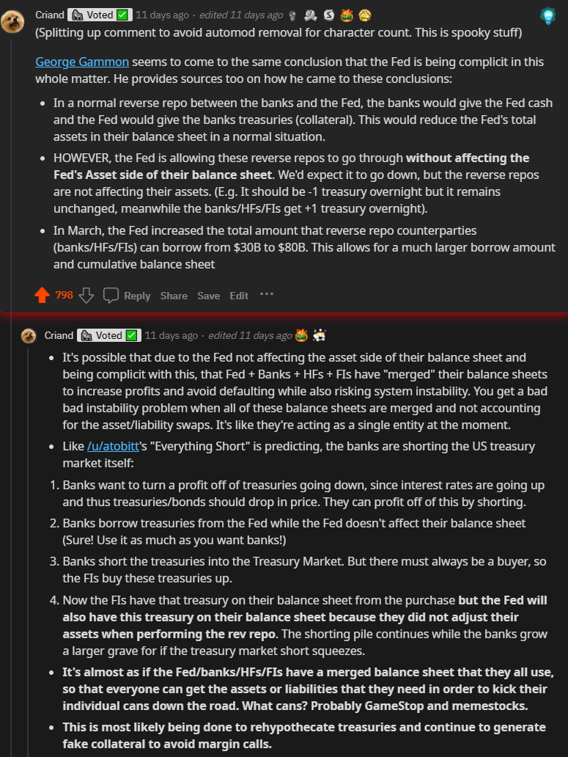
Possible Collusion In Repo Market
But hey, all it takes is that one.
GME has to close just high enough for everything, everything, to come crashing down.
Back to Table of Contents
IMPORTANT: This is why they mentioned
"more than a majority represented" at the
meeting. It's simple. Read this. Please.
DD 👨‍🔬
I have extensive experience with public company shareholder meetings.
There has been a lot of discussion about the statement made that "There are present at this meeting in
person or by proxy more than the majority of all shares that are entitled to cast votes". This statement
was made by the secretary at the meeting.
TL;DR: This was a standard statement made for the meeting to
be valid.
WHY DID THE SECRETARY SAY THAT?!
It is part of his script for the meeting so that they have on record that quorum was met so the meeting
could be validly held.
What is quorum? A quorum is the answer to the question: "How many stockholders need to vote for the
shareholder's meeting to be validly held".
From the proxy statement, here are the quorum requirements (bolded by me):
**6. What Constitutes a Quorum?**A quorum of common stockholders is required to hold a valid annual
meeting of stockholders. Unless a quorum is present at the annual meeting, no action may be taken at
the annual meeting except the adjournment thereof to a later time. The holders of a majority of the
outstanding shares of our common stock entitled to vote at the meeting must be present or by
proxy to constitute a quorum. All valid proxies returned will be included in the determination of
whether a quorum is present at the annual meeting. The shares of a stockholder whose ballot on any or
all proposals is marked as “abstain” will be treated as present for quorum purposes. If a broker indicates
on the proxy that it does not have discretionary authority as to certain shares to vote on a particular
matter, those uninstructed shares, constituting “broker non-votes,” will be considered as present for
determining a quorum, but will not be voted with respect to that matter.
https://news.gamestop.com/static-files/8f795a88-54a3-4320-b3e2-a2d5f28be6c4 page 10
Does that language look familiar? Yep.
DOES THIS MEAN THERE WASN'T OVER VOTING?
NO. This has nothing to do with over-voting. This is required for the secretary to say in order to properly
conduct the meeting.
BUT THEN WHAT DOES THIS MEAN?!
It means that the shareholder meeting was validly constituted to conduct the business that it meant to
conduct. It meant that the shareholder approvals made at the meeting are valid.
That's it.
Don't spread FUD or drama about this. It's nothing more than that.
EDIT 1: I've seen a couple different questions or comments stating that over-voting would have made
the meeting invalid. I'm not sure where the source of that came from, but too many votes would not
make the process invalid. In fact, Delaware law (GME exists under Delaware law) even contemplates
that there might be over voting for public companies that is corrected by the inspector of elections.
(https://delcode.delaware.gov/title8/c001/sc07/index.html, section 231(d)).
The quorum statement is purely procedural to ensure the meeting is valid. This has nothing to do with
over-voting and this does not confirm that there was or was not over-voting.
Back to Table of Contents
A House of Cards - Part 1
DD 👨‍🔬
TL;DR- The DTC has been taken over by big money. They transitioned from a manual to a
computerized ledger system in the 80s, and it played a significant role in the 1987 market crash.
In 2003, several issuers with the DTC wanted to remove their securities from the DTC's deposit
account because the DTC's participants were naked short selling their securities. Turns out, they
were right. The DTC and it's participants have created a market-sized naked short selling
scheme. All of this is made possible by the DTC's enrollee- Cede & Co.
____________________________________________________________________________________________________________
Andrew MoMoney - Live Coverage
I hit the image limit in this DD. Given this, and the fact that there's already SO MUCH info in this
DD, I've decided to break it into AT LEAST 2 posts. So stay tuned.
Previous DD
1. Citadel Has No Clothes
2. BlackRock Bagholders, INC.
3. The EVERYTHING Short
4. Walkin' like a duck. Talkin' like a duck
____________________________________________________________________________________________________________
Holy SH*T!
The events we are living through RIGHT NOW are the 50-year ripple effects of stock market evolution.
From the birth of the DTC to the cesspool we currently find ourselves in, this DD will illustrate just how
fragile the House of Cards has become.
We've been warned so many times... We've made the same mistakes so. many. times.
And we never seem to learn from them..
____________________________________________________________________________________________________________
In case you've been living under a rock for the past few months, the DTCC has been proposing a boat
load of rule changes to help better-monitor their participants' exposure. If you don't already know, the
DTCC stands for Depository Trust & Clearing Corporation and is broken into the following (primary)
subsidiaries:
1. Depository Trust Company (DTC) - centralized clearing agency that makes sure
grandma gets her stonks and the broker receives grandma's tendies
2. National Securities Clearing Corporation (NSCC) - provides clearing, settlement, risk
management, and central counterparty (CCP) services to its members for broker-to-broker
trades
3. Fixed Income Clearing Corporation (FICC) - provides central counterparty (CCP)
services to members that participate in the US government and mortgage-backed
securities markets
Brief history lesson: I promise it's relevant (this link provides all the info that follows).
The DTC was created in 1973. It stemmed from the need for a centralized clearing company. Trading
during the 60s went through the roof and resulted in many brokers having to quit before the day was
finished so they could manually record their mountain of transactions. All of this was done on paper and
each share certificate was physically delivered. This obviously resulted in many failures to deliver (FTD)
due to the risk of human error in record keeping. In 1974, the Continuous Net Settlement system was
launched to clear and settle trades using a rudimentary internet platform.
In 1982, the DTC started using a Book-Entry Only (BEO) system to underwrite bonds. For the first time,
there were no physical certificates that actually traded hands. Everything was now performed virtually
through computers. Although this was advantageous for many reasons, it made it MUCH easier to
commit a certain type of securities fraud- naked shorting.
One year later they adopted NYSE Rule 387 which meant most securities transactions had to be
completed using this new BEO computer system. Needless to say, explosive growth took place for the
next 5 years. Pretty soon, other securities started utilizing the BEO system. It paved the way for growth
in mutual funds and government securities, and even allowed for same-day settlement. At the time, the
BEO system was a tremendous achievement. However, we were destined to hit a brick wall after that
much growth in such a short time.. By October 1987, that's exactly what happened.
____________________________________________________________________________________________________________
"A number of explanations have been offered as to the cause of the crash... Among these are computer
trading, derivative securities, illiquidity, trade and budget deficits, and overvaluation..".
If you're wondering where the birthplace of High Frequency Trading (HFT) came from, look no further.
The same machines that automated the exhaustively manual reconciliation process were also to blame
for amplifying the fire sale of 1987.
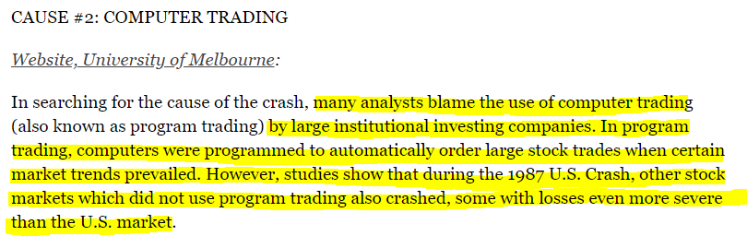
https://historynewsnetwork.org/article/895
The last sentence indicates a much more pervasive issue was at play, here. The fact that we still have
trouble explaining the calculus is even more alarming. The effects were so pervasive that it was dubbed
the 1st global financial crisis
Here's another great summary published by the NY Times: *"..*to be fair to the computers.. [they
were].. programmed by fallible people and trusted by people who did not understand the computer
programs' limitations. As computers came in, human judgement went out." Damned if that didn't
give me goosiebumps...
____________________________________________________________________________________________________________
Here's an EXTREMELY relevant explanation from Bruce Bartlett on the role of derivatives:
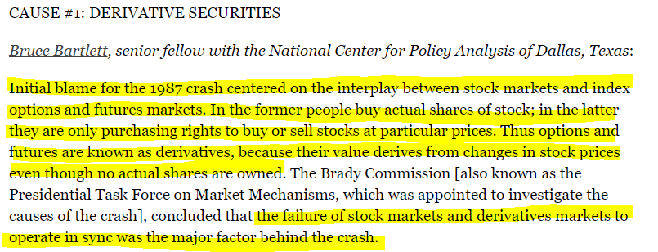
Notice the last sentence? A major factor behind the crash was a disconnect between the price of stock
and their corresponding derivatives. The value of any given stock should determine the derivative value
of that stock. It shouldn't be the other way around. This is an important concept to remember as it
will be referenced throughout the post.
In the off chance that the market DID tank, they hoped they could contain their losses with portfolio
insurance. Another article from the NY times explains this in better detail.
____________________________________________________________________________________________________________
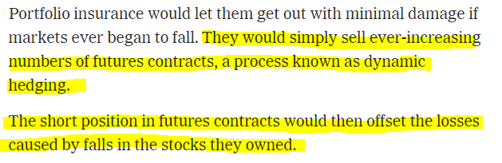
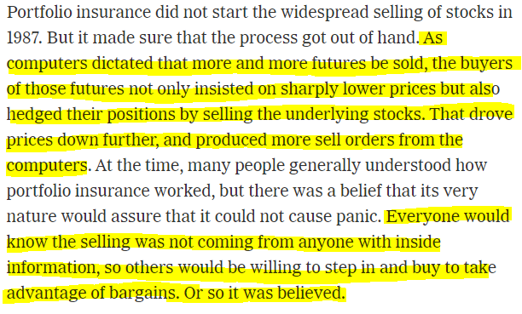
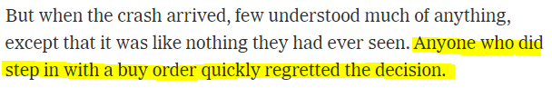
A major disconnect occurred when these futures contracts were used to intentionally tank the value of
the underlying stock. In a perfect world, organic growth would lead to an increase in value of the
company (underlying stock). They could do this by selling more products, creating new technologies,
breaking into new markets, etc. This would trigger an organic change in the derivative's value because
investors would be (hopefully) more optimistic about the longevity of the company. It could go either
way, but the point is still the same. This is the type of investing that most of us are familiar with:
investing for a better future.
I don't want to spend too much time on the crash of 1987. I just want to identify the factors that
contributed to the crash and the role of the DTC as they transitioned from a manual to an automatic
ledger system. The connection I really want to focus on is the ENORMOUS risk appetite these
investors had. Think of how overconfident and greedy they must have been to put that much
faith in a computer script.. either way, same problems still exist today.
Finally, the comment by Bruce Bartlett regarding the mismatched investment strategies between stocks
and options is crucial in painting the picture of today's market.
Now, let's do a super brief walkthrough of the main parties within the DTC before opening this can of
worms.
____________________________________________________________________________________________________________
I'm going to talk about three groups within the DTC- issuers, participants, and Cede & Co.
Issuers are companies that issue securities (stocks), while participants are the clearing houses, brokers,
and other financial institutions that can utilize those securities. Cede & Co. is a subsidiary of the DTC
which holds the share certificates.
Participants have MUCH more control over the securities that are deposited from the issuer. Even
though the issuer created those shares, participants are in control when those shares hit the DTC's
doorstep. The DTC transfers those shares to a holding account (Cede & Co.) and the participant just has
to ask "May I haff some pwetty pwease wiff sugar on
top?"____________________________________________________________________________________________________________
Now, where's that can of worms?
Everything was relatively calm after the crash of 1987.... until we hit 2003..
*deep breath*
The DTC started receiving several requests from issuers to pull their securities from the DTC's
depository. I don't think the DTC was prepared for this because they didn't have a written policy to
address it, let alone an official rule. Here's the half-assed response from the DTC:
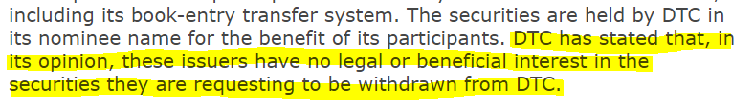
https://www.sec.gov/rules/sro/34-47978.htm (section II)
Realizing this situation was heating up, the DTC proposed SR-DTC-2003-02..
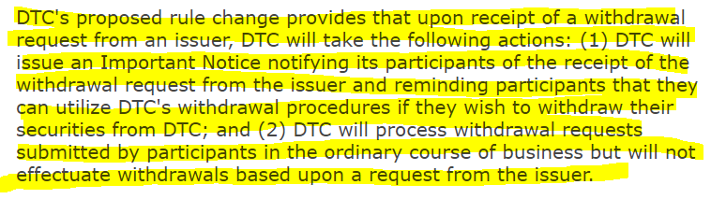
https://www.sec.gov/rules/sro/34-47978.htm#P19_6635
Honestly, they were better of WITHOUT the new proposal.
It became an even BIGGER deal when word got about the proposed rule change. Naturally, it triggered a
TSUNAMI of comment letters against the DTC's proposal. There was obviously something going on to
cause that level of concern. Why did SO MANY issuers want their deposits back?
...you ready for this sh*t?
____________________________________________________________________________________________________________
As outlined in the DTC's opening remarks:
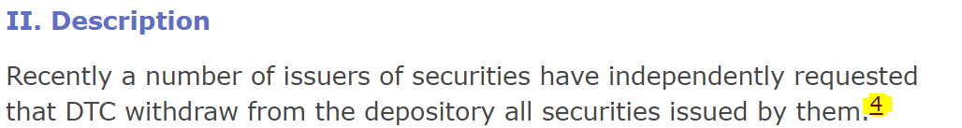
https://www.sec.gov/rules/sro/34-47978.htm#P19_6635
OK... see footnote 4.....
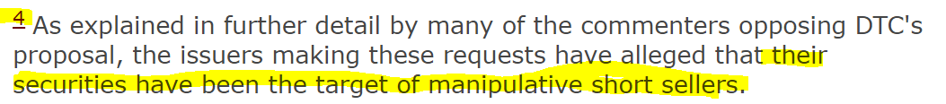
https://www.sec.gov/rules/sro/34-47978.htm#P19_6635
UHHHHHHH WHAT!??! Yeah! I'd be pretty pissed, too! Have my shares deposited in a clearing company
to take advantage of their computerized trades just to get kicked to the curb with NO WAY of getting my
securities back... AND THEN find out that the big-d*ck "participants" at your fancy DTC party are literally
short selling my shares without me knowing....?!
....This sound familiar, anyone??? IDK about y'all, but this "trust us with your shares" BS is starting to
sound like a major con.
The DTC asked for feedback from all issuers and participants to gather a consensus before making a
decision. All together, the DTC received 89 comment letters (a pretty big response). 47 of those letters
opposed the rule change, while 35 were in favor.
To save space, I'm going to use smaller screenshots. Here are just a few of the opposition comments..
____________________________________________________________________________________________________________
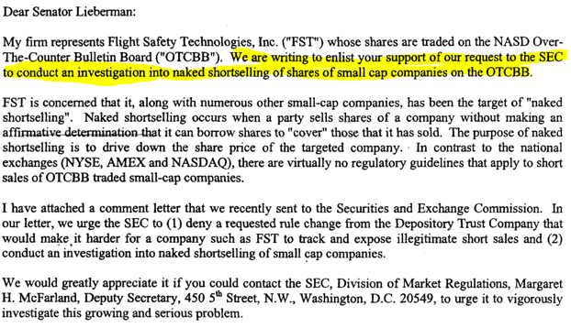
https://www.sec.gov/rules/sro/dtc200302/srdtc200302-89.pdf
____________________________________________________________________________________________________________
And another:
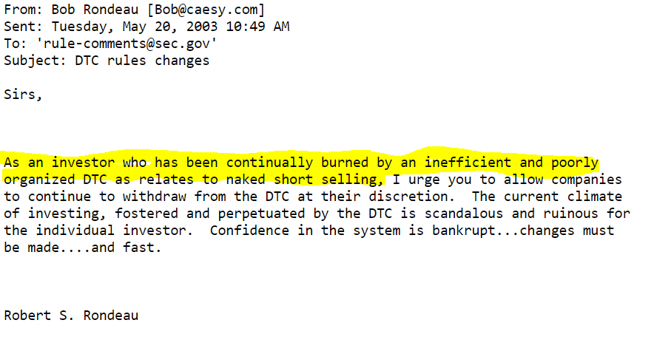
https://www.sec.gov/rules/sro/dtc200302/rsrondeau052003.txt
____________________________________________________________________________________________________________
AAAAAAAAAAND another:
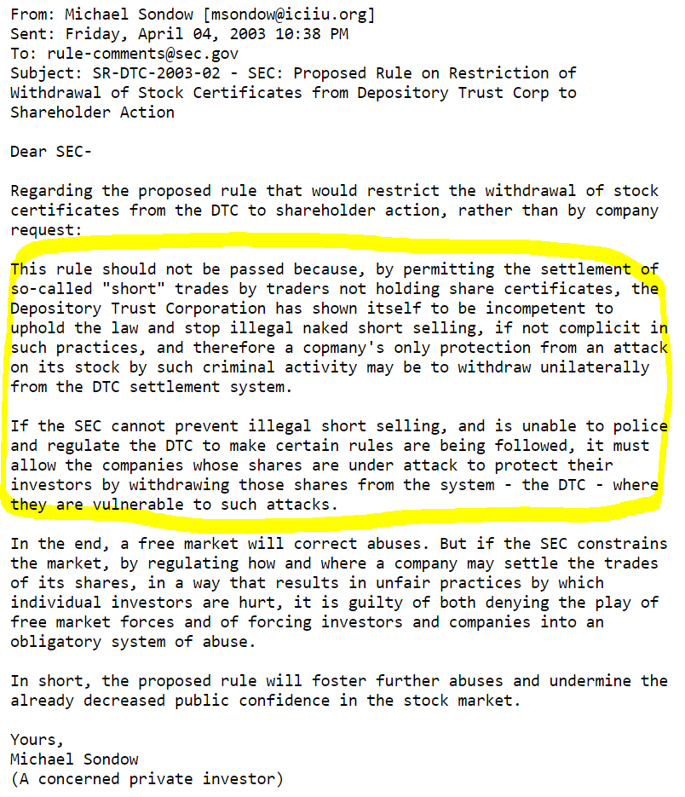
https://www.sec.gov/rules/sro/dtc200302/msondow040403.txt
____________________________________________________________________________________________________________
Here are a few in favor*..*
All of the comments I checked were participants and classified as market makers and other major financial
institutions... go f*cking figure.
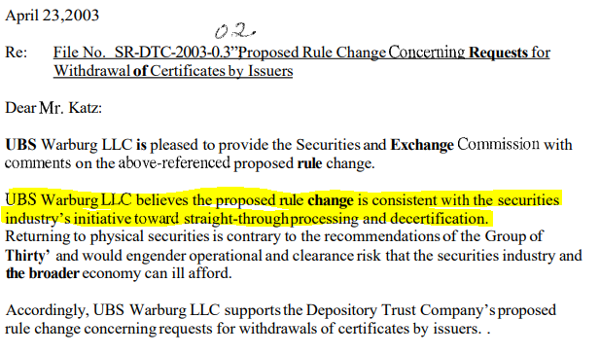
https://www.sec.gov/rules/sro/dtc200302/srdtc200302-82.pdf
____________________________________________________________________________________________________________
Two
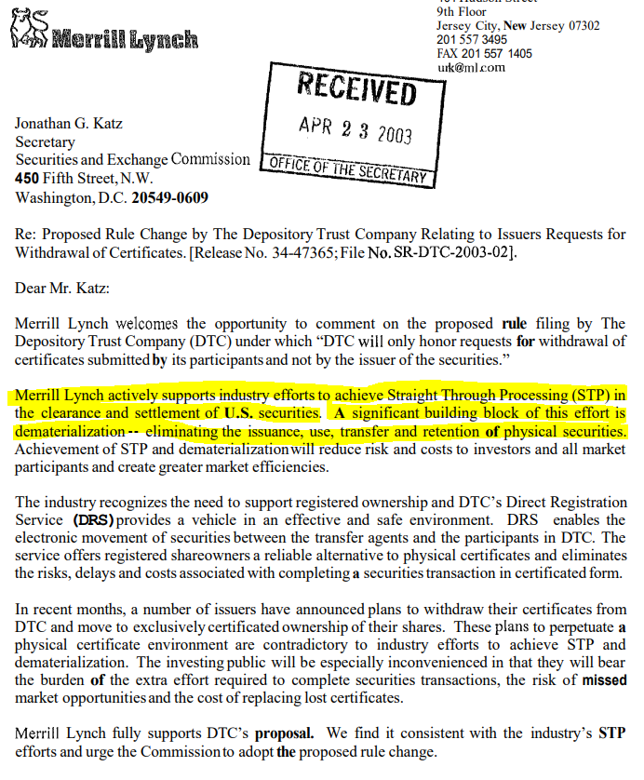
https://www.sec.gov/rules/sro/dtc200302/srdtc200302-81.pdf
____________________________________________________________________________________________________________
Three
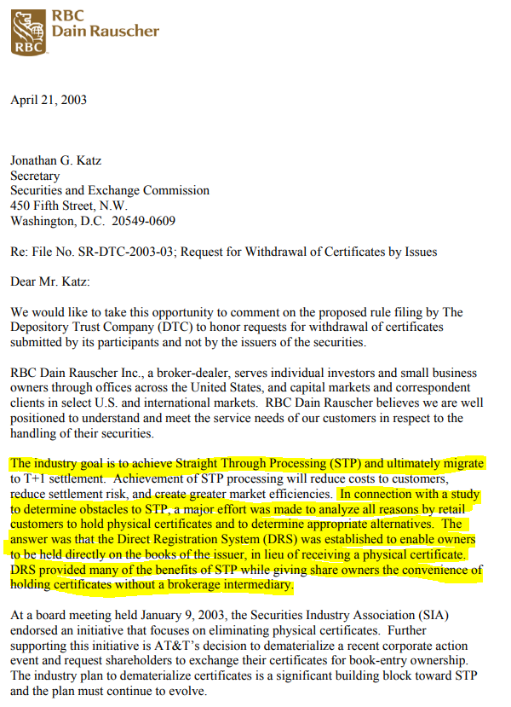
https://www.sec.gov/rules/sro/dtc200302/rbcdain042303.pdf
____________________________________________________________________________________________________________
Here's the full list if you wanna dig on your own.
...I realize there are advantages to "paperless" securities transfers... However... It is EXACTLY what
Michael Sondow said in his comment letter above.. We simply cannot trust the DTC to protect our
interests when we don't have physical control of our assets**.**
Several other participants, including Edward Jones, Ameritrade,
Citibank, and Prudentialoverwhelmingly favored this proposal.. How can someone NOT acknowledge
that the absence of physical shares only makes it easier for these people to manipulate the market....?
This rule change would allow these 'participants' to continue doing this because it's extremely profitable
to sell shares that don't exist, or have not been collateralized. Furthermore, it's a win-win for them
because it forces issuers to keep their deposits in the holding account of the DTC...
Ever heard of the fractional reserve banking system?? Sounds A LOT like what the stock market has just
become.
Want proof of market manipulation? Let's fact-check the claims from the opposition letters above. I'm
only reporting a few for the time period we discussed (2003ish). This is just to validate their claims that
some sketchy sh*t is going on.
1. UBS Securities (formerly UBS Warburg):
a. pg 559; SHORT SALE VIOLATION; 3/30/1999
b. pg 535; OVER REPORTING OF SHORT INTEREST POSITIONS; 5/1/1999 -
12/31/1999
c. PG 533; FAILURE TO REPORT SHORT SALE INDICATORS;INCORRECTLY
REPORTING LONG SALE TRANSACTIONS AS SHORT SALES; 7/2/2002
2. Merrill Lynch (Professional Clearing Corp.):
a. pg 158; VIOLATION OF SHORT INTEREST REPORTING; 12/17/2001
3. RBC (Royal Bank of Canada):
a. pg 550; FAILURE TO REPORT SHORT SALE TRANSACTIONS WITH
INDICATOR; 9/28/1999
b. pg 507; SHORT SALE VIOLATION; 11/21/1999
c. pg 426; FAILURE TO REPORT SHORT SALE MODIFIER; 1/21/2003
Ironically, I picked these 3 because they were the first going down the line.. I'm not sure how to be any
more objective about this.. Their entire FINRA report is littered with short sale violations. Before anyone
asks "how do you know they aren't ALL like that?" The answer is- I checked. If you get caught for a short
sale violation, chances are you will ALWAYS get caught for short sale violations. Why? Because it's more
profitable to do it and get caught, than it is to fix the problem.
Wanna know the 2nd worst part?
Several comment letters asked the DTC to investigate the claims of naked shorting BEFORE coming to a
decision on the proposal.. I never saw a document where they followed up on those requests.....
NOW, wanna know the WORST part?
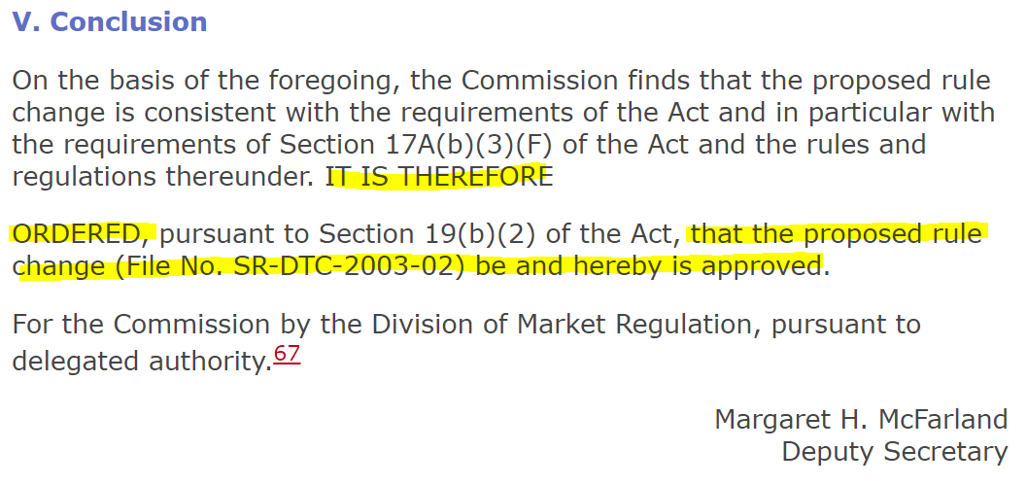
https://www.sec.gov/rules/sro/34-47978.htm#P99_35478
The DTC passed that rule change....
They not only prevented the issuers from removing their deposits, they also turned a 'blind-eye' to their
participants manipulative short selling, even when there's public evidence of them doing so...
....Those companies were being attacked with shares THEY put in the DTC, by institutions they can't even
identify...
___________________________________________________________________________________________________________
..Let's take a quick breath and recap:
The DTC started using a computerized ledger and was very successful through the 80's. This evolved
into trading systems that were also computerized, but not as sophisticated as they hoped.. They played a
major part in the 1987 crash, along with severely desynchronized derivatives trading.
In 2003, the DTC denied issuers the right to withdraw their deposits because those securities were in
the control of participants, instead. When issuer A deposits stock into the DTC and participant B shorts
those shares into the market, that's a form of rehypothecation. This is what so many issuers were trying
to express in their comment letters. In addition, it hurts their company by driving down it's value. They
felt robbed because the DTC was blatantly allowing it's participants to do this, and refused to give them
back their shares..
It was critically important for me to paint that background.
____________________________________________________________________________________________________________
..now then....
Remember when I mentioned the DTC's enrollee- Cede & Co.?
https://www.sec.gov/rules/sro/34-47978.htm#P19_6635 (section II)
I'll admit it: I didn't think they were that relevant. I focused so much on the DTC that I didn't think to
check into their enrollee...
..Wish I did....
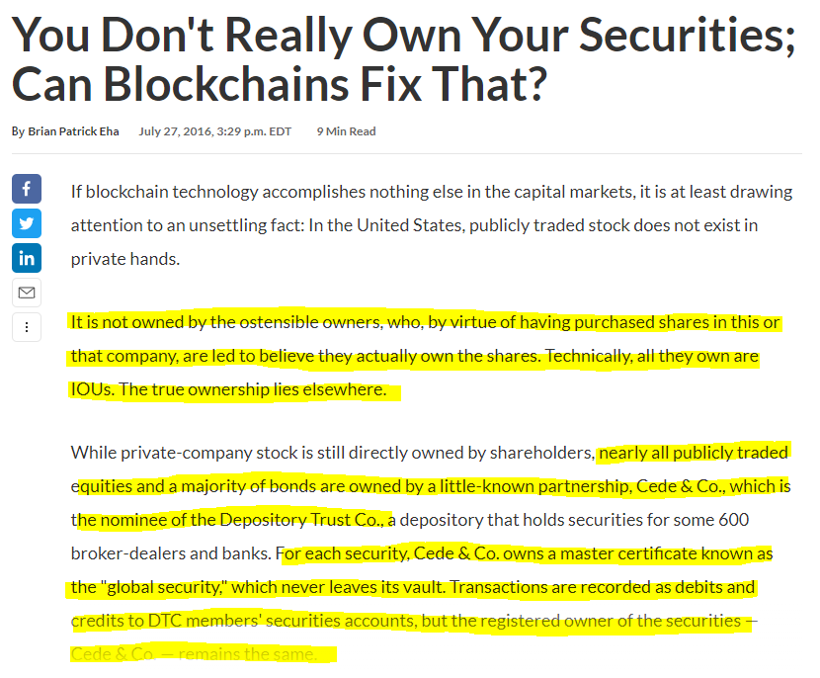
https://www.americanbanker.com/news/you-dont-really-own-your-securities-can-blockchains-fix-that
That's right.... Cede & Co. hold a "master certificate" in their vault, which NEVER leaves. Instead, they
issue an IOU for that master certificate..
Didn't we JUST finish talking about why this is such a major flaw in our system..? And that was almost 20
years ago...
Here comes the mind f*ck
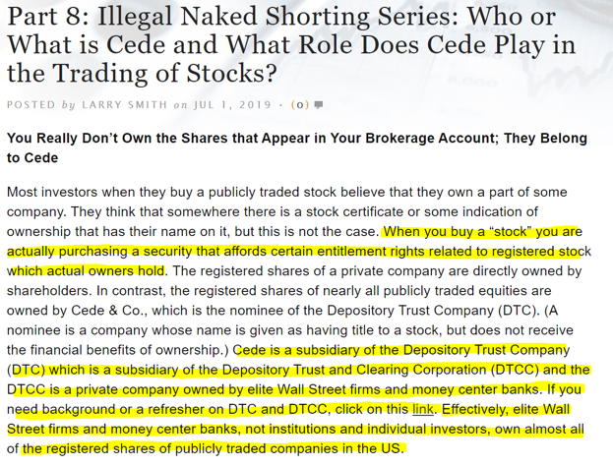
https://smithonstocks.com/part-8-illegal-naked-shorting-series-who-or-what-is-cede-and-what-role-does-cede-play-in-the-
trading-of-stocks/
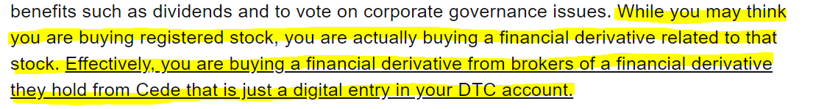
https://smithonstocks.com/part-8-illegal-naked-shorting-series-who-or-what-is-cede-and-what-role-does-cede-play-in-the-
trading-of-stocks/
____________________________________________________________________________________________________________
Now.....
You wanna know the BEST part???
I found a list of all the DTC participants that are responsible for this mess..
I've got your name, number, and I'm coming for you- ALL OF YOU
to be continued.
DIAMOND.F*CKING.HANDS
Back to Table of Contents
House of Cards - Part 2
DD 👨‍🔬
Prerequisite DD:
1. Citadel Has No Clothes
2. The EVERYTHING Short
3. The House of Cards – Part 1
____________________________________________________________________________________________________________
TL;DR- No freaking way I can do that.
____________________________________________________________________________________________________________________
1. Pilot
I wasn’t looking into GameStop when all of this began. Most of my time was spent researching the
pandemic’s impact on the economy. I’m talking about the economic steam engine that employs people
and puts food on their tables. Especially the small businesses that were executively steamrolled by
COVID lockdowns. It was scary how fast they had to close their doors.
I spent a lot of time looking at companies like GameStop. Brick-n-mortar businesses were basically
running out of bricks to sh*t. Frankly, GameStop looked a lot like the next Blockbuster and it just seemed
like a matter of time before they went under. Had DFV not done his homework, it's possible we wouldn’t
have a rocket to HODL or a story to TODL.
Whoever has/had a short position with GameStop was probably thinking the same thing. The number of
shares that can be freely traded on a daily basis is referred to as “the float”. GameStop has 70,000,000
shares outstanding, but 50,000,000 shares represented “the float”. With a small float like this, a short
position of 20% becomes significant. Heck, Volkswagen got squozed with just a 12.8%short position. So
let’s use little numbers to walk through an example of how this works.
Assume VW has 100 shares outstanding. If 12.8% of the company has been sold short, then 12.8 shares
(let’s just say 13) must be available to purchase at a later date (assuming VW doesn’t go bankrupt).
However, VW had a float of 45% which meant there was no real strain to cover that 12.8% short
position at any moment. However, when Porsche announced they wanted to increase their position in
VW, they invested HEAVILY.
“The kicker was that Porsche owned 43% of VW shares, 32% in options, and the government owned
20.2%.... In plain terms, it meant that the actual available float went from 45% down to 1% of outstanding
shares” (bullishbears.com/vw-short-squeeze/).
Let’s revisit our scenario. With 100 shares outstanding and 13 shares sold short, what happens if only 1
share was available to cover instead of 45?
Well….. THIS:
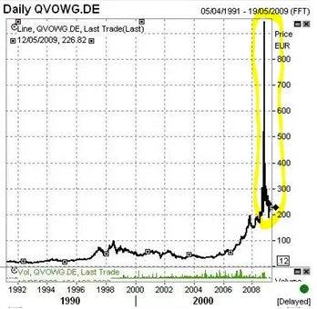
____________________________________________________________________________________________________________
GameStop is/was the victim of price suppression through short selling. I discussed this topic with Dr.
Tand Carl Hagberg in our AMAs. Every transaction has two sides- a buy and a sell. Short selling artificially
increases the supply of shares and causes the price to decline. When this happens, the price can only
increase if demand exceeds the increase in supply.
I started looking closely at GameStop after confirming their reported short position of 140%. It’s
important for me explain this why this is so much different than the VW example…
140% of GameStop’s FLOAT was sold short. There were 50,000,000 shares in that float, so 140% of this
was equal to the 70,000,000 shares the company has outstanding. This means AT LEAST 100% of their
outstanding shares has been sold short. Now compare that to VW where the short position was only
12.8%... Simply put, it is mathematically impossible to cover more than 100% of a company’s
outstanding stock.
The peak of the VW squeeze was reached when the demand for shares became surpassed by the supply
of those shares. Here, demand represents 12.8% of their stock which must be available to close the short
position. With only 1% of shares available, this guaranteed a squeeze until the number of shares
available to trade could satisfy the remaining short interest.
When a company has a short position with more than 100% of total shares outstanding, the preceding
argument is thrown out the window. Supply cannot surpass demand because the company can only
issue 100% of itself at any given time. Therefore, the additional 40% could only be explained by multiple
people claiming ownership of the same share... Surely this is a mistake.. right? I thought this level of
short selling was impossible..
..Until I saw the number of short selling violations issued by FINRA..
As we go through these FINRA reports, there are a few things to keep in mind:
1. FINRA is not a part of the government. FINRA is a non-profit entity with regulatory
powers set by congress. This makes FINRA the largest self-regulatory organization (SRO)
in the United States. The SEC is responsible for setting rules which protect individual
investors; FINRA is responsible for overseeing most of the brokers (collectively referred
to as members) in the US. As an SRO, FINRA sets the rules by which their members must
comply- they are not directly regulated by the SEC
2. FINRA investigates cases at their own pace. When looking at the “Date Initiated” on their
reports, it is not synonymous with “date of occurrence”. Many times, FINRA will not say
when a problem occurred, just resolved. It can be YEARS after the initial occurrence.
The DTC participant report is littered with cases that were initiated in 2019 but occurred
in 2015, etc. Many of the violations occurring today will take years to discover
3. FINRA can issue a violation for each occurrence using a 1:1 format. When it comes to
violations like short selling, however, these “occurrences” can last months or even years.
When this happens, FINRA issues a violation for multiple occurrences using a 1:MANY
format. I discussed this event in Citadel Has No Clothes where one violation represented
FOUR YEARS of market f*ckery. What’s sh*tty is that FINRA doesn’t tell you which
violations are which. You have to read each line and see if they mention a date range of
occurrence within each record. If they don’t, you must assume it was for one event…
BRUTAL
4. FINRA’s investment portfolio is held by the same entities they are issuing violations to…
Let that sink in for a minute
____________________________________________________________________________________________________________
2. State your case…
Can you think of a reason why short sellers would want to understate their short positions? Put yourself
in their situation and imagine you’re running a hedge fund…
You operate in a self-regulated (SRO) environment and your records are basically private. If the SEC asks
you to justify suspicious behavior, you really don’t have to provide it. The worst that could happen is a
slap on the wrist. I wrote about this EXACT same thing in Citadel Has No Clothes. They received a cease-
and-desist order from the SEC on 12/10/2018 for failing to submit complete and accurate records. This
‘occurred’ from November 2012 through April 2016 and contained deficient information for over
80,000,000 trades. Their punishment… $3,500,000… So why even bother keeping an honest ledger?
Now, suppose you short a bunch of shares into the market. When you report this to FINRA, they require
you to mark the transaction with a short sale indicator. In doing so, FINRA builds a paper trail to your
short selling activity.
However… if you omit this indicator, FINRA can’t distinguish that transaction from a long sale. Who else
would there be to hold you accountable for covering your position? This is especially true for self-
clearing organizations like Citadel because there are less parties involved to hold you accountable with
recordkeeping. If FINRA thinks you physically owned those shares and sold them (long sale), they have
no reason to revisit that transaction in the future… You could literally pocket the cash and dump the
commitment to cover.
Another very important advantage is that it allows short sellers to artificially increase the supply of
shares while understating the outstanding short interest on that security. The supply of shares being
sold will drive down the price, while the short interest on the stock remains the same.
So.. aside from paying a fine, how could you possibly lose by “forgetting” to mark that trade with a short
sale indicator? It would seem the system almost incentivizes this type of behavior.
I combed through the DTC participant report and found enough dirt to fill the empty chasm that is Ken
Griffin’s soul. Take a guess at what their most common short selling violation is.. I’m going to assume
you said “FAILING TO PROPERLY MARK A SHORT SALE TRANSACTION”.
For the record, I just want to say I called this in March when I wrote Citadel Has No Clothes. Citadel has
one of the highest concentrations of short selling violations in their FINRA report. At the time, I didn’t
fully understand the consequences of this violation… After seeing how many participants received the
same penalty, it finally made sense.
There are roughly 240 participant account names on the DTC’s list. Sh*t you not, I looked at every short
selling violation that was published on Brokercheck.finra.org. To be fair, I eliminated participants with
only 1 or 2 violations related to short selling. There were PLENTY of bigger fish to fry.
I literally picked the first participant at the top of the list and found three violations for short selling.
*cracks knuckles*
ABN AMRO Clearing Chicago LLC (AACC) is the 3rd largest bank in the Netherlands. They got popped for
three short selling violations, one of which included a failure-to-deliver. In total, they have 78 violations
from FINRA. Several of these are severe compared to their violations for short selling. However, the
short selling violations revealed a MUCH bigger story:
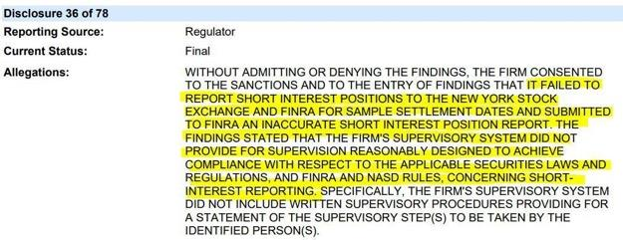
So… ABN AMRO submitted an inaccurate short interest position to the NYSE and FINRA and lacked the
proper supervisory systems to comply with… practically everything…
In 2014, AMRO forked over $95,000 to settle this and didn’t even say they were sorry.
In these situations, it’s easy to think “meh, could have been a fluke event”. So I took a closer look and
found violations by the same participants which made it much harder to argue their case of sheer
negligence. Here are a couple for AMRO:
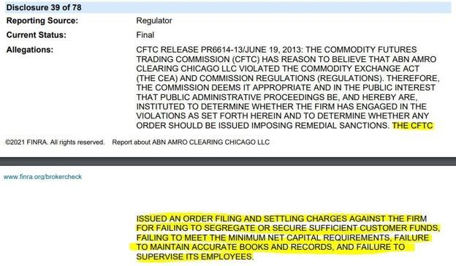
ABN AMRO got slapped with a $1,000,000 fine for understating capital requirements, failing to maintain
accurate books, and failing to supervise employees. If you mess up once or twice but end up fixing the
problem- GREAT. When your primary business is to clear trades and you fail THIS bad, there is a much
bigger problem going on. It gets hard to defend this as an accident when every stage of the trade
recording process is fundamentally flawed. The following screenshot came from the same violation:
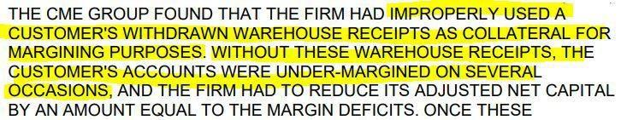
Warehouse receipts are like the receipts you get after buying lumber online. You can print these out and
take them to Home-Depot, where you exchange them for the ACTUAL lumber in the store. Instead of
trading the actual goods, you can trade a warehouse receipt instead… so yeah… since this ONE record
allowed AMRO to meet their customer’s margin requirement, it seems EXTREMELY suspicious that they
didn’t appropriately remove it once they were withdrawn.
Do I think this was an accident? F*ck no. Because FINRA reported them 8 years later for doing the SAME
F*CKING THING:
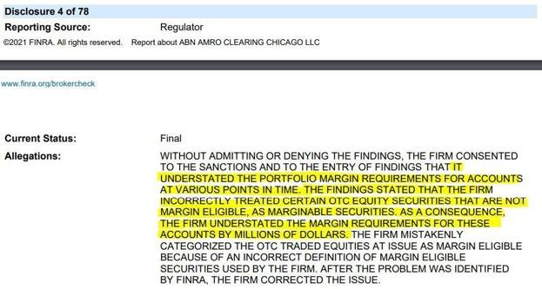
Once again, AMRO got caught understating their margin requirements. Last time, they used the value of
withdrawn warehouse receipts to meet their margin requirements. Here, they’re using securities which
weren’t eligible for margin to meet their margin requirements..
You can paint apple orange, but it’s still an apple..
The bullsh*t I read about in these reports doesn’t really shock me anymore. It’s actually the opposite..
You begin to expect bigger fines as they set higher benchmarks for misconduct. When I find a case like
AMRO, I’ll usually put more time into it because certain citations represent puzzle pieces. Once you find
enough pieces, you can see the bigger picture. So believe me when I say I was genuinely shocked by
the detail report on this case…
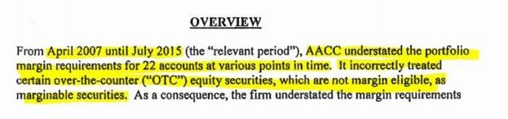
This has been going on for 8 F*CKING YEARS!?
Without a doubt, this is a great example of a violation where the misconduct supposedly ended in 2015
but took another 4 years for FINRA to publish the d*mn report. If my math is correct, the 8 year
“relevant period” plus the 4 years FINRA spent… I don’t know… reviewing?... yields a total of 12 years. In
other words, from the time this problem started to the time it was publicized by FINRA, the kids in 1st
grade had graduated high school…
Does anyone else think these self-regulatory organizations (SROs) are doing a terrible job self-
regulating…? How we can trust these situations are appropriately monitored if it takes 12 years for a
sh*t blossom to bloom?
…OH! I almost forgot… After understating their margin requirements in 22 accounts for over 8 years,
ABN AMRO paid a $150,000 fine to settle the dust…
____________________________________________________________________________________________________
I know that was a sh*t load of information so let me summarize it for you:
One of the most common citations occurs when a firm “accidently” marks a short sale as long, or
misreports short interest positions to FINRA. When a short sale occurs, that transaction should be
marked with a short sale indicator. Despite this, many participants do it to avoid the borrow
requirements set by Regulation SHO. If they mark a short sale as long, they are not required to locate a
borrow because FINRA doesn’t know it’s a short sale.
This is why so many of these FINRA violations include a statement about the broker failing to locate a
borrow along with the failure to mark a short sale indicator on the transaction. It literally means the
broker was naked short selling a stock and telling FINRA they physically owned that share..
Suddenly, a “small” violation had much bigger implications. The number of short shares that have been
excluded from the short interest calculation is directly related to these violations… and there are
HUNDREDS of them. Who knows how many companies have under reported short interest positions..
To be clear, I did NOT choose them based on the amount of ‘dirt’ they had. AMRO’s violations were like
grains of sand on a beach and It’s going to take A LOT of dirt to fill the bottomless pit that is Ken Griffin’s
soul. Frankly, ABN AMRO wouldn’t get us there with 10,000 FINRA violations. So without further ado,
let’s get dirty..
____________________________________________________________________________________________________
2. Call em’ out…
When FINRA publishes one of their reports, the granular details like numbers and dates are often left
out. This makes it impossible to determine how systematic a particular issue might be.
For example, if you know that “XYZ failed to comply with FINRA’s short interest reporting
requirements”your only conclusion is that the violation occurred. However, if you know that “XYZ failed
to comply with FINRA’s short interest reporting requirements on 15,000 transactions during 2020” you can
start investigating the magnitude of that violation. If XYZ only completed 100,000 transactions in 2020,
it means 15% of their transactions failed to meet requirements. This represents a major systematic risk
to XYZ and the parties it conducts business with.
I spent some time analyzing Apex Clearing Corporation after I left ABN AMRO. Apex is 8th on the list and
the 2nd participant I found with an evident short selling problem.
In 2019, FINRA initiated a case against Apex for doing the same sh*t as ABN AMRO. However, the
magnitude of this violation really put things into perspective: I got a small taste of how f*cked this house
of cards truly is..
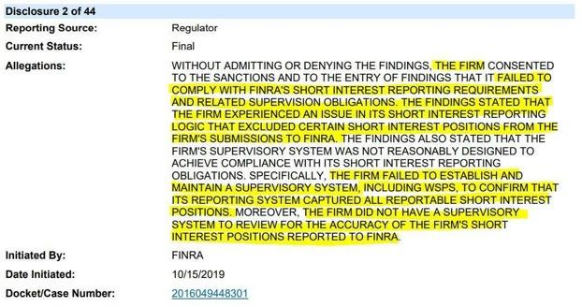
This is practically a template of the first ABN AMRO violation we discussed. To see the difference, we
need to look at their letter of Acceptance, Waiver and Consent (AWC)..
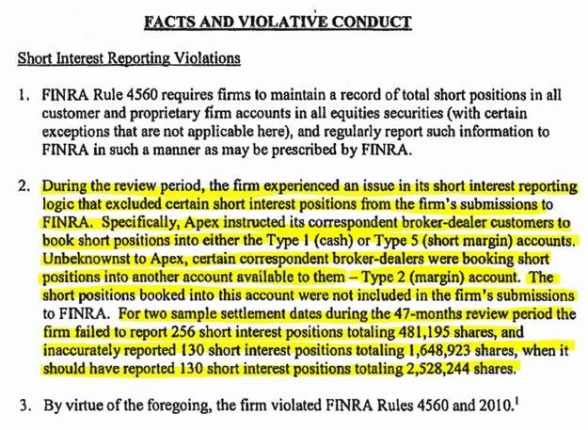
Let’s break this down step-by-step…
Apex had an issue for 47 months where certain customers recorded their short positions in an account
which was NOT being sent to FINRA. It only takes a few wrinkles on the brain to realize this is a
problem. The sample data tells us just how bad that problem is..
When you see the term “settlement days”, think “T+2”. Apex follows the T+2 settlement period for
both cash accounts and margin accounts which means the trade should clear 2 days after the original
trade date. When you buy stock on a Monday, it should settle by Wednesday.
Ok.. quick maff…
There are roughly 252 trading days in one year after removing weekends and holidays. Throughout the
47 month “review period”, we can safely assume that Apex had roughly 987 ((252/ 12) *
47) settlement dates…
In other words: 256 misstated reports over 47 months is more than 1 misstatement / week for
nearly 4 years. Tell me again how this is trivial?
The wording of the “sample settlement” section is a bit ambiguous… It doesn’t clarify if those were the
only 2 settlement dates they sampled, or if they were the only settlement dates with reportable issues.
Honestly, I would be shocked if it was the latter because auditors don’t examine every record, but I can’t
be certain…
Anyway… FINRA discovered 256 short interest positions, consisting of 481,195 shares,
were incorrectlyexcluded from their short interest report. In addition, they understated the share count
by 879,321 in 130 separate short interest positions. Together, this makes 1,360,516 shares that were
excluded from the short interest calculation. When you realize nearly 1.5 million ‘excluded’ shares were
discovered in just 2 settlement periods and there were almost 1,000 dates to choose from, it seriously
dilates the imagination…
Once again… FINRA wiped the slate clean for just $140,000…
I want to talk about one last thing before we jump to the next section. Did you happen to notice the
different account types that Apex discussed in their letter of Acceptance, Waiver and Consent ? They
specifically instructed their customers to book short positions into a TYPE 1 (CASH) account, or TYPE 5
(SHORT MARGIN) account. A short margin account is just a margin account that holds short positions.
The margin requirement for short positions are more strict than regular margin accounts, so I can see
the advantage in separating them.
In the AMA with Wes Christian (starting at 7:30), he specifically discussed how a broker-dealer’s margin
account is used to locate shares for short sellers. However, the margin account contains shares that were
previously pledged to another party. Given the lack of oversight in securities lending, the problem keeps
compounding each time a new borrower claims ownership of that share.
Now think back to the situation with Apex..
They asked their customers to book short positions to a short-margin account or a cash account. The
user agreement with a margin account allows Apex to continue lending those securities at any time. As
discussed with Dr. T and Carl Hagberg, the broker collects interest for lending your margin shares and
doesn’t pay you anything in return. When multiple locates are authorized for the same share, the broker
collects multiple lending fees on the same share.
In contrast, the cash account falls under the protection of SEA 15c3-3 and consists of shares that have not
been leveraged- or lent- like the margin-short account. According to Wes (starting at 8:30), these shares
are segregated and cannot be touched. The broker cannot encumber-or restrict- them in any way.
However, according to Wes, this is currently happening. He also explained how Canada has legalized this
and currently allows broker-dealers to short sell your cash account shares against you.
____________________________________________________________________________________________________
Alright…. I’ll stop beating the dead horse regarding short sale indicators & inaccurate submissions of
short interest positions. Given the volume of citations we haven’t discussed, I’ll summarize some of my
findings, below.
Keep in mind these are ONLY for “FAILURE TO REPORT SHORT INTEREST POSITIONS” or “FAILURE
TO INDICATE A SHORT SALE MODIFIER”. If the violations contain additional information, it’s because
that citation actually listed additional information. It does NOT represent an all-inclusive list of short
selling violations for these participants.
…You wanted to know how systematic this problem is, so here you go... (EACH BROKER-DEALER NAME
IS HYPERLINKED TO THEIR FINRA REPORT)
1. Barclays | Disclosure 36 – “SUBMITTED 86 SHORT INTEREST POSITIONS TOTALING
41,100,154 SHARES WHEN THE ACTUAL SHORT INTEREST POSITION WAS 44,535,151
SHARES.. FAILED TO REPORT 8 SHORT INTEREST POSITIONS TOTALING 1,110,420
SHARES”
a. $10,000 FINE
2. Barclays | Disclosure 54 – “SUBMITTED AN INACCURATE SHORT INTEREST POSITION TO FINRA AND
FAILED TO REPORT ITS SHORT INTEREST POSITIONS IN 835 POSITIONS TOTALING 87,562,328
SHARES”
a. $155,000 FINE
3. BMO Capital Markets Corp | Disclosure 23 – “SUBMITTED SHORT INTEREST POSITIONS TO FINRA
THAT WERE INCORRECT AND FAILED TO REPORT TO FINRA ITS SHORT INTEREST POSITIONS
TOTALING OVER 72 MILLION SHARES FOR 11 MONTHS”
a. $90,000 FINE
4. BNP Paribas Securities Corp | Disclosure 53 – “FAILED TO REPORT TO FINRA ITS SHORT INTEREST IN
2,509 POSITIONS TOTALING 6,051,974 SHARES”
a. $30,000 FINE
5. BNP Paribas Securities Corp | Disclosure 9 – “ON 35 OCCASIONS OVER A FOUR-MONTH PERIOD, A
HEDGE FUND SUBMITTED SALE ORDERS MARKED “LONG” TO BNP FOR CLEARING. FOR EACH OF
THOSE “LONG” SALES, ON THE MORNING OF SETTLEMENT, THE HEDGE FUND DID NOT HAVE THE
SHARES IN IT’S BNP ACCOUNT TO COVER THE SALE ORDER. IN ADDITION, BNP WAS ROUTINELY
NOTIFIED THAT THE HEDGE FUND WOULD NOT BE ABLE TO COVER. NEVERTHELESS, WHEN EACH
SETTLEMENT DATE ARRIVED AND THE HEDGE FUND WAS UNABLE TO COVER, BNP LOANED THE
SHARES TO THE HEDGE FUND. IN TOTAL, BNP LOANED MORE THAN 8,000,000 SHARES TO COVER
THESE PURPORTED “LONG” SALES”
a. $250,000 FINE
6. Cantor Fitzgerald & Co | Disclosure 1 - (literally came out on 5/6/2021) – “THE FIRM SUBMITTED
INACCURATE SHORT INTEREST POSITIONS TO FINRA. THE FIRM OVERREPORTED NEARLY 55,000,000
SHORT SHARES WHICH WERE CUSTODIED WITH AND ALREADY REPORTED BY ITS CLEARING FIRM,
WITH WHICH CANTOR MAINTAINS A FULLY DISCLOSED CLEARING AGREEMENT”
a. $250,000 FINE
7. Cantor Fitzgerald & Co | Disclosure 31 - “…THE FIRM EXECUTED NUMEROUS SHORT SALE ORDERS
AND FAILED TO PROPERLY MARK THE ORDERS AS SHORT… THE FIRM, ON NUMEROUS OCCASIONS,
ACCEPTED SHORT SALE ORDERS IN AN EQUITY SECURITY FROM ANOTHER PERSON, OR EFFECTED A
SHORT SALE FROM ITS OWN ACCOUNT WITHOUT BORROWING THE SECURITY…”
a. $53,500 FINE
8. Cantor Fitzgerald & Co | Disclosure 33 - “…EXECUTED SHORT SALE ORDERS AND FAILED TO
PROPERLY MARK THE ORDERS AS SHORT. THE FIRM HAD FAIL-TO-DELIVER POSITIONS AT A
REGISTERED CLEARING AGENCY IN THRESHOLD SECURITIES FOR 13 CONSECUTIVE SETTLEMENT
DAYS… FAILED TO IMMEDIATELY CLOSE OUT FTD POSITIONS… ACCEPTED SHORT SALE ORDERS
FROM ANOTHER PERSON, OR EFFECTED A SHORT SALE FROM ITS OWN ACCOUNT, WITHOUT
BORROWING THE SECURITY OR HAVING REASONABLE GROUNDS TO BELIEVE THAT THE SECURITY
COULD BE BORROWED…”
a. $125,000 FINE
9. Canaccord Genuity Corp | Disclosure 17 - “THE FIRM EXECUTED SALE TRANSACTIONS AND FAILED
TO REPORT EACH OF THESE TRANSACTIONS TO THE FINRA/NASDAQ TRADE REPORTING FACILITY
AS SHORT”
a. $57,500 FINE
10. Canaccord Genuity Corp | Disclosure 20 - “THE FIRM EXECUTED SHORT SALE ORDERS AND FAILED
TO PROPERLY MARK THE ORDERS AS SHORT”
a. $27,500 FINE
11. Canaccord Genuity Corp | Disclosure 31 - “…SUBMITTED TO NASD MONTHLY SHORT INTEREST
POSITION REPORTS THAT WERE INACCURATE”
a. $85,000 FINE
12. Citadel Securities LLC | Citadel Has No Clothes – LITERALLY ALL I TALK ABOUT IN THAT POST. GO
READ IT
13. Citigroup Global Markets | Disclosure 10 – “THE FIRMS TRADING PLATFORM FAILED TO RECOGNIZE
THAT THE FIRM WAS SELLING SHORT WHEN IT WAS ACTING AS THE CONTRA PARTY TO A
CUSTOMER TRADE. AS A RESULT, THE FIRM ERRONEOUSLY REPORTED SHORT SALES TO A FINRA
TRADE REPORTING FACILITY AS LONG SALES… EFFECTING SHORT SALES FROM ITS OWN ACCOUNT
WITHOUT BORROWING THE SECURITY…”
a. $225,000 FINE
14. Citigroup Global Markets | Disclosure 59 – “…THE FIRM RECORDED 203,653 SHORT SALE
EXECUTIONS ON ITS BOOKS AND RECORDS AS LONG SALES, SUBMITTED INACCURATE ORDER
ORIGINATION CODES AND ACCOUNT TYPE CODES TO THE AUDIT TRAIL SYSTEM FOR
APPROXIMATELY 2,775,338 ORDERS… “
a. $300,000 FINE
15. Citigroup Global Markets | Disclosure 76 – “…FAILED TO PROPERLY MARK APPROXIMATELY
9,717,875 SALE ORDERS AS SHORT SALES… FINDINGS ALSO ESTIMATED THAT THE FIRM
ENTERED 55 MILLION ORDERS INTO THE NASDAQ MARKET CENTER THAT IT FAILED TO
CORRECTLY INDICATE AS SHORT SALES…”
a. $2,250,000 FINE
16. Cowen and Company LLC | Several Disclosures – almost every other disclosure is for failing to mark a
sale with the appropriate indicator, including short AND long sale indicators
17. Credit Suisse Securities LLC | Disclosure 34 – “NEW ORDER REPORTS WERE INACCURATELY
ENTERED INTO ORDER AUDIT TRAIL SYSTEM (OATS) AS LONG SALES BUT WERE TRADE REPORTED
WITH A SHORT SALE INDICATOR”
a. $50,000 FINE
18. Credit Suisse Securities LLC | Disclosure 95 – “BETWEEN SEPTEMBER 2006 AND JUNE 2008, CREDIT
SUISSE FAILED TO SUBMIT ACCURATE PERIODIC REPORTS WITH RESPECT TO SHORT POSITIONS…”
a. $40,000 FINE
19. Deutsche Bank Securities INC. | Disclosure 50 – “THE FIRM FAILED TO REPORT SHORT INTEREST
POSITIONS IN DUALLY-LISTED SECURITIES”
a. $200,000 FINE
20. Deutsche Bank Securities INC. | Disclosure 52 – “THE FIRM… EXPERIENCED MULTIPLE PROBLEMS
WITH ITS BLUE SHEET SYSTEM THAT CAUSED IT TO SUBMIT INACCURATE BLUE SHEETS TO THE SEC
AND FINRA… INCORRECTLY REPORTED LONG ON ITS BLUE SHEET TRANSACTIONS WHEN CERTAIN
TRANSACTIONS SHOULD HAVE BEEN MARKED SHORT”
a. $6,000,000 FINE (SEVERAL OTHER ISSUES REPORTED IN ADDITION TO SHORTS)
21. Deutsche Bank Securities INC. | Disclosure 58 – “BETWEEN JANUARY 2005 AND CONTINUING
THROUGH NOVEMBER 2015, THE FIRM IMPROPERLY INCLUDED THE AGGREGATION OF NET
POSITIONS IN CERTAIN SECURITIES OF A NON-US BROKER AFFILIATE… IN ADDITION… DURING THE
PERIOD BETWEEN APRIL 2004 AND SEPTEMBER 2012, THE FIRM INAPPROPRIATELY REPORTED
CERTAIN SHORT INTEREST POSITIONS ON A NET, INSTEAD OF GROSS, BASIS..”
a. $1,400,000 FINE
22. Goldman Sachs & Co. LLC | Disclosure 32 – “THE FIRM REPORTED SHORT SALE TRANSACTIONS TO
FINRA TRADE REPORTING FACILITY WITHOUT THE REQUIRED SHORT SALE MODIFIER”
a. $260,000 FINE (SEVERAL OTHER ISSUES REPORTED IN ADDITION TO SHORTS)
23. Goldman Sachs & Co. LLC | Disclosure 54 – “FAILED TO ACCURATELY APPEND THE SHORT SALE
INDICATOR TO FINRA/NASDAQ TRADE REPORTING FACILITY REPORTS… INACCURATELY MARKED
SELL TRANSACTIONS ON ITS TRADING LEDGER”
a. $55,000 FINE
24. Goldman Sachs & Co. LLC | Disclosure 63 – “…SUBMITTED TO FINRA AND THE SEC BLUE SHEETS
THAT INACCURATELY REPORTED CERTAIN SHORT SALE TRANSACTIONS AS LONG SALE
TRANSACTIONS WITH RESPECT TO THE FIRM SIDE OF CUSTOMER FACILITATION TRADES… THE FIRM
REPORTED SHORT SALES AS LONG SALES ON ITS BLUE SHEETS WHEN THE TRADING DESK USED A
PARTICULAR MIDDLE OFFICE SYSTEM…”
a. $1,000,000 FINE
25. Goldman Sachs & Co. LLC | Disclosure 150 – “GOLDMAN SACHS & CO. FAILED TO REPORT SHORT
INTEREST POSITIONS FOR FOREIGN SECURITIES AND NUMEROUS SHARES ONE MONTH… THE FIRM
REPORTED SHORT INTEREST POSITIONS IN SECURITIES TOTALING SEVERAL MILLION SHARES EACH
TIME WHEN THE ACTUAL SHORT INTEREST POSITIONS IN THE SECURITIES WERE ZERO SHARES…
ACCEPTING A SHORT SALE ORDER IN AN EQUITY SECURITY FROM ANOTHER PERSON, OR EFFECTED
A SHORT SALE FROM ITS OWN ACCOUNT, WITHOUT BORROWING THE SECURITY OR BELIEVING THE
SECURITY COULD BE BORROWED ON THE DATE OF DELIVERY…”
a. $120,000 FINE
26. Goldman Sachs & Co. LLC | Disclosure 167 – “…THE FIRM FAILED TO REPORT TO THE NMC THE
CORRECT SYMBOL INDICATING THAT THE TRANSACTION WAS A SHORT SALE FOR TRANSACTIONS IN
REPORTABLE SECURITIES…”
a. $600,000 FINE (SEVERAL OTHER ISSUES REPORTED IN ADDITION TO SHORTS)
27. HSBC Securities (USA) INC. | Disclosure 26 – “FIRM EXECUTED SHORT SALE TRANSACTIONS AND
FAILED TO MARK THEM AS SHORT… HSBC SECURITIES HAD A FAIL-TO-DELIVER SECURITY FOR 13
CONSECUTIVE SETTLEMENT DAYS AND FAILED TO IMMEDIATELY CLOSE OUT THE FTD POSITION…
THE FIRM CONTINUED TO HAVE A FTD IN THE SECURITY AT A CLEARING AGENCY ON 79 ADDITIONAL
SETTLEMENT DAYS…”
a. $65,000 FINE
____________________________________________________________________________________________________________
I’m going to stop at ‘H’ because I’m tired of writing. Hopefully, you all understand the point so far. We’re
only 8 letters into the alphabet and have successfully buried Ken to his waist.
The system that is used to mark the proper transaction type (sell, buy, short sell, short sell exempt, etc.)
is obviously broken… There, I said it.. the system is INDUBITABLY, UNDOUBTEDLY, INEVITABLY
F*CKED..
Regardless of the cause- fraud or negligence- there are too many firms failing to accomplish a seemingly
simple task. The consequences of which are creating far more shares than we can imagine. It’s a gigantic
domino effect. If you fail to properly mark 1,000,000 short shares and a year goes by without catching
the problem, it’s already too late. They’re like the f*cking replicators from Stargate..
In each of the examples listed above, the short interest on the stock was understated by the number of
shares excluded… and that was just a handful..
Knowing this, how can someone look at the evidence and say it’s trivial….?
No one really knows HOW systematic this issue is because it is so deeply incorporated in the market that
it has BECOME the system itself. Therefore, there is obviously something much deeper going on, here..
How does one argue against the severity of these problems after reading this? There are FAR too many
things that don’t make sense and FAR too many people turning a blind eye..
The only conclusion I keep coming back to is that the people with money know what’s going on and are
desperately trying to keep it under wraps..
..So…. In an effort to prove this, I looked for violations that showed their desperation to protect this
f*cked up system.
..Buckle up..
____________________________________________________________________________________________________________
HOUSE OF CARDS - PART 3 (I'm uploading it now; will link ASAP)
Back to Table of Contents
House of Cards - Part 3
DD 👨‍🔬
Prerequisite DD:
1. Citadel Has No Clothes
2. The EVERYTHING Short
3. The House of Cards – Part 1
4. The House of Cards - Part 2
____________________________________________________________________________________________________________
TL;DR- No freaking way I can do that.
_____________________________________________________________________________________________________________________
Continuing from HOC Part II...
4. Slimy…
If you watched the AMA with Wes Christian, he talks about the number of occurrences where the actual
short interest is severely understated based on the data his firm obtained for legal proceedings.
According to his numbers, in most cases the short interest is 50% - 150% MORE than what is reported
by the SEC (starting at 14:30).
The objective isn’t to address the issue: it’s to keep the issue hidden. Firms that underreport their short
interest are gaming the system by taking advantage of how the short interest calculation is done. When
the SEC relies on reports that broker-dealers provide, and FINRA takes YEARS to reveal the lies within
those reports, the broker-dealer can lie without immediately facing the consequences. It allows these
firms to operate in a high-risk environment without exposing just HOW big their risk-appetite is.
Another example that Wes mentioned was Merrill Lynch. Merrill was fined $415,000,000 (violation 3) in
2016 for using securities held in their customer’s accounts to cover their own trades. Check out this
screenshot I took from that case:
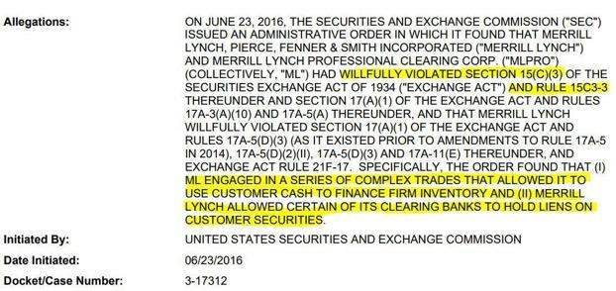
Remember when we mentioned SEA 15c3-3 in the case with Apex? They were asking customers to book
short positions to either a cash account or a short margin account. SEA 15c3-3 protects those customers
from allowing brokers to lend out the securities within their cash accounts…
Well Merrill Lynch knocked that one right out of the f*cking park…
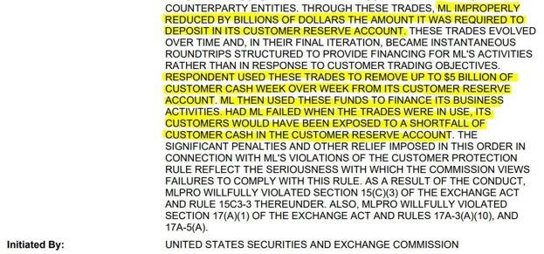
Merrill made it seem like the required deposit in their customer reserve account was much lower than it
truly was. They wouldn’t have been able to use that cash if it reduced the amount below the minimum
capital requirement, so they found a way to fudge the numbers. In doing so, they managed to prevent a
CODE RED while reaping the benefits of a high-risk ‘opportunity’. Should Merrill have filed bankruptcy
during that time, those customers would have been completely blindsided.
In the case of short selling, the true exposure of short interest is unknown… and I’m not just talking
about the short sale indicator. When a firm fails to deliver securities that were sold short, there’s a
pretty good indication that they’ve exposed themselves to a bit of a problem.. Now imagine a case where
the FTDs start piling up and they STILL continue to short sell that same security.. think I’m joking?
Check out the Royal Bank of Canada:
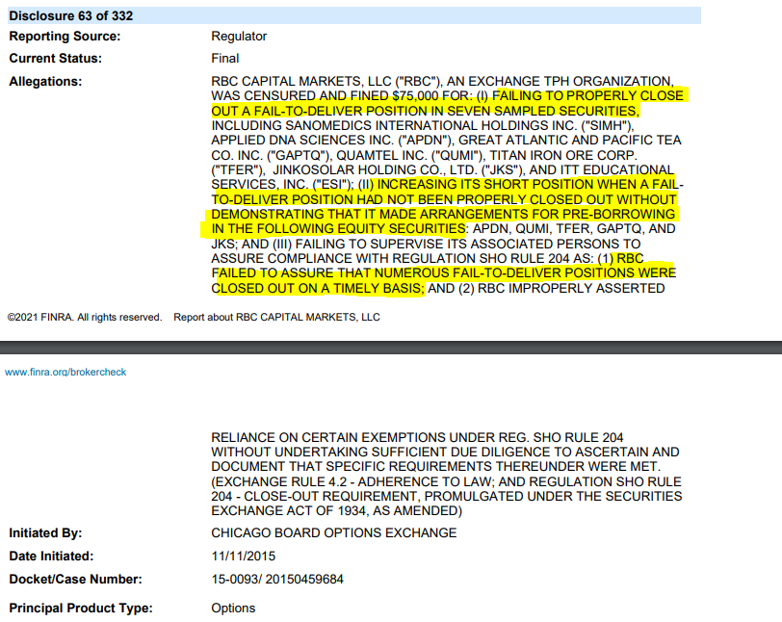
Again… I was pretty shocked at that one. However, nothing rang-the-bell quite like this one
from Goldman Sachs:
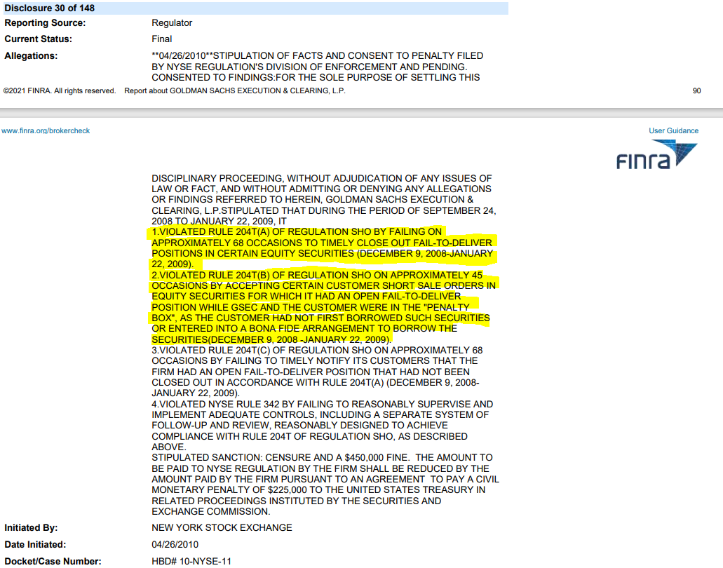
Goldman had 68 occasions in 4 months where they didn’t close a failure-to-deliver… In 45 occasions,
they CONTINUED to accept customer short sale orders in securities which it had an active failure-to-
deliver…
When a firm is really starting to sweat, they pull certain tricks out of their ass to quell the situation.
Again, this is nothing but smoke and mirrors because that’s all they can really do. Just as Merrill Lynch
artificially lowered their customer reserve deposit, other firms make it look like they cover their short
positions.
One of the ways they do this is by short selling a SH*T load of shares right before a buy-in… Since we’re
talking about Goldman Sachs, this seems like a great time to showcase their experience with this..
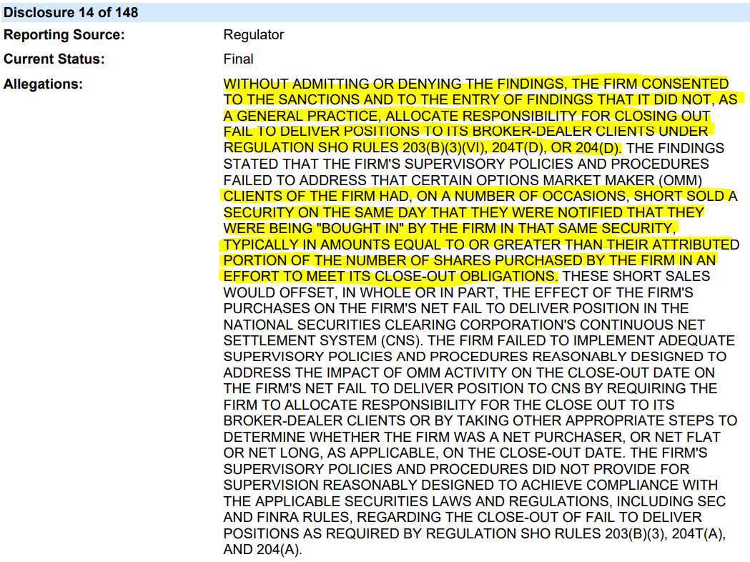
I promise… It really is as dumb as it sounds…
So the perception here is when Goldman’s client has a FTD and they find out a buy-in is coming, the
required buy-in would obviously be too extreme for the client to handle.. So they begin to buy those
shares while simultaneously shorting AT LEAST the same amount they were required to purchase…
Have you ever failed to repay a loan so you went to another bank and got a loan to cover the first one?
Well that’s exactly what this is… I know what you’re probably thinking… “didn’t that just kick the can
down the road?”. The answer is YES: it didn’t actually solve anything..
There’s still one more citation that Goldman received which truly represents the pinnacle of no-sh*ts-
given. After I cover this, I don’t know how anyone could argue the systematic risks that exist within the
securities lending business.. Check it out:
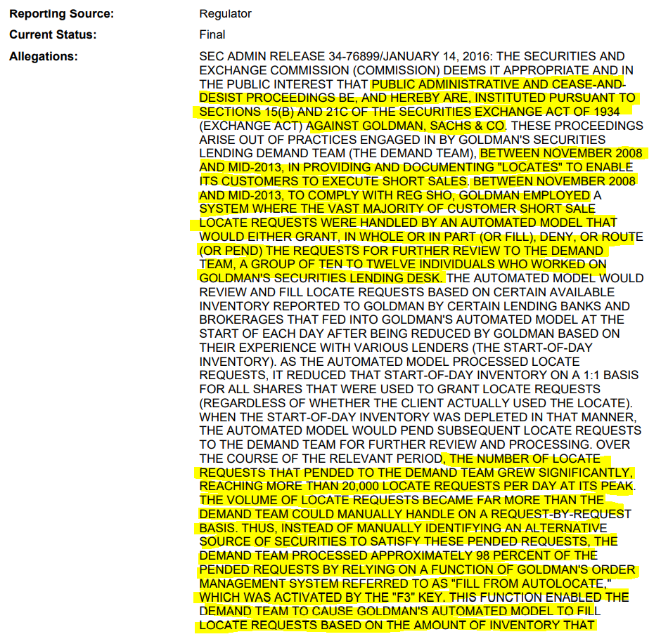
For 5 years, Goldman relied on a team of 10-12 individuals to locate shares to be used by its clients for
short selling. This group was known as the “demand team”. Naturally, as the number of requests coming
in the door started to increase, it became difficult for the team to properly document all of them. The
volume peaked at 20,000 requests PER DAY, but the number of individuals that handled this job stayed
the same.
Obviously, this became too much for them to handle so they opted out of the manual process and found
another solution- the F3 key….
Yes- the F3 key… This button activated an autofill system which completed 98% of Goldman’s orders
to locate shares
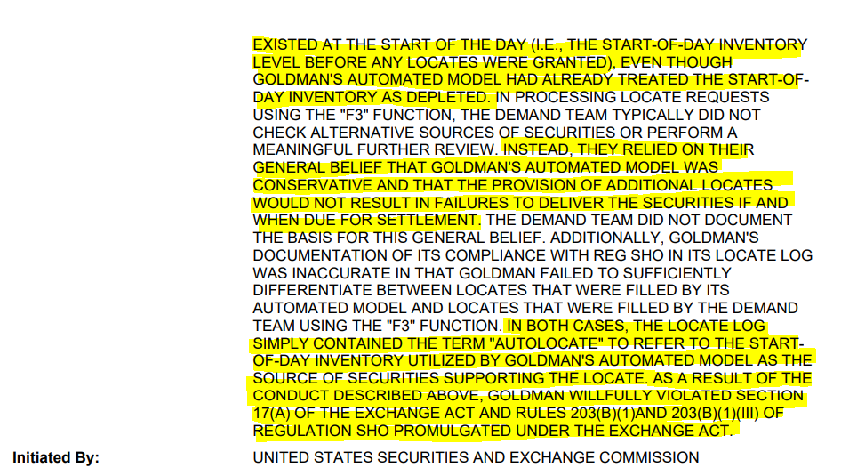
The problem with Goldman’s autofill system was that it used the number of shares available to borrow
at the beginning of that day, which had already been accounted for. After using the auto-locate feature,
the demand team didn’t even verify the accuracy of the autofill feature or document which method was
used to locate the shares for each order… and this happened for 5 years..
Just goes to show how dedicated firms like Goldman Sachs truly are to the smallest of details, you know?
Great f*cking work, guys.
By the way, I have to show one of Goldman’s short sale indicator violations… It’s too good to pass up.
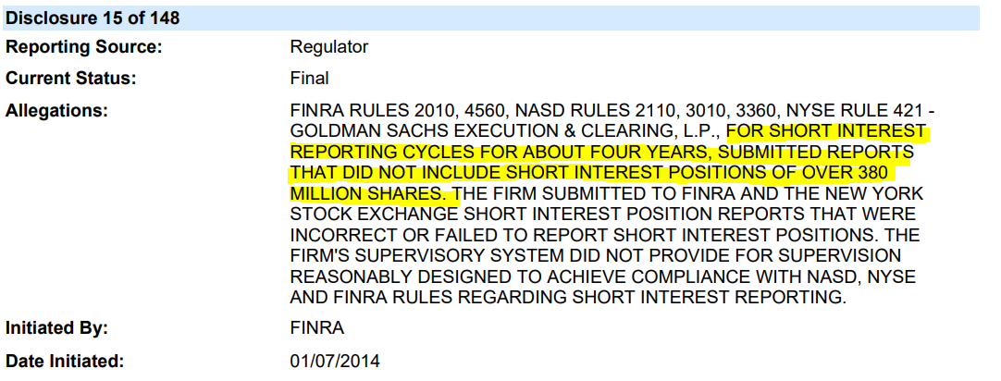
At some point, you just have to laugh at these ass clowns… I mean seriously… one violation for a 4 year
period involving over 380,000,000 short interest positions… they have plenty of other short interest
violations, I just laughed at how the magnitude of this one was summarized by FINRA with 10 lines and
roughly 4 minutes... whoever wrote that one must have been late for lunch..
The last thing I’d like to note here is the way in which short sellers use options to “cover” their positions.
Wes gave a great overview of this in the AMA (starting at 6:25). Basically, one group will buy puts and
another group buys calls. This creates a synthetic share that is only provided if the option is activated.
Regardless, short sellers will use that synthetic share to cover their short position and the regulators
actually accept it…
However, as Wes points out, most of those options expire without being activated which means the
share is never delivered. This expiration can be set months down the road and allows the short seller to
keep kicking the can.
I doubt I need to say this, but we all remember the wild options activity that was happening shortly after
GameStop spiked in January. u/HeyItsPixel was one of the first to point this out. While a lot of that
activity was on the retail front, I suspect a lot of it was done by short sellers to cover those positions.
____________________________________________________________________________________________________________
5. Hedgies are f*cked…
I’m officially +20 pages deep and there’s still so much I’d like to say. It’s best saved for another time and
another post, I suppose. So I guess I’ll wrap all of this up with some of the best news I can possibly
provide…
It all started with a 73 page PDF that was published in 2005 by a silverback named John D. Finnerty.
John was a Professor of Finance at Fordham University when he published “short selling, death spiral
convertibles, and the profitability of stock manipulation”. The document is loaded with sh*t that’s
incredibly relevant today, especially when it comes to naked short selling. He dives into the exact
formula that short sellers use, which is far beyond what my wrinkled brain can interpret, alone…
..However, when firms are naked shorting a company with the goal of bankrupting them, they leave
footprints which are only explained by this event. The proof is in the pudding, so to speak..
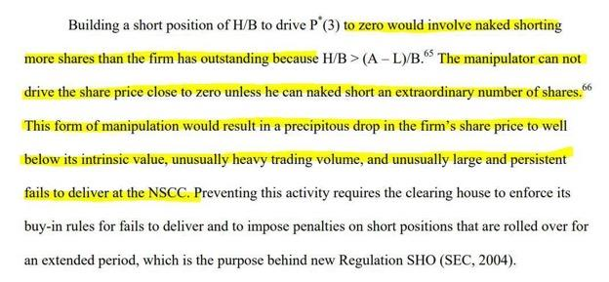
Any of this sound familiar??
“The manipulator can not drive the share price close to zero unless he can naked short an extraordinary
number of shares… this form of manipulation would result in… unusually heavy trading volume, and
unusually large and persistent fails to deliver at the NSCC”.
Anyone else remember the volume in GME during the run-up in January? The total volume traded
between 1/31/2021 and 2/5/2021 was 1,508,793,439 shares, or an average daily trade volume
of 88,752,555 shares. On 1/22/2021, the volume reached 197,157,946… that’s roughly 3x the number
of shares that exist..
if this doesn’t sound like unusual volume then I’m not sure what is. Furthermore, the FTD report on
GameStop was through the roof during this time:
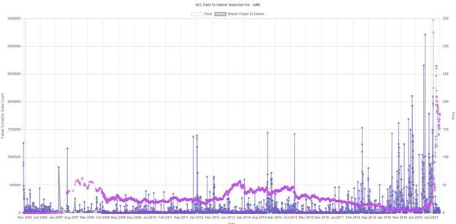
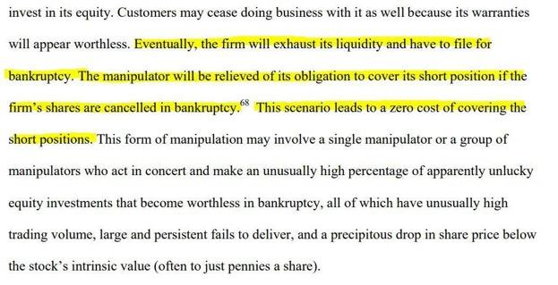
Notice the statement where the manipulator will be relieved of its obligation to cover IF the firm’s
shares are cancelled in bankruptcy? Did you happen to see footnotes 65 & 66 in the first screenshot of
his PDF? It references a company that he used for his analysis…
Charter Communications had a whopping 241.8% short float in 2005… The ONLY way the
manipulator could have escaped this was by bankrupting the company and relieving the
obligation to repurchase those shares…
Guess what happened to Charter? They filed for bankruptcy in 2009…
However, unlike John’s example where naked short sellers were driving down the price without
opposition, GameStop had extremely high demand from retail investors to counter this activity. As I
have discussed with Dr. T and Carl Hagberg, the run-up in volume during January and February was
largely conducted by naked short sellers in an attempt to suppress the share price. As I have shown in
the example with Goldman Sachs, firms will short sell during a buy-in for the same exact reason. To
stabilize the price, you must stabilize supply and demand.
…You know what Charter didn’t have?
AN ARMY OF APES TO HODL THE STONK
DIAMOND. F*CKING. HANDS
Back to Table of Contents
What's happening today - 6/8/2021
DD 👨‍🔬
EDIT 1: There is an issue with Reddit right now and my images are not loading. I've added IMGUR
links instead. Furthermore, I cannot see the upvote total for this post, which is still stuck at 1.
EDIT 2: The comments in EDIT 1 seem to be fixed now. I also added an example of how the
additional deposit could have been made in shares rather than cash. This would force the short
seller to buy enough shares to meet their new margin requirement. Otherwise, it was a legitimate
margin call to cover a short position.
________________________________________________________________________________________________________________
There are significantly underfunded short positions on GME. With the recent spikes in price, it puts an
even bigger strain on these positions because they must deposit more money to keep their accounts
current with the new price. I'll use some simple numbers to describe what this means.
If you have $100 in a deposit account to "cover" your short position and the price skyrockets, you must
make an additional deposit to meet the new price. So the account holder will deposit an additional $20
to make their account current. To do this, the short seller can either deposit shares or cash in their
account. If you cannot meet this requirement, a margin call will occur. I believe the uptick in volume this
morning resulted from short sellers purchasing enough shares to meet the new requirement. It could
also be from them covering the position, directly. I could be wrong but the outcome is still the same.
Take a look: https://imgur.com/vdzZUaa
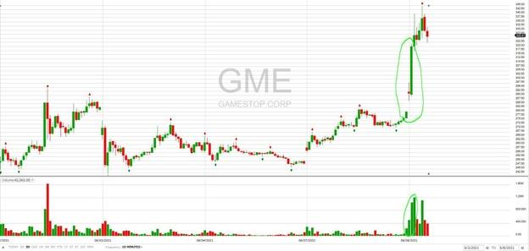
We had at least 2,000,000 shares traded within 20 minutes which boosted the price by roughly $45. This
means there are now MORE positions which are underfunded and must make additional deposits to
meet the increase in exposure. Ergo, we should have a domino effect. The "sideways" trading occurs
between these purchase periods because retail investors continue to diamond hand their stonk.
____________________________________________________________________________________________________________
What does this mean? Volume upticks like this will drive the price up. Once that spike is over, the price
will trade sideways (basically) until another volume spike occurs. We know this because apes basically
forgot how to use the sell button. This will send the price up again. Rinse, wash, repeat.
However......
Think back to the House of Cards - Part III. Remember the example I gave of Goldman Sachs when they
were being "bought in"? What did they do?
They shorted EVEN MORE than they purchased on that day to keep the price down. As I am writing this,
it is literally happening with GME.
https://imgur.com/abvlt1L (pictures AND links are really f*ckey with Reddit right now)
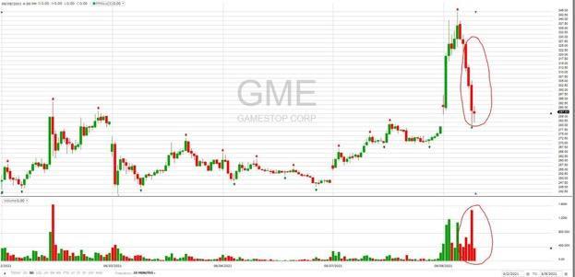
I honestly do not believe this is retail selling, but rather, a flash-crash to drive the price down. I wrote
about it in Citadel Has No Clothes when it happened on March 10th. I would have a hard time believing
this a few months ago, but after seeing Goldman Sachs get caught doing the same exact thing, it's become
obvious: this is their textbook move. The goal is to return the price to a point it was at prior to the
increase this morning. Obviously, this will prevent more market makers & broker-dealers from having to
make additional deposits.
This is not normal behavior and is HIGHLY unlikely that retail is responsible. Prepare for EXTREME
volatility and know that these actions are performed to prevent OTHER BROKER-DEALERS from being
margin called.
As you continue to hold, THEIR problem will become worse and worse. It will ONLY work if you sell.
Once the short attack is over, you should see the price rebound. We know that $350 has been a
dangerous point for them because they triggered a flash crash at $350 on Mar10 (Mario day). Low and
behold, they done-did-it again
https://imgur.com/NnLH3We
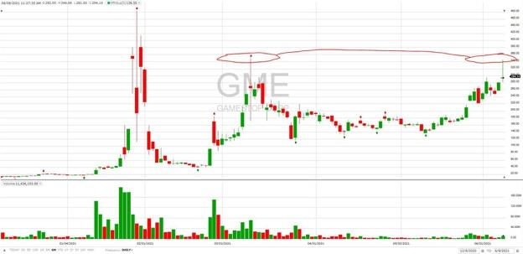
To me, this is us catching them in their lies. There would be NO NEED for this if their positions were
covered. It is blatant market manipulation and we are SUFFOCATING THEM.
DIAMOND.F*CKING.HANDS
*Not financial advice*
Back to Table of Contents
THE MOTHER OF ALL WEDGES: AN ENDGAME
DD. Technical and Fundamental Analysis with
Warden. Where we are now, where we are
headed. When might the MOASS begin?
DD 👨‍🔬
Hey everyone! It's Warden. I'm taking a brief moment to write a chart analysis post because I feel that
we are nearing a critical junction point. The volume today has been extremely low, currently sitting
at around 1.7 million, and I feel that a lot of people are sensing that something big is coming. I've
emptied the rest of my bank account into the dip today to buy more tickets to the moon.
There's a lot of questions people are wondering at this point.
When do we squeeze?
What happens at the Apex of a wedge?
Are there any important catalysts coming up?
These are all questions that have answers, and I will try my best to address these. My thesis for this post,
is that as the stock breaks out of the wedge, if it chooses to follow the uptrend, it becomes
increasingly expensive and impossible for shorts to bring this down any further. We may
possibly climb to a point of no return for the shorts. Let's examine why by starting with
understanding what a wedge is.
The wedges I will reference in this post are symmetric wedges.
Why wedges form, and what they mean fundamentally: the long
and short theses
We are indeed nearing the Apex of the Mother Of All Wedges (MOAW); this is the ultimate hedgie
wedgie. I wanted to provide a fundamental explanation for why this wedge has formed and what it
means for the stock.
Let's examine the simple uptrend. This is when the price forms higher lows, and higher highs.
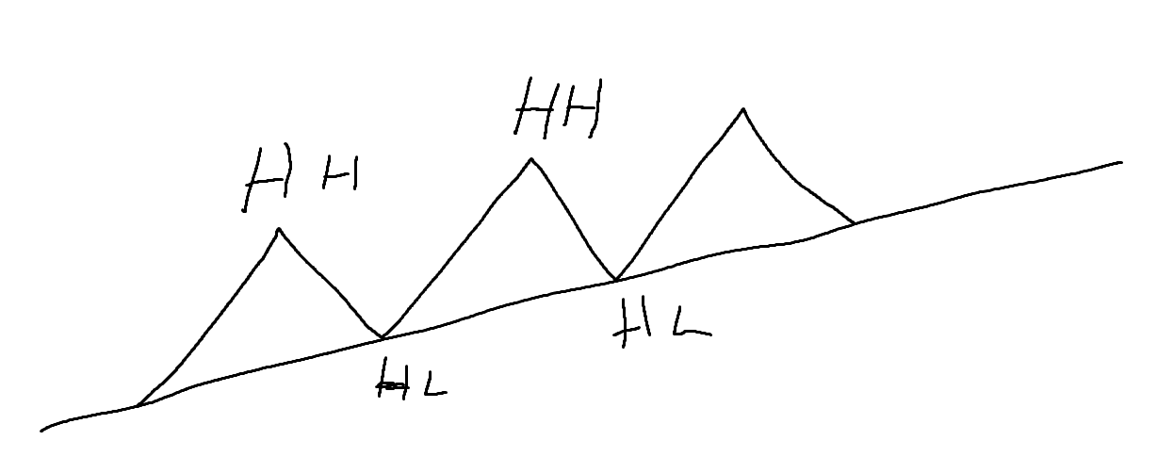
And we also know what a downtrend is. Lower highs and lower lows.
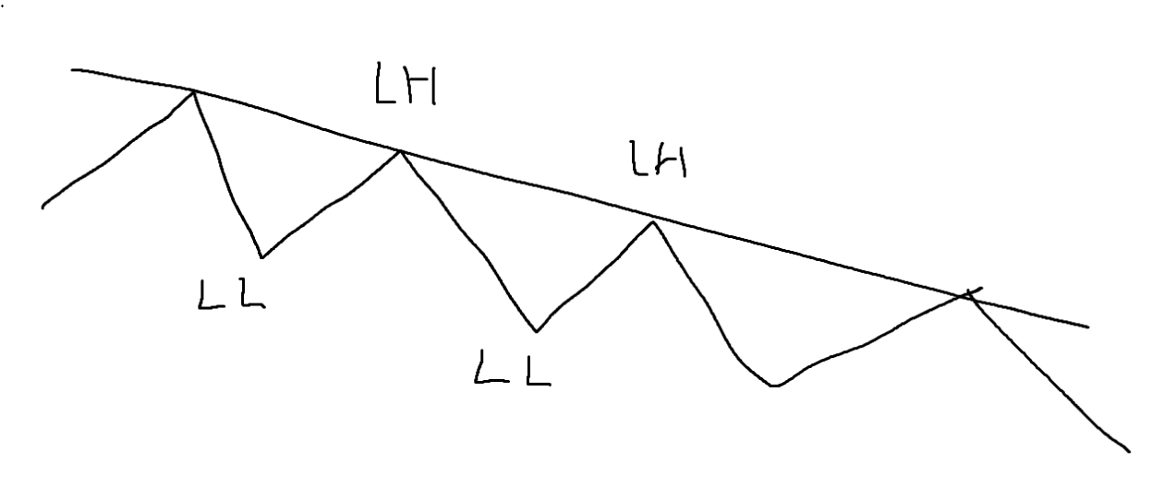
And uptrend is called the frontside, and the downtrend is called the backside. The thesis of people
trading the frontside, is that they think it will go up. For short sellers, they trade the backside, because
they think it will go down.
Now if you get a really volatile stock, you might end up with a combination of the two theses, with two
parties doing different strategies. This is why a wedge forms. Both theses are valid, and so both parties
continuously trade in this wedge pattern.
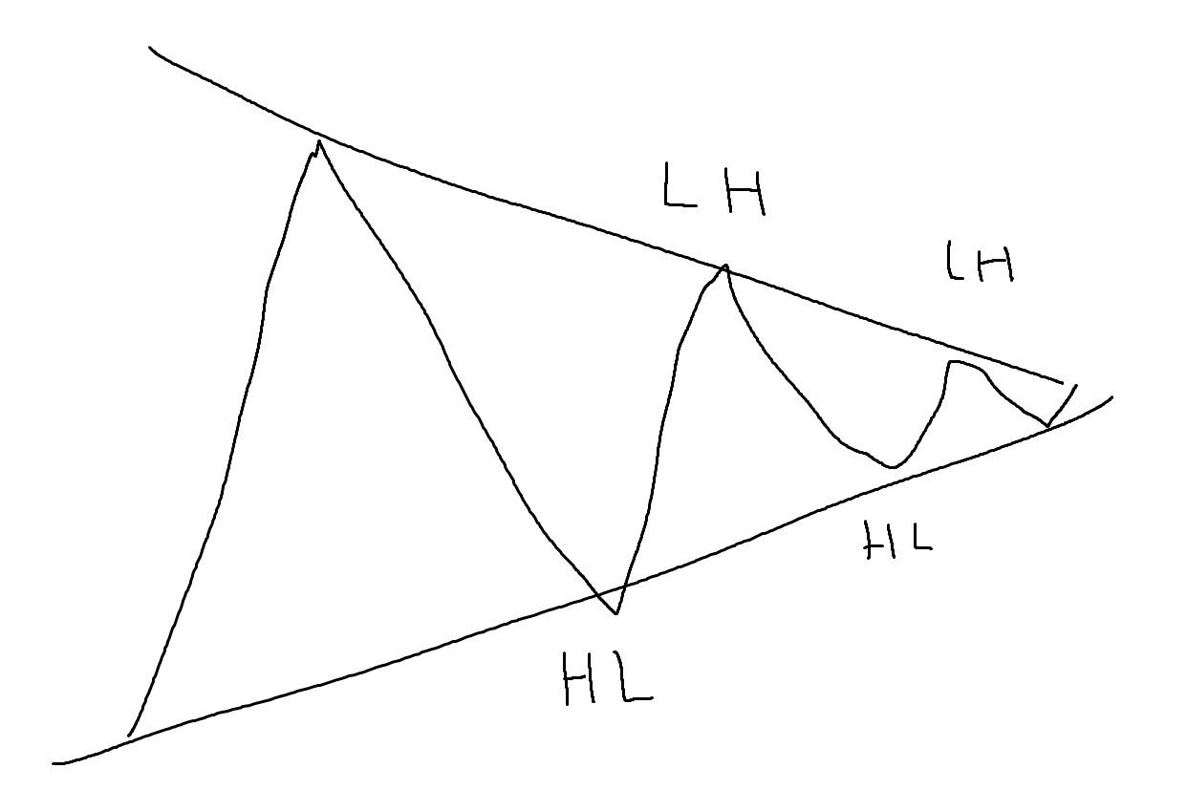
The short side thesis and strategy looks like this:
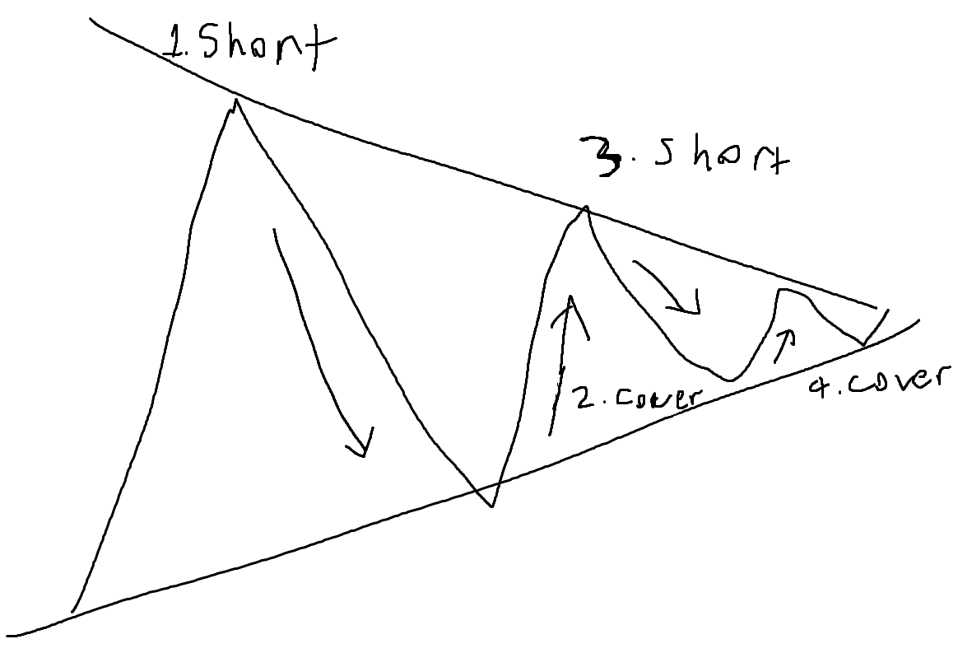
Imagine the opposite for longs. They buy at the dips, and the sell at the peaks.
Thus, combining these two theses, we can conclude that:
When the stock moves up, that's buying plus covering.
When the stock moves down, that's selling plus shorting.
Simultaneously, Longs and Shorts are both making money because they both have valid theses. One
thinks the price will go down, and the other thinks it goes up.
Why the short thesis is invalid. Understanding OBV, the Spread,
and FINRA's own short volume data
However there is a big problem with the short thesis for GameStop.
The short thesis is actually invalid.
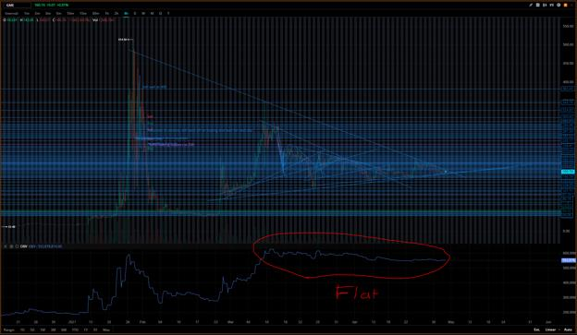
Notice how throughout the entire duration of this triangle, OBV is flat. On Balance Volume
info: https://www.investopedia.com/terms/o/onbalancevolume.asp
Take a look at a normal stock like Palantir. When a short thesis is valid, the price breaks out to the
downside after the Apex. Palantir in the below picture, was a short side success. Notice how OBV falls
during a short side success.
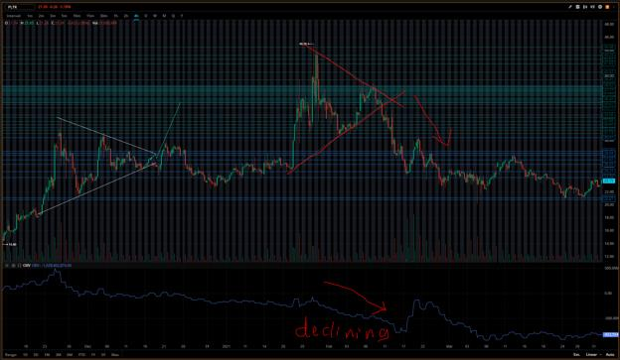
PLTR
Or Activision. In this case, OBV goes up when the longs win.
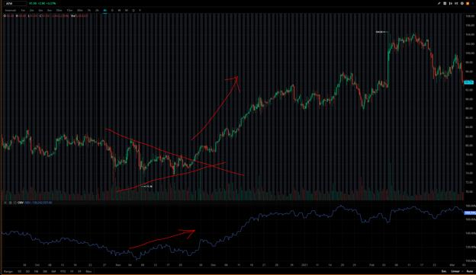
ATVI
I challenge you to find a stock that doesn't follow these rules on a macro level timescale.
OBV increases, if there is more volume during uptrends than volume during downtrends. That means
there is greater buying interest. Vice versa.
When there is an imbalance of buyers and sellers, at the Apex of the triangle, there will be a
"breakout". This is because, at the apex, one of the two trends breaks. Either the upside or the
downside trend is violated, forcing one of the parties to flip their thesis. So if we go to the upside,
the short sellers would flip to long side either by buying stock, or finally covering their shares.
So what about a flat OBV?
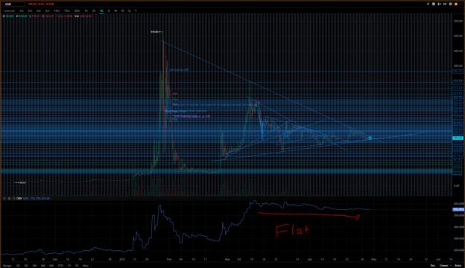
GME
I believe it means that throughout the duration of the wedge starting 2/24, nobody was f*king selling. It
was almost exclusively shorts short selling combined by less covering than shorting and retail buying in.
In a way, it's actually an illusion that they are tanking the price. In reality, the real price is whatever the
uptrend line is. So here, I think the "real price" is around 155 dollars. We've actually been climbing up
at the macro level. I think this has to do with the spread.
If you look at the Level 2 order book, you see the highest bid is 160.6, and the lowest ask is 160.74.
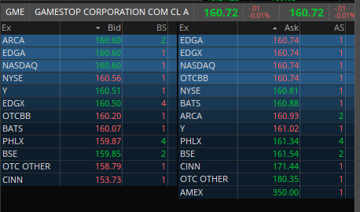
The goal of short selling is to tank the price. So you typically sell on the Bid. When you want to cover
your shares, you want to ideally also buy on the Bid, because buying on the Ask is more expensive.
However the issue is that liquidity is low, so if you have a deadline to cover FTDs, you need to buy on the
Ask a lot. You actually end up losing money and the amount you lose is roughly equal to the average
spread multiplied by how many shares you shorted. The only way to profit from short selling, is if
people sell more than they buy after you short. Trading is a Zero Sum game, so the goal of short
attacks is to paper hand people.
The problem is we see consistent higher buy:sell ratio, meaning that more people are buying than
selling. Thus you probably can't make money if you short millions of shares, because eventually
when you cover:
A) You lose money from the Spread
B) The price is already increasing from an excess of buyers.
Furthermore, what's even worse, is that the daily short volume percent is greater than 50% on average.
u/dinghino crunched FINRA's own short volume numbers and concluded that the majority of daily
volume was short selling. Here's his tool for grabbing historical
data: https://github.com/dinghino/stocks-historical-data
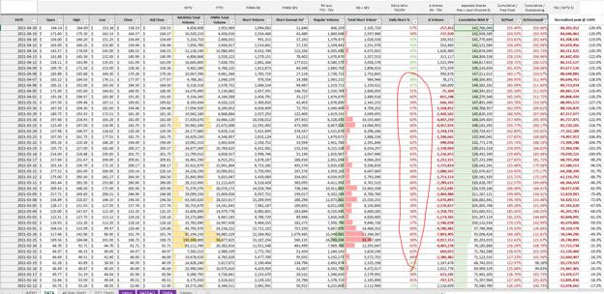
Keep in mind FINRA both underreports short volume, and total volume. So the data we have is limited in
reliability. There is a probability that short volume might be <50%. I have not been able to find other
data sources that can confirm or reject this analysis.
Okay, so first, we realize that they cannot really profit from shorting at the downtrend, and second
despite this fact, they are shorting more than half the daily volume.
Ouch.
Now let's tie in the last two pieces of the puzzle. So how can there be a flat OBV if there are an excess of
buyers? I believe it's because the Bid has been hit so much more than the Ask from the short sellers that
it has caused the price to be artificially lower than normal. Thus, there's an increased number of days
that the stock ends in the red, decreasing OBV.
I believe that the OBV is actually trending upwards. It's an illusion that it's flat. The Bid has been
hit from selling more than buying has hit the Ask. Therefore the net direction is down. The excess of
retail buyers balances this out and causes the OBV to end up going flat.
We are not losing this fight. We are in fact holding strong and buying.
Furthermore, from the updated institutional data for Q1 present so far in Bloomberg, we see a couple
institutions "derisking" and others actually buying more shares. Some institutions appear to be out, but
a lot more are actually in. Institutions are HOLDING so far, and perhaps actually buying.
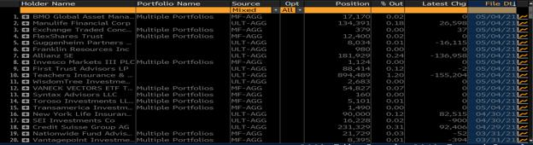
Keep in mind that this is a TINY SUBSET of all the Q1 13F updates that will be filed before 5/17. I
will be closely watching everyday to see what the majority of institutions are doing.
I believe 5/17 will be a very important deadline for us to find the new data.
So great, everyone is holding thus far, shorts keep shorting, and the spread and buyers are killing them.
Lol.
After the Apex, shorts will drown.
After the Apex, the downtrend breaks. Shorts will be forced to create a new downtrend.
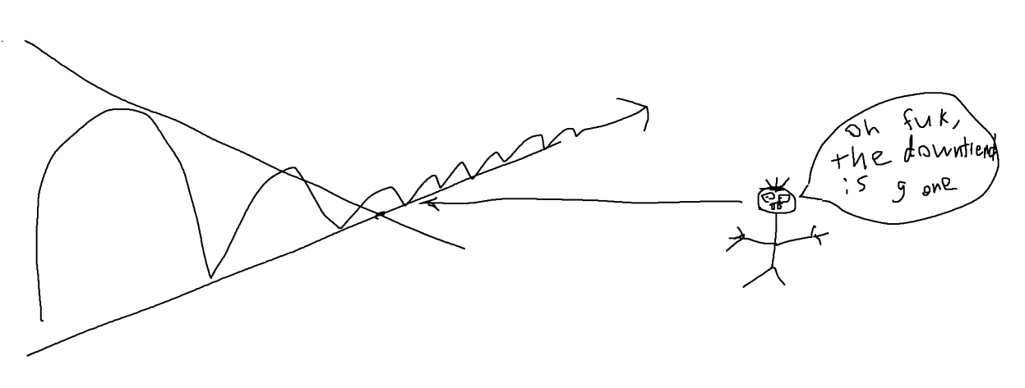
If they haven't given up, they'll likely react with a large short attack in an attempt to establish a
downtrend.
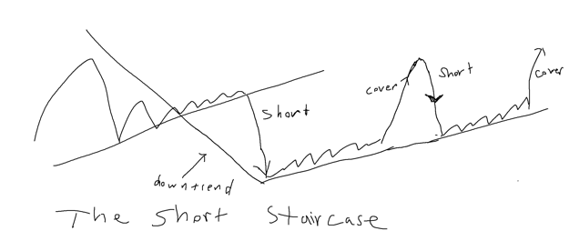
However, given that GME is hard to borrow, they can only short a limited amount of shares. And because
people won't sell, the shorts will be stuck trying to short into an uptrend due to the excess of
buyers. This is the short staircase, the establishment of a new uptrend slightly below the Apex
that will slowly choke the shorts to death. Every time they try to bring it back down, they have to
eventually cover on the Ask. Couple that with the buying pressure, their short attacks get weaker and
weaker each time as this uptrend slaughters their P&L.
Take Tesla as a historical example.
A short staircase choked the shorts. They were like "oh fuck, I'm screwed, better cover".
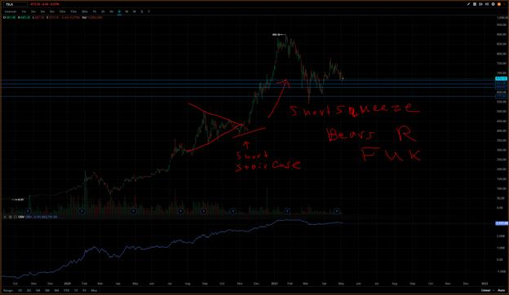
Seriously. I see no fucking way out for the shorts. To create a downtrend, you need a continuous supply
of shares to short. Or you need people to sell. Both options are out of the question.
The catalyst might actually be the chart itself. Not so much a fundamental change in the company.
But a fundamental change like a new CEO can certainly light the fuse.
Summary/TLDR
Wedges form because Longs and Shorts both see a profitable strategy.
Shorts are not able to profit because of the Spread and the excess of buyers. OBV is flat because
everyone is buying and holding.
The price might drop after the Apex, but an uptrend will form that will smother the shorts. Eventually
they will panic cover.
Bloomberg shows recent institutions are buying and holding on average.
After the Apex, the short thesis of being profitable from shorting becomes invalid (if not already).
5/17 is an important date. It reveals the poker hand of the Longs as 13F Q1 filings are due by
then. If they are still holding, then shorts are DOOMED.
The price isn't actually decreasing from these short attacks. It's actually steadily increasing. The
drops are an illusion.
Thank's for reading. I'm as bullish as ever on this stock.
-Warden
Back to Table of Contents
Looks like the recent RobinHood Class Action
SI Report just proved /u/broccaaa's data. That
the shorts haven't covered, that they hid SI%
through Deep ITM CALLs, and SI% is a
minimum of 226.42%.
Possible DD 👨‍🔬
Edit: Numbers from RobinHood case are alleged so far, not
proven. I cannot edit the post title. That being said, results of
Deep ITM CALLs comes up with roughly the same 226.42%,
which is quite telling. We also see that PHLX exchange is used
to buy and exercise these calls almost immediately - exactly as
outlined in the SEC document on how to shift a short position to
become synthetic.
0. Preface
I am not a financial advisor and I do not provide financial advice. Thoughts here are my opinion, and
others are speculative.
Shout out to king /u/broccaaa for their contributions. I always figured that your assumptions were
correct that the SHFs were using these Deep ITM CALLs to hide SI%, but we never got some quick maths
behind it to see if it was true. (Maybe we did though! Sorry if I did not see anyone's posts about this)
Well, this is for you /u/broccaaa, and all the apes.

Spreading Love To All
1. GME SI% Is A Minimum Of 226.42%; Shorts Were Hidden
With Deep ITM CALLs
Way way back in time, since many of you probably feel like you've aged years over the course of 6
months, there was a blip of 226.42% SI in January. Many believed this was a glitch:
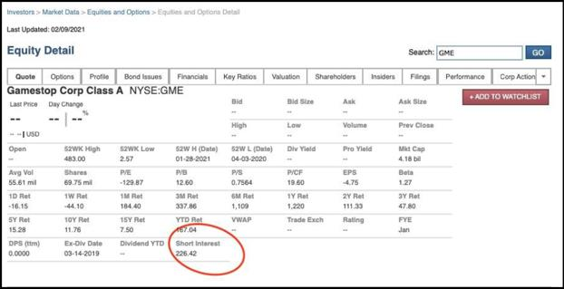
https://www.reddit.com/r/GME/comments/lgjztf/wtf_is_going_on_with_finra_is_it_7846_or_22642/
That's what many may have thought, that it was just a glitch, until recently a Class Action against
RobinHood proved that was, indeed, the SI% upon January 15th, 2021:
Edit: Thank you much for everyone's replies. We must consider this as still speculative and not proven
as it is a number alleged by the plantiff.
Allegedly, per a Class Action against RobinHood, the SI% was 226.42% upon January 15th, 2021:
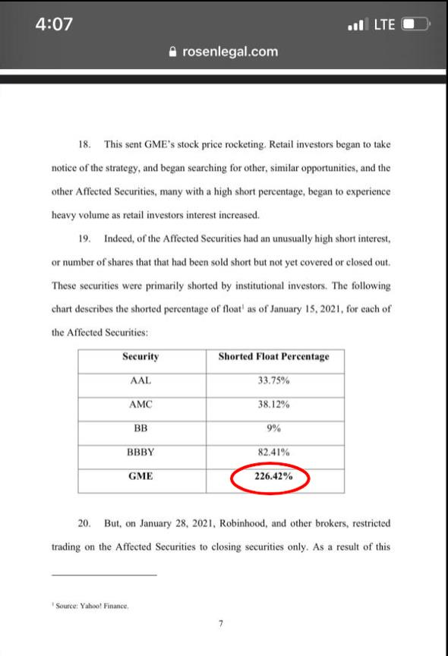
https://www.reddit.com/r/Superstonk/comments/o6mp0c/from_class_action_against_rh_look_at_that_juicy/
Put yourself in the SHF's shoes. You have a shitload of retail buy pressure going on. You're way
overshorted. What do you do? Do you cover? Pfft. Nah. That's way too much. Impossible to cover.
Absolutely screwed.
Lucky for you the SEC has identified malicious options practices which can be used for just such an
occasion to make it appear that you've covered.
Let's say you want to make it "appear" that you covered your short. You can perform a buy-write trade
with a bona-fide Market Maker. Who might help you out as a bona-fide Market Maker? Citadel might
come to mind (not saying it's them, just an example since they are well known)! The trade ends up being
the following:
1. Trader A who needs to hide their short position enters the buy-write trade with Trader B
(Citadel).
2. Trader A sells a Deep ITM CALL to Trader B (Citadel).
3. Trader A simultaneously buys shares from Trader B (Citadel).
4. Trader A now appears to have purchased shares to cover their short position, and Trader
B (Citadel) gets a small amount of cash in return.
• They tend to trade Deep ITM CALLs that have little to no OI so that the trade is almost
guaranteed to be between Trader A and Trader B.
• Trader B tends to exercise these CALLs on the same day. And this is exactly what we
have been seeing because CALL OI does not increase.
• The net effect on this is that Trader B has looped around their shares. They sold them to
Trader A, and then got them back through exercising the CALL. Meanwhile, Trader A has
"covered" their original short position but now they are "short" the CALL, meaning it is
now a synthetic short.
Here is the supporting text from the SEC itself if you want to verify for yourself. A report from 2013 titled
"Strengthening Practices for Preventing and Detecting Illegal Options Trading Used to Reset Reg
SHO Close-out Obligations":
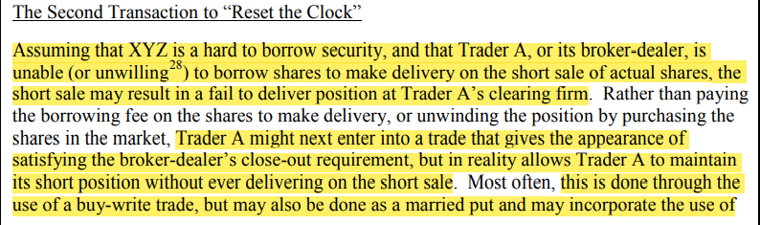
https://www.sec.gov/about/offices/ocie/options-trading-risk-alert.pdf Section II
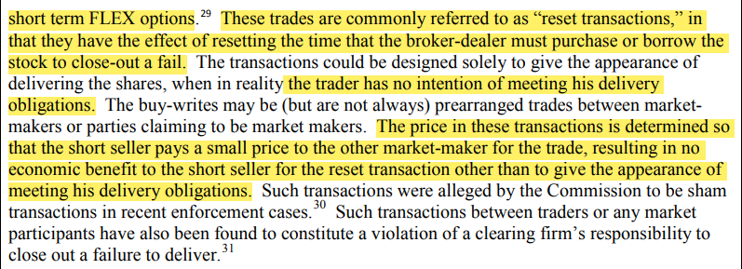
https://www.sec.gov/about/offices/ocie/options-trading-risk-alert.pdf Section II
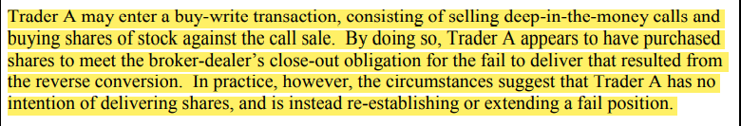
https://www.sec.gov/about/offices/ocie/options-trading-risk-alert.pdf Section II
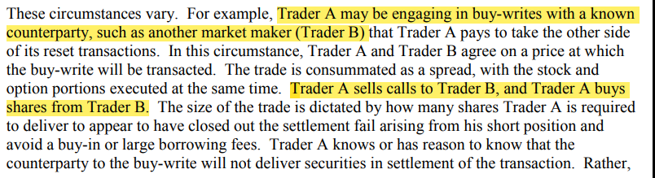
https://www.sec.gov/about/offices/ocie/options-trading-risk-alert.pdf Section II
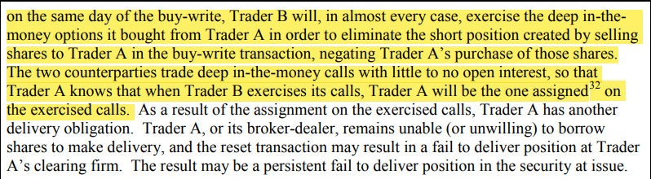
https://www.sec.gov/about/offices/ocie/options-trading-risk-alert.pdf Section II
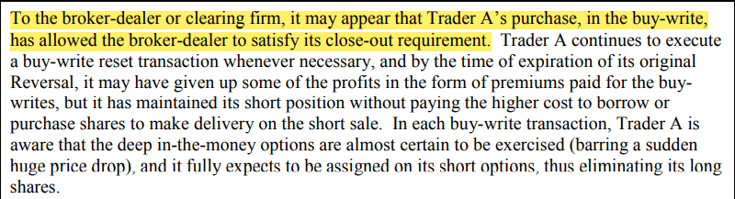
https://www.sec.gov/about/offices/ocie/options-trading-risk-alert.pdf Section II
So, they can utilize Deep ITM CALLs to hide their short positions.
We don't care about identifying Trader A and Trader B in this case. Just the fact that trades occurred on
these Deep ITM CALL strikes and that OI is unaffected the day thereafter. That's enough to support the
above theory that they're utilizing this practice to make it 'appear' that they've covered their short
position.
Check out what /u/broccaaa's data identified. Tons and tons of Deep ITM CALLs were traded in January
prior to SI% dropping off of a cliff. By my estimations, about 1,100,000 CALL OI was traded prior to
January 29th SI Report Date:
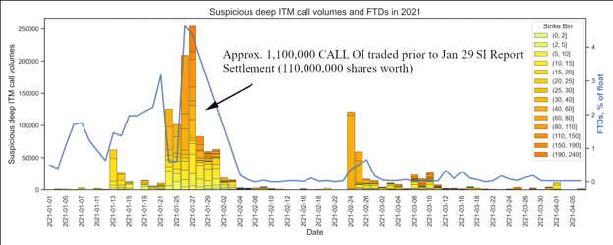
/u/broccaaa Data on Deep ITM CALL Volumes Vs FTDs of GME
The SI Report Date of January 29th matters because that is the cutoff of when FINRA will require
settlement of short interest numbers for the next SI report date. The next SI report date following January
29th settlement is February 12th.
And we can see that after the mayhem of Deep ITM CALL purchases, SI% dropped from 226.42% of the
January 15th report, to 30.2% upon February 12th:
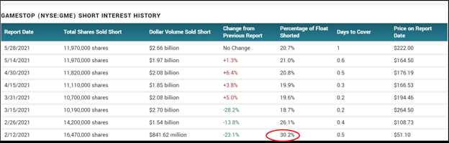
https://www.marketbeat.com/stocks/NYSE/GME/short-interest/
With the difference in SI% from 226.42% on January 15th down to 30.2% on February 12th, we can
assume that they have not covered their short position but rather hid their short position in
synthetics if we can come up with a roughly equivalent SI% from the approximate Deep ITM
CALL purchases.
The float of GME in January was approximately 57,840,000.
The estimated Deep ITM CALL OI that was swapped is ~1,100,000 OI = ~110,000,000 shares worth.
Which then gives an estimated SI% reduction of ~110,000,000 / 57,840,000 = ~190.18% shorts hidden
between January 15th and February 12th report date.
And since SI% on February 12th was 30.2%, then that gives a grand total of 190.18% + 30.2%
= 220.38% SI per estimations.
That's dangerously close to the reported 226.42% SI from January 15th.
So with that in mind - do you think they covered?
Estimations of SI% Based on Deep ITM CALL Purchases Up To January 29th
Back to Table of Contents
Why We're STILL Trading Sideways and Why
We Haven't Launched
DD 👨‍🔬
EDIT May 12, 2021: SR-OCC-2021-004 Is Scheduled to Finalize This Week Also, I have been banned from
Superstonk...
EDIT May 18, 2021: I have been unbanned; thanks for all the folks who reached out and thanks to the
mods!
We've made it through an exciting weekend of suspense only to end up with yet another day of sideways
trading. I'd like to examine why I think we have not yet launched based on the bits and pieces that we
know.
In this post, I'll be rehashing some of my earlier posts for folks who haven't read them and also
examining my earlier thoughts in the context of the information we've come across over the last two
weeks.
One of my favorite topics in science is black holes. Black holes had been theorized to exist soon after
Einstein's theory of General Relativity. Until 2019, the existence of black holes was known, but never
actually seen. So how did we know where to look? Even though we can't actually see the black hole and
even though it may be millions of light years away, we can observe how bodies of mass interact with it,
how it affects the space around it, the energy that is dissipated from the black hole, and other signatures
of its existence.
The GME MOASS is like a black hole in more ways than one. We can only speculate on what is happening
based on how the different entities in this system are interacting. Let's revisit my earlier post with some
new data points.
Who Are the Entities Circling this Black Hole?
On APR13, u/jamiegirl21 posted this S-4 filing for a merger with Apex Clearing.
Check out page 84:
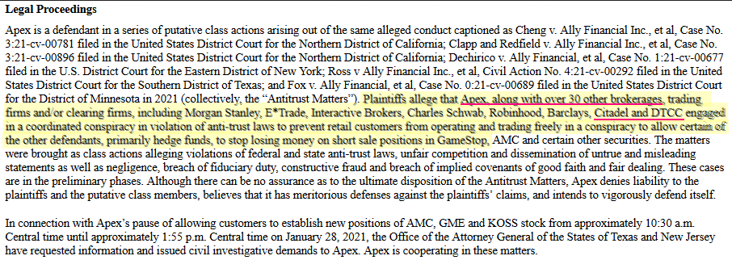
"Apex, along with over 30 other brokerages...including...Citadel and DTCC engaged in a coordinated conspiracy..."
While this is alleged at the moment, what is clear is that some law firm(s) believes that there is a case
against multiple entities -- including the DTCC -- for conspiring to shut down the JAN28 squeeze.
Set aside the idea that Citadel or the GME shorts alone can suppress the price of GME; if that were the
case, we would not have even had the JAN and FEB spikes in the first place since Citadel and the shorts
alone could have stopped it.
As I have mentioned in my previous posts, rather than thinking of the situation as "Citadel is shorting the
market" or "It's a battle between Short HF and Long Whales!" to "DTC, OCC, SEC, and the shorts are
preparing for the squeeze".
Literally every major entity in global banking is entangled in this through the DTCC. Even the non-DTCC
members are entangled as they use DTCC members for clearing their trades.
• DTC: https://www.dtcc.com/-/media/Files/Downloads/client-center/DTC/alpha.pdf
• OCC: https://www.theocc.com/Company-Information/Member-Directory
Just a cross section:
Member DTC OCC
Apex Clearing ✔ ✔
Barclays ✔ ✔
Bank of America ✔ ✔
Charles Schwab ✔ ✔
Citadel Clearing ✔ ✔
Citadel Securities ✔ ✔
Credit Suisse Securities ✔ ✔
Deutsche Bank ✔ ✔
Goldman Sachs ✔ ✔
Interactive Brokers ✔ ✔
JP Morgan ✔ ✔
Merrill Lynch ✔ ✔
Robinhood Securities ✔ ✔
TD Ameritrade ✔ ✔
UBS Securities ✔ ✔
Vanguard ✔ ✔
How Are They Preparing?
The fallout from this squeeze is that there are multiple DTCC members who are going to fail and default
(we'll see some possible evidence of this in a moment). When this happens, the DTCC or corresponding
subsidiary (hereafter just referred to as DTCC) will step in to manage the default through Recovery and
Wind Down Procedures which are documented in their member agreements.
During the squeeze, the DTCC will intervene and provide immediate liquidity when a member defaults.
In turn, DTCC will use the assets of the defaulting members as collateral for that liquidity (which itself
may originate outside of DTCC). Those assets from the defaulting member will then be auctioned off to
recover those loans.
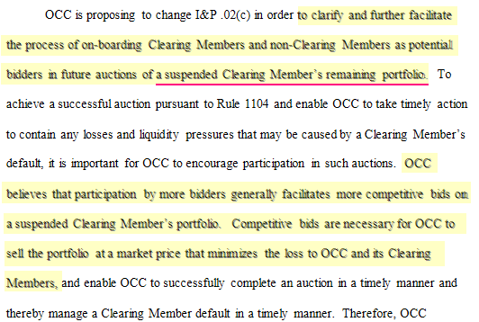
SR-OCC-2021-004 page 4: "OCC is proposing...to clarify and further facilitate the process of on-boarding Clearing Members and
non-Clearing Members as potential bidders in future auctions of a suspended Clearing Member's remaining portfolio"
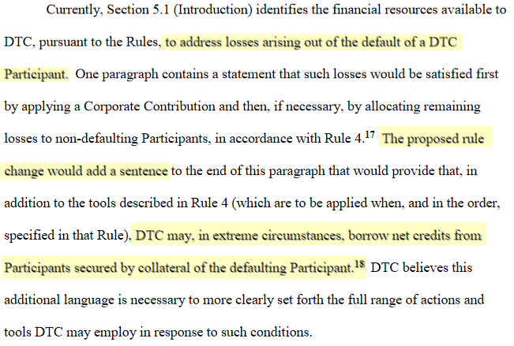
SR-DTC-2021-004 page 11: "...to address losses arising out of the default of a DTC Participant...[t]he proposed rule change would
add a sentence...DTC may, in extreme circumstances, borrow net credits from Participants secured by collateral of the defaulting
Participant"
If you are interested in diving deeper into this, check out my earlier post on the topic.
But let's talk about why this is interesting.
There are generally three views on what is about to happen:
1. The entire system and the banks are going to go belly up because of the scenario
described in the Everything Short DD so these additional billions are to buffer them
from collapse
2. The banks are reacting to increased liquidity requirements stemming from last year and
the expiration of SLR
3. A few entities are probably going to collapse due to overexposed positions and other
entities are moving into position to profit from that collapse
My sense is that #1 is a bit too extreme. Having gone through 2001 and 2008, I have learned one lesson:
the rich will not allow themselves and this system that props them up to fail because they are dependent
on this system to support their bottom lines and lifestyles. What alternative do they have? The Yuan?
The Euro? The GBP? The Yen? The Ruble? Crypto? What are you going to do with that Doge or Bitcoin if
you can't convert it to an actual currency? How are you going to buy your lattes from Starbucks with
Doge? There is no alternative.
That said, we are at a nexus of multiple blows potentially impacting these financial institutions and GME
is just one possible primer that sets off the chain reaction.
I think it is most likely a combination of #2 and #3. What if:
1. You are a non-defaulting member
2. And You know that there are going to be member defaults
3. And you know that that there will be an auction for their assets at a market discount
How would you prepare for this? Perhaps you'd want to have cash on hand to meet liquidity
requirements and emerge from any collapse flush with assets? How might you go about this?
• What if you're Goldman Sachs? Wouldn't it be nice to have an extra $10.6B cash on
hand?
• What if you're JP Morgan? How does $13B of cash sound?
• What if you're Bank of America? Why not add $15B to your warchest?
• What if you're Morgan Stanley? How about loading up on $5B?
Then there's the curious case of the increased short volume of BlackRock's IXG ETF which is a basket of
finance and banking stocks.
What is important is to understand the difference between short interest and short
volume. Squeezemetrics' white paper does a great job of explaining this:
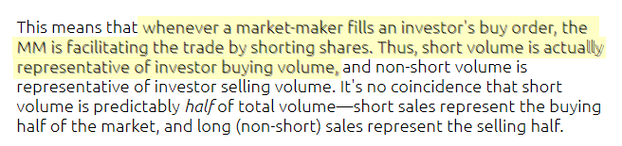
"Thus short volume is actually representative of investor buying volume"
The purpose of a Market Maker is to provide liquidity. Say you want to buy a bunch of IXG. Rather than
waiting precisely for a seller of the same exact block size to enter a sell order that mirrors your buy
order, they create the short (an "IOU") and hand you the shares and then close the IOU when they can
round up the shares.
Thus this increase in short volume indicates demand for IXG which the Market Maker is fulfilling using a
short which they will balance by buying shares.
u/choompop highlights something interesting about IXG:
Berkshire Hathaway, JPMorgan Chase & Co, Bank of America, AIA Group, Wells Fargo, Citigroup HSBC
Holdings, Royal Bank of Canada, Morgan Stanley, Commonwealth Bank of America
Twist: The 2nd largest institutional owner of JPMorgan is Black Rock Inc. with 192 million shares.
The 3rd largest institutional owner of Bank of America is Black Rock Inc. with 509 million shares.
You might be thinking of the DD highlighting that Warren Buffett dumped many bank stocks over the
last year, but keep in mind that he also notoriously dumped airline stocks near their lows at the outset of
the pandemic.
How Do They Know There Will Be a Default and Who Will
Default?
How can we know which of those two scenarios above is more likely? No one can say with certainty
what will happen except for a few very privileged insiders. Everything I've hypothesized can get blown
away tomorrow. But we can consider some of the evidence that we can observe and see where it leads
us.
Tucked into SR-DTC-2021-004 is an interesting bit of text on page 12:
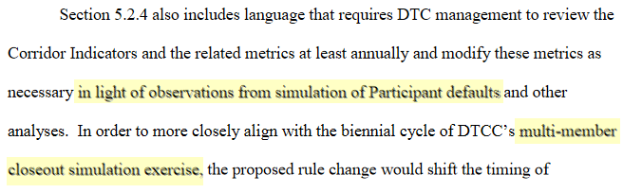
SR-DTC-2021-004 page 12: "in light of observations from simulation of Participant defaults" and "multi-member closeout
simulation exercise"
They have an existing model that they can use to simulate market conditions and it is possible that they
have already simulated the squeeze and the aftermath. My assumption is that they also have some idea
of the probabilities of which of their member entities are going to fail, when they will fail, how they will
fail, and how much liquidity they need to contain these defaults.
This proposed change would "shift the timing of management's review of the Corridor Indicators and
related metrics from annually to biennially". What are these Corridor Indicators?
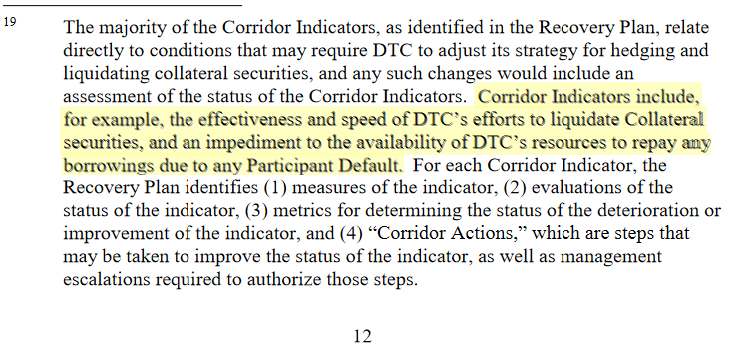
SR-DTC-2021-004 page 12: "Corridor Indicators include, for example, the effectiveness and speed of DTC's efforts to liquidate
Collateral securities...due to any Participant Default"
The key indicator called out as an example is how quickly DTC can liquidate a defaulting member's
collateral assets. We don't know who will default, but I think that DTCC members have an idea. Think
about that.
SR-DTC-2021-004 was filed on 2021MAR29 and effective immediately. They have long been
planning for the defaults that will occur as a result of the squeeze.
Of course, models can be wrong. I have read in Michael Lewis' Panic that the financial models involved in
the 2008 collapse didn't account for the fact that real estate value could go down and the effect of that
downturn on over-leveraged positions.
What Does This Have To Do With Trading Sideways?
Two weeks ago, I posted Why are we trading sideways? Why is the borrow rate so low? When will we
moon? because I was puzzled why we seemed to be stuck in a monetary Lagrange Point and I stated
then:
What you can take away from this is that we will not see significant price movement up or down for the
foreseeable future until OCC-004 and OCC-003 are in place; you are literally fighting against all of Wall
Street, even the GME long institutions. There is literally no point buying deep OTM options until there is
a whiff of OCC-004 and OCC-003 getting close to implementation. We will keep trading sideways,
borrow rate will be inexplicably low, volume will be absent, etc. until DTC and OCC members are
protected and they let off the brakes; Citadel and GME shorts are not and have not been in control. DTC,
OCC, and all non-defaulting members have been preparing for the default of GME shorts.
Since that time, we've had the drop to $140 and then more or less back into a stasis point. Millions in
options will have expired OTM.
I had pointed out the timing and coordination of the two prior drops and now we have a third set of data
points to consider:
1. The dip to $120 coordinated with the Q4 earnings and an almost immediate return to
stasis
2. The dip to $160 coordinated with the positive Q1 preliminary results and an almost
immediate return to stasis
3. And now the slow dip to $140 possibly coordinated with: 1) Melvin's Q1 results, 2)
Sherman being denied his shares and being replaced, 3) the early discharge of their long
term debt, and 4) DFV's options being exercised.
Now it appears we're back to sitting in a new Lagrange Point and trading sideways again.
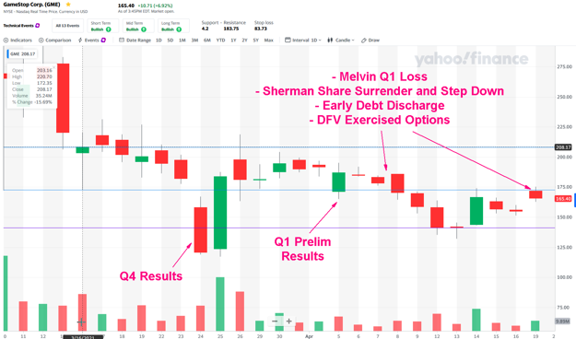
Is this a Long Whale inflicting "max pain"? Or simply multiple parties conspiring to establish "max stability"; to keep us in this
Lagrange Point while waiting for all of the firewalls to be in place and positioning to profit from this event before we ignite the
boosters?
As I've stated before, I think that the variety of tools that we see at play are all part of the arsenal being
deployed by multiple parties coordinating to keep this strapped down until the non-defaulting members
are firewalled. The deep ITM calls, the dark pool trades, all of it is plainly visible to DTCC and the SEC yet
no action is being taken.
DFV's tweet on APR08 is very interesting (turn on audio):
Why is this happening to me?"
"It's OK bud, it's just from the medicine, OK"
"Is this going to be forever?"
"No, it won't be forever"
Are these SRs "the medicine" that we're waiting for "forever"?
I think if we look at the actions over the last few weeks -- for example, the additional liquidity acquired
in recent weeks by some of the major entities like Goldman Sachs and JP Morgan -- it seems exceedingly
plausible that everyone wanted time to prepare for this event, especially because of the expiration of
SLR and the approaching date of the SEC memo that goes into effect on APR22 converging in one
window.
What About the Share Recall or [INSERT CATALYST]?
My conjecture has always been that we will be waiting for SR-OCC-2021-003 and SR-OCC-2021-004 as
long as possible because these two codify key changes to the OCC member agreement to contain the
fallout of the defaulting members.
In particular, SR-OCC-2021-004 has a very curious proposed change on page 5:
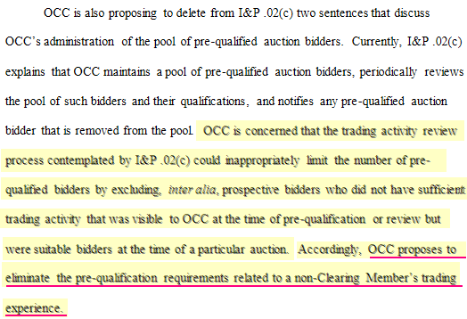
SR-OCC-2021-004 page 5: "OCC proposes to eliminate the pre-qualification requirements related to non-Clearing Member's
trading experience"
Which basically blows the auction process wide open and allows a much broader array of bidders to the
auction. Remember: Fidelity and BlackRock are NOT members of OCC but now they get a streamlined
path to the auction.
I think that in an ideal world, BR and Cohen want to wait until SR-OCC-2021-004 is codified to launch
and in fact, perhaps thought that everything could have been finalized by now and they would be able to
ignite this launch sequence. SIG threw a wrench into this by objecting to SR-OCC-2021-003, thereby
pushing out its finalization which would have been APR10 (45 calendar days from FEB24) setting us
up potentially for this week if 004 had also been finalized but now could go out to MAY31.
We are now running into the issue of the calendar and the shareholder meeting since some number of
shares will likely have to be recalled in the next few days.
What Will BlackRock and GME Longs Do?
This is where it gets interesting.
Here's Larry Fink, CEO of BlackRock on CNBC talking about Reddit and GameStop:
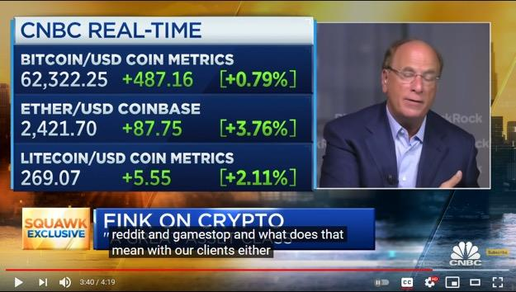
"...reddit and gamestop and what does that mean with our clients either..."
BlackRock knows what's going on at the highest levels.
I have a hunch that the early payoff of GME's long term debt may not have been the initial plan because
perhaps they were going to use the share recalls to trigger the squeeze. But I think that there's a chance
that we may see BR and other institutional longs choose to not recall their shares OR wait until the last
possible moment to execute the recall because it's too early to launch.
With the delay in SR-OCC-2021-003, this may have forced them to put another tool into play: the crypto-
dividend by taking a page out of the Overstock playbook. Thus they prepared this play at the cost of
$216M so that they have another tool to be able to initiate the squeeze if they do not recall their shares.
I think that GME board will delay action as long as possible because the conditions are simply not
favorable at the moment. They were even less favorable in JAN, but it is possible that at that time, no one
quite knew the full depth of the situation otherwise the same shenanigans going on now would have
happened in JAN and FEB. Prior to JAN28, the assumption may have been that a few small HFs would
fail. After JAN28, it was clear that the stakes were much, much higher and I have an idea why we've been
trading sideways since MAR16.
What Happened on March 16 and Why Have We Traded
Sideways Since?
SR-DTC-2021-003 on MAR16:
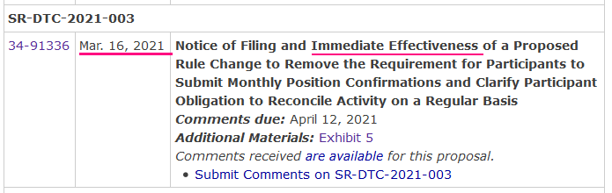
SR-DTC-2021-003 was effective immediately on MAR16
The key change is that DTC Participants were required to reconcile and confirm their records of their
positions with the DTC's records of their positions on a monthly basis prior to SR-DTC-2021-003. After
SR-DTC-2021-003? The Participants have to reconcile and confirm their positions on a daily basis.
So let's look at the data:
Date Open High Low Close
MAR15 277 283 206 220
MAR16 203 220 172 208
And we have since then largely been in that sideways zone with a few days of movement since.
This allowed all parties to see the deck that they are working with because previously, Citadel could try
to "clean things up" before the monthly reconciliation. Prior to SR-DTC-2021-003, this was to occur "No
later than the 10th business day after the last Friday of the month" (page 5). You might be thinking now
"what's the last Friday of January"?
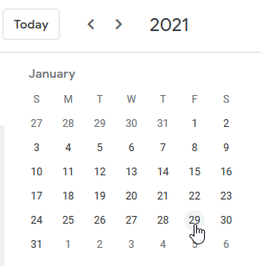
January 29th was the last Friday. Could the squeeze on the 28th been a result of Citadel starting to reconcile their positions with
the DTC?
So the JAN28 event may have been caused by Citadel starting the process of reconciling their positions
to submit and confirm with the DTC. After JAN28, all parties had a sense of the magnitude of this
event but probably could not get enough transparency to make the right decisions.
Why wouldn't Citadel just continue to "fudge" their books? There's something interesting on page 12
and 13 of SR-DTC-2021-003 which gets referenced again in SR-DTC-2021-004 which is filed 13 days
later. Here is the text of the existing member agreement on page 12:
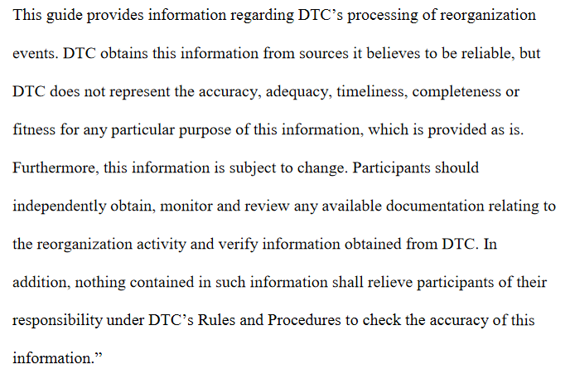
SR-DTC-2021-003 page 12: the original text which gets replaced.
And the text that replaces it on page 13:
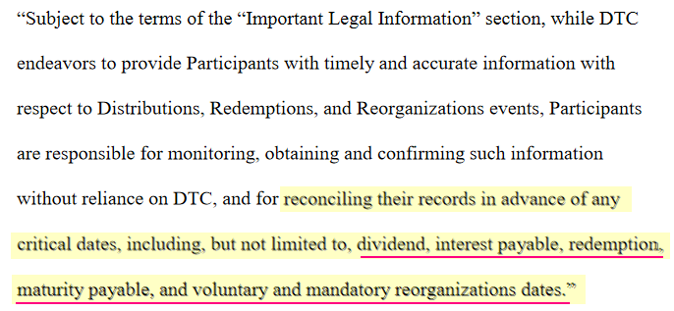
SR-DTC-2021-003 page 13: note the underlined text which was added.
Now let's look at a piece of text in SR-DTC-2021-004 on page 9:
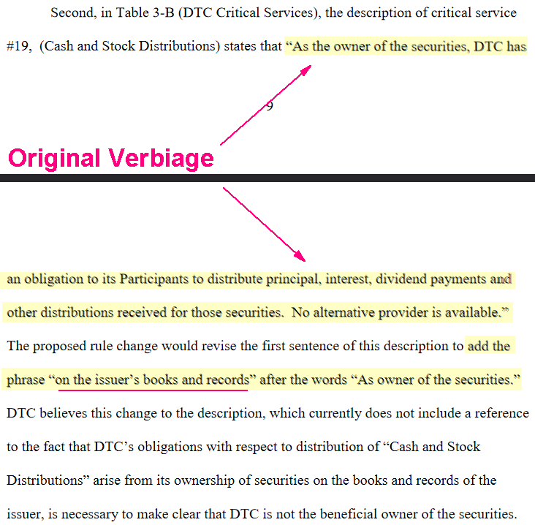
SR-DTC-2021-004 page 9: notice the addition of the text "on the issuer's books and records"
In other words, DTC is highlighting that it will only release dividends, interest, other distributions,
and redemption for any securities it has on record. 003 and 004 fit together to clarify that DTC will not
make payments for anything that is not reconciled with their systems.
TL;DR. So...What Ape Do?
Same as always: HODL.
My conjecture is that in an ideal world, SR-OCC-2021-004 is the key piece to get into place to re-define
the liquidation of failing members. But we may now be pushing up against the calendar and RC, GME,
and BR may be forced to play their cards rather than wait. Or I could be wrong and everything gets
blown open tomorrow.
While I do not buy into much of the technical analysis around this stock, there is something very
interesting if you look at the charts and volume leading into the spike at the end of February and where
we are now.
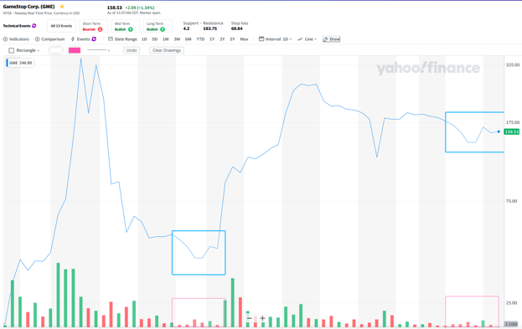
Look at the pattern leading into the February spike and the pattern we're in right now over the past week.
I think we are getting really close to another big price move. It may or may not be the squeeze, but we
see a repeat of almost the exact same price movement and volume as the last time we moved out of a
stasis.
Like a black hole, we cannot actually see it because even light does not escape, but we can observe how
the mass bodies around it interact and how it distorts the space that it occupies. The squeeze is there.
The best that we can do is to observe how the major players are positioning and preparing.
Back to Table of Contents
Holy shit. I was skeptical of all the high ceilings
being thrown out until I put the pieces
together. I honestly think GME is priceless, and
the most valuable stock you will ever buy.
Here's the full picture, as I understand it...
Possible DD 👨‍🔬
First of all, I’d like to start off by stating this post is completely nonpartisan. GME is not a political
debate, it’s a class war.
Okay, let me ask you guys this — how many of you knew that when the pandemic began, the FED
pumped $3 trillion dollars into the markets? I watch the news in the background all day, every day, and I
didn’t know at the time when the injections were happening. This news would have been of great
interest to me since I day trade, so it would not be something that I wasn’t paying attention to. I just
simply wasn’t looking in the right places.
You may not have been aware of the pump either because they were discreet. MSM that isn't financial
news never mentioned them. And we were even misled about it. How many times did you hear Trump
brag that markets being at an all-time high? This literally had nothing to do with how well the economy
was doing. Or the markets for that matter. The record high is completely artificial.
This isn’t a political issue; this is a class issue. What should infuriate you most is that people were
literally starving, unable to pay their rent, and job losses were reaching record highs, while our
government withheld aid to desperate Americans, and even took a vacation in the middle of their debate
about it. But the Federal Reserve wasted no time (in March 2020) spending trillions of dollars bailing
out banks. Again.
It was not to protect your retirement accounts. They claimed there was not enough liquidity in the
markets, and Fed Chair Jerome H. Powell stated he will do whatever it takes to prevent another Great
Depression. But their actions are what is about to cause the next potential Great Depression.
Not only was $3 trillion pumped into the market, but the Federal Reserve also lent an additional $1
trillion a day to large banks for 14-days. None of that was taxpayer money, by the way. The FED was just
printing money. They loaned TRILLIONS OF DOLLARS to big banks, while the U.S. Government told the
American people they didn’t even deserve a $600 check of their own, taxpayer money.
The banks, investment firms, and hedge funds got too greedy and pumped too much into the market
(Here’s what the s&amp;amp;p currently looks like if you haven't seen this image), and the SEC and the
DTCC were complicit. Now, there’s too much liquidity. There is more borrowed money than real cash in
the market and it has no real value. It’s a house of cards, ready to fall at any moment. The wheels are in
motion. It is happening. Correction is imminent.
The SEC realized the market bubble at least 6 months ago. You may have heard that big banks recently
had huge record-setting sales last week on bonds and were taking advantage of a recent dip in Treasury
yields. That was a lie. The SEC told brokers that as of April 22nd, they must have the capital to cover
every share they borrowed from investors and lent out to hedge funds. So, banks needed billions of extra
capital on hand by April 22nd or they would have had to recall shares.
I personally believe that the crash has begun and has been in motion since early February. I wrote a post
about it yesterday, after realizing the trends for every stock on my watchlist have been extremely
unusual. I received hundreds of comments from people saying they’re noticing the same unusual trend.
The crash isn’t obvious to the average person because the stock market has continued to report record
highs, every week. However, my trading strategy focuses entirely on penny stocks that are owned by
hedge funds known to manipulate the market. Most stocks I invest in are all complete garbage, but I look
for pump and dumps, obvious manipulation patterns, and anticipate runners based on near-identical
charts of multiple companies. So, none of the stocks on my watchlists are in any of the benchmark
indexes like the s&amp;amp;p 500, Nasdaq, and the Dow.
In one of the most interesting comments, Comotron explains it perfectly: "High-momentum stocks,
which are risky at any time of the market cycle, are particularly so in the weeks prior to a bull market
top. There could be a 'smaller dip first, followed by another rise for a few months and finally a much
larger correction that officially ends the bull cycle. That’s the conclusion I reached upon analyzing all U.S.
bull markets since 1926. Stocks that are riding a wave of momentum do not crest in unison with the
broad market averages. They instead start to lose steam several weeks in advance. It is probably fair to
say that "penny stocks" fall into the "high-momentum stocks" category. Either way, based on historical
data, there appear to be credible indicators that suggest a market correction might happen in the near
future.”
That information is fucking. fascinating. From early December to mid-January, the market was
ridiculously bullish. I literally made more money in one month than my annual salary. Then all of a
sudden, every single one of my stocks just started trending downward, had a short rise, and have
continued to bleed for the past few weeks. All of them. Exactly the same time. And exactly like he said in
the comment.
There has definitely already been a mass sell-off of securities by hedge funds who have lost AT LEAST 70
billion dollars in the past quarter, because of the tremendously dangerous and reckless risks they’ve
taken recently, which alone would have crashed the market without the pump from the Federal Reserve.
As we know, the hedge funds knew it would too, but gambled with our money anyway. This is just the
beginning. There is a domino effect of bankruptcies on the way for hedge funds.
We know the media has recently reported that investment banks and hedge funds had record-breaking
quarters recently. Which, technically they did. But that’s because losses are only reported when you sell.
They have not covered any of the short positions yet and are paying millions of dollars every single day
until they do. In fact, capital from the mass sell-off isn’t going towards paying off their debt, millions of
dollars are going towards suppressing this information, manipulating the market for more capital, and
reducing losses. What they’re doing is completely illegal and the media is not reporting it, the left or the
right-wing media. It’s because they’re all controlled by billionaires. In the past three months, I have
never seen so much lying and corruption in my life.
As the SEC’s deadline to secure capital approaches there have been other signs that things are going to
blow up very soon. For instance:
• The SEC announced in a press release that it will award a record-breaking $114 million
to whistleblowers whose information and assistance lead to the successful enforcement
of SEC and related actions.
• Gary Gensler was confirmed as the new chairman of the Securities and Exchange
Commission (SEC) on Wednesday. He was sworn on Saturday. What’s interesting about
that is that it’s not typical to be sworn in on Saturdays. The last SEC chairman to be
sworn in on a Saturday was George Bradford Cook, and it was before the Watergate
scandal broke.
When all this does break, they will try to change the narrative. They’re going to blame it on retail traders
and say overvalued stocks bought during the pandemic caused the crash. Fox will probably even blame
the Biden administration. But either way, they’ve already started pushing an alternative narrative. For
example, CNN linked an interview with some dude (I really don’t care enough to look for his name or the
video, because I don’t find him credible) who owns a market intelligence company. The guy apparently
predicted every single market crash since 1987’s Black Monday. I watched the whole interview, and he
went on and on about how there will be a market crash soon and said the reason is that tech stocks are
overvalued right now. If he were an actual market expert explaining the upcoming market bubble, he
would have mentioned any of the information above, but he didn’t. He strictly talked about tech stocks.
So, yeah, it’s out there. Billionaires control the stock market, media, and our politicians.
I don’t know about you guys, but I’m fucking sick of it. And for that, they need to pay.
The Ceiling/Floor:
There are many factors in all this that we need to calculate into our ceiling/floor. First of all, we should
demand back the $17 trillion dollar bailout given to banks, that was gambled away recklessly, and will
inevitably crash our economy.
$17 trillion / 55.6 million (float) = $303,571.00/share
That would be my floor if there was no market bubble. But there is. And it’s their fault. Therefore, our
floor should hold them accountable for the massive amount of money Americans are about to lose when
the market crashes. The only problem (for hedge funds) is that no one knows how much this is going to
cost.
For that reason, I believe GME is priceless. They can't afford to keep the price down, once the squeeze
begins. We literally choose the price. The limit does not exist.
I believed it before, but I see it now. And I have all the information, which makes me believe we are owed
this money. Not just for past for corruption, but to cover future, unavoidable losses.
I ask you all to stop fighting about the floor and ceiling, take down your sell limits, and repeat after me:
“My shares are not for sale.”
Stop thinking about selling. I will remind you again that we own the float. They’re paying millions of
dollars in interest each day and will eventually be forced to cover. Force the liquidity to dry up. Watch
buy orders rise from $1,000, $5,000, $10,000…$1,000,000…because they’re not being filled.
Sell when you feel comfortable and believe it’s an amount you deserve. Everyone has different risk
tolerances, not everyone will sell at the same time, and we know the original members
of r/wallstreetbets have an extremely and unusually high tolerance for risk. So, trust us and each other.
This really is a revolution. As Scaramucci Tweeted, this is like the modern-day French Revolution of
finance. Gamestop is a MOTHERFUCKING (Keith) GILL-OTINE.
This is the way.
Trust me. Everything is going to be fine.
Edit: Since this hit r/all, I thought I would mention that I am a female because WSBs has gotten a lot of
criticism about it being a "boys' club". It isn't.
Edit 2: Yo, Mr. Gensler - FOR SOME REASON, Jay Clayton and the mainstream media were unable to
figure most of this information out. (I know, crazy!) So, will I be receiving my $114 million
whistleblower check in the mail...or...? Also, Jay Clayton might not be aware he's out of a job yet. You
guys may want to let him know. Not on top of things, that one.
Back to Table of Contents
$GME - The Mother of All Short Squeezes
(MOASS) Thesis. Summarized and broken
down in a way for all (or most) to understand.
We are in the end-game everyone, and this
rocket is taking off with or without you. If you
want to understand that whole "GME thing"
this is my best shot at explaining it
DD 👨‍🔬
moass French Translation, Courtesy of "The Bagguette Guy"
I. IMPORTANT LINKS FOR NEW MEMBERS TO r/superstonk
• APE Security Protocol (how to secure and protect yourself online)
• DD Beginners Guide Page
• Wiki
II. INTRO / INTENTION OF POST
The core intention of this post was to frame the MOASS Thesis in a way that was understandable to
individuals inside and outside of the community (especially those who are relatively new to the market).
It also is intended to serve as a reference to leverage if you are ever trying to explain to someone why
you think it is a good investment option.
This post will give a relatively simplistic breakdown of the current situation and landscape of GameStop
Stock (GME). It will summarize the theory that GME's price will soon reach astronomical levels during a
massive short squeeze, AKA "The Mother of all Short Squeezes (MOASS) Thesis". The bulk of this post is
a breakdown of the market terms and concepts that will need to be understood in order to fully
comprehend the who-what-when-where-why-how.
III. Personal note
Feel free to use the contents of this post however you want. Don't worry about asking for permission to
copy it, cross-post it, translate it, refine and use it in your own posts, etc.
Leave a comment if you have any questions. If you prefer Chat or do not meet karma requirements, you
can hit me up on chat as well
Note that, while I may have a good grasp on the concepts broken down in this post, my background is
not in finance, investing, or trading, so there may be some questions I do not have the answer do
(especially if they are not called out in this post)
I have found myself more active on Twitter than I ever really expected to be, so feel free to follow me if
you want things like the below:
• Antagonizing Market Adversaries, MSM Shills, etc.
• Meme-ing with SuperStonk and the other Apes in the community
• Getting Notifications for Future DD I post
Disclaimer
This writeup is NOT intended to serve as a source of proof/evidence behind this theory, and it operates
under the assumption that the theory is valid and that the conditions it is built on are valid. Credit for
the DD this Thesis is based on belongs to the broader retail community inside and outside
of r/superstonk. I personally contributed very little beyond synthesizing and summarizing the thesis
and mechanics in a digestible way to help enable others to get the word out, and I am not an expert on
really any of these topics despite having some knowledge in them.
IV. TL;DR (Also at Bottom)
1. Toxic Market Participants have built up massive short positions made through Naked
Shorting
2. Retail caught on to this strategy and discovered it can backfire if the company being
shorted does not go bankrupt, especially if shares are bought and held indefinitely
3. Rules and regulations have implemented by the DTCC and its subsidiaries have been
geared towards preventing market collapse, as well as to minimize the ability to
perform illegal trades (naked shorting)
4. The SEC is also doing more to enforce compliance with the "rules"
5. The manipulators are at the mercy of a vicious trade cycle (t+21 FTD Cycle) that is
forcing those with naked short positions to perform actions to cover (buy back shares
that are short), or risk regulatory consequences
6. This act of rapid covering drives up the price, making it more expensive to cover during
the next cycle if the share price continues to increase week over week
7. Eventually, the prices of GME will get so high that prime brokers/clearing houses will
have no choice but to Margin Call these participants which most likely will not be
affordable due to the nature of Short Squeezes, causing them to default
8. The Prime-Brokers will then take on the position, and if the Prime Brokers cannot cover
them and also defaults, the NSCC will be next to attempt to settle all positions left over
based on their Recovery and Wind-down Plan (p42)
9. If NSCC cannot afford to close everything with the money reserved for this type of
situation, they the Fed must navigate the remaining positions (potentially via printing
money/bailout)
V. KEY CONCEPTS
These terms are key to understanding the theory and speculated value of a GME investment. Hyperlinks
to Investopedia, "the world's leading source of financial content on the web", have been included for
most market terms and concepts and it is recommended to check them out if they are not clear. We will
be breaking down some of the more complex terms and concepts within the post and framing them
within the context of GME.
Table of Contents for Key Concepts
1. Stocks Concepts
a. Share/Stock
b. Synthetic Shares
c. Outstanding Shares
d. Restricted Shares
e. The Float
f. Annual General Meeting
g. Shareholder Votes
2. Trade Positions
a. Long Position - Buying/Selling Stock
b. Short Position - Shorting/Covering Stock
c. Naked Short Position - Naked Shorting/Covering Stock
3. Market Participants
a. Retail Investors
b. Institutional Investors
c. Market Makers
d. Prime Brokers
e. Clearinghouses
f. MSM
4. IMPORTANT MARKET/TRADE MECHANICS (MOASS)
a. Fails to Deliver (FTD)
b. Margin
c. Margin Calls
d. Margin Calls Who Calls Who
e. Short Squeeze
1 - STOCKS CONCEPTS
1.1 - Shares/Stock
Shares are the smallest unit of a Companies Stock
• Stocks and Shares are often used interchangeably
• Technically "shares" would represent how many of a specific company's stock, where
buying multiple "stocks" would main that shares of multiple company's were bought
o ex. I bought 2 stocks; 10 shares of GME, and 60 shares of AMC
• There are different classes of shares that are distinguished on their voting rights, sales
charges, and other factors
o Classes of shares have relatively complex dynamics, but I will not go
further into them here, as it is not as relevant to GME/AMC
1. 2 - Synthetic Shares
Synthetic Shares are the financial instruments that get produced through Naked Shorting
• Not to be confused with synthetic options positions, which are legal/legitimate trade
strategies that "simulate" the profits/losses as if the trader actually held those shares
• Synthetic shares entitle the owner to all of the same rights as an investor owning a non-
synthetic share
• Cases where there is an excessive amount of synthetic shares point to the possibility
that a stock is being abused or manipulated
• Cannot be easily measured due to limited public transparency at the Market Maker and
Prime Broker level
1.3 - Outstanding Shares
The number of Outstanding shares encompasses the amount of issued shares held by all shareholders
(both private and public)
• It is possible for there to be more shares outstanding through Naked shorting, which
produces Synthetic shares
• The number of issued AND synthetic shares outstanding is very difficult to measure, as
they are only recorded on the books of the market makers generating synthetic shares
and the prime-brokers they trade through
o These parties are not incentivized to be transparent and actively obscure
these numbers, as the practice of naked shorting excessively is fraudulent
and illegal
1.4 - Restricted Shares
Restricted shares include the number of issued shares held by insiders of the company
• These shares are not publicly traded on the stock market
1.5 - The Float
The Float, or Floating Stock is the number of shares of stock that are available to be publicly traded (the
number of Outstanding shares minus the amount of Restricted shares that are owned by insiders).
• In theory, the number of shares owned by retail investors and institutional
investors should not exceed the float
• GME’s float total is currently ~56.89 Million shares (as of 6/10/21)
1.6 - Shareholder Votes
Annual General Meetings basically is an annual meeting that allows shareholders to vote
• Votes are cast for things like
o Appointment of directors
o Executive compensation
o Dividend adjustments
1.7 - Shareholder Votes
Shareholder Voting is a right extended to shareholders holding shares in the stock that entitle the owner
to vote on cooperate policies
• Examples of what votes are cast for
o Appointment of directors
o Executive compensation
o Dividend adjustments
• Overvoting (info in the middle of this page)
o When there is an overvote (like GME on 6/9), the votes will be
normalized to a number based on the amount of shares that are held by
DTC
o The official 8K form cannot be officially submitted with an overvote
When this happens, the SEC and Company are notified
2 - TRADE POSITIONS
2.1 - Long Position - Buying/Selling Stock
When an investor buys a stock they are considered long on it (this is the type of position most people
associate with trading stocks)
• Not to be confused with a long-term investment
• In other words, holders of long positions have a positive number of shares
• To close a long position the owner would sell their shares on the stock market
Basic flow of obtaining/closing a long position is:
1. Buy the stock
2. Hold it until the price of it increases to a desired amount
3. Sell it for a profit
2.2 - Short Position - Shorting/Covering Stock
When a short seller shorts a stock they hold a short position on the stock, or owe the party they
borrowed from however many shares they shorted
• Not to be confused with a short-term investment
• Investors with short positions effectively are in debt or owe the number of shares that
they have shorted and can be considered negative on the stock
• To close that position, short-sellers must buy a number of shares equal to the size of
their short position (buying to close a short position is known as covering)
• Short positions must be reported to regulators (unlike naked short sales)
Basic flow of obtaining/closing a short position:
1. Borrow a share owned by a lender
2. Sell the stock that was borrowed
3. Gaining the cash based on the price it was at the time it was “shorted”
4. Pay interest as a percentage of the stock's value
5. Since this is a percentage the cost of interest increases if the stock's value increases
6. Hold the position until the price has dropped to a desired price
7. Buy the stock on the open market
8. Ideally the stock is bought back at a lower price than originally borrowed for so the
investor can pocket the difference
9. Return the share back to the lender
2.3 - Naked Short Position - Naked Shorting/Covering Stock
Naked Shorting effectively allows a Short Seller, working with a market maker, to short a stock using a
without having a borrowed share like normal short selling
• Naked short sales do NOT have to be reported the same way as normal "Short Sales" and
can be "hidden"
o Failures to Deliver the shares that were "fake-borrowed" to the buyer are
on of the main ways to find evidence of naked shorting
• Due to a loophole and lack of oversight by regulation, Naked short selling can be used to
manipulate the price of certain stocks
o This type of trade illegal outside of specific situations involving Market
Makers
• Naked shorting was targeted for tighter regulation during the financial crisis of 2008 but
enforcement has unfortunately not been effective in preventing it from manipulating the
market
Basic flow of obtaining/closing a naked short position (kind of complex and involves two specific parties
for 2 initial trades called a married put)
1. A Short Seller "A" buys 100 shares from a Market Maker "Z" who can technically sell
them without locating them
a. Market Maker is Naked Shorting the stock, and the Short Seller is
receiving 100 synthetic shares
2. Short Seller "A" now buys a Put Option (1 options contract is worth 100 shares) from
Market Maker "Z" who is the writer of the put
a. Writing/selling a put nets +100 shares to the Market Maker, which
results in the -100 shares that were naked shorted to be neutralized, so
the Market Maker no is at a neutral position (Market Makers generally try
to remain net 0 on trades
b. Short Seller "A" now has 100 shares that can be short sold (they
"borrowing" the synthetic shares the Market Maker effectively printed
out of thin air), and one put contract that they can make money on as long
as the price goes down
3. The steps or the short seller are basically the same as a normal short sale now (2.2 steps
2-8), however, interest from the Short seller does not need to be paid to a lender (no one
is formally lending it)
a. The premium from the put being purchased from the Market Maker is
how they benefit
b. Short Seller "A" now has a short position that they can cover simply by
buying 100 shares, which would cancel out the synthetic short position
3 - MARKET PARTICIPANTS
3.1 - Retail Investors
• Retail Investors, also known as individual investors, are your average investors (not a
company or organization)
• Referred to as the "Dumb Money" by Wall Street and the "professional" financial
community
• Reddit communities
o Notable subreddits
r/Superstonk
r/gme
r/amcstock
r/wallstreetbets
3.2 - Institutional Investors
Institutional Investors are organizations that invest on individuals' behalf
• Examples of Institutional Investors
o Endowment Funds
o Commercial Banks
o Mutual Funds
o Hedge funds
o Pension funds
o Insurance companies
3.3 - Market Makers
• Market Makers are very different from "Investors" and are a bit harder to explain but
basically are there to increase liquidity in the market
• When you buy and sell stock those trades are often going between you and a market
maker
• Market makers get "special rules" that enable them to keep liquidity in the market when
there is low liquidity
• Naked shorting is one of the options Market Makers have when navigating a trade that
other investors do not have
3.4 - Prime Brokers
• A Prime-Broker is a bundled group of services that investment banks and other
financial institutions offer to hedge funds and other large investment clients that need to
be able to borrow securities or cash in order to engage in netting to achieve absolute
returns
• Broker vs Prime-Broker
o A broker is an individual or entity that facilitates the purchase or sale of
securities, such as the buying or selling of stocks and bonds for an
investment account. A prime broker is a large institution that provides a
multitude of services, from cash management to securities lending to risk
management for other large institutions.
• Market Makers like go through Prime Brokers
o The Prime Broker is who would Margin Call Shitadel if their short
position gets too large or they bleed too much capital
3.5 - Clearinghouses
Clearinghouses are intermediaries between buyers and sellers
• Finalize transactions
• Regulates delivery of assets
• Reports on trading data
3.6* - MSM (Mainstream Media)
Though not a traditional market participant (as in they are not trade/financial entities) the MSM is
worth noting due to its role in influencing the financial atmosphere and landscape
4 - IMPORTANT MARKET/TRADE MECHANICS (MOASS)
4.1 - Failures to Deliver (FTD)
• FTDs occur when a buyer of a stock ends up not having the money to purchase the stock
that they traded for OR, when a short seller does not own the stock at the time of
settlement
• FTDs are one of the main check-balances to naked shorting, so very high amounts of
Failures to Deliver are indicative of this
o Spoiler: GME and AMC have tons of FTDs reported
4.2 - Margin
• Margin is basically credit that that an investor can use to buy more stock
• When you buy on margin you must stake the assets you have already purchased with
your own cash as collateral
• The amount of Margin you can have depends on the value of your collateral
• The value of your collateral and cash but meet the margin requirements in order to
continue to buy on margin
• Keep in mind the value of your collateral can change if the price goes up or down and if
the value of your collateral/cash drops below the margin requirement you will received
a Margin CallAnother way to think about it:
1. Imagine I have $1,000 in stock
2. You obtain a personal loan for another $1000
3. To get the credit you stake your $1000 in stock (if you default it goes to the lender to
cover your debt)
4. You buy $1000 more stock with that loan (you now own $2000 in stocks, half in cash
half on margin)
5. You will pay interest on the $1000 on margin but if your investment makes more money
than the interest then you are still profiting
6. If your investment turns bad (lets say the price of your stock falls 50% and you are left
with $1000) your lender can forcibly close out your positions (everything you bought in
cash and staked as collateral along with what you bought on margin so that they can get
the $1000 they loaned you back)
4.3 - Margin Call
• A Margin Call is a notice indicating you have a specific amount of time to deposit enough
of your own funds to meet your margin requirement (if you cannot meet the
requirement the lender is entitled to sell all of your holdings to recover what you
borrowed
Margin Examples:
This is a slightly complicated scenario that can be a little hard to follow. Give it a few reads if it doesn't
make sense the first time, but basically, Margin is a credit line that you can use to buy more assets
(effectively a loan backed by collateral and cash in your own account). If you buy assets with it, you have
to pay back what you borrowed, whether the value of your investment goes up or down (if the
investment goes up in value, you make more than you normally would, but if the investment goes down
in value, you lose more than you otherwise would have without margin).
This gets even more (or less maybe) complicated when you have short positions AND long positions, like
most institutional investors. To have short positions, I still need to have margin, but I do not need to use
it to buy stocks, It can act as a buffer if I have a short position on a stock that is increasing in value (with
a short position, if the price of something I short goes up, I am losing money), and if it gets too high, it
can run against my margin line, causing a margin call.
GAIN: Long Positions
1. Imagine I have $1000 in stock XXX (let's say 10 shares worth $100 each)
2. My broker may lend me margin credit line equal to the value of my assets (so $1000 in
margin), and let's say they give me a margin requirement of $800, meaning that the
value of my non-margin assets (the ones I bought with my money) must be above $800
in order to keep using margin (so as long as stock XXX stays above $80 a share, then I
will not get a margin call for being below the requirement)
3. I then choose to use the margin, buying 10 more shares of stock XXX for $100 each, so I
now have 20 shares of stock XXX, valued at 100$ a piece
4. If the price of stock XXX goes up to %25 per share, and I sell all 20 shares, I just profited
$500 (+$25 on 20 shares)
a. In this case, closing the position clears me from the margin debt, as I am
no longer using it in an open position
b. If I had not used margin, I would have only walked away with $250 in
profit ($25 per share on 10 shares), but instead I made $500, and paid
back the credit, plus a little bit of interest.
5. Yay.
LOSS: Long Positions
1. Imagine I have $1000 in stock XXX (let's say 10 shares worth $100 each)
2. My broker may lend me margin credit line equal to the value of my assets (so $1000 in
margin), and let's say they give me a margin requirement of $800, meaning that the
value of my non-margin assets (the ones I bought with my money) must be above $800
in order to keep using margin (so as long as stock XXX stays above $80 a share, then I
will not get a margin call for being below the requirement)
3. I then choose to use the margin, buying 10 more shares of stock XXX for $100 each, so I
now have 20 shares of stock XXX, valued at 100$ a piece
4. If the price of stock XXX goes down %25, bringing the value per share down to $75 a
share, the value of my total position is now $1500, and the value of my non-margin
assets is $750, which is below the margin requirement (keep in mind, I borrowed
$1000, so that is still the amount I have to pay back)
5. My lender will give me a margin call, indicating I have two business days to deposit 50$
into my account in order to meet the margin requirement
a. If I have the cash to deposit the extra $50 would take my assets to $800
($750 in stock XXX + 50$ cash)
i. If the price of stock XXX recovered to above $80 per share,
it could also satisfy the requirement
b. If I do not have the cash to deposit, then I am in trouble, as after two days,
they are allowed to liquidate (sell) the assets I bought with my own
money, as well as the assets I bought on margin
i. Let's say this happens, all my borrowed assets are sold
first to cover my $1000 loan (since the price of stock XXX
was only $750, it only covers $750 of my $1000 margin
line
ii. I now have $750 left in assets of Stock X, but I still owe
money from margin, so my lender is entitled to sell $250
work of my shares in order to get their full $1000 back
iii. I am now left with $500 total ($750 in 10 shares of stock
XXX - $250)
6. Not Yay
LOSS: Short and Long Positions
THIS IS THE RELEVANT ONE TO GME/AMC
1. Imagine I have $1000 in stock XXX (let's say 10 shares worth $100 each)
2. My broker may lend me margin credit line equal to the value of my assets (so $1000 in
margin), and let's say they give me a margin requirement of $800, meaning that the
value of my non-margin assets (the ones I bought with my money) must be above $800
in order to keep using margin
3. Instead of using the margin to buy more, I instead short 10 shares of stock YYY which is
at $50 a share currently (giving me $500 in extra cash), which I use to buy 5 more
shares of stock X
a. I am now long 15 shares of stock XXX valued at $1500 and short 10
shares of stock YYY valued at -$500 (negative $500) for a net value of
$1000
b. No margin is actively committed to open positions, and I am still using my
$1000
4. Now, lets say a short squeeze happens involving stock Y, causing the price to skyrocket
to $200 per share
a. My short position is now -$2000 (10 shares of -$200 each)
5. My net account value is now $-500 ($1500 - $2000) which is now using my margin, and
because my account's value is no longer above $800, I no longer meet margin
requirements so I get a margin call
6. If I cannot balance my account, the lender will liquidate my $1500 in stock XXX in order
to pay the -$2000 I owe, leaving me with -$500 left in debt
a. I have now defaulted, as I cannot pay the $500
7. Now that I have defaulted, the lender who gave me margin owns my short positions,
meaning they are now short whatever was left
a. The lender can now navigate the short positions however they want
(they can hold them and hope the price goes down, and cover to close
them, or they can close them immediately, costing them the whole $500 I
still owed)
8. GUH! (Translation if you are not WSB: Ah @#$%)
4.4 - Margin Calls Who Calls Who
• Margin calls happen at levels 1-4 when the cell to the left cannot meet margin
requirements
o Broker Margin Calls Retail Traders
o Prime Brokers Margin Call Brokers, Hedge Funds, and Market Makers
o The NSCC Margin Calls Prime Brokers
• Defaults roll up left to right
o If Retail Trader defaults, Broker must take on their leftover positions
o If Broker, Hedge Fund, or Market Maker defaults, the Prime Broker must
take on their leftover positions
o If Prime Broker Defaults, the NSCC must take on Position
o If the NSCC Defaults, the Fed must take on the position
Level 1 Level 2 Level 3 Level 4 Level 4
Retail Trader Broker Prime Broker NSCC (DTCC) Fed (JPOW)
x Market Maker Prime Broker NSCC (DTCC) Fed (JPOW)
x Hedge Fund Prime Broker NSCC (DTCC) Fed (JPOW)
4.5 - Short Squeeze
• A Short Squeeze is a market event that occurs when there is a large short position on a
stock whose price rapidly increases higher than expected, normally due to a catalyst
• During the short squeeze, the losses of those who have short positions continue to
increase higher it goes
o Since they owe shares, the cost to cover their position increases
depending on how high the price goes (there is theoretically no limit on
how high a stock can go)
• As market participants who are short on the stock buy to cover, supply decreases and
demand increases, causing the price to increase even more rapidly
• While short sellers are scrambling to cover their positions, the rapid price change may
entice investors who are not short on the stock to buy it in order to make a quick profit
o Again, lowering supply and increasing demand
VI. The Mother of All Short Squeezes (MOASS)
Explanation
Now that we have gone through the many important terms, we can get to the theory behind MOASS.
Due excessive short-selling and naked shorting of GME by certain market participants (primarily large
hedge funds and market makers), retail investors and long institutional investors collectively own a
number of shares that exceeds the the float. The amount of shares that are currently owned is theorized
to range roughly between 200%-400% of the float if not more, meaning that 100%-300% of the float
has a corresponding short position (mostly naked shorts). For context, most stocks generally have
around 1% Short Interest, and 10%-20% short interest is considered to be excessive, let alone over
100% of it.
Short sellers must eventually close, or cover, their short position
• The only way to do that is to buy the shares owned by the investors who are long
o in the meantime Short-sellers are paying interest on that short position
until it is closed proportional to the cost of the shares, which bleeds their
capital over time
• Unfortunately for the short sellers, the owners of the shares ARE NOT obligated to sell
their shares.
o The short-sellers, however, ARE obligated to buy in order to close their
position (or else keep paying interest)
So what happens if no one is selling the shares they are “long” on, but short sellers need to buy them?
• Supply and Demand
o With very little supply and high demand, the price of a stock can increase
far beyond its fundamental value
o If short sellers receive a margin call due to no longer meeting their
margin requirement and are unable to meet it in time, their assets will be
forcibly liquidated by their lender in order to pay back the margin, as well
as close out the position if the borrower defaults
If you are wondering why an organization would abusively short a stock like this if they eventually have
to cover their positions:
• If a company goes bankrupt or gets delisted from the stock market:
o The short sellers DO NOT have to close the position
o All of the proceeds from the short sale effectively disappear from their
books
o They do not even have to pay taxes on this profit
Short positions amount to the total number of long positions minus the float, meaning (based on the
theorized range) that somewhere between ~56-170 Million shares will need to be bought in order to
close all short positions
• It is expected that the members with short positions (hedge funds and market makers
who have been naked shorting the stock) will be unable to cover their short positions,
resulting in a situation where their lenders, all the way up to the clearinghouse (DTCC)
will have to sort out the positions
• If the DTCC/NSCC is forced to unwind the positions, it is widely believed that they will
rapidly cover short positions at whatever price they are available for (this is how their
systems are said to handle a member default), liquidating whatever assets are necessary
from the defaulting member
Consideration
This is a totally unprecedented situation, so, in truth, there is a lot of uncertainty around what wind-
down will look like once this gets to the Prime Brokers (major banks) and NSCC, as well as around how
high the price peak will reach. There is a real risk of broad negative impact across the entire market
because of this and the current Repo Rates and margin debt.
A few things I think are safe to assume are:
• Before anything happens that will cap or negatively affect the MOASS, all of the Hedge
Funds and Market Makers who conspired to manipulate the market will likely have been
bankrupted and eliminated from the market landscape by then
• Prime Brokers will have been dealt a massive blow (like Credit Suisse after Archegos
Collapse by way worse) that should hopefully ensure regulators tie up every loophole
that was exploited to manipulate the market and harm it
• The peak will reach higher than any other short squeeze in history and will likely never
be beaten in the future (EVER)
VII. Final thoughts...
This is the GME MOASS thesis. GME is a stock that stands to hit an unprecedented price point due to the
fact that manipulators of the market have failed to bankrupt GameStop thanks in huge part to the
Legendary Keith Gill AKA u/DeepFuckingValue, Ryan Cohen, Michael Burry, and all of the GME investors
who took part in this saga. It may not be today, this week, or even this month, but one day soon, these
toxic participants have no choice but to buy the stock to close out their short positions.
In some schools of thought, it is thought that these participants over-estimated how "reasonable" retail
investors can be (who could be dumb enough to hold a stock as it fell from almost $500 to $40?). In
truth, these manipulators didn't understand the demographic they were fighting with. Gamers are some
of the most stubborn people on the planet. These are individuals who will sink tens of thousands of
hours into the same video game because "they just like it". Well, "we like the stock", and to us, the
adversaries on Wall Street just are just another "boss". We may have needed to retry a couple times, but
we always win eventually. On top of that, they pissed off reddit, and under no circumstances, should you
ever piss off reddit.
At this point, if you are still reading this, know that it is up to you to decide your next move, whether that
is to do some due diligence of your own, walk away, or say screw it and buy a few (or a lot of) shares just
in case we are right. Many of us have set our floor (minimum amount of acceptable gains) at
$20,000,000 per share, and you might think that is crazy, but in truth, we know we can pick our own
price if we hold long enough. We don't care if anyone else buys or not, because we know the outcome is
inevitable. Time is running out for the toxic market participants involved, and even the news can't hide
that we are on the brink of a massive market event that will ripple through the entire global financial
system, and we will probably never see an event like this again in our lifetime.
This is a fight Wall Street, Shitadel, Melvin Capital, and ever other toxic party is not going to win
against the "dumb money". Chances are this will truly be "THE MOASS", meaning there will never be
another like it in our lifetime (or ever). While the conditions in play (the ability for big money to brutally
manipulate the market) enabled what may end up being the greatest transfer of wealth in history, actual
reformation to prevent a landscape like this from forming again is probably best long term (I say this as
a pragmatist, and am honestly very far from an idealist). If you want to influence reform, Buy, Hold, Vote.
If you are just here for the tendies, Buy, Hold, Vote.
VIII. TL;DR
1. Toxic Market Participants have built up massive short positions made through Naked
Shorting
2. Retail caught on to this strategy and discovered it can backfire if the company being
shorted does not go bankrupt, especially if shares are bought and held indefinitely
3. Rules and regulations have implemented by the DTCC and its subsidiaries have been
geared towards preventing market collapse, as well as to minimize the ability to
perform illegal trades (naked shorting)
4. The SEC is also doing more to enforce compliance with the "rules"
5. The manipulators are at the mercy of a vicious trade cycle (t+21 FTD Cycle) that is
forcing those with naked short positions to perform actions to cover (buy back shares
that are short), or risk regulatory consequences
6. This act of rapid covering drives up the price, making it more expensive to cover during
the next cycle if the share price continues to increase week over week
7. Eventually, the prices of GME will get so high that prime brokers/clearing houses will
have no choice but to Margin Call these participants which most likely will not be
affordable due to the nature of Short Squeezes, causing them to default
8. The Prime-Brokers will then take on the position, and if the Prime Brokers cannot cover
them and also defaults, the NSCC will be next to attempt to settle all positions left over
based on their Recovery and Wind-down Plan (p42)
9. If NSCC cannot afford to close everything with the money reserved for this type of
situation, they the Fed must navigate the remaining positions (potentially via printing
money/bailout)
IX. STILL TL;DR
Margin Calls happen across the market and force all market participants with short positions in GME to
cover or go bankrupt if they cannot afford to. The NSCC's systems that will settle positions after mass
defaults liquidates all short hedge funds and covers as much GME as it can. If the NSCC cannot pay
everything, it fails up to the Fed and JPOW to print money to settle the trades.
X. Hedgies, velkommen til helvete. Vi kommer for tårene dine.
PDF Link - I recommend accessing through an incognito browser so that no one else is able to see your
email address if you are logged into google (I initially had this on OneDrive, which did not do this,
however, shills seem to have gotten my Microsoft account blacklisted so I cannot access OneDrive now
lol):
https://drive.google.com/file/d/18SDUrEd-wNjKDwblo3ykoIxn627Vni0G/view?usp=sharing
EDIT: updated on 6/13/2021 to version 2.0 (kept the same post since it is referenced in a few places).
EDIT: 6/19/2021
I recommend also reviewing these two links, which go into market abuse elements around naked
shorting. Some of the content over laps, but it is useful.
"Counterfeiting Stock"
- https://web.archive.org/web/20210131014127/http://counterfeitingstock.com/CS2.0/Counterfeitin
gStock.html
"Paid Bashers" (shills)
- https://web.archive.org/web/20210131200557/http://counterfeitingstock.com/CS2.0/CS16Confessi
onsOfAPaidStockBasher.html
Back to Table of Contents
The flurry of rules before the storm. DTC, ICC,
OCC are prepared. GME might be hitting T+35
and T+21 crossover next week, pulling the
house of cards down.
DD 👨‍🔬
0. Preface
I'm not a financial advisor - and I am not providing you financial advice! This is all my interpretation of
what is going on.
Anyways, I wanted to ask...

I'm hype. Are you pretty hype? I keep coming back because I love you guys, and I love the fact that there
has been so much research freely accessible to teach millions of people all the nooks and crannies of the
market. I'll just say - once this is all over, I'll miss you apes. Thank you all. ❤️
TL;DR: The market is an overleveraged and rehypothecated bomb. The banks have been fighting
a collateral crisis since the end of March due to the government emergency liquidity programs
ending and inflation kicking in. The repo market could blow up at any moment from a lack of
collateral and short squeeze the US Treasury market itself. The entire market is hanging by a
thread and the DTC, ICC, and OCC are prepared for the fallout. The moment GME surges again,
they can cascade defaults to members in all clearing corps and end it in one fell swoop.
1. The DTC, ICC, and OCC
Let's clear up some confusion! Lots of apes are posting rule numbers with no prefix, so it's going to be a
problem understanding one another. Let's forge some wrinkles! 🧠🔨🦍
These are all major clearing corps of the market. They all are their own beasts in and of themselves. For
simplicity, we'll label them as such:
DTC = stocks
ICC = default swaps
OCC = options
Each of them operate independently, so they're all filing their own rules that affect them individually.
Important distinction. The DTC rules don't apply to the ICC, and vice-versa. That is why we see the rule
prefixes. These prefixes can help you distinguish between each of the entities.
• Example 1: SR-DTC-2021-004 is a rule for the DTC
• Example 2: SR-ICC-2021-005 is a rule for the ICC
• Example 3: SR-OCC-2021-004 is a rule for the OCC
It helps a lot to add the prefix before the rule number since we're now seeing multiple 003/004/005
rules. Less confused ape = happy ape!
2. Almost Everyone Is Ready For Member Defaults
You've probably heard the term defaulting member being thrown around a lot lately. You can think of
that as being equivalent to a margin call. The member defaulted on something - making them go
negative in net capital - and thus they're in debt. Bye bye!
The DTC, ICC, and OCC all pretty much share the same members. Market Makers and Banks. Except of
course the ICC which only has Banks as members. You might think that all these rules being passed
have nothing to do with GME, but it deals with the market itself blowing up, which in turn effects
GME. All three of them passing similar rules is spooky and not a good sign for the market.
If a member defaults in the ICC, they most likely default in the DTC and OCC as well. The DTC, ICC, and
OCC do not want to be left paying up for the defaulting member's debts in the event of a default. They
also want to contain the nuke as much as possible so that it doesn't completely obliterate the market.
To prepare for the market nuke, the DTC, ICC, and OCC have passed rules/plans to deal with
defaulting members.
We won't go into super detail here. Just a brief summary of the infinity stones which the DTC, ICC, and
OCC have collected:
• DTC-004: Wind-down and auction plan. In effect.
• ICC-005: Wind-down and auction plan. In effect.
• OCC-004: Auction plan. Allows third parties to join in (E.g. Blackrock). In effect.
• OCC-003: Shielding plan. Protects the OCC from paying up too badly by having extra
liquidity. Will be in effect on June 1. Not in effect, but the OCC deposit of ~$600m
that was due the morning of May 19th could have supplemented for this. If not,
can go into effect any day between now and May 31st.
Every single one of them now has some form of rule which allows the defaulting members assets to be
auctioned off. This allows other members to buy the defaulters assets at a discount while funding the
defaulting member's positions. Say someone defaults from GME short positions and has, oh, I don't
know, 500 million shares short. The money used to pay for the covering of the GME short position will
be funded partially by this auction.
In the end, this transfers assets to other entities while also pushing the damage to those entities as much
as possible - a way to contain the nuke. It's a win-win situation. Other members get securities/assets on
the cheap, while the DTC, ICC, and OCC worry less about payout, and the market might be able to prop
itself up.
Now the case with the OCC, third-party members can join in on the fun. E.g. Blackrock. There's some
theories that Blackrock will delete Citadel from existence and press the MOASS button. I don't think so. I
think they've just been waiting this out to gather enough cash to bid on as many assets as possible.
They're not going to waste their money on igniting the MOASS, they're going to spend it to feast on the
defaulters remains.
The key takeaway is that all three of them, the DTC, ICC, and OCC are ready to pull the plug.
Any one of the DTC, ICC, or OCC can margin call a member and cause a default.
The moment a member defaults in the DTC, ICC, or OCC, it will cascade to the other clearing corps
and cause them to default over there as well. In one fell swoop, all the stocks, options, and swaps
of defaulting members are up for auction.
3. Do We Need The Other Rules?
You're probably thinking about DTC-005, NSCC-002/801, and others. And no, from my understanding
GME does NOT need them to squeeze.
GME doesn't even really need a catalyst. The T+21 and T+35 crossover event is probably enough to push
it over the edge (discussed later). The market is literally hanging by a thread right now and a big move in
GME can push it into margin call territory, causing the cascading defaults.
The DTC-005 and NSCC-002/801 rules are to protect the future market. The guys in charge might have
finally learned to impose more restrictions, and hopefully they stick to it.
DTC-005 will help avoid another stock from becoming over-shorted again. No more naked shorting. No
more adding to your short pile with malicious options practices. It prevents another group of absolute
retarded hedgefunds from doing this again. The T+21 and T+35 loop will cause the price floor to
increase regardless of this rule and eventually cause margin calls. Remember, liquidity bomb is a
growing issue, so the margin call price is most likely dropping as well.
NSCC-002/801 will speed up margin calls for extreme volatile movements like we saw in the January
and March squeezes. They will make sure that if someone enters margin call city territory, they'll issue it
with a one-hour timeframe. Pay up within one hour or you're toast. This ensures that volatility will kill
off shorters who get caught with their pants down.
Those rules help the future market avoid this bullshit again. They are not necessary for the MOASS.
The ICC itself has introduced a wild rule ICC-008, which is in effect, that performs hypothetical margin
calculations based on market movements. So again, the ICC could trigger a margin call to its bank
members based on their new margin model rather than the DTC. Boom, the defaulting bank cascades
through the banks members and eventually to GME.
After all is said and done, the DTC will ensure that these rules are in place so that nobody can cause a
GameStop situation again.
The most important rules are the wind-down and auction plans. They cover the DTC, ICC, and
OCC's asses and try to protect the market as much as possible. These wind-down and auction
plans are the OK 👍 to initiate launch when the time is right.
4. Shit Is Close To Hitting The Fan
The whole market is an overleveraged bomb. GME isn't the only problem here.
I'm sure you guys remember Archegos. Those guys abused what, 5x leverage? And you all saw what
effect they had on the market.
Imagine how bad leverage must have been abused by all the large firms which are STILL standing today.
Imagine what will happen if a very large firm with equivalent or larger margin goes bust. How about a
handful of them going bust? Bad, bad things, my fellow ape. Bad things.
I'm sure you guys have seen this posted a million times today. This screams liquidity crisis in the banks
because they've been really fucking stupid for the past couple of years, even more so since 2020 by
allowing firms to abuse the pandemic.
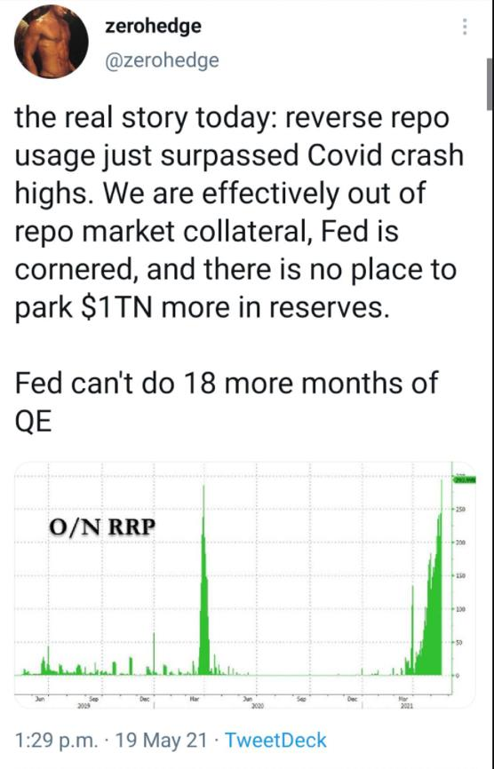
When did these reverse repos start showing up?
January 29th.
February 25th.
March 11th.
Woah what? Liquidity problems around the dates GME surged? It's not necessarily connected but hey,
nice coincidence - right? 😉
The reverse repos started coming at ever-increasing frequency towards the end of March. Hmmm.
Wonder why? Could it be that the fed ended their liquidity programs?
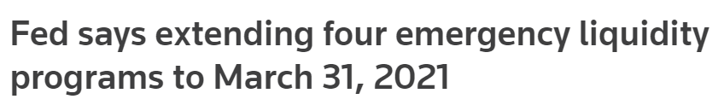
Yup. Those programs dried up on March 31, 2021. This suddenly put much more liabilities on the Banks
balance sheets, where they need to obtain assets to counteract their liabilities.
Ever since then, banks have been STRUGGLING with their balance sheets, and the potential of a short
squeeze on the US Treasury Bond Market (See "Everything Short" by /u/atobitt):
1. Banks have a "balance sheet" of assets and liabilities. Liabilities? Could be cash they owe
to people/entities. Assets? Some form of collateral, such as treasury bonds
2. Banks have ever-increasing liabilities every day due to over-leveraged borrowers.
3. In order to not default, banks need to maintain balance on their sheets by obtaining
assets/collateral.
4. Banks will go to Fed and to get their collateral in order to avoid defaulting (Reverse
Repo).
5. When the banks borrow collateral they might even 'short' sell those borrowed bonds
into the treasury market, hoping to flip a profit due to inflation.
6. Repeat #2 -> #5 and you get your ever increasing reverse repo amount.
7. Not only this, the Fed is sucking out $80Billion in treasuries (collateral) each month.
Reducing the supply in the market.
8. As the reverse repo amount continues to increase, demand continues to go up for
collateral.
9. As the fed continues to suck out collateral, the supply of collateral drops.
10. Eventually you hit a critical point where the supply is too low, and the treasury value
shoots up. Banks who are short might now be forced to buy back up the treasuries on
the market and cause a short squeeze in the US Treasury Market itself.
11. Banks default. Members default. Everything collapses except some Banks/HFs/Financial
Institutions which weren't completely stupid.
At any moment, the collateral bomb can pop and drag the whole system down. Definitely
recommend George Gammon's Summary.
5. The T+35 and T+21 Crossover Event of Meme Stocks
I've posted a theory about us getting close to another February 24th repeat where massive amounts of
volume and buy pressure could surge GME. You can find the post here:
FTD Loop Missing Link T+35 and T+21
The actual why to the mechanics behind these loops might not actually be FTDs. But instead Net Capital,
which operates on a similar timeframe. T+7, T+14, T+21, T+28. They're forced to buy up shares, causing
buy pressure, in order to return neutral and deliver. You can find that post here:
Net Capital Bomb
In quick summary of T+35 and T+21, we seem to be in multiple price spike loops. And a new one is
about to pop up. Where did these originate from? So far, it looks like three main dates:
• January 15th: Major option date. One of the only 2021 option dates available in early
2020. Shorters must have piled in here.
• February 5th**:** The date Robinhood and other brokers fully lifted restrictions. Most
likely reset the clock from another options date or some other factor. [Trying to pin this
down] Edit: I think we can ignore this. The only option expirations that matter are Jan
15 and April 16 due to them being two of the major option dates that were available in
2020.
• April 16th: Major option date. One of the only 2021 option dates available in early
2020. Once again, shorters must have piled in here. I'm pretty sure Melvin's PUTs
expired on this date, FYI. 😉
Each date coincides with the following loop:
1. Option Expire date. T+35 days later a price spike occurs. (January 15 -> February 24th)
2. An endless cycle of price spikes T+21 days later starts. (February 24th -> March 25th ->
April 26th -> May 25th)
The first T+35 spike is more significant than the T+21 spikes. Check it out. I've also plotted the
hypothetical next price spikes which occur on May 24 (T+35) and May 25 (T+21).
Please note: T+35 is CALENDAR days. T+21 is BUSINESS days. Take a look at the above DD for the
walkthrough of this timing.
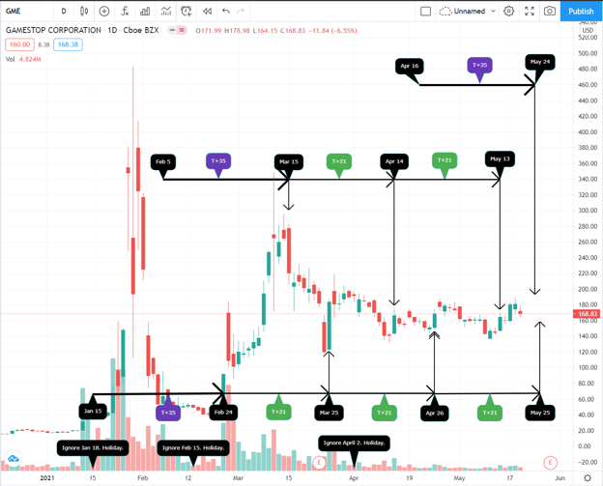
GME T+35 and T+21 Loop
Guess what? This happens in AMC too. You can apply this to KOSS as well, and find the same exact
patterns. Anyone want to have fun and check more meme stocks? Be my guest!
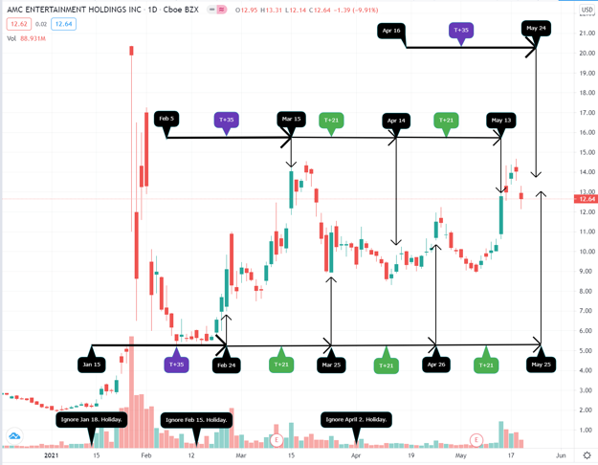
AMC T+35 and T+21 Loop
See that shit? We're lining up for not just a T+35 spike, but a T+21 spike one day after another next
week. This is going to effect all meme stocks if the cycle continues and April 16th actually triggers
another loop.
The timing of all of the wind-down and auction plans being in effect along with the increasing collateral
issue of the banks with reverse repos means there's a massive collateral bomb being juggled, which
could blow up with another volatile movement in GME or the market itself. When that happens, anyone
could default. And what happens when a member defaults in DTC, ICC, or OCC? It cascades to the other
two clearing corps. The margin calls start blasting out to all of the way overleveraged firms who get
screwed by this volatility, and down goes the house of cards.
Call me a tinfoil hat wearer, but it sure as hell feels like the SEC, DTC, ICC, OCC, everyone high up,
planned this all out. The flash crashes, everything, in order to get their nuke fallout plans in
place. They probably always knew the timer was going to tick, tick, tick, run out, and boom the
week of May 24th due to April 16th options expiration.
So the SEC, DTC, ICC, OCC, all the higher-ups shut things down in January. They shut things down
on March 10th. They crash the price on March 15th to avoid a pre-emptive margin-call. They pull
many strings to buy time, pump all their wind-down plans in place at the last minute, wait for the
next surge of GME, and then...
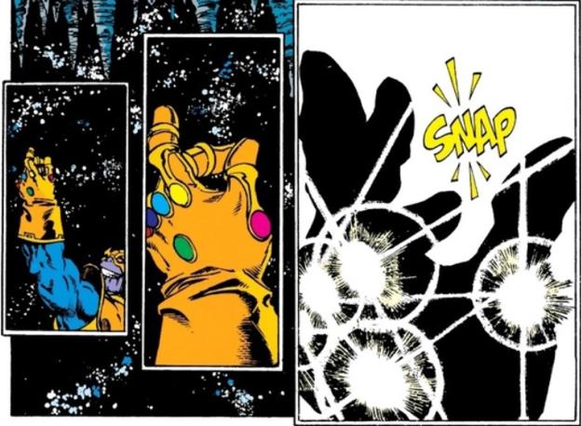
Back to Table of Contents
Wait... Is NSCC-002 about to turn the
T+21/T+35 loop into a death spiral of T+0 as
we approach Q2 end?
Possible DD 👨‍🔬
0. Preface
I am not a financial advisor. I do not provide financial advice. Many thoughts here are my opinion, and
others can be speculative.
So, NSCC-002 just got approved, along with NSCC-801 for one-hour margin calls. Not only did it get
approved, it got accelerated approval and will be in effect Wednesday, June 23rd.
This got me JACKED. But of course don't get too hyped just because of me. It could all be a nothing
burger in the end. But, there's some crazy shit going down that I think is telling of what is about to come.
There's also comments of "these rules mean nothing until they are enforced". Yes, I agree. But, consider
the fact that the NSCC, ICC, OCC, DTC have all been drafting up rules to protect themselves in the
event of member defaults and extreme market stress. They aren't just drafting these up to say, "Meh.
Nevermind". The NSCC, ICC, OCC, DTC are full of members who are NOT short on GameStop or other
positions that put these entities at risk. The other members have influence and do not want to be
dragged down either. It's a battle of survival.
I also apologize if anyone has already posted about this. I do know that /u/dentisttft had identified these
SLD periods in their post about T+35 when tying in the spikes of price! Such a smart ape! I'm going to
expand on their post here, identifying the importance of NSCC-002 to the theory.
A comment by /u/minnowstogetherstonk also encouraged this discussion, first identifying that
T+35/T+21 could turn into T+0 that feeds on itself. If this is what is about to happen... genius ape!
I personally think that NSCC-002 will trigger a death-spiral for SHFs as we approach Q2 end, and shit is
about to hit the fan across all markets.

Awww shit
1. NSCC-002 And It's Effects On Liquidity Deposits
Note: Like I said above, this is expanding off of /u/dentisttft's post of T+35 found here: T+35 Is The One
True Cycle. It visually showed the NSCC liquidity cycle times and the effects it had on FTDs, which never
really clicked until thinking about NSCC-002 a bit more. Give their post a read! :)
Something big to remember is that NSCC-801 now goes into effect along with NSCC-002, which allows
for one-hour margin calls. This means that when a member does not have sufficient liquidity, they will
be asked to post it within one hour to the NSCC. If they do not post the liquidity, then the member
defaults. And thus, the snappening begins.
Let's investigate the most important bits of NSCC-002. First, a glance at what the rules used to be and
the NSCC's concern driving the rule change**:**
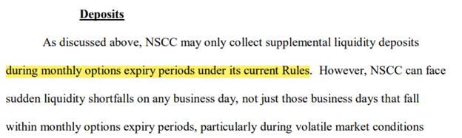
NSCC-002 Part 1; Old Liquidity Requirements
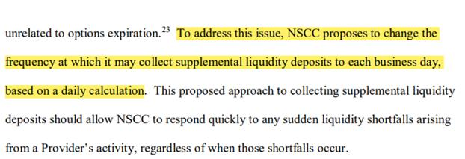
NSCC-002 Part 2; Old Liquidity Requirements
Prior to this rule change, the NSCC would collect liquidity deposits only during Monthly Options
expiry periods. What is a monthly option? It is the third Friday of each month:
• January 15
• February 19
• March 19
• April 16
• May 21
• June 18
• July 16
• Etc.
The NSCC realized that shit could get really wonky between those liquidity periods of the monthly
options. These volatile movements in the markets would put the NSCC itself at risk due to some of its
members positions. So, they decided to draft up this rule which allowed them to not only grab liquidity
around monthly options, but to be able to ask for more liquidity on a daily basis. This allows the
NSCC to take hold of volatility and say, "enough is enough, you're done for".
Now, check this out:
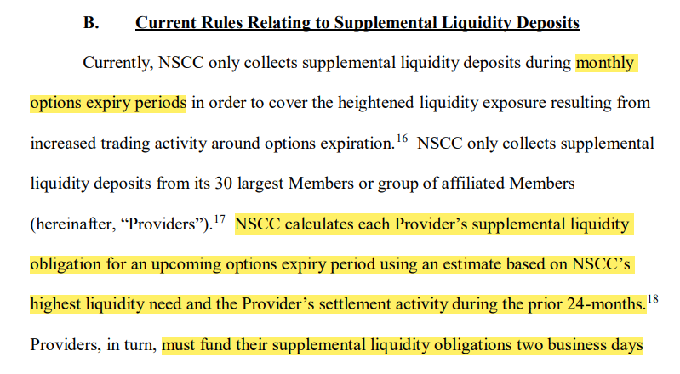
NSCC-002 Part 2; New Liquidity Requirements
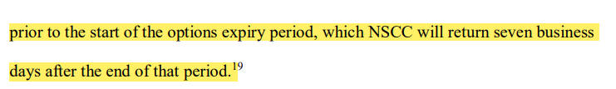
NSCC-002 Part 2; New Liquidity Requirements
The NSCC defined a period of grabbing liquidity and holding it to be 2 business days prior to monthly
expiration, and ending 7 days after monthly expiration. From the dates listed above, this gives you the
following time periods of liquidity deposits for monthly expirations:
Monthly Liquidity Deposit Given By Liquidity Deposit Returned To
Option Date Member To NSCC Member From NSCC
January 15 January 13 January 27
February 19 February 17 March 2
March 19 March 17 March 30
April 16 April 14 April 27
May 21 May 19 June 2
June 18 June 16 June 29
And if you remember from /u/dentisttft's posts, these periods all contain the T+21/T+35 dates of
January 25, February 24, March 25, April 26, May 25, and June 24. So it appears that,
as /u/dentisttftconcluded, that they struggle with liquidity during these time periods of FTD deliveries
and the price gets much greater upward momentum.
Going back to the images above of NSCC-002... notice that in the old rule that the amount of liquidity that
needed to be posted for monthly expirations was based on settlement activity of the prior 24
months. That's a lot of leeway on how much liquidity is needed per member as it was not checking real-
time data.
NOW... the NSCC is changing it to a daily calculation. It's no longer a one-and-done deal of the
monthly liquidity based on the prior 24 months. It is going to be based on a constant check of real-
time data. This can shift the total liquidity required from the previous rule up significantly, mainly
because it is no longer based on the prior 24 months of settlement activity.
2. T+21/T+35 Loop Turns Into A T+0 Death Spiral
Remember how shit went absolutely wild around March 10th? That was outside of a liquidity deposit
phase. And then, the price was tanked and brought down severely JUST BEFORE the next liquidity
deposit was required.
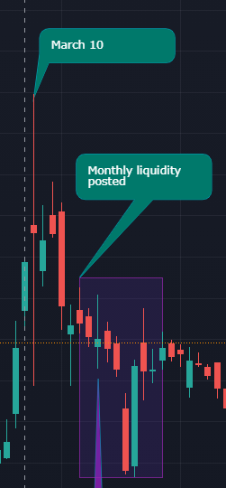
GME Price Action Prior To Next Liquidity Requirement
In fact, something curious is that the price has never been above $228 entering the next liquidity
posting date, and has never been above $300 during these liquidity dates. Hmmm? Margin call
price could be dangerously close. And with NSCC-002/801, it can absolutely screw the SHFs.
What does this all mean in the end? Well, it can turn the T+21/T+35 loop into a T+0 death spiral.
They used to have to post liquidity two days prior to the monthly options. But now, the NSCC has the
discretion to ask for MORE liquidity at ANY time based on daily movements of prices. The previous
liquidity posting was a one-and-done deal instead of a liquidity requirement that would constantly
update every day of the year. And if they fail these new liquidity checks? One. Hour. Margin calls.
Here's a figure based on /u/dentisttft's liquidity deposit phases identifying what could happen starting
Wednesday, June 23rd:
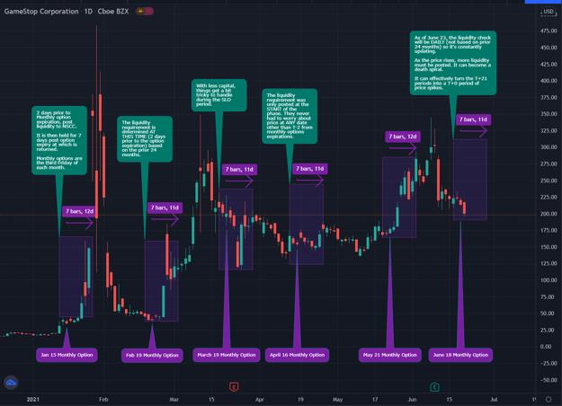
GME Price Action And Liquidity Deposit Phases
This could very well be why they are trying to obliterate the price at the moment.
The next FTD spike can cause the price to absolutely soar into a price range which requires more
liquidity, making it harder for them to suppress the price, and pushing GME more towards the margin
call price. Which then feeds on itself requiring more liquidity, and it continues on an absolute death
spiral.
Which can then lead to this:
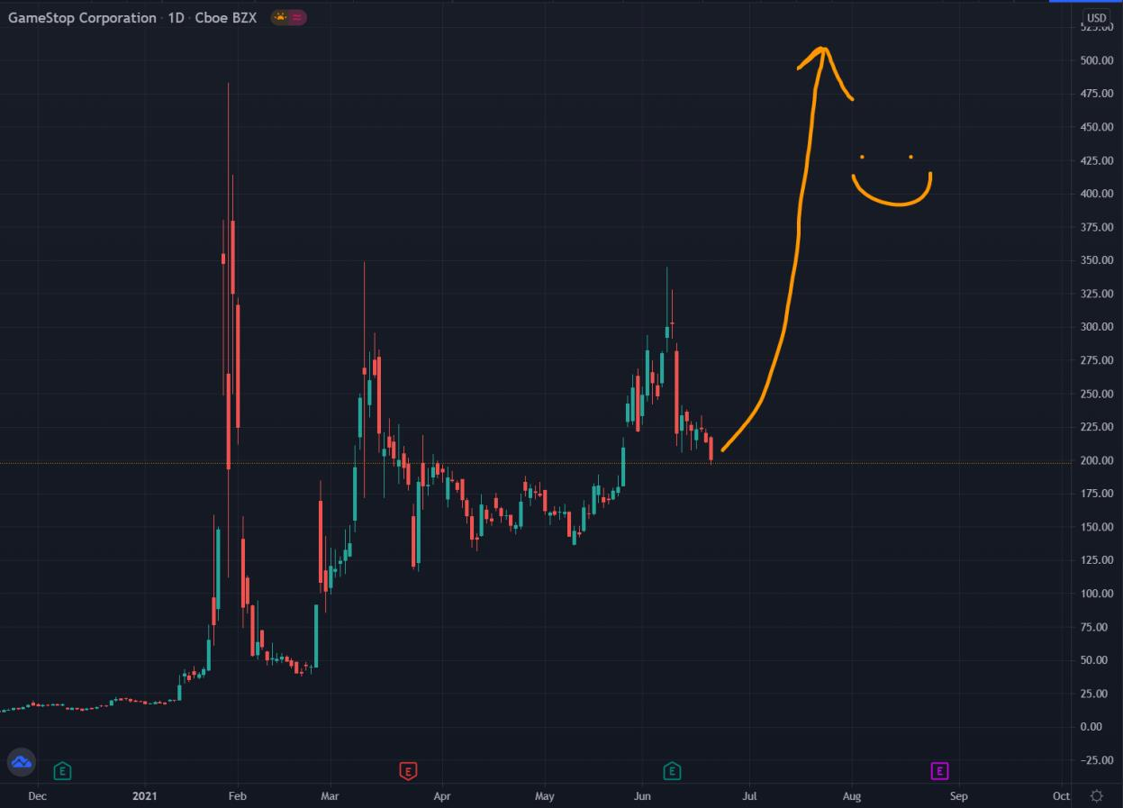
Happy GME TA
2. Urgency to Approve NSCC-002; Quarter End Of June 30th;
Meeting Between Biden, Powell, Yellen, Gensler
Guess what? The 2008 crash "started" around the end of Q3 with the collapse of Lehman Bros
on September 15, 2008. End of quarters are when the system gets really strained due to the
underlying plumbing of the markets and the necessity to pump balance sheets.
Banks’ “reporting” dates are known inflection points in the short-term funding markets and typically fall
at the end of the month, quarter, and of course the year. But periodically, the 15th of the month is also
a pressure point. - Source
Fast forward to when the Fed attempted to reverse QE. A year after performing QT (reverse of QE), the
repo market blew up to 10% interest on September 15, 2019 due to way way way too many loans that
had to be handled. You can see how strain on the markets starts to amplify around particular
dates of Quarter-ends and occasionally the 15th of months.
We're approaching the end of Q2 which is June 30th. Hm. Quarter end?! Sound familiar? 👀
The NSCC-002/801 is having accelerated effectiveness. There is huuuge urgency to get this passed for
margin requirements and margin calling members. Why would they be pushing this to get it out the
door? I think shits about to hit the fan. They NEED to protect themselves.
Something else to note is that Biden, Yellen, Gensler, and Powell all met for "Climate Change" discussions
today.
“The regulators reported that the financial system is in strong condition,” the White House said in a
readout of the meeting. - Source
That's the entire context of the quote. That the financial system is "in strong condition". What are
they actually doing at this meeting? Something similar to discussing letting X Y and Z fail just like they
discussed letting Lehman Bros fail in 2008?
The Jungle Beat Monday Post talked about this very briefly and it was something I latched onto
immediately. I remembered the meeting for 2008 but did not connect the dots to this meeting between
Biden, Powell, Yellen, and Gensler possibly being similar in scope.
Wild times we live in. But remember - don't fuckin' dance.
Back to Table of Contents
Things are shockingly similar to the February
24th and March 10th runup so far. Gamma
squeeze indicators from the previous
T+21/T+35 have returned. Their doom
approaches.
DD 👨‍🔬
0. Preface
I am not a financial advisor, and I do not provide financial advice! Everything within this post is my
opinion and observations. They should be taken with skepticism. So grab a crayon my friends! June has
started off absolutely wild!
TL;DR: Hedgies are close to meeting their doom. DOOOM.

I've been labeled as "Doomsayer" by my friends.
Actual TL;DR: June 1st has kicked off with the DTC, ICC, OCC auction and wind-down plans
officially being in place. This means it is OK to launch the rocket because those three entities are
now protected. We're seeing very similar price movements and gamma squeeze signals
compared to the previous T+35/T+21 runup that occurred from February 24th to March 10th.
This means that we could very well see another gamma squeeze of similar or greater magnitude
which would begin to go parabolic around June 9th.
Note: This does NOT mean that a gamma squeeze WILL be coming. This is data supporting the
fact that it COULD be coming. Do not take this as financial advice, and be aware that if you day
trade you could miss the rocket.
1. June Kicked Off A Few Things
Here's a list of things you might have missed (save for OCC-003) that are now in place as of June 1st.
Which further supports that the MOASS is getting close!
• JP Morgan opened MORE netting accounts.
o These are piggy banks for sucking up assets of defaulting members in the
auctions of the DTC, ICC, and OCC. I wonder who JP Morgan is going to
consume?
• DTC, ICC, and OCC wind-down and auction plans now all in place.
o OCC-003 was the final one to join. Welcome, OCC! All three entities are
finally ready for the bomb.
o In my opinion this means that the rocket is ready for takeoff because
these entities are now protected.
• ICC index swaption discounts started through ICC-014.
o Think of this as an index like SPY/QQQ/VIX/etc. that watches for the
potential defaults of others in the financial world.
o The base swaptions are just like options, they give you the right but not
the obligation to buy (or sell) insurance. But, this rule is for
the INDEX discounts - meaning it is a bundle of these swaptions among a
bunch of entities.
o The ICC must be preparing for members of the index to be going on the
brink of defaulting, or defaulting. From my interpretation, these
discounts give others a cheaper hedge against defaults, and potentially
get to scrape by instead of going under. This won't save the guys who are
in too deep, it just helps everyone else to remain afloat after this market
bomb goes off.
• "Trading halt" rule amendments were passed May 28th, and are therefore in effect as of
June 1st.
o The wording of these amendments are VERY interesting. And the timing
is VERY interesting. Take a look.
o They will allow halts "In the event of a series of quotes, orders, or
transactions at prices substantially unrelated to the current market
for the security or securities"
E.g. They are preparing for people to be placing sell orders
on securities/stocks that are WAY far away from the
current trading price. Sound familiar? Like if GME is
trading at $260 and a sell order comes in for $100k, $500k,
$1m, $10m, etc? Yeah. Very curious why they'd push this
amendment out.
Edit: This is most likely to have a slow burn upward in
price on the standard +/-10% within 5 minutes
trading halt. Don't worry about what has yet to
happen. Only time will tell how this plays out!
2. Similarities To The Previous T+21 T+35 Runup
It's quite amazing to look at everything right now and see the similarities. We already know that the
T+21 loop is confirmed. It's like poetry. GME hits a beat in a cyclical manner every 21 trading days, and it
is evidence that shorters are stuck in an endless dance. [Can we really look at T+21 and think that "they
have covered their short positions"...?]
If we can see patterns emerge from T+21, we can most likely see patterns emerge from T+21 and T+35.
And so far, the current T+21/T+35 looks shockingly similar to the previous T+21/T+35.
One similarity is the resurgence of gamma squeeze signals.
The amazing ape /u/yelyah2, and I'm sure many others, have been identifying signs that a gamma
squeeze could be coming:
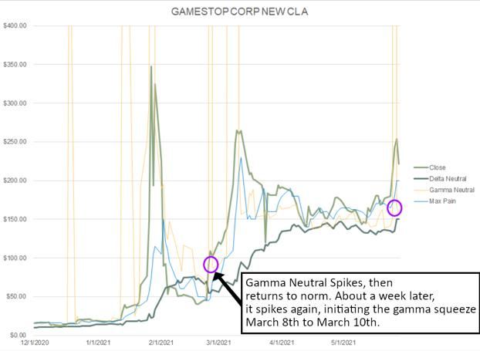
Figure 1: Gamma Neutral Values; From /u/yelyah2
The most important data point to keep an eye on here is the yellow that spikes up/down. This is the
"Gamma Neutral" value.
The gamma neutral price is the underlying price that creates a total market gamma of 0 across all
GME options (all expiration dates). It is often associated with high volatility, and sometimes
(especially in GME's case), it's associated with gamma squeezes. - /u/yelyah2
In other words, if you see Gamma Neutral spike up to the thousands and GME is currently trading in the
hundreds, that means a Gamma Squeeze could be coming. Because the price needs to shift up to that
amount in order to return gamma to 0 for a low-risk hedge. I'd definitely recommend reading their work
on their findings!
You'll see that in the first purple circle of Figure 1, Gamma Neutral spikes up on February 24th. Gamma
Neutral then slams back down a few days later because the pressure was killed off. About a week later,
March 5th, Gamma Neutral spikes again and remains high until the flash-crash of March 10th. Up until
the flash crash, GME went on an absolute run in price and was starting to go parabolic.
Take a look at the second purple circle of Figure 1. The same spike up/down over the course of a few
days occurred again starting May 25th. Oddly similar to February 24th's spike up/down, right? Both
brief anomalies initiated on T+21 dates.
Between March 10th and May 25th, Gamma Neutral hasn't spiked up at all, despite there being two
additional T+21 cycles between:
• March 25th (T+21)
• April 26th (T+21)
Huh. What could have changed this time on May 25th?
Enter T+21 and T+35. The mechanics aren't fully fleshed out for why T+35 happens, I mean it's all based
on patterns we see, but T+35 most likely applies to Net Capital. Net Capital being that the shorters must
adjust their short position debts after a timeframe of their debts being discovered, or risk going net
negative. This must be done in order to not default, because going net negative would trigger a margin
call.
These T+35's initiate from three major option dates:
1. January 15th, 2021 (--> February 24th)
2. April 16th, 2021 (--> May 24th)
3. July 16th, 2021 (--> August 23rd)
So, we're not looking at purely T+21 days, but a wombo-combo of T+35 and T+21 which could very well
be the reason gamma squeeze signals are flashing again. Per my theory, a T+35/T+21 occurred last
week, May 25th, due to April 16th options expirations. And the previous T+35/T+21 occurred on
February 24th.
COOL. So it appears that T+21/T+35 cycles can cause gamma squeezes due to the extra pressure on the
shorters, and that might be why we're seeing a resurgence of the Gamma Neutral squeeze indicator this
cycle. Oof, not a lot of data points, but hey. I like the patterns. 👀
Moving forward, let's take a look at the price movements over the past few days. Of note:
• The purple call-out boxes are pointing to T+21/T+35 cycles (Feb 24, May 25).
• The red call-out boxes are pointing to purely T+21 cycles (March 25, April 26).
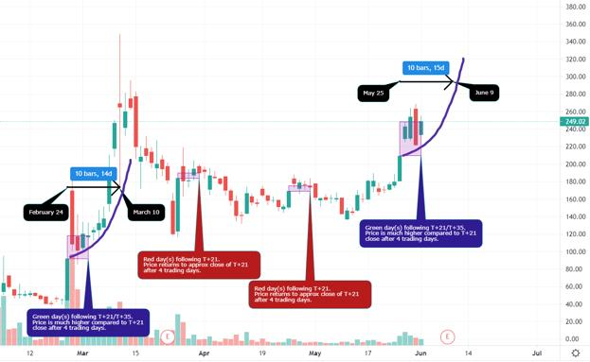
Figure 2: GME Price Activity; Similarities Between Feb 24 T+21/T+35 and May 25 T+21/T+35
Starting back at February 24th, all the way to the left of Figure 2, you'll see the purple callout box
pointing to a purple box around the actual prices of GME. The lower bound of the box starts at the close
price of February 24th, and the upper bound of the box ends at the close price of March 2nd, which is 4
trading days later. I used 4 trading days because, well, that's how many days we have seen since May
25th so far. I've applied this same method to all other T+21 dates and plotted their respective boxes.
This is a visual to show you the behavior of the price following T+21 and T+21/T+35 cycles, and the
differences between the two.
You'll notice how on the T+21 days between February 24th and May 25th (red callouts), that the price
was anchored around the same closing price of T+21 and not much upward pressure was applied.
Meanwhile, the T+21/T+35 cycles (purple callouts) have had breakaways from these prices and are
gaining much more momentum. The prices following T+21/T+35 have more support and are doing that
beautiful bull-flag pattern that TA apes love. Further supporting that we're in a potential runup to a
gamma squeeze in the near future.
Can't stop. Won't stop. GameStop.
The similarities of the price movement so far are quite hype, because this is on top of the resurgence of
the gamma squeeze indicators.
With all of the DTC, ICC, and OCC auction and wind-down plans being in effect as well as the other items
I identified in Section 1.... man. It seems too good to be true right now.
For fun, I plotted in blue ("10 bars, Nd") the gamma ramp timeframes in Figure 2. Check out when the
next parabolic move like March 10th could occur. June, frickin' 9th. Sound familiar? Shareholder
meeting? It's probably just coincidence, but damn. Good timing. Also haha 6/9. Nice.
Further possible support is this post by the amazing ape /u/isnisse. They have identified that a breakout
could be coming on June 10th. They've used a really clever approach to guesstimate the breakout.
Definitely take a look! Confirmation bias overloaded once I saw this.
One last thing to note before moving on is the number of consecutive green close days that have
followed May 25th. We have not seen that before, where there's a ton of support following T+21 or
T+21/T+35, even back for the February 24th cycle.
Are shorties losing their grip? One metric I was watching for the longest time was Deep ITM CALL
purchases, which could also signal that their DOOOM is near.
3. The Death of Deep ITM CALLs?
In my previous post, I was thinking that these Deep ITM CALLs were being used to satisfy FTDs. Now I'm
not entirely sure - it could be used for that purpose, certainly. But it could simply be that they were used
to delay the FTDs rather than satisfying them as people were predicting for the longest time. If that is
the case, then the shorties are most likely losing their grip, as shown by the increase of volumes in meme
stocks across the board. The <insert offensive word> is about to hit the fan.
I'm grabbing this figure from /u/broccaaa's post The Naked Shorting Scam which compares Deep ITM
CALL Volumes to FTDs:
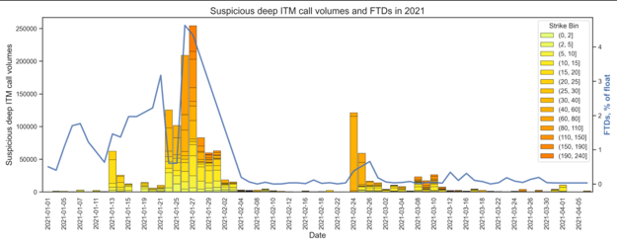
Figure 3: Deep ITM CALL Volumes Vs FTDs; From /u/broccaaa
When FTDs skyrocket, Deep ITM CALLs are eaten up. You see this occur extensively in January due to
the mini-squeeze that occurred from massive FOMO of retail around the world. And then a resurgence of
these Deep ITM CALL anomalies in the February 24th to March 10th runup due to more FTDs appearing.
Ever since March 10th, these Deep ITM CALL purchases have slowly decayed and died off.
User /u/Dan_Bren had been posting about these anomalies for weeks, and weeks, until suddenly - the
anomalies stopped. The only significant purchases that have been made since the Deep ITM CALLs died
off have been for Deep OTM CALLs and Deep ITM PUTs.
• Deep OTM CALLs were purchased. Possibly a big entity expecting the price to pop by
July 16th.
• Deep ITM PUTs were purchased as well (same link). We got a warning that they could be
used to flash crash the price on May 28th, and sure enough, it happened.
So what does this mean? The give-up on Deep ITM CALLs could be many things.
Perhaps there's no more liquidity to use them?
Maybe they came up with a better way to delay FTDs?
It could be too expensive and they can't delay FTDs any more?
Maybe, by some weird reason, DTC-005 is actually in effect and blocking this practice - which makes the
FTDs come to fruition these next few weeks?
The resurgence in meme stocks across the board makes it look like they're losing their grip and its
simply too expensive for them to delay it any more. The volume, in my eyes, is not shorts covering but
the volume is due to the FTDs beginning to pour out into the world.
The peddling of AMC could be that is their last and only option. To divide and conquer. Their best chance
now is to try to pull GME apes into AMC because, despite it being shorted heavily as well, it is a much
higher float and lower price. Therefore it would be easier to contain and take control of. They have to try
to push AMC because all their other efforts failed. That being said, when GME goes off, AMC, KOSS, and
other meme stocks will most likely squeeze as well. But - GME is the backbone, and only as long as GME
remains strong will every stock experience a squeeze.
The latest T+21/T+35 cycle is prepping a gamma squeeze, just like what we saw from February 24th to
March 10th. It's surprising how similar things are looking so far, especially in the price movement and
support staying in the $260s as of after hours of June 1st.
It's even scarier that the gamma squeeze, if it happens, would start to go parabolic exactly on June 9th.
Ryan Cohen - did you know? DID YOU?
Back to Table of Contents
Hank's Big Bang: Quant Apes Glitch the
Simulation
DD 👨‍🔬
********** I am not a financial advisor, this is not financial advice **********
Edit: Credit for the correlation tables to u/phalanxhydra
Edit 2: I am retarded. It's u/Ivorypetal.
Introduction
Apes, because of the sheer amount of information in this post and because I wanted to get it to you at the
beginning of this week because of earnings and the meeting, this post will not have the usual funny intro
and memes.
Usually, my DDs are done completely by me with maybe some inspiration from a few apes or a
section/link from an ape or two. This one is not that. This DD is an orgy. Apes, I have gathered an army.
A fucking army of quant apes. They have been gracious enough to team up and answer the questions
that I posed in my previous post and..... I am astonished at what they did. Seriously, I didn't expect this in
my wildest dreams. Quant apes, I am eternally grateful for what you've done and I know that this sub is
too. Again, this just shows how many extremely smart apes we have in this fight. This is going to be by
far my most data-driven DD of all time.
Many of you have probably seen the spoilers that I gave in my request for data that this DD would be
about using correlations, models, and data to get to an extremely high level of certainty that shorts have
indeed not covered by analyzing GME as compared to the other meme stocks and some other indicators
as well. This was inspired by the pretty obvious fact that they all have traded in very similar patterns
since around December. I also noticed that they all seemed to have some sort of FTD cycle component to
them as well. I really drew the line when all of these stocks started this upward momentum in the past
week - it was just too much of a coincidence for there not to be a relationship. A short squeeze is rare.
Stocks following the same trading pattern is weird. A stock squeezing two times in less than a year is
weird. A stock trading at over 4x it's book value consistently for months is weird. But 6 stocks doing all
of those things simultaneously is..... ASININE. Some might call it improbable, but I think we all know
what it is. This DD will use data, a shit ton of it, to give us the closest proof next to actually seeing HFs
positions that they have indeed not covered..... ENJOY
Roadmap
In this DD, I will discuss why the meme stock craze is not a just a bunch of retail traders pumping up
stocks. Instead, it is the product of the greatest shorting fail in the market of all time that was made
possible by easy money policies and apes' uncanny ability to buy and hold. Next, I will discuss the
statistical significance and origin of the FTD cycle. Finally, I will give you a random dump of DD at the
end of my thoughts.
Part 1: A data driven approach to the meme stock craze
A visualization of what you already knew
As many of you know from some of my previous posts, my thesis is that the “meme stocks” are all
related. This was based on observations that the charts looked similar from December to now in terms
of price action and volume. The quant apes did an excellent job of visualizing this. Below is a
visualization of the meme stocks compared to cryptos and boomer stocks for reference. The parameters
are volatility and volume.
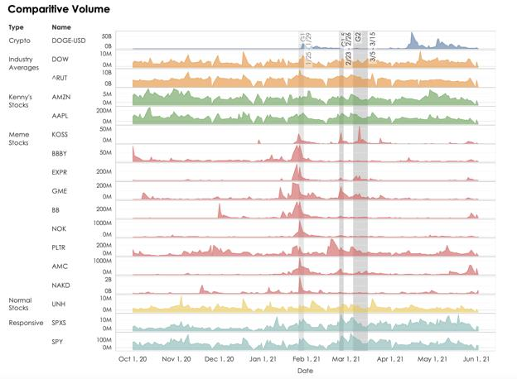
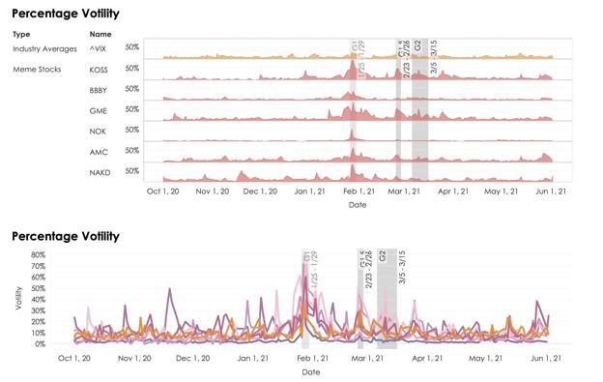
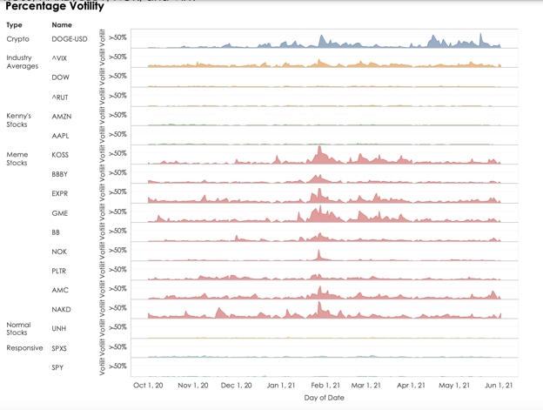
(Credit for above three charts to u/Ivorypetal)
A visualization of what you already assumed
This is a visualization of what we already know but haven't been able prove: the stocks are related.
Looks like there’s a relation, right? How can we be sure? If you took a college or high school statistics
course, you probably know that there are certain tests you can run to determine if inputs are correlated,
the degree of the correlation, the certainty, and the statistical significance. Below, the quant apes used a
statistical test (I won’t explain it because if you aren’t familiar with statistics it’ll take too long to explain,
but this is not a guess, it uses an equation to determine the level of correlation, so it is extremely
accurate) to determine the correlation of GME to other meme stocks and the VIX. I put GME in red
because it’s all we care about right now. The top is a comparison of these stocks entire data (i.e. all time),
while the bottom compares them in the last year:
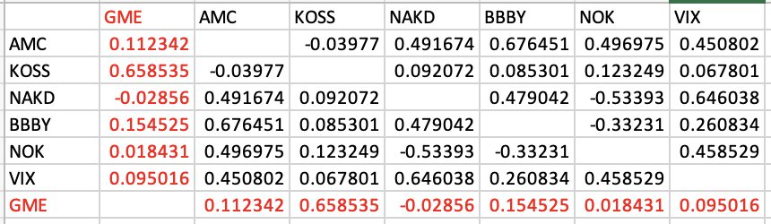
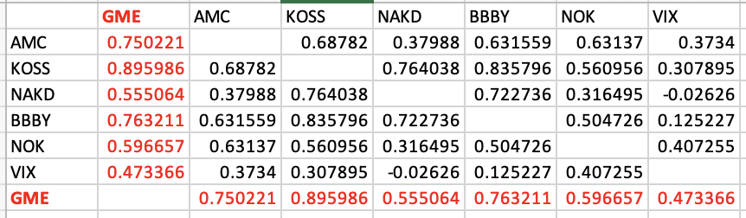
(Credit to u/phalanxhydra)
As you can see, the difference between all time and the last year is striking. The above decimals are
called correlation coefficients. They go up to 1 (which means they are identically correlated). Anything
above 0.7 is considered a strong correlation. As you can see all of them except for NAKD and NOK have a
strong correlation to GME. What really struck me was the VIX. Because the market usually goes down
when the VIX goes up, the fact that GME and the VIX have such a strong correlation in the past year is
extremely important for our thesis that HFs are actively acting against it.
OTC Data
The chart below takes the OTC data from FINRA and plots it for each of the meme stocks. Notice how
they all seem to follow a pattern of spiking every few weeks (FTD cycle) except for the blue one. The
blue one is not a meme stock, it's Apple. I used Apple as a reference security so you can contrast how
weird this is. Sadly, we don't have FINRA data before 2019, so it's difficult to analyze this in terms of
when it started, but you can definitely see a related pattern of abnormality:
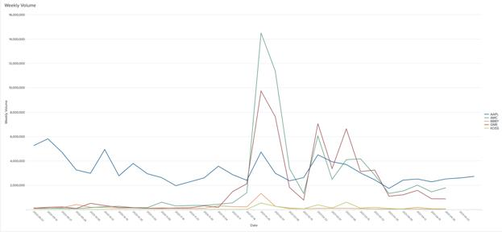
(Credit to all of the quant apes who made this customizable program that allowed me to do this)
How common are squeezes?
Squeezes are rare. Extremely rare. Whether you think the January price run up was a short squeeze, a
gamma squeeze, or just a big price increase does not matter because, in asking the quant apes to find the
exact number of short squeezes that have occurred in the stock market, I gave them VERY broad
parameters. The parameters I gave them were: any stock that has doubled in price within a week.
Because of this, this is undoubtedly a gross overestimate of the number of short squeezes in the history
of the market (i.e. some little known penny stock getting FDA approval and going 4x overnight). The
numbers that they found show us just how rare a short squeeze is, and remember, even this is an
overestimate, so they’re probably even rarer. The quant apes used the major exchanges NYSE, NASDAQ,
and AMEX. Here are the results:
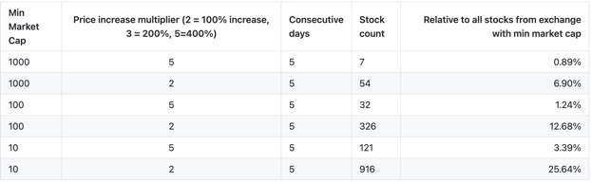
(Credit to u/jyzaya)
If you can't understand that data, here's the point: they are rare, even with parameters that purposefully
overestimate it. They are so rare that you could call them an anomaly because that's what they are.
Remember that’s a purposeful overestimate that allows small stocks getting good news, IPOs, etc. to be
considered. So yes, short squeezes are rare. Multiple squeezes following the same pattern and all
squeezing at the exact same time? Some might call it improbable, but we all know what we call it.
My take
So, you’ve seen the data. These stocks are correlated. Does a correlation mean that there is some
orchestration going on or that something is forcing them to move in concert? No. It means that they
typically move in the same direction, reason unknown. A statistical test can’t tell us the reason for the
correlation, it can just tell us the correlation. I think I know the reason.
What I think many people, especially the media, take for granted is just how weird January was. As you
now know from above, short squeezes are rare. Stocks correlating is weird. Stocks correlating for
months is weird. Stocks squeezing at the same time is weird. Stocks doing all of those things at the same
time is unheard of. The weird thing about January is that brokers, all of them, simultaneously restricted
the buying of all of these stocks. Because liquidity works both ways (buy and sell), if they really had
liquidity issues, they would’ve stopped buying and selling. Also, does it make any sense that every single
broker would have liquidity issues at the exact same time during the times of the lowest interest rates
ever and an easing of banking restrictions? No. None of that makes sense. My thesis is that all of these
stocks are related and the data backs that up. I believe that the brokerages saw that these stocks posed a
SYSTEMIC risk because of how exposed major market makers and HFs were on the short side. Why else
would they all simultaneously ban only buying?
To add even further to that, many brokerages have banned the shorting of these stocks (months after
the squeeze). Even more is all of the shill activity of people messaging us saying “I’ll pay you to write
something bad about GME.” Moreover, the brokerages must have seen that retail, and now the rest of the
market, was piling on buying orders and that eventually, some of the most important institutions could
go bankrupt and cause an economic crisis. So what did they do? They restricted all buying. Even if every
single ape hodled, the price would still be able to go down significantly due to shorting and institutional
selling. So yes, they forced it to go down. Now, what was that systemic risk I was talking about? What
exactly did the HFs do? As most of you know, I was one of the apes that started the talk of FTD cycles and
found many of the rules behind it. The FTD cycle has been the only thing that we’ve been able to
consistently predict (well that and the media being retarded but I digress). IMO, the FTD cycle is our clue
into what the HFs did to cause a systemic problem. The FTD cycle has been increasing exponentially,
which leads me to believe that the systemic risk has only gotten worse, and I think I’ve discovered it’s
origins…
PART 2: The statistical significance and origins of the FTD
cycle
Now that I’ve left you with that cliff hanger and probably a half chub, it’s time to take an extremely in-
depth dive into the FTD cycle. First, I will be demonstrating the statistical significance of the FTD cycle,
so that we know it’s not just a fluke. Next, I will discuss the origins of the FTD cycle. Finally, I will discuss
what I think it all means.
First, let's start with a brief summary and update on the FTD cycle. The FTD cycle is the idea that
because of SEC regulations requiring market makers to cover FTDs within 35 calendar days, there is a
predictable increase in price and volume every 21ish trading days or 35 calendar days. So far, it has
continued to repeat itself. The idea is that shorts are in so deep that they are doing the bare minimum to
cover and continue to dig themselves in a deeper hole by kicking the can down the road. It is currently
increasing exponentially, which indicates that it is getting more and more expensive for shorts to stay in
the game.
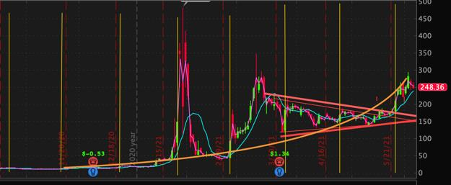
Orange line represents FTD cycle increases each month. Yellow lines are FTD cycles. Disregard the red lines, those were my trend
lines before we broke out
SI by the charts
Below is a chart that the quant apes gathered from Ortex showing the SI of the meme stocks over time.
Many of you will say that this is inaccurate because the real SI is hidden. While we have many instances
of that being true, this is the best concrete data that we can gather (much better than Fintel and FINRA),
so it’s what we must use to avoid speculation. So, yes these numbers are probably an understatement
but that’s a good thing because we do not want to speculate. If we can find significant results on
incomplete data, our thesis is strengthened:
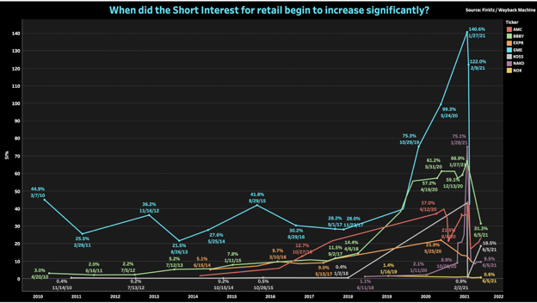
(Credit to u/orangecatmasterrace)
I noticed some very interesting things from this chart. First, I noticed that the SI of most of the meme
stocks markedly increased in mid 2019. GME had an exceptional increase (I think because of their
issuance of bonds, shorts saw that as a debt death sentence). There was also a slight, but noticeable, rise
in SI of most of these in mid 2016 as well. Hmmmmmm. My original thesis was that they were all heavily
shorted after the covid crash because HFs predicted a bad economy and the destruction of brick and
mortars, so they used the low interest rate and low liquidity environment to their advantage. That is still
probably true as I bet they did it with naked shorts, but this chart made me think even more. What
happened before Covid that could’ve led to these SI increases.
Friend of the shorts: The US economy
The first thing I did was get a chart of short volume data in the stock market over time to get the big
picture:
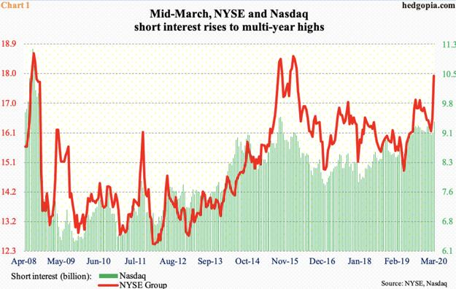
As you can see SI has increased markedly in 2015 and 2019. So that got me thinking, there must be some
kind of law, some correlation with FED policy, or some kind of macroeconomic happening that led to
this. So next, I looked at the interest rates for interbank lending:
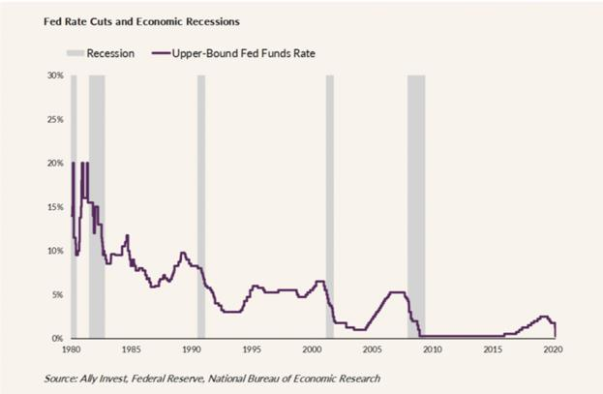
This is not mortgage interest rate, this is federal funds interest rate, which is essentially the interbank
interest rate for excess lending. As you can see it’s been insanely low since the 1990’s, but particularly
low as of recently. Next, I looked at the balance sheet of the FED. This essentially shows the Fed's buying
of assets over time.
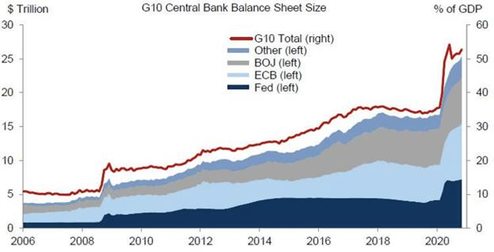
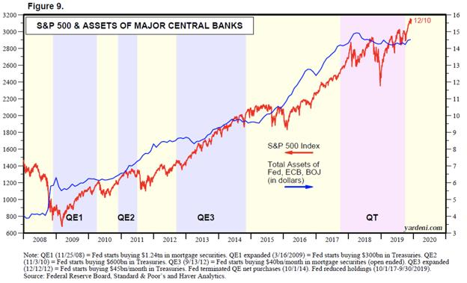
The above graph is especially striking. It shows the FED's balance sheet is increasing proportionately
with the SP500. The FED's Quantitative easing policies have been extremely aggressive since 2008. QE is
where the FED purposefully stimulates the economy by buying assets like bonds. This was necessary
after 2008 and the FED kept it going for a while then started tightening (QT). However, and this chart
doesn't show it, the FED had to parabolically increase its QE policies duirng covid. You know what else
parabolically increased? Yep, the stock market.
The statistical significance of the FTD cycle
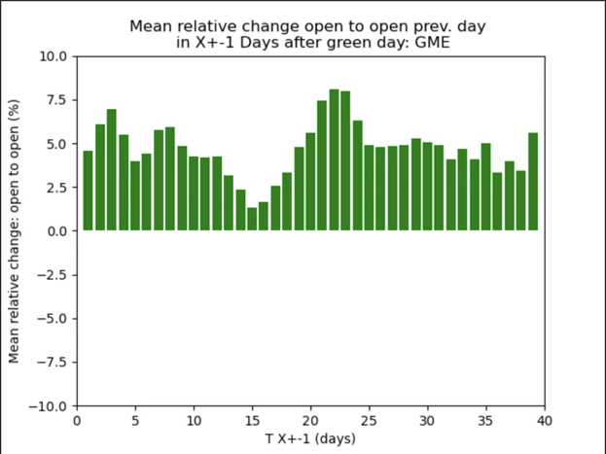
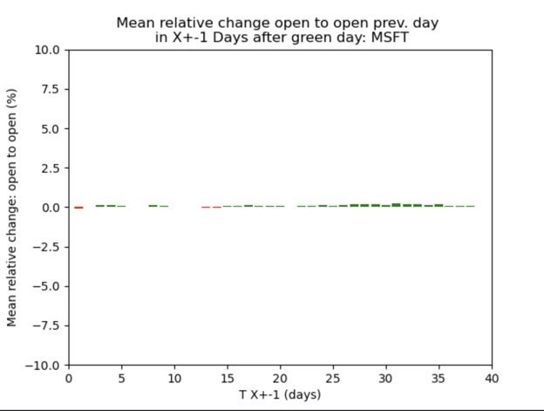
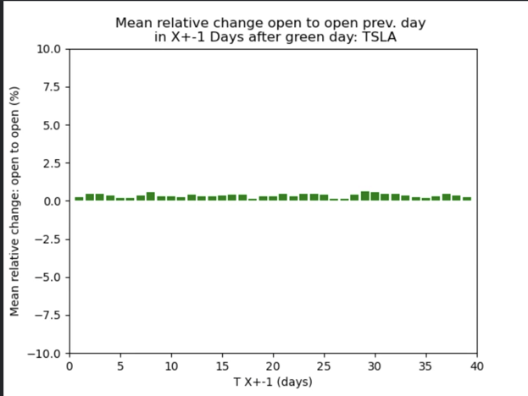
(User wished to remain anonymous for this)
The above charts show GME's FTD cycle increases after a certain number of days. I put TSLA and MSFT
in there so that you could see how abnormal GME is. Even compared to a volatile stock like TSLA, GME
has a way more recognizable pattern, which gives us further statistical evidence of the FTD cycle. Also,
note that there were many other users in different posts on this sub who found the FTD cycle
statistically significant, this is another view to add to the body of work. Below shows the short interest of
the meme stocks in relation to each other, so you can see when they started and how they've increased
together:
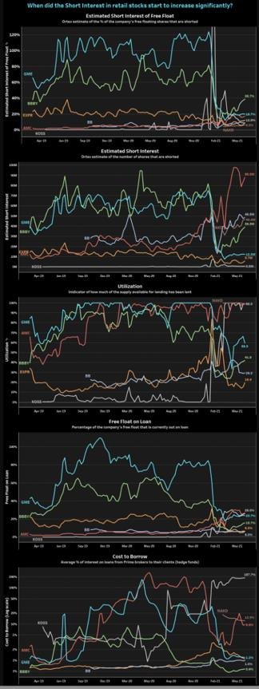
(credit to u/orangecatmasterrace)
Keep the above chart in mind while reading below.
The takeaway:
We are in an EXTREMELY easy lending environment. Rates are dirt cheap. The FED is buying up assets,
which is pushing up the prices of literally all assets. The market is flush with liquid assets, so much so
that the FED was trying to slow it down. This makes the perfect storm for a short-friendly environment.
We were also in the longest and biggest bull market run of all time in 2010's, so it would make sense for
it to come to an end soon - that's where shorts really make a killing.
What I think happened is that we saw the longest bull market of all time in the 2010 decade. HFs
realized that this bull market was propped up on the FED’s massive balance sheet and that there would
need to be more economic tightening soon and/or a correction. Anticipating an end to the bull market,
they initiated a giant short campaign in 2019 with the aforementioned meme stocks and probably tons
of others (the meme stocks are just the ones that retail investors took interest in). Once Covid hit, their
campaign was successful, but they wanted more. They wanted to hit the bankruptcy jackpot, so they
turned it up with the naked shorts, which is why the data doesn’t show that, in an attempt to put brick
and mortars out of business.
Instead, the FED accelerated its easy money policies and the economy had one of the quickest recoveries
of all time. This is why I think we started seeing the FTD cycle in late 2020 - it was a result of their failed
mega short during covid. This alone would’ve made them lose money but they've run into roadblocks
like this before so it's not what caused the squeeze and mania. What caused that was the fact that apes
literally buy and hold but never sell. This essentially created a giant wall that wouldn't allow the HFs to
short down out of their positions and got them into this mess. Then some retail investors caught wind of
it and bought into some of their most shorted stocks, which is why we saw what happened in January.
They are still in that hole because the brokers’ pausing of buying didn’t solve the problem, it just delayed
it. That’s why we see the FTD cycle exponentially increasing. This economic environment has been
brewing for this for a long time, and it would have continued if not for reddit (mainly DFV). I mean how
crazy is it that GME’s SI was over 100% for so long and no one noticed?
I am convinced that this would not have been able to continue to happen if apes didn't hold. That's why
this was all able to happen. It's because there has never been a phenomena in the market where a
significant portion of investors in a stock will hold it no matter what the market conditions are. So when
shorts started aggressively shorting and things turned south because of the FED's recovery policies,
retail's refusal to sell just added insult to injury and is why we are in this position now.
(Please note that the above data I only actually displayed a fraction of the quant apes' data. They gave
me an amazing amount. I used some of it to inform my/guide myself and displayed charts that went well
with my DD, so believe their work is even more in-depth than this post portrays)
Part 3: DD Drop
Alright apes, the above was a mouthful, but wow aren’t our quant apes amazing! Now that you’ve read
all of that, I am going to do another one of my DD drops on some random theories, updates, etc.
Everyone remember what happened with Archegos? That was a real funny one wasn’t it? Bill Hwang
plead guilty to insider trading, so he had to operate a family office. The man lost $20 billion in the span
of 2 days, now that’s a level of yolo retardation we should all strive for. One of the companies that
Hwang invested in was Discovery, here’s it’s chart:
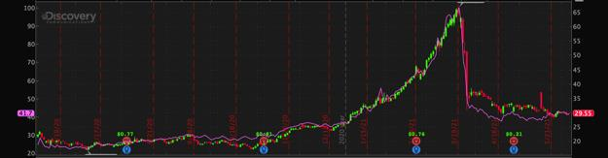
See that purple line? I bet you probably think that’s VWAP or a SMA line, right? NOPE. That’s VIAC
(Viacom CBS), one of the other companies he bet big on. Hwang used an instrument called total return
swaps, which basically allow you to “swap” the delta of one baseline security for another. Here’s an
example: a total return swap of Apple and SPY. You get the returns of APPL. If AAPL outperforms SPY,
you make money, but if not, you owe them money. That was all a huge oversimplification but essentially,
it allows you to have exposure to a company without owning it (derivative). That above chart was just a
1 year chart, but essentially, Hwang applied so much leverage to these companies through these swaps
that they were trading at double their fair market price.
This hypothesis is backed by no data whatsoever and is really just a thought experiment. Based on the
fact that meme stocks correlate (as shown above), what if HFs are using some type of swap on them? It
would make sense given the extremely low interest rates. It would make even more sense given the
negative beta of GME (i.e. SPY would be the reference security). Perhaps they use total return swaps or
another instrument to cover or to add more pressure? Idk. Just a thought.
Another hypothesis: could this all be the work of an algo? I mean, there's no more observing the
similarities, we now know they are statistically significant and related. IMO, it's impossible for human
traders to create this pattern – it’s just too precise and based on too much volume, so the options are
either they shorted all of these at the exact same time and are being forced to cover at the exact same
time (FTD cycle), an algo is doing that for them, or some algo is orchestrating all of this. I find that
unlikely because of the difficulty and obvious market manipulation charge they'd get but we have to
consider it! Again, just another thought, not much else to it.
The Midday Spikes: An Answer
Apes, we might have an answer to the midday volume spike phenomena. If you don’t know what I’m
talking about, see my other post. My hypothesis was that these midday spikes were HFs covering to
satisfy some kind of requirement or to avoid some kind of FTD cycle. I had no evidence for the cause, I
just had tons of observations for the occurrence. Let tell you though, if there’s one thing I know, it’s that
it’s not retail. Whatever is behind the midday spikes is a single entity. It is impossible for a bunch of
unorganized people to consistently buy a stock in the same minute interval in mass. That is a single
entity doing that and I think whoever it is is our enemy. A beautiful ape by the name
of u/KFC_justturned me on to the idea that it may be to comply with net negative rules. I scoured the
interwebs and found this on NASDAQ:
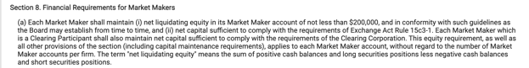
Notice that it also talks about clearing corporation requirements, which adds another elements into the
mix. Though I can’t find any information about exact requirements in terms of liquidity/numbers, I think
that this is pretty definitive proof of the reasons for the midday spikes. Essentially, it seems as though
these midday spikes are some fund covering in order to "maintain net capital sufficient to comply with
the requirements of the Clearing Corporation." Also, the final sentence explains why they need to cover
(i.e. to remain positive).
Earnings and 6/9
A lot of you are probably extremely excited for earnings and the annual meeting on 6/9. I am too.
However, I wanted to make this to tell you to not get your hopes up too much and to not be surprised if
it doesn’t go our way. What I will say is, I am confident that we will see a dildo candle one way or
another. For earnings, remember that last quarter the earnings were not even bad and the stock had a
GIANT red dildo candle. Unless earnings are absolutely spectacular, I could see HFs using it as a way to
put negative momentum on the stock (remember, it's all about the narrative). Now, earnings could be
spectacular. GME has gotten so much more attention this past quarter and I know that apes have been
feverishly shopping there, so we do have hope.
As far as the annual meeting I have absolutely no clue what to expect. However, like earnings, I expect
another dildo one way or another. If you remember last earnings, we all thought that the
guidance/conference call is what would put us over the edge. Instead, it was barebones minimum, and
we succumbed to the HFs earnings downward momentum. I expect this to be different. An annual
meeting is different from an earnings call and definitely warrants more speaking, more guidance, and
more detail. If GME was going to announce some blockbuster move, it would be during this because,
assuming they know about the massive short interest, that gives them plausible deniability against
market manipulation charges. Some important topics we could hear about are: Ryan Cohen speaking in
general, a new CEO, crypto/NFT, acquisitions, digital transformation / direction, and, most importantly,
the voting results. Is there a guarantee that these things will be discussed? No. Do I expect many of them
to be discussed? Yes. Similar to earnings, we could get great news and see a giant red dildo candle.
Remember, expect anything. If we get more shorting on positive news, it just keeps proving we are right.
As for my thoughts on when we moon, I personally don’t think we’ll moon here almost no matter what. I
think that it will be overall good and that we will see a very significant jump, but instead of that being
the MOASS, I think it will be what starts the MOASS. The only thing we’ve been able to predict has been
FTD cycles so far. The MOASS will come when a HF gets margin called and we just can’t predict the exact
time for that. So, I believe that if we see a big jump next week, the MOASS should be coming in the near
future but will nevertheless be unpredictable.
Clarification of my statements about retail buying
In one of my past posts, I said something along the lines of “retail is tapped out.” Thankfully, another
user made a post disagreeing with that and it got tons of replies of apes saying things like “I have tripled
my position in the past month.” If you haven’t seen that post, I’d look at it, the responses are amazing.
With that in mind, I wanted to clarify what I said about that. What I meant in that post is that retail is not
responsible for the mass, synchronized buying that we’ve seen in the past week or so, I think that is HFs
being forced to cover. Retail, instead, has been holding like champs and steadily buying. IMO it’s pretty
hard to believe that retail just randomly decided to buy every stock that squeezed in January at the same
time. Instead, I think it’s something much bigger but apes’ ability to hold is why it’s able to happen.
However, I do think that once we start squeezing again, it will bring in a new wave of retail that formerly
wasn’t in just like January, so we still do have gas in the tank (or ions in the battery if you drive electric).
Big Thanks to the Quant Apes
I can't tell you how seriously amazing the quant apes are. They deserve all of the credit in the entire
world and they are one of the most valuable parts of this sub.
Here is a list of some of the quants who helped with this post (this is not exhaustive as some wanted to
remain anonymous)
u/orangecatmasterrace
u/spambot9k
u/rubberbootsinmotion
u/Ivorypetal
u/creativelord
u/collegeneral
u/xpurplexamyx
u/jyzaya
u/epk-lys
u/head4headsup
u/squirrel_of_fortune (he made a great DD as well and I would encourage you to check that out to see
another perspective with a very interesting, advanced method)
u/sudoshu (Special thanks to him as he was the organizer of the group. If you are a quant ape, he said to
message him if you are interested in being in the group, but serious inquiries only).
Mods: many of these users do not have the karma requirements to comment on posts. If you could
somehow waive that requirement for the listed users, I think it would really benefit the sub because the
amount of knowledge that these apes possess is amazing. They put so much time into this and gathered
so much data (I literally couldn't even show close to all of it) and I believe that they will be integral to
the continued success of this sub.
Finally, the quant apes have created a website: https://www.superstonkquant.org/
They are still currently working on the mechanics of it but I encourage you to monitor it in the future
because I have witnessed first hand what they are capable of and it is nothing short of amazing.
Conclusion
Alright apes, that was very long but I appreciate you for reading. This sub keeps doing a great job of
pumping out DD and I think we will be rewarded for it in the very near future. I am going to take a break
from making DDs because it is really time consuming and can be extremely tiring, but I will still be
looking at this sub, commenting, and possibly making short posts. As always,
Stay strong, apes.
********** I am not a financial advisor, this is not financial advice **********
Back to Table of Contents
The naked shorting scam in numbers: AI
detection of 140M hidden FTDs, up to 400M
naked shorts in married puts and massive dark
pool activity by Shitadel and the shorts
DD 👨‍🔬
Edit: I made a new post describing how I trained the binary classifier (AI) used in this post.
This could be it. This could be the whole scam.
TLDR: HODL. Simple as that. HODL and the shorts have no way to escape. They just writhe around in
desperation as FTDs escalate, their options expire and New DTCC rulings approach. To support this
belief I:
• Built an AI to detect Deep ITM calls used to create naked shares. 140M naked
shares produced this way since Jan. Deep ITM call covering appears to be their last resort
of illegal desperation. It's so easy to spot.
• Investigated married put naked shorting. At the Jan mini-squeeze put open interest went
wild and aligns with the creation of millions of naked shares with married put trades. Put
volumes appear to be sustained at higher levels to keep rolling over FTDs. Up to 400M
naked shares created in total.
• Looked through all 13F filings for funds with large GME positions (long/short). We have a
clear idea of who is on which side of this battle and what a true idiot short position looks
like (hint: Melvin).
• Gathered all Dark Pool trading data from FINRA and show massive changes in trade
behaviour since Jan. Huge increases in shares traded, but each trade is of few shares. And
the key players? Known short funds. Supportive evidence for naked short trades and
suppression of retail buy pressure.
I encourage you to read the post and take a look at the data so you can understand it for yourself.
Correct me if I'm wrong somewhere. My suggestions? HODL with patience. Take a break from ticker
watching. Take a walk outside. The shorts cannot escape 🚀🚀🚀🚀🚀
Note: this is not financial advice. I am not a cat. I read gathered some data, made some figures and tried to understand them. Any number of my
interpretations could be flawed and wrong. Do your own research, make your own mind up.
Introduction
In this post I build an AI to detect suspicious Deep ITM Calls volumes used to hide FTDs. Take a look at
historical options data to show recent fuckery in the options consistent with naked shorting tricks. And
then compare these trends with Dark Pool trading volumes by known short funds.
The post will be broken down into the following sections:
1. An AI to detect Deep ITM calls used to hide FTDs
2. A recap of the major short funds and their recent positions
3. A recap of naked short selling and the married put
4. Options fuckery consistent with naked shorting and the married put
5. Dark Pool matters
6. Conclusions
The motivation for the work was to try and test a number of predictions I made in my first post on the
naked shorting scam and the married put trade.
These are the main ideas I wanted to test or at least find additional data to support or disprove them:
• short interest is manipulated through naked shorting
• the vast majority of options (both puts and calls) might be due to naked short selling
• short shares are 'washed' and able to be dumped on the market even during SSR
• the large number of way out of the money calls seen recently are actually part of a naked
short trick
• increased trades in OTC / Dark Pools are due to naked shorting and price manipulation
I've gathered a lot of data to better understand these questions. I believe that some of the data is now
conclusive. Other areas more supportive. But the big message is that shorts have no way out and never
had a chance to cover 🚀🚀🚀🚀🚀🚀🚀🚀🚀🚀
An AI to detect Deep ITM calls used to hide FTDs
When a share is sold without being owned or borrowed (located) it is sold naked, a "naked short". This
can happen as part of normal market activity by market makers and I've described this process and how
it can be abused in a previous post. When this occurs the SEC has clear guidelines on how long the seller
has to find a share and deliver it to the buyer. If a share is not located in time it must be reported as a
Fail to Deliver (FTD). Funds that have FTDs outstanding are required to resolve the position within a
given timeframe and are restricted from selling short until then. I won't go into all the details on this but
point you towards the God Tier DD that covers this.
One way that a naked short seller can 'resolve' their FTDs without actually covering is through options
fuckery. Deep in-the-money (ITM) calls can be bought and exercised immediately to acquire the shares
and close the FTDs. The SEC published a paper on this ILLEAGAL practice.
Other great DD has been posted showing when Deep ITM volumes have been used to cover FTDs.
I wanted to train a machine learning algorithm (often called an AI) that could automatically identify this
illegal fuckery and point us towards what exactly has been going on with GME this last year and
particularly since Jan 2021. I won't go into the full details here. I've made a separate post describing all
the details of the classifier.
• End of day options data for all strike prices between Jan 1st 2020 and April 6th 2021 was
collected
• I manually labelled more than 10,000 rows of data from mid-Jan to mid-Feb for
suspicious volumes likely due to FTD hiding
• Labelled data was used to train different classifiers (AIs) reserving 30% of the data for
testing
• The best classifier (BalancedBagging-Adaboost) has an accuracy score of 91%
• I used the model to identify all Deep ITM call options fuckery in the last year
THE AI FOUND EVIDENCE FOR MORE THEN 140 MILLION FTDs BEING HIDDEN SINCE JANUARY!!!
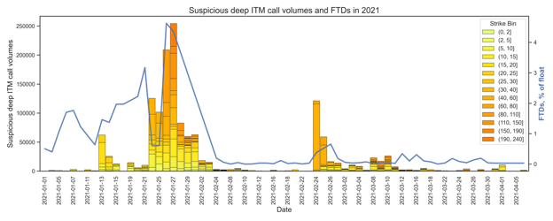
AI detection of option volumes used to hide FTDs and FTD values since January.
The above figure shows all the suspicious Deep ITM call volumes since January as coloured bars. The
colour scheme shows the different strike prices that were used for the trade. FTDs as % of float are
drawn on top in the blue line.
As FTDs were spiking and the situation became more and more unsustainable for the shorts towards the
end of Jan ILLEAGAL Deep ITM options purchasing was used to naked short and cover FTDs. Smaller
increases in Deep ITM volumes also occurred just before FTD spikes at the end of Feb and mid-Feb.
On Jan 27th 25 MILLION shares were magically acquired using this trick. 140 MILLION in total since Jan
1st.
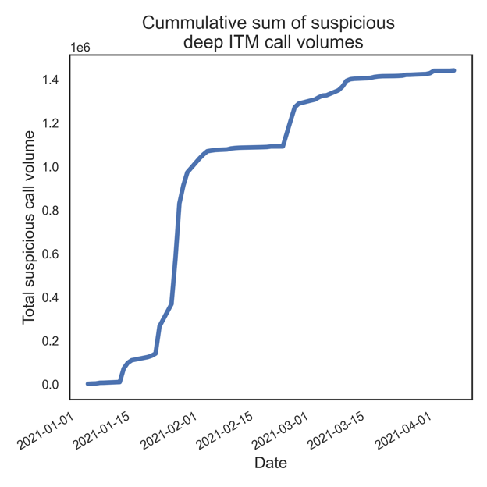
Running total of suspicious call volumes since Jan 1st. 140 million as of April 6th.
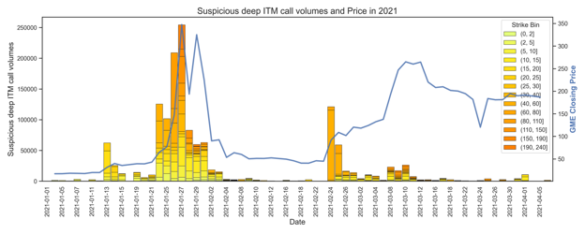
AI detection of option volumes used to hide FTDs and GME price since January.
Here we see that suspicious Deep ITM call volumes often precede big price increases. This suggests that
this illegal trick is used as a last resort. It's so easy to see even by eye when looking at the options chains.
When shorts get desperate they go to the deep calls.
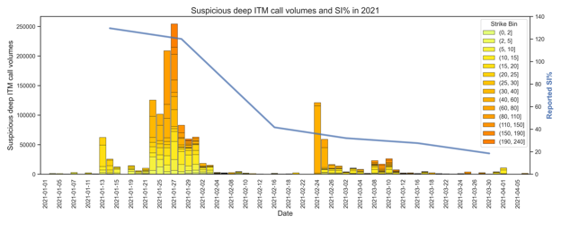
AI detection of option volumes used to hide FTDs and Short Interest (SI%) since January.
We see that Short Interest (SI%) decreased massively after all of the suspicious call option activity in
late Jan. As well as getting the FTDs under control the suspicious Deep ITM call volumes might have
been used to close legitimately borrowed shares to hide the true SI%.
With all the hype and attention the shorts knew they were completely fucked if they couldn't get
everyone to believe it was over. But as we've seen after the lows of Feb this ride is far from over.
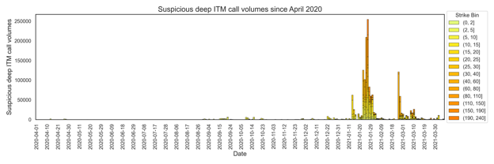
AI detection of option volumes used to hide FTDs and Short Interest (SI%) since April 2020.
Finally, if we look back over the past year very few suspicious Deep ITM call volumes were occurring.
This changed in January 2021 as the FTDs started to get out of control and a huge amount of hype
followed the price rises. This again makes me believe that the suspicious Deep ITM call volumes are a
sign of desperation from the shorts.
Speculation alert: Deep ITM calls are bought in times of desperation by the shorts when FTDs, price
and/or SI% are getting out of control. At the end of Jan more than 100 million naked short shares were
created this way to hide FTDs, hammer down price and hide SI%. Through Feb and up until April
another 40 million naked short shares were created this way when the shorts began to lose control of
their hidden positions.
A recap of the major short funds and their recent positions
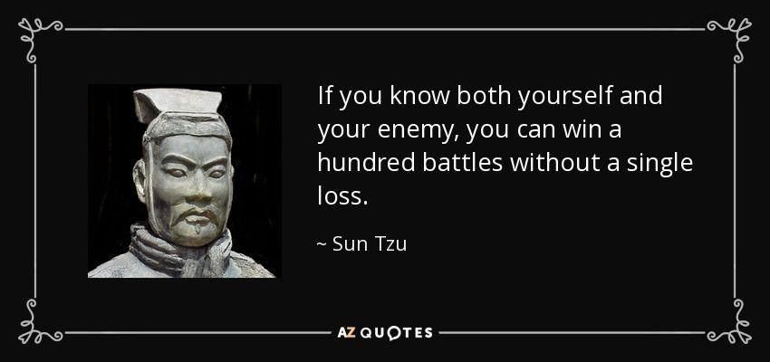
Regulation SHO stocks with large, unsettled trades often exhibit a similar characteristic: “short selling”
hedge funds with significant put holdings in 13F filings.
MARRIED PUTS, REVERSE CONVERSIONS AND ABUSE OF THE OPTIONS MARKET MAKER EXCEPTION
ON THE CHICAGO STOCK EXCHANGE
John W Welborn, EconomistThe Haverford Group October 9, 2007
In my earlier post The naked shorting scam revealed one thing that struck me was coming across the
above quote. So I've gone though all the latest 13F filings that contain GME on whalewisdom.com to get a
clearer picture of the enemy. Note: the last 13F filings were made on December 31st 2020.
First a reminder of the known biggest GME shorting losers:
• Melvin Capital suffered a 49% loss in the 1st-quarter
• Hedge Fund Maplelane lost 45% on Gamestop
So what does a massive short GME position look like in 13F filings?
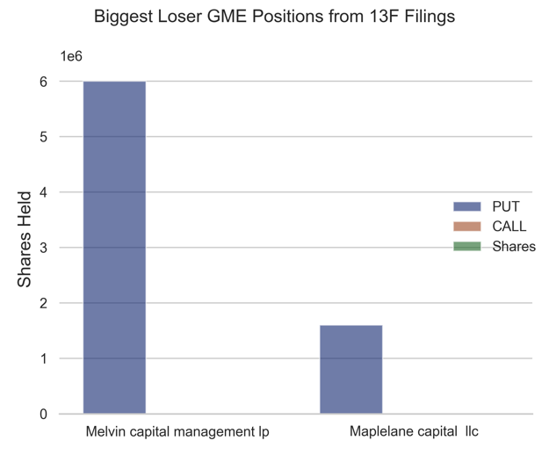
GME positions from 13F filings for the biggest known losers in GME shorting
That's a lot of puts without any GME shares or calls! Melvin had 6 million shares in puts and Maplelane
close to 2 million. Depending on where you look on whalewisdom Maplelane either has no calls or about
500k shares in calls but never any real shares. For now let's assume Maplelane is all in on puts.
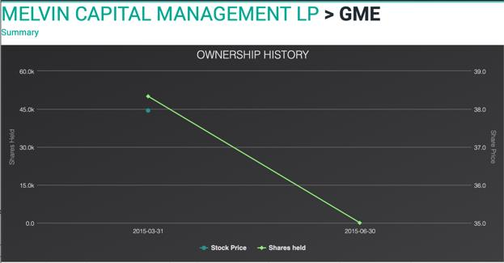
Melvin hasn't held any GME shares since 2015.
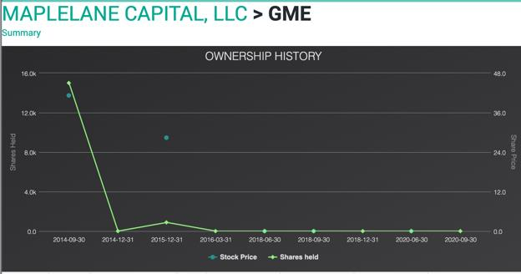
Maplelane hasn't held any GME shares since 2014.
So big short losers have:
• No shares in GME
• Large put positions in 13F filings (either exclusively puts or the majority of their position)
What do other funds report for their GME positions?
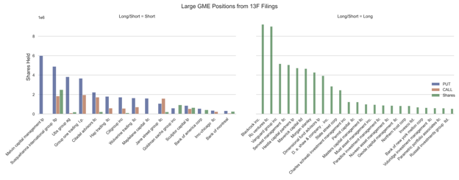
All funds with at least 300k in either shares, calls or puts. Short positions are on the left and long positions on the right chart.
Here we see many of the known offenders. A bunch of short funds with majority puts and sometimes a
smaller number of call options. Melvin takes the biggest idiot prize with 6 million shares in puts and
nothing else. Here are the main offenders based on their end of 2020 filings:
• Melvin capital management lp
• Susquehanna international group llp
• Ubs group ag
• Group one trading l.p.
• Citadel advisors llc
• Hap trading llc
• Citigroup inc
• Wolverine trading llc
• Maplelane capital llc
• Jane street group llc
Some of these market participants operate market making and hedge fund activities. It is difficult to
completely separate normal versus abusive practices. That being said these are the likely candidates and
a good place for future DD digging.
Wolverine trading llc had an almost identical position to Maplelane capital llc who reported massive
losses. Ubs group ag is an interesting one with almost 4 million shares in puts and nothing else. Is UBS a
final boss?? Hap trading llc & Citigroup inc each had almost 2 million shares in puts and not much
else. Group one trading l.p., Shitadel advisors llc, Susquehanna international group llp & Jane street group
llcfeature prominently too.
Let me remind you of the earlier quote:
Regulation SHO stocks with large, unsettled trades often exhibit a similar characteristic: “short selling”
hedge funds with significant put holdings in 13F filings.
Many of these funds exhibit this characteristic and around the end of December and early Jan SI% and
FTDs were through the roof. This looks like fuckery.
Next 13F filing updates should arrive by May 17th. This will be big.
Speculation alert: Any fund holding predominantly or exclusively a put position is short and likely
engaged in illegal married-put naked shorting. The biggest know idiots Melvin and Maplelane have
positions that look similar to other large funds (Wolverine, UBS etc.) suggesting we may have a clearer
idea of who is up against us. And facing bankruptcy.
A recap of naked short selling and the married put
The reason that large put positions in 13F filings is suspicious is because those puts are likely to be the
by-product of naked shorting. For a detailed description of how options trading can be used to sell
naked shares you can take a look at this post and the follow-up post. Here is a brief description:
Being a 'bone-fide' market maker grants you special privileges. One big privilege is to sell shares without
needing to fulfil the 'locate' requirement. In other words, 'bone-fide' market makers are allowed to
naked short sell, but they must find the shares after a certain amount of time.
What is a 'bone-fide' market maker? No one really know. The SEC did a shitty job defining it so many
brokers can likely pretend they deserve the title.
How can the 'bone-fide' market maker privileges be abused? Well...
If a hedge-fund wants to short sell but no shares are available to borrow, or they're too expensive, the
hedge-fund can go to their 'bone-fide' market maker friend and follow this simple 'married put'recipe:
1 Buy puts from the market maker covering the number of desired shares.
2 Buy shares from the market maker at the same time. The 'bone-fide' market maker can sell the shares
naked as he remains net neutral on the trade.
3 Make the 'bone-fide' market maker happy by paying a tasty premium for the puts.
4 Dump the bought shares on the market to suppress prices and remain net short on the puts!
For an extra spicy recipe that is harder to detect add the following step before step 4:
3b Sell way way out of the money call options equal to the bought shares that you never expect to be
worth anything (800c calls anyone?) to the 'bone-fide' market maker for a small premium. The trade
now looks like an innocent reverse conversion.
Options fuckery consistent with naked shorting and the married
put
So, if massive naked short selling via the married put trade has been used to cover up FTDs and SI%
since Jan we should see some anomalies in the options chain. Let's take a look.
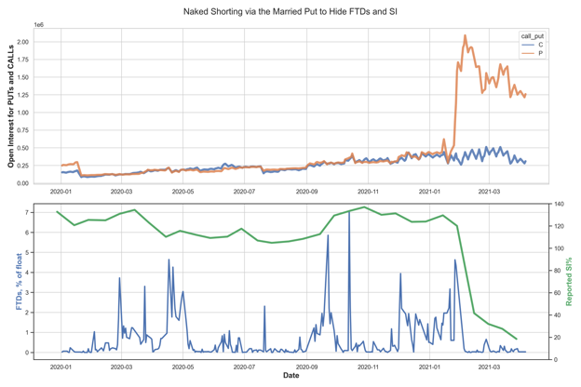
Total open interest for puts & calls as well as FTDs & SI% since Jan 2020.
HOLY FUCK THATS A MASSIVE JUMP IN OPEN PUT INTEREST!! And it's been sustained since the end of
Jan. for the last year open interest in puts and calls remained very similar. At the end of Jan put open
interest increased by more than 300% and completely disconnected from call interest. Immediately
after this change FTDs and SI% dropped massively.
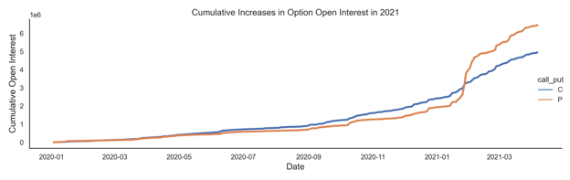
Cumulative open interest for puts & calls since Jan 2020.
If we look at the cumulative open interest over time we see the number of newly opened put contracts
has remained steady throughout Feb and into early April. The rate at which these contracts are being
bought is far greater than anything seen in 2020.
Speculation alert: The huge jump in open put interest could've provided up to 150 MILLION naked
short shares to fight the January price spike and hide FTDs and SI%. When combined with certain
brokers restricting retail buying, media FUD, January paper hands etc. their ploy appeared quite
successful. Since pushing the price back to 40$ in Feb the constant and significant opening of new put
contracts has been used to roll over the FTDs and do their best to keep their naked asses covered. Since
Jan up to 400 MILLION naked short shares could've been used to hide FTDs and manipulate the price.
Dark Pool matters
Previously I speculated that Dark Pools could be used to facilitate the naked shorting trades. This
hypothesis can be supported with data by looking at the OTC data made available by FINRA.
Getting this data was a pain in the ass but I now have all Dark Pool volume data for GME since Nov 2020.
This includes Alternative Trading System (ATS) and Over-the-Counter (OTC) volume data.
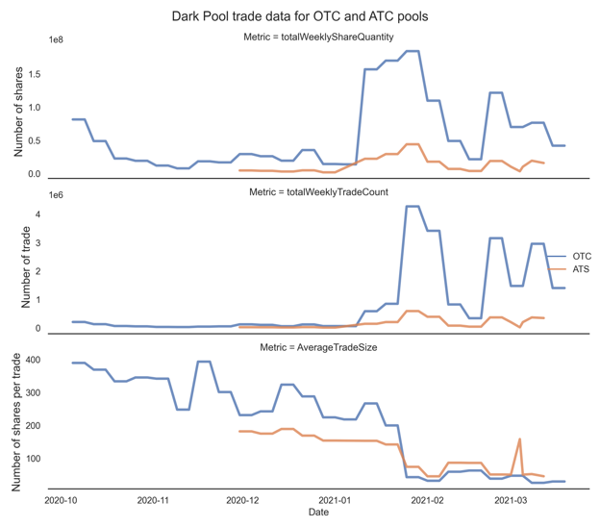
Dark Pool trade data for OTC and ATS trade pool.
Dark Pool activity ramped up massively at the start of Jan, particularly in the OTC pool. Towards the end
of Jan as prices spiked during the mini-squeeze the total number of trades more than quadrupled and
the average trade size dropped to around 50 shares per trade, remaining there ever since.
Re-routing of order flow anyone? Short ladder attacks in small share batches anyone?
If OTC trading was being used to suppress retail buy pressure we'd probably expect to find the worst of
all the brokers *Robinhood* involved in the trading pool.
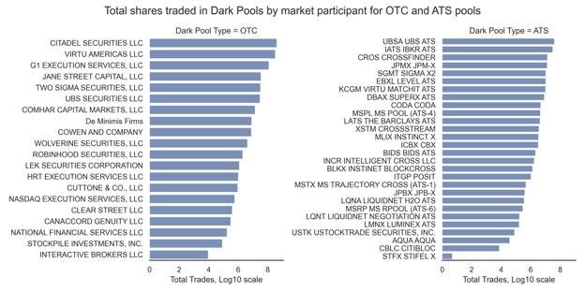
Total shares trades by firm for OTC and ATS pools since Jan. Note: using Log10 scale for comparison. Citadel actually traded
400M shares OTC!!!
Well what a surprise. Citadel trading 400M dark pool shares. Robinhood trading 2 million shares on
OTC. The average trade size was ≈1 share which is fucking weird. Interactive Brokers only traded 9559
shares OTC but they made 9559 trades. Exactly 1 share per trade. Fucking weird.
Looking at the OTC market participant names, does anything look familiar? Oh yeah! Some of our market
participants with massive puts in 13F filings also love to trade OTC!!
• CITADEL SECURITIES LLC
• JANE STREET CAPITAL, LLC
• UBS SECURITIES LLC
• WOLVERINE SECURITIES, LLC,
And the worst offenders for Robinhood payment for order flow (PFOF):
• CITADEL SECURITIES LLC
• VIRTU AMERICAS LLC
• G1 EXECUTION SERVICES, LLC
• JANE STREET CAPITAL, LLC
• TWO SIGMA SECURITIES, LLC
TWO SIGMA SECURITIES, LLC is an interesting one. As well as benefiting from PFOF they are also a
known short. They don't show up in the 13F filings but they were reported to take a big hit from short
positions in Gamestop.
COMHAR CAPITAL MARKETS, LLC is a Chicago based firm just minutes away from Citadel. What are they
doing trading 14 million GME shares OTC?!? I'm calling bullshit and suggesting this firm can be added to
the short fund list.
COWEN AND COMPANY have 100k shares in puts from 13F but didn't show up in the earlier list as I set
a minimum of 300k shares to be included. Another short hedge.
LEK SECURITIES CORPORATION don't have any obvious short positions in GME or news reports of
losses. However they were slapped by the SEC for large scale market manipulation in the recent past.
Edit 1: G1 EXECUTION SERVICES, LLC is actually owned by Susquehanna International Group, one of the
funds with tons of puts in 13Fs.
Edit 2: Some helpful comments point out that there can be some confusion with market makers and
hedge-funds. Citadel is often referred to on this sub as the firm with the most to lose in GME. They
operate market making and hedge fund activities. So do a number of other firms (Wolverine, Jane Street
etc.). For naked shorting the participation of 'bone-fide' market makers is crucial. This is how they can
abuse the locate rule and naked short. None of this contradicts the data in this post or the conclusions
but it remains difficult to completely separate normal market making activities from abusive ones.
Speculation alert: OTC trades have seen massive volume and order size changes since early January.
Many of the participants are known short funds. Changes in OTC trading align with evidence of
manipulative naked short selling (Deep ITM calls and married-puts). OTC trading has been used to
create millions of naked short shares and reroute retail orders to suppress buying pressure.
Conclusions
Hedgies are fucked. Just look at the amount of effort they've had to put into keeping a lid on this
thing!!! When they lose control of the FTDs they lose control of the price. Millions of illegal naked short
shares created in a desperate effort to make retail go away. But guess what??
Speculation alert: Here are my thoughts for what's happened with GME in 2021:
• FTDs and SI% were getting out of control in early Jan
• As prices increased and more hype came to GME the shorts got more and more desperate
• Dark Pool OTC volumes went through the roof and Deep ITM call volumes were used to
create naked shares ahead of the end of Jan price spike
• When prices really started to move from Jan 25th - 29th more than 100 million shares
were created with Deep ITM call and married-put naked shorting and used to hammer
down price and hide SI%
• A coordinated blocking of buy orders on key retail brokers and media induced FUD
helped the shorts knock down the price and scare off some of the FOMO paper hand gang.
• Something happened to the short share borrow fees that completely disconnect from
normal pricing.
• From Feb onwards average trade size on OTC decreased to around 50 shares per trade.
That's a 70%+ drop in trade size. Retail orders were funnelled through Dark Pools to
control buying pressure and 'short ladder attacks' used to control price.
• ETFs were used to hide more and more FTDs from the apes. I have data on ETFs but its
such a pain to analyse (70+ funds, all different GME allocations, rebalancing over time
etc..).
• DFV doubled down. RC tweeted an ice-cream cone. Deep ITM calls increased. FTDs
remerged and on Feb 25th prices started flying again.
• All this time FTDs and prices have been manipulated with tricky options trades. Up to 200
million naked short shares could've been made from Feb through to April 6th using
married put trades.
• But the apes are still here. Millions of short fund options have expired. FTDs are shown to
get uncontrollable over time. An unprecedented FTD squeeze will come. New DTCC rules,
a stronger SEC, GME annual meeting and share recall. So many catalysts. Shorts are
fucked.
🚀🚀🚀🚀🚀🚀🚀🚀🚀🚀🚀🚀🚀🚀🚀🚀🚀🚀🚀🚀🚀🚀🚀🚀🚀🚀🚀🚀🚀🚀🚀
Back to Table of Contents
Hank's Definitive GME Theory of Everything
DD 👨‍🔬
********** I am not a financial advisor, this is not financial advice **********
Introduction (DD starts below)
Apes, did you know that there are usually about 80 confirmed cases of deadly shark attacks per year.
You know what nobody ever talks about though? The fact that sharks have TWO, count it TWO, FUCKING
PENSIS. I am not making that up. Imagine what I could do with two penises. I'd have twice the total dick
length. I might have to rename myself HomeDepotHank3InchesTotal.
On the topic of cocks, did you know that many reptiles have two penises as well? They call them
hemipenes. SUCK MY HEMI PEEN SHILLS.
As many of you know, I am a music aficionado. I like to listen to my fair share of classical music like
Megan Thee Stallion and Linkin Park, Jazz music like Fifth Harmony, and even heavy metal like Coldplay
and Carly Rae Jepsen. However, I recently came across a beautiful artist who I was not previously aware
of. He is a contemporary opera singer named Wheeler Walker Jr. Some of his most popular songs
reminded me of this current situation:
"Fuck you bitch" - how I feel about shorts
"Pictures on my phone" - my DD
"Pussy King" and "Rich Sumbitch" - apes when the squeeze is over
"Finger up my butt" - me sitting on the toilet scrolling through this sub every morning
"Sleeping on the Blacktop" - shorts after they go bust
"Drop 'em out" - shorts getting squeezed out of their positions
"Sit on my face" - me every time I see my wife's boyfriend
"Still ain't sick of fuckin you" - apes when the shorts beg for mercy
"Dicked down in Dallas" - shorts who live in Texas during the squeeze
"I like smoking pot (a lot)" - my wife
(These are the actual titles and this guy is actually real, I love the internet).
Alright apes, enough joking around, it's time to get serious
Where the DD actually starts
There has been an absolute slew of data in the past month about FTDs, dark pools, and rule changes. As
many of you know, I have been pumping out a bunch of DD about the FTD cycle. After reading tons of
posts about dark pool DD and DTCC rule changes, I think I now understand how all of this fits together
and have thus made this GME theory of everything. The DDs that I read on dark pools and OTC trading
are the glue that connects everything together IMO.
In this post, I will be me connecting my own DD about FTDs to other users' DDs about dark pools, DTCC
rule changes, and ETF shorting in order to give us a bigger picture of what all of this is and means. Thus,
there will be absolutely no prediction in this post, however, it should help you understand how
everything is tied together and the fact that because we don't know the exact extent of shorts' exposure,
it is impossible to predict when the MOASS will occur. I am confident though that we are nearing the
light at the end of the tunnel. With that, Apes, I present to you: HOMEDEPOTHANK69's DEFINITIVE GME
THEORY OF EVERYTHING. Enjoy....
Roadmap
Alrighty apes, I am going to first briefly explain my own DD on the FTD cycle. Next, I am going to
summarize some DD from a user about OTC trading and dark pools relating to GME. After that, I will
summarize some DD from other users about how new DTCC and other agency rules affect GME in the
future. Finally, I will summarize how ETF shorting plays into GME. After that, I will go into how all of
these fit together in one big beautiful orgy that explains where the HFs are at with GME and why they
are there. This will allow us to understand our current position.
Summarizing DD of FTD Cycle, new rules, OTC trading, and
ETF shorting of GME
FTD Cycle
Below are the links to my posts on the FTD cycle:
Post 1 Post 2 Post 3 Post 4 Post 5
Essentially, the FTD cycle is the idea that because shorts have continuously shorted GME, covered it with
borrowed shares, and used naked shorts, their short exposure is multiples higher than the actual shares
of GME in existence. Because of this and SEC rules forcing them to cover every 35 days, there are
predictable price and volume hikes on the chart that coincide with them covering. As every FTD cycle
passes, the price to cover gets more and more expensive, and more and more shares are required
(naked or not) to maintain their position, which makes it progressively more expensive and
progressively increases their position. This increase in expense is going up exponentially, so each cycle
is more expensive for them to keep their positions, and eventually, the pressure will be too much for
them and they will be forced out. Because heavy naked shorting probably started in early 2020 for GME,
with each passing month their exposure increases drastically because a naked short gives them double
the obligation (they must cover the short and the nakedly created share). This is why I believe that their
current short position is multiples higher than the amount of GME shares in existence. Therefore,
they've dug themselves into a hole (hole is an understatement, it's more like an abyss) that they cannot
get out of and are trying to slowly unravel the FTD cycle, which is only possible if apes sell. Because apes
have not sold, the FTD cycle continues and gets progressively more expensive and they cannot get out of
the abyss, they can only kick the can down the road. Similar to the January squeeze, eventually the
pressure will be too much and they will be forced out. Here is a picture of the FTD cycle on the charts
from one of my posts:
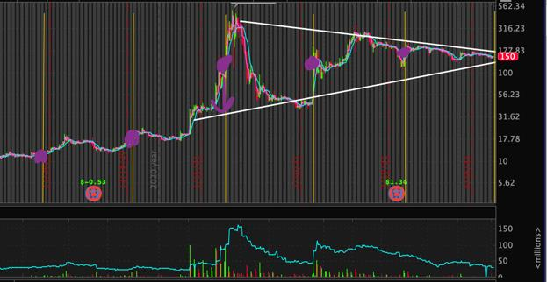
This doesn't give you the full picture of the FTD cycle but it gives you a generalization of its thesis. If you
want to learn more about it, see my other posts.
OTC/Dark pool trading
All credit for this goes to the absolute KING who is u/nayboyer2*. Here is his* original post.
According to his post, Citadel, Virtu, and Two Sigma are and have been trading MILLIONS of GME shares
in dark pools and OTC exchanges. He used publicly available data from FINRA and converted it into
charts and spreadsheets (again FUCKING KING). He plotted the ownership of GME shares of these firms.
He found that these firms are trading over 1000 shares of GME for every one that they own (let that sink
in). He also found that an exorbitant amount of shares are trading in dark pools when compared to the
float. This data is irrefutable because, again, it is publicly available FINRA data (i.e. he's not just making a
theory, he's just saying what the data shows). Here are some important screenshots from his post:
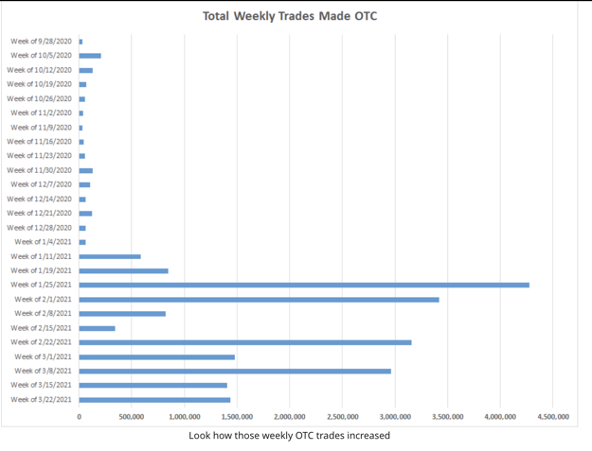
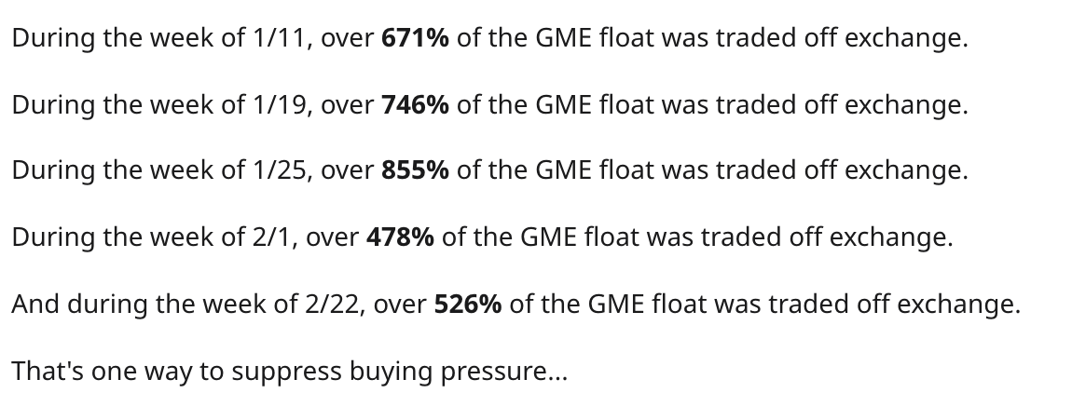
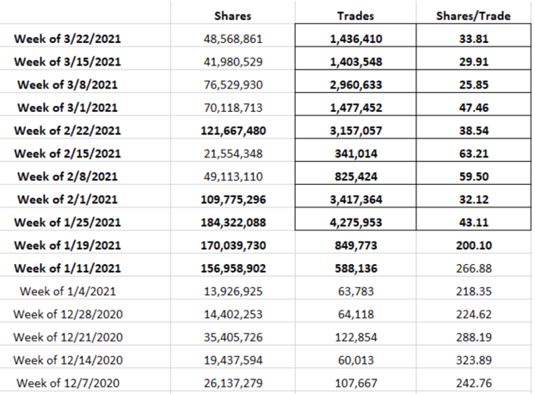
The takeaway: there is a massive amount of dark pool and OTC trading of GME, it's multiples higher than
the actual float. This is just publicly available data that they've reported, so I would guess there's even
more to this than we can see from public data. Seriously, check out this post if you haven't, it is a
masterpiece.
I am just scratching the surface of this, it's only meant to be a summary, I encourage you to read his post.
I'd let him have a night with my wife ANYTIME.
New Rules
All credit for this goes to the absolute KING who is u/c-digs*. Here is his* original post.
In his post, he theorizes that all of Wallstreet knows what's going on with GME and that we have been
trading sideways for so long because Wallstreet is waiting on several crucial rules from organizations
like the DTC and OCC to be passed that will essentially ensure that Citadel can't completely break the
market when they go bust. The user believes that once these measures are passed, a firm (he thinks
BlackRock) will put tons of buying pressure on GME and cause the squeeze because the measures would
make the blow to the financial system more containable. He also points out that in a single week
multiple banks broke the record for bond offerings (i.e. they want to have cash on hand). This user
believes that a few institutions are in GME too deep and everyone knows it and the influx of rules is
meant to make the unraveling safe for Wallstreet, therefore, Wallstreet is waiting to pounce on GME
until the middle of the summer when these rules would be passed (at the latest). He gives specific rules,
how they will essentially take exposure off of clearing companies and put it on members and the
defaulting institutions, and shows the latest possible dates that these proposed rules may go into effect.
I am just scratching the surface of this, it's only meant to be a summary, I encourage you to read his post.
I'd let him have a night with my wife ANYTIME.
ETF Shorting
All credit for this goes to the absolute KING who is u/leenixus*. Here is his* original post.
There are tons of posts about how ETFs are being shorted in order to a. put indirect pressure on GME
and b. hide FTDs. I particularly liked this post because of all the charts, which make my smooth brain
tingle. I won't go too far into this because most of us already know that another tactic used by HFs is to
use these ETFs to put more pressure on GME and to hide FTDs. Here are some important screenshots:
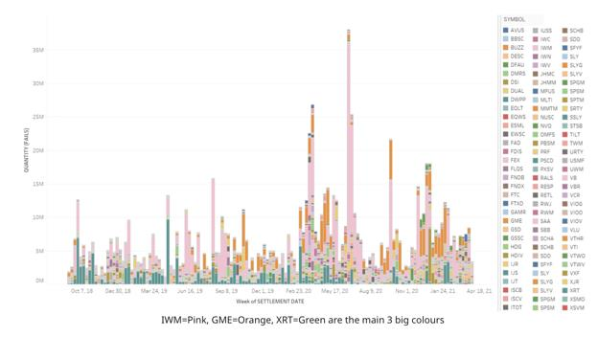
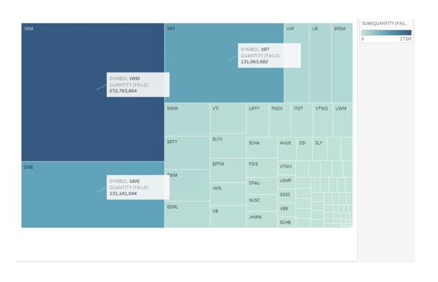
I am just scratching the surface of this, it's only meant to be a summary, I encourage you to read his post.
I'd let him have a night with my wife ANYTIME.
**I am not taking credit for the above three DDs. I am using their DD to contribute to my overall theory.
Please see their posts as they are spectacular. These are truly KING apes**
How all of this fits together
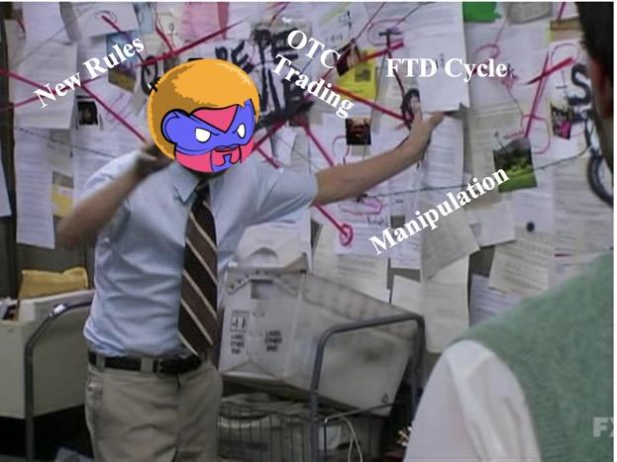
So, we have the FTD cycle, Dark pool/OTC activity, ETF shorting, and upcoming rules that could benefit
us. But how do all of these fit together? (again, this is just my opinion and it could be wrong). I will guide
you through the conclusions I make as I go by bolding them.
First, the dark pool/OTC data indicates what we all already know: HFs are in a giant fucking hole, an
abyss. They borrowed shares, covered those borrowed shares with borrowed shares, shorted with
borrowed shares, covered those with borrow shares, and so on. They have been repeating this forever,
which is why the price of GME is still so high and volatile. They do most of this covering in dark pools to
suppress buying pressure and do other shady things in these dark pools so it goes unnoticed (more on
that below).
Moreover, GME's OBV has always perplexed me. How could OBV still be this high post squeeze? The DD
on dark pools explains that (i.e. they are covering on dark pools to suppress buying pressure and OBV
shows that). This means that apes did not sell post-squeeze and that the HFs did indeed use naked
shorts to create artificial selling pressure (OBV is the yellow line):
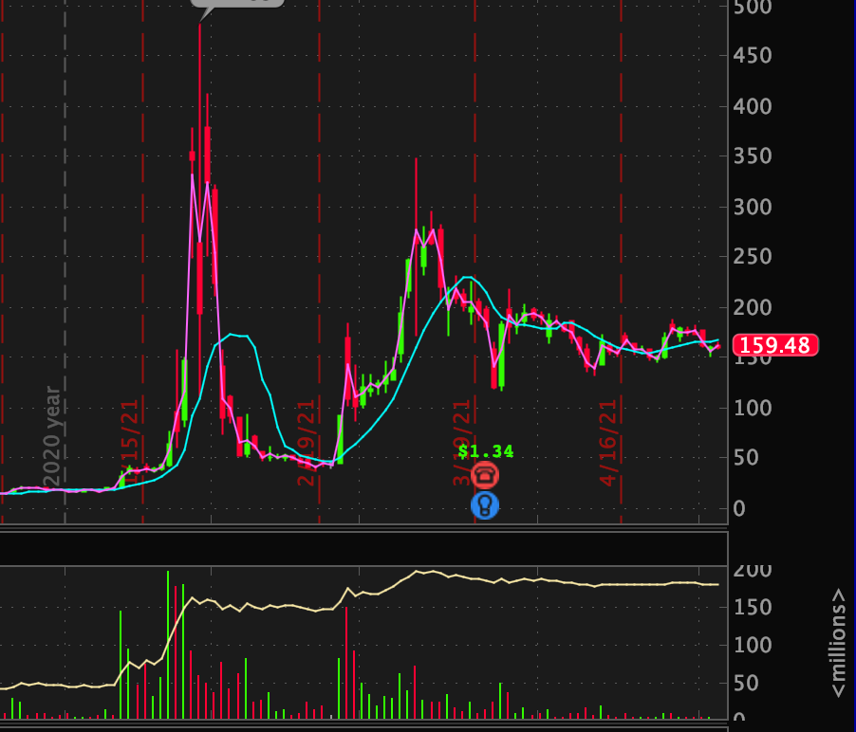
The OTC data also explains the low volume. The funds are covering in dark pools in an attempt to
suppress buying pressure, which is why volume has been so low lately. This also explains the random
1pm jumps in buy volume that I noted in a previous post. Finally, this further explains why GME reacts
so strangely to catalysts - there are outside forces (OTC trading) that are currently bogging down the
price. If a catalyst happens to line up with when they have to cover (i.e. February 24), then we will see
positive volume, if not, there is still massive selling pressure on even positive news.
Furthermore, the dark pool/OTC data provides almost irrefutable evidence that 1. there is still fuckery
afoot with GME, 2. the shorts have indeed dug themselves into a hole that they cannot get out of 3. the
exposure that the short funds have is astronomical, and 4. unless for some odd reason all apes sell, the
MOASS will in fact happen and it will happen big. Essentially, I believe that we now know exactly what's
going on, we just don't know the exact numbers of it (i.e. we don't know their precise exposure or how
many shares they borrow or use to short during an attack). The fact that GME's price is still insanely
volatile and is trading over 5x what most analysts think it should be and the fact that an INSANE amount
of volume is coming from OTC markets demonstrates that shorts still indeed have large positions are
still very much IN THIS BITCH.
Conclusion 1: HFs are indeed in a deep hole, have not covered, and are trading in high volumes in
dark pools in an attempt to kick the can down the road. All of this explains the low volume.
In the OTC data post, the user shows that the institutions involved in these dark pools do in fact own
shares of GME; however, they are trading over 1000x the shares that they own. A few days ago, I
remember seeing a post from someone who contacted Interactive Brokers asking why the borrow fee
was so low (I don't remember the post but if you do please link and give user credit). The person said
that GME is one of the hardest stocks to short right now but the reason that the borrow rate is so low is
because there is almost zero demand.
Conclusion 2: GME is insanely hard to borrow right now and there is very little demand to short it
Next, dark pool activity helps us to further explain the FTD cycle. Why do we see these spikes in price
and volume every 35ish calendar days? SEC regulations force them to cover. Why does it keep
happening? The OTC data shows us that they are STILL naked shorting. Why else would there be this
much OTC activity. That shows us that HFs are continuing to naked short and cover with borrowed
shares every day, thus digging themselves in a deeper hole (because naked shorting creates 2
obligations - covering the short and covering the naked share) and it's getting more expensive to do so
as time goes on (FTD cycle) because their short position is increasing rapidly as shown by the OTC data.
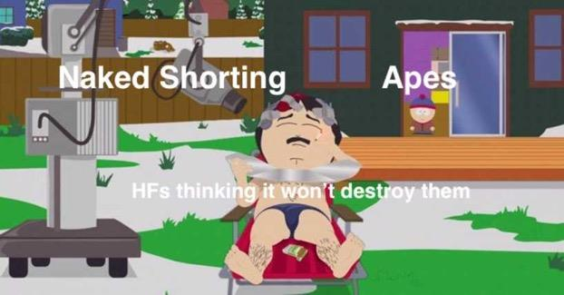
Conclusion 3: The OTC data adds credence to the idea that the FTD cycle is getting more and
more expensive and that shorts are increasing their short positions rapidly as time passes
So if all of this is true, why isn't some whale coming in to take advantage of it and benefit from a squeeze
as many of them did in January? That's where the new rules DD comes into play. Because Wallstreet has
access to better, more accurate data than is publicly available, they probably already know what we are
just starting to figure out. Why else would the DTC and OCC put in all these rules related to liquidation,
bankruptcy, and oversight right after the GME squeeze? Therefore, potential whales are purposely
sidelining themselves until these rules are passed, so that they don't completely destroy the financial
system in unraveling these short positions. If some whale came in and tried to start the squeeze now,
there's a good chance that it would cause a collapse in the financial system because clearinghouses
would go bankrupt from having to cover for the shorts who default, which would tank the whales' other
assets; however, because of the proposed rules, doing so would only make a few institutions collapse,
which would save the whales' other positions in the market.
Conclusion 4: Whales have purposely sidelined themselves and are waiting for the proposed
regulatory rules to take effect so the squeeze doesn't destroy the financial system.
Back to OTC data. Why would an institution want to trade on a dark market? The first reason is to
suppress buying pressure. The second reason is so that the broader market cant see what they're doing
(without taking a deep dive like our ape KING did). The third reason is because they may be employing
trading strategies that are borderline illegal, would cause a lot of suspicions, and would make GME
dangerously volatile. Because dark pools allow institutions to trade with each other absent an exchange,
I believe that this is what they're doing on those pools: they are buying and selling back and forth
between each other at a rapid rate in order to drop the price. These are the short attacks that we see.
Ever notice that it seems to take about half the volume for the price of GME to go down $5 (arbitrary
number) as it does for it to rise $5 (arbitrary number)? This could be why. Moreover, I also believe that
they are limiting their covering ONLY to dark pools to suppress buying pressure in public exchanges.
Why do I believe this? If there was nothing crazy going on with GME then why is there still an asininely
high amount of dark pool activity similar to what we saw during the squeeze?
Conclusion 5: Shorts are using dark pools to suppress buying pressure and to drop the price by
rapidly trading between each other.
Back to the fact that it is getting harder and harder to borrow GME and there is very little interest. What
I believe is happening is, as said above, these funds are rapidly trading back and forth between each
other to drop the price, are borrowing shares from each other, are covering with borrowed shares, and
continue to use naked shorts. HOWEVER, because the availability of borrowed shares in the broader
market is drying up and because the shorts only own so many shares that they can borrow and trade
between each other, their supply is drying up, so they can't continue this forever. Because apes continue
to buy, the amount of shares available is further drying up. The longer these funds continue to borrow
shares, make naked shorts, cover with borrowed shares, and borrow each other's shares, the more the
shares available to borrow dry up. As the FTD cycle rages on, this also becomes more expensive over
time. Thus, they are playing a losing game but financially cannot stop playing this game because they're
in so deep. Therefore, the squeeze will happen when the supply of shares completely dries up and their
short positions slowly (or rapidly) start to unravel or when the FTD cycle makes continuing their game
too expensive.
Conclusion 6: The squeeze will happen once the availability of shares to borrow is completely
dried up, which seems to be rapidly approaching.

Moreover, many people have also noted that GME and AMC trade disturbingly similar in price and
volume. I'll also add that this seems to be true for other stocks that were squeezed in January. Why do
you think stocks like AMC, GMC, KOSS, BB, NOK, EXPR move so similarly? It's because they are all victims
of the FTD cycle as well. Why do you think all of these stocks squeezed at around the same time and why
do you think brokers simultaneously halted trading on all of these stocks? Because naked shorting is a
cancer infecting the market. Shorts got too risky during covid and thought that all of these companies
would go bust, so they abusively shorted them hoping to get the bankruptcy jackpot. Bankrupting these
companies would let these funds be off the hook for covering because the company would no longer
exist, so there would be no share to cover. However, J Pow then turned on the money machine and we
saw the greatest recovery of all time. Realizing how bad HFs fucked up, brokers had the choice of facing
bad press for restricting buying or allowing the FTD cycle to unravel and let the financial system
collapse. They did the rational thing. Then, realizing that the problem was still grossly persistent,
financial regulatory companies started implementing more and more rules to prevent the unraveling of
this from destroying the economy when it does happen.
No one says this but why do you think literally every brokerage did exactly what RH did? Do you really
think they all had liquidity issues? No. It's because they all knew what was happening because they had
the access to the data. They knew that if they let it squeeze, it would bankrupt Citadel and they'd be on
the hook for it. However, now that there are all of these new rules in place, they can allow it to happen
once all of the rules are passed.
Conclusion 7: The FTD cycle is persistent and exemplifies the naked shorting problem in
Wallstreet that Dr. Trimbath discussed.
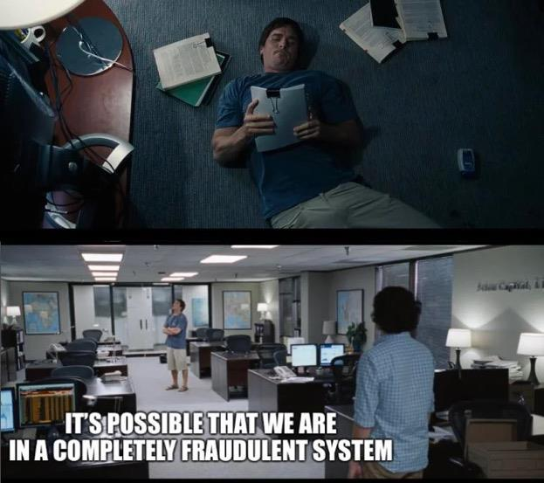
Back to GME specifically. In one of my previous posts on the FTD cycle, I used this chart to make sense of
T+35:
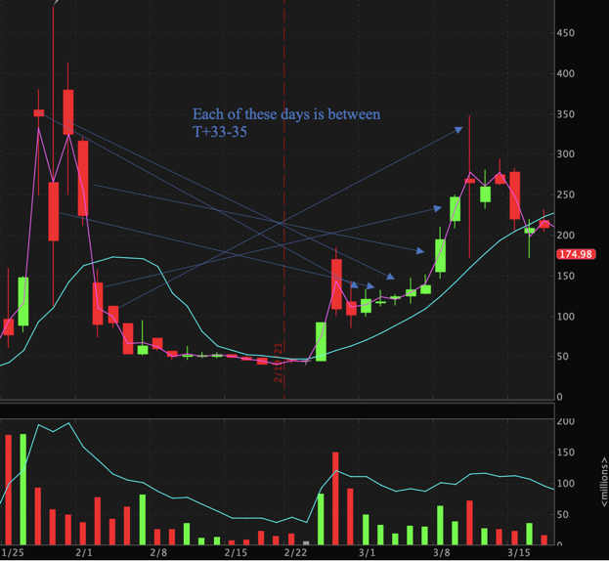
Notice the low volume in February. I have long said that I don't think that the CFO being ousted is what
caused GME to double in February, it just doesn't make sense. Instead, I believe that once brokerages
turned off buying power in January, the HFs again amped up their naked shorting to get the price down
to where they could possibly cover. Obviously, some people sold but OBV tells us that it wasn't enough
people to get the price all the way down to $40. What explains this? Naked shorting in dark pools to
disguise what's really going on. Then, at the end of February, T+35 starts coming in to play and HFs must
cover for what they did to end the January squeeze. Obviously, they continued to apply more naked
shorts throughout this (March 10th anyone?), so their short positions continue to grow and the FTD
cycle continues to persist. Perhaps today's low volume, slightly downward price action is similar to what
was happening in February (just a thought).
Conclusion 8: The February rise was the result of forced coverings from the January drop and
demonstrates that the shorts still have large positions.
Back to the dark pool data. One of my favorite things from that was the fact that there is not just one
player. There are multiple players in this game, which suggests that they are working in tandem. What I
posit happened is that these funds all saw the same thing in early 2020: GME is struggling, covid will
likely bankrupt it, so let's take some risk and apply naked shorts to hit the bankruptcy jackpot. Instead,
the market roared back, GME had a slew of good news in mid-late 2020, and the shorts got themselves in
this abyss because they continued to apply more and more pressure on GME. Again, a naked short makes
your obligation double because you have to pay back the share that you borrowed and you also have to
fulfill the obligation of the share you nakedly created. So every time they apply more pressure, sure the
stock goes down, but their net short position goes up exponentially. This is why the FTD cycle persists.
Just to kick the can down the road, they use synthetic longs and ETFs to hide and delay their FTDs.
Conclusion 9: Funds are working in tandem because they are both in too deep but it is futile and
is just delaying the inevitable.
But what are some of their other tricks? As we know, they like to hide/delay their FTDs through
synthetic longs (ITM calls). But what they also do is short the ETFs that contain GME. This applies much
less efficient pressure to GME and shows that they are getting really desperate. How do we know that
they are doing this? Well, just look at the FTD numbers of those ETFs.
Conclusion 10: Their activity on GME-containing ETFs demonstrates how desperate they are
getting
But wait a minute, Hank. Do you have any actual hard data that can back up the FTD squeeze theory? If
you would've asked me this any other day except for today the answer would have been no. Thanks
to u/AOCsquad126 and u/leenixus for this beauty of a post. In short, the post uses a model with a linear
margin call price trigger on GME. It's very fascinating and I suggest you take a look. In short, I believe
this post gives further credence to the idea that the shorts are bleeding more day by day because it is
getting more and more expensive to maintain their positions. Why do you suppose it gets more
expensive day by day? Oh I don't maybe it's because of they keep borrowing and borrowing. Finally, the
OP makes an excellent point here that, when they get margin called, we will not know for up to T+35
days (he gives the example that Archegos was margin called in February but the effects weren't seen for
another month). This gives further credence to the idea that the MOASS will come randomly and out of
nowhere. Here's a screenshot from the post:
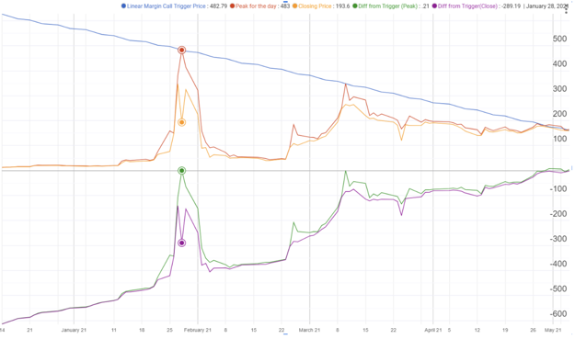
Conclusion 11: I like the stock. I like the FTD cycle.
Putting all of the conclusions together and putting them in context:
Below is what I believe is the timeline of GME thus far. This is a summary of my theory of everything:
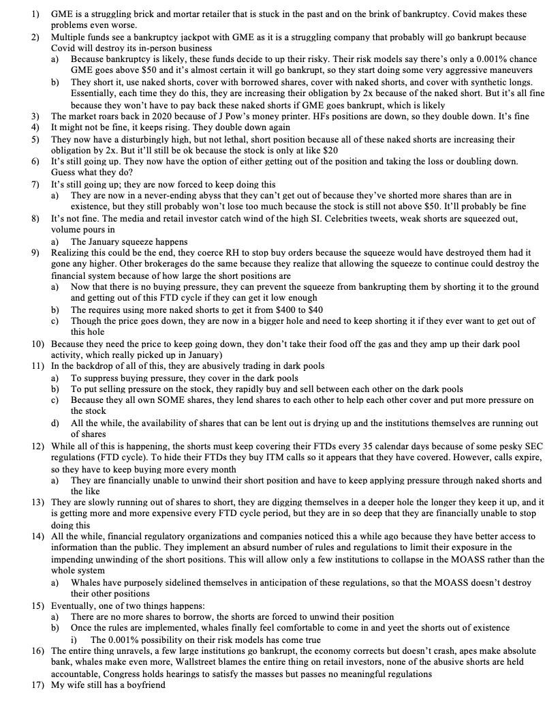
Conclusion 12: Tendies
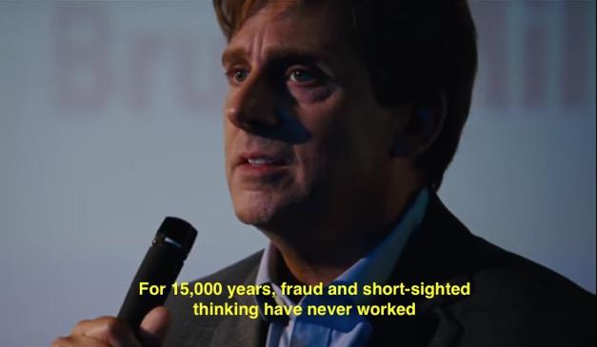
Some other thoughts
Catalysts
It has long been a sentiment that a catalyst will cause the MOASS. Though I wholeheartedly agree that
this COULD be true, I want to emphasize that is not the only option. First, as I've said above GME reacts
strangely to catalysts because of FTDs and shorting (doubled on CFO ousting but went down on RC being
named daddy/master/lord/senpai of the board). We still have many possible catalysts: CEO
announcement, partnerships, crypto shit, etc. However, it's important to remember that January was not
caused by a catalyst. Sure, the events leading up to January were caused by catalysts (SI being sky-high,
media coverage, RC, tweets, etc.); however, the actual squeeze in January wasn't spurred by a catalyst. It
was just the shorts being forced to cover due to the price rising. After seeing how GME reacts to
catalysts, I believe that the squeeze will not happen because of a catalyst but will happen in a similar
fashion to January: completely unexpected because the shorts were forced to cover. Could a catalyst
cause the squeeze? Hell yes. I personally think that a catalyst might cause it to rocket, but similar to
January, the real squeeze will happen after an initial rocket due to catalysts and will be the result of the
shorts being forced to throw in the towel, not a catalyst squeezing them out. Essentially: catalyst-> rapid
price jump but not squeeze (think early January) -> parabolic price jump caused by rapid price jump
squeezing out shorts (think January squeeze).
How this is disturbingly similar to 2008
In 2008 institutions sold risky mortgages to people who shouldn't have qualified for them. That was bad.
They also created mortgage-backed securities with these risky mortgages in them and sold them across
Wallstreet, which gave the entire financial system exposure to bad mortgages. That was worse. They
then created collateralized debt obligations that were essentially bets for and against a default on these
loans (i.e. they made derivatives of these MBS). That was fucking terrible. They then made synthetic
CDOs, which were bets on the reverse side of the CDO (i.e. a derivative of a derivative). That was a nuke.
All the while half of Wallstreet was buying credit default swaps, which are derivatives that bet for a
default to happen. This was Wallstreet canabalizing itself. That was a huge generalization of 2008,
though. So essentially, the derivates market for these bad mortgages was about 10-50x more than the
value of the actual underlying asset (the MBS), which is why when the underlying failed, it almost caused
another Great Depression. By making bets on bets on risky assets, they created a web that, once
volatility happens, would unravel (because once the underlying fails the derivatives fail and the
derivatives of the derivatives fail). They essentially dug themselves into a hole that you couldn't get out
of because they made all of these derivative bets that far exceeded the actual value of the underlying
asset. Sound familiar to what I said above? Financial crises happen when institutions place risky bets
and make bets on these bets. When they make layers of derivates like this, it makes the system seem like
it's booming for a while but as soon as something goes bad, it all unwinds in a tragic way. That's what's
happening now with these webs of naked shorts.
The Future
With all of this in mind, here are my thoughts about the future. As I have said, I believe that the FTD
cycle is slowly chewing away at the shorts, and I think that the dark pool data helps confirm this. I also
believe that the timing and contents of the aforementioned rules is very interesting.
Therefore, I believe that either A. the pressure on the shorts will overwhelm them and their positions
will be forced to unravel, or B. with the safeguards put in place from the new rules, a whale will come in
and unravel the positions for them.
This post has no dates. I personally like posts with dates if they have a ton of research behind them and
are logical. However, as we've seen, though some people can predict certain price action, no one can
predict the MOASS. The MOASS will come, we just won't know when because we don't know exactly how
much blood the MMs have lost yet and how close they are to dying. All we know is that they've lost a lot
of blood and keep losing more. So, none of us will see the MOASS coming, but it will come (just like my
wife when she's with the mailman).
Though I have no dates as to the happening of the MOASS, I leave with this:
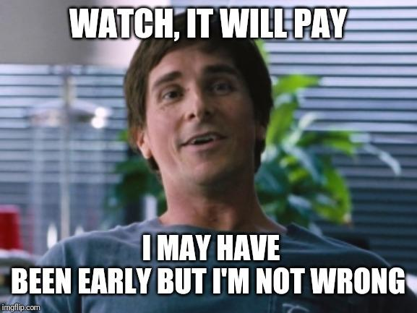
If you have FUD, read this
I, like all of you, have been a victim of FUD. I often think to myself, "they know more than us, there's no
way they'll let this happen again" or "it's been trading sideways, it's all over" or "they have more
resources than us and will end this quick." FUD is a bitch. FUD is the type of girl that your wife's
boyfriend avoids. To help some of you who are experiencing FUD, here is what I always remember
whenever those thoughts enter my head:
The thesis of this part of the post is that what's happening to GME is not normal, which validates
all/most of the topics discussed in this sub. Yes, a short squeeze to that magnitude is abnormal, but what
really gets me with GME is what happened AFTER the squeeze. Find any stock that has been massively
squeezed, and you will see that it doesn't behave like GME has been for the past few months. If GME
would have held around $30-50 like it did post-squeeze and didn't rocket up to 100>200>300 in the
past few months with all of this crazy trading action then all of these theories would be very farfetched.
However, as I have said a billion times, the chart and data are all that you need to see to know that this
stock is still not normal.
Therefore,
It is not normal for a stock double in the span of a few hours on news of a CFO getting fired (2/24). It is
not normal for a stock to open at above 250, go to 350 before noon and then fall down to 172 all before
2pm on absolutely no news (3/10). It is not normal for a stock to tank on earnings and then literally
make back those losses the very next day on absolutely no news (3/25). It is not normal for a stock to
double on news of the CFO being ousted but to go down 5% on news that the key player (Cohen) is being
announced as the senpai of the board of directors. It is not normal for a stock to stay above $150 when
every Wallstreet analyst says it's not worth more than $50. It is not normal for a stock to have an
extremely negative beta. It is not normal for a stock to fluctuate in value by 10x over the span of a few
months (up AND down) on very little fundamental news. It is not normal for multiple forums talking
about the same stock to be infiltrated repeatedly by suspicious accounts trying to create FUD (i.e. shills
really on exist on forums discussing GME, not regular retail investing forums
like r/investing and r/stocks (which I am banned from hahahaha)). It is not normal for a stock to be
universally hated by mainstream finance yet still be trading over 5x what they believe the fair value to
be. It is not normal for a stock to get squeezed, fall back down, then almost regain its squeeze price on no
fundamental news. It is not normal for a stock to have OTC activity that is multiples higher than its daily
volume and float. It is not normal for that OTC volume to be comparable to the January squeeze levels
despite "ThE sQuEeZe BeInG oVer." It is not normal for DTC to be implementing a slew of rules about the
very things we are talking about. It is not normal for a stock to have random volume spikes in the middle
of the day on absolutely no news. It is not normal for ETFs containing said stock to be abusively shorted
as well. I could go on and on. If you have FUD, come back to this, and you'll realize that though we might
be early, we're not wrong.
Does it really make sense for GME to be trading on volume below 5 million consistently (on Wednesday
we hit a number we haven't seen since early October) when every boomer analyst says it's 5x
overvalued in price and there's an insane amount of interest from retail investors? No. It makes zero
sense. On one hand, you'd expect those boomers to short it because it's so overvalued, but they're not.
That's because it's almost impossible to borrow (unless you're a MM) and they know what's going on.
On the other hand, you'd expect the media to be saying "this is crazy, it shouldn't be 5x overvalued, short
short short" every day, but they aren't. That's because they know what's going on. Apes, I'll say it again,
THIS ISN'T NORMAL!
Conclusion
Well apes, if you've made it this far I applaud you. That was a mouthful to say the least. Thank you for
sticking with me to the end of it, this was probably my most in-depth DD and also the one I enjoyed
making the most. Please take this with a grain of salt and remember that it is just my opinion, you should
always do your own DD before making any decisions.
Apes, I hope you realize what this community has done because it's astounding. Between WSB, GME, and
SuperStonk, regular, novice investors have pieced together the puzzle that only large financial
institutions are usually able to do. What's even more amazing is that this was done using limitedly
available, often incomplete public data. The level of complexity of some of the DDs that I've read is on
the level of publishable. The volume, complexity, and completeness of data in this sub is spectacular.
Fuck Robinhood's "DeMoCrAtIzIng iNvEsTiNg" bullshit. This sub is democratizing investing, and let me
tell you, it's been an honor to be a part of this community. As always...
Stay strong, apes.
TL;DR
See "Putting all of the conclusions together and putting it in context" section with the 17 numbered
points.
********** I am not a financial advisor, this is not financial advice **********
Back to Table of Contents
Actually useful info you might have missed,
23/04/21
DD 👨‍🔬
The shitshow this morning is arguably the result of forum sliding, so let's counter that by collating some
of the better stuff until the mods can clean up the front page. Here's what I found buried that is probably
of interest.
1. u/broccaaa has posted a follow-up to his earlier post about trying to detect hidden FTDs
with machine learning. It outlines the method behind his data labeling and the AI
architecture. https://www.reddit.com/r/Superstonk/comments/mwrycd/how_to_train_a_bi
nary_classifier_ai_to_detect/
2. The proxy filing is encouraging voting to happen quickly - this wasn't in previous filings
by
Gamestop. https://www.reddit.com/r/Superstonk/comments/mwmgne/important_im_sure_
everyone_has_seen_that_the/ EDIT: u/ColCrabs claims that it was in the 2020 filing,
page
9https://www.reddit.com/r/Superstonk/comments/mwuszf/actually_useful_info_you_might
_have_missed_230421/gvkuwn4/?context=3
3. People were speculating about some random shitcoin being pumped to fake the amount
of collateral a fund had on hand - some has pointed out that the price is only seen on one
very low volume exchange, and this is just a general crypto scam, not anything to do with
us. It's unlikely a bank would view it as valid
collateral. https://www.reddit.com/r/Superstonk/comments/mwhqwu/the_truth_about_cap
ital_x_coin/
4. The free float is lower than previously thought (now around 25m), going by the numbers
in the proxy filing. It appears that institutional ownership has grown. I can't speak for the
accuracy of the 25m shares held by retail, as I haven't checked how that was
calculated. https://www.reddit.com/r/Superstonk/comments/mwgyfw/free_float_is_267_mi
llion_didnt_count_cohen_twice/
5. A user claims that BlackRock and other institutions who were lending out their shares on
the 15th of April do not have the right to vote at the shareholder meeting. I think it would
be worth checking, if at all possible, what the lending numbers actually looked like on the
15th. Were they unusually low? In that case, could BlackRock still have the right to
vote? https://www.reddit.com/r/Superstonk/comments/mwj1ko/clarification_on_gamestop_
record_date_shares/. EDIT: u/Spiaa claims the filing explicitly states that BlackRock
can vote on their
shares:https://www.reddit.com/r/Superstonk/comments/mwuszf/actually_useful_info_you
_might_have_missed_230421/gvkgusd/?utm_source=reddit&utm_medium=web2x&context=
3
6. I've seen reports that $2m has been spent on $300 puts with an expiration date of today.
Could do with someone verifying, but I have no reason to not believe my source (someone
in the Unusual Whales discord) - basically, two people have made a very large bet on the
stock doing something today. u/welcometosilentchill claims this is a bearish sign,
whereas u/Blussi claims it's a bullish
one. https://www.reddit.com/r/Superstonk/comments/mwuszf/actually_useful_info_you_mi
ght_have_missed_230421/gvkgxyx/?context=3https://www.reddit.com/r/Superstonk/comm
ents/mwuszf/actually_useful_info_you_might_have_missed_230421/gvkmkql/?utm_source=
reddit&utm_medium=web2x&context=3
There are probably countless more good posts that I missed. If you saw any in the last day or two
that are worth looking at, please comment them and give a quick outline for people.
Let's do our best to actively fight forum sliding and topic dilution by remaining on-topic. Mods, please do
your best to keep the sub clean.
P.S: This isn't something I plan on doing every/most days - for the people who do do the morning news
round up things, I think I speak for a lot of us when I say a more straightforward layout of the research
and the findings like this would be preferable to a couple of confused sentences and then a giant
1000x1000px cringe meme
P.P.S: Please upvote the people linking research in the comments moreso than people saying thank you
:D I appreciate it, but the point of this was to collect the substantial stuff
P.P.P.S: The reaction to this post is honestly pretty strange - I had a huge number of awards come in on
relatively few comments and upvotes. Now the post is doing really well, but I go and check the first thing
I linked and it only has 196 upvotes. What gives? I'm wondering if I've accidentally included misinfo on
here that someone wants people to see. Be critical about everything I've written.
Back to Table of Contents
Walkin' like a duck. Talkin' like a duck
Serious DD 👨‍🔬🔬
TL;DR - I have prepared a case which strongly indicates that Citadel Securities, along with it's
"affiliates" are committing securities fraud. On March 26th 2021, FINRA released a new citation
against Citadel Securities for nearly 2 years worth of securities violations. The only reason
Citadel HASN'T been busted for fraud is because they hide behind the veil of 'unintentional'
behavior. However, this post illustrates how Citadel's actions flag ALL 3 corners of the fraud
triangle- pressure, motivation, and opportunity. It's time for these people to be held accountable.
____________________________________________________________________________________________________________
Trying something new this time.
I recorded a video walkthrough of this DD with u/isitabuy, prior to dropping the DD.
If you wanna watch that, click here
Prerequisite DD
1. Citadel Has No Clothes
2. BlackRock Bagholders, INC.
3. The EVERYTHING Short
____________________________________________________________________________________________________________
My fellow apes,
Many of you are wondering how these posts about Citadel relate to GameStop. Perhaps I've lost sight on
explaining this connection, so let me clear this up before diving into MORE sh*t on them.
As u/dontfightthevol pointed out: you just never know what a company's short position is because they
aren't required to disclose it. And unfortunately, she's right.
What we can do, however, is expose the sh*t surrounding them. The fraud triangle WORKS because
people act maliciously when they have the pressure, incentive, and opportunity to commit it. PERIOD.
This means if it walks and talks like a duck, it's most likely a f*cking duck.
I hope I've done a good job revealing the evidence of their ever-tightening noose. To name a few big
ones:
1. the FINRA violations for naked shorting, failing to post a short sale indicator on
transactions, withholding large customer orders to lower the market price, FLASH
crashes
2. the growth of rehypothecated assets for both treasury & equity securities (especially in
2020)
3. the growth in liabilities as their PROMISES to repay keeps getting bigger and bigger
(especially in 2020)
4. FINRA's concern regarding the lack of preventative measures within their system to
detect these issues
5. the number of times they've been documented for 'accidently' removing logic to detect
these issues
Everything fits within ALL corners of the fraud triangle. Citadel commits violations just to make a few
million, knowing their fines are essentially just a small tax. Now that their exposure to shorted stocks
and bonds is increasing, the PRESSURE to commit these actions is even higher.
For far too long, people with money have been draining the wealth out of the global economy.
Everything around us becomes more expensive and the power to do anything about it, decreases. We are
forced to think about pinching-pennies just to make ends-meet, while there are people benefitting from
ALL of this injustice- the ultra-wealthy.
This aggregation of wealth has been going on behind the scenes for centuries. Slowly and gradually like a
frog sitting in a pot of boiling water. Debt has been designed to be carried for life.
Their confidence and greed reached a level SO HIGH that it should have been impossible for them to fail
on their bet against GameStop. The ONLY thing that could blow their victory was if we all started
listening to one another.. and most importantly- learning.
And learn, we did...
We sat down at the World Series of Poker, called their bluff, and won.
GameStop is the lynchpin; GameStop opens the flood gates; GameStop is our checkmate.
GameStop exposes them to a LIMITLESS and IMMEDIATE transfer of wealth back to the 99%. This
situation is dangerous because those who put their vote into GameStop are finally able to take back
control.
GameStop is our hedge against the
funds____________________________________________________________________________________________________________
Hopefully that's been cleared up and we can get back to the point of this post.
Now.... This sh*t just KEEPS COMING!
To me, this is further evidence of their desperate actions within a rigged market. After calling out
Citadel for shorting US treasuries, I recently found out they've been slapped with ANOTHER FINRA
violation on 3/25/2021 for US treasury securities..
yeah....seriously..
BTW, this wasn't even something I was searching for.. I literally walked Cory (the host) through my
investigative process and uncovered it in our first live interview (this link is for the short version; I
uncovered it in the long version which wasn't posted).
Anyway, these violations occurred between July 2017 and October 2019 while the Fed's tapering
program was kicking off. It's extremely hard to be conclusive about the little details when you can only
see a portion of the puzzle, so I usually start these DDs by finding WIDE holes that scream for attention-
this violation is one of those holes. Citadel Securities has been slapped 58 times for regulatory violations
and those are JUST within the stock market. To me, the reason why THIS violation is so monumental is
because it represents their FIRST treasuries violation (first page under background). FINRA issued
them a $275,000 fine along with a censure order, meaning they really disprove of Citadel's actions, here.
____________________________________________________________________________________________________________
I'm going to show you pieces of the disclosure event and gently massage it into your smooth brains.
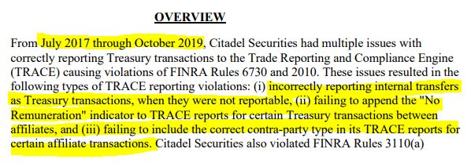
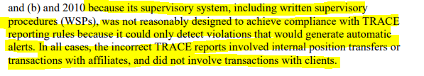
1. Incorrectly reporting internal transfers as treasury transactions
2. Failing to append the "No Remuneration" indicator to TRACE reports for certain
transactions between affiliates
3. Failing to include the correct contra-party type in its TRACE reports for certain affiliates
To me, the biggest red flag in this comes from the very last sentence: "IN ALL CASES, THE INCORRECT
TRACE REPORTS INVOLVED INTERNAL POSITION TRANSFERS OR TRANSACTIONS WITH AFFILIATES
AND DID NOT INVOLVE TRANSACTIONS WITH CLIENTS". I'll touch back on the rest of the violation,
shortly.
Now, lemme take you to school.
I'll walk you through these indicators and then discuss how they relate to Citadel's situation.
____________________________________________________________________________________________________________
What are related party transactions and why do they matter?
The codification (official accounting bible from FASB) explains related party disclosures under ASC 850.
I'd love to have a subscription to this, but it's about $1,200 a year. So here's a link from Deloitte that
gives a decent overview of ASC 850-10.
A typical related party transaction occurs just like a normal transaction, but the parties involved have a
connection, somehow. They can be:
1. A parent entity and its subsidiaries
2. Subsidiaries of a common parent
3. An entity and trusts for the benefit of employees, such as pension and profit-sharing trusts
that are managed by or under the trusteeship of the entity’s management
4. An entity and its principal owners, management, or members of their immediate families
5. Affiliates.
Transactions can be any of the following:
1. Sales, purchases, and transfers of real and personal property
2. Services received or furnished, such as accounting, management, engineering, and legal
services
3. Use of property and equipment by lease or otherwise
4. Borrowings, lendings, and guarantees
5. Maintenance of compensating bank balances for the benefit of a related party
6. Intra-entity billings based on allocations of common costs
7. Filings of consolidated tax returns.
When you have related parties, or affiliated parties, the biggest concern is that a relationship materially
affects the way that business is conducted. For example, you should disclose situations where
subsidiaries are conducting transactions with the parent entity. Or if the subsidiary is wholly owned,
which means you're doing business with yourself, at least in practice. The failure to disclose this
information may materially mislead investors.
For example, party A (affiliate) may be selling products / services to party B (also an affiliate) at a rate
that differs significantly from the open market. For example, Party A sells treasuries to Party B at an
amount that's much lower ($990) than fair market ($1,000). This would allow Party B to sell those
securities back into the market at the normal market rate ($1,000), and record a bigger profit ($10)
because their cost is much lower ($990). Party A then offsets the expense ($10) back to yet ANOTHER
company, and removes it from their books. Hedge funds and offshore funds are perfect for burying these
transactions because they don't report financial statements like public companies.
Likewise, Party A may need to remove something from their balance sheet (bad loans, etc.) and simply
use Party B as a dumpster. This is EXACTLY what Enron did with their special purpose
entities(REMEMBER THAT TERM), or SPEs. When Enron had to incur huge losses, they simply shifted
those losses to shell companies and left the "good" stuff on their books.
Queue violation # 1
____________________________________________________________________________________________________________
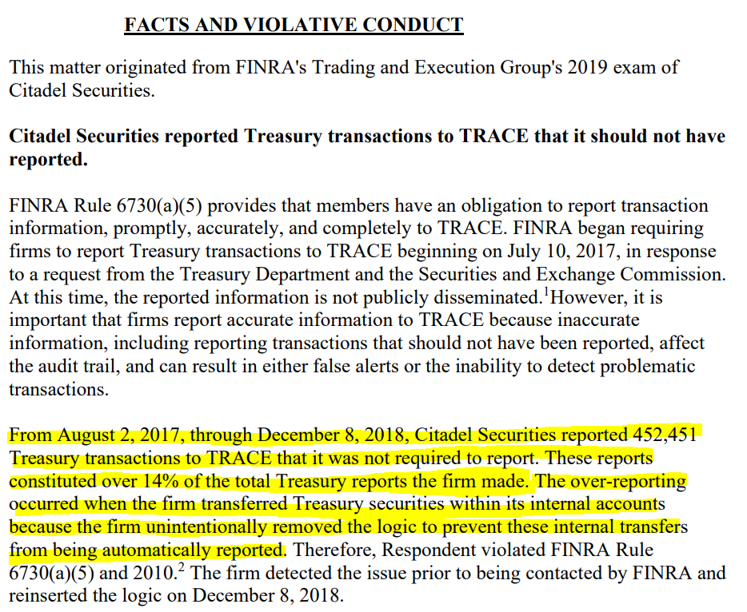
Ok.... when you send transactions to the TRACE system, they ask you to prove they are legitimate. If they
are legitimate, and occur with an affiliate, FINRA needs to know that.. This is to prevent frauds like
Enron from happening again.
For sake of argument, let's just ignore the part where they "unintentionally" removed logic and then
"intentionally" reinserted it..... because that would make this DD too damn easy.
Breaking this down:
1. Citadel OVER reported 452,451 securities transactions which represents only 14% of
total REPORTED transactions to TRACE. This means that Citadel reported 3,231,792
treasury transactions, and 1 transaction doesn't necessarily mean 1 treasury...
could be thousands
2. They were not required to report 14% of those because they SHOULD have been flagged
as internal transfers and not treasury transactions
Now we begin to uncover the corners of the fraud triangle (pressure, incentive, opportunity). Citadel was
obviously compliant for 86% of their treasury reports, so WHY would they feel the need to
"unintentionally" OVER-report 14%....
Hey Citadel... why you WALKIN' like a duck?
____________________________________________________________________________________________________________
How did FINRA find out these were actually internal transfers? Probably the same way I did- by looking
for clues. Check out Citadel Securities "Related Party Disclosures" from 2020 (same as in 2019, I
checked).
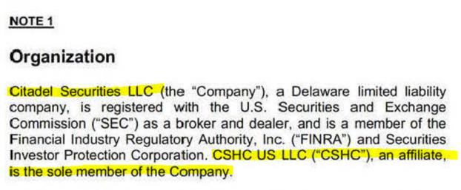
CSHC..... Who are you, REALLY???
Ladies and Gentlemen,
Presenting Citadel Securities Institutional, LLC!!!

Think it's the same company?
Nope..

Citadel Securities INSTITUTIONAL is a completely different company in the books. These guys
are AFFILIATED to one another, but exist separately as SPECIAL PURPOSE ENTITIES, or SPEs..
____________________________________________________________________________________________________________
Let's walk through this again..
Citadel SECURITIES lists CSHC US LLC ("CSHC") as an affiliate (PG 2), and the sole MEMBER of the
company....
Citadel Securities INSTITUTIONAL ("CSHC") lists CSHC US LLC ("CSUH") as an affiliate (also PG 2), and
ALSO as the sole MEMBER of the company....
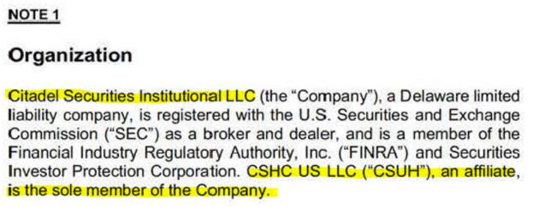
CSHC US LLC ("CSUH")???? Who the hell is this?
Had to go back to a financial disclosure in 2016 to dig up this lil' jewel....
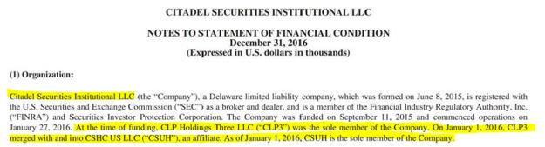
CLP Holdings Three LLC ("CLP3")........
WTF....
On January 1, 2016 "CLP3" merged into ("CSUH")....
So WHO is CLP Holdings Three LLC ?!?!?!?!?
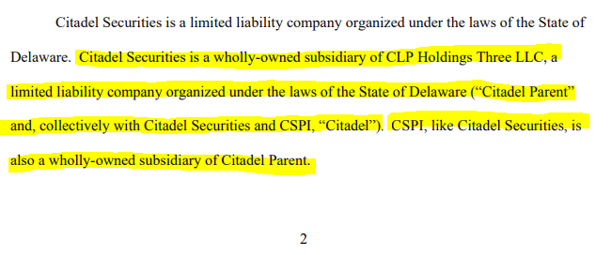
....found this from 2015 (bottom paragraph, PG 2)...
1. Citadel Parent Owns 100% of CLP Holdings Three LLC, which became "CSUH" in 2016
2. CSHC US LLC ("CSUH") is the ONLY member of CSHC US LLC ("CSHC")
3. CSHC US LLC ("CSHC") is ALSO managed by Citadel Parent.....
So basically......
...Citadel, is Citadel, is Citadel, is Citadel....
No wonder why FINRA was pissed. It LOOKS LIKE Citadel took treasuries from Citadel Securities and
transferred them to Citadel Securities Institutional, but reported them as sales transactions to TRACE......
____________________________________________________________________________________________________________
Queue violation # 2
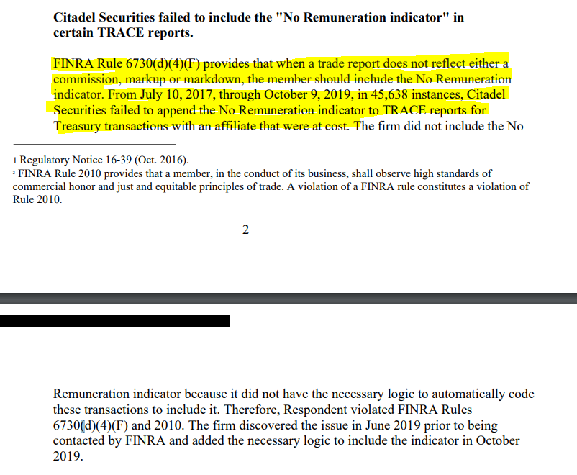
Again, let's ignore the part where they pretended to "discover" the issue in June 2019 prior to being
contacted. Let's also ignore the lack of "necessary" logic to determine which transactions are which.
They do this in almost every f*cking violation they get...
Now what is remuneration?
Basically, it's a type of compensation. In the case of Citadel Securities, it's the price adjustment that is
passed to Citadel Securities Institutional when a treasury is sold / lent.
A normal market transaction might sell a treasury security for $1,000. In this case, the $1,000 is entirely
represented by the bond's value.
An affiliated market transaction might sell a treasury security for $990, with $10 in remuneration for a
total of ($1,000). In this case, the bond is ONLY worth $990, but the $10 in remuneration makes it
APPEAR like a $1,000 bond..
FINRA asks for companies to disclose this because it can be heavily abused, obviously...
This is what happened to Citadel Securities. There were 45,638 instances between July 2017 and
October 2019 where Citadel Securities did NOT appropriately indicate this....
If you fail to indicate this, and ALSO report internal transfers as normal transactions, it REALLY starts to
look like you're covering your tracks....
Citadel...... Why you TALKIN' like a duck?
Queue Violation #3.
____________________________________________________________________________________________________________
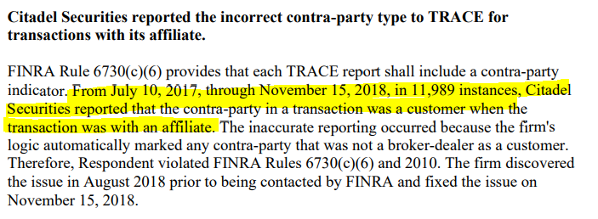
Call this the smoking gun.....
Really.... it doesn't get much more obvious than this....
Citadel Securities gets busted pushing transactions into the TRACE system when they were really just
internal transfers between SPEs....
They're then cited for failing to indicate a No Remuneration transaction with affiliated parties....
And finally, they "misclassified" the nature of the contra party in 11,989 transactions, saying they were
customers instead of their own... you guessed it.... SPEs..
____________________________________________________________________________________________________________
Want more? Check out this disclosure from Citadel Securities....
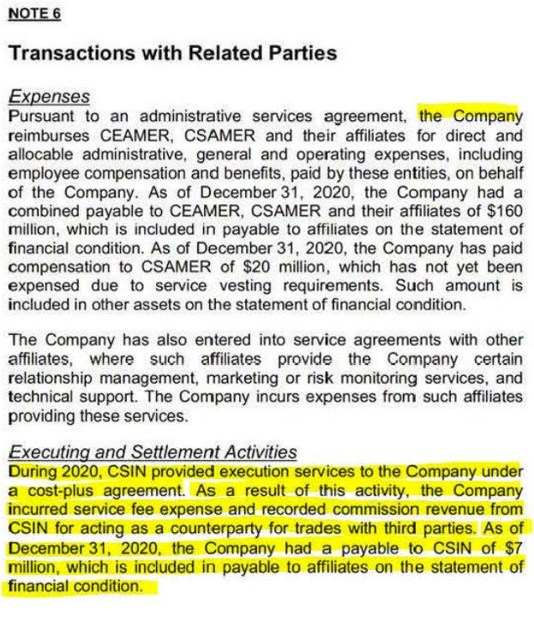
Citadel Securities Institutional (CSIN) provided execution services to Citadel Securities under a cost-plus
agreement..
huh.... cost-plus..... sounds a lot like a remuneration agreement.... because it is.
____________________________________________________________________________________________________________
Let's bring this all together, shall we?
1. Citadel Securities sells treasuries to "affiliate" parties, such as Citadel Securities
Institutional
2. Citadel Securities marks (most) of their transactions with a 'No-Remuneration' indicator
after selling the security to the "affiliate" party.
3. To FINRA, this complies with TRACE because it looks like a typical transaction without a
markup / markdown on the price of the treasury
4. At the end of the month, Citadel Securities reimburses Citadel Securities Institutional for
the cost of their treasury purchases, plus an little more in profit for their services
5. Citadel Securities records the commission revenue from Citadel Securities Institutional
once the treasuries are finally sold to the outside party
Did you catch the loophole?
Citadel Securities is able to remain compliance with FINRA because they pay for the services (markup /
markdown) provided by Citadel Securities Institutional AFTER the transactions are cleared through this
system... they just disguise them as "service fees".
Instead of paying DURING the transaction, by remuneration, they simply leave it off the books and hide
it on their financial statements....
____________________________________________________________________________________________________________
If you're wondering where the SEC is in all of this mess, listen up.
THE SEC AND FINRA ARE BOTH REGULATORY AGENCIES FOR FINANCIAL INSTITUTIONS.
I am now 100% convinced that the SEC has given the responsibility of investigating fraud to
FINRA, while the SEC 'works' on creating the legislation to stop these acts...
However, it appears the SEC and FINRA are working as totally separate agencies while the SEC is
supposed to be overseeing FINRA.... I'm convinced the money flows directly to the SEC from
FINRA fines and the SEC is at risk of losing that revenue if they actually start cracking down on
these pigs.
I am presenting a genuine case, here.
If you're wondering where the auditor (PWC) is in all of this, they just have to verify the statements are
FAIRLY PRESENTED. THEY DON'T HAVE TO SAY ANYTHING ELSE! All audit firms are now in the
business of consulting, like Arthur Andersen did with Enron. They all sit in a room and discuss
the best way to present this sh*t without looking like a giant fraud.
You want to see how bad the situation has become? Check out this 10K (PG 4) from one of Citadel's
recent 13G/A filings on 2/16/2021. Keep in mind, this is an acquisition company that specializes in
purchasing companies that are headed for bankruptcy...
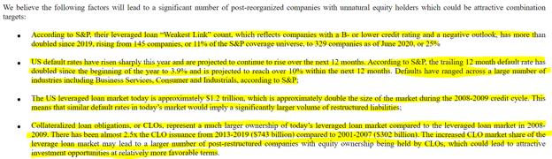
MUDRICK CAPITAL ACQUISITION CORPORATION II
This is so much more than speculation..... Citadel is a duck.
DIAMOND.F*CKING.HANDS
This is not financial advice
Back to Table of Contents
I've estimated the current SI% based on the SI
Report Cycle and Deep ITM CALL purchases.
DD 👨‍🔬
0. Preface
Not a financial advisor. Yada yada. If you actually listen to me you might want to get your brain checked
for crayons.
Probably no need for any more DDs from me after this one - its a cumulation of my thoughts over the
past few months. People were interested in an SI% estimate so I thought, hell yeah, that's interesting
shit. Why not?
On a side note, I've learned pretty much everything I have about the stock market from Peppa Pig. Good
stuff. Definitely recommend.
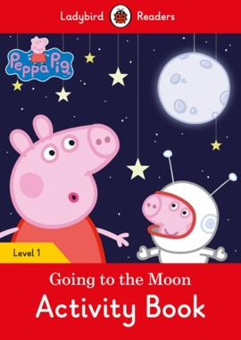
Once again I'll be referencing charts from the mastermind /u/broccaaa and their post The Naked Shorting
Scam. Go read that shit. Seriously.
Also, sorry. TLDR is very difficult besides the bullets of Section 0 and my calculated result in Section 2.
0. What's Going On Here?
I've posted a few DDs in the past, and have basically come to the conclusion of the following per the data
I've seen. I'll show you a few charts from /u/broccaaa's post to support this:
• The price movements we've been seeing, both volatile moves up and down, are
caused by the shorters themselves by holding back buy pressure and then
unleashing it at a later date. They are the reason we see bursts of high volume and
large surges on certain days. This is due to the "SI Report Loop" that they're
trapped in, paired with the fact that there are no more shares left in GME and there
have been no shares for quite some time. I'll go into more detail in the next section
because it is the basis of the SI% calculation.
o They held back buy pressure from May 1 to May 12, and then it
started to be unleashed on May 13. Refer to Section 1 where I discuss
the SI Report Cycle.
• I do not believe they are delaying FTDs or hiding FTDs. Ever. They are satisfying them
immediately with fake shares and simply hiding their ever-growing SI%. This is why we
never see the "FTD squeeze" theory play out. They aren't juggling a pile of FTDs - they're
simply adding to their ever growing short position until they inevitably get margin called
from too high of a risk. (Hello??? Reverse repo loans coming out at higher frequencies
lately?!)
• Each type of option is used for a very specific play. We see large purchases of OTM PUTs,
ITM PUTs, OTM CALLs, and ITM CALLs popping up in anomalies.
o OTM PUTs = Used to hide their SI%. This has no effect on the price of
GME because these are not being exercised and they maintain OI even until
expiration. The shorters are using these to hide their SI% from the world.
The main counter-argument to the MOASS is "their SI% is 20%, they
covered". So if you're a shorter and you hide your SI%, you can push that
narrative that you covered and hope people sell. Supporting Data: Figure
1, PUT OI Versus SI%. Check out how SI% drops when PUT OI
skyrockets.
o ITM PUTs = Used to flash crash the price. This is an expensive move and
I believe we only saw this happen once, on March 10. This is a last-ditch
effort move where you mass exercise ITM PUTs to crash the price down
from a critical point. If you don't remember - March 10 the price hit $350
before being flash crashed down. They have purchased up many more ITM
PUTs lately, so they might attempt this again. Supporting Data: Figure 2,
PUT OI For Options, March 9 to March 11. Look at how the PUT OI
dropped on March 10, indicating mass exercise of options to flash
crash.
o OTM CALLs = Used by other large players who want a profit. We only
just recently started seeing these from what I can tell. I'm assuming that
because these just started popping up that other big players are looking to
make some cash. The ones that were purchased expire on July 16, 2021.
They might be hoping for the squeeze before then and maybe thought
$140 was the bottom.
o ITM CALLs = Used by shorters to filter synthetic shares through and
satisfy FTDs. These purchases occur a lot when FTDs pile up. I believe that
they continue to use this in conjunction with Citadel in order to fulfil FTDs
because there is no liquidity. These options have an effect on price because
they are immediately exercised so that the shares can be
delivered. Supporting Data: Figure 3, ITM Call Volumes Versus FTDs.
Deep ITM CALL volume skyrockets when FTDs increase.
• And my most important finding: shorts r fuk
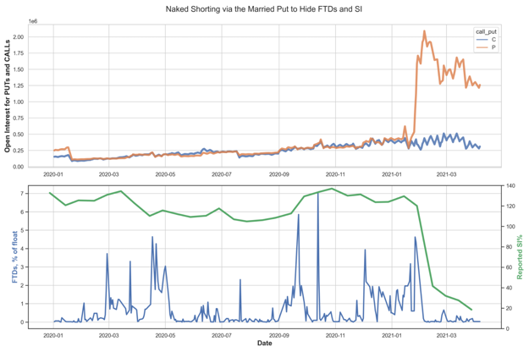
Figure 1: PUT OI Versus SI%
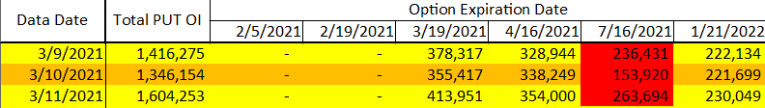
Figure 2: PUT OI For Options, March 9 to March 11
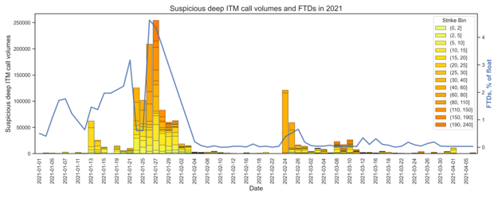
Figure 3: ITM Call Volumes Versus FTDs
1. There Are No Shares Left. Every Share Being Bought Is
Synthetic
Well, at least most of them are synthetic. A vast majority are synthetic due to SI% being over 100% since
December. You don't just suddenly find liquidity in GameStop after naked shorting the shit out of it. It's
going to have to be continuously naked shorted (and produce synthetics) to satisfy buyers until the
MOASS. Otherwise, whoopsie. They'll have to start unwinding a bunch of FTDs from being forced to
deliver (and find the shares). So instead of that route, they'll make fake shares for the FTDs.
I've been trying to understand what the hell has been going on with the price. Why did it surge in
January? Why did it surge in February? Why March? Why did we see volatile jumps all over the place?
Why does buying pressure seemingly get negated? T+13? T+21? T+35? No, no, no. It is all SI Report
Loop. They're stuck in that loop and can't get out. I've talked about this in my other DD but I'll recap
because it's very relevant here for why we can use ITM CALLs to calculate SI%:
The shorters are stuck in a loop revolving around Fina Short Interest Reporting. What exactly is this?
FINRA requires firms to report short interest positions in all customer and proprietary accounts in all
equity securities twice a month.
There's three columns on that link. What are they:
• Settlement Date: The date at which short interest positions must be determined.
• Due Date: The date at which the report of the SI from the settlement date is due by.
• Exchange Receipt Date: The date when FINRA finalizes the reports and delivers them.
You want to make sure that your short positions are hidden by the Settlement Date so that it pops up to
the world on the Receipt Date. For example, they opened up a shitload of OTM PUTs (Figure 1, PUT OI
Versus SI%) prior to January 29th Settlement. Upon February 9th, SI% dropped like a rock. As long as
short positions are hidden or covered by the Settlement date, then the receipt date will not take those
into account.
Refer to Figure 1 on PUT OI skyrocketing when SI% dropped. At that point in time (early February), they
could claim to the world that they covered, and they did claim that, but they actually just hid their short
position from the world's eyes.
Here's a copy/paste of the dates for 2021. I'm going to only copy the ones through the start of June:
Settlement Date Due Date Exchange Receipt Date
January 15 January 20 January 27
January 29 February 2 February 9
February 12 February 17 February 24
February 26 March 2 March 9
March 15 March 17 March 24
March 31 April 5 April 12
Settlement Date Due Date Exchange Receipt Date
April 15 April 19 April 26
April 30 May 4 May 11
May 14 May 18 May 25
May 28 June 2 June 9
June 15 June 17 June 24
So we can say that between each Settlement Date is a loop where they'll have new shorts open up, and
then they want to hide those new shorts by the next Settlement Date so that it doesn't appear on the SI%
report and increase it. (Imagine if one day we saw SI% jump back up from 20% to 140% or more.
Imagine the headlines. They can't risk that happening).
And what exactly goes on between each loop? Let me bring up my handy-dandy chart again before
continuing. I've plotted the Settlement Dates here and boxed volatility moments. You'll see that there is
ALWAYS a volatile move up and a volatile move down between these dates.
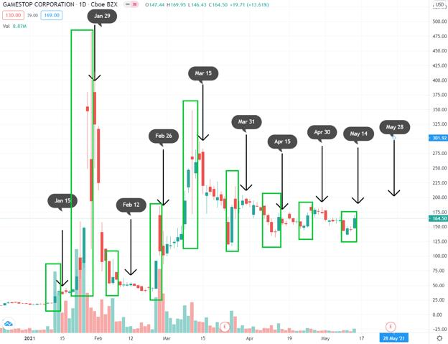
Figure 4: SI Report Loop And Volatility
Here's what I am assuming happens:
1. Retail starts buying. They (Citadel & Co) create synthetics to match this buy pressure
because there's no liquidity/no shares available. This negates buy pressure and any
additional shorts (iborrowdesk) helps drive the price downward.
2. Retail doesn't get their shares delivered. FTDs start piling up. The synthetics created in
#1 and the shorts that were opened in #1 need to be hidden by the next SI report date
otherwise it will pump the SI% up again. The FTDs must be satisfied as well or it will start
an unwinding of their massive web of bullshit.
3. They feed these synthetics into Deep ITM CALLs that are then purchased up, exercised,
and used to satisfy the FTDs that were created by retail buying. This process drives the
price up. Retail now owns more fake shares and their overall short position continues to
grow.
4. Combination of #1 and #3 cancels out the downward pressure on the price. GME creates
a higher low as long as retail didn't sell. If you look at the GME price chart, you'll notice
how it continues to create a higher floor between each SI Report Cycle. Basically, the
"true" GME price is revealed after #1 and #3 cancel each other out because it shows how
retail buying increased the price relative to the prior SI Report Cycle.
5. Any additional shorts they have will be pushed under the rug with OTM PUTs.
Each cycle they continuously grow an ever larger short position and thus an ever larger SI% with these
synthetics and additional borrowing. Meaning they continue to have higher risk, and their margin call
price slowly moves downward. They keep making it worse for themselves. Every cycle they spend a
little money kicking it down the road. Every cycle the price floor rises. Every cycle they increase their
short position.
You know how we see >=50% short volume each day? That's most likely them pairing 1:1 with retail
buys for synthetics so that they can be later delivered through ITM CALLs. A bold assumption of course,
but it could be relevant and might explain why we've been seeing that data of short volume.
That's why I believe that the volatile price movements both up AND down are caused by the
shorters themselves by holding back buy pressure and then unleashing it at a later date. They are
the reason we see bursts of high volume and large surges on certain days. They suppress the buy
pressure with synthetics, but then must deliver those synthetics to satisfy FTDs. Upon exercising
the ITM CALLs to deliver these synthetics, they cause the price to surge upward.
I am assuming that every one of these Deep ITM CALL purchases are synthetic-covered and thus
100 fake shares per contract.
2. Assumptions In Calculating SI%, And Results
We're assuming that the Deep ITM CALLs are not used to hide FTDs but they are rather used to
satisfy the FTDs immediately with fake shares. This is most likely why we never saw the "hidden FTDs"
pop out again to support the FTD squeeze theory. Because they've already been delivered, and the
synthetics keep pumping into their total SI%. So they're in the process of juggling an ever-increasing
SI% position while the price also continues to rise.
Per /u/Dan_Bren, between March 1st and March 11th, inclusive, there were approximately 27,650 Deep
ITM CALLs purchased. If we assume that all of those were to fulfill FTDs and are synthetic due to no
liquidity in the market, then that comes out to 27,650 * 100 = 2,765,000 synthetic shares from March
1st to March 11th.
In another post, on April 1st, there were approximately 5,960 Deep ITM CALLs purchased. Likewise, this
equates to 5,960 * 100 = 596,000 synthetic shares on April 1st.
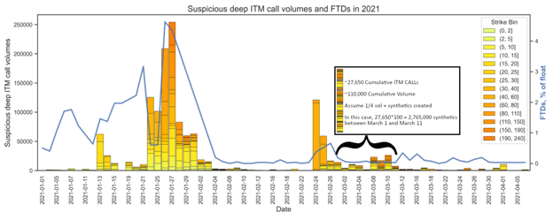
Figure 5: Cumulative Deep ITM CALL Volumes, March 1st to March 11th
Look at the volumes between March 1st and March 11th compared to everything else. Oof. All those
blips of ITM CALL anomalies is nothing compared to January and the spike in February.
To be conservative I'm going to ignore straight up "volume" and rather calculate SI% based on a ratio
of /u/Dan_Bren's data to the volumes we see. Here's results based on March 1st to March 11th, and April
1. I'm going to do an even value closer to the lower bound of 0.25 to get our "Average". It just makes the
math easier.
March 1st to March 11th April 1
Cumulative ITM Calls 27,650 5,960
Cumulative Volume ~110,000 ~14,000
Ratio of Volume to CALLs ~0.25 ~0.42
"Average" Ratio ~0.3
Since we don't have historical data prior to 3/1, I'm going to use these two data points (March 1-March
11, and April 1) as our estimated "synthetics created" per volume.
With a conservative estimate, we'll say that we get 30 synthetic-covered CALLs that are exercised for
every 100 volume (0.3 ratio). And thus 3,000 synthetic shares per 100 volume.
Let's tally it up based on Figure 5. I'm doing approximations for volumes because I do not have the data
sheet that was used to create this figure. It's also easier to work with even numbers. Sorry for the long
table.
Approximate Synthetic Approximate Synthetic
Date Volume CALLs (Volume*0.3) Shares (CALLs*100)
Janaury 7 3,125 938 93,800
January 11 3,125 938 93,800
January 13 62,500 18,750 1,875,000
January 14 25,000 7,500 750,000
January 15 12,500 3,750 375,000
January 19 13,000 3,900 390,000
January 20 6,250 1,875 187,500
January 21 10,000 3,000 300,000
January 24 125,000 37,500 3,750,000
January 25 100,000 30,000 3,000,000
January 26 210,000 63,000 6,300,000
January 27 260,000 78,000 7,800,000
January 28 80,000 24,000 2,400,000
January 29 61,500 18,450 1,845,000
February
1 62,500 18,750 1,875,000
February
2 18,750 5,625 562,500
February
3 13,000 3,900 390,000
February
4 3,125 938 93,800
February
5 3,125 938 93,800
February
8 3,125 938 93,800
February
9 6,000 1,800 180,000
February
10 3,125 938 93,800
February
11 1,000 300 30,000
Approximate Synthetic Approximate Synthetic
Date Volume CALLs (Volume*0.3) Shares (CALLs*100)
February
16 1,000 300 30,000
February
19 3,125 938 93,800
February
24 120,000 36,000 3,600,000
February
25 60,000 18,000 1,800,000
February
26 14,000 4,200 420,000
March 1 13,000 3,900 390,000
March 2 4,000 1,200 120,000
March 3 10,000 3,000 300,000
March 4 8,000 2,400 240,000
March 8 24,000 7,200 720,000
March 9 15,000 4,500 450,000
March 10 26,000 7,800 780,000
March 11 6,500 1,950 195,000
March 12 2,000 600 60,000
March 15 2,000 600 60,000
March 17 6,000 1,800 180,000
March 18 3,125 938 93,800
March 25 3,125 938 93,800
March 29 3,125 938 93,800
March 31 4,000 1,200 120,000
April 1 10,000 3,000 300,000
Total 42,713,000
Yup. Assuming only 30% of the volumes resulted in actual synthetic CALLs being exercised to cover
FTDs, we come up with a potential of 42,713,000 synthetic shares being created between January
7th and April 1st.
Just for fun though, and I'm sure some of you are curious. Let's assume 100% of the volumes were
accounted for. What would that give us? Dun dun dun... 142,375,000 synthetic shares. But I'll stick with
the conservative estimate for now. Just thought I'd slap that in there for fun.
Now let's assume that these were all NEW synthetics created because the SI was already over 100%.
(Why else would they be buying these? The assumption is ITM CALLs are necessary for zero liquidity.)
So we'll take the peak SI% since shitheads never covered and never will cover. The SI was 141% at its
peak. Since 141% is based on 55,000,000 float, we'll say the original short position was 77,550,000,
resulting in a grand total of 120,263,000 shares short as of April 1.
What is the theoretical SI% now with our estimated shorts/synthetics just up to April 1st if the GME
float is either 55,000,000 or the theoretical 30,000,000 as of late?
GME Total Float SI%
55,000,000 218%
30,000,000 400%
Oh dear god. That's a lot of tendies.
They're amassing such a huge position that keeps growing every single SI Report Cycle. It's no surprise
these reverse repo rates are coming out more frequently and in larger sums. They are battling a massive
risk position now and GME is continuing to rise in price. They've got to be on their last legs.
GME has been edged so much and so long that when it explodes it's going to rip a hole in the fabric of
space and time and the simulation we live in will crash.
Cheers apes. I'll see you on the other side.
Back to Table of Contents
Glacier Capital Exists - And It's Much Spicer
Than You Thought
DD 👨‍🔬
(Skip to !!!!!!! - This was the initial part of my investigation. Skip to that bit. Promise.)
In the linked in profile, they are advertising for one position in China with email domains
for glacierchina.com
Running the advertisement through Google Translate, we can see that they have a public WeChat
account: GlacierCap.
Throughout the rest of the job post, they refer themselves to Gengxin Capital.
Introduction:
Founded in September 2018, Gengxin Capital is an enabling boutique investment bank. The founding
team comes from core members of companies such as LAZARD, Yuanhe Chenkun, Kaisheng Rongying,
Huafeng Capital, Blue Lotus Research Institute, Analysys International, and has extensive contacts in the
capital market, Internet, and technology industries.
Gengxin Capital is committed to deep participation and long-term empowerment in the value creation
and value discovery of technological innovation companies that are the engine of global economic
growth and unicorns generated in the tide of inclusive consumption in China. Since its establishment, it
has assisted 26 projects to complete financing, with a total financing of 5.36 billion yuan.
Additional information I can tell you about the Chinese domain is that while it was initially registered in
2018, the Registry of the domain (RDAP) has been updated within the last 24 hours. Circumstantial, but
the domain for the Chinese email accounts do not have anything else allocated to them other than their
emails.{"eventAction":"last update of RDAP database","eventDate":"2021-03-14T06:57:12Z"}]
Registered with Alibaba.
Source material: https://whois.aliyun.com/rdap/domain/GLACIERCHINA.COM
-------
!!!!!!!!!!!!!!!!!!!!!!!!!!!!!!!!!!!!!!!!!!!!!!!!!
Bringing it back to Glacier Capital in Lux, I ran a WHOIS on the Domain and got a different address
than u/timmmmmmmyy.
Domain name holder
GLACIER CAPITAL SARL
18, rue Jean Oster
LU - 8146 Bridel
https://www.google.com/maps/@49.6582799,6.0771793,3a,75y,326.47h,77.66t/data=!3m6!1e1!3m4!
1sqXom6bxDm2-6Pd1NdeLZEw!2e0!7i13312!8i6656?hl=en-AU
Wonderful, modern house. Could hold 4 employees in the silo looking part next door, but otherwise a
suburban street.
------
The official business registration yields the same address as u/timmmmmmmyy
Buisness ID: B212426
A new player has entered the game, Norbert Raymond Becker. Owns 48.08% of Glacier Capital, where
Marc-Francois Joseph Daubenfeld owns 51.92%. Both Luxembourgers.
(I'm looking to upload the supporting paperwork - standby).
(EDIT GOES HERE: https://imgur.com/i9lTtDc Verifiable at https://www.lbr.lu/ which is the
Luxembourg Business Register. Put the above Business ID into the "RBE" which is the Beneficial Owners
Registry.)
---
What's Norbet up to?
He has a Directorship at Lia Holdings Limited. (Very close to Liar, lol). with the following address - 52
LIME STREET, LEVEL 27, LONDON, EC3M 7AF
Fancy new building there for Norbet. What's on level 27, the registered address for Lia Holdings
Limited?
https://www.thescalpelec3.co.uk/#Neighbourhood
Level 27 holds Lombard International
https://www.thescalpelec3.co.uk/wp-content/uploads/2020/12/SCA005_Scalpel_Floorplans_V32.pdf
https://pomanda.com/company/12049264/lia-holdings-limited
This looks more like a spicy meatball. We have a list of other directors in London that we can chase
down, along with business names that contain the word CAYMAN in them. Niiiice.
So.... who is this rag tag bunch of professionals for Lia?
https://www.lombardinternational.com/en-US/About-us/Leadership-team
Oh look - Hi Norbet! He isn't a small fish either - used to be Global CFO for EY (one of the big four
consulting and accounting firms in the world).
I see that they have their funds managed by Blackstone, a fairly large and spicy meatball in the U.S (I
know this because they just tried to buy a Casino group in Australia).
I must say that many of the board on Lombard International Group are not small fish - international
Chief Investment Officer of HSBC is a spicy meatball (Stuart Parkinson) or a senior figure of Blackstone's
Tactical Operations Group in Qasim Abbas (sounds like a lame Bourne movie).
So what has this got to do with our situation?
https://www.businessinsider.com.au/blackstone-and-citadel-have-reportedly-held-deal-talks-2019-
10?r=US&IR=T
Fuck. Off.
TL:DR - The strawman at Glacier, whom has a Residential Office but has a 48% owner in the
former Global CFO of EY Norbet Raymond Becker, who sits on the Board and is Vice Chairman of
Lombard International Group, whose funds are managed by Blackstone, whom have been
looking to merge with Citadel going back to 2019.
Edit: Adding the screenshot for the Public Record of Beneficial Owners of Glacier Capital, which ties
them to LIA, which ties them to Blackstone Tactical Operations, which ties to
Citadel.https://imgur.com/i9lTtDc
Edit2: Do not confuse BlackRock (who are long on GME and are listed as an institutional investor in
GME) to Blackstone, the company listed above. Have a read of this 2018 article. To help remember,
Blackstone = BS = Wanted to merge with Citadel in
2019. https://www.economist.com/business/2018/01/13/blackrock-v-blackstone
Back to Table of Contents
All Shorts Must Cover. They're Entering The
Danger Zone. The SI Report Loop Consistently
Brings Us Ever Closer To The Squeeze.
DD 👨‍🔬
0. Preface
This is your daily hit of hopium. In this case maybe a full rip of it since I see many people discouraged
about 002 - but there is no need to worry. I want to show you that apes are winning and shorts are
losing. You hold, you win. (But please note I am not a financial advisor. I don't want you guys bitching at
me if you YOLO it on deep OTM options expiring within 24 hours).
It is my belief that we do not need ANY of the new rules for the MOASS to occur. These rules were
created for the purpose of preventing future stocks from ever being in the same position that
GameStop is in. Think of it as they're introducing rules to ensure that a January runup in another stock
never occurs again post GameStop MOASS:
• The DTCC will no longer have a 'pool' of collateral. Now the members will be hurting
more and its easier to hit a margin call. High volatility up = 1 hour margin call from 801.
• No more delaying FTDs. The DTCC will catch any attempt at this and shut it down.
Volatility from FTDs can't be suppressed = 1 hour margin call is easier to push through.
• Positions will have much more visibility to the DTCC and risk always calculated. No
more hiding from the margin calls during high volatility.
Again, all the bullets above are to prevent future stocks from squeezing. They never want this to
happen again. Remember Tesla? It slow squeezed upward without any of these rules on a 15% SI. It's
going to happen to GameStop eventually.
All I'm saying is don't get discouraged! Things can ignite literally any moment - and they will ignite,
with or without the DTCC rules.
1. The Price Floor Is Moving Towards The Danger Zone.
On January 25th, 2021, Melvin received a total cash injection of $2.75 Billion. The price spiked
to $159.18. So they were cutting it pretty close at that point - or at least, it was preemptive because
Shitadel and Point72 knew things would spike a little bit more and this was to avoid the inevitable call
from Marge. On another note, they absolutely hate the price of $350, which is where we saw the January
and March peaks.
So it's probably safe to assume that somewhere in the range of $160 and $350 is when our good friend
Marge will give them a call. We can apply $160 here because that's around when Melvin got bailed out
by his buddies, and them bleeding money over time could eventually make $160 the margin call price
point. They can't continue this forever. And it shows. They are slowly but surely running out of time.
How fast they are bleeding money? Eh, I don't know. I saw some linear predictions of the margin call
price and that prediction could very well be true or very close to being accurate, but I'll leave it as a
range for now instead of a "THIS IS THE PRICE TARGET WE'RE WAITING FOR!"
It's literally just a war of attrition while the apes have infinite supply of time as we approach and enter
what I like to call the DANGER ZONE. Kenny G and his friends are on that highway right now and have
been ever since January.
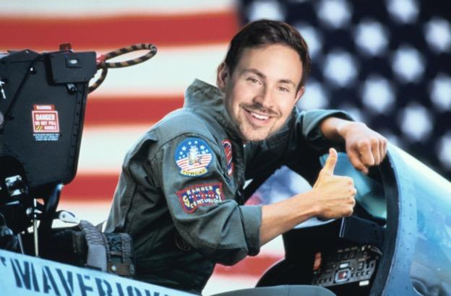
Source: Ryan Cohen in Top Gun (1986)
You'll start to notice something wonderful when you look at the charts starting from January and ignore
the trend downward but rather look at the trend upward. Your doubts should erase from your mind
when you notice it.
GME did a very quick decay from the January spike, and then a very slow decay from the March spike.
Felt like it was going down in price, and the shorties were winning, huh? So I'm just wondering - how
would you have felt if this was the chart we saw instead? What if the price decayed really quick in
March again and then settled around $120?
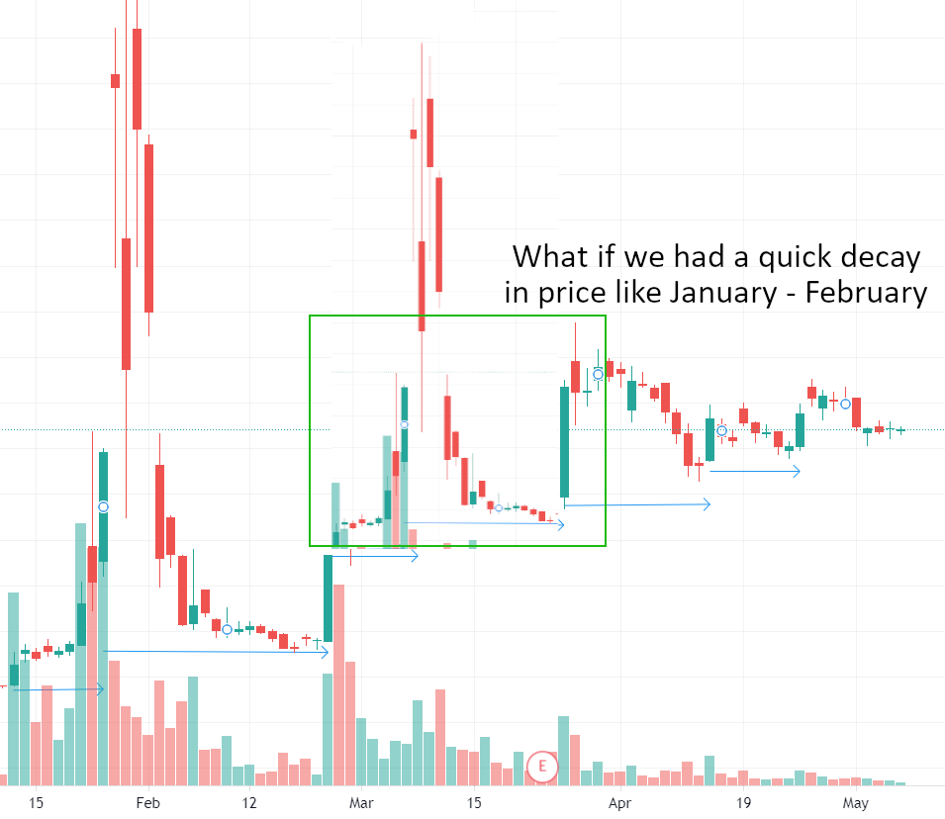
Hm. I'd feel completely different. Give me that sweet sweet hopium hit. It would have no longer felt like
it was going down in price but continuing to rise in price. The slow bleed from
around $220 to $160sucked - though trusting in the DD certainly helped. Now, imagine that SAME
squeeze pattern on top of the arrows I drew. Let the price decay quickly in your mind. See what's going
on here?
I only needed to bust out one crayon 🖍️ from my mega 96-crayon pack for this chart. The price floor
(blue line) is continuing to rise. Not only this, we're just now entering the DANGER ZONE!!
(purple box). While it appears we are on a downtrend from looking at the decay in price from $220 to
$160, GME is in fact going to higher and higher floors on these smaller and smaller bursts up. (FTD loop
theory is right boys and girls, but I don't think it's been ironed out yet).
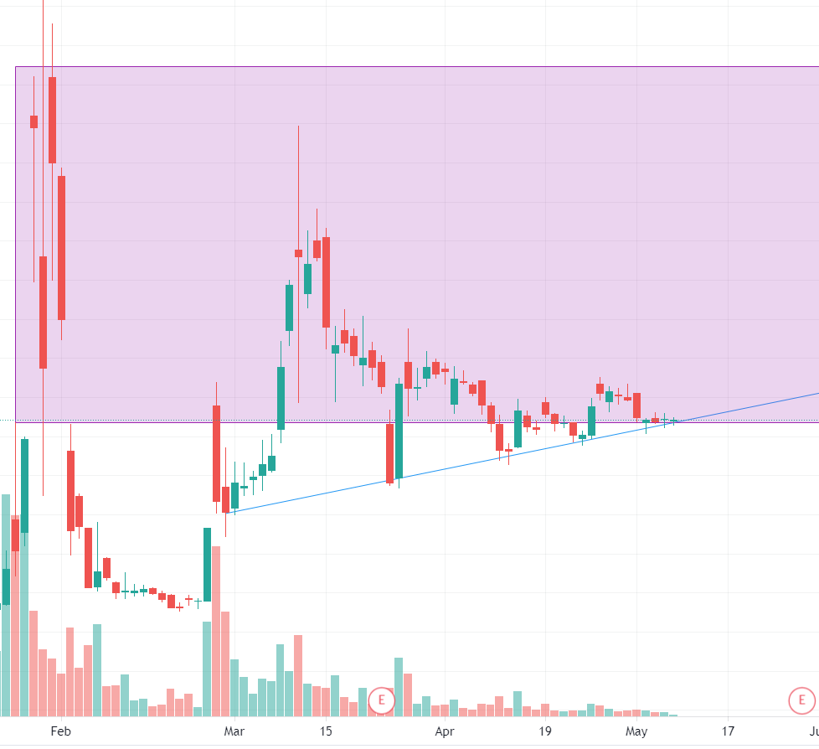
GME Price Floor Rising Into The Danger Zone
Well well well. The price floor continues to rise in this dampening effect of price peaks and troughs. It's
not going down! It's already going into the GODDAMN DANGER ZONE! They are growing weak at trying
to suppress the price. Their efforts can't contain it forever.
Now keep in mind, this is not to say that it is over once we're in the purple box. It is to say that the longer
we stay in the purple box, the closer and closer we get to the margin call price. I can hold out for it - can't
you? It's almost time for you to pick out your favorite lambo model.
Anything can kick this over the edge and finally trigger the MOASS without 002 and 801. We're already
stable at the price that GME spiked when Melvin received their cash injection. It's really just a
matter of time at this point, because their attempts to kick the price back down are dampening.

The longer this drags out, the higher the price floor becomes, until it kicks off.
• GameStop could find over 100% of their float voted and initiate a price spike, possibly
through a recall.
• The entire market could tip just one way out-of-favor of the shorts, causing their margin
price to drop.
• A long whale gamma squeeze can spike us into margin call territory long enough for the
natural margin call (non-801) to occur.
• GameStop can slowly bleed upward until the critical danger zone price is hit with no
other catalysts.
• Or perhaps, another FTD loop spike pushes GME over the edge. Let's investigate
this to try to iron out the missing pieces of the FTD loop theory.
2. Hello FTD Loop - Or Should I Say SI Report Loop
This isn't T+21 or T+35 or anything. But I think it might finally paint the picture of why we have theories
ranging from T+13 to T+21 to T+35, and everything in between. We definitely have a loopthat is
occurring. And it's most likely due to something called Short Interest Reporting from FINRA.
Short interest?! That's two words we're all very familiar with. What exactly is this?
FINRA requires firms to report short interest positions in all customer and proprietary accounts in all
equity securities twice a month.
There's three columns on that link. What are they:
• Settlement Date: The date at which short interest positions must be determined.
• Due Date: The date at which the report of the SI from the settlement date is due by.
• Exchange Receipt Date: The date when FINRA finalizes the reports and delivers them.
Ah nice. So if you were a shortie in January and your SI% is well over 100% of the float, and the world
thinks you haven't covered because of the high SI%, then you might want to drop that SI% number
down! If you maintain a low SI% for a long time, then the world will believe the squeeze is done for and
you can claim that you've covered your positions. In order to drop your SI% that will be reported on the
Receipt Date, you'd want to hide your short position before EOD of the Settlement Date.
You risk causing a mini squeeze right here. AKA the "Fake
Squeeze" of January. But you MUST try it to shake off the
holders. Dump it all. Pretend you covered. Hope that the apes
sell.
Here's a copy/paste of the dates for 2021. I'm going to only copy the ones through the start of June:
Settlement Date Due Date Exchange Receipt Date
January 15 January 20 January 27
January 29 February 2 February 9
February 12 February 17 February 24
February 26 March 2 March 9
March 15 March 17 March 24
March 31 April 5 April 12
April 15 April 19 April 26
April 30 May 4 May 11
May 14 May 18 May 25
May 28 June 2 June 9
June 15 June 17 June 24
You could look at the Receipt Dates and say, "Hey! We spiked/dipped there! January 27, February 24,
March 9, March 24! So the next spike would be May 11!", but not necessarily. It's interesting how some
spikes occurred on a few of the receipt dates. I mean, the price certainly could spike again on May 11,
but that's probably going to be a coincidence once more. I'm more interested in the Settlement
Datecolumn.
Like I said earlier, it appears that they'll want to stuff away their shorts on days up to and
including the settlement date. When this happens, we get volatility in the price due to the ITM CALL +
OTM PUT tricks they've been using. The price spikes up, then crashes down. Or vice-versa. And this
is consistently happening. Here's a few thoughts that I'm unsure of, but would like to propose:
• It's possible that a bunch of their shorts pour out after being hidden at critical dates,
which result in massive ITM CALL and OTM PUT purchases prior to settlement dates,
which consequently spikes/crashes the price in much larger movements. This could be
why we're seeing smaller movements (February 12, April 15, April 30) because fewer
shorts are popping out and we're waiting for a big pour out again.
• They like to waste money on flash-crashing the price, probably through exercising a
bunch of PUT ammo, while simultaneously suppressing the SI% and moving FTDs out
once more with ITM CALL and OTM PUTs (February 26, March 15, March 31). This
bleeds them money when spikes occur, and thus makes the Danger Zone ever closer
with a slowly incrementing price floor.
• The overlap of a bunch of their shorts pouring out and FTDs having to be reset occurs on
these large movements (January 29, March 15, Some future date?)
• This is why we see discrepancies between T+21 and T+35 and dates in-between. It's not
a cycle on those exact dates but rather any days before the settlement date.
To help visually, I plotted each settlement date on the lovely GameStop chart starting in January. You can
see that prior to every single receipt date, some kind of volatility occurs. Even for February 12, I
would argue that the spike/drop from February 5 to February 6 was one of these volatile movements,
though ever slight of a movement like we're seeing now.
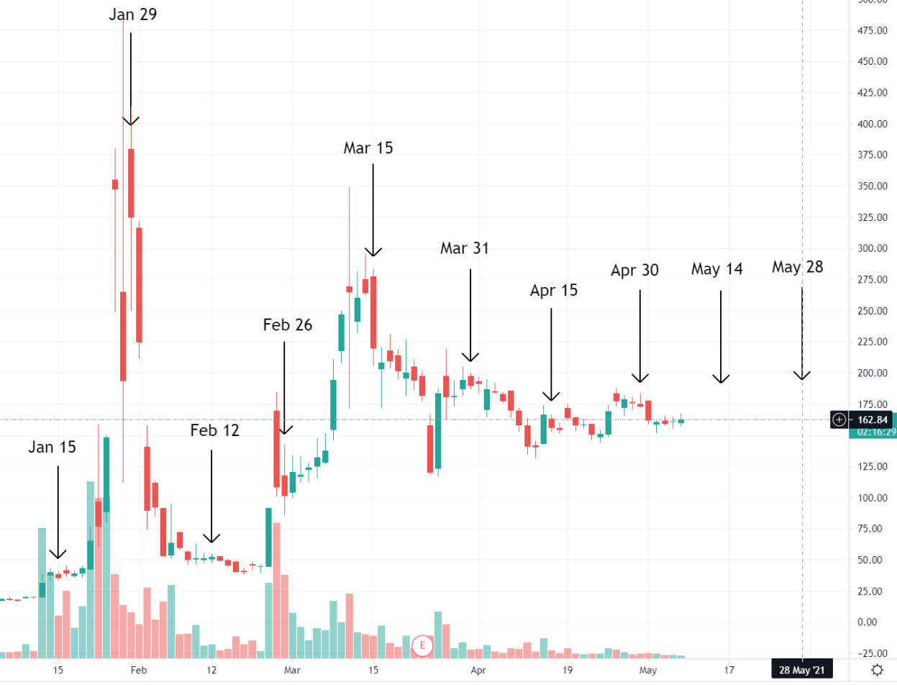
So, what does this mean? Well, it's not a date but more of a "watch for shit to go down close to or on
these Settlement Dates (May 14, May 28, June 15, etc.)". The next few Settlement Dates could
continue to be dampening with smaller and smaller volatile movements. But they could also be a
repeat of the January, February, or March spikes due to the possibility that a ton of shorts and FTDs
will need to be brushed under the rug once more.
• If GME spikes again due to this, they could attempt to flash crash the price once more.
• If GME spikes again due to this, and they are unable to flash crash the price, they'll be
sitting higher in the DANGAH ZONE.
• Regardless, we can assume the price floor will continue to rise. Perhaps since we
are at a critical point here of $160 and it has been dampening to an ever smaller volatile
swings around $160 - that we will see a huge burst again just like January, February, and
March in order to maintain that ever-increasing price floor.
It sounds like I'm covering my ass because I said it could spike significantly or not at all lol. But I think
there's enough data points here to assume that volatility will always occur prior to the next SI
Report Settlement Date. Whether or not it is a big jump depends entirely on the amount of shorts and
FTDs they need to hide. When do those pour out? Is it a specific date? That's what I'd like to find out.
Personally I still believe April 16, 2021 caused something big that is coming. You don't just have all
these banks + Shitadel working overtime day and night as of that date and not prior to it. If a big
amount of shorts popped out of April 16 and they did not hide a lot of them prior to April 30
settlement, then the receipt date of those positions is May 11.
• Note: Receipt date of May 11 does not imply a price spike will occur. This implies that
the next SI% report could cause a SI% spike if April 16 shorts popped out and
were unable to be hidden by April 30.
• If the next SI% report date shows a spike in SI%, then its very possible that a portion of
their hidden short position will be calculated into their risk, and the margin call price
will go further down in the danger zone, making the tendies that much closer.
3. Conclusion
We're reaching a critical point here, and its obvious that the shorters are going to lose. Apes will win.
Don't get discouraged. Anyone telling you you're crazy might be right - that you're crazy just in a general
sense - but you're not crazy for believing in GME.
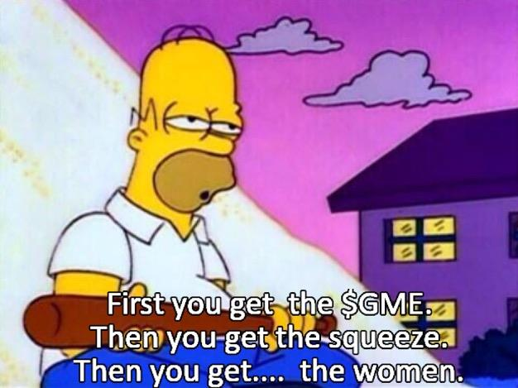
Blast off from here with some hopium / TLDR:
• Melvin received a $2.75B injection on the day GameStop spiked to $160. They have flash
crashed the price from going above $350 every time. It's probably safe to assume they
are entering the Kenny Loggin's DANGER ZONE as of this week which ranges from
$160 to $350. This zone is where the margin call price theoretically lives.
o GME is already stabilizing around this $160 price point. Melvin, are you
scared?
• The Danger Zone will continue to shift down while they bleed money attempting to
suppress the price. The margin call is inevitable. All shorts must cover.
• We consistently see volatile movement at some point in the week or week before
a SI Report Settlement Date. EVERY single date has had this occur. The next
settlement date is May 14.
o This could be only a slight movement just like the past few Settlement
Dates.
o This could be a big movement due to April 16 from an overlap of a large
amount of shorts having to be suppressed and FTDs shifted out (but who
knows).
• Every Settlement Date spike results in an ever higher price floor. The past few
floors, starting Feb 26 through May 7 = $100, $120, $140, $150, $160. This brings us
closer to, and into, the Danger Zone.
• The Settlement Date following April 16 was on April 30. If a bunch of shorts spilled
out from April 16 and they are no longer able to suppress them, then the Receipt
Date on May 11 can result in a spike of SI%. Note: not price spike. SI% spike.
o If the SI% spikes and they now have to include those shorts in their risk
calculations, then that might shift the Danger Zone even lower and make
the margin call price even closer.
Also note to not day trade. Imagine you make the wrong mistake and the volatile movement ends
up being the MOASS. See ya.
The end feels so close. We'll see what the next few weeks bring. 😎
Back to Table of Contents
Tombstone Tweet Confirms Reverse Merger?
Reposted Reverse Merger DD
DD 👨‍🔬
RC TOMBSTONE TWEET
"A tombstone is a written advertisement that gives investors basic details about an upcoming public
offering."
EDIT #1 THANKS FOR ALL THE UPVOTES! I didn't expect this to blowup as I was just reposting it in light
of the tweet. This is my theory based on facts. Also a great timeline of rc involvement with GME.
Gamestop future is very bright in the near term and future. Not financial advice.
Reposting Merger DD
What's RC plan, does he have a plan?
Reverse Merger
Here is what I think Ryan Cohens plan is
Ok I have heard allot of talk about stock splits, reverse splits, dividends or crypto dividends ect on how
RC can shake the shorts.
None of those really go the whole way. Reverse split is out of the question as the stock is not liquid
enough, and there is legal questions surrounding the crypto dividend. OVERSTOCK
Also none of these moves benefit Ryan Cohen and GameStop at the same time. They may hurt the shorts
or help retail investors but none of the options help Gamestop and RC at the sametime.
I have Posted and others have thought about RC buying more GameStop, after reviewing the filings he
can buy up to 20% of the company at any point. This whole time I have been waiting for him to buy,
and thinking that he is waiting for volume to dry up, or to save his ammo to protect the stock if the price
starts to fall.
but there is a serious flaw in that thinking......it doesn't help Gamestop.
I lay out the timeline of RC and GameStop below more in-depth below, but at this point RC has control of
the board and the chairmanship, he doesn't need to buy anymore stock the way normal people do.
GameStop, with the help of RC and his marry band of Apes has erased its long term debt (minus leases)
and raised 555m (a nice down payment on the transformation)
Ryan Cohen wants to own more of GME, most owner/CEO own over 20% of the companies they run.
He is totally invested in the GameStop turnaround, the best thing he can do is a Reverse Merger.
He capitalizes RC ventures with allot of money (500m, 750m, 1.5b) he can even bring in other private
investors.
RC Ventures and GME merge, they create a Holding Company that they both merge into. The holding
company is renamed Gamestop and eventually trades as GME under a new CUSIP#
How does it help Ryan Cohen- He gets ownership of whatever % of the stock at the agreed upon
merger price (it would be the same amount as if he bought on the open market)
How does it help Gamestop- they actually get the CAPITAL, if Ryan buys on the open market they
don't get the money they sold that stock when they issued it. this way Ryan gets to infuse the company
with much needed cash and increase his ownership stake at the same time.
You are probable asking
HOW DOES IT HELP APE - Did you gloss over the part about the CUSIP#...here read this
Example 1 or https://theintercept.com/2016/09/24/naked-shorts-cant-stay-naked-forever/
" Changing the stock cusip number results in each share with the old cusip number having to be
exchanged for a share with the new cusip number, which causes each short position to have to prove the
borrow. Naked short positions would be unable to comply and those positions could have to be covered
by purchasing shares with the new cusip on the open market. "
Now the reverse split or the reverse merger has been tried before and it does squeeze the stock price a
bit, but then it goes right back down. Typically this is because it is done on Penny Stocks and the shorts
can simply cover as its not that expensive or there is not as many Naked shorts as people think.
but what if there is a ton of NAKED SHORTS, then those SHORTS ARE FUCKED. If they sold a bunch of
shares naked and kept doing it without ever thinking they would need to be returned they would be
foreced to buy a TON of GME under the new CUSIP #
ADDITION More research and DD need to be done on how a merger or reverse merger affects
users on ETTORO https://www.etoro.com/posts/0__entry__19ed9016-5e15-4642-be20-
64b8dc9bb89fAdding alpha merger info from Etoro. My take is not to worry if you are on Etoro, there
would be a minimum 30 day period from the announcement of a merger to an actual merger, probably
more. So the stock would squeeze during that period not after. Also any merger would cause a change in
cusip number.
Remember Citadel Securities is the DMM for GME right now if they change their cusip number they can
change DMM OR CHANGE EXCHANGES.
SHortsplan was never to cover
I have been writing a DD where I believe that Citadel and SUS has been stashing their Naked options
sales or Naked short sales in Sold not yet purchased liabilities which are Ballooning. Citadel has no
clothes describes the naked shorting done by Citadel securities the best.
Oh and GME has done this before when the merged with EB games
Gamestop EBgaming Merger
They created a new Holding company like a laid out above
More Fuel for the Fire-
Ryan Cohen changed lawyers (DFV pointed it out in his tweets)
new lawyer.....rising start in Mergers and Acquisitions
https://profiles.superlawyers.com/new-york-metro/new-york/lawyer/ryan-p-nebel/c6896fb3-ede6-
4eca-8bbe-40b0dc317589.html
He also has a team of lawyers but Ryans on the Filings now . NEW TEAM
Ryan Cohen has the Assets-
He sold CHewy for Billions....he bought two stocks Apple and Wells Fargo (we don't know the ratio but
articles point to it being heave on apple)
Do you like apples?
RC ownes 6.2 Million Shares of APPLE
Tinfoil Hat time-
Apple has been acting weird since mid February.
Apple bought back 19B in March, the stock didnt pop up until they crushed earnings and annouced that
they are going to buy back 90B more....and its dipping again.
I have been thinking it is Funds selling out to cash out or to cover your position. Probably covering the
position as apple it is safe haven stock.
but what if it was someone ready to go .....all in on GME
yeah crazy theory
https://preview.redd.it/xt08lsjvv1271.png?width=1072&format=png&auto=webp&s=d8276c1f6fa1cb5
bad92332610c7f69da848d1ee
https://preview.redd.it/8iif6rzwv1271.png?width=782&format=png&auto=webp&s=c1cae8e7524d54
2837656f5a8f76f4eacf79deb6
Lets Recap what Ryan has done to Date-
-Ryan Cohen Started purchasing Gamestop on 8/13/2020
-Registers and Incorporates RC Ventures LLC on 8/28/2020
-Files first 13D on 8/28 signifying that he owns more than 5%
-Buys more GME and then on 11/16/2020 rights a letter to the board (This really the only DD I need)
he points out in the letter Game stop is failing and squandering a Golden opportunity
He knows they were short
Would not be bought off with board seets
- On 12-21-2020 RC aquires more GME he now owns 12.9%, DFV eagle eyes it a notes Ryan switched
attorneys, thanks DFV you look at everything
- GME and RC file a 13D/A that they have come to agreement that the board will expand from 10-13
seats, and Alan Attal, Ryan Cohen and Jim Grube will be added to the board. At the share holders meeting
it will go back to 9 members. Agreement (please read)
https://preview.redd.it/qonwquv3w1271.png?width=1624&format=png&auto=webp&s=9b08866cd3b
1bfe64c052ede6c671fb57b8d2371
the standstill provision last until 120 days after the annual meeting (unless they amend or terminate it)
https://preview.redd.it/p8cj95x6w1271.png?width=1649&format=png&auto=webp&s=96036d237f1a
27eb901611291970f7073b8551e4
Standstill period for stock ownership, and it changes the definition of an interested stockholder from
15% to 20%. it notes that an interested stockholder would be restricted on any business combination
for 3 years after they reach 20% (changed from 15%)
He is approved to buy 20% of the stock to date...but has not
-James Bell Resigns 2/23
-GME hires new COO from amazon 3/23 (they also hired a series of C-suite executives to lead the
transformation)
-Gme 4/5/2021 updates their ATM offering reduce shares from being offered and increased the target
price and the press thought it was Bad??? (side note in late 2019, GME bought back over 30,000,000
shares!!! so they bought back 30,000,000 shares in 2019 for 150 million, and sold 3.5 million shares in
2021 for 555million)
-GME 4/8/2021 announces Ryan Cohen will be director of the board on 6/9 and that the board will be 6
members (Ryan has 4 of the 6 seats) OK He wrote a letter on November 11/16 and 6 months later
he is the chairman of the board and has board control.
-Gme 4/13/21 Announces Voluntary Early Redemption of Senior note (cool they will be debt free) lets
check out the note
He can now do the merger
GME 4/19/21- Announces CEO succession plan ( I don't think it matters if its Ryan or not, Ryan is
steering the ship another person would just bring in added brain power and experience)
GME 4/26/21- Gme Complete At the market equity offering program (21 days) Sells 3,500,000 shares
for $551,000,000
GME 4/30/21 Retired the debt and announced the opening of a new Fulfillment center
Ryan Cohen buys in August, wrights a letter in November and in less than 6 months he has
-erased long term debt (outside of leases)
-raised over 500million dollars
-Remade upper management
-Started the process of opening a fulfillment center for the east coast
-Added NFT and Blockchain to the Pipeline
Orginal Post on reverse merger( POsted 3 weeks ago)
https://www.reddit.com/r/Superstonk/comments/n7bv2h/ryan_cohens_kill_shotthe_reverse_merger/
Back to Table of Contents
If you STILL dont understand why today we
went red again after we were big green
yesterday and WHY you should get a hold of
yourself and stop fucking caring.
DD 👨‍🔬
I swear to god this place is like a daycare sometimes. You all go wild if we go green, and you get
despressed and FUDdy if we go red. You STILL don't understand why the price doesn't fucking matter....
I made this post in the daily and it was highly upvoted, and I was asked to post it like this too.
Here goes.
Guys I can't believe some of you still dont understand.This will
moon when AND ONLY WHEN there is a forced buyback
How to achieve forced buyback?
1. Share recall
2. Margin call
3. Small raw buying pressure to push unhedged new options ITM so that hedging provides
'free' upward movement on TACTICAL MOMENTS ONLY.
4. Forced liquidation by DTCC
5. Hard intervention by the SEC
Unless one of these happens, the price can go anywhere.... and it doesn't matter if it's $200 or $40 a
share...
Red days dont mean the squeeze is off, green days dont mean the squeeze is on. The price is
fucking irrelevant (unless you're buying, then big red days are something to celebrate)
You should stop caring. We've been saying this for months, but everytime we have a green day you guys
want to celebrate and cheer because "where lambo" like a bunch of spoiled children. And on red days
you freak out way too much.
You're setting yourself up for constant disappointment which will paperhand you and ruin this for
yourself. Yesterday I told you not to overcelebrate and I was told to fuck off and not ruin the fun. See
where the 'harmless fun' yesterday got you? Totally (and without good reason) disappointed today.
Get fucking patient
For those 5 catalysts that I listed there are many things 'in the works'.
The DTCC is spewing new regulations like a toddler that ate too much icecream.
There is a shareholder vote 9th of June, GME hasn't released what we'll be voting on however.
SEC just got a new head that is known to be anti hedgefund bullshit.
What IS important?
- Buy if you can. This determines how much exposure you have once we moon. More shares is more
tendies.
- HOLD. Seriously. Don't daytrade, don't sell. Just hold. Doesn't matter if we're down 50% or up 40%.
Stop giving a shit. This will only moon if there are not enough shares to go around. By holding, you are
taking your shares and you're saying "These are mine now. Less to go around".
- Stop fucking promising yourselves dates. Especially if you're smoothbrained. Don't get excited at all.
Stop it.
Not fucking advice, go ahead and be stupid if you think that's better
you dumb apes want to hear a secret? Max pain is at 150 🤷🏻‍♂️
Long whales are going to defend that point to bleed large option owners. You know who owns lots of
options? People who needed to buy them to reset FTDs and huge short positions. That's who.
We will hover around 150 all day and that is a good thing for us. "Red bad, green good" is such an ape-
unworthy simpleminded approach to this. Grow some wrinkles for gods sake. Do you want $200 as a
price today if that helps shorts by letting them make a shitload of money on options? If you're saying yes
then you're seriously almost a real ape.
Smart apes know that to win the war you don't have to win every battle. You have to win key
battles.
Back to Table of Contents
Time to expose the shell game. FTDs can
be "reset" through borrowing from ETFs. Read
the Truth.
DD 👨‍🔬
🚀 Time to expose the shell game.
The Shell Game
FTDs are not “reset”. FTDs on ETFs help show the short positions on the
underlying securities.
Edit: Each Shell Game post is intended to be read sequentially. You've been misinformed on FTDs. You'll
feel great after you go through this journey with me.
• Shell Game II
• Shell Game III
Many talented DD writers have theorized that FTDs are being reset using deep ITM call options and
although it appears to be a credible theory that no doubt applies to many stocks, the singular attention it
receives may have clouded our vision. I invite you all to take a step back and look at the raw data with
me. The truth is, FTDs are a mechanism of an illiquid stock. They are an obligation on the part of the
broker/dealer that carries a clear T+5 requirement to be rightfully delivered. That obligation requires
that the security be purchased off the open market to be paid back within T+13 days, otherwise, the
broker/dealer is restricted from accepting short sale orders from anyone else.
For more information on FTDs (“failure to delivers”), please see my entire body of work, specifically the
links DD tab to get up to speed. I promise you will not regret it:
• https://docs.google.com/spreadsheets/d/1VhxsUkiMEdSFybr5E4jI0iARQ6urRvVYafjZe1uLly4/
edit#gid=0
Special call-out to the ETF document from /u/turdfurg23. It has been a huge help for me.
• https://docs.google.com/spreadsheets/d/1vhbn6HqmkhwHqtSj0CDNHeCNuNOp-
hPcmfur0pZUuFs/edit#gid=0
Now these FTD obligations can be granted extensions.
See here: https://www.finra.org/rules-guidance/notices/information-notice-120120
Settlement Dates that an FTD position can extend to
In my FTD document, I believe I have identified the smoking gun of how these shares have been
borrowed and subsequently extended against. T+5+30 (T+35) FTD obligations of IWN created massive
volume-upticks on the T+35 date. In my opinion, I have proven that ETFs were used to “reset” FTDs, but
I am open for arguments against it.
🚀 The Train of Thought.
Imagine this scenario.
You shorted GameStop in December because you have a raging FTD problem that keeps biting you in the
ass every 13 days, and you MUST exit this position. Unfortunately, GME is now too expensive to short
and you are running out of options.
iborrowdesk.com screenshot
So, you call up your friend who holds the a bunch of settled GME shares in an ETF (XRT) and you borrow
those to wash yourself of the FTD problem with GME. I say XRT, because look at the GME FTD rate on
12/14/2020 and then the pop of FTD rate out of nowhere from XRT on 12/16/2020!
ETFs are the timebombs they use to hide FTDs
On 1/29/2021, the extent of that borrow becomes obvious. At least 2 million GME shares were utilized
to wash someone short out of their FTD problem that they dumped onto the SPDR S&P Retail ETF.
And the best part. The highly advertised XRT ETF was not the only one that did this on that same day. In
fact, they WEREN’T EVEN THE MOST:
If you smellllllllllll. What the Rock. Is Cooking.
Blackrock’s IWM ETF exploded without warning and then dissipated away. What is happening here?
🚀 FPL Programs and why haven’t we talked about this?
Because the FTD #s were just starting to become talked about in mid-to-late January in the mainstream
WSB community, the shorts knew they had to rotate that FTD reporting off the "GME" books and hide in
internal Q1 data reporting. Coincidentally, by rotating the FTD problem internally through using ETFs,
this freed up A LOT of settled shares to limit the FTD problem with OR allowed to be borrowed to short
again (Blackrock).
So, with that line of thinking established, we should see a clear rise in FTDs in
these ETFs of anyone who is running a “FPL Program”.
What is an FPL Program?
I will let this letter from Ms. Elizabeth Baird of the SEC to Kris Dailey, Vice President of the Office of
Financial and Operational Risk Policy of the Financial Industry Regulatory Authority @ One World
Financial Center (phew), speak for itself. https://www.sec.gov/divisions/marketreg/mr-
noaction/2020/finra-fpl-20201022-15c3-3.pdf
She said it. Not me. I’m merely just a messenger
What does this mean to an ape?
https://www.thebalancecareers.com/sec-rule-15c3-3-1286902
Rule 15C3-3 established the requirement to keep enough cash and securities in a segregated account
that will cover a portion of the costs of a major market move. Here is the law for review:
https://www.law.cornell.edu/cfr/text/17/240.15c3-3
Therefore, this is my interpretation of the days to come. I know dates are frowned upon, but I believe I
can call attention to the date established by the Financial Industry Regulatory Authority.
🚀 TOMORROW (DAWN OF THE FIRST DAY) April 22, 2021:
The markets will open “frothy”. All the players are aware of the collateral requirements of their own
positions. Every advancement on a position your institution is not long on, is a direct attack on that
another institution’s way of life. GME will be in a very precarious position. As a negative beta stock, and
the biggest one of them all, all volume on long/short will influence the direction the market moves. It is
both equally possible for the stock to explode with volatility we have never seen before, or it remain
pinned on the Max Pain line for another day to continue to bleed off delta. In either case, the world will
be watching with bated breath.
Assuming there are broker/dealers out there that did not come into compliance with Rule 15c3-3 by end
of trading tomorrow, they will officially be out of compliance and everyone will be looking to the SEC for
action. But… if there is a broker/dealer out there right now wondering if they have enough collateral to
cover tomorrow’s many hypothetical situations… you can bet your ass they are sweating bullets right
now.
The “winner” of this battleground will set the collateral requirements for the
“loser” as outlined here:
Margin is Calling
🚀 In Conclusion
IT IS TIME TO COVER
Moon Soon.
Back to Table of Contents
I Got What You Quant - 6/2/21 Trading
Analysis and a Deeper Dive Into Today's Tape
DD 👨‍🔬
HOLY MOLY! GME has highest close since 1/29! If you haven't seen yesterday's POST, I recommend
taking a look before getting into today's action, because BIG THINGS ARE HAPPENING! Congrats to the
💎🖐🦍 that like movies, as without you, GME wouldn't be on the brink of launch. Prepare yourself, it's
time for the tea. This is not financial advice, my 🧠 is smooth.
Up until 5/27, GME price movements were strongly correlated to AMC, making the year to date R2value
between the two 76%. In 🦍 speak, statistically a price change in GME was 76% dependent on a similar
change in AMC, and vice versa. After today's trading, that R2 value has decreased by 40% to 0.45!
MASSIVE DECOUPLING!
1. 6/2 Update - Plot of AMC and GME closing prices - R(square) = 0.45
From a risk management perspective, especially ones based on linear analysis, this means a long AMC
position can no longer effectively hedge a short GME position based on this correlation breakdown.
Some entities use more dynamic analysis for certain pair trades, especially volatile ones, and instead of
relying solely on linear regression, can adaptively use a "BEST FIT" model. I now present you the
logarithmic regression -
2. 6/2 Update - Plot of AMC and GME closing prices - LOG R(square) = 0.72
Well, after the last four trading days, on a logarithmic scale going long AMC can still hedge a GME short
as ~72% GME price movements are dependent on AMC price changes. But this comes with SIGNIFICANT
risk management implications! I'll explain -
3. GME-AMC prices 1/4 - 5/26/2021
As of 5/26, the price of GME can be modeled by the price of AMC with the equation GME(price) =
16.8*AMC(price) - 12.36. To hedge a GME short, a HF looks at the derivative of the off setting long, and
in the case of a linear model, a standard hedge would be to buy ~16.8 shares of AMC for every share of
GME that is short. This will reduce the VaR (Value at Risk) of the short GME position. I don't want to get
into the full details of how to calculate VaR, but the key thing to understand is VaR models take historical
prices to determine the daily price variance of a holding, as well as the covariance between holdings, to
give a 95% confidence measure of the max drawdown of a portfolio from one day to the next. Some
examples below, please scroll past if the math makes your head spin -
--------------------------------------------------------------------------------------------------------------
What a 95% Confidence looks like for single tail normal distribution
VaR Example 1 - 100 shares of GME
• VaR on a 100 share GME exposure - On 5/26 the YTD variance of GME closing prices was
22.8% from one day to the next, and the volatility of GME is the sq root of variance,
which is 47.8%. To calculate a 95% confidence interval, you then have to multiple the
volatility by 1.645 to statistically capture 95% of probable outcomes based on a normal
distribution, bringing the value to 78.5%. GME closed 5/26 at $229, so 100 shares is
worth $22,900 and the VaR of that position is $22,900*.785 = $17,987. In 🦍speak,
hodling 100 shares of GME going into the trading session on 5/27, there was a 95%
chance that position would not gain or lose more than $17,987. Another way to look at
it, which is what risk management really is focus on - Over the next 20 trading days, 100
shares of GME should statistically GAIN or LOSE more than $17,987 in a single trading
session.
Var Example 2 - 100 shares short of GME with Offsetting AMC Long 1,680 Shares Pair Trade
• Now, AMC's volatility must also be taken into account, along with AMC's correlation to
GME. The variance of AMC on 5/26 was 11.9%, the volatility was 34.5%, and the
correlation between the two stocks was 0.81. The math gets a bit more complicated
here, but involves linear algebra and matrix multiplication, but by offsetting a 100 share
short GME position by going long 1,680 shares of AMC, the overall portfolio VaR is
reduced to $9,476 based on my model.
Model Snapshot - I'm not just pulling numbers out of the sky
_______________________________________________________________________________________________
Whew, lot's of math, but that's what you quanted, right? Just a bit more math, but we need to revisit the
now dominate logarithmic correlation GME and AMC have. From Chart 2 - GME(price) = 101.7ln(AMC)
- 73.533. The derivative (sorry, calculus) of that is 101.7/(AMC). What does that mean? Unlike a linear
regression that can provide an optimal amount of shares needed across prices, a logarithmic correlation
results in a constantly fluctuating amount of AMC shares needed to hedge a GME short based on the AMC
price, and the higher that price goes, the more AMC shares are needed. (Edit 1) - A hedge using a linear
regression has a constant capital requirement, because if f(x) = 2x, f'(x) = 2. In regards to a
logarithmic regression, f(x) = ln(x), and f'(x) = 1/x. When using a logarithmic correlation of a long
position to hedge the short position, the overall capital required to maintain the hedge increases
exponentially as the long side of the trade increases in value, resulting in a feedback loop caused by
more buying of the long side of the trade as prices rise, with the "hedging" buying also increasing
the price of the long position, until a price point that causes the relationship to fully break down.
Eventually the hedge becomes non existent because 1/♾ = 0. At a AMC price of 101.7, the shares
needed reaches a 1 to 1 parity, and beyond 101.7, the effectiveness of a long AMC position to hedge a
short GME share begins to diminish exponentially. This is a catch 22, because if AMC is being used to
hedge a GME short, more shares are needed as AMC prices rise, causing further upward price pressure
on AMC.
So now I'm going to try and tie everything together for all 🦍 to understand. HFs short GME have been
able to hedge their position with AMC, but the last 4 trading days have forced institutions and MARGE to
reassess risk models as the linear relationship turned into a logarithmic one. Because of this change, the
amount of AMC shares needed to hedge a GME short position has begun to rise exponentially. This has
resulted in an exponential increase in buying pressure in AMC, also leading to an exponential price rise.
This strategy can continue based on the models until AMC reaches $100, but is becoming exponentially
more expensive to execute with each tick higher in AMC's price. If/when AMC reaches $100, the
effectiveness of this hedging begins to exponentially decay, and in theory will lead to an infinite amount
of AMC shares being needed, which in reality is not possible.
The next critical point, is today's price action is just now being updated in risk models across all
institutions, and these models also determine counterparty risk and MARGIN requirements. Due to the
nature of logarithmic relationships in hedging/VaR, there is still time and pricing intervals available to
maintain a long AMC position to offset a GME short, HOWEVER, if AMC reaches $100, this will no longer
be the case, and institutions lending out margin to counterparties short GME will no longer be able to
use the relationship to AMC to lower VaR used with margin calculations. Instead, each position will be
taken independently, and the now exponentially larger AMC positions of SHF, combined with whatever
short GME exposure the SHF has will almost certainly blow out all VaR models, leading to margin calls.
Now I want to be clear, everything to this point has been about hedge funds short GME in general, and
not HFT trading firms like Shitadel. These are the players with short GME exposure that hold positions
overnight for days/weeks/months at a time. The overnight/premarket moves in AMC have significantly
contributed to AMC's outperformance of GME since last week, but during the regular trading session the
two have moved nearly tick for tick, until today. I present you today's tape -
The Most Important Pink 🍆 You've Ever Seen
Take in what these two charts are showing for a moment, and specifically what happened during and
right after AMC's first trading halt. Now, this is just theory, based off the evidence presented above, but
the most exponential price rise GME had all day WAS DURING THE AMC TRADING HALT. If there was
ever a smoking gun what 💩a🔔 is doing to ward off a margin call, this is it. During the halt, the main
vehicle Shitadel has been using to hedge their GME short went away, right before one of the most
important times in the day that institutions use in calculating counterparty VaR and margin needs. GME
goes parabolic, because they couldn't hedge the short by purchasing AMC stock, they actually needed to
start covering, and that volume spike gives all the confirmation anyone should need to infer some
serious forced buying started. The exponential price rise continued until the moment AMC reopened.
The HFT algos across the markets are currently programmed to respond to AMC price dumps with
corresponding price dumps of GME, and the moment AMC reopened, 10 million shares were dumped,
bringing AMC down over $10 in 2 minutes (hmm, recalling GME on 3/10 🤔), triggering another trading
halt, but effectively stopping GME's exponential price rise. Now I have no idea exactly how the algos are
programmed, but after today it's clear to me there is a clear line of logic that states something along the
lines of "If AMC price declines >="x", sell "y" GME shares". It also seems the HFT algos have removed
most, if not all logic rules for "If AMC price increases >="x", buy "y" GME shares", and this makes
complete sense to me after the AMC-GME correlation has shifted from a linear relationship to a
logarithmic one, and most likely why AMC upticks had diminishing magnitude upticks in GME shares as
the day progressed. This ALSO means the magnitude of downticks in GME is amplified in relation to AMC
during big sell offs.
So what's next? I expect the institutions that solely handle VaR and counterparty margin requirements
with linear modeling are going to raise capital requirements for any account with short GME exposure,
whereas those with more dynamic modeling still have a few days. I'm not sure what's going to happen
with AMC, but I think it is more likely that AMC continues higher for a bit longer to give SHF more ammo
with the algos to stop GME price rises by dumping AMC shares, but as shown in this DD, the higher the
price goes and closer AMC approaches $100, the more things get dicey. I do not think $100 necessarily
needs to be a ceiling for AMC, but it will cause the final breakdown between AMC and GME and cause
margin requirements to rocket higher across the markets due to massively increased VaR. If 🦍 that like
movies continue to 💎🖐, the entire market will enter a phase never seen before. I am incredibly
impressed thus far what 🦍 that like movies have been able to achieve, and gives me even more
confidence in hodling GME, for the MOASS is close. I do think things start getting really interesting
if/when GME gets above $300, because after the events of 1/28, 3/10, and today after AMC's first
trading halt, it is clear $300 is the line 💩a🔔 MUST DEFEND. Nothing in this post should be considered
financial advice, do not buy or sell anything based on any wrinkles this post gave your 🧠.
TL/DR (for🦍 that can't read) :
💎🖐🦍➡💩a🔔🎆➡🔥🚀🚀🚀🌙➡🍗🍗🍗
Edit 1: Clarifying Logarithmic Analysis Below VaR Examples with strikethrough and new text.
Back to Table of Contents
The end has begun. (IMPORTANT INFO INSIDE)
DD 👨‍🔬
https://www.dtcc.com/-/media/Files/pdf/2021/5/4/B15129-21.pdf
DTCC is imposing a 100% haircut for MBS bonds "Not Rated or Rated below Aa2/AA"
What does this mean?
What is a "haircut"?
Source: http://www.columbia.edu/~td2332/Paper_Repo.pdf
" The recent financial crisis centered on the sale and repurchase (“repo”) market, a very large short-term
collateralized debt market. Repo transactions often involve overcollateralization. The extent of
overcollateralization is known as a “haircut.” Why do haircuts exist? And what determine the size of the
haircut? We show that the existence of haircuts is due to sequential trade in which parties may default
and intermediate lenders face liquidity needs. When there is a positive probability that the borrower
will default, then the lender’s liquidity needs and own default risk in a subsequent transaction to sell the
collateral become paramount. The haircut size depends on (i) the default probabilities of the borrower,
(ii) the liquidity needs of the lender, (iii) the default probability of the lender in a subsequent repo
transaction and (iv) the nature of the collateral "
&#x200B;
What is a "MBS" or "CMBS?"
Source: https://www.investopedia.com/terms/c/cmbs.asp
" Commercial mortgage-backed securities (CMBS) are fixed-income investment products that are backed
by mortgages on commercial properties rather than residential real estate. CMBS can provide liquidity
to real estate investors and commercial lenders alike. "
Why are these important?
Required watch for all investors:
https://www.youtube.com/watch?v=x2xIgseFCpc&start=41s
So, what are the implications behind a 100% haircut. Well, this essentially makes all MBS /CMBS bonds
that are "Not Rated or Rated below Aa2/AA" worthless as collateral. Why is this important? Because in
the Repo Market (https://www.brookings.edu/blog/up-front/2020/01/28/what-is-the-repo-market-
and-why-does-it-matter/) collateral is king.
The repo market is the glue that holds our global economy together, and it's fueled by bonds. In laymans,
Repo Markets are where big banks go for 24hr loans. These 24hr loans mean they don't need cash on
hand, and can utilize it in the market. These markets are integral to ensuring our global economy runs
smoothly. If the repo markets go under, we get 2008 all over again.
Edit: Let me add this example from the knvesropedia article, familiar?
“Long-Term Capital Management's (LTCM) Failure and Collateral Haircuts Example LTCM was a hedge
fund started in 1993. By 1998 it had amassed massive losses, nearly resulting in a collapse of the
financial system. The basis of LTCM's profit model, which worked very well for a while, was to suck up
small profits from market inefficiencies. This is commonly called arbitrage. The firm used historical
models to highlight opportunities and then deployed capital to profit from them.
Each opportunity typically only produced a small amount of profit, so the firm utilized leverage—or
borrowed money—in order to increase the gains. The firm had $5 billion in assets, yet controlled over
$1 trillion worth of positions.
Banks and other institutions allowed LTCM to borrow or leverage so much, with little collateral, mainly
because they viewed the firm and their positions as non-risky. Ultimately, though, the firm's model
failed to predict inefficiencies accurately, and those massively sized positions began to lose far more
money than the firm actually had...and more money than many of the banks and institutions that lent to
them or allow them to purchase assets had.
The failure of LTCM, which required a bailout of the financial system, resulted in much higher haircut
rules in terms of what can be posted as collateral, and how much the haircut has to be. LTCM had
basically no haircuts, yet today an average investor buying regular stocks is subject to a 50% haircut
when using those stocks as collateral against the amount borrowed on a margin trading account. So, let's
start tying some of this together.”
What we know:
1. DTCC is making all bonds below a Aa2/AA rating worthless in MBS repo markets,
they're also devaluing AAA/Aa2/AA by 7%.
2. The DTCC will only do this if they fear foreclosure, or high risk in an asset. In this case
Mortgage Backed Securities and Commercial Mortgage Backed Securities.
&#x200B;
Cool, now what has happened, literally tonight?
https://www.dtcc.com/-/media/Files/pdf/2021/5/4/MBS981-21.pdf
BoFA just shutdown one of it's MBS clearing companies.
Both of these announcements on 5/4.
If I'm understanding this correctly heads are rolling. Be safe tomorrow apes, we're in the endgame.
Edit: Let's get deeper.
This literally effects ALL bonds, AND securities! Meaning
https://preview.redd.it/zeaw7mjl69x61.png?width=537&format=png&auto=webp&s=b4ef561cb0cad7
042bdefe5340063058a80ebb46
If you're on this list and your bonds don't meet the requirements, you're fucked.
Who's fucked?:
&#x200B;
For reference:
Fucked:
Citadel: https://www.spglobal.com/marketintelligence/en/news-insights/latest-news-
headlines/moody-s-affirms-citadel-securities-changes-outlook-to-positive-from-stable-60446734
Jp Morgan: https://www.jpmorganchase.com/ir/fixed-income
Bofa 80% fucked: https://investor.bankofamerica.com/fixed-income/credit-ratings
UBS AG Stamford: https://cbonds.com/company/34937/
Credit Suisse: https://www.credit-suisse.com/about-us/en/investor-relations/debt-investors/ratings-
credit-reports.html
Goldman Sachs:https://www.moodys.com/research/Moodys-assigns-provisional-ratings-to-Prime-
RMBS-issued-by-GS--PR_432499
I can keep going on, but literally everyone on that list.... is fucked.
Shoutout u/open_significance_43 for the assistance on this post in the r/truestock discord!
As measurement of expectations is key, I'm going to add some very insightful comments that may
disprove/alter this theory! Shoutout to these brave soldiers for sharing counter DD! <3
https://www.reddit.com/r/Superstonk/comments/n59n8x/the_end_has_begun_important_info_inside/
gx04yog?utm_source=share&utm_medium=web2x&context=3
https://www.reddit.com/r/Superstonk/comments/n59n8x/the_end_has_begun_important_info_inside/
gx059wr?utm_source=share&utm_medium=web2x&context=3
This looks to have happened before, that being said the relation to BOFA was not there at the time. Per
my understanding, BOFA shutting these two wings down means they're getting out of the MBS/CMBS
game.
Someone agrees.
https://www.reddit.com/r/GME/comments/n50im1/need_a_wrinkle_brain_to_review/gwyw8pt?utm_s
ource=share&utm_medium=web2x&context=3
&#x200B;
&#x200B;
Final Edit 5/5:
Just got off the phone with the DTC's risk department to see if they could provide any additional insight.
Here's some takeaways.
Calvin was kind enough to let me know a couple of things. One, this hasn't been done before February.
This is a new line of credit that was just established post rona. This was because of something called Reg
W (https://www.investopedia.com/terms/r/regulation-
w.asp#:~:text=Regulation%20W%20is%20a%20U.S.,requires%20collateral%20for%20certain%20tra
nsactions.)
The list of lenders is updated manually and applications start in early May, hence the update. Two
lenders fell off the list this go around so they sent an updated list and re-published it.
From the sound of it, there were some issues with Reg W compliance and some of the lenders had to
drop off.
So what do we know now, and has my theory altered?
I believe my timeline has altered, unbeknownst to me this program is for the following:
"How Regulation W Works Regulation W was published in 2003, to consolidate rulemaking under
Sections 23A and 23B of the Federal Reserve Act. Its main purposes were to protect banks from financial
risk resulting from transactions with their affiliates and to limit the banks' ability to use the U.S. deposit
insurance system to cover their losses from such transactions."
and
https://www.federalreserve.gov/aboutthefed/section23a.htm (Very long read)
Alrighty, final theory.
Event#1:
Michael Burry dropping hints
https://www.reddit.com/r/brkb/comments/mh4nkb/michael_burrys_new_twitter_profile_banner_hint
ing/
After researching, from what I can tell, our hero was back at it again blowing the whistle this time to the
public via code. In the post above, it shows his final twitter header before deleting his twitter. The one
previous to that, was simply a picture of bricks and mortar. My assumption is he was alluding to the
CMBS fraud that got whistle blown about last year.
Event #2:
Okay so, last year a whistleblower goes the the SEC and says "Hey! They fraudin
again!" https://www.sec.gov/news/press-release/2021-62
Event #3:
SEC starts looking into it, sees the fraud, and calls the DTCCs. Once they investigate and collaborate they
start rolling out changes late December. Hence the bond ratings changing overnight.
More whistleblowers come out as they realize the music is ending and they'll make more than they
would've bonused.
Event#4:
TBD
That's all I got for now folks, seems to be huge news even though it did occur already. I think we may be
seeing the effects of this play out over the rest of this year so keep your nose to the ground.
Disclaimer
I do not provide personal investment advice and I am not a qualified licensed investment
advisor. I am an amateur investor.
All information found here, including any ideas, opinions, views, predictions, forecasts,
commentaries, suggestions, or stock picks, expressed or implied herein, are for informational,
entertainment or educational purposes only and should not be construed as personal investment
advice. While the information provided is believed to be accurate, it may include errors or
inaccuracies.
I will not and cannot be held liable for any actions you take as a result of anything you read here.
Conduct your own due diligence, or consult a licensed financial advisor or broker before making
any and all investment decisions. Any investments, trades, speculations, or decisions made on
the basis of any information found on this site, expressed or implied herein, are committed at
your own risk, financial or otherwise.
Back to Table of Contents
The March to Zero Liquidity: Volume or Bust
DD 👨‍🔬
Edit 1: Requested TL;DR - Remember that scene in Independence Day where the great Will Smith
during a dogfight takes the baddie alien super low and into the canyon before they both crash? Or when
we lost the indomitable Jamie Foxx in Stealth? Well, the lower you go the higher the probability there is
for fatal error. GME volume has been suppressed to a point where any slight mistake by Citadel or added
buy pressure will make price go BOOM.
I wonder which is DFV and which is Papa Cohen
Sorry for the spoilers.
Anyways....
Overview and educational terms
Let me ask you: what happens when a market maker stops making the market?
In life, and certainly when it comes to the tale of naked shorting $GME, sometimes one problem creates
another. That’s exactly what Citadel is experiencing with their well-documented movement of buy
orders to dark pools.
During this brief Ted Talk, I’ll venture to prove that Citadel’s strategy of selling in the open market while
buying in dark pools is marching GME toward Zero Liquidity. Tick tock. Tick tock. The motive behind
removing buying from the open market is to limit buying pressure and balance with selling to stabilize
the price. Over time, this action has reduced liquidity with a trajectory of it being near zero.
While zero liquidity is impossible without delisting, my argument is that this march to a theoretical
point of zero liquidity has created a new problem for the short hedge funds – high risk of extreme
volatility and slippage.
But first, a few definitions of terms:
• Volume: the number of shares traded of a security within a single day. Edit #3: reword
for clarity.
• Bid-Ask Spread: the space between the lowest seller and highest buyer, which facilitates
the market.
• Market Maker: a firm that actively makes bids and asks to provide liquidity for
participants to have a market that fairly quotes price. They make money by setting buy
orders at $100 and simultaneous sell orders at $101, for example.
• Liquidity: the degree to which an asset can be quickly bought (bid) or sold (ask) in the
market at a price reflecting its intrinsic value (spread). If there is a big gap between the
bid and ask, $95-$105, it’s hard for a trade at or near the mean of $100 to happen.
• Volatility: how bigly a security can move around its mean value.
• Thinly Traded: a security that cannot be traded without significant change in price.
• Slippage: the difference between the expected price of a trade and the point at which the
trade is executed. This can occur when a large order is executed and there is not enough
volume to maintain the current price range within the big-ask spread.
• Dark Pool: a system for private trading of large orders outside of the market until the
trade is settled.
Their January solution turned into May’s problem
Ever since mid-January, volume moved on a decreasing slope. I downloaded historical quotes
( https://www.nasdaq.com/market-activity/stocks/gme/historical) to begin my research here. Sure,
we’ve had spikes that likely are instances resulting from the well-documented FTD Cycle. However,
when charting a 5-day trailing average of volume by percentage of the mid-January squeeze, the number
of shares traded according to NASDAQ historical volume is declining significantly.
Raw NASDAQ volume data since mid-Jan squeeze
5-day trailing average data (I'm good with crayons, not with excel)
So significant to the point where multiple days this past week had only 5% of mid-Jan volume
levels traded. Furthermore, every five trading days results in a halving of the percentage of volume
traded relative to the initial problem.
There are likely three causes for this decline in volume:
• Reduction in buying from retail as price increased / our SOs found out
• Reduction in buying from institutions as implied volatility of options made the trade less
attractive
• Increase in dark pool buy orders executed by short hedge funds
(https://www.reddit.com/r/Superstonk/comments/mpebkz/sells_through_the_major_
exchanges_buys_through/) cc: u/koreanjc
Now, as we all know, it doesn’t cost us anything but our wives’ boyfriend’s trust to buy and
hodl.However, short hedge funds are spending money each day to push off not covering the massive
amount they shorted before and especially during January.
Tick tock. Tick tock.
To do so, they are rehypothicating shorts and limiting buy pressure in the open market by routing their
purchases through dark pools (cc: u/broccaaa). The result is that the daily volume continues to decline
each week to the point where GME price action has become a shell of its old self. I can relate. The result
of their limiting volume in the open market is that they have turned GME into an unnaturally thinly
traded stock that is primed for significant volatility should any amount of buy or sell pressure hit
the order book.
Tick tock. Tick tock.
So, what happens if this trend continues toward theoretical Zero Liquidity?
1. Regular Trading Hours will look more like Pre-Market – low volume of shares moving
each minute.
2. Widened Bid-Ask Spreads – the gap between what the lowest seller is willing to sell and
highest a willing buyer is interested in paying for through limit orders will widen
making orders fill far above or below expectations.
3. Slippage – whenever any substantive buying pressure happens, the price will slip
upward significantly. Logically, a thinly traded stock can slip down significantly too
should there be substantive selling pressure. However, we apes illogically (to them) buy
every dip historically.
A quick subjective note on slippage: Do you recall those odd mid-day spikes in volume that are greater than
the first minute of trading? I think someone is taking GME’s temperature to see how subject it is to slippage.
4/29 after lunch high volume candle, which was greater than first minute of regular trading hours
candle.
This is their new problem.
If volume continues to stay this low or goes lower, a whiff of buying pressure will make the stock price
shoot upward. If Ken gets the nervous poops and eases up on the selling because he spent too much time
on the pot, stock price will shoot upward. And, given the trend, there are probably less than 5 trading
days (edit 2: this is a trend-based guess) before they have to add liquidity back into the market or
else.
You see, the problem is that when the short hedge funds, particularly Citadel, moved volume to the dark
pools, they stopped making the market. This is a dereliction of their duty as a market maker. And, they
can only do it for so long. Tick tock. Tick tock. A market with buys and sell is required to keep the bid-
ask tight, establish a fair price for participants, and limit slippage when large orders come in. In fact, the
whole point of dark pools is to be a portal for large orders so they don’t eat up all the bids or asks. Now
that half the market is being made in the dark pool while the other is in the open market, they
have created the new problem.
They have marched GME to the point of theoretical zero liquidity, which poses threats of extreme
volatility and slippage.
Citadel is at a point of needing to add volume or go bust. And, we all know what happens when GME
gets volume.
Tick tock. Tick tock.
Back to Table of Contents
SR-DTC-2021-004, The DTCC and J.P Morgan.
They're getting ready for defaults and
bankruptcies, they've just opened THREE
additional netting accounts.
DD 👨‍🔬
Edits at the bottom
I know what you're thinking. What the hell is a netting account and why does this matter?
WELL.
My wonderful apes let me feed you with some information. As always, I know nothing and may be
putting 2+2 together to make banana. Please critique and help me fill in the gaps, my knowledge on this
started approximately 10 minutes ago.
The background
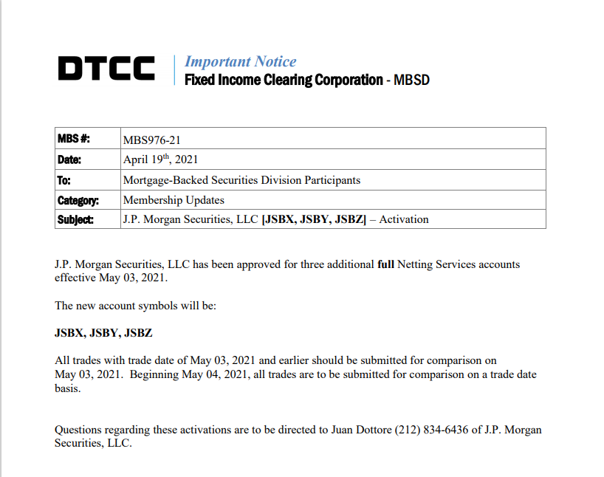
So yesterday JP Morgan was approved for three more netting services accounts. You might be
wondering, why is this important?
Well lets explain the purpose of Netting.
___________________________________________________________________________________________________________
Netting
Netting is a method of reducing risks in financial contracts by combining or aggregating multiple financial
obligations to arrive at a net obligation amount. Netting is used to reduce settlement, credit, and other
financial risks between two or more parties.
As I will explain, netting has various purposes depending upon its' use. In trading it's described as
offsetting losses in one position with gains in another. For example;
• I'm short 60 bananas
• I'm long 100 bananas
• My net position is long 40 bananas
Easy right?
___________________________________________________________________________________________________
Netting some failing whales
Well it also has other purposes.
Netting is also used when a company files for bankruptcy, whereby the parties tend to net the balances
owed to each other. This is also called a set-off clause or set-off law. In other words, a company doing
business with a defaulting company may offset any money they owe the defaulting company with money
that’s owed them. The remainder represents the total amount owed by them or to them, which can be
used in bankruptcy proceedings.
Netting Definition (investopedia.com)
There are various types of netting are available;
• Close out
• Settlement
• Netting by novation
• Multilateral
The one that is the most interesting? Multilateral.
Multilateral netting is netting that involves more than two parties. In this case, a clearinghouse or
central exchange is often used. Multilateral netting can also occur within one company with multiple
subsidiaries. If the subs owe payments to each other for various amounts, they can each send their
payments to a central corporate entity or netting center. The main office would net the invoices and the
various currencies from the subsidiaries and make the net payment to the parties that are owed.
Multilateral netting involves pooling the funds from two or more parties so that a more simplified
invoicing and payment process can be achieved.
Now I know what you're thinking, 'one company with multiple subsidiaries'. I may be wrong but there
would be no requirement to register with an account with the DTCC in such a way if it was all internal.
_______________________________________________________________________________________________
What does this mean!?
Well remember this lovely rule? SR-DTC-2021-004 and this wonderful DD?
Why We're STILL Trading Sideways and Why We Haven't Launched
I quote -
"DTC may, in extreme circumstances, borrow net credits from Participants secured by collateral
of the defaulting Participant"
Again I quote u/c-digs/
What if:
1. You are a non-defaulting member
2. And You know that there are going to be member defaults
3. And you know that that there will be an auction for their assets at a market discount
How would you prepare for this? Perhaps you'd want to have cash on hand to meet liquidity
requirements and emerge from any collapse flush with assets? How might you go about this?
Well I think opening 3 new netting accounts would be perfect to prepare for this situation.
However, these don't come into effect until 05/03/2021. So make of that what you will.
___________________________________________________________________________________________________
TL;DR - J.P Morgan opened three additional netting accounts with the DTCC on 04/19/2021.
These generally have many different purposes although it I don't believe its' coincidental
regarding the rule changes, increase in liquidity and ever impending doom of other DTCC
members. This looks to be the groundwork to have means to profit off of the defaulting, over
exposed members.
_____________________________________________________________________________________________
Edits start with the newest at the top
Edit 4 -
What a wonderful comment by u/Themeloncalling
I feel that there is need for some counter-DD here. The Netting account is addressed to the Mortgage
Backed Securities department. You know, the good folks responsible for the financial collapse, who like
another MBS, are good at chopping things up and bringing them elsewhere. I believe the shitstorm here
with netting accounts and the weekend meetings has to do with commercial mortgage backed securities
(CMBS) having their books cooked. This article detailing overstating of CMBS income is a widespread
problem:
https://theintercept.com/2021/04/20/wall-street-cmbs-dollar-general-ladder-capital/
The graph shown by the university researchers shows that the incomes of the leaseholders are 25% to
50% overstated, and delinquency rates are spiking at the same rate or worse compared to 2008 among
CMBS - can you spot the banks that just issued record amounts of bonds this week in the first chart? A
netting account would be necessary because the delinquencies are skyrocketing with covid support and
SLR ending on March 31, 2021. I believe there is rampant shorting of the Treasury Bonds, and since the
SLR now requires disclosure of Bonds again (which are heavily shorted), the banks now need to issue
bonds to cover their bad bets and the overstated income of their mortgage owners - the netting account
is where you settle your bad bets and pick up the pieces.
To further reinforce this point, the Infinity Q hedge fund was liquidated because they overstated their
NAV value by at least 30%:
https://www.reuters.com/business/finance/exclusive-new-yorks-infinity-q-winds-down-hedge-fund-
valuation-issues-spread-2021-04-19/
The emergency appointment and meetings on the weekend would make sense given that there will be a
lot of bagholders from the CMBS fallout that will begin to rear its head in May. The firewalls will be put
in place to ensure one firm's toxic pile of CMBS does not become a systemic problem.
Since we do need to tie GME into this somewhere, I believe the biggest impact will be reducedincreased
margin requirements for hedgies. As liquidity dries up, banks will reduce the amount they lend out on
margin, forcing hedgies to close short positions. If they are already upside down on a short, let's say one
where an $8 short position now owes over $145 a share, there's no way out except liquidation - a
margin call that sets off all the dominoes. The catalyst for a margin call may not be anything to do with
GME at all, it may be another cancer like CMBS that reduces the amount of margin available for hedgies.
In any case, buy and hodl.
__________________________________________________
___
EDIT 3 - Oh I'm sorry. I've been corrected. IT'S NOW
SEVENTEEN. u/patthetuck
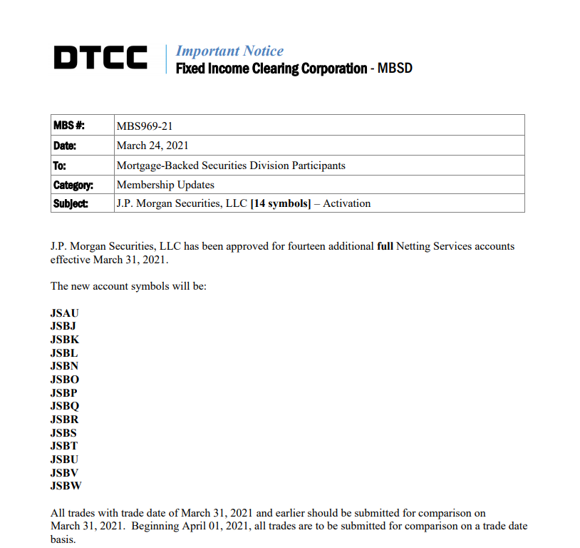
Edit 2 - What a wonderful comment. u/Longjumping_College
Here's DTCC's page on netting and settlement services.
This kinda freaked me out when I saw it on that page as a essentials document to check....
$103 trillion in mortgage backed securities...
The page?
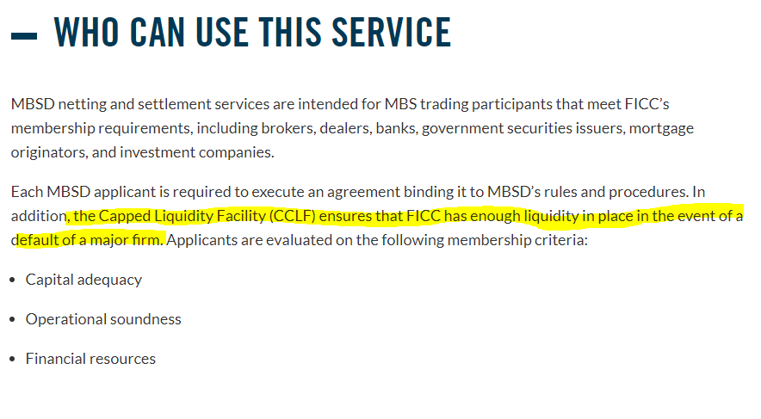
Crayon go brr
____________________________________________________________________________________________________
Edit - Oh yeah, BOFA added one too. Also CitiBank. Wonder what these accounts are used for...
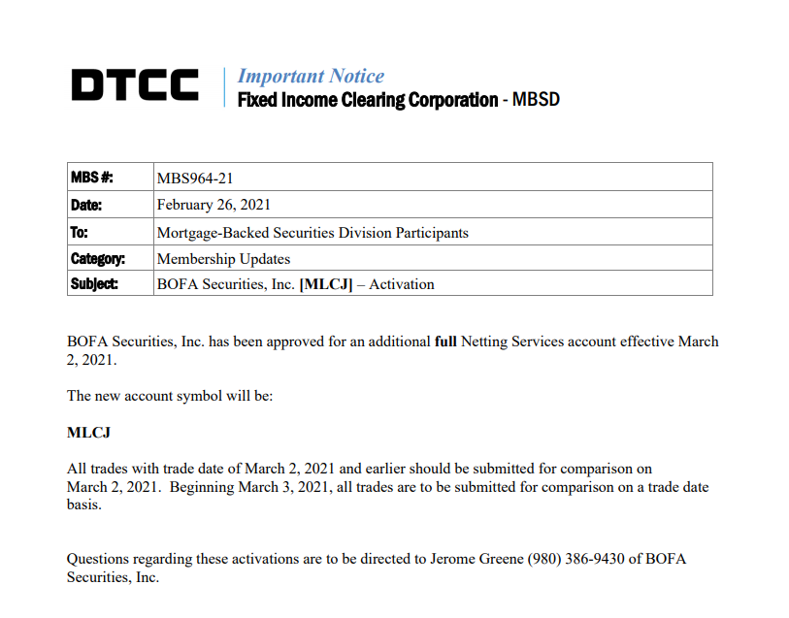
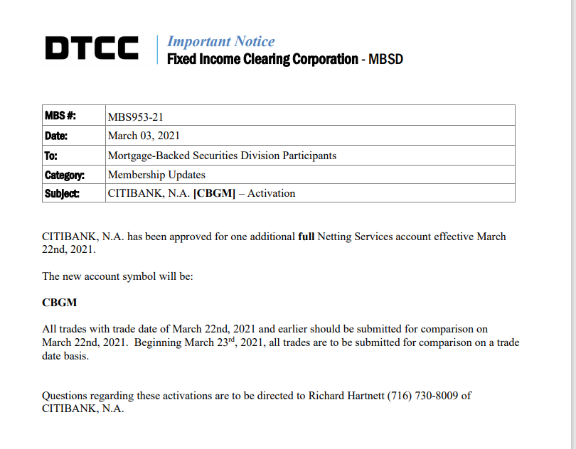
Back to Table of Contents
CITADEL, MARGIN CALL, 1M MISSING SHARES
& THE TRADING HALT
DD 👨‍🔬
Sit the fuck down before you read this.
MY THEORY: u/Leenixus was almost certainly correct in Thinking that "They" got margin called today.
In After Hours 1M shares seemed to "disappear" from EOD Volume before "reappearing" in the EOD
Volume later before AH close. I BELIEVE this is because Citadel got margin called @ 1127 today and
therefor those 1M shares traded had to be re-routed or re-done or what have you. I can't be certain. I
don't know if that's a thing or not but the concept makes a LOT of sense.
Part 1: Introduction to the theory
Part 2: Running the numbers
Part 3: Pictures of the EOD Volume bouncing between 2.7M to 1.7M back to 2.7M during AH
Part 4: Extra stuffing for your tinfoil hat & confirmation bias
Part 5: Putting it all together
_______________________________________________________
PART 1: INTRODUCTION TO THE THEORY
In case you live under a rock and don't spend every minute during trading hours staring at the $GME
ticker & refreshing r/superstonk, today there was a 5 minute market wide trading halt from 1127-1132.
There was also a case of 1M shares disappearing off of EOD (end of day) volume in AH (afterhours).
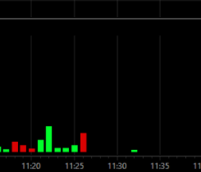
5 Minute Trading Halt - You can verify this yourself easily. credit to u/harbinger2nd for image
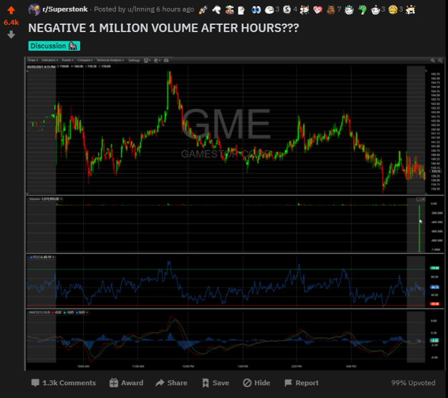
credit to u/lnning for image
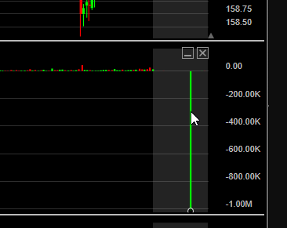
*enhance*
I was reading This Post by Leenixus about how he has a theory Citadel got margin called today. Well, I
think you're right u/Leenixus. Let me explain why.
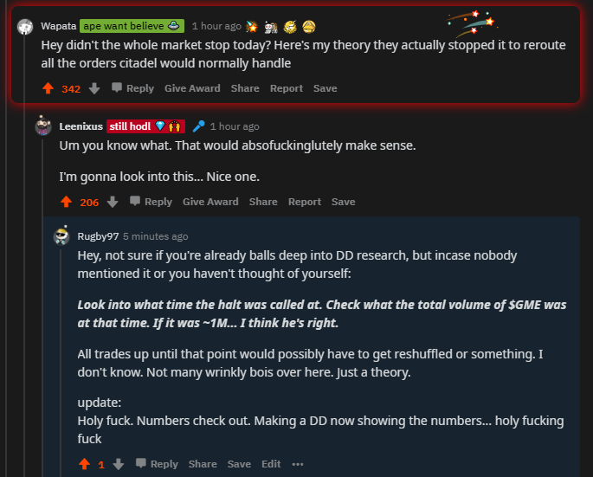
In the comments under his post u/Wapata bought up an idea. So I ran some numbers
_______________________________________________________
PART 2: RUNNING THE NUMBERS
I looked at what the volume was when the market got halted at 1127.
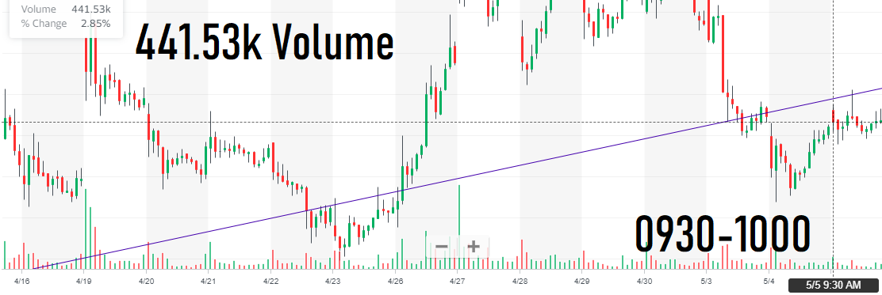
From 0930-1000 there was 441.53k volume
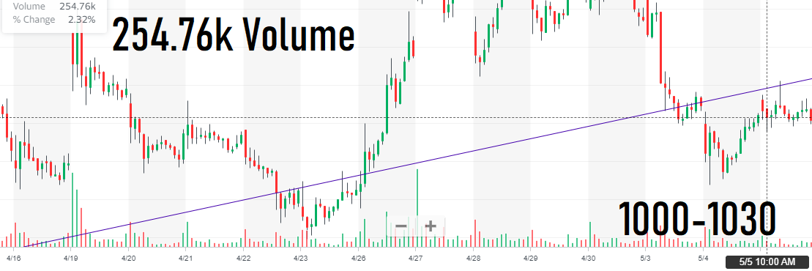
From 1000-1030 there was 254.76k volume
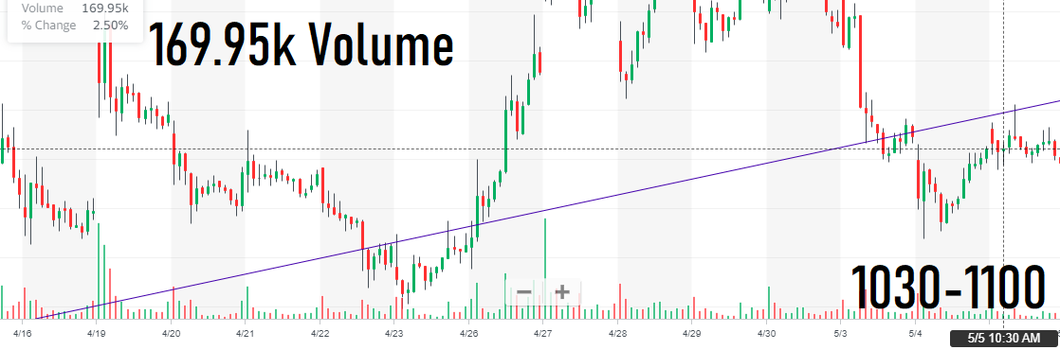
From 1030-1100 there was 169.95k volume
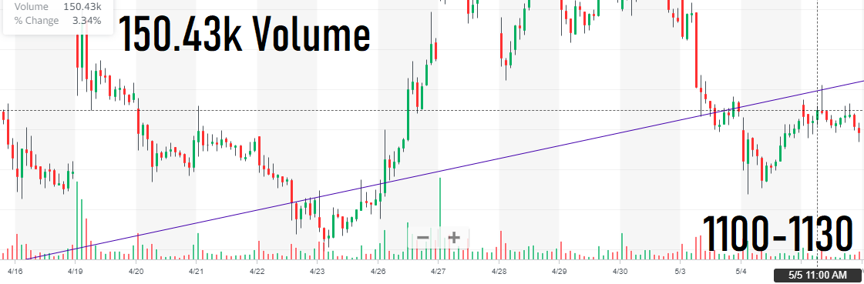
& Finally from 1100-1130 there was 150.43k volume
Lets add this into a calculator
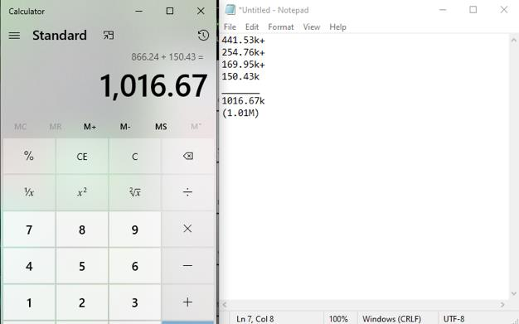
1M shares nearly on the fucking dot.
Compare this to the AH candle again:
It's BARELY nudging over that 1M line. That looks a lot like 1.016M shares to me.
_______________________________________________________
PART 3: PICTURES OF THE EOD VOLUME BOUNCING
FROM 2.7M TO 1.7M BACK TO 2.7M DURING AH
Here's some pictures of the EOD volume not being at the "correct" 2.7M today during AH:
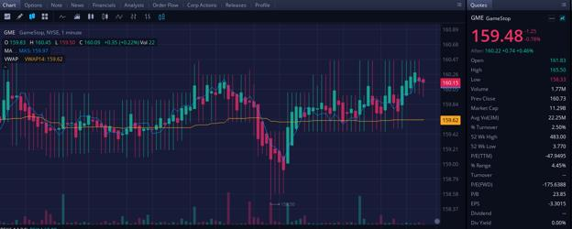
Webull
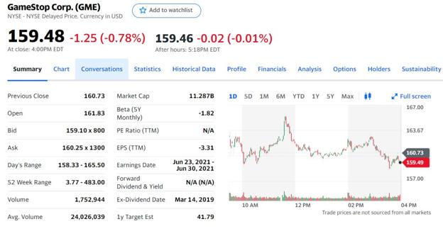
Yahoo @ 1718 EDT
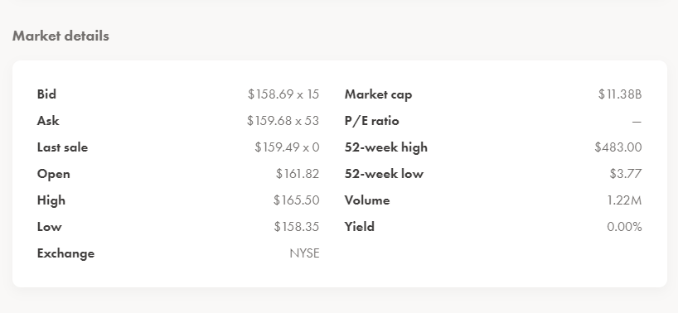
Wealthsimple at 1.22M??? *by the way, it's at 1.23M now, it has not "corrected" like Yahoo & others. ????????? I've reached out to
them, however replies usually take ~2 days
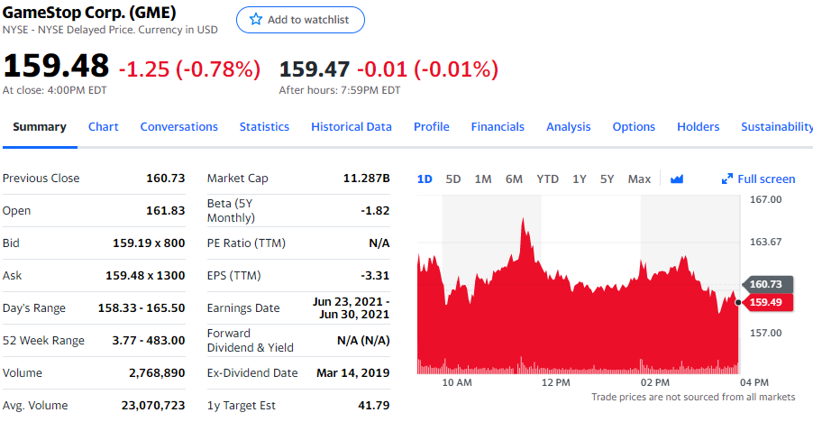
Yahoo correcting EOD Volume by end of AH back to 2.7M, many other sources did same
_______________________________________________________
PART 4: EXTRA STUFFING FOR YOUR TINFOIL HAT &
CONFIRMATION BIAS
At the end of the day we Todd Barker, the head of Citadel's Surveyor Capital step down.
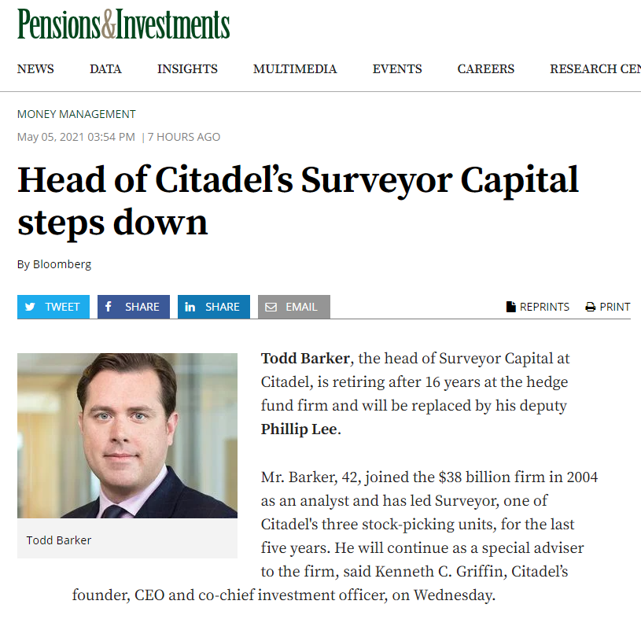
Sorry to hear that, Todd.
In This Post by Leenixus they mentioned how todays price to get margin called is estimated* to have been
$161.19
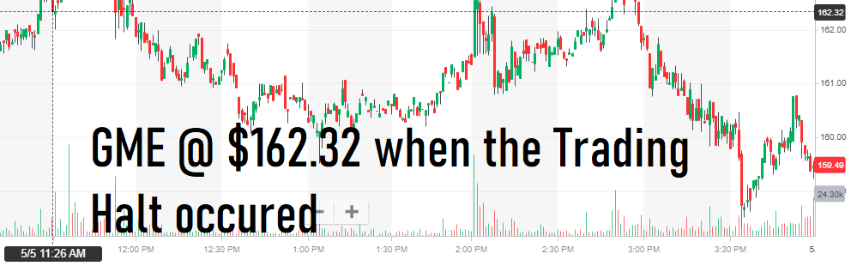
That's above the estimated $161.19 margin call trigger. Coincidence?
_______________________________________________________
PART 5: WRAPPING IT ALL TOGETHER + TLDR
1. Citadel Securities is one of the main market makers. Market makers route orders to the
market.
2. When NYSE was halted for 5 minutes @ 1127, the total trade volume for $GME at the time
was ~1M shares
3. It's estimated that $161.19 was the margin call trigger price today for the major short
sellers of GME (This includes Citadel, theorized to be the biggest) The price was $162.32
when the market was halted
4. In After Hours 1M shares seemed to "disappear" from EOD Volume before
"reappearing" in the EOD Volume later before AH close. I BELIEVE this is because
Citadel got margin called @ 1127 today and therefor those 1M shares traded had to
be re-routed or re-done or what have you. I can't be certain. I don't know if that's a
thing or not but the concept makes a LOT of sense.
It took over a month for us learn Archegos got Margin Called. So there may not be confirmation/proof
saying otherwise for this theory for awhile. Regardless, the numbers add up and the rabbit hole leads to
kens back yard.
EDIT1:
I should mention that just because a margin call happens, does NOT mean an institution needs to cover
all their positions etc. Institutions CAN satisfy a margin call by having enough capital in your "margin
account" (unsure if this would be called the same thing for hedge funds). If you can't satisfy it that way,
one of two things can happen
1. You buy securities to cover your short positions or
2. Get liquidated
EDIT2:
Check out An ape explained the missing 1million volume. I think I'm gonna throw up.
EDIT3:
A very good point brought up by u/Jvic111 & my counter to it
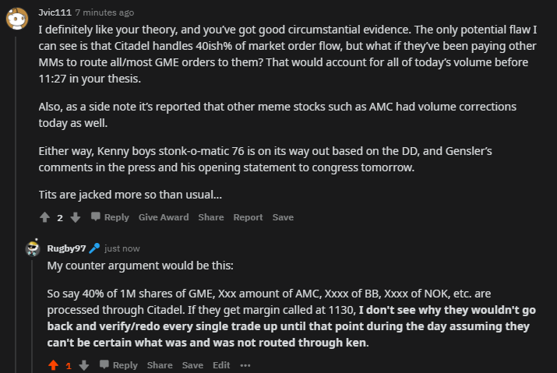
Always encourage both sides of an argument! Thank you Jvic!
EDIT 3.1:
This may be another possible solution to the argument above alternative to my guess
EDIT 4:
More Counter DD (thanks to u/diskodik for pointing this out):
https://www.reddit.com/r/GME/comments/n5pj2q/negative_1_million_on_volume_afterhours_wtf/?utm_
medium=android_app&utm_source=share
My best guess against it: They started to run into problems because Citadel was in the process of getting
margin called and it started to fuck with their processing due to the fact Citadel is one of the largest
Market Makers for the NYSE. This would undoubtedly lead to difficulties processing orders/bids to the
market https://www.reddit.com/r/Superstonk/comments/n5v5m0/an_ape_explained_the_missing_1million
_volume_i/
Or
This: https://www.reddit.com/r/Superstonk/comments/n5yrd7/holy_shit_this_could_be_a_missing_link_be
tween/?utm_medium=android_app&utm_source=share (Courtesy of u/diskodik again!)
EDIT 5:
Well, I guess I'm not sleeping tonight:
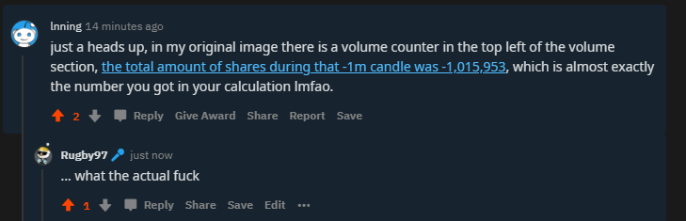
are you
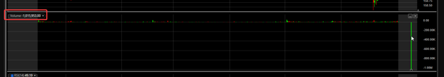
fucking kidding me
My calculation: 1,016,670
Negative Candle: 1,015,953
None of this is financial advice. I'm an idiot. Pure speculation for entertainment purposes only.
tick tock ken
Back to Table of Contents
Major Deep ITM CALL Option Dates. A Massive
Net Capital BOMB Might Explode This Week.
DD 👨‍🔬
0. Update
Edit: Ah here we are after cinco de buyo. No big price move was made. That's some good shit if you ask
me. The prediction was that we'd see a price surge again if they delayed FTDs once more. The fact that
it didn't happen today - no Deep ITM CALLs or PUTs occurred today - is reason to believe this is almost
over. If Net Capital theory is correct, there's two possibilities here:
A) They raised enough capital to kick it to the next threshold on May 17. Remember, only 50% will be
accounted for as of tomorrow. More time to try to hit the price down.
B) They went net negative and it's over. They were unable to reset FTDs. Only a matter of time before
things start unwinding.
I also see some exciting stuff being posted today. Two caught my eye:
DD pointing to theoretical margin call price has been passed three days in a row.
We also possibly saw 1m+ in volume evaporate in after hours. Interesting shit.
So once more - see you soon moon.
1. Preface
I am not a financial advisor.
Take it all in, and then question what you read. We want all perspectives here. Criticism of DD is
what makes this subreddit so amazing - it helps us re-evaluate our theories.
I also love dates. I think they should be promoted more as long as there is data behind it. Picking
arbitrary dates based on Tweets, yeah, I can see a problem with that. But it really feels like we can
pinpoint this shit down. And if it's wrong - you know what - we come back and re-evaluate everything. It
helps us grow, learn, and find new perspectives. You no longer look at data one way, you take a new
approach.
I have never done a TLDR but let's put it this way:💎🤲 =💣=💀🐻
TLDR in picture form:
https://preview.redd.it/vjttbykab1x61.png?width=316&format=png&auto=webp&s=ce91afc315f2e1872aa80
43a9eb941fee53669c5
Edit: a real TLDR:
Deep ITM CALL + OTM PUT options expiry causes MMs (Shitadel) to have a debt due to them pushing
FTDs out. The debt must be resolved quickly or they could become net negative, violating a Net Capital
rule. If they violate the rule they essentially lose their MM privileges because they don't have enough
capital for their positions in the event of a default.
Day 0 = 0% of debt accounted for in calculations
Day 7 = 25% of debt accounted for in calculations
Day 14 = 50% of debt accounted for in calculations
Day 21 = 75% of debt accounted for in calculations
Day 28 = 100% of debt accounted for in calculations
They appear to not want more than 50% of the debt accounted for and try to push FTDs out between
day 0 and day 13 because once day 14 hits the 50% could bring them net negative.
Day 13 coincides with the spikes I've been observing:
Feb 5 -> Feb 24
Feb 19 -> Mar 10
And what might be coming:
April 16 -> May 5
2. Recap
I posted the other day theorizing a link between certain option dates and a spike the second Wednesday
following expiration. For example:
February 5 Options Expiration -> February 24
February 19 Options Expiration -> March 10
April 16 Options Expiration -> May 5
What happened on February 24? We spiked up. Significantly.
What happened on March 10? We climbed up. Significantly, until a flash crash brought us down. And
there's pretty good evidence that points to the flash crash being caused by nearly 80,000 PUTs from July
16, 2021 being exercised on March 10th.
What happened on May 5? We'll find out. But I'm sure I'll get a bunch of shit spam comments if it all goes
downhill lmao.
3. Theory Hole
I was claiming that the link was due to T+13 forcing of FTDs by the broker, but that isn't necessarily
true. /u/keijikage identified that:
T+13 only counts if it is on the threshold securities list (10k shares FTD + > 0.5% of shares outstanding).
HOWEVER...there may be some nonsense going on around net capital"
We haven't seen GME on the threshold list since February 3rd. So the T+13 FTD delivery theory seems
to be out the window. However, the pattern still stands. And boy does this new information look
spicy.
4. The Link Between Options and Spikes Still Exists
There's no doubt in my mind that we're witnessing a pattern here, and that it will repeat. Each spike in
price has to link to a date in the past - that's where I started going down this rabbit hole. I mean, shoving
a few crayons up my nose like Homer Simpson might have also influenced me.
https://preview.redd.it/kwr9wb8o30x61.png?width=507&format=png&auto=webp&s=57af9773746a233aeb
9486f978437507e413034b
In my last post, /u/beyond-mythos pointed out a wonderful source of information - another DD with
crazy amounts of data for Deep ITM CALL purchases: The SI Is Fake I Found 44,000,000 Shorts
The DD poured through data finding that FTDs were hidden in very specific options with Deep ITM
CALLs. What dates enticed the shorters so much? *queue ominous music* dun dun DUN...
https://preview.redd.it/11gjaljq70x61.png?width=559&format=png&auto=webp&s=1f1d295244e648846d7a
fd9cac6c1b1fe32ce193
February 5, February 19, March 19, April 16, July 16, January 2022, and January 2023. I got
absolutely JACKED when I saw that there was evidence pointing to the exact dates I wanted to link to
the spikes:
February 5 and February 19.
Now you're probably asking, hey, I see March 19 on that list. Why didn't it spike on April 7?! Don't
worry, because it's going to need a little bit more explaining in this post. I'll get there just bear with me.
You also might be wondering, "Ok what the hell are you looking at these Deep ITM CALL purchases for?".
It is because we're theorizing that FTDs are being hidden through this malicious options
practice. And on the other end of the spectrum, it's theorized that the SI% is being hidden through PUTs
which also expire on these major dates. Both old and new shorts and being stuck in PUTs.
The DD also posted the following table, and I absolutely love u/dejf2 for this glorious artwork. I'd pay at
least 10 and a 1/2 Shmeckles for it. It shows the amount of deep ITM calls which were purchased not
only for certain expiration dates, but when those purchases were made.
https://preview.redd.it/i5xh3f2350x61.png?width=1933&format=png&auto=webp&s=8594466c3aa5675ebff
db39a8364e18c4f39d7f3
You can see that they went absolutely nuts purchasing these Deep ITM CALLs on the January runup
(dark red highlight) because liquidity was AWFUL. Robinhood pulled the plug on buyers, and let the buy
pressure dry up while the HFs and MMs swapped FTDs to later dates because there were so many
shares that had to be delivered. The retail buy pressure is the whale that is now splashing larger
and larger FTD waves until the MOASS.
So thank you Robinhood, the floor was $1,000 back then but now there's going to be so much more
money sucked out of the 1%.
https://preview.redd.it/wmlo5r9yc1x61.png?width=594&format=png&auto=webp&s=8d786347ecdf326c3c9
40538547b93d76f7a72d0
I did a rough calculation of the cumulative amount of Deep ITM CALL purchases for these dates ONLY
with the red-highlighted area:
Option Cumulative Deep ITM Call Purchases Number of Shares
Expiration Date (Red Area Only / January Runup) Equivalent
Combined 287,000 28,700,000
February 19,
2021 51,000 5,100,000
March 19, 2021 4,000 400,000
April 16, 2021 143,000 14,300,000
July 16, 2021 31,000 3,100,000
January 2022 58,000 5,800,000
Fucking... WHAT? In the January runup alone they had to purchase at least 287,000 Deep ITM CALLs to
handle FTDs? That's equivalent to 28,700,000 shares. Hello float - or should I say more than the float -
since it's now estimated that the float is around 23,000,000. Remember that this table is ONLY for the
red highlighted area, so the total number upon option expiry is greater than the rough calculation table.
Let's look at the dates and their significance:
• February 19 had 51,000 purchases. Two Wednesdays later, March 10, we see $GME
climb to a price of $350 before being smacked down.
• March 19 had 4,000 purchases. Two Wednesdays later, April 7, nothing. Hmm. Well, it
certainly isn't a lot of CALLs in comparison but it should have done something - right?
Even a tiny bump instead of the red day on April 7? Don't worry. I'm almost there.
• April 16 had 143,000 purchases. Two Wednesdays later, May 5, we'll find out! Take a
notice the magnitude of deep CALLs that were purchased for this day compared to
February 19 - big fucking oof if the price spike happens again.
• July 16 had 31,000 purchases, and January 2022 had 58,000 purchases. So obviously
they wanted to spread out the FTDs among all the dates but for some godawful reason
poured into April 16. If this does indeed pop again on May 5 but doesn't trigger the
MOASS, we can expect it to pop following the next major Deep ITM CALL option
expiration date.
But this doesn't really explain why the spikes occur two Wednesdays following option expiry.
5. Ok, If Not T+13 From FTDs Then What Is Causing The
Movement?
/u/keijikage pointed out a tasty rule. Net Capital Requirements For Brokers or Dealers - 240.15c3-1.
In summary, 240.15c3-1 is a net capital rule which:
...is designed to ensure that a broker-dealer holds, at all times, more than one dollar of highly liquid
assets for each dollar of liabilities (e.g., money owed to customers and counterparties), excluding
liabilities that are subordinated to all other creditors by contractual agreement. The premise underlying
the net capital rule is that if a broker-dealer fails, it should be in a position to meet all unsubordinated
obligations to customers and counterparties and generate resources sufficient to wind down its
operations in an orderly manner without the need of a formal proceeding...
...A broker-dealer must ensure that its actual net capital exceeds its required minimum net
capital at all times. - Source
More ape-speak, this rule makes it so that if a Market Maker (Shitadel) wants to continue operating and
not get ass-fisted by the SEC, they cannot carry a debt that makes their capital net negative. Otherwise, if
they default, they're an idiot and have insufficient capital for the positions to pay out. How do you carry
a debt? Let's say you are all nice and happy, shorting GME without a care in the world because you're a
moron, operating net-netural, when suddenly a shitload of FTDs pour on you all at once. Oh shiiiit. I owe
those shares and am carrying a debt! What do I do? Hmm I can either:
1. Raise some capital or
2. Sweep those FTDs under the rug using some sneaky sneak tricks. I'll pay that shit later,
hoping the price of the stock is much lower and thus my debt calculation doesn't bring me
negative.
What did we see every time a spike-up occurred? More god damn Deep ITM CALLs being purchased.
Because they're hitting the (2) button and kicking them further down the road.
You know how much time they have to solve this net capital issue? Not long. The following is from rule
240.15c3-1 I linked, towards the bottom.
https://preview.redd.it/4dsve3w3d0x61.png?width=1166&format=png&auto=webp&s=b88384871b2de08e3
7b92826df32f5e5c1322707
This is my interpretation, please correct me if I am wrong. Every 7 days that pass by, their debt is
subtracted from their capital at an increase of 25% each tick. In other words, each 7 days your
debt is 25% more accounted for:
Day 0 -> Net Capital = Capital - Debt*0.00 = 0% of the debt accounted for in calculations
Day 7 -> Net Capital = Capital - Debt*0.25 = 25% of the debt accounted for in calculations
Day 14 -> Net Capital = Capital - Debt*0.50 = 50% of the debt accounted for in calculations
Day 21 -> Net Capital = Capital - Debt*0.75 = 75% of the debt accounted for in calculations
Day 28 -> Net Capital = Capital - Debt*1.00 = All debt accounted for in calculations.
------
Example A (Good Situation):
Imagine you have $100. Then suddenly you get a piece of paper saying "your debt is $90".
Day 0 -> Net Capital = $100 - $90*0.00 = $100
Day 7 -> Net Capital = $100 - $90*0.25 = $100 - $22.5 = $77.5
Day 14 -> Net Capital = $100 - $90*0.50 = $100 - $45 = $55.0
Day 21 -> Net Capital = $100 - $90*0.75 = $100 - $67.5 = $32.5
Day 28 -> Net Capital = $100 - $90*1.00 = $100 - $90 = $10.00
All good! You're still net positive. This must have been what occurred for March 19 option expiry.
The debt was insignificant! So much more time to spread out some Deep ITM CALL purchases.
There was no way that they'd cross the net negative threshold from only 4,000 Deep ITM CALLs +
PUTs.
------
Example B (Bad Situation, Shitadel):
Imagine you have $100. Then suddenly you get a piece of paper saying "your debt is $250".
Day 0 -> Net Capital = $100 - $250*0.00 = $100
Day 7 -> Net Capital = $100 - $250*0.25 = $100 - $62.5 = $37.5
Day 14 -> Net Capital = $100 - $250*0.50 = $100 - $125 = -$25.00
Whoops! You're now net negative and you violated the rule and only when 50% was accounted for. Bye
bye.
------
It's important to note that the debt is based on current market price of the security. So if GME is
trading $170 then the debt is based off of $170. If it drops to $150 the next day, then the debt is
based off of $150. They want to kick this down the road until the price is really low. Probably in
the $20s range. They're absolutely fucked.
So, Day 0 they'll see the debt but might not need to worry about it. If it's not a problem, such as Net
Capital having no chance to go negative, then they're fine. Whatever. They won't violate the rule and
they can go on being a happy Market Maker. But if it is a problem which would bring them negative and
violate the threshold rule, then they'll start panicking. They want to resolve this before the threshold
occurs which would make them net negative.
The fact that 50% of the debt is subtracted at T+14 is very curious. That implies they (Shitadel) can't
risk the debt even being 50% accounted for. So it must be an absolutely massive position. Let's walk
through February 19 expiration as an example:
1. February 19 options expire. Deep ITM CALLs and possibly married PUTs expire that were
used to hide FTDs and shorts. Day 0. Their Capital does not account for the FTD and
short position yet. Well... they can try to drive the price down and hope that the debt
calculations don't carry them net negative.
2. Day 7 arrives on March 2. The FTDs and shorts are 25% accounted for. Maybe they'll start
shifting some stuff out by purchasing new Deep ITM CALLs between March 2 and March 9
since the price doesn't seem to be going down as fast as they want.
3. Day 13 arrives on March 10. Oh SHIT. They can't let Day 14 arrive or else 50% of the debt
will be accounted for and they'll be net negative and thus violate the rule. So they start to
move out a ton of FTDs to later dates by purchasing more Deep ITM CALLs. (If you
reference the purchase anomaly chart in my previous post, you'll see tons of Deep ITM
CALLs are purchased on the spike dates and run-up dates)
4. Day 14 arrives on March 11. All is well in the world (for now) because their debt has been
moved out.
Edit: But...why exactly does the price move up? On Discord, "Assets" has a great possible explanation.
Assets - you are the best. ❤️
1. You are obligated 100 shares through FTDs.
2. You buy an ITM Call and Sell an OTM put.
3. You short 100 shares of the underlying saying that it's actually covered by your ITM Call.
4. You exercise your call and you are credited 100 shares.
5. You tell your broker that you wish to cover your shorts with 100 shares and you tell the
clearing house that you wish to satisfy your FTD with the same 100 shares.
6. Both parties take the same shares and both parties look to the market maker to satisfy
those 100 shares because you said they were good for it when you exercised.
You've succesfully shorted and reset the FTD.
Apply this to the other major option expiry dates and you get the same picture. They want to fix this
issue by the second Wednesday following option expiry because the massive amount of Deep ITM CALLs
caused their debt to be too significant to carry the full 28 days. It brings them net negative by day 14. At
least... that's the theory now. ;)
Let's finally apply this logic to our wonderful, beautiful, April 16th date which is the option expiration
date of when a dumpster load of Deep ITM CALLs have been purchased:
1. April 16 options expire. Day 0
2. Day 7 arrives on April 27.
3. Day 13 arrives on May 5. They (in theory) don't want it to hit day 14 when their net
capital would be negative due to accounting for 50% of the debt. Whatcha gonna do this
time, Shitadel?
------
• Perhaps this is what /u/Suspicious-Singer243 was observing in The March To Zero Liquidity.
The Market Makers are about to have a net capital bomb go off. They NEED to eliminate
their debt by wiping out their FTDs that have appeared once again in order to become net
neutral. They were able to swipe the FTDs under the rug on January 13, the January run-
up, March run-up, and a few times here and there since then. But if 005 is enacted before
the next pop then they have to deal with this massive 143,000 order from April 16
without delaying it any longer. RUH-ROH RAGGY.
• Of course while I'm writing this, I see that May the Fourth could indeed end up being the
Golden Ticket day per /u/Door_Public. It's very likely that 002/801 go into effect
tomorrow. I've been thinking we'll see 002/801 as well as 005 enacted and within
24 hours a price spike would occur. If I see these rules go into effect tomorrow, I
will NOT be able to sleep. May the 4th Be With You
• Bank netting accounts coming into effect by May 5
• US Treasury Issuing 0% Bonds on May 4 and Maturing June 1
------
See you on the moon. If not this week - sometime soon. ❤️
Back to Table of Contents
Another GME DD dump from Hank
DD 👨‍🔬
********** I am not a financial advisor, this is not financial advice **********
Apes, I've recently gotten into comedy and wanted to test out some of my jokes on you:
Why did the chicken cross the road? Because my wife is fucking the mailman.
What's the difference between GME and my wife? GME doesn't have four boyfriends.
How many HFs does it take to screw in a lightbulb? Seriously guys my wife is a cheating whore.
What happens after you eat five bags of flaming hot cheetos? You take a dump.
And that brings me to my next point. DUMP. Yes, apes, this will be yet another DD dump. No main
purpose or direction, just a few DD theories from your favorite guncle Hank. As always this is not
financial advice and I am not a financial advisor.

Hankey the Christmas Poo for those of you who don't know
FTD cycle update
Alright everyone, so the FTD cycle theory was correct again for this period. For those of you who don't
know/remember, this theory says that because of SEC FTD regulations, there is a predictable price and
volume spilke every 21 trading days or 35 calendar days with about a +/- one day margin of error. If you
look at the FTD cycle since september when it was only $10, the price each cycle is increasing
exponentially as it is now over $200, which means that it is getting more and more expensive to stay in
this game. Not gonna spend much time on this because I've covered it tons in my past DDs and many
other apes are also getting into smaller FTD cycle research (which I love):
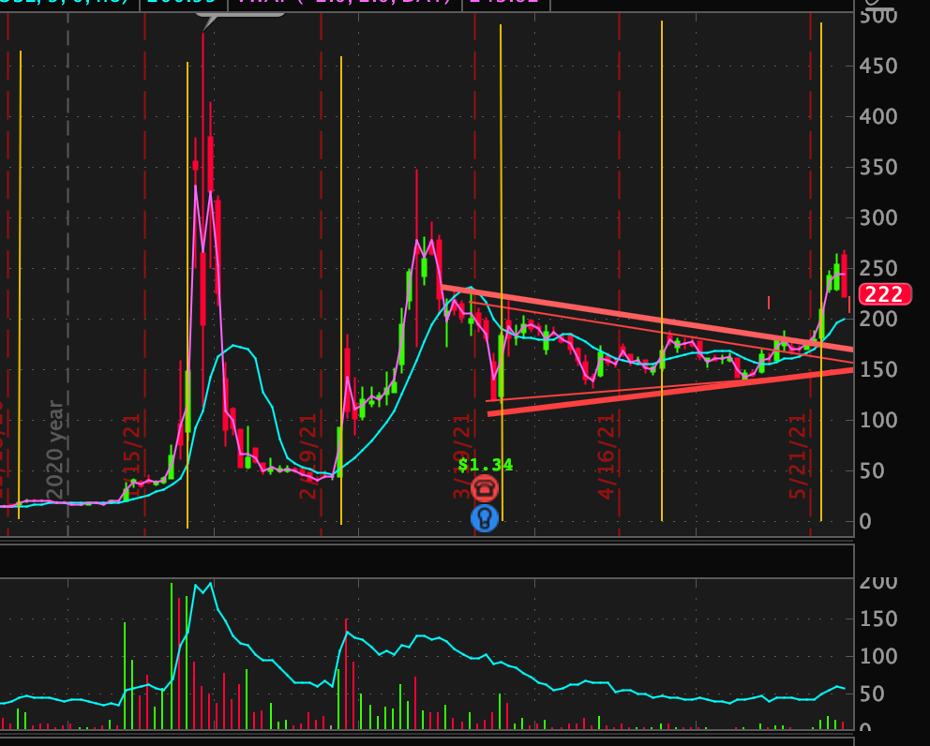
In my opinion, this shows us something very important. First, it shows us that it is getting exponentially
more expensive to stay in this game and that there should be a breaking point soon. Second, it shows
that the media narrative that retail is the reason for this run up is flat out wrong. IMO retail stopped
mass-buying GME in late January and has simply held and bought small amounts since then. This right
now is all about institutions being forced to cover because retail continues to hold. It makes absolutely
no sense that retail is just randomly deciding to buy GME in mass on absolutely no news every 21
trading days. This narrative makes sense because then they can blame us when it all blows up.
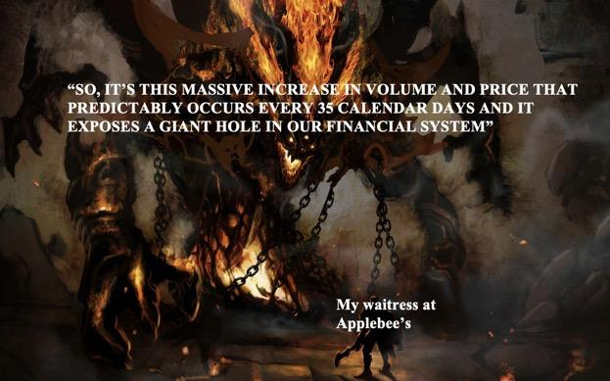
Midday spikes
Apes, this has been one of the most baffling things for me to research and it has taken a ridiculously long
amount of time. As I've explained, I have noticed that GME has these midday spikes in positive volume
and price. Here are the requisites for those spikes:
1. They occur between 11am - 2:30pm (any times before or after that cannot be counted
becuase it could be due to early market high volumes or power hour volumes)
2. They are the highest, second highest, or third highest single minute volume candles for
the whole day (usually the highest)
3. They occur on no news and preceeding and proceeding candles are always significantly
lower than them.
Here is an example of one:
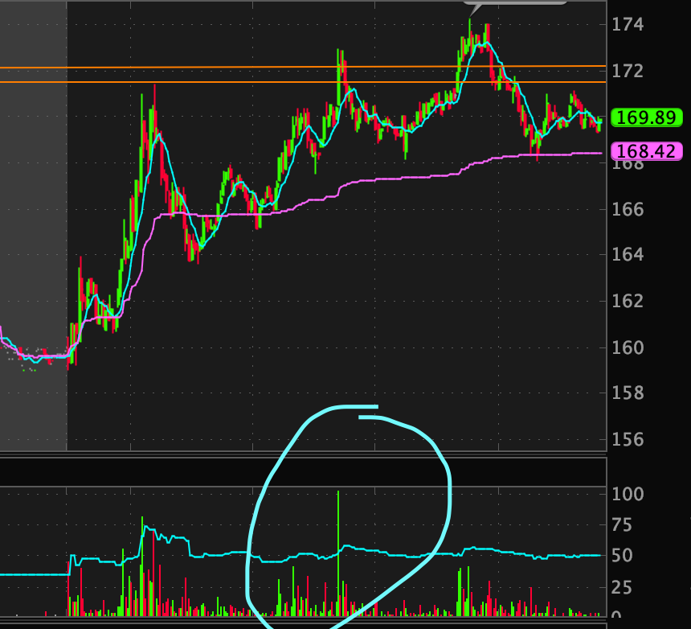
Just to show you how pervasive this is, I went to a random day and found this one on my first try
Here is an example of one that IS NOT one of these spikes:
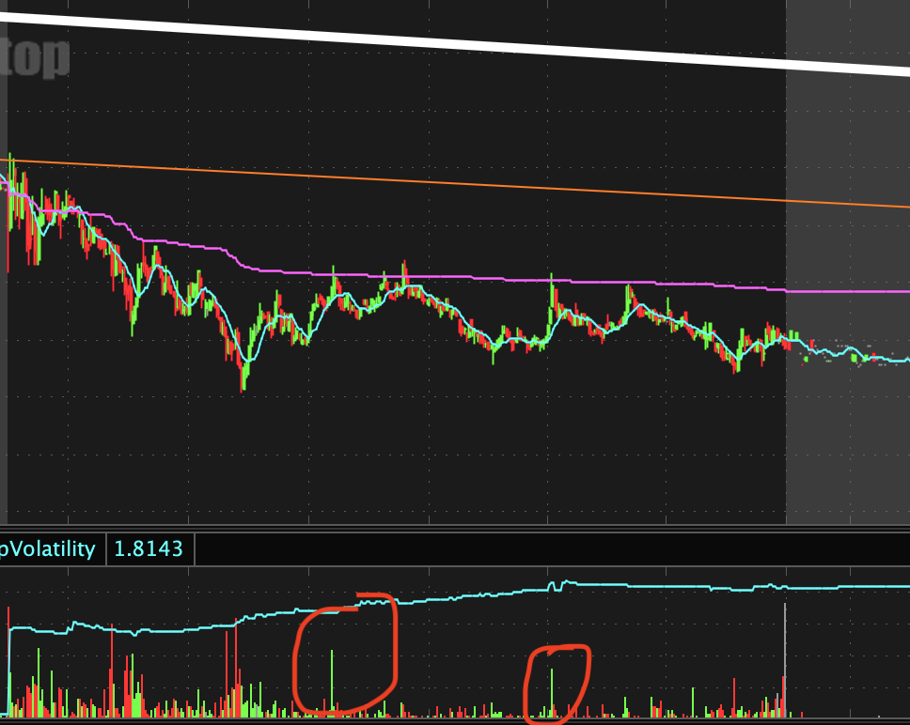
Volume is far too low compared to other times in the day.
IMO it would be far too dificult to document literally every single one of these and run some data
comparisons on it. However, after looking at many of these, here are my observations:
1. This DOES NOT happen to normal stocks, this is extremely weird
2. This DOES happen to stocks like AMC, EXPR, NOK, etc. but happens less frequently
3. These midday volume spikes have picked up drastically post-squeeze
4. The spikes also started to pick up after GME hit $10 in October 2020
5. The spikes increased progressively more throughout 2020 and up to the squeeze
6. The spikes have been going on since 2018ish and have been increasing more and more
7. The spike sometimes happen for a few days in a row but never more than three days in a
row
8. There is typically a 1-4 day break in between spikes but never more than 5 days
9. The volume of these spikes (not price) has increased pretty regularly since 2020 but not
consistently
What do I take away from all of this? I said in my last post that I think they are covering during these
times. That would make sense because 11-2:30 is usually the lowest volume of the trading day, so they
want to cover when they can be positive that a HFT wont swoop in and screw them over on the price.
They also don't want their trades to give the stock momentum during high volume times because that
could cause a price spike.
If you all rememeber that big beautiful FTD squeeze DD doc (I think it's from this
website https://iamnotafinancialadvisor.com/DD/GME/og/GMEv14.pdf which is now defunct) they say
that the GME shorting likely happened in 2017 or 2018 when they took on some debt and it was likely
that they would default in 2020. Why did these midday spikes start increasing more in 2020? I'm
guessing that the shorts piled on more naked shorts between March-May (when GME hit its all time
lows) because they thought that it was going to go bankrupt because of covid. Once it got above $10,
their positions got more and more expensive, so these midday FTD covers happened more and more.
Now these midday covers seem like a mainstay, which IMO indicates that they are indeed fucked in their
short positions.
Sadly, there is far too much data for me to codify and find significance; however, I have done enough
observations that I'm pretty confident my above findings are correct. So IMO, it appears that this is what
we are looking at in terms of the FTD cycle:
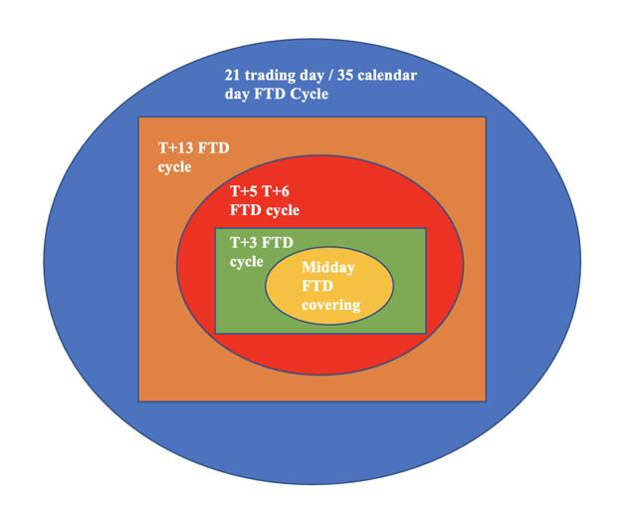
So within our giant 21 day FTD cycle we have these other cycle occuring as well (the smaller the shape,
the more frequently it happens, but the more frequently it happens the smaller and less noticable it is).
Again this is just a theory / my opinion but what this means is that because the shorts have such a giant
short position that's too big for them to unravel (they financially cannot do it), there are predictable
days and times where they have to cover based on SEC regulations. Now, this is not an invitation to try
to predict these times and profit off of them, that's stupid and will probably lose you money (not
financial advice). However, the fact that some retard named hank can find this simply by using trading
chart patterns, a calendar, and SEC rules, shows that they are indeed in too deep.
What's the best part about all of this? Well, it's increasing at an exponential rate meaning it's getting
exponentially more and more expensive for them to keep this shit up (see one of my previous posts for
proof of exponential increase as this recent FTD cycle increase only adds to that). AGAIN, this, unlike my
other FTD posts, is not based on concrete data, it is based on my observations when doing back testing.
However, because I did many hours of back testing, I am confident that these observations are accurate.
If someone does some kind of data collection on this, WOW you really are a god becuase that would be
the most time consuming thing ever, but I think that based on what I've observed, my findings are
correct.
One genius-retard, u/startanks, sent me this message a week ago and it has been giving me wet dreams
ever since:
"Current regulations forces market makers to have their net capital requirements positive, which they
check once a day at 1pm est. Therefore it is most likely shorts, as you said, buying back stock so their net
cspital stays positive for the day. This is what dtcc-002 is trying to change. To add to your discussion of
the spikes around 2pm everyday - Reverse Repos have same day maturity date that closes ~1:15-2pm
everyday."
This, IMO, is fucking genius and gives even more credence to the DD coming out of this sub about the
repo market. Apes, I have been a bull my entire life. I legit drink bull semen. But holy fuck, this market is
making me a 🌈🐻. IMO, the market is over-leveraged, the market is pricing things like the recovery
happened 6 months ago, banks and institutions did some shady-overleveraged shit with the SLR releif
and other easings of restrictions during covid, inflation is likely to happen, the repo market is absolutely
fucked, etc. etc. etc. I could literally write a giant DD on why I think that there is going to be a serious
correction soon (not financial advice) - don't ask me to do this though - I am focused on GME and
nothing else. I think this is why Burry shorted TSLA. I think that he has the same thesis as I do, but he
thought that growth stocks would be hit the hardest during a correction. So his bet against TSLA is really
just a bet against the market that uses TSLA as further leverage. If the market corrects it is likely that
HFs will be forced to liquidate their GME positions. Like I said in my other post, we should not be
praying for a market crash because that destroys lives. Instead, we should be grateful for the fact that we
seem to have found a way to profit off of it at the expense of those who created it. Does GME benefit from
a market correction or does it cause a market correction? Who knows.
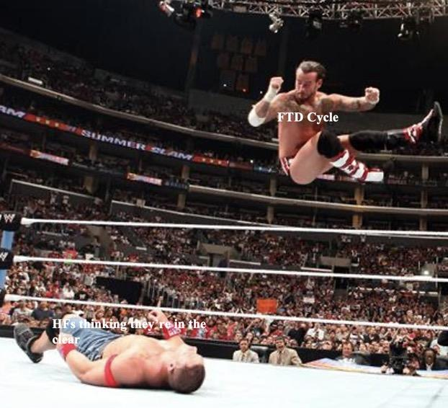
Earnings and annual meeting
You might have noticed that the very first chart in this post shows a consolidation pattern (red lines)
that converge on earnings. I also covered this in a previous post. It appears that we have broken that
trend. IMO, as I said in my post recent post, there is a good chance that this was simply to make apes
think that the squeeze is over so that we sell before the annual meeting. IMO, I think that the annual
meeting will be a slam fucking dunk. It will probably be the start of the squeeze (i.e. the catalyst that gets
it going) but will probably not be the squeeze itself. Essentially, the annual meeting, IMO, will show us
whether the MOASS will be a January-style squeeze (rapid and short) or a TSLA-type squeeze (slow and
long).
The reason I think it will be the start is because of the lack of information that we've been given about
GME from leadership in the past few weeks and their incentive to have a good meeting. We've seen
teasers (NFT thing) and RC tweets (btw there's no doubt in my mind that he reads through GME reddit
posts and is on our side because you don't tweet like that if you're not. He's just being vague so he
doesn't get investigated) that all point to a huge announcement. Could it be a CEO, a crypto dividend,
notice that there are more votes than shares, NFT stuff, etc.? Either way, I think there will be an
announcement there that kicks off the squeeze. More importantly, I think that it will gives whales a good
entry point. Here's why:
I am going to use the example of George Soros' genius British pound trade (you can watch literally a
billion Youtube videos on this). George soros made one of the greatest trades in history by shorting the
British Pound. Essentially, he saw the British Central Bank doing dumb things that were going to devaule
the currency and he saw technical weakness as well. He knew he was going to do this trade and knew
why, however, he first needed some kind of news event or catalyst so that he could enter the trade so
that others would join in. Essentially, Soros took a huge short position after some only slightly negative
news about the Pound and it tanked. This made the rest of the market think that everyone was bearish,
so it created a panic (after hours I may add so the volume was easily affected). People didn't realize that
it was just one man doing this until it was far too late. (This is a metaphor for what I believe will happen
to GME, George Soros is not involved in GME in any way - do not put your tin foil hat on).
I theorize that there is a long whale or several long whales waiting to pounce on GME for this exact
reason. Whoever they are they have been consolidating GME's price for the past few months. I don't
even think it's to lower IV anymore to set up a gamma squeeze. I know fully believe that whoever is
doing this is trying to tame GME's price and will then pounce on it once there is appropriate news. Why?
If the long whale just did this on no news the market wouldn't pounce on and be like "oh shit positive
news, market loves GME" it would just be like "oh great more gamestop shit, it's retail again and it's
gonna go away, I'm not getting in on this." Instead, if there's news and an influx of buying, the market
might perceive that as "oh shit this news was way better than I thought I gotta get in. This is actually a
fundamentally good opportunity." It doesn't matter if this is short or long term buying because once the
price gets sufficiently high, the shorts get a call from marge. Again, this is all just a theory. However, RC
tweet seems to confirm this as it says its coming back from the dead
If you have FUD, I would direct you to see my previous posts where I address FUD, but just to add some
more. Remember all of the things that aren't normal about GME. Remember that DFV doubled down.
Remember that we have more evidence of a squeeze happening than the people pre January did... and
they didn't have a previous squeeze to compare to. Imagine how crazy people mustve thought they
sounded, "you think it's gonna squeeze past $300? yeah ok." Then it happened. If they can hold with less
evidence, fewer apes, and no previous squeeze to compare to, then yeah I FUCKING CAN TOO. (Not
financial advice).
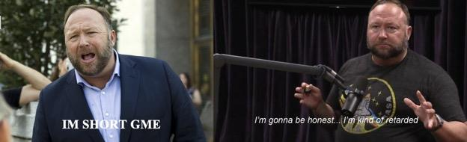
Crypto and the FTD cycle
A few sexy apes have sent me some messages about crypto and GME. At first I thought this was bullshit
but after doing some research, there seems to be something there. Every single FTD cycle is the lowest
point that BTC gets (i.e. it decreases up to that day but doesn't decrease on that actual day by much then
it goes back up). This got me thinking more about crypto and GME. Just like with GME's FTD cycle, when
you see a repeating pattern like this in BTC (especially because it's so unregulated and easily
manipulated) it's probably not a coincidence. What I think could be going on is that shorts are storing
liquid cash in BTC in an attempt to hide their cash positions for disclosure/filing purposes. They are
then liquidating those positions in the days preceeding the FTD cycle so they can pay for it. Notice how
BTC climbs up the next few days after every FTD cycle? I still think there's something more going on
here, however, because IMO it doesn't make sense to store cash in such a volatile asset, so if anyone has
more ideas please send them my way:
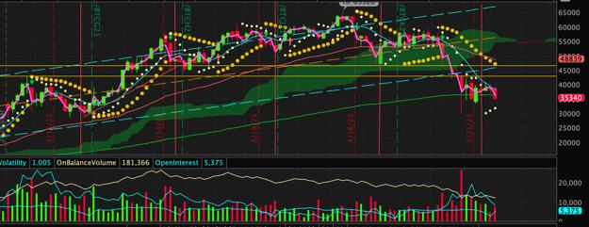
Sorry about all the crazy dots and stuff those are my tard indicators. The red lines are FTD cycle days.
Notice how there isn't a discerable up or down day on those dates. However, before each of those dates,
BTC drops precipitously a few days prior. Like I said, that makes me think that HFs are storing capital in
BTC (for whatever reason) and are liquidating it a few days prior to pay for the FTD cycle. Why was this
recent BTC drop particularly bad? Well, it's because this FTD cycle was extremely more expensive AND
there was horrible BTC news (elon tweets and investigations for one of the exchanges). Again, I think
there's something else that I'm missing here, so if anyone has any ideas please send them my way or
make your own DD!
Here is perhaps the most interesting thing that I've seen all week. A genius-retard by the name
of u/pleasantlyunbothered (great name btw) sent me some information on a unique type of crypto that
may have some relation to GME. This ape brought to my attention something called Saffron Finance,
which "is designed to pool lioquidity to ease pressure off of over leveraged investors." So, I went on it's
chart and marked the FTD cycle dates and circled days where GME had significant price dips:
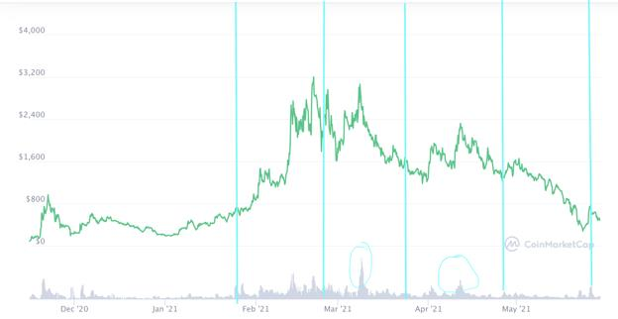
It's not entirely clear if there is a correlation; however, it seems obvious, IMO that this concept (a place
to ease liquidity troubles for overleveraged investors) could be a safe-haven for someone trying to hide
a short position or hide capital to be used for short attacks. I am not saying anything definitive here and
definitely need to do more research on this coin but it is something interesting to think about and again
excellent find by the user who sent this to me.
AMC
I am now going to adress AMC. I've heard a lot of talk on here about how AMC is a distrction from GME
or how anyone talking about AMC is a shill or how AMC is a HF ploy. What I'm about to say may make
some of you mad but it needs to be said: stop fucking saying that because it's untrue, it makes us look
jealous, it divides retail, and it makes us look like conspiracy theorists. Before I go further, let me first
say that I have no position in AMC and am all in on GME. I think that GME is the better stock and has
millions of times more potential than AMC.
If you look at my previous post where I discuss how there's a group of stocks that all have a similar
pattern to GME (AMC, NOK, EXPR, KOSS, etc.), you will see that AMC is one of them. These stocks have a
remarkably similar pattern and all seem to have started around may 2020. In that post, I go into how I
think that HFs shorted all of these in concert because they expect covid to destroy them. When the
market picked up, they got shafted on these bets, so they unravelled together. I said that GME was
probably shorted the most and the best news happened to it, so that's why it shot up the most.
Moreover, it is impossible for someone to be able to make a series of stocks behave in the exact same
pattern for such a long period of time - it is the result of them being similarly shorted and SEC rules
requiring similar coverages. Moreover, it makes absolutely no sense for a fund to pump up a stock that is
already heavily shorted for the purpose of distracting from GME. Why would they spend their money on
that when they could just short GME? It's clearly the result of an FTD cycle similar to GME (I mean GME
did rise pretty significantly this week as well).
The thing that I keep seeing are these posts on days that AMC rises more than GME saying "if you talk
about AMC, I'll report and downvote you." ARE YOU KIDDING ME? We should be saying "look at AMC,
this shows us that the FTD cycle and naked shorting are happening to yet another GME-related stock.
This is further evidence for our theory!"
So, please PLEASE stop saying that bullshit about AMC being a ploy to make us forget about GME. That is
illogical, makes us look like conspiracy theorists, divides retail, and makes us look jealous. Do you realize
that the fact that GME and AMC are rising in concert is further evidence that we are correct about all of
this? It shows that HFs are being forced to cover on specific dates. If GME and AMC went up and down
separately then the media would probably be correct about retail just buying in at random times, but
this rise in concert gives us proof that they did the same thing with AMC that they did to GME (but to a
lesser extent). So again, we should not be hostile to AMC - it is bad for us. Again, I do not have a position
in AMC and think that GME is a better stock by miles (not financial advice). We should use the AMC run
up as FURTHER PROOF that the FTD cycle theory and naked short theories are correct - we should not
be saying that it's a distraction. To add to that, I've long said that if AMC squeezes first, I'd bet that
people will use their profits on AMC to join GME.
We are all apes, we all have the same thesis about our respective stocks, and we are all fighting
the same enemy - so let's not divide retail with this anti-AMC nonsense.
Before you message me, dont ask my thoughts on AMC. I am all in on GME because I like it better than
AMC, so I will not be giving my thoughts on that stock, I just wanted to adress that point becuase I've
been seeing it a lot.
Messages
Finally, I just wanted to adress my messages. As I have said, my inbox is always open and I try to answer
every question. Just a warning though, if you want to message me, do it through my PMs (DMs). My posts
get a lot of awards and activity so it's much harder for me to see regular messages because they get
lopped in with award notifications, so if you want to reach me I'd recommend PMs. I'd say my response
rate to PMs is probably 95% or so, but my regular message response rate is probably only like 50%.
Finally, please do not message me about price floors, "thoughts on GME for the week," financial advice,
selling advice, predictions, etc. as I will not be responding to these. If you have some information you'd
like to share, I'd be happy to discuss it or if you have a question like "what is a gamma squeeze" I will
probably answer it. But please do not ask me any questions about financial advice and the like as I will
not be responding to those. To those of you who send me information, however, thank you so much.
Many of you are often inspirations for my DDs and often contribute legitimate points to my DDs.
Closing thots
Apes, I, like many of you, feel that something is coming. The price action alone says enough but the
information surrounding it says even more. As I said in my most recent warning post, be ready for some
absolutely crazy price action in the coming weeks. I'm not sure when I'll be posting again but I hope that
it will be soon. I will not be posting just for the fuck of it, I will be posting when I have something to say,
so hopefully that will be within a week or two. Many of my very close followers saw that I put out a
message saying I was thinking of expanding to another platform. You all overwhelmingly said YouTube. I
am not sure when I will be doing this but I think it's a great idea and am going to make a plan to expand
sometime in the future (probably not the near future but sometime in the future). As always,
Stay strong, apes.
********** I am not a financial advisor, this is not financial advice **********
EDIT: I did not want this post to be about AMC but so many people have messaged me about it so I had
to make this edit. It makes absolutely zero sense for a fund to spend money on AMC for the sole purpose
of making apes transfer over to AMC when they could be spending that money on shorting GME. If you
think that AMC doubled this week because of FUD and misinformation and not institutions buying in
then you don't understand how markets work. No stock doubles in a week without it being because of
institutional buying. Retail has power but has been holding for months, so it was not retail. If it was
retail, then wouldn't we have seen a drop in GME due to apes selling GME to buy AMC? Instead, we saw
both increases. It's the result of two stocks being the victims of naked shorting. I absolutely love this sub
more than anything and it kills me to see this kind of illogical, confirmation bias from some of you. Again,
I do not have an AMC position and think that GME is infinitely better than AMC but we need to stop with
this rhetoric because it's not helpful.
Back to Table of Contents
CHAOS THEORY - The FINAL Connection
DD 👨‍🔬
The final picture is starting to come together. The ties of the former CFTC (who now works for citadel) &
SEC chairmen to the industry appear to be pointing to fraudulent activity in efforts to prolong the
necessity of SOFR being implemented. SOFR the last time it was attempted to transitioned into (in
2019) almost IMPLODED the market due to many realizing that banks and others could not handle a
higher interest rate (based off the DAILY TRESURY YIELD RATE) versus the fabricated one that banks
provide.
With that being said, let's get into it.
/u/sharkbaitlol here again for another post in the "Chaos Theory" series that delves deeper into the
underworking of the financial realm. Just for a reintroduction of myself from other posts, my career has
revolved around the data realm having worked on data collection, interpretation and machine learning
for the last decade or so. I am also a lifelong gamer and have always been addicted to identifying
patterns in real-life and games. I do not claim to be a financial advisor; THIS POST IS NOT FINACIAL
ADVICE. Apes should always challenge information and supplement with your own.
It is in my hopes that these posts result in an increase of people seeking out MORE information that
could continually lead us in the right direction; I want our children to grow up in a system where it is not
rigged against them. I would like to thank the hundreds of fellow apes that have messaged me or
commented with links and thoughts as we sweep the world for information. Apes together strong.
I don't know how else to say this, but it is with great concern
that I write this post.
There are elements here that go deeper into describing what danger the economy finds itself in (as if it
wasn't evident already through all the countless DD already provided by this community).
I will attempt to provide you as many pieces of factual evidence possible and will make it known when
my opinion on the matter is being presented. I will be creating links to some of my previous DD and
others throughout the post. This is my attempt at connecting the dots in what I believe is one of the final
connections of the story.
NOW GRAB THE COOLER OF BEERS AND GET BACK ON THE ROCKET BECAUSE WE'RE ABOUT TO
GO DEEPER INTO SPACE 🚀👨‍🚀👩‍🚀🐱‍🚀🦧🦍
------------------------------------------------------------------------------------------------------------------
Right from the top I will simplify the presentation of my findings for ease of understanding with the
table of contents you see below.
1. CFTC & SEC --- You Can't Make Old Friends
2. Credit Suisse --- A Leaky Boat
3. Gary Gensler --- GG GLHF
4. LIBOR vs SOFR --- Global Financial Evolution
5. THE GREAT TRAP
------------------------------------------------------------------------------------------------------------------
Section 1 --- CFTC & SEC --- You Can't Make Old Friends
------------------------------------------------------------------------------------------------------------------
As identified in "Chaos Theory - Conflicts of Interest", we were able to find out that the former chairman
of the CFTC & SEC appear to be in one hell of a conflict of interest. If you've read my last post, you can
probably skim over this and head into Section 2.
Former SEC Chairman Jay Clayton just took a job at Apollo Global Management in a newly created role
of lead independent director on its board last month. We start digging here and find out that Tiger
Global Management holds a 14.8% stake in; making them the largest shareholder of Apollo other than
a private holdings company from Apollo themselves (BRH) (https://fintel.io/so/us/apo).
In relation to this, don't forget that Bill Hwang is an alumni of the Tigers and the mess he's been
involved in with Archegos. This as we know has resulted in a massive hit to Credit Suisse's books in
the tune of billions (we still don't know the full extent of this).
We also found out that Apollo and Tiger so happen to be in the same building in New York (the Solow
Building) and are doing shady dealings + tax evasions down in the Cayman Islands and Bermuda;
namely the Ugland House (which was labelled by former president Obama as "the biggest tax scam in
the world"). Even new SEC chairmain Gary Gensler has some thoughts on the
matter: https://www.youtube.com/watch?v=b_GcpsIyQFc&t=1259s (We also know that the U.S. is losing
$1 trillion annually to tax cheats: courtesy of /u/vadoge). REMEMBER CITADEL IS DOING THINGS DOWN
HERE TOO DIRECTLY THROUGH VARIOUS ENTITES LIKE PALAFOX.
NOW we encounter our first conflict on interest here as we delve into Jay Clayton's new
employer, Apollo Global Management. As it turns out the former CEO of Apollo stepped down JUST
LAST MONTH because of his ties with Jeffery Epstein. Here's the story from a couple weeks ago ago.
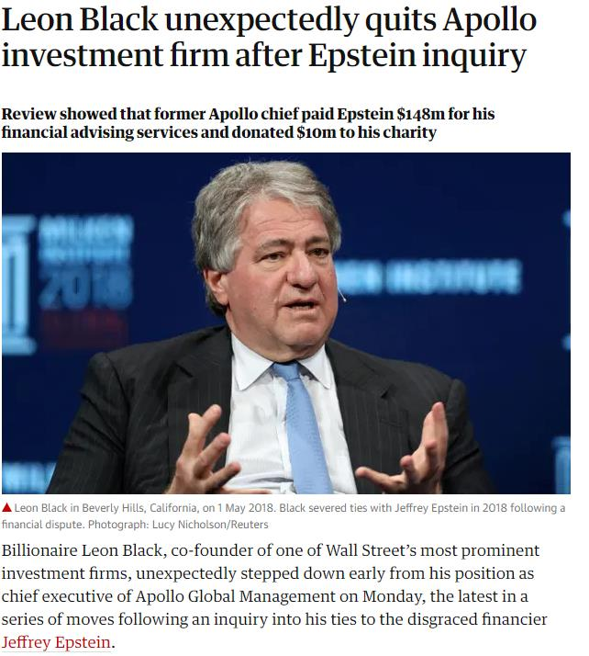
https://www.theguardian.com/us-news/2021/mar/22/leon-black-quits-apollo-jeffrey-epstein-ties-inquiry
Wait so you're telling me that the former SEC chairman is working for a company that was connected
with one of the most infamous criminals of all time? YUP. Well at least the old CEO isn't there anymore
right?
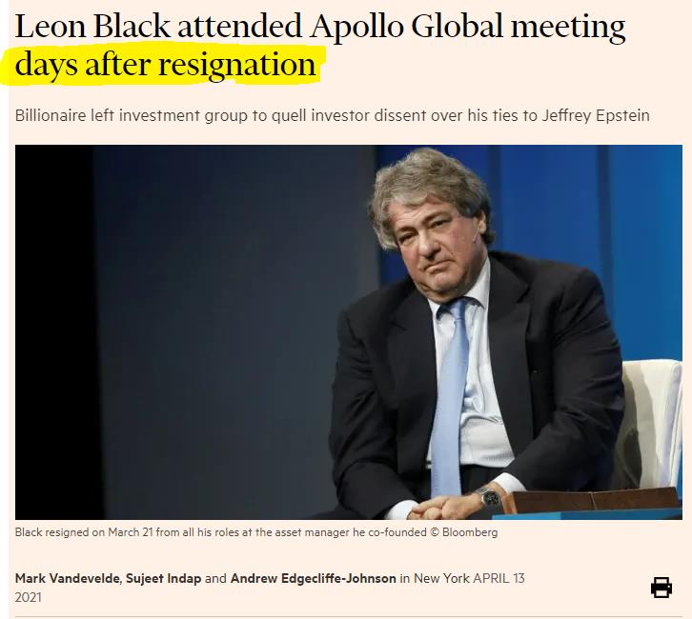
Yikes, almost like this shouldn't be allowed right?
Now lets take a step back about two weeks ago or so; recall Mr. Heath Tarbert? Who was the former
chairmen of the CFTC (Commodity Futures Trading Commission). Last we heard he just got hired by our
boy Ken Griffin as his Chief Legal Officer.
Turns out that Jay Clayton and Heath Tarbert (brought in during the Trump administration) know
each other pretty well. In-fact Heath had this to say about his friend Jay Clayton.
“It has been an honor to serve alongside Jay Clayton. He is one of the smartest and most capable
transactional attorneys in the country and an even better colleague and friend*. As leaders of the SEC
and CFTC, we have* worked together closely to harmonize our rules where appropriate and hold
wrongdoers accountable."
Directly from the CFTC site: https://cftc.gov/PressRoom/PressReleases/8310-20. So now we have two
former chairman of the organizations meant to control Wall Street who are working for the very thing
they were regulating. The same Wall Street they were "harmonizing rules" for --- oh and one of them is
working at a Hedge Fund associated with a criminal. Great, totally not a problem.
MY OPINION: There's nothing from these two from continually working together even now; only a few
months have passed since these two were last collaborating. This begins to lead us into an ordeal that
starts to paint a picture of what may have happened in the last few years and how some hedge funds
might have further screwed themselves with super cheap interest rates introduced during the pandemic
on loans with these two formerly at the helm stoking the flames.
Wonder how Gary Gensler as the new SEC chairman will play into all this now? That will be covered
soon.
------------------------------------------------------------------------------------------------------------------
Section 2 --- Credit Suisse --- A Leaky Boat
------------------------------------------------------------------------------------------------------------------
NOW how does Credit Suisse (CS) find themselves in this mess? They just can't seem to keep
themselves out of the news. More holes keep getting blown out in their ship that they're desperately
trying to patch. We already mentioned the situation with Archegos, but something that hasn't been
mentioned as much is their losses associated with Greensill Capital and their filing for insolvency
on March 8th, 2021.
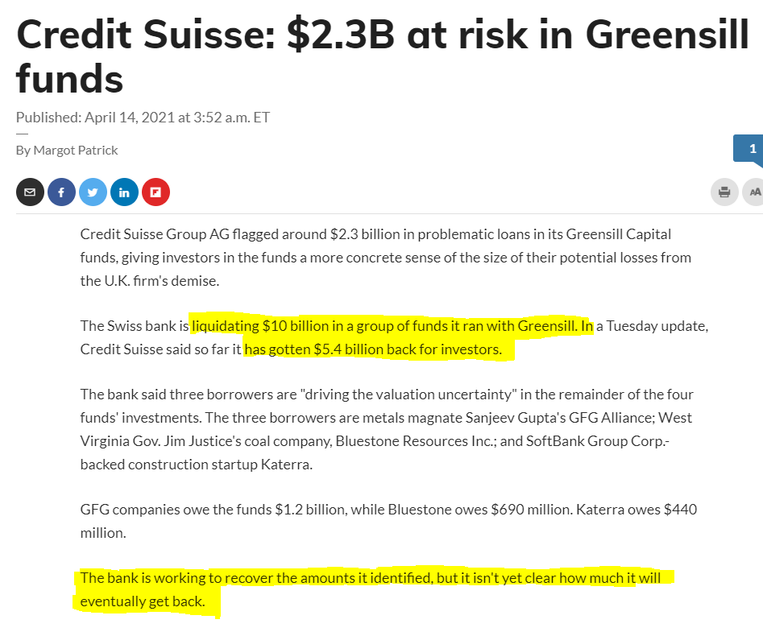
As a result of their bankruptcy, 50,000 people lost their jobs when it became evident that during
courthouse hearing in Sydney, Australia - $4.6 billion was owed and no one was extending out a hand to
loan anymore to Greensill (THIS IS A BIG PIECE OF THIS STORY, HOLD THIS THOUGHT FOR NOW
BECAUSE THIS IS GOING TO GET CRAZY LATER ON).
As a result different parts of Greensill had to be liquidated as a means to recoup costs. One of the
impacted was Greensill's tech partner Taulia. Guess who had plans to acquire them?
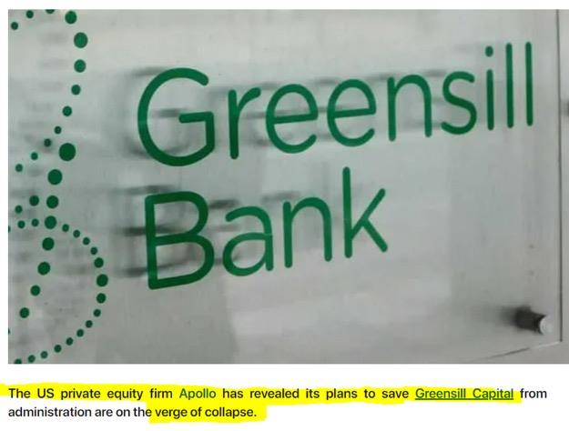
what are they doing here???
YES APOLLO IS MEDDLING HERE. Now everything was going according to plan for Apollo, seems like
they'd be able to get a pretty cheap cost of entry on Taulia who from their site:
" Taulia is a financial technology business that provides working capital management, electronic invoicing,
supply chain finance, and dynamic discounting services. The company helps buyers and suppliers
accelerate payments*, improve supply chain health, and* unlock trapped cash. "
But SURPRISE!
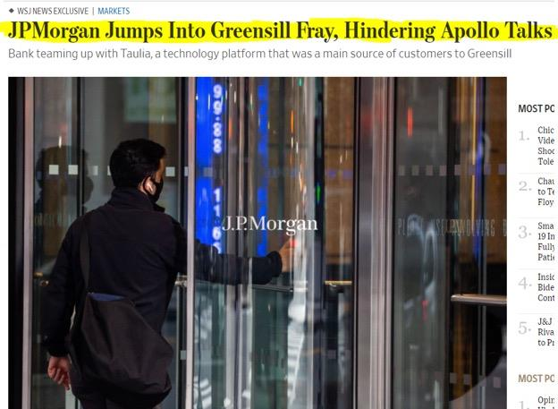
https://www.reuters.com/article/us-britain-greensill-apollo-idUSKBN2B4233
YOINK. JPMorgan decides to play the uno reverse card and that they want Taulia on their side too. Oh
and it turns out UniCredit + UBS Group want a piece of the action as well.
Don't forget who are the two major institutional owners of JPMorgan...
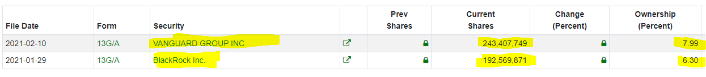
if it isn't our boys BlackRock, and Vanguard. Source: https://fintel.io/so/us/jpm
As a side note did I mention that UBS is the direct competitor of CreditSuisse in Switzerland and that
the two are planning a merger? https://www.fnlondon.com/articles/ubs-chair-axel-weber-says-a-
merger-with-credit-suisse-could-take-years-20201207
To add to all this, we now we also know that BlackRock is looking to make a move on Credit Suisse in
the midst of this storm. This is in addition to their existing relationship with Swiss Re (scroll down for more information in
that thread to Section 5.)
MY OPINION: From researching around it seems that for one reason or another, consolidation of banks
appears to be a focus headed into the near future. BlackRock is looking to somehow join the narrative
and become further ingrained in the banking world. This becomes especially interesting considering
how BlackRock is positioning themselves as the 'fourth branch of government'. I believe I explain
this relationship a bit better in anticipation of what the future is going to bring (Section 4).
------------------------------------------------------------------------------------------------------------------
BONUS ROUND --- UK EDITION
------------------------------------------------------------------------------------------------------------------
Just so our fellow apes in the UK don't feel left out of all the drama, none other than former Prime
Minister David Cameron was heavily involved with Greensill, lobbying for the company.
Just some examples of what he's being called out for:
"
• He texted Chancellor Rishi Sunak, asking for the company to be included in a Covid-
related government loan scheme
• He also contacted Treasury ministers Jesse Norman and John Glen about the company
• He met Health Secretary Matt Hancock - along with Lex Greensill - for a "private drink"
in 2019 to discuss a new payment scheme for NHS staff
"
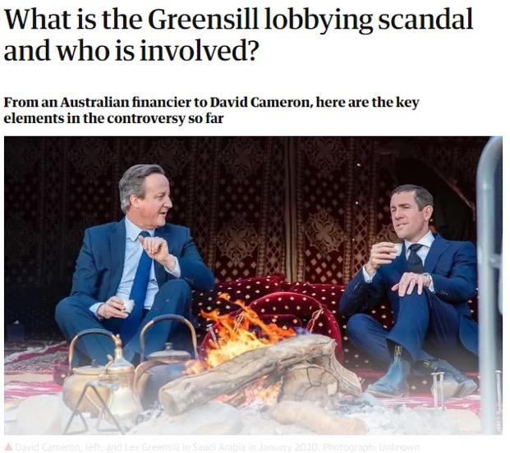
IT NEVER ENDS DOES IT.
Now back to our friend GARY "GG" GENSLER and how this all potentially plays together.
------------------------------------------------------------------------------------------------------------------
Section 3 --- Gary Gensler --- GG GLHF
------------------------------------------------------------------------------------------------------------------
Now I'm not going to go into too much depth here about Gary himself; apes have done a TON of research
already in this regard. If you're not familiar with him, please have a read of other apes work and then
come back.
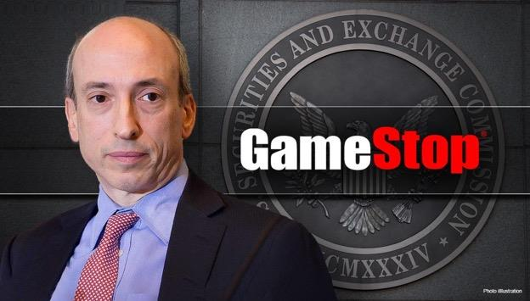
For a short synopsis from ape /u/AAces_Wild (I totally agree with their statement here):
"Fellow apes, please warmly welcome Professor Gensler to the SEC. If there’s anyone I would trust to wield
the power as SEC chairman while closing loopholes, protecting investors, and policing the largest financial
center in the world, it’s Gary Gensler.
Key Takeaways*: Gary has extensive expertise in the prosecution of big banks and has shown support
for market transparency. Without hesitation, I believe he's the man for the job. Gary is good.*
As Gary likes to say: "Markets work best when there's a cop on the beat.""
I would add to this that he also has a fairly deep background in crypt0-currencies which explain the
recent movement of C0inBase and the currencies associated with it. Gary is very likely to implement
new legislation that favors crypt0. He's also fairly knowledgeable about darkpools and their inner
workings.
One of the major concerns that I have however is that Gary was involved with bringing the big banks to
light back in 2008. To have him appear now and for such a short period of time (his contract is until June
when it'll be renegotiated) raises a bit of a flag.
There is another point here that is of concern, but before we get into it...
DISCLAIMER DISCLAIMER DISCLAIMER DISCLAIMER DISCLAIMER
POLITICS ARE ALL SCREWED --- THIS ISN'T AN ARGUMENT OF LEFT VERSUS RIGHT. BOTH SIDES
HAVE INVOLVEMENT WITH WALL STREET AND ACCEPTS BRIBES. REMEMBER APES ARE
TOGETHER BECAUSE WE ARE FIGHTING A CLASS WAR REGARDLESS OF RELIGION, GEOGRAPHY,
BELIEFS. WE WANT A BETTER LIFE FOR EACH OTHER.
Fellow ape /u/justoneshyboy, dug into all those who voted 'Nay' against the election of Gary Gensleras
the new chairmain.
Here's what they found:
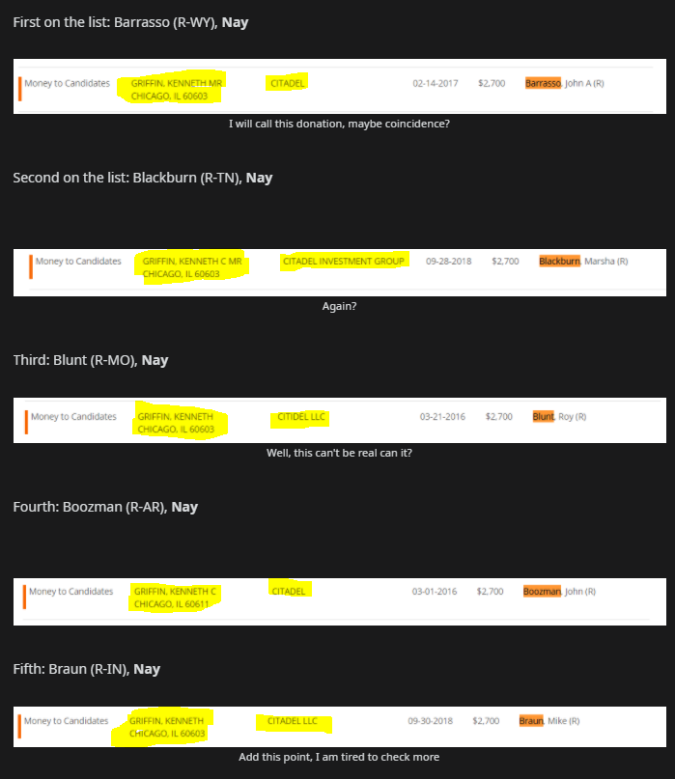
As it turns out, Kenny boy has donated to majority of the 'nay' sayers. Of course, this was bound to
happen considering Gary was selected on behalf of the democrats. Where does this lead us to?
Well one of the major topics of focus come from this clip of GG himself; give this a quick watch for about
2 minutes:
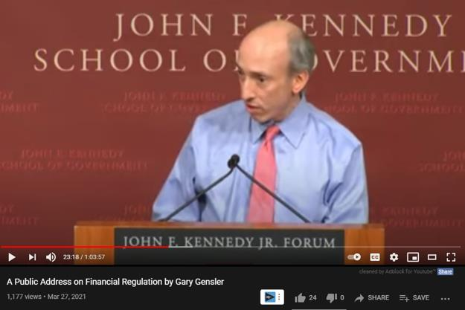
https://youtu.be/b_GcpsIyQFc?t=1425 from 2014
https://youtu.be/b_GcpsIyQFc?t=1425; a quote directly from Gary in the video:
"Today the CFTC announced it's fifth settlement with a bank for pervasive rigging interest rates[...]
these interest rates called the London Inter-Bank Offer Rate (LIBOR) is a critical reference rate for
the U.S. economy. Student loans are sometimes tied to them, mortgages are tied to them, small business
loans, and yes 70%; seven-zero of the international derivatives market, futures, swaps are tied to
LIBOR"
REMEMBER THESE TWO THINGS MENTIONED IN
ASSOCIATION WITH EACH OTHER:
• "PERVASIVE RIGGING INTEREST RATES"
• "London Inter-Bank Offer Rate (LIBOR)"
MY OPINION: Look at what's happening with the bond market in the last few days in China and
the U.S. (more on this in /u/Captain_Omar 's post) --- With so much of the world's loan market tied up in
this "LIBOR", why is it a big deal now? Well we know that the CFTC is the one establishing settlements
for any rigging of game that may be taking place within interest rates.
Oh right, and the former chairman of the CFTC now works at Citadel was in charge of policing this
for the last 4 years. In addition, what are the chances he's intertwined with the congress
members who've received donations from Citadel do you think? Seems like this LIBOR thing
might be a problem for certain parties?
Okay so something's up, what is LIBOR anyways? This leads us into Section 4.
------------------------------------------------------------------------------------------------------------------
Section 4 --- LIBOR vs SOFR --- Global Financial Evolution
------------------------------------------------------------------------------------------------------------------
Take a breather here if you haven't already. This is a lot of information in digest and LIBOR (London
Inter-Bank Offer Rate) is not a light topic. Thank you /u/RegularJDOE1234 & /u/HCRDR on further
research into this.
There is about $350 - 400 trillion (yes that is TRILLIONS with a T, about 4x the size of the global
economy) tied up in it.
A short explanation of what LIBOR is:
" Libor is an average interest rate calculated through submissions of interest rates by major banks
across the world. "
IN 🦍 SPEAK, GRAB YOUR 🖍️'s IT'S TIME GO TO🏫🎒. Interest is something all of us have dealt with in
one fashion or another. Credit card payments, mortgages, student loans. The concept is all the same. You
borrow money from the bank, and they tell you that you'll be paying a fee monthly (known as the
interest rate) on top of the money you've loaned out from them. On top of this you get told what your
interest will be ahead of time (forward looking interest rate) so you know what to expect your bill to be.
Now the reason LIBOR is a problem is that it can easily be gamed and has been for quite some time. It
also doesn't adjust for another crazy shit that might happen until the next payment period. If the
economy crashes in that time frame and you're still paying a super low interest rate because of a
contractual agreement, the banks lose BIG TIME. Directly from Wikipedia on the "LIBOR Scandal":
" The scandal arose when it was discovered that banks were falsely inflating or deflating their rates so as to
profit from trades, or to give the impression that they were more creditworthy than they were.[3] Libor
underpins approximately $350 trillion in derivatives
The banks are supposed to submit the actual interest rates they are paying, or would expect to pay, for
borrowing from other banks. The Libor is supposed to be the total assessment of the health of the financial
system because if the banks being polled feel confident about the state of things, they report a low number
and if the member banks feel a low degree of confidence in the financial system, they report a higher
interest rate number."
REMEMBER THIS, the interest rate drops to low percentages when the market is confident or is looking
to inject growth (like how it is now); the inverse happens when the market is fearful (higher rate =
higher cost of borrowing money usually). This is like letting your buddy Good Guy Greg borrow 20 bucks
versus your half-cousin twice removed, Scumbag Steve.
The banks here would deliberately rig the interest rates between each other in order to get massive
loans to profit from (they basically are making themselves appear like Good Guy Greg to everyone
around them, when in reality they're stealing your wallet out your back pocket). THE LIBOR SYSTEM IS
WHAT ALLOWS FOR THIS TO HAPPEN. As it turns out, a lot of people are fed up with this and want see
it changed for good reason as seen below...
WORTH NOTING:
LIBOR was a massive playing piece involved in the 2008 financial crises, this quote is directly
from the congressional hearing on the matter:
" The LIBOR’s self-reporting structure has created opportunities for individuals or institutions to
manipulate or falsify data*. In the wake of the 2008 financial crisis, upon discovering a widespread
culture of LIBOR manipulation built around industry relationships, U.S. and U.K. regulators settled with
various banking institutions, including some of the world’s largest banks such as Barclays,* JP Morgan
Chase*, Citigroup, and* UBS over allegations that these institutions manipulated the LIBOR bypressuring
their colleagues to report artificially low or artificially high interest rates in order to manufacture
trading opportunities. "
Talk about the timing of Gary Gensler coming back into the picture right? One of the few people in
the SEC who directly dealt with this type of scenario before.
FEAR NOT, HERE COMES THE EVOLUTION OF THIS SYSTEM
Introducing SOFR (Secured Overnight Financing Rate)!!!!! This is a MASSIVE 200 trillion dollar
transition that will take place over the next few years.
OH and it almost imploded the entire fucking market the first time it was attempted to be
implemented back in 2019 https://www.federalreserve.gov/econres/notes/feds-notes/what-
happened-in-money-markets-in-september-2019-20200227.htm
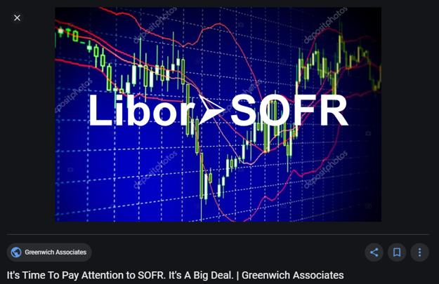
And it looks like they just had a hearing on this evolution just YESTERDAY.
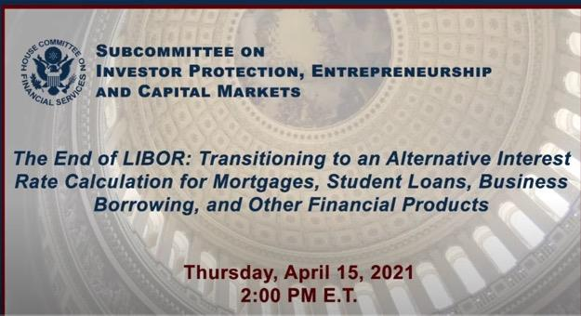
https://www.youtube.com/watch?v=igmJ-SFvyRU two hours worth of content, watch at your own risk
I watched them talking about it live, I would be lying if I told you it was a thrilling piece of
entertainment. Watch it if you're really curious and want to get a deeper understanding of what's at
stake.
What this means is SOFR will change how interest rates are calculated.
Yet again in a very simple explanation: if Libor is "forward-looking" meaning you get an interest rate
ahead of time (you know exactly what your payment will be) - SOFR is the inverse, meaning it's
"backward-looking".
WHAT THIS MEANS IS THAT BANKS AND OTHER PARTICIPANTS WILL NOT KNOW WHAT THEIR
MONTHLY PAYMENT FOR THEIR LOAN WILL BE(for example) UNTIL THE DAY OF PAYMENT
(From reading I believe it's about 5 days prior, I could be wrong). THIS IMPLIES THAT THE RATE
THEY WILL HAVE TO PAY FLUCTUATES ON A DAILY BASIS. THIS DAILY FLUCTUATION WILL BE
BASED OFF THE DAILY TRESURY YIELD RATE. This transition is expected to be completed by 2023,
however no new contracts can be written under Libor as of... MARCH 31ST, 2021.
To illustrate this point, the image below shows how much more "variable" (dynamic) the rate (in blue)
will be, versus the fixed variant (in red) of it we see today.
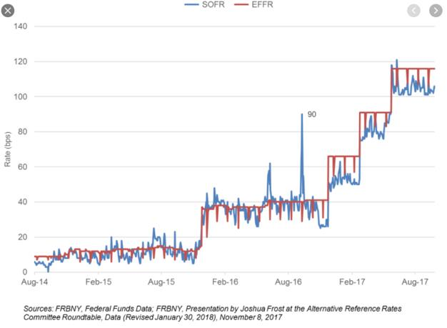
This solves two things:
1. If the market fluctuates in the time that a loan was given, the banks will not be put into a
vulnerable position nor profit from it. Think of this as a "we ride together, we die
together" type of scenario. They'll be impacted as much as any of us should the market
take a down turn or rise.
2. The rates can no longer be gamed as easily because they're no longer based off self-
report data, but rather the rate of the daily treasury yield on the market.
Now here's the thing, we should've already started transitioning to this new system over quite some
time. The fed wanted all the new loans being given out in the last year to be already implemented
through SOFR, but instead the banks chose to STILL tie them to Libor. But wait a minute some of these
are 3-year, 5-year loans; but Libor will only be around for another 2 years. Sounds like it can be another
problem in the making and the banks don't want to face reality yet. Knowing this it's not surprising
they posted such great earnings right? Easy to make the picture look pretty when it's full of shit.
Watch about 45 seconds of this clip for concerns coming straight from Grant Thornton UK on the
matter.
https://www.youtube.com/watch?v=HAf6Bk5szIk&t=1245s
HERE'S THE REASON MANY ARE TERRIFIED AT WHAT THIS WILL MEAN FOR THE MARKET:
"I think it's fair to say that people like myself are getting a bit of an odd feeling in the gut about what is
going on about some of these books - so to drive transparency there, the cyclical quarterly testing on
impairments and cogence the data will be out in June, and I think the views we have are that some of the
borrowers will fail." --- Grant Thornton UK Advisor
[Source: https://www.youtube.com/watch?v=HAf6Bk5szIk&t=1553s]
LONG STORY SHORT; THEY'RE WORRIED THAT WHEN BANKS AND BUSINESSES ARE FORCED TO PAY
THE ACTUAL RATES OF THE MARKET (and not their made up ones) BECAUSE OF THE LIBOR -> SOFR
TRANSITION, THAT THEY WILL NOT HAVE THE CASH ON HAND TO MEET THE SOFR REQUIREMENTS
AND RUN INTO SERIOUS FUCKING TROUBLE. THIS IS SIMILAR TO WHAT HAPPENED ALREADY IN
2019.
NOT ONLY THIS, THE PEOPLE WHO BORROWED MONEY WILL BE STRESS TESTED ON A REGULAR
BASIS (think monthly/quarterly) TO SEE IF THEY ACTUALLY CAN SUPPORT A HIGHER INTEREST
RATE SHOULD THE MARKET GO TO SHIT. Once again no new contracts can be written under
Libor as of... MARCH 31ST, 2021.
YOU WILL NOW SEE THE MARKET STARTING TO DELEVERAGE THEIR LOANS IN ORDER TO HAVE
MORE CASH ON HANDS TO MEET THESE SOFR REQUIREMENTS AS QUICKLY AS POSSIBLE. THIS
EXPLAINS WHY JPMORGAN AND OTHERS ARE SELLING BONDS AFTER 'STELLAR' EARNINGS (once
again still in a Libor system). This would also explain why BlackRock is the heaviest in cash
they've ever been. The reintroduction of Gary Gensler during this timeframe, is a concerning one
as he dealt with the 2008 crash once before which involved LIBOR.
EDIT: Bank of America just posted a 15 billion dollar sale of bonds couple of hours ago; the dominos are
starting to fall https://www.bloomberg.com/news/articles/2021-04-16/bofa-to-set-record-for-largest-
bank-bond-sale-at-15-billion
Now the question becomes, who's already caught in the web?
------------------------------------------------------------------------------------------------------------------
FINAL SECTION --- THE GREAT TRAP
------------------------------------------------------------------------------------------------------------------
My Opinion: I believe that many of the "bad" hedge funds, took on massive risks with
expectations that the 7rump administration would get re-elected and prolong the need for
transitioning to SOFR and others (involving the former SEC + CFTC chairmen). This would give
them ample amount of time to make profits on the companies (and banks?) they bankrupt.
It appears to me that they didn't properly hedge their risk for any other outcome.
Now lets have a look at who might have abused the low interest rates fabricated by banks, and provided
collateral with rehypothecated assets?
Well a good place to start looking is to see who's grown the most in the last year.
we have a pretty good starting point as we've seen in /u/yosaso's post about the war to control the
DTCC: (I'm just renaming these teams for the sake of vulgarity, and adding some names)
TEAM Good Guys
JP Morgan, BOA, Morgan Stanley, State Street, Vanguard, BlackRock, Goldman Sachs
TEAM Bad Guys
Citadel, Virtu, Citi, Susquehanna, Melvin, Apollo
TEAM UNKNOWN
BNY Mellon - 2
Here are the good guys, seems like pretty stable growth since last year right roughly returning to where
they were before
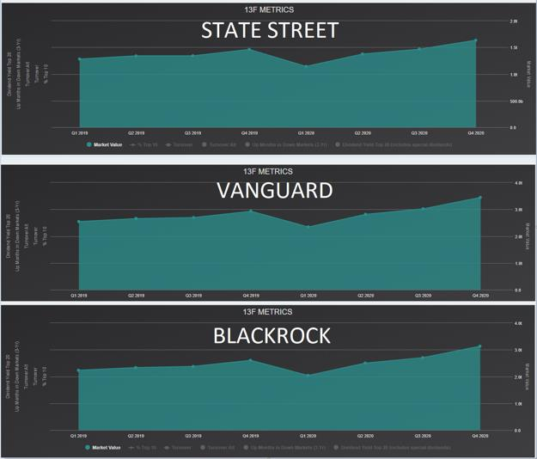
NOW HERE ARE THE BAD GUYS. WHOA THEY JUST RIPPED OVER THE LAST YEAR.
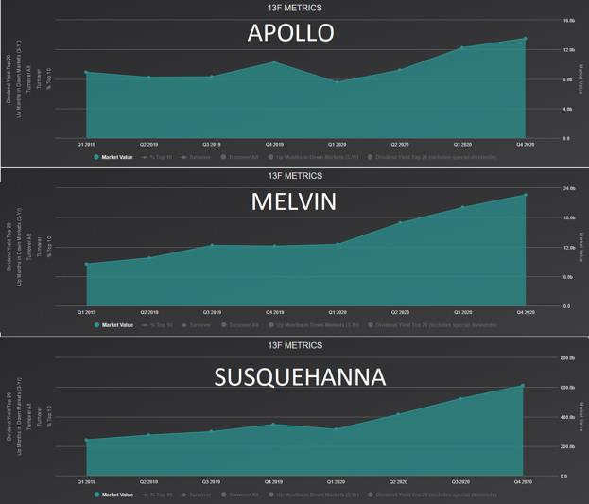
WOW WHAT GROWTH!
Growth over the last 4 quarters:
Good Guys:
Company Growth Since Q1 2020
State Street 42.8%
Vanguard 46.9%
BlackRock 53.3%
Bad Guys:
Company Growth Since Q1 2020
Apollo 78.4%
Melvin 80.5%
Company Growth Since Q1 2020
Susquehanna 94.8%
Now we plug in /u/atobitt 's "Everything Short" thesis here. I believe Hedge Funds have been taking
advantage of the low interest rates that are being gamed. They decide they're going to take this to a
whole new extreme through rehypothecation and the repo market.
MY OPINION: THIS IS MONEY THEY'RE NEVER GOING TO BE ABLE TO PAY BACK. CITADEL AND
FRIENDS ASPIRED TO REACH THE GRAND SIZE THAT THE LIKES OF BLACKROCK AND VANGUARD ARE
THROUGH ANY MEANS NECESSARY. I BELIEVE THEY'VE TAKEN ON MASSIVE RISK AND ARE NOW
BEING CLOSED IN ON BY THE DTCC + THE SEC WITH THE SOFR ADJUSTMENT.
THEY'VE PUT MULTIPLE BANKS AT HUGE RISK A BLOWING UP ON FAKE BONDS --- IT'S ONLY A
MATTER OF TIME BEFORE SOFR DROPS THE BOMB ON THEM. I believe this is the reason why
BlackRock and Co have been pushing for "max pain" each week; this is so that it makes it impossible to
keep up with SOFR interest rate requirements.
------------------------------------------------------------------------------------------------------------------
As time progresses I believe we will see more evidence of multiple parties attempting to deleverage
their positions before 2023. Coincidentally GameStop has just paid off all their debt that was due that
exact year.
So this becomes a two pronged problem;
1. Assets are being rehypothecated which are being used as collateral
2. Banks are providing absurd interest rates off the old LIBOR system instead of SOFR; this
has resulted in the taking on a position that will be extremely difficult to get out of.
As we can see they're fighting against these changes through politics, but it appears they've brought
in Gary Gensler to kick some ass.
TLDR: DIAMOND HANDS APES. 💎✋
NOT FINANCIAL ADVICE
Back to Table of Contents
SEC Filing: Merger with brokarage, detailing
lawssuit, mentions 30 brokerages engaging in
coordinated conspiracy
DD 👨‍🔬
SEC Filing for Northen Star and Apex merger link: S-4 (sec.gov)
Addendum— these lawsuits are mentioned in an upcoming merger- lawsuits related to the debacle fall
out from GME in January - the reason I think it’s a positive thing is the merging brokerage must disclose
and they state an increase of awareness of market manipulation and this makes them more liable and
also more apt to regard Sec laws. Also it provides more info to help us know the bigger picture. I think
this is all GOOD- there will be more eyes and more regulation. I personally am not changing my broker.
Just personal opinion and absolutely not financial advice. I’m a silly ape who doesn’t know anything.
*Note I only had time to start perusing it-- I think this document is a great filing that can help gather
more info. Just putting it out there for all the other ape nerds like myself that like to research-- I
appreciate you all as all of us that play by the rules need to see the bigger picture to stop allowing the
bigger parties to make their own rules.
Part of merger goes into detail about APEX lawsuits and "conspiracy"--
" Plaintiffs allege that Apex, along with over 30 other brokerages, trading firms and/or clearing firms,
including Morgan Stanley, E*Trade, Interactive Brokers, Charles Schwab, Robinhood, Barclays, Citadel
and DTCC engaged in a coordinated conspiracy in violation of anti-trust laws to prevent retail customers
from operating and trading freely in a conspiracy to allow certain of the other defendants, primarily
hedge funds, to stop losing money on short sale positions in GameStop, AMC and certain other securities.
"
Engaging in unfair competition
" Apex Pro, ETC Processing Technologies LLC and ETC Global Holdings, Inc. (collectively, the “ETC
Defendants”) are defendants in the matter captioned as InteliClear, LLC v ETC Global Holdings, Inc., et al.,
filed in the United States District Court for the Central District of California (the “District Court”) in 2018.
The plaintiff in this matter alleges that the ETC Defendants misappropriated trade secrets under the
Defend Trade Secrets Act and California Uniform Trade Secrets Act, breached a contract with plaintiff
and engaged in unfair competition. "
Please disregard my spelling errors in title- my iPad wasn’t the ideal typing platform and I’m horrified I
cannot edit it. ashamed ape
*cheers my beautiful apes*
Back to Table of Contents
a followup to the HoC DD- the "everything" in
Everything Short. I present, RAGNAROK
DD 👨‍🔬
Atobitt made some great DD. House of Cards 1-3. Everything Short. Classics. However, part 2 and 3 of
HoC felt incomplete. No offense to the man, no offense to the data. I think it is spot on, i think we all know
what to do. HODL.
But, I am here to add this, somewhat controversial, somewhat illuminating piece of information. I
hesitate to post this because I don't want to insinuate there are other plays. There are not. i want to be
clear- this is in no way intended to diminish, nor will it, your desire to do nothing more but BUY AND
HODL. Ready for it? it's not even much of a surprise...
its not just GME.
Several Hedge Funds like Citadel, Melvin, Highfields, etc... develop a significant position in certain
companies they like. The big boys. Now, when Atobitt said it was the Everything Short he fucking meant
it is the EVERYTHING SHORT. So for the sake or brevity, i will only focus on a select few. namely,we are
going to be discussing some rather interesting connections between amazon, netflix, target and GME and
the like. This is going to be a bit of a swim, so please bear with me. let us dive in
Recently, Netflix has been rumored to be entering the video game
industry. https://www.polygon.com/22447410/netflix-executive-games-expansion-the-information-
report
And, as you know, Amazon recently purchased MGM
studios. https://www.cnbc.com/2021/05/26/amazon-to-buy-mgm-studios-for-8point45-billion.html
Now i am sure it doesn't take a few crayons to see our big boy GME is in the video game industry, and
little brother AMC, is in the movie biz. Okay. I see that connection. Let's divert a bit and look into some
other connections. i turn your attention to Kevin
Turner https://en.wikipedia.org/wiki/B._Kevin_Turner:
"Kevin Turner is an American businessman and investor who is currently the chairman of Zayo Group
and the vice chairman of Albertsons/Safeway .He previously served as the COO of Microsoft from 2005
to 2016. Prior to joining Microsoft, Turner was the CEO of Sam's Club and the CIO of Walmart. He is also
the former Vice Chairman of Citadel LLC and CEO of Citadel Securities "
wow okay, citadel connection, sure. but what's Zayo Group?
From: https://finance.yahoo.com/news/were-hedge-funds-flocking-zayo-190533381.html
"The largest stake in Zayo Group Holdings Inc (NYSE:ZAYO) was held by Senator Investment Group,
which reported holding $205.5 million worth of stock at the end of September. It was followed by
Citadel Investment Group with a $162.9 million position. Other investors bullish on the company
included Kensico Capital, Zimmer Partners, and Hunt Lane Capital.... [most] stocks had an average of
21.25 hedge funds with bullish positions and the average amount invested in these stocks was $365
million. That figure was $1248 million in ZAYO's case."
Okay! that's a fine connection there. Who is Senator Investment Group, though?
https://finance.yahoo.com/news/hedge-funds-aren-t-crazy-234734875.html.
" VICI Properties Inc. (NYSE:VICI)[https://viciproperties.com/about-us/]. At Q3's end, a total of 37
of the hedge funds tracked by Insider Monkey held long positions in this stock, a change of -37% from
the previous quarter. .Soros Fund Management with a $419.8 million position. Other investors bullish on
the company included Senator Investment Group, Citadel Investment Group, and Point72 Asset
Management. total hedge fund interest was cut by 22 funds in the third quarter."
Okay, im going off the rails a bit. My point is, all of these Hedge funds are obviously connected. And all of
them, have their fingers in a few different pots. Now lets get back on track. Now senator Investment
group has large holdings in Amazon and Five Below. https://whalewisdom.com/filer/senator-
investment-group-lp, among many others. I started looking into their competition and found something
odd.
Now i apologize, i will be referencing a lot of charts, so please google them yourself. Look at the chart for
FIVE stock- it has had significant growth year after year but has followed GME chart inversely, every
spike for GME correlates with a dip. This will be true for many, many other stocks. I started looking into
other Brick and Mortar Companies and comparing charts. i found quite a few. Again, for sake of brevity, i
will be focusing on a few.
FIVE, AMAZON, Walmart, Dollar Tree- their competition is other retail brick and mortar stores. CVS, Rite
Aid- their competition is pharmacies. however, target recently partnered with CVS pharmacy in 2015 for
their own stores. Amazon recently wants to enter into brick and mortar pharmacy or add them to whole
foods. https://www.cnbc.com/2021/05/26/cvs-walgreens-shares-fall-on-report-that-amazon-may-
open-pharmacies.html.
target and CVS was interesting to me, because check Citadel's institutional ownership of CVS over the
years-. https://formthirteen.com/filers/0001423053-citadel-
advisors/holdings/126650100?quarter=2020-12-31. Notice the spike in 2015 prior to Target
announcing CVS agreement?
Citadel has also created a bunch of call/put LEAPS throughout the years on Rite Aid- CVS
competition. https://fintel.io/so/us/rad/citadel-advisors-llc. Citadel is also very bullish on
Amazon. https://finance.yahoo.com/news/billionaire-ken-griffin-bumps-stake-123655840.html. Griffin
even stated at one point he was considering moving Citadel's headquarter's because of
Amazon https://www.cnbc.com/2019/03/14/ken-griffin-says-hes-less-likely-to-move-citadel-to-nyc-
after-amazons-heartbreaking-exit.html.
**********
edit- further info i forgot to add from CVS
https://www.hstong.com/news/detail/20090104245156133 " Of the funds tracked by Insider Monkey,
D. E. Shaw's D E Shaw has the number one position in CVS Health Corporation (NYSE:CVS), worth close
to $218.8 million, comprising 0.3% of its total 13F portfolio. Sitting at the No. 2 spot is Cliff Asness of
AQR Capital Management, with a $218.6 million position; the fund has 0.4% of its 13F portfolio invested
in the stock. Some other professional money managers that are bullish encompass Ken Griffin's Citadel
Investment Group, Phill Gross and Robert Atchinson's Adage Capital Management and Ken Griffin's
Citadel Investment Group. "
https://www.fi-desk.com/chang-reported-to-leave-aqr-for-citadel/ " Citadel has confirmed that Isaac
Chang, the head of trading at AQR Capital Management since 2016, will join the Citadel hedge fund in
September as the firm’s first head of execution trading for fixed income. Chang’s work history combines
trading on the buy-side, sell-side and high frequency trader (HFT) market making, via his position prior
to AQR as global head of fixed income, currency and commodities (FICC) at HFT firm KCG, now Virtu,
and in US interest rates electronic trading at Goldman Sachs..
VIRTU Financial is a marker maker similar to citadel. if you google virtu and "fined" you will find many
violations, one for this in particular- https://www.financemagnates.com/institutional-
forex/brokerage/finra-slaps-175000-fine-at-virtu-for-not-offering-best-execution/, something our good
friend Robinhood recently got in trouble for https://www.sec.gov/news/press-release/2020-321
**********
Now, Amazon bought Whole Foods a few years back. Whole Foods largest competition is Albertson's.
What's interesting is Albertson's was going to merge with Rite Aid until the deal was killed after
immense pressure from a certain hedge fund, Highfields
Capital. https://www.forbes.com/sites/brucejapsen/2018/06/27/a-big-investor-opposes-rite-aids-
albertsons-deal-amid-flat-pharmacy-growth/?sh=55f37f9c37fe
Some more connections here: https://www.businessinsider.com/amazon-deal-for-whole-foods-true-
genius-hedge-fund-2017-7. "genius move" they called the acquisition. Remember when They killed the
Rite Aid deal, and Target bought CVS?
[https://www.wallstreetoasis.com/forums/7-best-long-term-stock-picks-by-morgan-
stanley](Currently, Target's shares are trading at $51.70 and are expected to reach $64 by the end of
2012....Jonathan Jacobson's Highfields Capital Management doubled its stake in TGT during the third
quarter to nearly $300 million.) TGT is in the top 50 of Citadel's
holdings. https://docoh.com/company/1423053/citadel-advisors-llc
Now, Look at the stock charts for Rite Aid (RAD), and compare it to GME. Interesting.
Now, more digging led me to find these same connections with Lowes/Home Depot. As well as BBBY and
Walmart. DLTR. All of these charts, and dozens and dozens of others have the same chart patterns as
GME or inverse if they are insider owned by hedges. Look at 5 yr charts and see the changes over time.
Also, Circuit city was acquired and tanked by Highfields. And many, many others are currently involved.
Literally, EVERYTHING that stands in the way of a long bet by these hedges are SHORTED.
Wanna know what's even scarier? All of the money maker
stocks connected to these hedges only started printing cash
AFTER the 2008 crash- almost as if they pivoted their strategy
to this.
WHAT THIS MEANS
TLDR: What appears to me, is that several hedge funds have placed large bets on their precious money
making stocks, and have over the years been systematically bankrupting, manipulating, and sabotaging
the competition of the acquisitions being made for their babies. Target wants a pharmacy? destroy rite
aid, place calls on CVS. Netflix wants gaming? Short GME. Amazon wants to buy movie studio? short the
movies. Amazon bought a grocery chain? prevent their competition from ever growing. Rinse, repeat.
GME is the one that stood against them and is fucking them up royally. However, what this means is that
there is not one bomb. There are dozens of mini-GME's littered around the market. If GME goes off, the
systematic margin calling will cause mini-short squeezes all over on these stocks. If you check recent
SEC ownership filings, these hedges have been reducing or closing their positions in these shorted
stocks like Rite Aid and Lowes (and many, many others). They are disarming these mini-bombs before
the big one goes. The longer we hold, the more we buy, the closer they get a cluster bomb. We have not
one Asteroid called GME heading to the Earth, but a meteor shower of smaller rocks following quickly
behind.
We will not have an entire market implosion. if the GME squeeze is an event that occurs over weeks, we
will have the long-manipulated stocks experiencing a sudden boon with these squeezes like GME and
AMC have and have benefitted from, breathing new life into these failing companies through the expense
of banks, hedges, and the US Federal govt.
Through their destruction, we shall have creation.
Ragnarok is upon us.
Audio reading thanks to /u/tyrant_tyra for those that don't want to
read. https://youtu.be/0Az%5C_91MJh-4
Back to Table of Contents
I've been scraping data used by hedge funds
for over a year now to make it freely available
to everyone. I think I might start doing regular
data reports on $GME on here if there's
interest, let me know if you have any feedback
on the report below.
Serious DD 👨‍🔬🔬
Hey guys pdwp90 here, founder of Quiver Quantitative for those of you who don't know me by Reddit
tag.
This report is primarily comprised of "alternative data" which can be loosely thought of as data that
comes from outside of traditional sources like earnings reports. The reason this type of data gets me so
jacked is because it's data that retail investors (you guys) often have an edge over Wall Street in
interpreting.
Sadly, it has also been largely inaccessible to normal people in the past as providers usually charge
thousands of dollars a month for any sort of access to their data, making it only available to hedge funds
and other institutional investors. That's what motivated me to start collecting this data myself, to make
it available to those who can't afford to another $10k a year bill.
So without further ado, here's the inaugural u/pdwp90 alternative data report
Twitter
GameStop's corporate twitter account has had a .17% gain in followers in the last day (#14 of 842
companies tracked), a 2.06% gain over the last week (#6 of 842), and a 6.69% gain over the last month
(#11 of 182)
Here's a graph of the twitter following of GameStop Corporate (@gamestopcorp) over time:
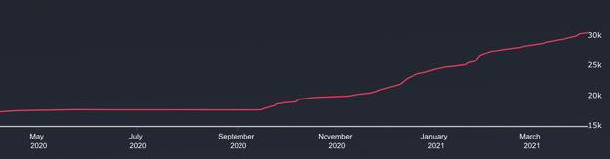
GameStop Corporate Twitter following over time
Off-Exchange Activity
Yesterday, 5.13 million shares of GME were traded off-exchange and 2.48 million of those shares were
sold short, giving GME a DPI of approximately .48. Below is a graph of the cumulative net off-exchange
short volume since 2010:
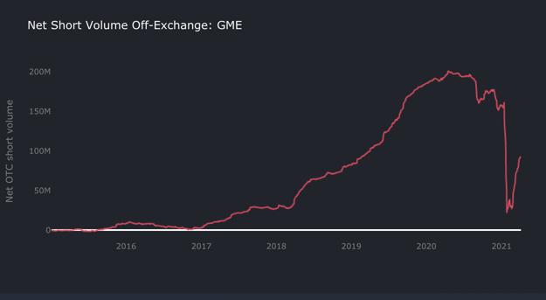
$GME cumulative net OTC short volume
Wikipedia
GameStop's wikipedia page has been viewed 37.6k times this week, making it the 11th most viewed
company page out of the 1342 that I track.
WSB Discussion
I know that this might ruffle some feathers in this community, but I put a lot of precaution into ensuring
the data is protected from the effects of manipulation and moderation. The reason for using WSB is that
it has years of historical data which allow for better analysis and modeling.
Yesterday, GME was mentioned 895 times on WallStreetBets daily discussion threads, making it the
most talked about stock on the sub.
The discussion around $GME has a sentiment score of .576, which is the highest it's been since late
January.
Insider Trading
"Insider trading" used in this context just means trading reported by company insiders, not the illegal
trading. Over the last 6 months, GameStop's directors and management have bought 2.79M shares of
$GME and sold 226k.
Trading by US Congressmen
There haven't been any trades of $GME in the last week by congressmen.
Disclaimer: This is not financial advice.
Back to Table of Contents
[UPDATED] DD: I did the math, there is literally
NO DOUBT that we own >100% of the
remaining float. [including updated remaining
float from GME's proxy statement]
DD 👨‍🔬
(clears throat) "ehem !"
First of all: Many thanks for all the great feedback you freaking apes gave me on my initial DD on r/GME.
As some time (around 1 month) has passed and we have some new apes and apettes on board and some
new information around my initial assumptions has been updated and revealed, I have decided to work
on an updated version of my initial DD. So let's start right away, main changes are as follows:
UPDATE 24th April:
The release of GME's proxy statement revealed some new figures around the floating shares. Using
figures from their 14A, we end up with around 26.6m remaining floating shares. (Please note that
there are some approaches that calculate with an even lower number of floating shares, but lets stay
conservative here). Credits to u/thr0wthis4ccount4way for putting this all together in a great overview
post. Also check out the subreddit this is posted in for some high-quality DD.
In addition to number of floating shares I have updated and added a lot of brokers to get a more and
more precise picture of the total retail situation. I dont trust Bloomberg terminal in any way regarding
individual ownership as numbers are heavily distored due to this fuckload of synthetic shares being
around.
Following brokers have been added since my first post:
• Saxo Bank,
• Lynx,
• Freedom 24,
• Hatch,
• Nordnet,
• Avanza,
• FP Markets,
• Questrade,
• Sharesies,
• Stake.
Following brokers have been identified as missing in my DD, but do not provide public
information about user numbers:
• OnVista,
• Consorsbank,
• TD Canade Trust,
• CashApp,
• RBC,
• Passfolio,
• Firstrade,
• TradeStation,
• Citibank Brokerage
o Basically all major 'banks' that offer investment accounts.
Important: If you are investing with on of the abovementioned brokers, please reach out to them
and ask about the total number of investment accounts (or even better about total number of
users investing in $GME).
Enough blah blah, lets dive into the (updated) DD:
Okay fellow apes, listen up, here is some fresh updated DD straight out of the oven to feed your
confirmation bias. 🚀
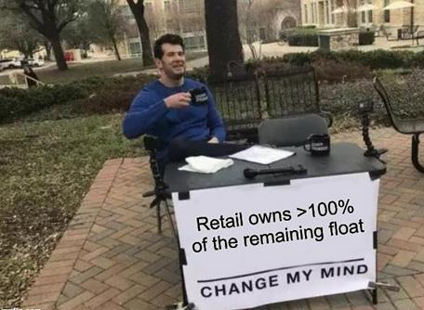
tell me more about how you covered your shorts...
This is a screenshot taken today (24th April) from eToro:
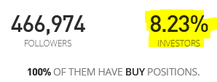
Seems like we like stock, huh?
Not to mention all the posts and screenshots from other investment brokers reporting GME as their
current top traded stock for the past month(s):
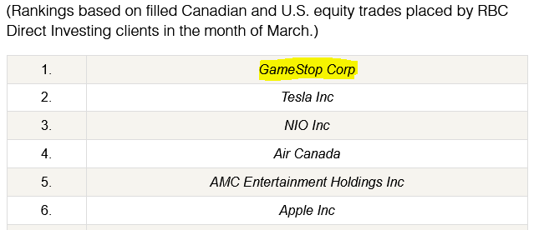
RBC statement for the month of March
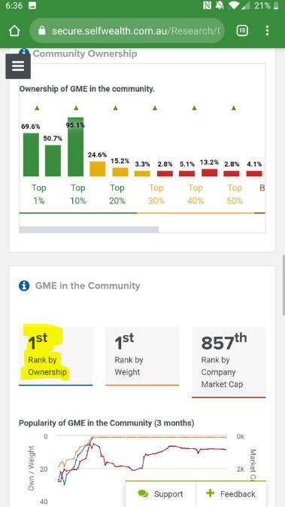
selfwealth community checking in ! Thanks u/Chabkraken for sending this screenshot !
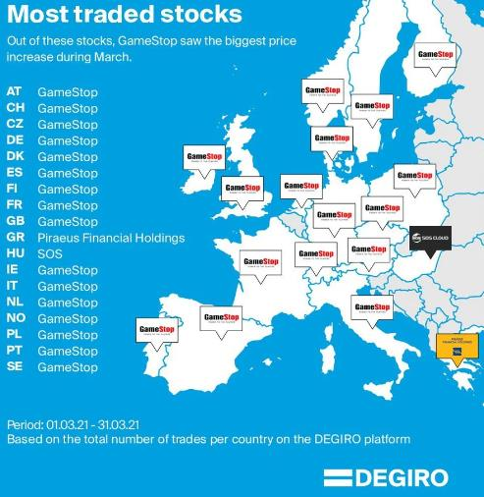
Europoors doing our part over here !
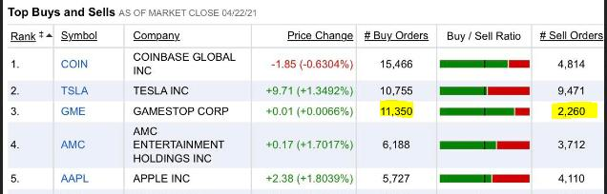
Fidelity checking in !
So i thought to myself, why don't we take this percentage from eToro and try to get an estimation about
how many apes in total are holding GME right now and see where some variables regarding shares per
ape get us. Are you exicted? Because I AM, LETS GO! 🚀🚀🚀
I spent the last hour(s) weeks or so researching the largest broker firms and gathered their total user
numbers. This list is by far not complete which means that the % held by retail investors could be way
way (!) higher than my estimates. Please let me know if you have access to more brokers data and i will
update my list.
Some friendly ape posted a statement from neo-broker Wealthsimple, thats states a GME-ownership
of up to 14% (!) of their total users. Therefore I made assumptions regarding the share of users that
invested in GME for each broker. For neo-brokers like eToro, Robinhood, Revolut and WeBull I went
with an average of 10% GME ownership of all users. (Also included a scenario for only 5% GME-
ownership for neo-broker, as some apes raised concerns that my 10% assumption may be too far on the
optimistic side. Considering eToro stats i am more likely to lean on my 10% assumption, but in order to
deliver a differentiated view, have your 5% scenario)
Of course we have to consider that the average eToro/neo-broker user might have a higher risk
tolerance and is more likely to invest in GME compared to the average boomer investor. So for 'classic'
brokers that are more known for "passive investing" like Vanguard or Schwab I went with a lower share
of users that are invested in GameStop. Some brokers from the Nordics report an ownership of around
1.5% - 2.0% of their users, so lets go with 1.5% for the classic brokerages.
Okay, now that we have a vague feeling of how many GME retail investors we are, lets play with some
scenarios.
Scenario 1: GME-ownership of 5% for neo-brokers and 1.5% for classic investment platforms:
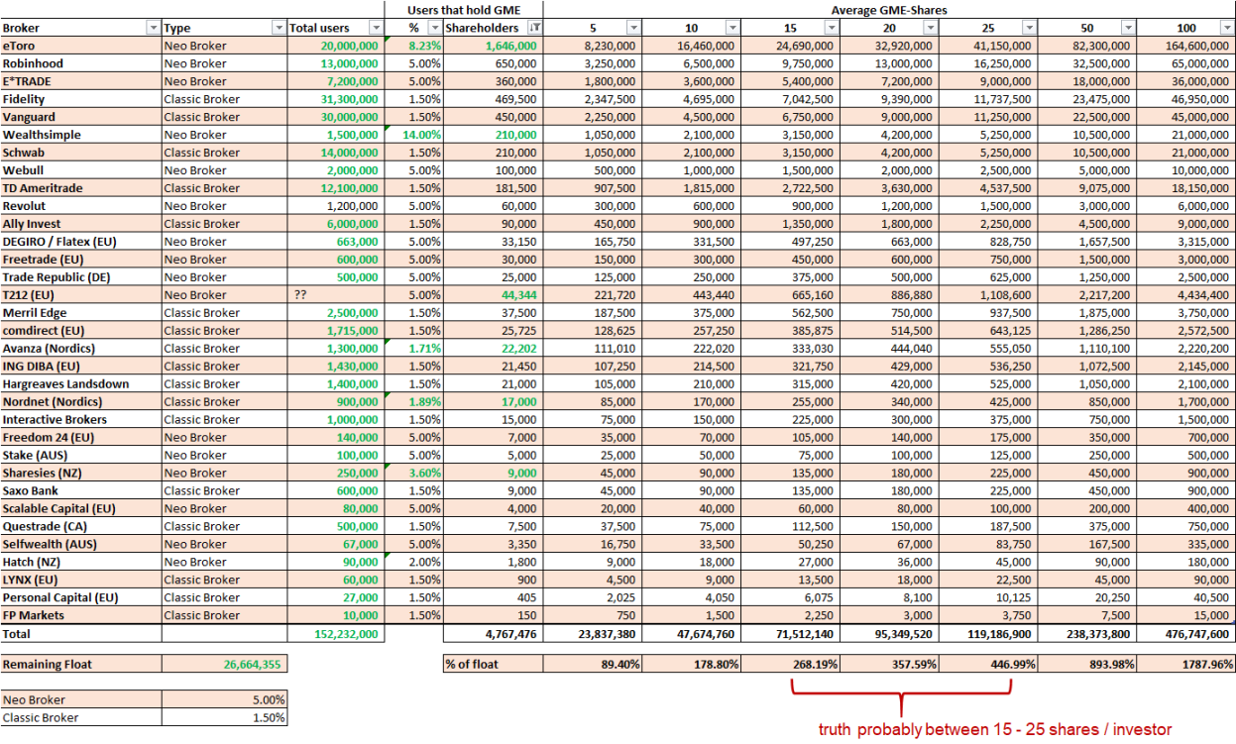
% of remaining float that is held by retail (Scenario 1)
Scenario 2: GME-ownership of 10% for neo-brokers and 1.5% for classic investment platforms:
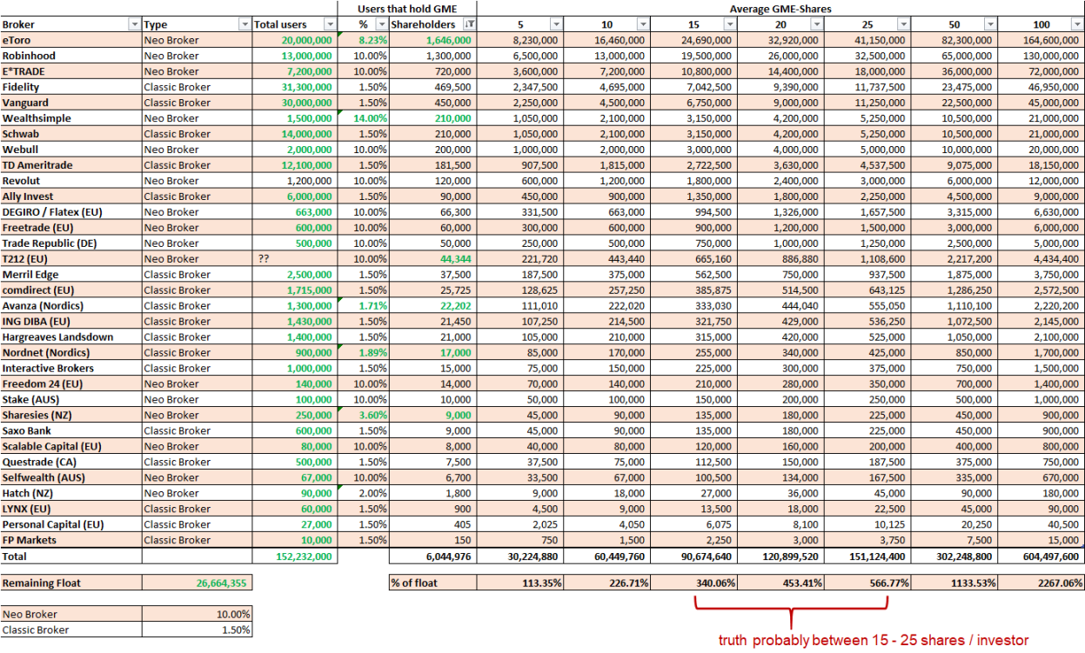
% of remaining float that is held by retail (Scenario 2)
As you guys can see, even with our lowest assumptions we easily land in the +100% ballpark. And
consider that this list does not contain all of the existing stock brokers or banks that offer investment
accounts! Real numbers should be way way higher!

Also keep in mind that we have some huge individual whales among us, talking
about u/DeepFuckingValue, u/HeyItsPixel, u/xeisu, u/Spielporn and many many more who hold xxxx
shares.
Oh no ! Looks like poor Kenny has to buy back our shares multiple times now.... Anyway!

retail whale has entered the chat
IMPORTANT: If you have access to more detailed data regarding number of users or even GME-
ownership for a specific broker, please let me know via dm. There are too many comments here and it's
hard to keep track of all of them. And please add your source (link or screenshot) so I can publish this
here as well.
THIS OVERVIEW WILL BE UPDATED ON A REGULAR BASIS, SO MAKE SURE TO FOLLOW!!
(no financial advice in any way)
EDIT 1 (25th April):
First wave of comments and suggestions came in over night. Fixing some typos, updating numbers and
adding brokers:
Thanks u/InferiorMonkeyRobot, u/MAD_broker, u/AdministrativeTurn84 for an update on Avanza GME-
Investors, checking in with 22,202 (+500 since last post).
Thanks u/binge360 for pointing out missing broker Hargreaves Landsdown. Added to the list.
Thanks, u/Icy_Rhubarb2857 for sharing most traded stocks from RBC statement for month of March.
Thanks, u/Chabkraken for pointing out missing broker Selfwealth and sending through a screenshot
about GME being traded as #1 stock.
TA;DR 🚀🚀🚀:
There is no way that retail holds less than 100% of the remaining float, the actuals number might be
much (!!!) higher, maybe even in the 1000%+. Buckle up, because this rocket is about to enter fucking
lightspeed! 🚀🚀🚀
It costs you nothing to hold, it costs them everything to cover.
u/InForTheSqueeze, 2021, lelz
🚀
Sources:
https://www.fidelity.com/about-fidelity/our-company
https://about.vanguard.com/who-we-are/fast-facts/
https://www.brokerage-review.com/online-brokers/largest-online-brokers-by-size.aspx
https://fortune.com/2021/02/02/robinhood-stock-trader-revolt-webull-alternative-china-app/
https://www.businessofapps.com/data/revolut-statistics/
https://www.businesswire.com/news/home/20180911005141/en/Merrill-Edge-Hits-200-Billion-in-Assets-
Under-Management
https://www.comdirect.de/cms/ueberuns/de/presse/monatszahlen-april-2020.html
https://www.interactivebrokers.eu/de/?f=564
https://flatexdegiro.com/en/company/who-we-are
https://finanz-szene.de/digital-banking/trade-republic-duerfte-schon-um-die-500-000-kunden-haben/
https://en.wikipedia.org/wiki/Freetrade
https://www.wealthsimple.com/en-ca/magazine/gme-data
https://www.interest.co.nz/personal-finance/108826/thousands-nzers-partake-gamestop-movement-
sharesies-users-alone-make-20
https://www.home.saxo/about-us
https://www.lynxbroker.de/
https://de.freedom24.com/about
https://www.hl.co.uk/investor-relations/key-financial-data
https://inspiredinvestor.rbcdirectinvesting.com/en/di/hubs/investing-academy/article/top-10-traded-stocks-
in-march/kkr40d4p
https://themarketherald.com.au/selfwealth-asxswf-finishes-december-quarter-with-yoy-revenue-growth-
2021-01-12/
Back to Table of Contents
PROOF of Artificial Price Movement:
Spreadsheets with Statistics to Soothe the Soul
DD 👨‍🔬
Edit/Update: Thank you for the love and awards!!! I have posted a question about this to Dr. Timbrath’s
AMA, here, if anyone else is interested on her opinion of this.
Apes, our primate community has gone through a lot in the last 4 months. We’ve been called names, lied
to, and manipulated through the same PsyOps techniques typically used on extremist groups.
Throughout everything you beautiful people have remained stubborn and hyper-rational while never
losing your love of crayons, and I have never been more proud to be an ape. Therefore, before we
completely undress GME time and sales data, I would like to dedicate this research to:
Shills. Thank you shills everywhere, for making this research
possible.
You’ve made sure I stay good and motivated (pissed off) by harassing my online friends, name-calling
good people for no reason, and attacking my computer with malware after every stats-based post I’ve
made public. (I may an idiot, but after the third time this happened, I was fairly sure it wasn’t random
bad luck.) Thanks for the 100s of subscriptions to random-ass pron sites, much appreciated. You’ve also
provided LITERALLY the best peer-review system I’ve ever experienced. Never has someone caught my
tiny mistakes SO quickly- your hard work and diligence has enabled me to very quickly correct and
refine my research, drastically improving the quality of the final product. THANKS.
NOW, time to strip time and sales data down to nothing but binary code and statistics. All methods, raw
datasets, and completed analyses can be found here: Materials, Methods, and Madness. Briefly: I have
created a spreadsheet analysis that runs on only one source of data, time and sales, exported from
Fidelity Active Trader Pro. The spreadsheet reports whether each trade had a POSITIVE or NEGATIVE
effect on the price, and thus designates the trade a “BUY” or a “SELL.” Many trades have no effect on the
price: these shares have been included in the total counts but not towards any buy or sell total. This is an
imperfect method to calculating total buy and sell volume, but as you will see, correlates well to overall
price movement of the stock and therefore provides a statistically significant buy:sell ratio that we
can use. The opening and closing prices are summed, and if the overall price movement does not match
the net buy/sell pressure, the spreadsheed tells you IN REALLY BIG LETTERS. The spreadsheet also
flags trades priced outside the bid-ask range, with a special check for prices that are crazy high (to
catch odd price spikes as I did in my first rant with statistics here). I also have it check for “odd lots“
from options-based exchanges- if a trade comes from a bid or ask exchange that specializes in options
only, it should really be 100 shares traded or a multiple (1 options contract = 100 shares). I’ve
relaxed the tolerance a bit, and the check is only for things that are non-divisible by 10 originating
from an options-based trade.
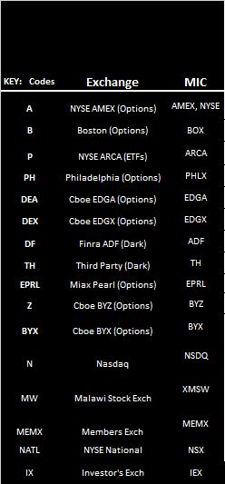
fidelity loves acronyms
First, let me show you some “controls;” aka super “boring” stocks that we are assuming
are NOTmanipulated and therefore do NOT have artificial price movement: their price movement is
natural and expected based on buy and sell volumes. And the most boring stock prize goes to....
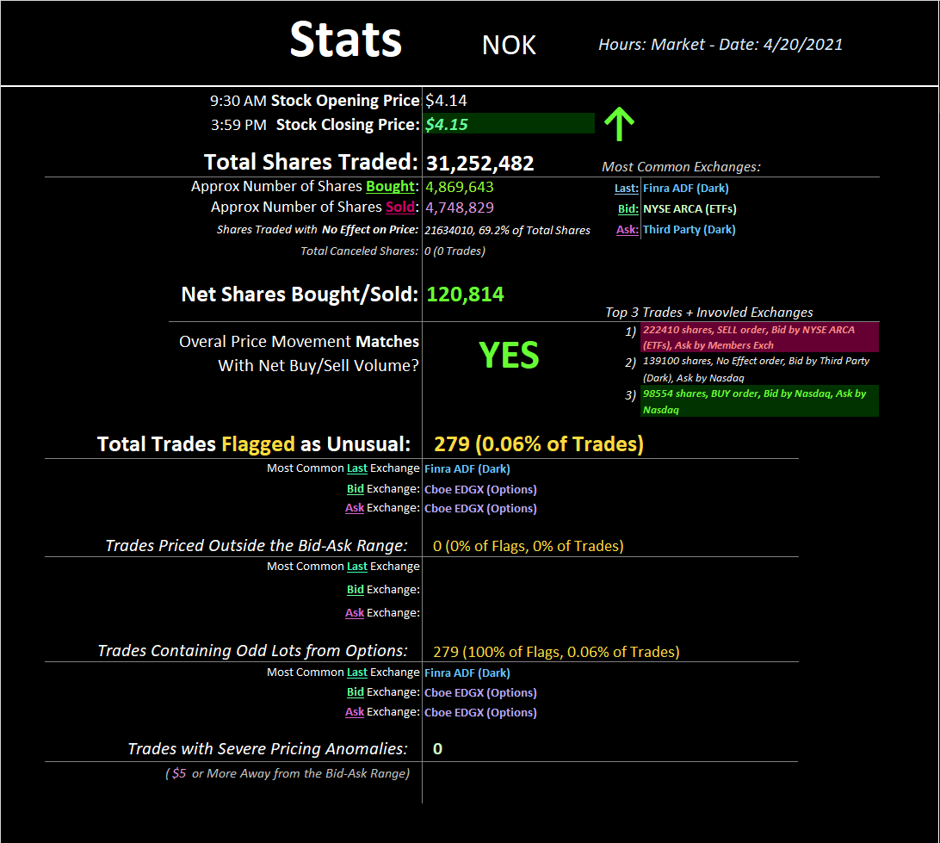
Nokia of course!!
This is the “summary sheet” that gets printed with all the nifty info. This is what “normal” looks like-
more buy volume than sell volume detected matches with the closing price going up. Pathetically small
number of trades were flagged as unusual, all having to do with odd lots being traded by options
exchanges. Looks good. Next control, the SPY-
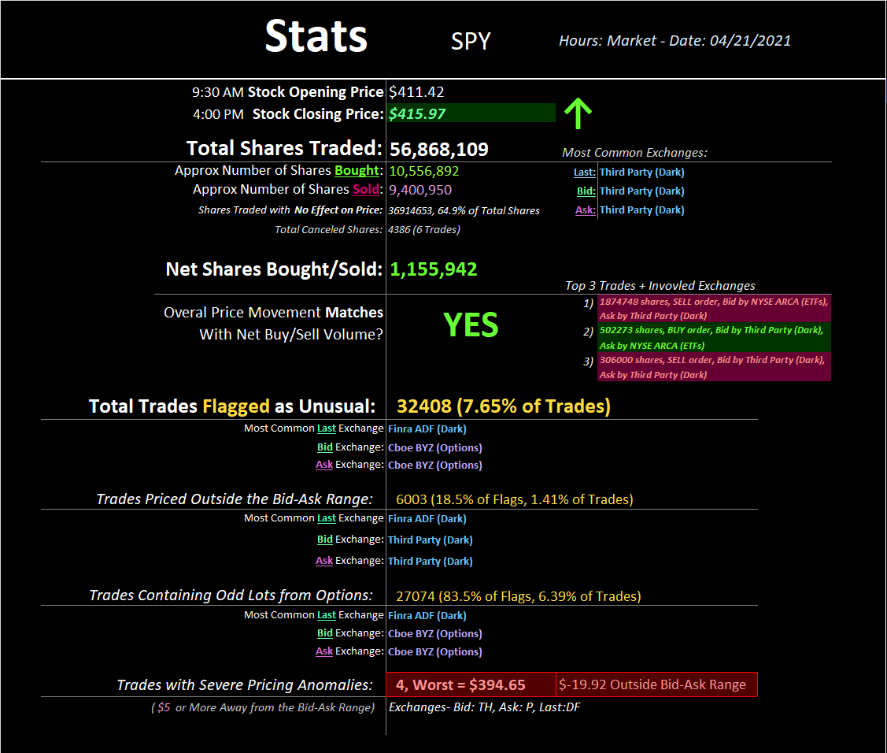
wait what
Everything looks great, happy spreadsheet, except for four really weird trades I totally did not expect to
find. Here's the full mind-fuck analysis on this data:
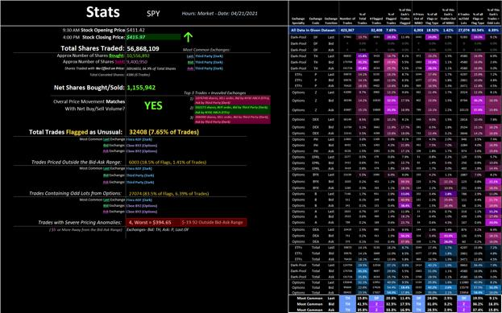
color-coded fuckery!
The "main offenders" are listed at the bottom- Options and dark pools. This is my surprised face. Let's
look at those crazy prices up close:
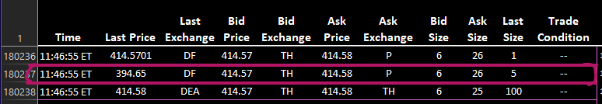
some ETF action
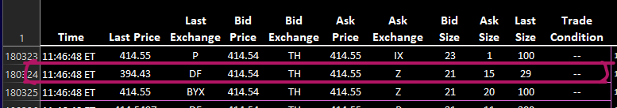
dark pools and options
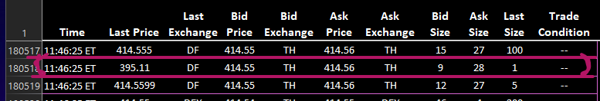
dark pool party
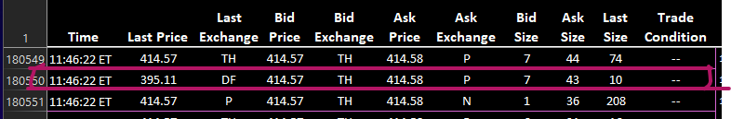
Can I please have shares for $20 under the going price?? I said please.
Except for those crazy trades, pretty normal. Here's another SPY, this time from 4/26:
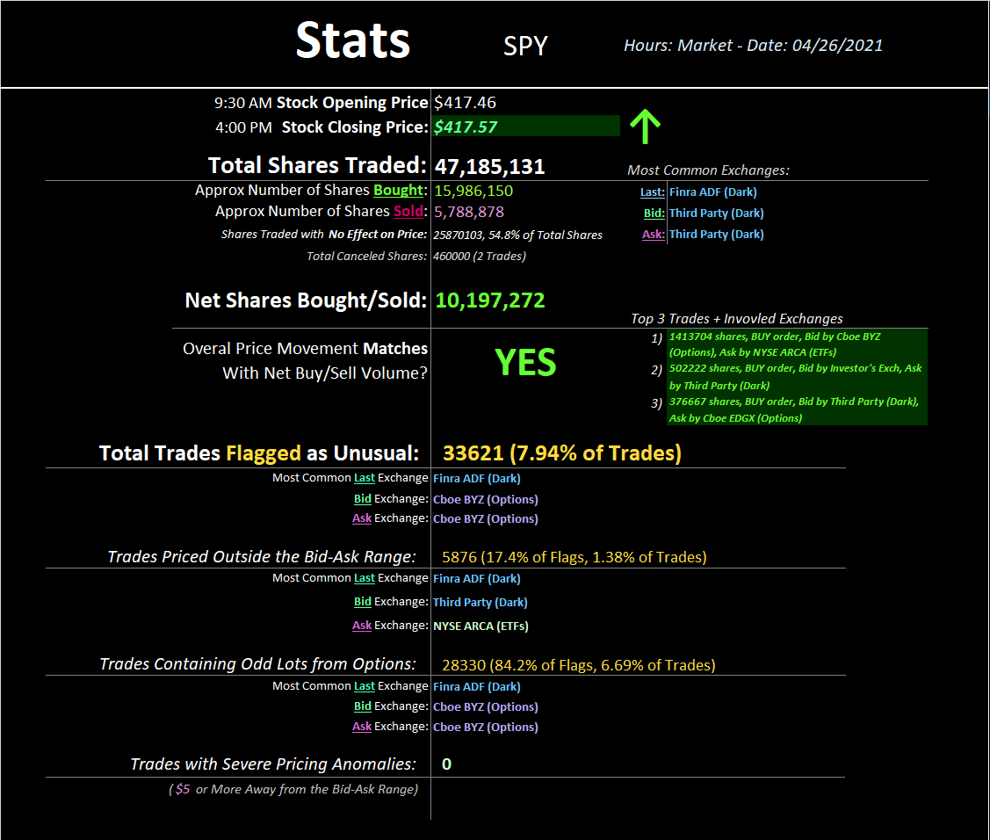
happy spreadsheet!
No wacky trades on this day for the SPY. How about one more control analysis:
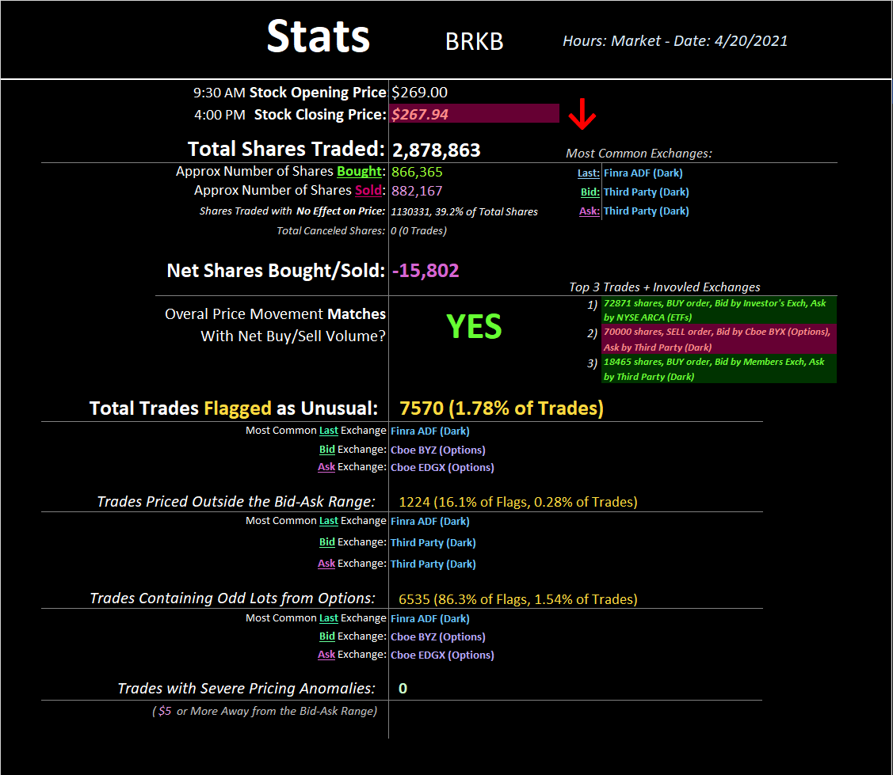
Overall, more shares detected were sold than bought, and the price for the day went down. Lovely! Now,
on to the main event. Let's plug and chug some GME! We start with 4/12. Why? Because I was pissed
that day.
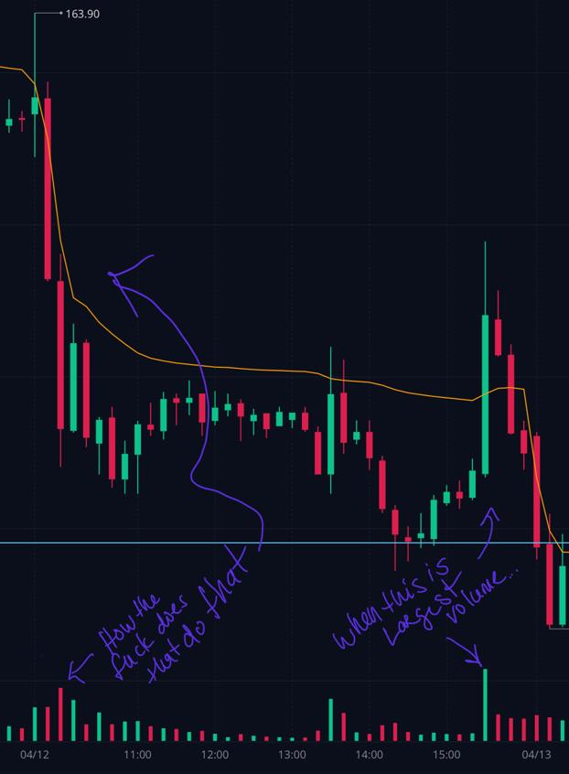
I ate a lot of crayons later that night
So I was very interested in looking at this dataset. Lo and behold....
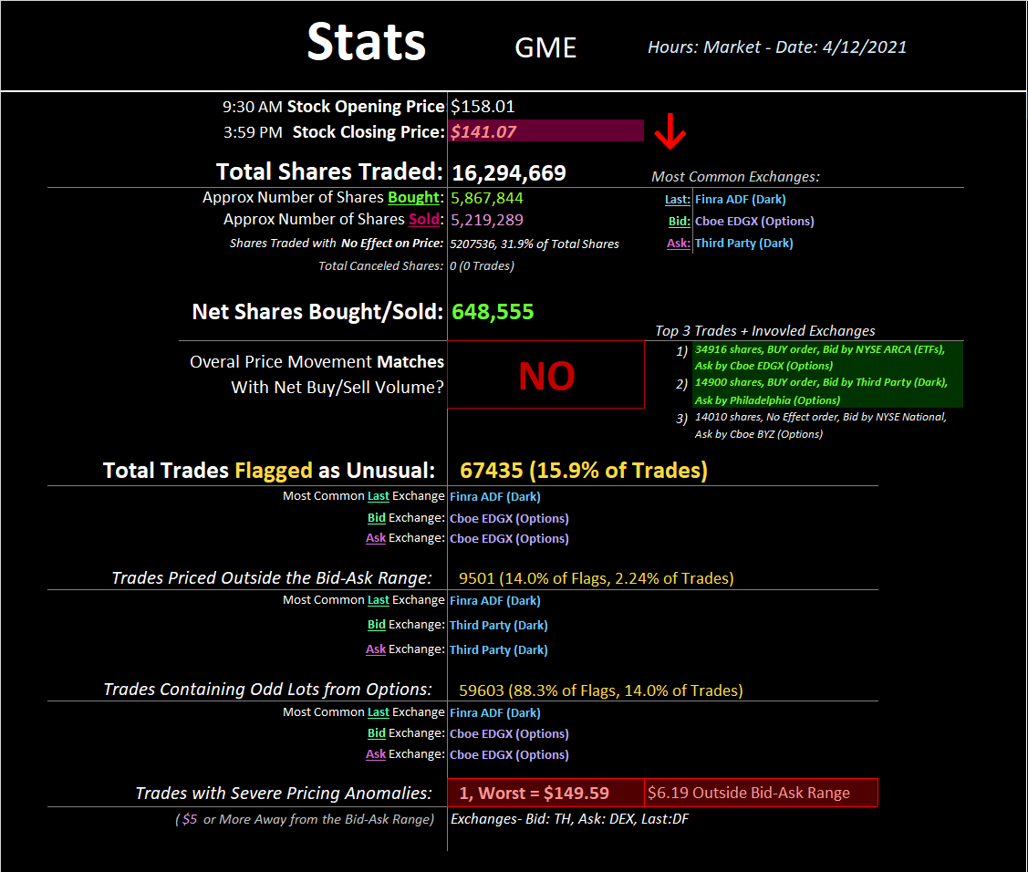
more surprise face
My beautiful spreadsheet telling me exactly what my eyes saw that day. There were more shares bought
than sold, yet somehow the price drops $17. Queue mind-fuck:
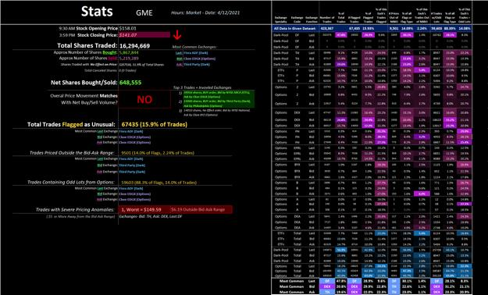
EDGX and dark pool buddies. But of course. These high numbers make me giggle, which offsets some of
the freshly pissed-off I am at this concentrated fuckery. I know your brains are tender, but how about
one last GME analysis- 4/21 because dyslexia:
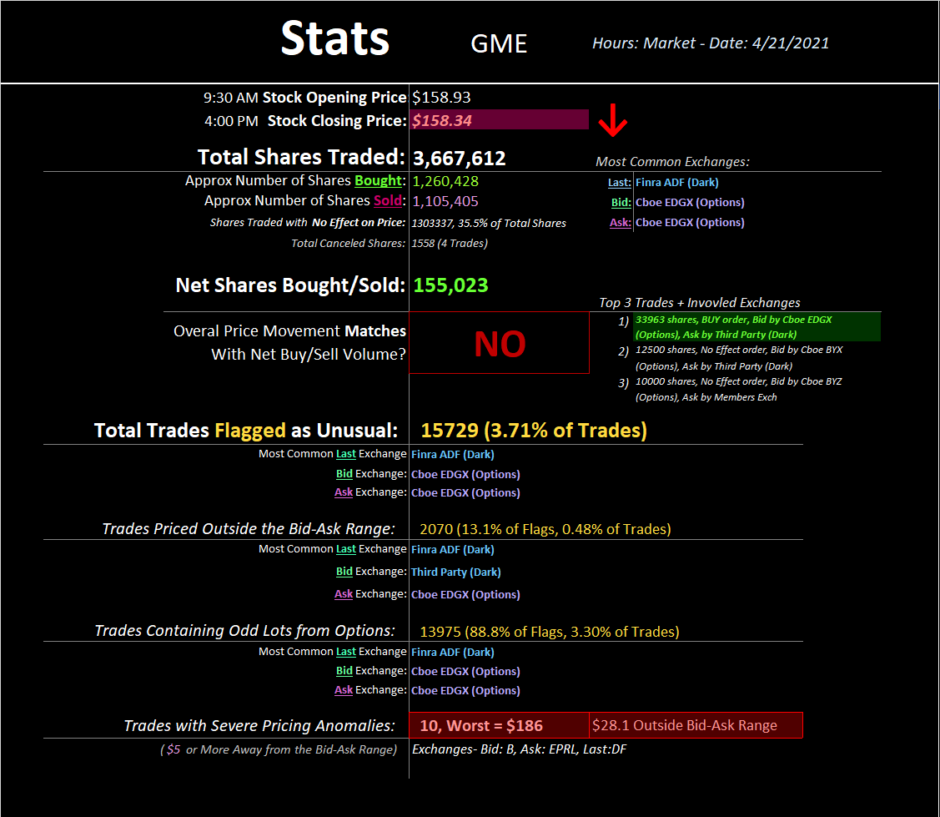
omfg?
Well $28 outside the bid-ask range seems..... excessive? That's like if some dude said "I'll sell this thing
for $158," everyone agrees, and then somehow he gets $186. Why doesn't my life work like that? Let's
see all of these crazy trades up close:
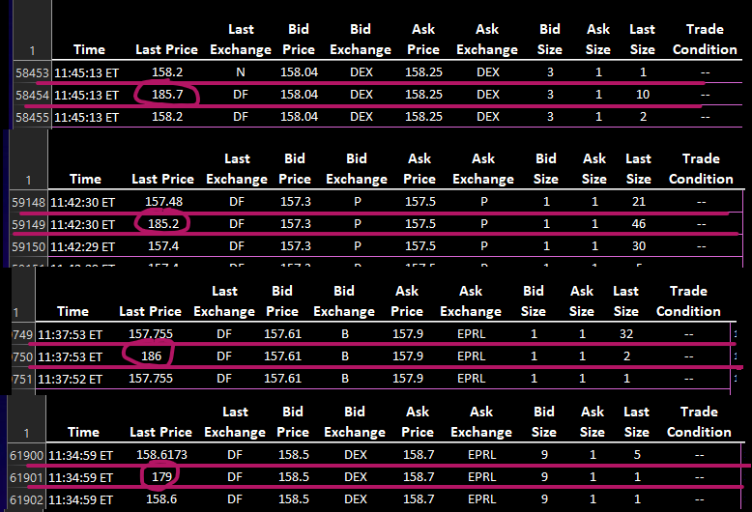
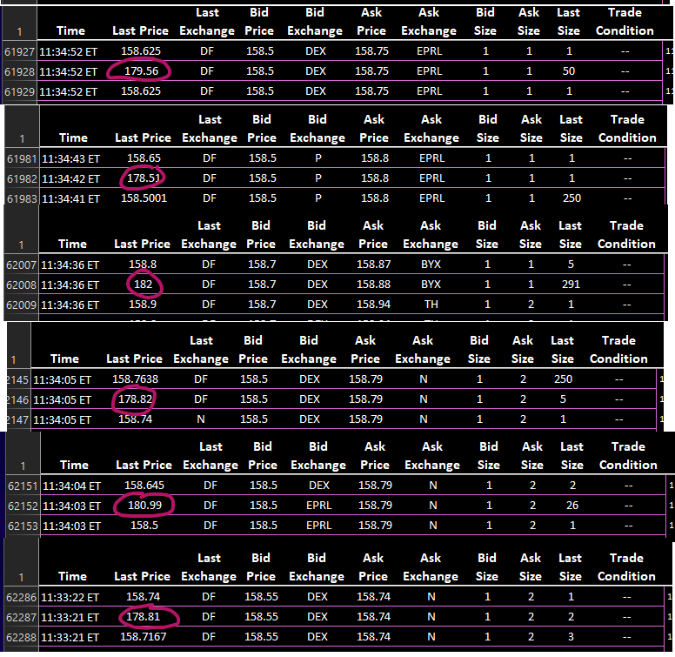
nothing to see here?
That's all I've got for today. But now that I've got my spreadsheets all set up, I think I will continue to
post revealing statistics until GME blasts off to the moon. Seems like a good way to pass the time?? 😈
TLDR: Either the matrix is glitching out or there's some really
fucky shit going on.🚀🚀🚀
Selling puts on my computer's CPU.
Back to Table of Contents
It's Just a Pyramid Scheme Part 1: The Missing
Cornerstone
DD 👨‍🔬
Hey Everyone!
What a fucking few days hey? GME closes almost 15% up, streamers that are more interested in their
weird tarot card readings than actual data, FUD that we can barely even spot anymore, and an IV
increase that is being hidden by a hidden company none of us have even talked about. Wait... what was
that last part? Oh yeah haha, another fucking DTCC that we have all neglected or overlooked or just got
buried somewhere. Here it is, another banker filled board that oversees ALL OPTION CLEARING DATA.
No, I am not fucking around - it is stated on their website:
https://www.theocc.com/
The mother fucking OCC.
https://preview.redd.it/n2mh2lwgkrz61.png?width=1035&format=png&auto=webp&s=1505e0d8779a
48ceeaa9797df719a8f203b2200e
The largest derivatives clearing organization. Stability. Integrity. Overseen by the SEC and CFTC. Major
OTC clearing for options.
Who might want to clear options OTC to maintain a free market that doesn't drown them?
How about banks and institutions who accepted these giant fucking pile of dog shit option contracts
from market makers who are hedging bets and cut off buying/selling in Jan?
1. Chairman - One of the most influential people in finance (knows Chicago trade and
mergers origins).
2. Managing Director, Head of Americas Asset Management Services, Bank of
America - Literally still works for BoA, previously Morgan Stanley. What a fucking
conflict considering what is currently going on between apes and the fact that BoA holds
shares and puts on GME, and we have successfully proved the data is being manipulated
(Ill come back to more on manipulation through these guys).
3. Founding Member - Literally has worked for BoA, Goldmans, Morgan Stanley. Probably
one of the geniuses behind this since he's the tech guy.
4. Partner and Head of Market Structure, Wolverine Trading - DONT THESE GUYS
HOLD A VERY LARGE, UNHEDGED PUT POSITION ON GME?!?! WHAT IN THE FLYING
FUCK IS GOING ON?!
5. Executive Vice President & CIO, Interactive Brokers, LLC - DIDNT THESE GUYS
HALT FUCKING TRADING TO GME IN JAN???? WE FUCKING KNOW THEY DID.
6. Managing Director, General Counsel Department at Credit Suisse Securities (USA)
LLC - Oh another banker overseeing the largest derivatives clearing corp, when the
banks are currently going through a liquidity crisis.
7. Vice Chairman, NASDAQ Inc. - I actually think the NASDAQ is probably the free and fair
market we are looking for. I have no comment.
8. Chief Strategy Officer, Intercontinental Exchange, Inc. - Seriously. This is getting
tedious. CSO. ICE which owns NYSE. Oh, and represents them on the DTCC board. Lol
fuck me, right? But retail is definitely the problem.
9. Executive Vice President, Chief Operating Officer, Cboe Global Markets - No issue
with this guy. I actually think the CBOE Bats thing might be beneficial to us. But that is
another DD.
10. Senior Vice President - Head of Product Management for North American Market
Services, NASDAQ Inc. - Ex Goldman-Sachs guy. Obviously.
11. Senior Vice President - Head of Product Management for North American Market
Services, NASDAQ Inc. - Just another individual investor exchange board member. TD
Ameritrade (didn't they do some shady shit?). Anyway.
12. Chief Regulatory Officer, Intercontinental Exchange & General Counsel, NYSE
Group - Oh look, another ICE/NYSE lawyer, which has let Citadel and friends run the
show on the NYSE, especially GME.
13. Former Financial Executive - Meh no issues she seems to have been just a hard nosed
finance person. Unless someone wants to dig in more, no complaints, just a derivative
guru.
14. Managing Partner, Windham Capital Management Inc. - Oh look, an ex Bear
Sterns PRESIDENT. Curious how he made out after the crash and I would be even more
curious about his insider trading reports for Bear.
15. Chairman, Risk Committee, Kepos Capital LP - Oh look, an ex Goldman Sachs partner.
Again...
16. General Counsel, Citadel Securities - My fucking favorite board member on the list.
This is pretty much self explanatory. Oh, and a FINRA grad.
17. Co-founder and Chief Executive Officer of DASH Financial Technologies - Meh.
Nothing crazy. Has a vested interest in OTC markets for large institutions.
18. Managing Director and Global Head of CCP Strategy and Resource Optimization,
Morgan Stanley - Literally works at Morgan Stanley
19. Economist - Ex Federal Reserve person. Regulated OTC derivatives market.
https://www.theocc.com/Company-Information/Board-of-Directors
There you go. That is the start of how the system has be built to keep the wealthy, well, wealthy. And
what I am going to conclude from the next bit should really show how they're bending the fucking rules
to make sure this doesn't cause too much of a ripple (in my opinion - this is how I cope in case they
decide to fuck it all over again and say "well retards it went to $x is that not enough? Greedy apes").
I said once, derivatives and options surrounding GME have become the main issue. This is how they are
balancing their books to avoid margin calls through their lenders (I.E. Goldmans, Morgan, BoA, get the
idea here of how and why?) They are purposefully changing the math, and I think I can prove it, right
now.
NYSE OPTIONS CONTRACTS
I found the mapping data for the NYSEArca contracts and it has some interesting data. They don't even
consolidate the option data until 5pm the next business day. Which means it is 100% probable that the
OTC trades take over for deals to settle option contracts for large financial institutions the next day. And
the lights are most likely on because they are making phone call after phone call trying to run their
quants and figure out what they can trade for some moon tickets. This means that these guys are trading
on the back end, in bulk, being overseen by our new favorite board of bankers and lawyers.
https://ftp.nyse.com/
https://preview.redd.it/r0c51cybxrz61.png?width=651&format=png&auto=webp&s=09ed8102c962ab
2f04b243d4244b6ec5fa76e35d
Ive been cross referencing the ArcaAmex data with the OCC data, because on OCC you can actually check
option data (which seems awesome because you would think the main derivative clearing corp would
have up to date info). And there is definitely some weird data coming from the OCC.
https://preview.redd.it/6hkc2jbfyrz61.png?width=297&format=png&auto=webp&s=c437168f9d1cad8
b2663d52847586eda0a97db92
0 OI for GME May 14 Calls (all in the money in this case).
0 OI for GME May 14 Puts (all in the money).
Ok but ok. Maybe they dont update it. But the May 21 Calls are there...
https://preview.redd.it/mat2h8ltyrz61.png?width=307&format=png&auto=webp&s=52f3d526485cd1
9469ff1d87056c56309f5df70c
Ok... And before you say these arent sourced from everywhere:
https://preview.redd.it/qqluvrv2zrz61.png?width=954&format=png&auto=webp&s=65e87312e800ff7
3309689899b93f3efaed9cd71
The info is here https://www.theocc.com/Market-Data/Market-Data-Reports/Series-and-Trading-
Data/Series-Search?symbol=gme&symbolType=Options
These should literally be updated daily. And depending on who's buying and paying attention, there
should definitely be some movement. But anyway, lets go look at TODAYS data for May 21 GME options,
through the company that OCC links all their derivative data through.
https://oic.ivolatility.com/oic_adv_options.j;jsessionid=a-dh_HwzV6lh
https://preview.redd.it/iwi1zukvzrz61.png?width=1905&format=png&auto=webp&s=a5d5a158b26d1
831c2170a8ecc8fb48fa8a2db88
Notice anything weird about the IV? And the cost of the option vs the strike price? Literally the Deep In
The Money calls mean worth is the exact same cost as a share. And we know that everything about "free
and fair market" in the last little while has been about "taking the best average cost at market value for
our clients" (my broker touts this - I assume most do).
And the IV is significantly lower than what other sources are saying. Barchart has $10 calls at 1600% IV,
yahoo same thing. Odd that this data is almost purposefully deflating the IV of GME, considering after the
last massive increase in IV was Jan. No, seriously:
https://preview.redd.it/6ro04put0sz61.png?width=547&format=png&auto=webp&s=5a1e601fc6c657
a49ec675ced38e8852f81917ed
And if we go back to the NYSE Arca data, the consolidated short interest changes with how many shares
are short as well. Check this out, I am only going to go to the end of Jan because there is a ton of data, but
maybe Ill do the rest after to prove their algo is betting against retail. Because they only changed it once
WSB reallyyy started to get into GME mid January. And they didn't expect the upward buy pressure, so
they manipulated the market through the OCC to make this work in their favor.
https://preview.redd.it/cjoc7rzc4sz61.png?width=562&format=png&auto=webp&s=2b3635a3b7388c
689b51820f2ec251819e3b6380
The short volume literally started to MIMIC THE FUCKING BUY VOLUME AFTER MID JAN. HOLY
FUCKING PYRAMID SCHEME BATMAN.
I said it before, and I personally think this definitively concludes that the banks, shitadel and other hedge
funds, and the regulatory bodies like the OCC are working against us through algos, reddit scraping, and
OTC. Thanks for attending the fucking TedTalk. I hope we can all buy and hold more. Not financial
advice. Just an ape who wants tendies from these people who have made a fortune off our hard work
and lower class lifestyle. Buckle up hodl, and dont forget your hellmits.
https://preview.redd.it/suvwgwjq5sz61.png?width=487&format=png&auto=webp&s=35219ddfceb08
0e409f2bf4cd0790476d237d3ca
References:
1. https://ftp.nyse.com/
2. https://www.theocc.com/
3. https://www.theocc.com/Company-Information/Board-of-Directors
4. https://oic.ivolatility.com/oic_adv_options.j;jsessionid=a-dh_HwzV6lh
5. https://www.barchart.com/stocks/quotes/GME/options?moneyness=allRows
6. Oh and the fucking terminal drops.
Back to Table of Contents
Dance of Darkness: The SEC and Dark Pools
DD 👨‍🔬
Dance of Darkness: The SEC and Dark Pools
Hello everyone, as requested I am trying again to get this on r/Superstonk so this stays documented, and
allows the light of transparency to be shone upon Darkpools, hopefully this time it uploads, and if it
does, enjoy:
Hello everyone, thank you in advance for your patience and for reading this thesis on dark pools and the
SEC. First, please note that this is strictly not financial advice and just research I have compiled over
weeks for entertainment purposes—it's all-public information and not intended to affect the price
action of any stock in any way, shape, or form.
The article will be divided into 3 major parts: SEC and the financial derivatives market, dark pools of
credit swaps and synthetic shares today, FUD dispersal, and legal ramifications of naked shorting. I was
motivated to write this article as a result of two conditions: the ongoing process of appointing Gary
Gensler as the SEC chairman, and the revelation of the existence of massive dark pool trading certain
meme stocks, in an effort, to bamboozle the retail investor.
---THE SEC SECTION---
Gary Gensler, the former chairman of the CTFC (Commodities Trading Futures Commission) is currently
in the process of being appointed the SEC chairman. Currently, the senate banking committee has
approved Gensler at a 14-10 vote (https://www.investmentnews.com/senate-banking-committee-
approves-gensler-nomination-203813 , https://www.c-span.org/video/?509429-1/sec-chair-cfpb-
director-confirmation-hearing ), and he will be voted on by the Senate proper in a weeks time on April
12th (https://www.thinkadvisor.com/2021/03/31/schwab-expects-activist-sec-under-gensler-senate-
sets-confirmation-vote-date/) . He is expected to have bipartisan support and to be sworn in as the new
SEC chairman. Gary Gensler is extraordinarily hated by Wall Street for a couple of reasons, the primary
being that he is a hard-nosed regulator interested in the transparency of the marketplace and
democratizing the information within it in favor of the little guy. This fundamentally goes against the
closed country club nature of Wall Street, which is shown by the enforcement of the Dodd-Frank Act
(https://en.wikipedia.org/wiki/Dodd%E2%80%93Frank_Wall_Street_Reform_and_Consumer_Protectio
n_Act , https://www.investopedia.com/terms/d/dodd-frank-financial-regulatory-reform-bill.asp ).
The last time Wall Street made a grievous market error was in 2008. This was due to the financial
derivatives market and credit default swaps market having a massive correction
(https://www.investopedia.com/ask/answers/052715/how-big-derivatives-
market.asp, https://www.investopedia.com/terms/d/derivative.asp ). The financial derivatives market
(futures, in particular) was designed by markets to allow farmers, ranchers, manufacturers,
industrialists, producers, etc., to lock in prices and mitigate risk in the production and operation of
businesses. Thus, the core of what these markets are about is to lock in prices for commodities and to
manage risk for the supply chain. Thus, the derivatives market is quite essential to the supply
management side of the real economy (the part of the economy where you and I work), as such any
meltdowns in the derivatives market further deteriorate our economy; in 2008, this spilled over to the
real market—which combined are gigantic markets, estimated at 640 trillion dollars
(https://www.investopedia.com/ask/answers/052715/how-big-derivatives-market.asp ) in market
capitalization. According to Gary Gensler that represents roughly $22 of hedging for every dollar
exchanged in the real economy (https://www.c-span.org/video/?304711-1/financial-regulations-
consumer-protection ); this is from 2010 though, so it could be a lot higher right now. Such futures and
swaps are invested in almost every aspect of our lives (food, fuel, mortgages, credit rates, interest rates,
etc.). So, given the importance of the derivatives market, it must stay transparent and competitive; this
was not the case in 2008.
Due to two things being in play in 2008, dark pools and credit default swaps, specifically CDSs insuring
against CDOs composed of collapsing mortgage bonds. As a result of the underlying assets (mortgages)
defaulting at a rapid rate, causing the collapse of the bonds, causing the CDOs composed of the bonds to
collapse/default in price; causing the CDSs to kick in and insure against the original value of the bond
upon inception of the CDSs. This transaction occurred, you guessed it, in dark pools. dark pools will be
covered highly in-depth so bear with me, Gary Gensler’s response needs to be analyzed first. First
definitions:
CDOs; collateralized debt obligations, think of these as financial products composed of multiple other
financial products backed by assets like bonds, collateralized loans, etc.
(https://www.investopedia.com/terms/c/cdo.asp#:~:text=A%20collateralized%20debt%20obligation
%20(CDO)%20is%20a%20complex%20structured%20finance,derived%20from%20another%20under
lying%20asset )).
CDS: Credit Default Swap; in short, it's insurance against a value of a security in case its value drops. It
works by taking out a policy against a security and paying somebody else to take the risk of its valuation
falling. This risk is taken off your shoulders, by you paying the other party a premium to maintain the
insurance policy (i.e. you hedge against your securities dropping in value). As such, the value of the
security you are insuring is safe if you keep up your premium payments, insuring you against risk.
Furthermore, if you choose to exercise your insurance, as the value of the security falls, you are paid out
your insured amount; if the value of the security rises and you choose to close out/exercise, you will
take that loss + premiums
(https://www.investopedia.com/terms/c/creditdefaultswap.asp#:~:text=A%20credit%20default%20s
wap%20(CDS)%20is%20a%20financial%20derivative%20or,with%20that%20of%20another%20inve
stor.&text=To%20swap%20the%20risk%20of,the%20case%20the%20borrower%20defaults ).
Dark pools: Dark pools are exchange forums that replicate open stock exchanges, closed off to the public
designed to hide institutional trading intent. In other words, by Gary Gensler himself, dark pools are
designed to lack regulation, transparency and the light of transparency must be shone upon them
(https://www.investopedia.com/terms/d/dark-pool.asp ).
As definitions have been established let us quickly reiterate the chain of events in 2008, and Gary
Gensler's response as the CFTC chairman; and how he dealt with dark pools before (meme stock
synthetic shares are in dark pools I would speculate):
Banks relax loan requirements to make cash of interest and mortgages-> package those into bonds -->
package those into CDO's --> market them as a great investment, while the underlying bonds are
absolute garbage (this became garbage around 2006) --> Michael Burry and co notice this and take CDS
on them --> wait 2 years, 08 roles around --> the market corrects itself violently where CDS are basically
used to wipe out mortgage CDO's; these transactions occur in dark pools, away from the public eye; all
the while like right now the media say everything is absolutely fine, you should totally hold onto your
mortgage and get it refinanced (sell your meme stocks today, the squeeze is definitely over, you should
totally believe us).
Thus, the unregulated swaps market split over into the real economy and exposed everyday Americans
to real risk (with meme stocks it’s reversed, the shorter are at real risk right now).
In comes Gary Gensler and the Dodd-Frank Act: https://en.wikipedia.org/wiki/Gary_Gensler .
Due to the crash, the Dodd-Frank Act was designed to curb excessive market abuses and speculation due
to the lack of transparency from dark pools—it had 3 main goals according to the prospective SEC
chairman (https://www.c-span.org/video/?304711-1/financial-regulations-consumer-
protection , https://www.investopedia.com/terms/d/dodd-frank-financial-regulatory-reform-bill.asp ):
i) Bring transparency and competition to swap dark pools
ii) Lower risk
iii) Increase market integrity
As such, according to Gensler, 90% of unregulated swaps and futures were brought from dark pools and
mandated to use clearinghouses, so position data could be marked real-time for the public to view.
Furthermore, the Dodd-Frank Act established several other protections
(https://www.investopedia.com/terms/d/dodd-frank-financial-regulatory-reform-bill.asp ), these are
as follows:
i) Protections against the formation of too big to fail institutions (so Citadel can fail, and everybody will
be fine hypothetically), as a failure of any one of them, could negatively affect the US economy.
ii) The Consumer Financial Protection Bureau (CFPB), established under Dodd-Frank also worked to
curb predatory mortgage lending, deterring high commission mortgage brokers from closing high-
interest loans with high fees; stopping the feedback loop of bad loans being dished out in exchange for
high commissions, fees, and interest. It also protects consumers from excessive credit and debit card
fees and interest, by my understanding (https://www.govinfo.gov/content/pkg/PLAW-
111publ203/pdf/PLAW-111publ203.pdf ).
iii) Volcker Rule: It restricts banks investing in speculative trading and eliminates proprietary trading
(https://www.investopedia.com/terms/p/proprietarytrading.asp); moreover, banks are not allowed to
be involved with hedge funds or private equity firms considered to be too risky; lastly, to minimize
possible conflicts of interest, financial firms aren't allowed to trade proprietarily without sufficient "skin
in-game". Furthermore, the Volcker Rule: "regulates financial firms' use of derivatives to prevent "too
big to fail" institutions from taking large risks that might wreak havoc on the broader economy" (Citadel
may be intimately familiar with this).
iv) Whistle-blower Program: The Dodd-Frank Act also goes ahead and strengthened and expanded the
whistleblower program. As such it specifically established a mandatory bounty program (you heard that
right, if you hunt down a shill spreading "insider information", that alludes to collusion or any other
illegal activities, you get a big fat reward). I'll let the text from Investopedia take this one here:
"Specifically, it established a mandatory bounty program under which whistleblowers can receive from
10% to 30% of the proceeds from a litigation settlement, broadened the scope of a covered employee by
including employees of a company's subsidiaries and affiliates, and extended the statute of limitations
under which whistleblowers can bring forward a claim against their employer from 90 to 180 days after
a violation is discovered".
Meaning, you as a whistleblower can receive up to 30% of the litigation settlement amount if you can
provide concrete evidence of collusion (we'll expand on naked short fines in a bit after the in-depth dive
through dark pools as promised.); so if you have proven insider information, happy
hunting: https://www.sec.gov/whistleblower/frequently-asked-
questions#:~:text=Under%20the%20program%20eligible%20whistleblowers,regulatory%20and%20l
aw%20enforcement%20authorities .
Lastly, to end this section I'll leave the actual Dodd-Frank Act here in case any legal scholars are reading
this and would like to dissect this: https://www.govinfo.gov/content/pkg/PLAW-
111publ203/pdf/PLAW-111publ203.pdf .
Now going back to the man who enforced this and brought the banks and other bad financial actors
under control the last time by busting these dark pools, Gary Gensler. If Gary Gensler is appointed, and if
these hedge funds have their short positions in dark pools to dupe the consumer; they will not only be
breaking a litany of federal financial regulation laws. Furthermore, the SEC, DTTC, and hedge
funds/institutions long on meme stocks (Blackrock) have already started swimming around sensing
blood in the water, once Gary Gensler comes in, based on his previous behavior of effectively curb-
stomping illegal actors into submission, I can see him litigating Citadel and co (if they are guilty) out of
existence and forcing them to close like he did last time as the Future's chairman.
*Recap for Apes*
So let us recap, swaps and dark pools were used in 2008 to insure against the financial collapse created
by the greed of financial institutions. The reason why we haven't had an exact repeat of 2008 is because
of the Dodd-Frank Act; and the enforcer that took out Wall Street Gary Gensler is going to be running the
SEC during meme stock chaos; which means the shorts lose their friends in high places that haven't been
enforcing the rules.
From here on we shall take a deep dive into how dark pools work, then talk about the hypothetical legal
implications of shorter being caught with illegal naked shorts in dark pools; so, let us begin.
---DARK POOL SECTION FOR APES---
Dark Pools for the layman are exchanges off of exchanges. A growing problem that brokers and retail
investors noticed is that if a lot of small-scale orders are going through a relatively large and
complicated fee system, for instance with the NYSE
(https://www.nyse.com/publicdocs/nyse/markets/nyse/NYSE_Price_List.pdf ).
Both retail and broker-dealers have issues with this due to a convoluted pricing model; if a certain
threshold of clients is reached, internal off-exchange trades can begin—this is the basis for a dark pool.
Morgan Stanley (https://www.morganstanley.com/disclosures/morgan-stanley-dark-pools ), Goldman
Sachs (https://www.thetradenews.com/guide/goldman-sachs-sigma-x/ ) and of course Citadel
(https://www.reuters.com/article/us-citadel-darkpool-idUSKBN0MN22Q20150327 , closed in 2015
after harsher reporting requirements, go figure), all have dark pools.
This creates a buffer of exchanges, as shares circulating in dark pools can fulfill buy and sell orders to
100% outside of the exchange during normal trading activity.
However, any buffer can be used as an amplifier. As such if a hedge fund wants to make a quick profit by
shorting a stock, they lend as many shares as possible; dump them on an exchange and watch as the
retail investor tries to “cut their losses''; while spreading FUD by calling in the media, till even the least
sophisticated investor sells. As volatility spikes, smart money comes in and the shorts are covered in a
dark pool. This allows you to buy shares on a downward momentum, influencing the price immediately
on the open exchange. The reverse works for long positions as well, if you would like to dump it at a
profit, just sell it off in a dark pool. Cramer admitted to part of the process in an interview
(https://www.youtube.com/watch?v=jIfixbq_u0Q), on the dark pools, while not mentioned, it is
certainly part of the process.
An illustrate how this might work in an example:
Company A wants to acquire company B ASAP by buying up let's say 30% of shares of company B.
Company A, therefore, goes to market maker M to buy shares for them. M then proceeds to start buying
shares on the exchange to drive the price up a bit.
Meanwhile, they try to buy up as many shares from the dark pools as possible, to not drive the price up
on the open exchange. The price on the exchange usually reflects in the dark pools, but not vice versa
(because people look at the exchange prices, shortages in dark pools only show after a slight delay).
If you were to say that a purchase of 5% of the float would drive up the price of shares from B up by 5%,
that would mean that after the buy the price would be 30% higher with around 15% higher than the
start price average.
That is if people were not to start day trading the shares, which probably will happen.
However: if you were to do the same thing with dark pools you suddenly see that while the price on the
exchange goes up, M is suddenly able to buy shares from places that do not influence the share price.
Again, a 5% purchase on the open market equals a 5% price increase. If 10% can be covered over the
dark pools, only 20% affects share price, leaving us with an average of about 10% higher than starting
price.
This is 5% that was "saved" for M and A. M obviously wants a small fee for the service totaling 2%,
which leaves A with around 3% saved.
That 5% came from the retail investor that was not aware of the movements in the dark pools. It costs
the retail investor money. It robs you of your 30% gain in that scenario and gives you 20% instead. It
costs you.
Remember Crammer stated sentiment is key in pulling the stunt off:
(https://www.youtube.com/watch?v=r07Gg92YjOI )? It would be exponentially by simply getting the
order flow, as such sentiment can be deduced without any bias. This allows the fund to take opposites of
trades by going short negating buying pressure, either in dark pools or exchanges, as well as directing
how the orders get executed. This possible order execution delay has been brought up in Congress
(https://youtu.be/RNgzOr-m6ok?t=89 ). This amounts to a hedge fund/ moneymaker being able to
make a small money printer for themselves (Citadel), which we can confidently speculate exits.
Furthermore, if Citadel doesn’t like your decision to buy, they can simply take the other side of the trade
giving you a shorted share.
This is where Citadel and CFD trading comes in:
Using dark pools, Citadel as a market maker could in theory capitalize on such scenarios massively;
furthermore, until 2015 they ran their own dark pool, called Apogee
(https://www.iotafinance.com/en/Detail-view-MIC-code-CDED.html ) which was decommissioned in
2015 possibly due to increased reporting/transparency requirements
(https://www.reuters.com/article/us-citadel-darkpool-idUSKBN0MN22Q20150327 ).
By operating Apogee, however, Citadel as a market maker was able to capitalize on such scenarios
massively. Since then, Citadel switched to Citadel Connect, which does not qualify as an alternative
trading system requiring no reporting.
The best-case scenario for Citadel, if they wanted to short a stock would be to not have shares involved
at all or making a contract for difference with you; this means you make an agreement with Citadel to
get the current share price at any time you like from them, without ever having to buy or sell the shares.
This kind of trading is heavily regulated, however, thus not common. However, they have engaged in
similar tactics: naked shorting.
Under Reg SHO 203 b 2 iii (https://www.law.cornell.edu/cfr/text/17/242.203 ) market makers are
allowed to short a security under a bona fide agreement, meaning without ill intent. As such, to naked
short a stock, good faith is pretended to be in effect, from there they buy naked calls from another party
they control (Citadel LLC in this case). From here, the equivalent amount of shares are lent out to either
"Citadel LLC" or any other party, which are then dumped on the open market. After 3 days, since the
“shares” never existed on the open exchange, becoming FTD’s. As FTD status is reached, they simply go
to a shell company or “Robinhood” and write ITM call options, exercise them, replacing FTD-IOUs with
the ones from the shell. As these reach FTD, the reverse happens, as Citadel IOUs replace ones from their
shell. Repeat to infinity and a stock price can be crashed by printing shares faster than the Feds print
money (these shares will quickly add up dark pools though and need to be cleared). As institutions
bailout, only retail would remain, if retail has no strategy on the security, a run by retail to get rid of the
bag happens.
Now what I've said may sound despairing and should get you angry, however, I believe this cycle has
almost been crushed, due to apes buying and holding. Allow me to present to you this diagram (the link
below contains a flow chart of how dark pools operate within the market):
https://ddextension68.blogspot.com/2021/04/dance-of-darkness-darkpool-methods.html
As shown, they can use synthetic share production mechanisms, blatantly creating synthetic shares in a
dark pool as a market maker (citadel runs it), making phantom shares using calls, Failure to Delivers,
explicit naked shorting (creating IOU's), etc. (there are tons of illegal production mechanisms, most of
which we're covered in my old DD's and a quick recap example above. Once they have determined which
method they'll use, they target the security, and the flowchart begins. If they use the dark pools, they can
theoretically create an infinite number of synthetic shares (they'd have to buy infinite real shares to buy
though to cover though if they are a) caught with synthetics or b) get margin called).
Apes for the last months have been buying up all synthetics and creating price floors as you've seen, a
hedge fund at this point has 2 choices; cover all the shares (the smart choice), or digging themselves in
the hole deeper hoping you will sell creating FUD (Reddit/discord infiltration will tell you when their
getting desperate); so they can finally cover, as such if investors keep buying and holding, either more
rocket fuel gets added to the rocket or they cover; either-or, doesn't matter what anybody else says.
Lastly here's a list of dark pools that I found that have existed in "the state of play", back in 2014, I
apologize I couldn't find any more recent data:
https://link.springer.com/content/pdf/bbm%3A978-1-137-44957-3%2F1.pdf ; (FYI Goldman Sachs
has one, and they just got margin called for
context: https://www.youtube.com/watch?v=mP4yaoQll7I (if your r/wsb YouTube links aren't allowed
for sources sorry) due to Bill Hwang)
*Recap for Apes*
Now let’s recap, the SEC chairman Gary Gensler is well versed in bringing swaps out of dark pools which
caused the last crash and is coming in during the point of the SEC during a speculative short squeeze
that will top all other short squeezes in human history (in my speculative opinion), This may cause the
greatest wealth transfer in history.
The elites from any society would not like this as it would mean, their status would be tarnished; as such
they will resort to any amount of financial war crimes to try to make sure that doesn't happen. However,
during the last financial war (2008), Gary Gensler came in and enforced the rules congress passed, this
time he's coming in again. I believe he will enforce the rules and bring justice to these financial war
crimes again as shown by his record; as such before that happens you will see FUD intensifying (which is
already happening, expect more of this); as such if you've been in the game this long, you should know
the drill by now.
---LEGALITIES FOR APES---
Let’s talk legal; if Citadel as a market maker is using order flow, dark pools, and synthetic shares to
balloon to the height of being too big to fail, they violate a half dozen federal laws and policies, targeting
you the consumer. Let’s go over them (I'm a physicist by training, not a legal expert so I'll link the laws
and tell you guys my speculation and let legal experts handle it):
Sources for these laws are coded in this link (I apologize there's a 40k reddit field limit):
https://ddextension68.blogspot.com/2021/04/dance-of-darkness-legal-sources-for-apes.html
As stated above, I am no legal expert; however, I will tell you of my understanding of them based on the
sources I have read, any legal expert reading this is; feel free to correct me and post them in the
comment section below (I want a specific rebuttal based on the legal text though, your co-operation is
appreciated).
If a market maker like Citadel, or any other firm that has shorted meme stocks, uses dark pools,
collusion, and synthetic shares to try and dupe retail investors that simply "like the stock" and are
buying and holding, by my understanding they violate:
i) Anti-collusion and market manipulation laws: By working together with other institutions they are
colluding and manipulating the price, that simple.
ii) Naked shorting: Borrowing a security that doesn't exist to shorting is straight-up illegal, and if you are
caught using naked shorts the fines can range from $5,128 - $14,887 (USD) per naked short (sources are
given in the naked shorting section).
iii) Synthetic share creation: This in my opinion would qualify as a naked short and market
manipulation; as not only are you shorting a share that doesn't exist, you are manipulating the market so
the price goes down by diluting supply, which also illegal.
iv) SHO rule violations: From the SEC: Regulation SHO requires broker-dealers to identify a source of
borrowable stock before executing a short sale in any equity security to reduce the number of situations
where stock is unavailable for settlement
(https://www.sec.gov/investor/pubs/regsho.htm#:~:text=Regulation%20SHO%20requires%20broker
%2Ddealers,stock%20is%20unavailable%20for%20settlement ) ; as such if a broker-dealer cannot
identify the source of a stock, before a short sale, it’s illegal.
v) Dodd-Frank Act violations: If Hedge funds are found colluding with each other to rig the market using
short shares to become too big to fail, that violates the Dodd-Frank Act as it is explicitly designed to stop
according to you guess it Gary Gensler the new incoming SEC chairman.
vi) Insider Trading Laws: Trading based on non-public information; in my opinion, this is blatantly
illegal as such the debate is black and white; thus illegal.
vii) Order flow payment: The SEC and Congress are currently debating whether order flow payment is
legal in the first place; we shall see what conclusion they come to.
This is all I've found so far, but if you find any more illegalities please go ahead and comment down
below.
Wrapping up these financial war crimes (their war crimes, because they are explicitly designed to hurt
the innocent; retail investors). If Citadel is using synthetic shares to make itself too big to fail
hypothetically it would break anti-collusion laws, the Dodd-Frank Act, prohibition against naked
shorting, SHO rules, prohibition of Market manipulation, insider trading, etc. (lawyers have at it); as
such, if they are caught, would be facing legal and financial extinction (of course this is just speculation
by a dude on the internet, confirm it for yourself; if this is true however and can be proven in court, I
believe it can be constituted as a financial war crime and should be dealt with accordingly).
Furthermore, if you have insider information proving this, you by the Dodd-Frank Act's whistleblower
program are entitled to up to 30% of the settlement amount, so happy hunting apes.
If you are reading this on r/wallstreetbets (if this gets on there) this is as far as I can go without it
violating the new rules, due to the subreddit’s size; as such, I thank you for reading my work,
List of additional sources:
https://ddextension68.blogspot.com/2021/04/dance-of-darkness-additional-sources.html
Thanks for your attention, and I hope you have a wonderful day; none of this was financial advice, and
purely opinion based on the sources given for entertainment purposes. Lastly, I am not a cat, and like the
stock.
If you are still here, this is for subreddits other than r/wsb. We shall begin the meme stonk section for
both GME and AMC; let’s dive in:
---MEME STONK SECTION---
I apologize this isn’t on reddit, however it has an absurd 40kb strict limit: as such I have coded back up
links: https://ddextension68.blogspot.com/2021/04/dance-of-darkness-meme-stonk-section.html .
Within this link you shall find the full extent of the darkpool arguments and memestonks, as well as
evidence of 4.6 billion, and 630 million synthetic shares of GME and AMC circulating in darkpools, while
entertaining the idea that this is simply just 1 darkpool, using empirical evidence to show it is not the
only one; I hope you enjoy it (This is also my first time modularly coding together blog pieces, so
feedback would be
appreciated)(https://www.reddit.com/r/amcstock/comments/mbuti6/another_sighting_of_that_possib
le_4_billion_share/?utm_medium=android_app&utm_source=share , https://www.reddit.com/r/GME/c
omments/mcpyid/after_exposing_the_525_million_shares_in_the_otc/?utm_medium=android_app&utm
_source=share ).
Going forward this will be a 3 part series for AMC, and 2 part series for GME; you beautiful apes have
held so far despite all this and you my friends have nothing but my highest respects, I believe your
efforts will be rewarded with Martian tendies sooner rather than later.
Quickly touching on the next piece FUD: the desperation of shorts, will consist of me addressing "mUh
gOvErNmEnT wIlL iNtErVeNe aT 500 #trustmysourcesbro", share dilution (in my opinion will not
happen, it's a ploy to get the share recounts), the squeeze not happening (total FUD cause math). As DFV
said, hang in there, helps on the way.
Recap apes; firstly the crucial point is they most likely owe more than 10x float on AMC, and 13x float on
GME hence they're desperate, they are resorting to financial war crimes breaking a dozen laws trying to
prevent you from picking up your tendie orders, this happened in 2008 and in case anything drastic
happens, memestonks are your insurance and you will more than likely have your insurance policy be
exercised, all the mathematical indicators for a squeeze are there, now it's just a when, dark pools are
designed to hide the truth and hide intent, and because of those synthetic shares in these pools, they are
most likely panicking; lastly when this squeezes, you holds you apes hold all the cards, and you, not the
institutions, you determine how this timeline and the future plays out.
---HIGH LEVEL SUMMARY---
A lot has been covered, let’s summarize. This is a repeat of 2008, but this time we hold the insurance
policies, in case this moons. The similarities are quite startling, from the SEC chairman Gary Gensler
coming to bust this down, them using dark pools to screw the average person out of tendies, committing
financial war crimes in broad daylight to shake apes. Furthermore, the dark pools explicitly showing
both meme stocks have been naked shorted by at least 10x, this squeeze is mathematically confirmed,
and we are looking at a fallout, how big the fallout will be depends on how big the hole they dug
themselves with these dark pools; but in any case, apes hold the insurance policies so I believe we
should be chilling, and if we continue to buy and hold we are simply buying more insurance for stonks
we like. As such to sum it up in one sentence, their hiding in dark pools, Gary Gensler is starting the hunt
and we have the insurance policies.
---What you can look forward to in this series--
As stated above, this series will diverge into 2 hyper focused parts; one GME focused, another one AMC
focused. The AMC series will be:
i) Dance of Darkness: The SEC and Dark Pools
ii) FUD: the desperation of shorts
iii) AMC the climb to 10k and battle of 12008.01
GME:
i) Dance of Darkness: The SEC and Dark Pools.
ii) GME, the journey too Olympus Mons.
---TLDR---
They’re hiding in dark pools and using ETFs, naked shorting and synthetic shorting to manipulate the
market hoping people will sell so they can exit the feedback loop as illustrated; there are most likely
multiple dark pools with synthetic shares hence their desperation (+ their overleveraged). These
memestocks have become swaps (CDS's: Credit Default Swaps), and those who hold them hold
insurance against any financial disturbance. The longer this manipulation continues, the larger the
correction will most likely be.
Lastly, I’d like to offer you two links, that I had to develop due to reddit’s archaic code (best crowd
communication technology we have so far though):
i) https://ddextension68.blogspot.com/2021/04/dance-of-darkness-thesec-and-dark-pools.html
ii) https://ddextension68.blogspot.com/2021/04/dance-of-darkness-sec-and-darkpools.html
In those links, you will find the unaltered cuts of this DD, the first one is edited; however, the Snyder Cut
is as raw as it gets. I hope you enjoy them
---Final Commentary and Thanks---
Thank you for sticking with me and going through this rather long article, the reason why I keep this
article long and extensive is because I believe in transparency and integrity. I believe all data should be
put on the table, for the reader to determine what they should make of it. I don’t believe in hiding data
and guiding people, I believe the average retail person is best suited in making choices that affect their
future, as such the data should be transparent and visible. Moving forward, these articles will remain
extensive and mathematical in nature; to bring transparency and integrity to the marketplace.
Furthermore, I understand there is a lot of FUD floating around on meme stocks, these articles serve as
papers that bring transparency, as they are designed to investigate memestonks.
I understand there’s a lot of FUD going around, as such I usually don’t ask much other than a request
that you give me feedback and try to break my thesis in the comment section below; however, this time I
will ask you to share this on your favorite social media (mine is stockwits) using #DanceofDarkness. I
believe a lot of people will benefit from market integrity and transparency so thank you in advance for
sharing this. I hope it helps a lot of apes; and as DFV, during congressional testimony, alluded to Hang in
there.
Here's a quick quote to encapsulate the entire article in my opinion: "You will never do anything in this
world without courage. It is the greatest quality of the mind next to honor"—Aristotle.
Finally, to reiterate here's a quick hashtag you may use if you feel like using social media to make this
article spread fast: #DanceofDarkness; and the original cuts are as follows:
i) https://ddextension68.blogspot.com/2021/04/dance-of-darkness-thesec-and-dark-pools.html
ii) https://ddextension68.blogspot.com/2021/04/dance-of-darkness-sec-and-darkpools.html
Legal Disclaimer: None of this was or is financial advice, this is purely speculative opinion based on the
sources as presented in this article—as such, it should be both viewed as and taken for entertainment
purposes (i.e. the entertainment of ideas). Lastly, I am not a cat, and I like the stock. Thank you for your
time.
Back to Table of Contents
[Final Update] Superstonk users ALONE hold
between 27 million and 35 million shares. No,
really.
DD 👨‍🔬
TL:DR; after doing two polls and comparing to another user's results, I estimate superstonk users
own between 27 million and 35 million shares of GME.
Edit: A very large point of misunderstanding is that the average shares are too high. In statistics,
averages are easily skewed by outliers. For example, you have two groups: 3,3,3,2,4,2,4,3 and
another 0,0,1,2,10,2,3,4. The average of both is 3. People have said it's impossible for the average
person to own $25-30k worth of shares. I agree. In this study, 70% of the respondents own less
than the average number of shares. The median user here owns 54 shares. This means that 50%
of users here own $9000 or less (based on a stock price of $170)
This is my last post (probably...) about the survey research I've done. I actually have work to do which
I'm putting off for this, and I really have to get back to it. If anyone else wants to play around with it, the
data is available in my previous post.
First
post:https://www.reddit.com/r/Superstonk/comments/mwziwn/users_of_superstonk_own_at_minimu
m_9_million/
Previous
post: https://www.reddit.com/r/Superstonk/comments/myaxaw/update_retail_users_own_at_absolute
_minimum_138/
Introduction
There have been many opportunities for short sellers to cover their short positions since January, and it
has been speculated many times this is the case. Publicly available data, such as SI%, have also predicted
a decline from over 140% to around 20-40% recently. Adding to this, institutional ownership has been
predicted to be around 137% on current bloomberg terminal updates
(https://www.reddit.com/r/DDintoGME/comments/mz6zq1/26042021_gme_bloomberg_terminal_info
rmation/). But as of yet, and remains to be a crucial variable, is that retail ownership remains a mystery.
It has been heavily speculated to be much greater than GME issued shares. Previously, I made a survey
to estimate retail ownership. Since last time, I added another poll. The first poll I was unsure of how
accurate (possibly because of trolling) the 500-1000 and >1000 categories were. I also tried to
extrapolate the results to all of retail. To account for this I removed the 500-1000 and >1000 categories.
Some users pointed out that even if I remove those groups, it's still comparing two different populations
as we have little general retail data. They were valid arguments. Instead, I'm now making inferences
only for superstonk users. The other issue with my first poll was overcrowding of the 100-500 groups
and absence of a 0 share group. After splitting these into more groups and adding the 0 group, I see a
more normal-like distribution of responses. Using a frequency distribution (https://www.spss-
tutorials.com/frequency-distribution-what-is-it/), which is a type of statistical binning or histogram
(https://en.wikipedia.org/wiki/Histogram), to predict superstonk ownership, I provide an estimate that
superstonk GME ownership is at minimum 27 million shares, upwards of 35 million.
Results
Respondent Bin Distributions
Group Respondents Percentage
0 4 0.250312891
1 to 5 87 5.444305382
6 to 10 106 6.633291615
11 to 15 113 7.071339174
16 to 20 90 5.63204005
21 to 30 151 9.44931164
31 to 50 199 12.45306633
51 to 100 278 17.39674593
101 to 150 159 9.949937422
151 to 200 72 4.50563204
201 to 300 106 6.633291615
301 to 400 52 3.254067584
401 to 500 43 2.690863579
501 to 750 44 2.753441802
751 to 1000 31 1.939924906
1000 | 63 | 3.942428035 Total | 1598 | 100
Based on bin sizes and ranges within them, the 11 to 15 bin had the highest representation. In the bins
as a whole, the highest number of respondents had between 51 to 100 shares, with 31 to 50 being the
next largest bin.
Estimation of 200,000 person population
Group 200000 people Shares min Shares max
0 500.6257822 0 0
Group 200000 people Shares min Shares max
1 to 5 10888.61076 10888.61076 54443.05382
6 to 10 13266.58323 79599.49937 132665.8323
11 to 15 14142.67835 155569.4618 212140.1752
16 to 20 11264.0801 180225.2816 225281.602
21 to 30 18898.62328 396871.0889 566958.6984
31 to 50 24906.13267 772090.1126 1245306.633
51 to 100 34793.49186 1774468.085 3479349.186
101 to 150 19899.87484 2009887.359 2984981.227
151 to 200 9011.26408 1360700.876 1802252.816
201 to 300 13266.58323 2666583.229 3979974.969
301 to 400 6508.135169 1958948.686 2603254.068
401 to 500 5381.727159 2158072.591 2690863.579
501 to 750 5506.883605 2758948.686 4130162.703
751 to 1000 3879.849812 2913767.209 3879849.812
1000 | 7884.85607 | 7884856.07 | 7884856.07 Total | 200000 | 27081476.85 | 35872340.43
Using the results of the bins, it appears that superstonk users alone own 27.1 million to 35.9 million
shares of GME.
Average share ownership of Superstonk users = 27081476/200,000 to 35872340/200,000 ** =
135 - 179 shares/person**
Using the data provided from the poll, I estimate Superstonk users own, on average, 135-179 shares per
person.
Edit: The median value is 54. This may be a better representation of the "mid-point" of the data.
Comparison to other studies
In another sampling method using direct share input and combing these into 5 ownership
bins, /u/Kalaeman used a sample size of over 2000 to predict that the average superstonk user has
around 166 shares (+/- 13) and the median user has 19 shares. Using this data to infer the population,
they predicted that from 200,000 superstonk users, 33,200,000 +/- 2,668.433 shares are owned by
users alone. Comparing this to my prediction of 27.08M - 35.9M million, I can't help but notice the value
fits exactly inside my
range... https://www.reddit.com/r/Superstonk/comments/mylv9k/1_billion_share_owned_by_retail_co
nfirmed/
/u/haydoboyo used 14A filing information to predict retail ownings and speculated that, if retail owns at
least 3 shares each, the free float is
owned. https://www.reddit.com/r/Superstonk/comments/mxkwlb/double_the_short_interest_half_the
_anxiety/
/u/InForTheSqueeze also used measurements from the GME 14A release and from brokers to estimate
retail ownership. Although there are speculations in these, they support the findings of my
study. https://www.reddit.com/r/Superstonk/comments/mxrdcb/updated_dd_i_did_the_math_there_is
_literally_no/
/u/DiamondsApes a month ago looked at broker information to estimate retail ownership as
well. https://www.reddit.com/r/GME/comments/m54vpq/serious_dd_retail_ownership_using_public_d
ata/
/u/thedav1d 1 month ago also predicted retail ownership including
options. https://www.reddit.com/r/GME/comments/mduj5t/dd_why_retail_is_holding_far_more_share
s_than/
/u/brocaa used AI (which is a fancy word for regression analysis) to estimate the number of FTDs
hidden by deep ITM options, and predicted around
140M. https://www.reddit.com/r/Superstonk/comments/mvdgf5/the_naked_shorting_scam_in_numbe
rs_ai_detection/
/u/eastrod, building on work
by /u/defj2(https://www.reddit.com/r/Superstonk/comments/mz7c7h/put_anomalies_pt1_were_127_
million_synthetic/), predicted that around 1.09 million puts were possibly used to reset 109 million
FTD https://www.reddit.com/r/Superstonk/comments/mzgtvx/a_method_for_hiding_ftds_that_uses_th
e_109mil/
/u/33a also shared their findings:
Estimate based on comparison to other securities and general buying
patterns https://old.reddit.com/r/Superstonk/comments/mwn95o/retail_is_the_whale/
Estimate based on fidelity order volume and level 2 order
sizes https://old.reddit.com/r/GME/comments/msyhlq/fidelity_users_purchased_about_61_million_mo
re/
/u/ColonelOfWisdom speculated, with relevant information, that hedge funds had plenty of
opportunities to close their short positions leading up until now. However, these methods offer
the opportunity for these events to happen, not proof they
happened https://www.reddit.com/r/GME_Meltdown_DD/comments/mxj6a9/faqs_about_the_gme_situ
ation/. Support for their argument came from the diminishing of reported SI% from 140% to 20-40% as
of last filing.
https://iamnotafinancialadvisor.com/GME/, who originally predicted the FTD squeeze and how
uncoiling the spring is a possibility, predicts that based on current trends of reported FTDs, the FTD
cycle is diminishing and a squeeze is statistically unlikely. However, based on information here, it is
entirely possible that the FTD cycle peaks are diminishing because of FTDs being hidden.
And lastly, SI% has been around 20 - 40%
(https://www.marketwatch.com/investing/stock/gme - https://finance.yahoo.com/quote/GME/key-
statistics/). However, as mentioned, SI% can be hidden in options and through other methods.
Now, the first question on your mind is: "can't users just mess with the results? I mean, that's what I
would do. Polls are useless anyway." I would agree this is possible. For example, in my two polls, the
percentage of respondents for each group changed a maxmimum of 2% over each bin. For large bins,
this doesn't affect the results much. But over smaller bins with high underlying values (the >1000 bin,
for example) the 2% is a large change. However, the underlying findings remain the same for either poll
and for the other presented by /u/Kalaeman, reducing the likelihood of tampering.
Methods
I used a poll to estimate superstonk GME ownership using strawpoll. Original poll is available
here: https://www.strawpoll.me/42979202/r and the newest poll is available
here: https://www.strawpoll.me/44432640/r. The settings were such that each IP address was only
allowed to vote once, and Captchas were in place to prevent bots from interfering with results. The polls
had 1200 and 1598 respondents, respectively. To try and minimize observation bias, such as through
trolling, manipulation, or other means, I used a frequency binning method. Bin sizes were determined
based on the first study to minimize overcrowding of bins. Frequencies observed from the 1598 sub
sample were used to infer the ownership from 200,000 superstonk users. Average share ownership was
calculated as predicted total shares / 200,000. At 1598 users, the margin of error was calculated to be
approximately 2%.
Edit: Some people have asked about how I calculated margin of error, so here it is. I did it two ways: A
quick and dirty method where ME = Z X std.dev / sqrt(N). Note that although this gives you a general
idea, it is meant to be applied to continuous data, not discrete data like mine is. The other method for
margin of error, and the one I used, was calculated as such: For each bin, the formula ME = Z X sqrt((P(1-
P))/N) where P = number of 'successes' or number of respondents in that bin, Z was the critical value for
a 95% confidence interval (=1.96), and N is the total sample size. The bin with the the highest margin of
error was the 51-100 bin, so it's value was used (1.54%) and rounded to 2% to be conservative.
Conclusion
After comparing the results of three different surveys, all placed the number of shares owned by
supserstonk users from 27M - 35M.
I don't know what overall retail ownership is (although there have been predictions), but from
superstonk users alone, it seems the free float is owned. Now, the question everyone wants answered:
"Will this moon? When?" I don't know the answer to either question. But considering that the remaining
free float is predicted to be 26-30 million ish and superstonk alone owns that much, I think it's safe to
assume GME is significantly oversold. What should you do? Fuck if I know. The data here isn't telling you
what to do, rather providing you with information to decide for yourself what fits your investing goals
best. And of course, if you have any comments or criticisms, I'm all ears to them! I'll probably argue with
you, but if you convince me with a good argument, I'll (hopefully) listen to your criticisms.
Back to Table of Contents
The MOASS is not a straight line up, do not
paper hand at a minor dip
DD 👨‍🔬
"It is said that if you know your enemies and know yourself, you will not be imperilled in a hundred
battles;" -Sun Tzu
There are several areas where the MOASS could be hindered. Saying the MOASS will be one straight
line up is FUD because people will paperhand the moment it goes down. However, these things may
or may not happen, so if you day trade, there is a very large chance you get left behind. Remember
we're up against a lot of big players, even if other players like Blackrock are on our side. Here are just
two main areas where they may be a dip.
Delay on Margin Call
First of all, unlike what some people think, margin calls are not instant (finra). You have two to five
days to pass a margin call before they start liquidating assets. Smaller hedge funds will fail the margin
call and get liquidated first. This may start the rocket. If the rocket starts before the margin call is
finished for Citadel, Citadel still has some time before they get liquidated. Two to five days is for the
average investor. Who knows how long Citadel, a market maker, could extend that period of time?
Update: The NSC 801 only gives Citadel one hour to fulfil liquidity requirements. However, once
liquidated, the NSCC has to close their positions within the settlement date. Which is typically T+2.
(Thanks for the source, /u/Ginger_libra)
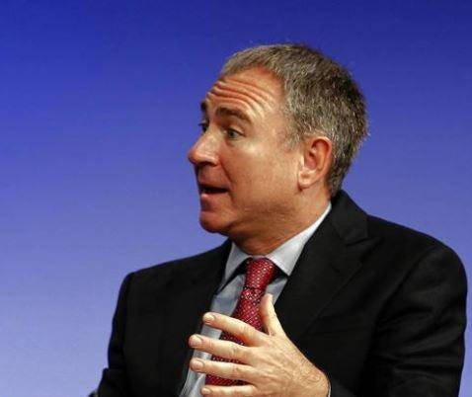
" We were losing hundreds of millions of dollars a week, if not more . . . And each day we bought one more day"
We all know Ken's philosophy of one more day. He will not give up, ever. He would rather the whole
economy tank before he does. The squeeze will only happen after he has done everything to suppress it
and fail. However, once he inevitably fails, we're not out of the woods yet, because now we're
threatening a new player, the DTCC.
The DTCC Taking over
Remember, THE DTCC DOES NOT WANT THE PRICE TO HIT 10 MILLION. The DTCC doesn't want to
pay out of pocket at all, that's why there are so many new rules. They're hoping the squeeze stops at
~5k, or even lower because higher prices mean the DTCC has to pay out of pocket. At higher prices, the
DTCC has to liquidate its members. Banks will lose massive amounts of money and assets and the US will
undergo turmoil. All of these new rules, such as auctioning off assets, won't matter at 10 million. At
10 million per share, the DTCC will be forced to liquidate banks like Credit Suisse and JPMorgan, causing
a huge chain reaction across the market. Do you think the big banks are going to sit quietly while they
get liquidated?
What if other market makers are forced to Naked Short Gamestop to survive because if GME goes
too high, the DTCC will be forced to liquidate them?
DTC-005, a rule too good for this world
You've probably heard of DTC-005 by now, if you haven't, the simple version is that it stops the naked
shorting of stocks, at least, you can't delay them with options anymore. While you can still naked short
for liquidity, you can't delay them for longer than a week. This means the naked shorting of GME will
never happen again. However, this rule was completely taken down, and no timelines are given when
they'll be back up. Without this rule, GME can be naked shorted by any market maker.
Isn't it a bit weird that this rule is the only one to have been completely removed?
Both J.P. Morgan and Credit Suisse have market-making capabilities (There are more in the DTCC). This
means they can naked short stocks just like Citadel. However, they don't appear to have shorted
Gamestop. They WILL NOT get margin called with Citadel.
However, as DTCC members, they'll be forced to pay up assets to buy GME and close naked short
positions. If GME goes too high, to the point where they'll have to sell everything. . . They may be forced
to try and halt the squeeze or end it prematurely to avoid liquidation. If they mass naked short a stock,
and you can short a stock during a squeeze, as there have been historical precedents for it, the price
will dip. . . temporarily.
Obviously, nothing can be done long term. Eventually, the squeeze will continue, and it will continue
much higher than before, as all the shorts will just be fuel for the rocket. In fact, naked shorting
Gamestop is not only reckless but extremely bad for the global economy. But. . .
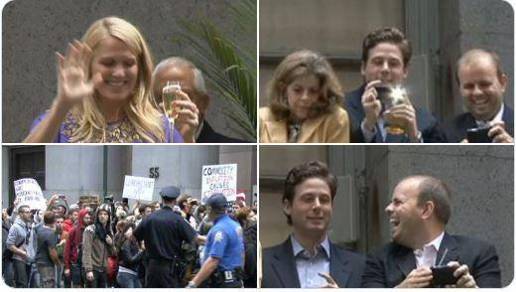
Do you think wall street cares about the global economy or the average citizen?
The only way this squeeze will stop is if a short attack causes apes to paperhand.
DO NOT BELIEVE THE IDEA THAT THE SQUEEZE WILL BE STRAIGHT UP
The banks aren't going to sit by quietly while all of their assets are being liquidated. They'll fight back
tooth and nail, just like Citadel did. If you want to change the world, be prepared for a world-changing
fight. Even if the DTC-005 gets approved before the squeeze, the market makers can still naked
short stocks for a few days for "liquidity".
Update: DTC-005 to be approved "soon" with no dates given. That seems extremely suspicious to me. It's
been months since the rule was taken down, and even now there are no dates given.
You may see the money dip from 500k to 200k, you may feel like the squeeze is over after it falls 3 days
in a row, but in reality, that could just be more market manipulation.
So what do we do? The same thing we've always done.
HODL through all dips. We own the float. Trust the DD. Trust the community. 10 million or
nothing, lambos or food stamps.
Not financial advice. Exit your positions when you feel comfortable. I personally only feel comfortable
exiting when I see real change when these scammers are put behind bars and corrupt politicians step
down.
Is my money safe in X and X bank?
What I believe happens is that your assets are safe because those assets are not equal to the bank's
assets. However, you may have a bit of trouble accessing them if the banks go bankrupt, and it takes a
little bit to swap the relevant information to another bank. I personally believe the US gov will bail the
banks out again, but just in case, I suggest having GME in multiple brokerages.
Edit 1: "Reposting" with a bunch more information
Edit 2: Wow, that's a lot of comments. I'll try to answer every question in the comments, but might take
me a bit tho.
Edit 3: Wow, my first time getting platinum. Thanks for that kind stranger! I didn't even know there was
an exclusive club for those people. Not that I do anything but spend time on Superstonk and write DD,
mind you.
Edit 4: I have since lost my flair because I was trying to make sure everyone in my comments voted.
Whoops. One more small sacrifice to the cause.
Edit 5: NSC-801 Changes Margin rules
Edit 6: Two Platinum Awards? holy shit guys. I'm honoured. Now I can blow it all on DFV's
postresponsibly award good new posts to make sure it gets to the top.
Back to Table of Contents
The Complete Bank of America Gamestop DD
DD 👨‍🔬
TL/DR It's possible that Bank of America is holding the biggest bag in the Gamestop saga
Note: This is just a theory, and I am not advocating anyone to do anything with their BofA accounts. Just
some information I found and felt an obligation to share. I am not a financial advisor.
If you owe the bank $100 that's your problem. If you owe the bank $100 million billion, that's the bank's
problem. -J.Paul Getty
Good afternoon Apes of the world. For the past couple of weeks, I've been digging into reports, and news
articles looking for evidence to connect Bank of America to the naked shorting situation and to postulate
who may be holding the bag at the end of this saga.
Now I'm still new to building DD's and if I am incorrect please forgive me and I will try my best to fix this
article. If anyone has additional information to refute or support my claims they are welcome as it's the
best way to find the truth. I would also like to thank u/Alert_Piano341 for their considerable help and
hours of research. I won't even touch that their building is always lit up on weekends/holidays
(Veterans day...really guys) and that they were one of the trading platforms that restricted trading in
January.
Hypothesis: Bank of America is the biggest bagholder in the Gamestop saga.
Supporting Evidence:
The 15 Billion Dollar bank bond.
On April 16th Bank of America issued a $15 Billion dollar bond. Now given they had an extremely strong
quarter, why would BofA need the additional collateral?
https://www.marketwatch.com/story/bank-of-america-tops-charts-with-15-billion-bond-deal-the-
biggest-ever-from-a-bank-11618606409
BAC needed that 15B bond for insurance
https://www.foxbusiness.com/business-leaders/bank-of-america-expects-to-increase-dividend-share-
buybacks-ceo-moynihan
watch this video at the 1:30 mark..... "assuming we get through the stress test...." he catches himself and
is like I HAVE TO BE SUPER CONFIDANT HERE.
I can't find one other article or media post about the liquidity test anywhere, and here is the CEO
mentioning it in an Interview....it was on his mind.
The Citadel Link
So the MM has a special exemption that allows them to Naked short the securities for the sake of market
liquidity and they classify them as "Securities sold but not yet purchased" labilities. Market Makers have
been fined for naked shorting before but nothing has been done to really curb it and the fact that we
have two companies with expanding balance sheets show it's being abused right now.
Citadel specializes in Option naked shorting, and because of GME they have an ever-expanding bag of
SHit. There "securities Sold but not yet purchased" went up to 57.506 B this year with 32.386B of it in
Options. To recap Abbot told us the liabilities are valued at fair value, and that this will be an issue for
citadel in the future. I think it is going to be an issue for someone else as well.
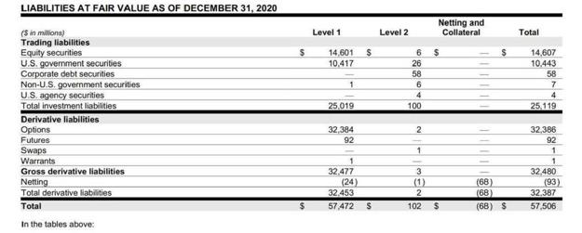
Citadels Liabilities
Notes from the financial statement for Sussqhana and Citadel
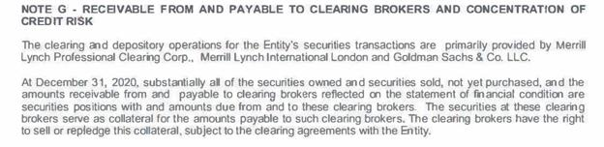
Susqhannas note makes it perfectly clear that the assist and liability are just on paper, the clearing broker can just sell their shit
when needed
Let's check what Citadel says about its Prime Broker ---->
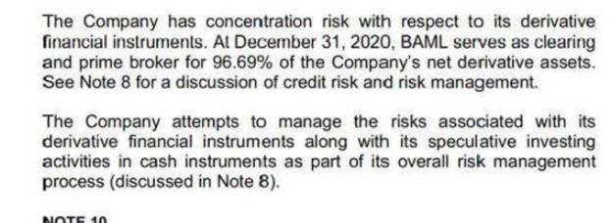
Who is holding Citadel's bag of shit?
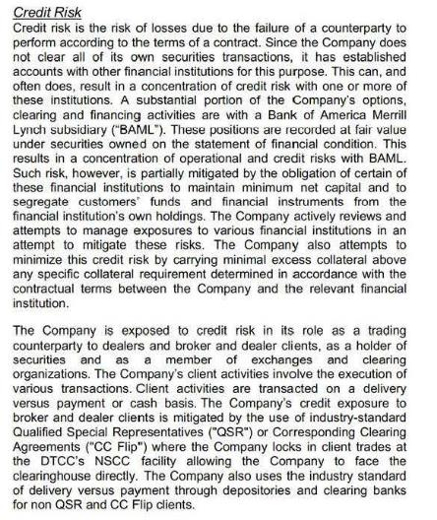
T his is also found in Citadels 2020 Annual Finacial report "A substantial portion of Citadels' options clearing and Financing
activities are with BAML"
BAML (which stands for BANK OF AMERICA MERRIL LYNCH) or now BAC is the prime and clearing
broker for 96.69% of all the net derivative assets of Citadel Securities? They are holding the 57.6 Billion
Bag on Citadel Poo... 32,386 Billion of it in options, with a ton of those, are going to explode in their face
or be worthless.
Something to consider...
Virtue Capital annual report
https://sec.report/Document/0001592386-21-000005/
They could note that their payment for order FLOW more than doubled in 2020 with the rise of RH .....
what do you think about Citadel's Payment for order flow (Virtue is a publicly traded company so we
have their expense data you will not find it for citadel) but Virtue and citadel are competitors. this article
says Virtue does 9.4% while citadel does 13.4% of the market in December of 2020. so if Virtue is paying
758M for order flow in 2020 Citadel is paying at least a 1B.
https://outline.com/SxAFCy
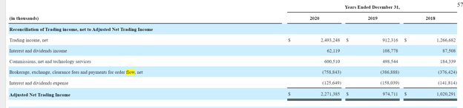
Virtue Capital payment for order flow
then they could look at Citadel's debt (most MM don't take on debt ....because they print money, they are
not supposed to have the liabilities citadels has and they may have a simple line of credit but Citadel got
a direct cash infusion last year. They sell options they don't own yet (with the expectation they won't
have to purchase most of them)......shit
The Loan
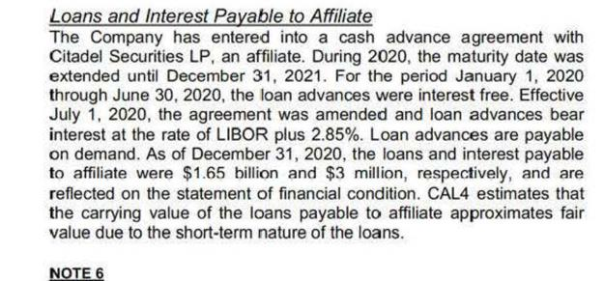
They issued a 1.653 billion loan to Citadel, when they also recently raised the 15 Billion for their bond.
SMH
The New Hire?
A key piece of information that I came across that I thought might support our thesis was the recent
hiring of Executive David Kim. David Kim was the head of equity client solutions at Bank of America and
was recently hired by Citadel Securities (link below). Now, this is speculative, lets say there's a new hire
named Mavid Jim, would it be possible that Jim has signed off on some terrible credit/increased risk, and
jumped ship on some hidden backdoor deal?
https://www.efinancialcareers-canada.com/news/2021/04/david-kim-bank-of-america-citadel
Look for the usual suspect
I speculate that Bank of America also contributed heavily to the naked short selling of the so-called
meme stocks (most likely Gamestop GME and Bed Bath and Beyond BBBY, as they are the stocks their
analysts mentioned). In an article as recent as 2018 its been documented that BofA has paid the most
fines out of all the major players since the 2008 financial crisis. It would appear that the rules simply
don't matter to them.
https://www.marketwatch.com/story/banks-have-been-fined-a-staggering-243-billion-since-the-
financial-crisis-2018-02-20
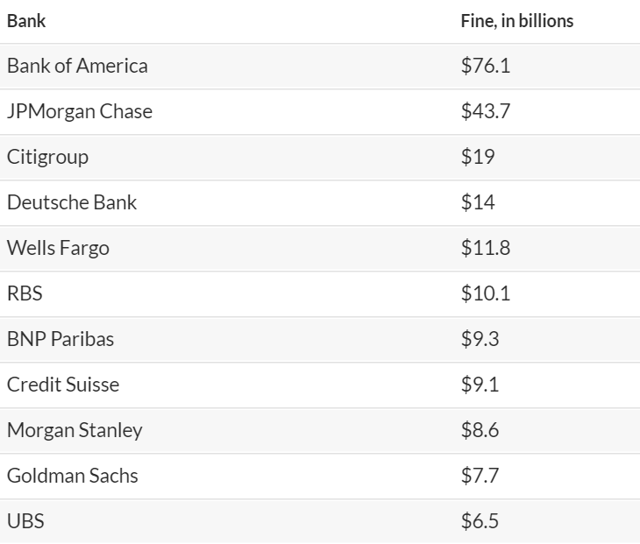
The 13F Filings
In recent 13F filings on whalewisdom you can see that Bank of America does hold decent-sized Put
positions on GME and AMC. As holding these put positions are a legal loophole way of holding a short
position and resetting an FTD, I believe it's possible that they also took short positions against these
meme stocks. As both organizations would benefit from colluding an aggressively short position, they
could drive the price down and both mutually profit.
https://whalewisdom.com/filer/bank-of-america-corp-de#tabform4_tab_link
The recent Bank of America Q10 Quarterly report
I decided to do some digging and when I was looking through the cashflows on their most recent
quarterly report a figure under trading and assets/liabilities I found this gem.
The net change in cash from derivative assets/liabilities from 2020 to 2021 was a womping deficit of
$53.756 Billion or a difference of $83 Billion from the prior year. That's just what is reported. I tend to
believe that it's probably worse than that.
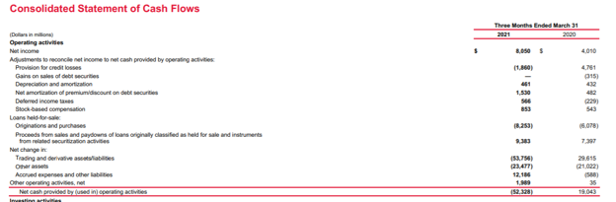
Page 47 on their recent Q-10
https://investor.bankofamerica.com/regulatory-and-other-filings/all-sec-filings/content/0000070858-
21-000063/0000070858-21-000063.pdf
The Bullshit Push for Silver
Who else thought it was total bullshit when the media spewed out that Reddit was into Silver, and that it
was the new Gamestop? Who on earth would benefit from crowds of people moving to purchase silver?
Honestly if/when Gamestop moons everything is Gold Plated. Silver is shit.
https://www.cbc.ca/news/business/silver-stocks-surge-1.5895790
https://www.northernminer.com/fast-news/bank-of-america-sees-further-upside-potential-for-silver-
in-2021/1003825311/
The Roaring Kitty
It seems that our beloved Roaring Kitty knows something is up with Bank of America as well. In his
recent Twitter post, he shows a scene from Baby Driver (A great film, check it out). It would appear
there has been a Gamestop logo inserted just above a Bank of America ATM. Interesting stuff.
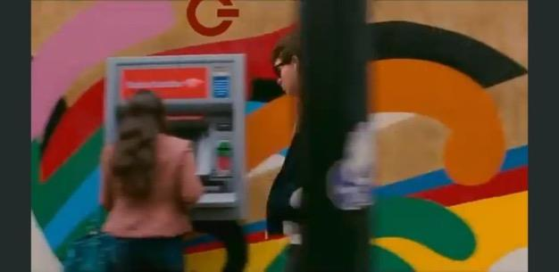
Bank of America ATM and the GME logo
The closed locations:
Currently, hundreds of Bank of America locations across the United States are currently closed. It was
definitely sus. To my understanding, some of these locations were being boarded up due to the trial of
George Floyd (RIP). This was very strange as some of these banks were being boarded up after the
verdict of the trial, and it appeared no riots would happen. I understand that with the shift to
mobile/online banking there is less need for physical locations, but does that facilitate about 1/5th of all
locations been temporarily closed (I did a sample of several states and came across 1/5th. I wasn't about
to spend a day checking all 4600 locations but I welcome someone else with more time on their hands to
take a look).
Bank of America Analyst Shitting On GME
"GameStop missed EBITDA estimates, which was a big negative for Bank of America analyst Curtis
Nagle. The analyst, which rates the stock at Underperform with a price target of $10, said the company
missed EBITDA estimates by 66%"
"This is not a good quarter," Chukumba said. "I will be listening to how they're going to pull a rabbit out
of the hat and turn this into a viable company."
Chukumba said GameStop needed "some magic beans and pixie dust" to help the company going
forward. He dropped coverage of the stock in January.
https://www.benzinga.com/analyst-ratings/analyst-color/21/03/20322372/gamestop-analysts-react-
to-q4-earnings-company-needs-some-magic-beans-and-pixie-dus
Conclusion: Based on all the evidence provided above, I asked the question, who else could be the
biggest big holder at the end of all this? If Archegos is a much smaller hedge fund and contributed to 10+
Billion dollars in losses to Credit Suesse, then I speculate that the losses from the margin calling of
Citadel and Susquehanna could be magnitudes larger. If you also consider the short selling of securities
from BofA itself, it is entirely possible for 100+ Billion dollars in losses. Let me know what you think.
Again big shout out to u/alert_piano341 for their help/contributions.
Note: If someone could get me some Bloomberg shots for a few of the major banks that would be great!
Ideally BofA, JPM, GS please and thanks.
**if you choose to use any of this in a DD please reference this article as it took a lot of hard work.
Back to Table of Contents
Elliott Waves, GME, WEN THE F*CK MOON!?
DD 👨‍🔬
Sup apes
not financial advice in the slightest.
Before I begin this analysis post, if you question the validity of fibonacci and Elliott Wave because it has
proven to be "incorrect" you are approaching this topic with the wrong mindset. Fibonacci and EW are
quite literally the "formula" to the stock market, but its much easier to understand than it is to
implement.
GET FUCKING HYPEEEE!!!!
Obligatory crank: https://www.youtube.com/watch?v=Phy75VJRObQ
Spotify link: https://open.spotify.com/track/21UoRIOIjkWdHU8xbxQ0Z7?si=1958348bf5524bf0
As always, I post intraday analysis on my twitter to provide updates on what I see, if you're interested in
the snippets/BTS charting, you'll love it.
In this post I am going to be going over mainly GME and touch on a few indices.
First off, if you've been reading my posts for a while, you'd know I was on the lookout for the current
trend to hold above 197 for my wave count to be correct. Friday and today we broke below this level,
seeing a low of 193.71.
Wut mean you ask?
All this means is that the count I was analyzing on a smaller scale was invalidated, as we broke below the
original supposed low target of 197.
In lehman's terms, instead of a 3 within a 3 within a 3 within a 3, the updated trend will be a 1 within a 3
within a 3 within a 3.
basically, nothing is changed.
I am also very well aware that bad actors read my and other's analysis and act on it as an attempt to
attack the validity of not only technical analysis but members of the sub that are looked up to for their
analysis.
To the shorts that do this, I say fuck you, pay me.
I have happily added more shares under 200, that's a fucking steal if you ask me.
Here's my updated chart factoring in today's low, simplified (I cleaned my shit up big time)
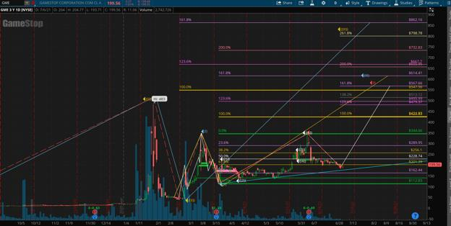
Daily
Note, the only targets changed from the recent downward pressure (white line/red annotation). All
larger scale targets remain the same, the only way the latter would be invalidated is if we broke below
112.83 (yellow line target) and 38 (blue line target)
The white (3rd largest degree) will go down proportionate to how much downside we have from hereon
out. example, the 1.618:1 ideal wave 3 target factoring in today's low of 193 comes out to 567.66. If we
drop to a low of 190 in the next few days before continuing up, then the updated 3 target would be
564.66.
My biggest reason for writing this is to clear up some misconceptions I have heard regarding the wave
structure.
So idk about you, but I could care less about what happens in the short term. The overarching setup is
(as always) screaming buy.
However, in terms of my previous prediction of 197 being the low, this fell through as we broke below
the smaller scale wave 1 low. Remember, for a motive (5 wave impulse) structure, wave 2 cannot
retrace into the territory of your wave 1, otherwise you must redraw. There is NO exception for this rule.
Before I continue with GME, I would like to shed more light on my $SPY analysis . I still hold my 432 top
target, I just want to go a bit deeper in the analysis. I was considering making another youtube video so
you could see how I analyze and draw targets, but I'll save that for another time. I do want to thank you
all for the insane amount of support on my first (and only) GME SPY EW video
Here's what I see on a 4hr view:
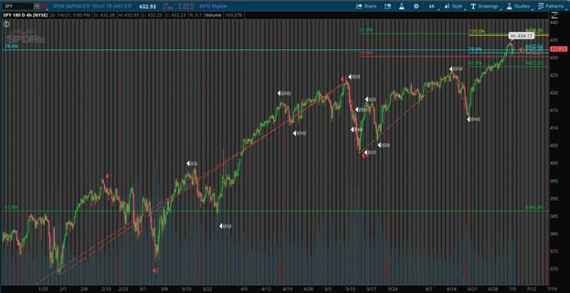
4hr
Monthly:
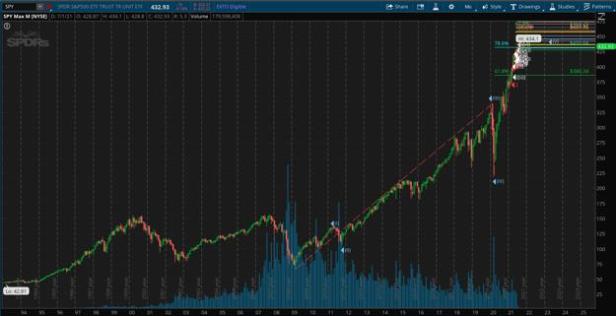
Monthly
Without a doubt, SPY is ridiculously extended to the upside.
I believe we will see 436 hit in the near future at the very least, highly doubt much more upside from
there. My reasoning for this is remember that EW is a fractal trading strategy, meaning targets on a
smaller timeframe line up to form larger time frame targets.
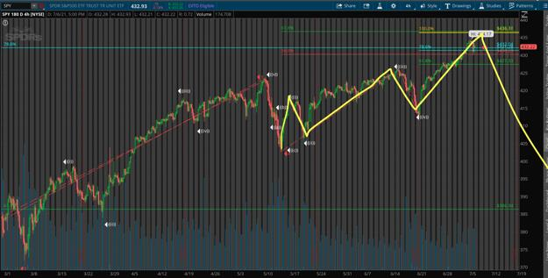
visualized
You can see the 5 wave structure from the recent lowest low, normally wave 4 can't retrace into the
territory of 1, however keep in mind the overarching wave is a 5, meaning 4 CAN retrace into the
territory of 1. This trips a lot of new EW traders up as they don't understand the rule of diagonals.
regardless, wave 5 usually targets .618 - .786 of 1. the .618 level of this move comes out to 436, where
the bigger cycle 5 next target comes out to 436 as well (1:1 level, yellow).
an extension of above .786 for a wave 5 is considered to be extended for what it's worth. The yellow
trajectory I drew is only for visualization purposes and in no way is saying this is exactly how SPY will
play out in relation to price/time.
the reason I'm talking so much about SPY here is because GME and a little something called negative
beta. in short, market go down, GME go up, and vise vera, though correlation does not mean causation all
the time. The market being near the top and GME near/at the bottom of the trend is interesting when
you compare the two, and the supposed trajectory of each from hereon out using EW:
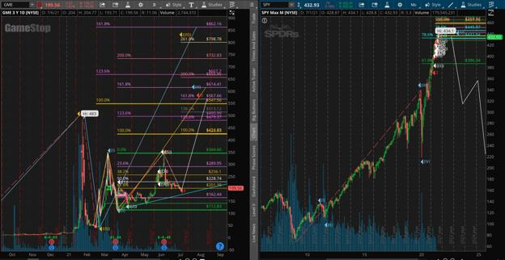
visualized
again, do note the white lines on SPY are only for visualization purposes, see my SPY DD for in depth
retracement targets for our seemingly imminent bear market.
SPY near top and GME near bottom, hmmmm...
In terms of GME downside should this not be the bottom, super dumbed down, here's the channel GME
is traveling in with fib dates worth keeping an eye on:
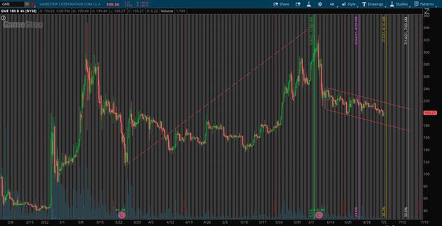
channel in red, time extensions colorful
Fibonacci time extensions can also be used to predict when a wave will change trajectory. In this
scenario, I measured the length of the 1 (from 113 to 344) to get fibonacci numbers in relation to this
time period. Stocks often need to cool off/consolidate after big moves before continuing the original
trajectory. Totally normal in the stock market.
However, given that GME is incredibly manipulated, take these fib dates with a grain of salt. I personally
don't use them often with GME, though on other tickers I have found it to be quite profitable. Not that I
endorse GME day trading at all, because you shouldn't, though when trading NORMAL (key word)
tickers, Ideally, when swing trading, you load a full position a bit after the first upwards move, and use
fib time extensions to predict when the corrective wave will end.
In this scenario, the 38.2 time extension comes out to tomorrow, which signals a potential reversal
coming tomorrow. Wednesday is also notorious for erratic GME movement, so stay buckled up!
What's realllllllly fucking interesting is the 50% time extension comes on the notorious 7/14 date.
What I want you to take away from the above visual is in the event that our reversal doesn't begin
tomorrow from today's low, lower bound of the channel comes out to around 175. Just keep an eye on
that level for some insane cheapies if Shitadel decides to abusively press the short button.
All in all, GME is incredible bullish and those that hodl through this wave 2 will be handsomely
rewarded. This I can guarantee. Fibs don't lie.
What make's me think today COULD be the low is, you guessed it, significant fib levels. This time, I
measured the low of february to the high of march (second highest degree of waves), visualized:
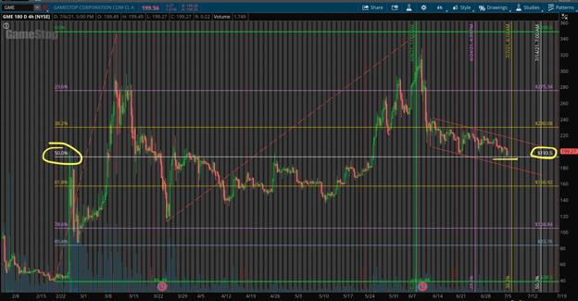
4hr
Fib level? 193.5. Today's low? 193.71.
so close to .69 :')
Until we have significant upwards pressure, I won't have narrowed down smaller timeframe upside
targets, but larger timeframe targets are still valid. It will be very hard to break the overarching setup
for the shorts.
I'm out. Thanks for reading 🍌
Time to go get high af and stare at fib levels some more.
TLDR: Boom soon, Market near/at peak, GME at/near bottom, negative beta, GME to 8+ figures is not a
meme and will happen if you believe and hodl for it. I know I will 🚀
Back to Table of Contents
SRO Filings
DD 👨‍🔬
Recently there has been a screenshot of a NYSE SRO filing being circulated purporting to show that NYSE
is "suspending a ton of dark pool groups." Or that NYSE is appealing an SEC ruling or something like that.
So to start, NYSE has nothing to do with dark pools. NYSE is a lit exchange regulated under the Exchange
Act, while dark pools are "Alternative Trading Systems" regulated completely differently (a combination
of the SEC and FINRA). The filing, which is available here has a much more relevant excerpt that was
obviously not included in the original tweet:
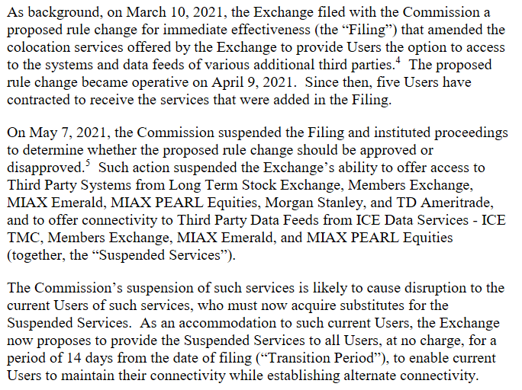
Here's what happened. Certain rule changes by exchanges are "immediately effective" - the rule change
takes effect when the exchange lets the SEC know, because the exchange deems the rule change non-
controversial. I won't get into whether this should even exist as an option here, it's a long and conflicted
story.
The NYSE filed a change to co-location as immediately effective, and several clients of the NYSE
contracted to receive the service. The SEC then decided that the rule change was not ok, and told NYSE
they couldn't do it. NYSE is asking the SEC to allow them to provide the service while those clients
transition off of it, because those clients (including other exchanges) likely rely on it for their NYSE data.
If you're interested in reading SRO files, you can find them here: https://www.sec.gov/rules/sro.shtml
I used to read every single SRO filing every money, and it was the best way to deeply learn about market
structure. They're incredibly boring and written in obtuse legalese, but once you learn to read them
you'll learn a lot.
The entire SRO status is frankly crazy, and I touched on it in my AMA. Wall St is the only industry in
which you have for-profit, publicly traded, self-regulatory organizations. An SRO is supposed to be a
quasi-governmental entity that regulates itself, and that balances the for-profit motive with a duty to
build and maintain fair and efficient markets. If that sounds as absurd to you as it does to me, welcome
to modern market structure.
Back to Table of Contents
A revisit to Net Capital. What is truly driving
these T+21 loops, the March and June gamma
runs, and how skyrocketing ETF FTDs might
cause big price movements in the coming
weeks.
DD 👨‍🔬
0. Preface
Well well, I think it's time to revisit an old topic. Net Capital. I posted about this in the past and for some
reason gave up on it. I can now provide counter DD to my own T+21/T+35 theory.
Remember - I am not a financial advisor and I do not provide financial advice! Everything in here is
based on research and discussion with others on the topics. As always, do your own research and
criticize. Take my opinions with a grain of salt.
Wanting to revisit the Net Capital topic was a few things. There were posts about ETF FTDs
spiking severely as of May 12th - even more than the highest peaks of January. I had my own doubts
over time of how we could possibly have multiple cycles overlapping, when it felt more like there would
be only a single cycle. And of course, some people commented and/or posted counter DD! Which I think
is awesome, it's always good to provide counter DD.
Kenny and his gang love to continue digging a hole for themselves - while the whole financial world tries
desperately to contain this potential market crash from coming to fruition.
GME shorts and Reverse Repo Market go brrrrrrrr.
TLDR: Sorry I'm too lazy right now. About to post this and go to sleep. 😎
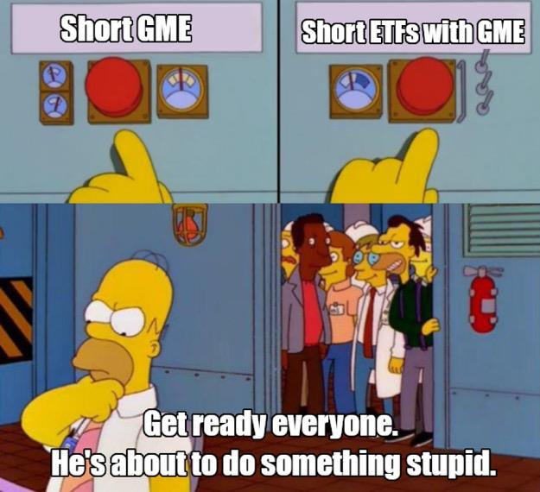
Kenny And The Boys
My previous post about Net Capital was thinking that we'd see significant price movement T+14 days
after April 16th options expirations. That didn't happen, so I tossed it out of the window. (Criand, you
dumb bitch)
Which then led me down the path of the T+21 Loop Missing Link. It got pretty popular. It's the whole
T+21/T+35 conjunction theory that occurred May 24th and May 25th. While it definitely appears to be
right, I have been doubting it ever since May 24th. Especially after a courageous
ape u/dentisttftposted the Counter DD to T+21 theory. T+35 (May 24th) didn't have significant enough
price movement. If it truly was a new T+35 initiating a loop, then it should have exploded up in price on
May
24th. And for that, I think it's time to put that theory to bed.
The counter DD that /u/dentisttft posted is excellent and you should definitely take a look. If my
post is wrong, /u/dentisttft still proposes another possibility: that T+35 from the FTD spike could
initiate buy pressure around June 17th.
Ever since the counter DD, I decided to revisit Net Capital since that is what /u/keijikage brought to my
attention so many weeks ago. Very smart guy by the way! Always very knowledgeable and provides
amazing discussion!
Looking back on Net Capital now, especially with the ETF FTD spike that occurred on May 12th, it might
finally paint the picture as to what has been going on this whole time with the "T+21 cycle", the March
Gamma Ramp, and the June Gamma Ramp.
1. GME FTDs, ETF FTDs, Massive Resurgence Started May 12
First, I want to discuss ETF FTDs, as something absolutely wild occurred in May. Note that we
do nothave the full months FTD data yet. The SEC releases the data in first half and second half of the
month reports. So, it cuts off quite conveniently when FTDs began to go haywire.
For a while now it's been theorized (with some pretty damn good evidence) that ETFs containing GME
have been heavily shorted. Supposedly they will short the ETF, buy up all of the other stocks in the ETF
that were shorted, but leave GME alone. There's a net 0 effect on the other stocks but a net short on
GME. This then starts to cause ETF FTD anomalies which they also try to suppress, but they can't hide
forever. Because it appears that as of May 12th, these FTDs have begun to spill out of hiding.
u/basketas87 posted about this surge of ETF FTDs in "New data shows a large increase of ETF FTDs":
GME Price Vs. GME FTDs and ETF FTDs (which contain GME); Source: /u/basketas87
You can immediately see the ETF FTDs absolutely SKYROCKETED just before the cutoff of the SEC FTD
bi-monthly report. We don't even know how high this has gone in the following days or if its come
crashing back down. Remember - these are aggregate. We don't sum up the FTDs between dates.
Whatever the number is upon a date is the current total of FTDs reported.
For a date-by-date tracking for these FTDs between January and the end of March, /u/broccaaaprovided
an excellent chart in "The naked shorting scam using ETFs: mass shifting of FTDs from GME to 20+ ETFs
& 27+ billion dollars still owed in remaining SI". This gives us an easier look at the exact dates when
FTDs spiked earlier in the year.
I selected GME and 19 ETFs containing GME. I chose to only look at the ETFs that contain the most GME
shares and had large numbers of FTDs in 2021. - /u/broccaaa
Aggregate FTDs for GME; GME and ETFs; Source: /u/broccaaa
Some notable aggregate FTD dates from this chart:
1. January 29th
2. February 2nd
3. February 18th
And of course, the latest absolutely insane May 12th. Once again, we don't even know what the FTD
numbers are for the second half of May. It could very well be much higher.
2. Net Capital And Market Makers; Citadel's Can-Kicked Bag
Net Capital is detailed out in this post but I will do a quick summary. It revolves around Net Capital
Requirements For Brokers or Dealers - 240.15c3-1:
...is designed to ensure that a broker-dealer holds, at all times, more than one dollar of highly liquid
assets for each dollar of liabilities (e.g., money owed to customers and counterparties), excluding
liabilities that are subordinated to all other creditors by contractual agreement. The premise underlying
the net capital rule is that if a broker-dealer fails, it should be in a position to meet all unsubordinated
obligations to customers and counterparties and generate resources sufficient to wind down its
operations in an orderly manner without the need of a formal proceeding...
...A broker-dealer must ensure that its actual net capital exceeds its required minimum net
capital at all times. - Source
Or in other words, you must have enough capital to not be "margin-called". In this case, Citadel is a
prime victim to this rule as they are a Market Maker and must sustain enough net capital to not go bust.
If they do not, they're a risk to their customers and counterparties. This rule tries to ensure that they
have enough money to pay up in the event of a default.
The very interesting part of this rule comes down to how they're calculating Net Capital in regards to
short securities:
Net Capital Rule; Short Securities Deduction From Net Capital Per "Days After Discovery"
What this basically means is that after the short security difference is found to be unresolved after
discovery (think FTD popping up is the "discovery"), then it's going to slowly start eating away at their
net capital the longer it remains unresolved/undelivered:
• Day 0 after discovery = 0% of the unresolved short security is calculated into their net
capital
• Day 7 after discovery = 25% of the unresolved short security is calculated into their net
capital
• Day 14 after discovery = 50% of the unresolved short security is calculated into their net
capital
• Day 21 after discovery = 75% of the unresolved short security is calculated into their net
capital
• Day 28 after discovery = 100% of the unresolved short security is calculated into their
net capital
When you have these debts accounted for into your net capital, it is taking away that value, because it is
a short difference you owe. As the days go by, net capital starts chunking down. So, if you have a rather
large short security difference discovered one day (such as May 12th) then you want to resolve it
quickly or risk defaulting.
Do you find a way to stuff the unresolved shorts back under the rug? Do you deliver and force buy-ins?
Both? That appears to be the loop they've been stuck in, which slowly bumps the price floor upward.
You'll notice that there's a familiar number in there. Day 21. T+21? Oooh. Tasty. Here we go.
The total timeframe for Net Capital is 28 days, but Citadel most likely cannot allow the Net Capital
threshold to go past 75%. They must kick-the-can and force buy-ins on or before T+7, T+14, T+21 but
complete the entire process by the net 75% threshold of T+21. They can't risk it going to 100% or else
they'll most likely default.
Wham, bam, the T+21 loop ignites itself continuously.
3. Plotting The Net Capital Loop - The Counter of T+21 and
T+35
The major option dates still play a big role. But I don't think T+35 theory is what's really applying here.
What are "major options"? These are the only options that were available for the year 2021 back in
early 2020. These are the option dates that were most likely opened up initially by shorters at the start
of COVID. Perfect time to place bets and start their kill shot on GameStop:
• January 15, 2021
• April 16, 2021
• July 16, 2021
Upon expiration, unrealized losses now became realized losses, and their overall capital receives a dent.
It most likely gets harder to hide FTDs and hide them under the rug.
You know the most curious thing?
Posts about Citadel working the night-shift started just after April 16th options expirations.
That's also right around when Bank of America shut down a bunch of their locations. I won't buy
their excuses. Bank of America looks like they're a bag holder and is freaking out too.
Something big had to of happened as of April 16th, and it's most likely that they had a huge dent in their
capital that is now causing a slow bleed-out of FTDs that they've hidden, which then must be satisfied
within the Net Capital timeframe of T+7, T+14, T+21, T+28, or else they can go net negative and default.
And of course, following April 16 options expirations, the ETF FTDs start to skyrocket on May 12th. My
main intuition is that they were unable to hide these any more and they have started to spill out. Ruh-
roh.
First, I'll plot out the T+21 Net Capital loop so that it isn't too cluttered:
Plotted Net Capital "T+21" Cycle, December 22 to July 26
Upon December 22, the clock starts ticking. It's possible that at this point the price was too high for them
to NOT worry about Net Capital any more, and they had to start can-kicking and forced buy-ins.
Each loop is separated T+21 because it appears that they cannot sustain higher than the 75% threshold
each time. You can see the T+21 loop we're familiar with, starting December 22, and then traveling
through January 25, February 24, March 25, April 26, May 25. And potentially continuing on to June 24
and July 26. [The next two dates if any apes are curious].
To get a closer look of the potential effects of the various Threshold amounts (T+7 (25%), T+14 (50%),
T+21 (75%)) I've zoomed in on March 25th to May 25th. ENHANCE!
Plotted Net Capital "T+21" Cycle, March 25 to May 25, Price Spikes Prior to Each Threshold (T+7, T+14) Date
In the above it's unlikely but there is a chance that they have too many FTDs to shuffle around by the
time Net Capital 25% (T+7) Threshold hits. This could initiate some buy-in pressure on or before that
date, typically the day before, as outlined in the light green circle. The day before because they don't
want those positions to be 50% upon the next day. They must be resolved BEFORE.
It is also unlikely but a greater chance that they have too many FTDs to shuffle around by the time Net
Capital 50% (T+14) Threshold hits. This again could initiate some buy-in pressure on or before that
date, typically the day before, as outlined in the blue circle.
And of course upon Net Capital 75% (T+21) Threshold, they must complete their rug-hiding and/or buy-
ins to avoid going Net Negative. It is possible that the rug-hiding and buy-ins are in conjunction with one
another, slowly increasing the price floor, and that between each threshold they try to short the
stock more to push down the price.
Looping back to Section 1 when we identified the major FTD dates:
1. January 29th
2. February 2nd
3. February 18th
4. May 12th
There's a potential relationship to be seen with these insane FTD dates. Now this chart I'm about to
show is highly speculative. I'm unsure if the Net Capital loop initiates upon the FTD spikes (though it
certainly should, per Net Capital rule, because that would be when they are "discovered").
I say I'm unsure because I only see one data point here so far and somewhat of a second data point from
the price run-up we've been seeing the past few days.
Plotted Net Capital "T+21" Cycle, December 22 to July 26, and FTD Spike Relationship
In the above picture, look at January 29th's FTD spike. Plotting the full 28 days of Net Capital out where
100% of the debts would be accounted for, that lands it on March 11th. They want to resolve
this before March 11th, while the debts are still 75% accounted for. Remember that date? March 10th? I
sure do. This could be why we saw the price spike, and why T+35 is incorrect in theory. But, it appears
the major option dates still play a role, because of the May 12th FTD spike that just occurred, which
followed April 16th options. Likewise, the January 15th options may have initiated the FTD spikes
around January 29th and February 2nd.
If the same situation occurs due to the May 12th FTDs, then plotting out the full 28 days of Net Capital
lands us on June 22nd. If these FTDs initiated Net Capital T+0 upon May 12th, then things could get
crazy on or before June 22nd.
It is very possible that the run-up from May 25th to June 8th was all due to this new set of FTDs, and
they had to start buy-ins on or before T+14 and T+21 from May 12th due to the sheer amount of
unresolved shorts that were eating away at their Net Capital. If the FTDs aren't fully hidden again or all
the buy-ins aren't complete, there's still T+28 to look towards, which lands on June 22nd. They would
need to hide these FTDs again and/or buy-in on or before June 22nd. This would keep in line with the
March 10th squeeze.
This could also very well explain what was going on with AMC. (Don't freak out on me yet, I love looking
at AMC because it's very good analysis to track. It's been following the same exact T+21 pattern as
GME)
4. AMC Behavior - Given Up On By Shorts? Too Expensive To
Juggle With GME?
AMC has gone on an absolute RUN. It increased nearly 70% in one day. Take a look at the following chart
now that you know about Net Capital and the different T+7, T+14, T+21, T+28 Thresholds:
AMC Behavior from May 12th to June 24th
Damn. Did they just GIVE UP on AMC and decide that it's too much to deal with? Do they not have
enough capital to deal with both GME and AMC (and possibly other short meme stocks)? I think so,
because this lines up quite well. They had to fix Net Capital for AMC by T+7 (25%) Threshold on June 4th
probably because it was too expensive to handle alongside GME, and GME is the one they really need to
keep their ammo for.
Between T+7 and T+14, they of course short some more, trying to pull the price down in preparation of
the next Threshold cycle of T+14, which will probably cause an equivalent or greater amount of buy-ins.
This lands on... June 15th. And if it's like previous cycles, that would imply that they want to do the buy-
ins by June 14th (next Monday) to avoid those unresolved shorts hitting the next threshold amount. Big
price spike coming again?
Even then, the current T+21 cycle isn't over. The threshold of 75% doesn't land until June 24th, where
things very likely will continue to spike upward with an equivalent or greater spike of the run before
T+7 (25%) Threshold.
I truly think that they've put all of their effort into containing GME and have more or less "given up" on
AMC because it's not as big of a deal to them. That's why it's mooning like crazy while GME is taking a
little time to wake up.
5. GME Behavior - Shorts Holding On As Long As They Can
With the same exact timeframe of AMC, let's finally look at GME and the current cycle going on. The ETF
FTDs from May 12th line up T+28 (100% Net Capital Threshold) on June 22nd. Again, if the Net Capital
loop initiated upon that FTD spike, then things could get absolutely wild on or just before June 22nd.
Otherwise, it might just be the standard T+21 Net Capital loop, which has that extra pressure from the
ETF FTDs, where the Net Capital loop initiated on May 25th, and ends on June 24th.
GME Behavior from May 12th to June 24th
By the time of T+7 (25% Threshold), it appears that they really needed to apply some buy-ins, and the
price started to rise quite significantly. Just like AMC, but not as extreme, because they want to put all of
their energy into keeping this bad boy from popping off.
Once again... take a look when T+14 (50% Threshold) will hit. June 15th. From the above analysis, the
buy-ins would occur on or before this threshold date, typically right before. Know where that lands?
Next Monday. June 14th.
It's possible that they won't be able to sustain to the 75% threshold any more, but now must sustain the
50% threshold of T+14 where they need to resolve their unresolved shorts by.
Maybe there will be a big price spike next Monday. Otherwise, keep an eye out for the T+28 date of the
ETF FTDs, landing June 22nd, or the original T+21 date, landing June 24th.
I believe we're also waiting for the Russell 1000 change the week of June 24th. ;)
Back to Table of Contents
Infinity War: The Final Exit DD Compilation
DD 👨‍🔬
Hello Superstonk!
I am just compiling this for those of you that might be interested in the more juicy non-TA parts of my
weekly DD's. Since a lot of this was written over several weeks, I wanted to get it all into one place for
ease of reference. Any additional exit strategies or information will be added to this post in the future.
For those of you that prefer the Video DD's they can still be found over on my YouTube.
I know many of you have already read this but there is some new information here.
PART I: Where the hell is the Sell Button? or How to time Exits.
Well, I guess I'll begin by going over some things about me I am generally a day and on occasion a swing
trader. Timing exits is a very important part of what I do everyday.
GME is nothing like those positions...
Normally if I hit 10% profit on a regular trade I'm out unless I have some previous reason to believe It
will run further.
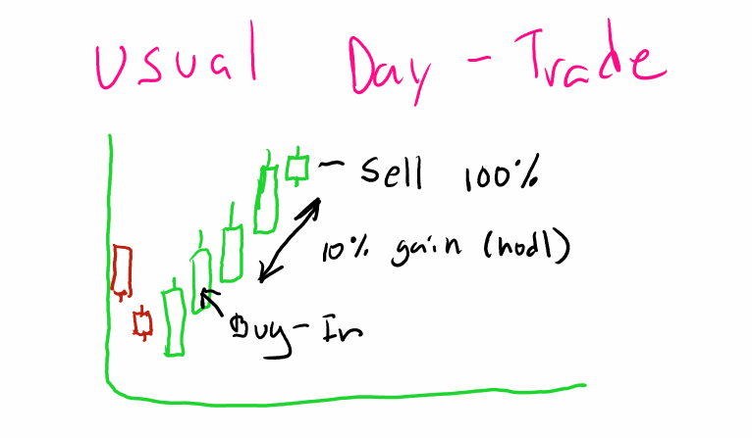
Usual Day Trade (Buy low, sell high)
GME WILL RUN FURTHER, MUCH FURTHER
Well, how do you handle stocks when you expect the realized profits to be much higher?
The answer to this is I usually don't. Day-trading should be defined by risk, My risk on this trade is 2%
and my upside is cut at 10%. I'm not going to risk higher profits. I am simply going to take my money
and walk away. If the stock goes up another 10% I don't care, as the trade is pre-defined.
This makes talking about GME and exits a difficult discussion. As we expect GME to be a Black Swan type
event there is no way to determine expected profits and the risk for most of us is the amount we put in.
I believe most positions in GME, mine included, are a YOLO (a stock trade defined by maximum risk and
maximum profit potential) . The mentality behind this is that by risking everything the reward should be
much greater than that. We have seen a lot of numbers float around on GME over the last months on the
expected price targets. It started at $1000 a share in January, then the unexpected halt of trading
occurred during the initial squeeze, that number has since increased. Partly based on information that
came to light on the short positions involved and partly on wild speculation we have seen price targets
of $10,000, $69,420, $100,000, $420,069, $10,000,000, and more recently $100,000,000.
While I like a lot of these numbers, the reality of the situation is...WE HAVE NO IDEA
This would be an event not only unprecedented in the stock market but of such impact and volatility
that it would be impossible to accurately predict any absolute price target.
Sounds like FUD...
No, to say X is a the absolute price target is silly and shows a lack of understanding how markets work.
Will this stock be worth $10M ? Possibly? It could peak at $9,989,000 or $69,420,000.
The point is this: WE HAVE NO IDEA, THIS HAS NEVER HAPPENED BEFORE!
So this week between streaming and Live charting everyday I tried to think how can I help my fellow
apes, no matter the smoothness of their brains, navigate such a tumultuous event. I had to ask myself
Two questions.
1. How do you discuss exit strategy with no known price targets?
2. How do you make it simple enough to understand?
I asked these two questions a lot and most of my answers fell short. I do believe I have finally settled on
the easiest way to explain it and hopefully make it easier to understand. For this I'm going dig a little
into the magical world of candlestick reading and pattern recognition.
First thing all this will be defined at the 1-min timescale on the charts. I believe this timing will be most
relevant in defining peaks. I will break this into sections and address each one.
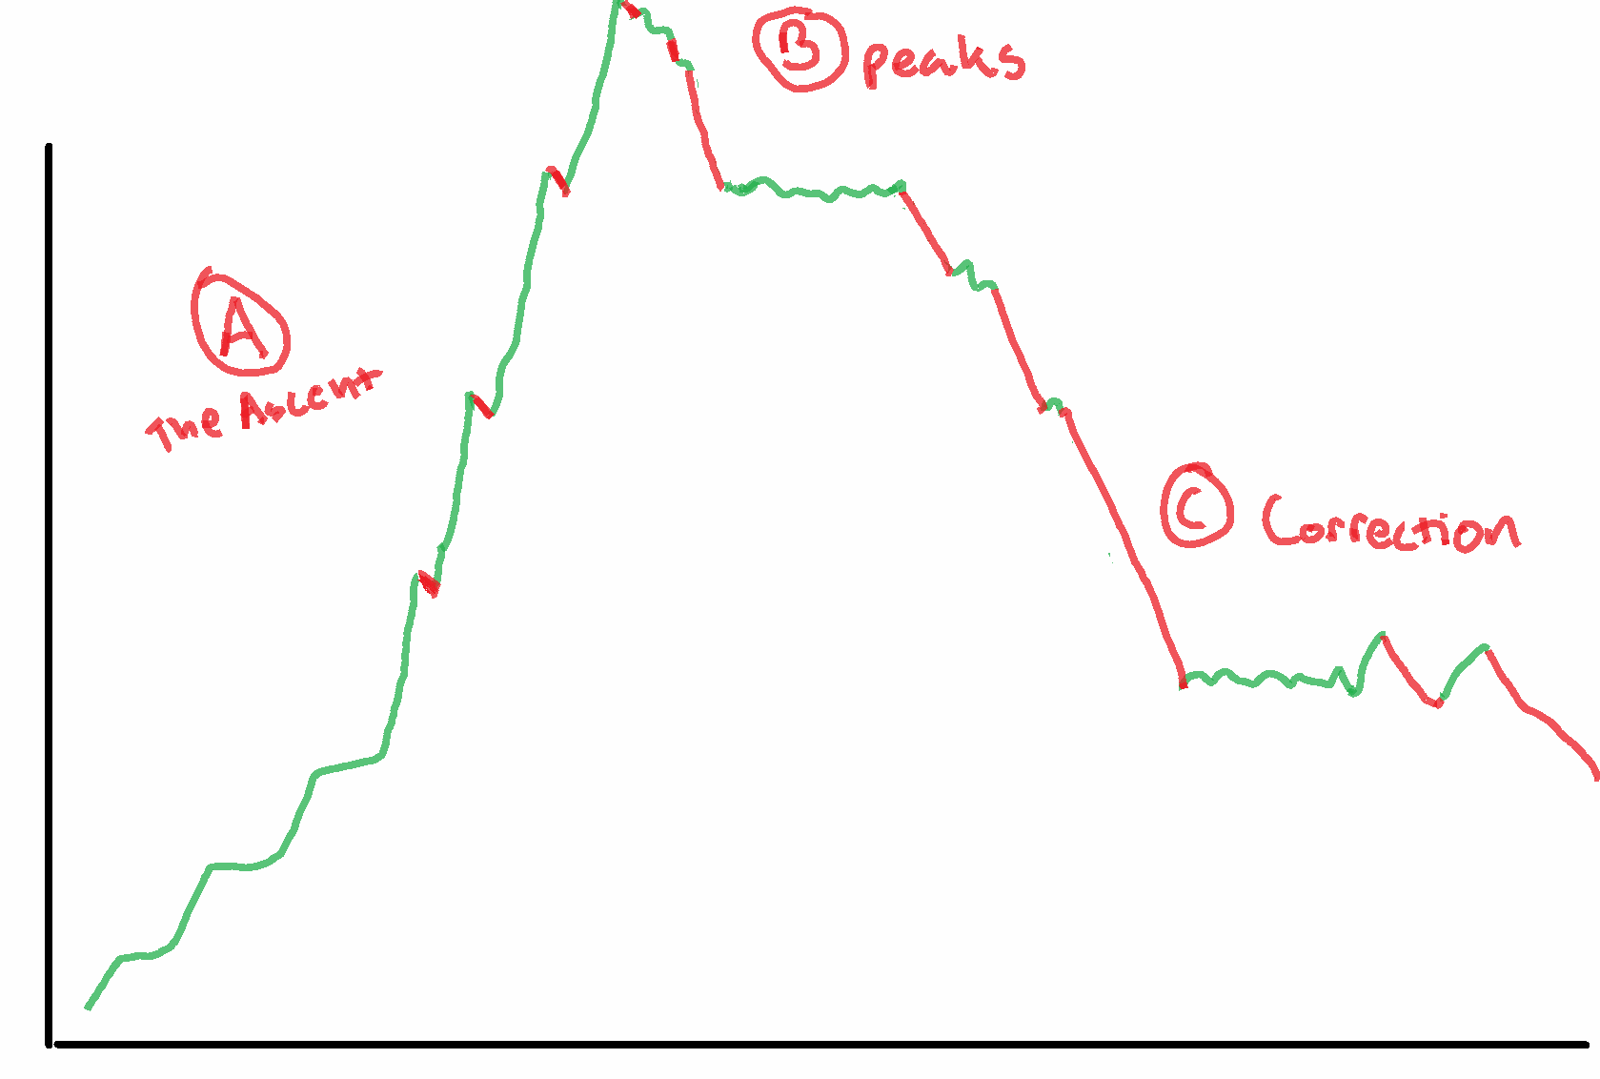
3 Pillars of the Squeeze
PART A: THE ASCENT
Part I: Upwards Price Movement (We are here)
This period will be marked by increasing upwards price movement, channel to channel, then periods of
consolidation. This is normal price movement not necessarily volatile but it can be at times. This will be
the movement as GME ascend upwards in the early stages.
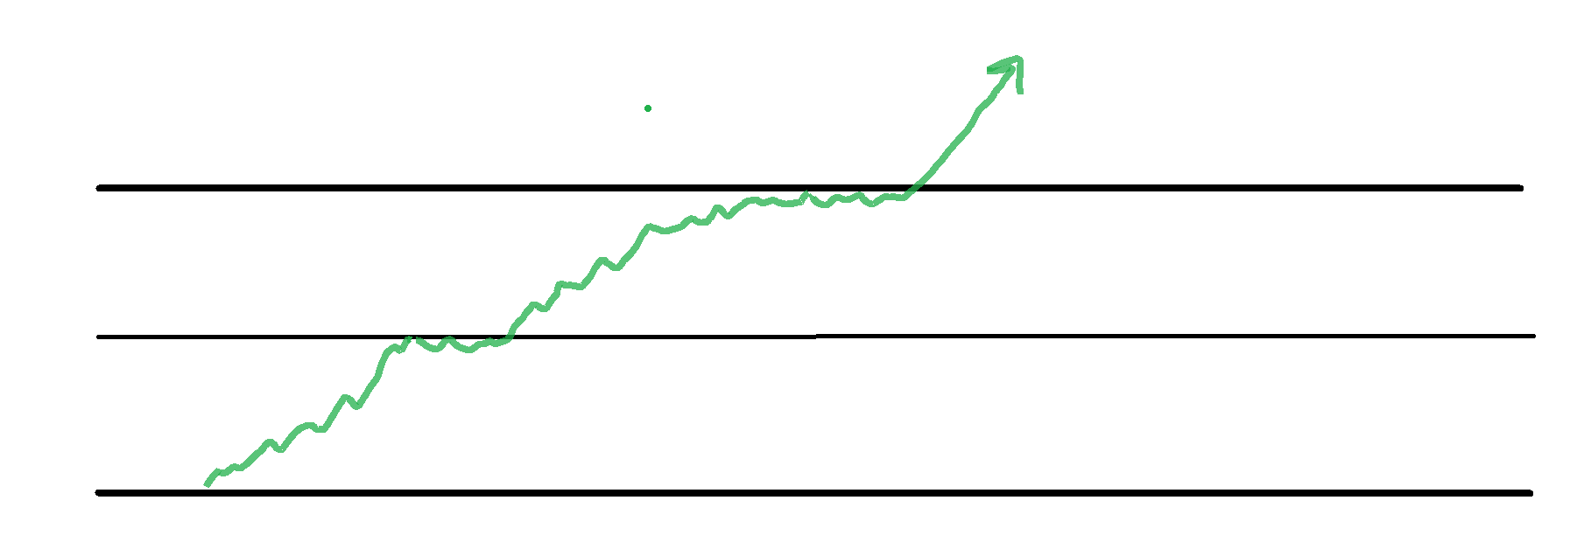
Resistance-Test-Break-Repeat
This period can take weeks, months, or minutes. We have seen in the past the price can jump very
rapidly in some cases. The end of this stage will most likely be marked by faster and faster moves
through these resistance levels. Bringing us to our next step in the ascent.
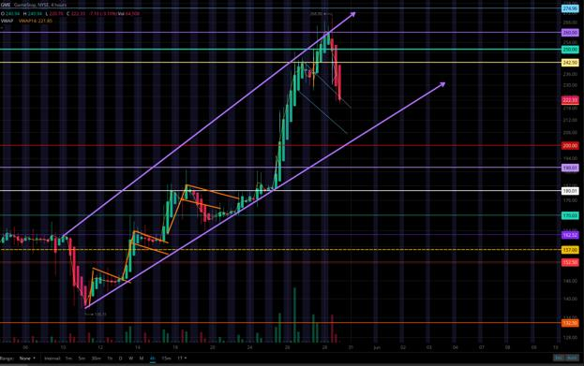
Current GME Chat on the 4HR Timescale
Part II: FOMO (Buckle up T - 10, 9, 8...)
The faster and faster breaks in upper resistance levels are going to ignite interest in the stock, as large
and small buyers rush in to capitalize on the squeeze. This is where fear begins to take affect as the price
start moving quickly upwards some will be afraid of becoming a bag holder. Don't worry this is just the
beginning. This Period will be marked by exponentially larger candles as volume rushes in and more
price movement occurs in shorter and shorter time frames. There will be halts, there will be dips after
those halts, as paper-hands, day-traders, and institutions cannibalize each other for small
profits. Breath here, stay CALM. This period will mark the wildest price swings as volatility picks up.
This will be the first pressure test of those Diamond Hands you've been bragging about.
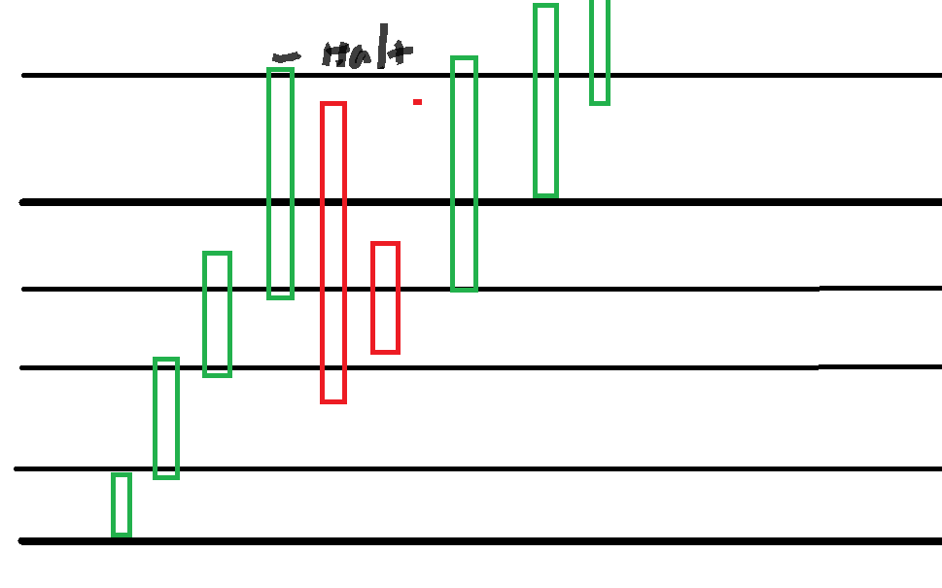
Price rises into a Halt, then dips, quickly recovering to the upside
Part III: The Margin Calls (Lift Off)
This is the moment everyone has been waiting the flight path to the moon! At some point we will hit a
price, nobody knows what that price is, I estimate somewhere between 250 and 600, but may begin on
some positions at a lower price. Whatever the price is, here is the moment that shorts must concede
their position. The Margin Call will be marked by a significant number of halts and large green candles.
The volume and range of these candles will increase dramatically from the previous stage. There will be
many more halts, possibly on each candlestick, as the open market orders go un-filled the bid will
continue to increase. So expect a pattern, of unhalt -rapid rise- halt. We will probably have more time
halted than actual trading as the price explodes. Additionally, there should be very little red after the
halts as upward pressure would be to great. Psychologically, this part will be easier as there is nothing to
do but watch the brief periods of active trading closely. I expect this to go on for awhile, possibly days.
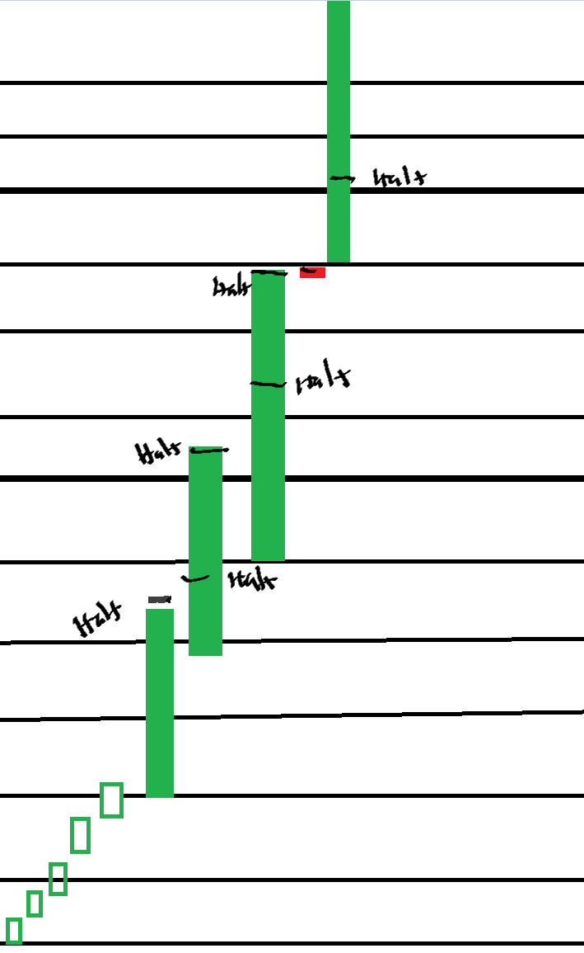
Expect many halts during this period these are absolutely normal and expected
PART B: THE PEAK
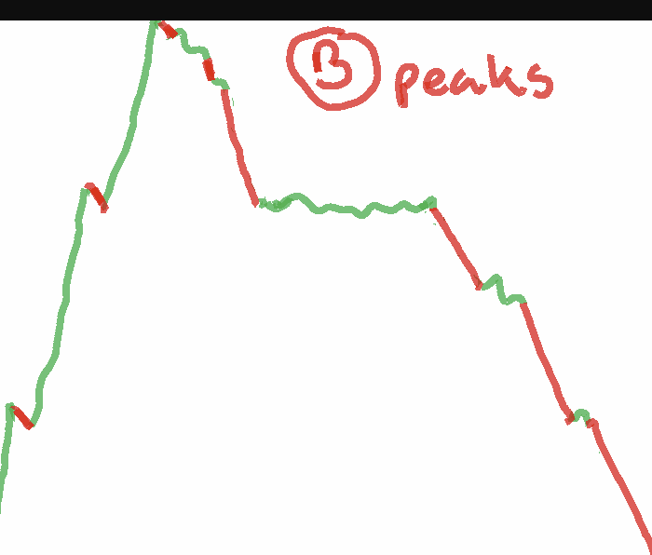
The Peaks
As all good things, even the Margin Call must come to an end at some point. So, how can this be
identified? The first thing we will see is fewer halts and decreasing volume as we approach the peak.
Some selling should be seen in here as holders attempt to time the peak. Large upwards movement,
some selling, another upwards movement. After looking at VW (2008) and GME's small squeeze in
January, I feel the breaking of the peak will be marked by a series of descending dogi's. Think of this as
little booster rockets easing our descent onto the moon. decreasing in volume as apes finally begin their
moon landing. Then patterns of large sells and smaller ascending candles. Lower highs, and lower lows.
This is when an exit can start to be planned.
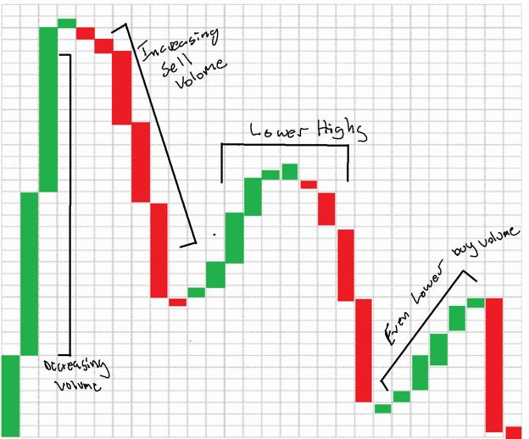
A period marked by decreasing volume, lower highs and lower lows. You will have time to confirm this, This is not the time to be
impatient.
Given new information that has come to light since I wrote the original DD. I do believe that this stage
will begin after the SI% has dropped to near 100%. So at this point I think that SHFs or their
Insurers(DTCC, FED, etc...) will have covered via institutions and other holders all but the remaining
retail positions. This entire stage is defined by apes negotiating power as we should be able to choose
the price from here on out. This is where the all that hodl'ing pays off. Furthermore the length of time we
stay in these peaks should be defined by the retail ownership, the longer we hodl the longer it lasts.
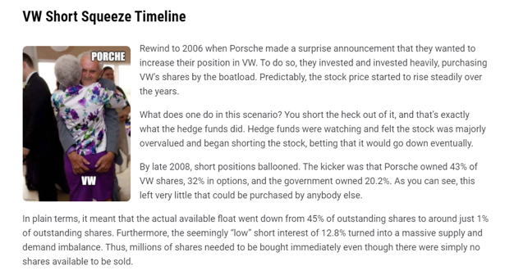
Apes are the Porsche/Government in the GME squeeze except we own more of the float and the SI is way, way higher...read this
twice
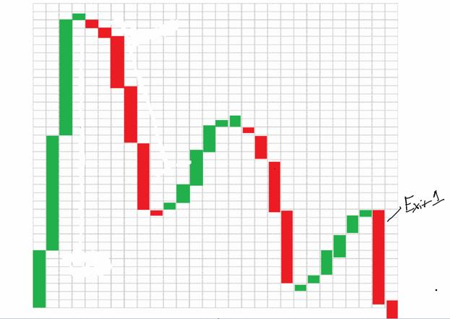
This is the first verifiable exit point at the apex of this wedge confirming a downtrend on the next candlestick. This is only the
first of these patterns to play out.
Several of these patterns should form as we remain in the peaks BE VERY CAREFUL HERE as selling all
of a position at the first sign of a wedge forming can reduce potential profits. Why? Well because this
wedge that formed above could break up.
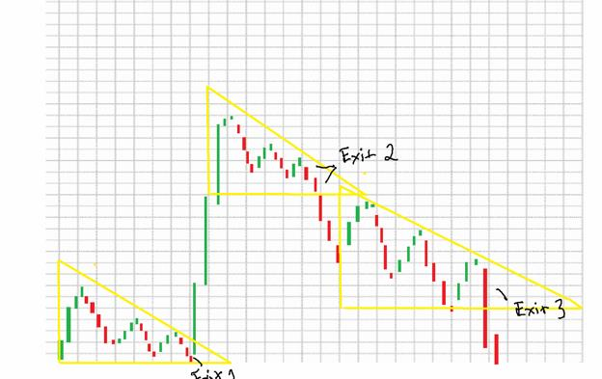
Notice how after Exit 1 the price broke upwards. This is why it is less profitable to exit an entire position all at once. It's much
more beneficial to slowly back out of a position at several points so as to maximize profit.
As this pattern continues eventually we will see larger and larger price decreases as each wedge breaks
down and shorts are covered. This action will mark the beginning of the next phase.
PART C: CORRECTION
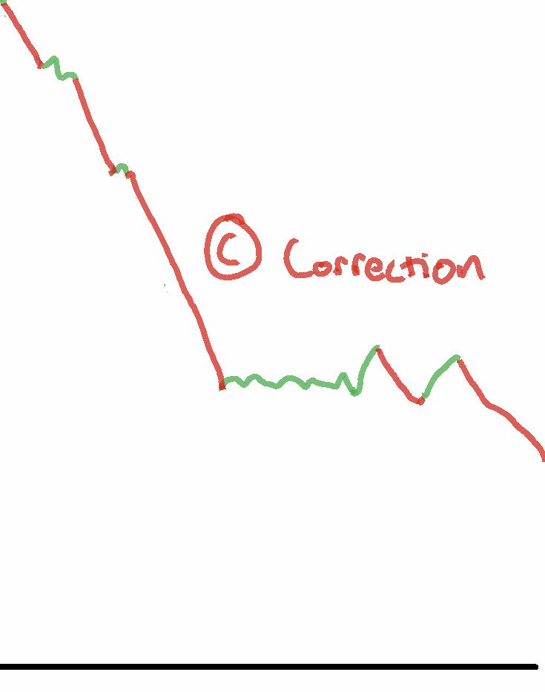
This stage will be easily verifiable as massive decreases in price will occur between halts very similar to the Margin Call stage but
in reverse this is the last opportunity to exit remaining positions at high amounts.
As the larger and larger price drops pick up steam, there will be more halts. Once these large sell offs are
confirmed this is the point at which you hope all your positions are closed (I will be holding 10% forever
so the x and xx apes can maximize returns, and morbid curiosity). We are returning to earth so we can
spend all the tendies we picked-up on that moon landing. The price will begin it's descent back to levels
previously traded at and possibly lower. This could be the last dip-buy in GME's history. If you are long
GME as I am, this will present an opportunity to get back in on a company that I believe has a bright and
profitable future.
Part II: Execution During High Volatility
First I would like to address the issues that can arise during a squeeze, some of these may have a greater
effect on retail investors.
• Delays - volatile markets are generally associated with high volume an this can cause
delays in execution. As online traders expect to sell at near the price listed on the screen,
remember this isn't always the case.
• System Issues - Everyone is familiar with this, as many online investors had issues in
January. Sometimes the system is overloaded. Investors may have difficulty accessing
their accounts as traffic ramps up. Remember that if you experience these issues
many brokers offer alternatives such as phone trades or live brokers to help
facilitate order execution. I urge people to investigate your brokers options now,
to best prepare for this.
• Incorrect Quotes - Even the best real-time quoting systems fall prey to this. I like to
think of it as lag in video game. The size of the quote (#of shares at a certain price) can
change rapidly, affecting the likelihood of quote availability.
• Algorithms - Algorithmic trading can actually exacerbate volatility. There is a nice
article on it here for further reading.
So, how do we navigate this?
I don't think there is a perfect answer.
If any human could time and predict volatility perfectly they would be exceedingly wealthy, we wouldn't
have automated almost all of the financial markets, and I wouldn't be having this conversation.
Like most things, the answer lies in learning.
I truly believe that the best way to understand something is to turn information into knowledge. When
you have knowledge of a thing, it is harder to be surprised, as it will already tie into knowledge you have,
giving you a basis for understanding.
The system for this type of learning is called the Feynman Learning Technique. I have attempted to use
this in all my DD up till this point, and will continue to do so.
The best way to address most of these tense questions is to give people knowledge and understanding.
That way, when faced with the actual issue, they will be able to address it with confidence that comes
only from understanding.
So here are the order types and their pros and cons.
• Limit Order - A limit order is an order to sell a security at a specified price or "better"
• Market Order - An order to buy or sell stock at the "best available" price
• Stop-Limit Order - A conditional trade that combines features of a Limit Order with
the risk mitigation of a stop-loss
• Stop-Loss Order - An order placed that converts to a "market order" when a set price is
reached
I suggest that everyone read these links this is important information to understand. Also this one.
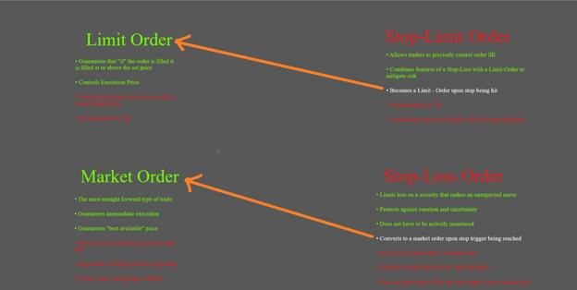
Pros and Cons of Each Order type. This does not reflect best use during MOASS.
This is simply to illuminate a confusing topic. Hoping that the knowledge of the order types will best
prepare people for using them appropriately.
As each one has their place.
Part III: Position Breakdown (New)
How does one break down a position instead of exiting all at once.
This is a question I get asked a lot and the answer is pretty straight forward. I think it applies to every
position size whether your x or xxxx it's irrelevant.
You want to maximize your number of available exits above your personal floor.
So here is an example an ape. The ape has 11 shares and a personal floor of $12M
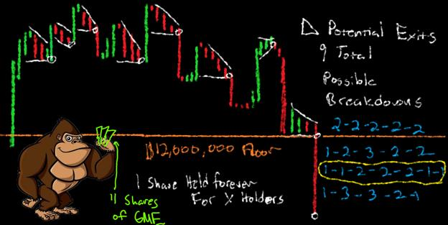
The best breakdown is highlighted as it creates the highest possible number of exit points, This same strategy applies no matter
the size of your position. You can break it down by whole numbers percentages whatever you want.
Everyone should practice breaking down their own positions. Take some time to figure out how to break
down your own position most effectively.
My breakdown is:
5% - 10% - 15% - 15% - 20% - 15% -10%
and then holding 10% forever
Part IV: Conclusion
I hope this helps everyone get all the information I've put out in one place. If I add any addition exit
information it will be posted here as well and I will keep this post pinned to my Profile until after
MOASS. If you guys have any questions feel free to post below as always I will try to get to all of them.
If you want to see more information on this subject matter feel free to join me in the :
Daily Live charting on r/Superstonk from 9am - 4pm EST on trading days
On YouTube Live Streams from 9am - 4pm on trading days
Or over on the Discord
or for memes and other fun stuff on r/dillionaires
As always thank you for the support
🦍❤️
- Gherkinit
* For those that only read the first paragraph. I in no way endorse day-trading of GME not only does it
present significant risk, it can delay the squeeze.
*This is not Financial advice. The ideas and opinions expressed here are for educational and entertainment
purposes only.
No position is worth your life and debt can always be repaid. Please if you need help reach out this
community is here for you. Also the NSPL Phone: 800-273-8255 Hours: Available 24 hours. Languages:
English, Spanish. Learn more
Back to Table of Contents
AndrewMoMoney Used My DD In A Live
Stream Ft. Shill Sniffing Dog And Deleted My
Comment, So I Analyzed His Channel
DD 👨‍🔬
Edit: I can't believe...I spent all weekend writing this... only for you guys... to react... the way I expected
you to! How exciting!! pulls up soap box So alright y'all, now that you're all here, let me make a brief
comment before I go to bed and I'll see you later if the mods allow it. I see red flag, I investigate, I report
my findings. You can agree, disagree, or anything in between and I will not lose a wink of sleep. What I
DO care about is some sweet little chimp has more resources to make their own decisions regarding the
media they buy into during arguably the most important event in their life via a case study. If you think
this is just about Andrew, you're missing the point but I still love you very much. Sound fair?
Edit2: oops; sorry guys. Had to come back and ask y'all to try to keep your comments fairly respectful. At
the end of the day, he's just a content creator. Like me. Like you. In this post I give him credit where
credit is due and I don't hate him whatsoever, I talk about things that are trendy OUTSIDE of him, and I
also make some suggestions on how he can remedy most of your concerns! Also if you think I'm losing
sleep over a comment... have you ever...had a toddler? Anywho.Happy reading. This goes without saying,
but y’all really need to do your own research and take everything you read, watch, or listen to with a
grain of salt. I don’t care who the source is and how much you trust them. So, let me give you some
friendly advice using my research to back me up: Stay away from AndrewMoMoney during the
squeeze.
Edit3: you ask for an alternative, here it is.
Andrewmomoney has been trying to leave a comment, but can't because of karma. You can find a
response copy pastes below. I'll be in contact later.
Disclaimer: I’ve mentioned before, I’ve been working in the design and marketing field for many years.
As such, there are often things I’ll talk about as if they’re common knowledge or I’ll explain them as if we
were good ol’ friends sitting around the campfire. That said, I’ll do my best to provide every single
resource. If I’m missing something critical for your understanding, just let me know and I’ll do my best
to provide. Moving on.
https://www.noxinfluencer.com/youtube/channel/UC23emuGbNM7twofQIrEgPBQ
Have you tried to start a youtube channel? Or a business? Yeah? Almost everyone I know has too. A
majority of the people I know have gotten as far as making a cover photo, a banner, the about, and
maybe ONE video. Then poof. It’s gone. They lose motivation. This tends to be the case for a lot of
people and the easiest way to combat this is by having a plan. You sit down and figure out who you
are and what you look like, what you do, who your audience is, why you’re better than everyone else,
and how you’re going to deliver the goods.
You’ll create some things like a business canvas, a marketing strategy (which will include your voice and
tone), and a content calendar among many other things. Here are some quick reads before I dive deeper:
• Creating a business plan
• Creating a business canvas
• Content calendar
• General tools
• Tone and Voice
Got some knowledge under your belt? Great. Too busy eating crayons, great. I’ll explain in layman’s
terms anyways.
I like to check out some analytics and watch content periodically throughout the channel’s history so I
have a better understanding of the initial strategy, how its evolved, as well as if there are any catalysts,
etc, etc.
Andrew’s channel was created April 7th, 2020 and formerly titled Data Leap. His bio:
“As a 26-year-old cryptocurrency data scientist in Silicon Valley that built 9 streams of passive
income in 2020, I want to help you find your own path to 6 figures in 6 months. Subscribe to keep up
with weekly uploads, cool kids are all doing it. Let's leap together.”
Since it’s important enough to be in his bio, I think it’s critical for me to understand what a data
scientist is. I did some research, I liked these videos (Joma Tech and Ken Jee. Check out the description
box of the latter for some key points), but I still found it to be unclear. However, I think it’s fair to say
that there will be a lot of CODING on this channel.
This is obvious in his earlier videos. I’ll give you a few examples.
https://preview.redd.it/3ai6k3t5dgv61.png?width=1094&format=png&auto=webp&s=666c9695a160e
60744c33c886ad9e5a2fccd06ab
Pretty on point with what we can deduce from the bio. His tone is pretty casual, yet sophisticated. He
wants to entertain you while putting some wrinkles on that brain. I'd say I nailed this because Andrew
says the same thing in a later video.
Now I take a look at how often he posts. Here are the dates from his first couple months:
• June 22
• June 26
• June 29
• July 7
• July 13
• July 16
• July 22
• Aug 3
• Aug 8
• Aug 10
• Aug 14
• Aug 17
• Aug 24
Now, this might be my low blood sugar talking, but man, this tight production schedule is making me
queasy. That’s a lot of videos in a short amount of time and you’ll notice they’re often just a few days
apart.
One of the most common questions someone will ask is what they can do to grow their channel. Usually
you turn to them and ask how much they’re posting, what they're posting, and when. Rule of thumb,
quality over quantity, but consistency is key. You put out one really awesome video every other 6
months, you get buried by the algorithm. You put out 20 videos of garbage and you get buried by the
algorithm. Most end up putting out 1-2 videos a week, but that won’t guarantee a bunch of subscribers
or a ton of views. Generally, you give them something of value and consistently provide that same
value to incentivize them to come back to your channel.
For example, I’d like a new kitchen table and the current trend is just my type, but I’m unwilling or
unable to pay such a high price for someone to build it for me. I’m willing to learn how to DIY and can
buy entry level tools to do the job myself. I turn to youtube and find a channel dedicated to simple
DIY builds with minimal tools. They explain the process start to finish very well and my table turns out
awesome. Turns out they have more videos! I decide to stick around and subscribe. Thousands of
people out there end up subscribing for the same reason..
https://preview.redd.it/2v41gaf2egv61.png?width=1148&format=png&auto=webp&s=a0f614c1423c9
47ea04e152ba82fe4fa9ab74ed5
It’s not always like that though. You ever seen the video of the lady making nachos with her bare
hands? What about the potato chip mashed potatoes? That person who thought they were a chicken
nugget? Some things are so silly or stupid you HAVE to watch it and tell your friends or leave a comment
letting everyone know how stupid they are. You may or may not subscribe, but you still hang around to
see what other silly thing they’re up to. Some people become successful by being controversial.
https://preview.redd.it/k9895hr9egv61.png?width=576&format=png&auto=webp&s=d73baaaf239189
4a3e2088b57f48bc3064da2637
And even then, it’s not always like that! What about the videos about stray puppies and kittens that
find their forever home? Military coming home videos? Helping the homeless? Y’know, the things that
pull at your heart strings?
https://preview.redd.it/i8c3bcpgegv61.png?width=986&format=png&auto=webp&s=d30dd5ee969b4c
9e607ee2e395fcf7eba92e47bd
See what I’m saying? Multiple ways to skin a cat. Just be consistent.
Andrew uploaded fairly consistently and did the usual tips and tricks with thumbnail art, titles, etc
(being click baity, but hey, I think everyone does that from time to time), but I noticed he still had very
low viewership and engagement. Why is that? Ultimately, a combination of things. Check out his bio
again, check out all the banners and video descriptions (I have to speculate just a LITTLE here and
assume he didn’t change anything recently), what do you see mentioned everywhere?
“Your guide to 6 figures in 6 months”
https://preview.redd.it/re52l6hnegv61.png?width=950&format=png&auto=webp&s=7842232cdd95f1
85672ccafa3b7bc29e2b97d975
Rapid fire answer. Do you think his channel matches that sentiment?
Here's mine: not really. I’ll give you an example of a channel I found from searching “6 figures in 6
months” :
https://preview.redd.it/ugflhivregv61.png?width=1202&format=png&auto=webp&s=2d44bdea196301
e0e124735c70d3ddf4af46da9a
Seems to mesh better with that idea, doesn’t it? One thing Andrew mentions in this video is that
starting a business can help you make 6 figures, but doesn't provide resources for running that business
on his channel. Sure, Andrew has more subscribers. I’ll give you that for now (come see me later though.
We’ll talk).
So then you start looking at the content and figuring out what it's actually about. Andrew starts making
videos centered around Python. There’s a few random videos in there, but he sticks to the code in the
beginning and I applaud him for not jumping with random videos when his channel didn’t pop off
immediately (and that production schedule is just crazy). Some hit better than others--it’s fairly obvious
when an influencer has found something that hit right because they’ll keep doing it. Then bang. The
channel evolves and we start hitting the clickbait.
https://preview.redd.it/k4q34ff7ggv61.png?width=992&format=png&auto=webp&s=9aad68c5749f87
1c307416f355b2c693b6f0bcb0
3.9k views on this video. Pretty damn solid. Then you'll notice we start sliding back down to 100-500
views per video immediately after until we hit another (what I like to call) viral video and that’s where
you’ll see a key difference between Andrew’s channel and Nate’s. Nate’s lowest viewership is 4k. Nate
generally has more substantial comments on his videos. Do you see where I’m going with this? More
subscribers isn’t always the best indication of success. Thanks Nate, you can go now.
https://preview.redd.it/ly4vl8bofgv61.png?width=1189&format=png&auto=webp&s=40c74ce394d257
0b3e47da6524e1181855fac0c9
So it seems like Andrew’s channel is more so centered around how you could land a 6 figure job or
increase your income to 6 figures… but likely not in 6 months and maybe not 6 figures. The content just
isn’t there... there isn’t a clear set of reasonable directions for the audience regarding how they can do
that in SIX months in his channel.. Consistently. Yes, emphasis on consistently. I’ll give you credit for
some of these earlier "on-target" videos although I CANNOT confirm how filling they are in relation to
the channel proposition:
• How to be a Millionaire by 30: Build one of THESE in 2021
• My Very First Job Offer was $100K+ (and so can yours)
• How I Built 9 Income Sources at Age 25 (and you can too)
• $100K in Passive Income in 2021 - Making Six Figures on Autopilot
By the way, y’all ever heard of Dr. Quarters?
https://preview.redd.it/5pmtr2p8hgv61.jpg?width=480&format=pjpg&auto=webp&s=97aa58581b681
e022d0e9065ffe87c042fef8ddb
I’ll keep it simple. This episode of King of The Hill is based on a real guy and a real trend that was more
popular (or perhaps, just popular in a different form) when I was kid. These people sold the idea you
could get rich quick with minimal effort (essentially click bait). Needless to say, it backfires and Kahn is
stuck in a bad situation, still working at a job he hates. He got off pretty easy in the show. People in real
life? Eh.
I’m not calling Andrew a get-rich-quick scam artist. I think he has some interesting videos of value,
but I do think his content is a little off kilter and he’s not delivering what he claims he can do for you.
Normally, a channel will fall off the radar because of this..
But then, there was a catalyst: Gamestop.
Remember how I mentioned you can see his videos hang out around relatively low views and once he
creates something people like, he keeps doing it? This is a fairly common practice so don’t come with
your pitchforks ready. Think about it like this:
Miley Cyrus has pivoted multiple times throughout her career. Madonna. Gwen Stefani. Taylor Swift.
Katy Perry. Kanye West. Pink. Y’all know 'Hot in here' by Nelly? What about his other hit 'Over and Over'
with Tim McGraw?
Nothing new here. This has been happening since before you were born.
never forgetti mom's spaghetti
There are a few problems with this pivot though. Andrew was missing his proposition value to his
viewers already and he’s further pivoting from it--this can affect how trustworthy and consistent he
seems. I’d say this is relatively minor and easy to fix.
This becomes a much larger problem when you examine how the content has evolved from the first
GME post. I have a specific word I’d like to use, but I’m going to abstain. Let me just talk about the video
and see if you see what I see.
https://preview.redd.it/5op9u4l6jgv61.png?width=946&format=png&auto=webp&s=25ecb51fbc2766
64fee6f7a3cd9bad3bbfaafbba
The first video was published February 1st, 2021. This is post January baby squeeze. It gives you a nice,
simple explanation of the Reddit vs. Wall Street situation, and basic trading concepts. This is an entry
level video. This is not for the folks already in the game. In my expert opinion, I’d describe this video as
targeting the FOMO crowd who saw the news, said “fuck, I want in” and searched for a video from a
trusted source (and the use of his job title in the video is very intentional. His channel name has changed
by now too) who could explain in 10 minutes or less.
Good results. Can he do it again?
https://preview.redd.it/4fecb7nfjgv61.png?width=958&format=png&auto=webp&s=5cf9ab03d65312c
4f4d2cb566b7afe01e05c25c9
Yes. He goes deeper into his explanation of the situation and the market as a whole and drops more
resources for beginners like links to trading apps like Webull or Robinhood. Yes, Robinhood. Even after
it had been put out there they had halted trading. He removes this in later videos but it can still be
found in the description and pinned comments of older videos. Do you think he isn't getting
something from that?
https://www.youtube.com/watch?v=a8AJNOYKkqc
https://preview.redd.it/0cptbbozsgv61.png?width=887&format=png&auto=webp&s=770a20bc41a180
446ff4ca024c143ecbd7506753
Within a week or so of posting, he hits 5k subscribers. By March, he hits 20k. By April, 70k. That’s some
aggressive growth. Of the 100+ videos that have come out since the OG video, I’ve counted ONE
that caters to his original audience. That’s fine, people are allowed to change, but you have to update
your brand. He hasn’t though. Nothing besides *looks at notecard* editing his original video descriptions
and pinned comments to include affiliate links to anything pertaining to GME, language such “tendies”,
“apes”, “moon”, “moon platoon”, and “space upgrades”. Even his first video that came out a year ago.
So pretty much everything to make money.
(And I have to throw in another disclaimer, I don’t know Andrew personally and he seems like a pretty
cool dude. This isn’t an attack on him for playing the marketing game. This post is just for you guys to
remember there are good shills and bad shills and everything in between. The human brain is more
fragile than you think and very susceptible to manipulation especially when emotions are running high. I
remember when I started investing I listened to every account out there instead of doing my research.
Within 5 minutes I bought a stock, read something, sold that stock, and bought another like a true
crayon muncher.)
The videos become more click baity as time goes on. Remember that one video I mentioned in the last
paragraph? You’ll notice a significant dip in viewership. When I talk to my friends about being an
influencer, I tell them that while it might seem like a great idea to hop on a hype train to collect
some followers, it winds up being very difficult to keep those followers. Why? Because they
followed you for x, not y and you can see that here. Increase in views. Increase in engagement. Increase
in subscribers. Nice. Back to business. Uh oh. Didn’t do so well. Back to Gamestop.
https://preview.redd.it/aj5hjntltgv61.png?width=1120&format=png&auto=webp&s=fd646e4fceb2d3a
3747a57f17e725ab30315d7aa
So now you’re stuck in a cycle of HAVING to keep making videos about this topic if you want to maintain.
That’s how we wind up with videos like “Should I sell Gamestop?” (multiple times), thumbnails with
words like “crash”, “you lose”, or “game over”.
Again, I stress that the target was the FOMO crowd, the baby chimps. They don’t know any better. They
need someone who doesn’t hurt their brain, keeps it short, and funny. Do you see how all the above is
dangerous for them as we move forward?
Put it this way.
Using a recent video at 68k views (and every single one of them is a new viewer).
If all of those people are holding 100 shares that’s 6,800,000 shares total.
Imagine he uploads a video mid squeeze with a title of “$GME PEAKS AT $5,000??” with a thumbnail
with something like “highest it can go?” or “game over?”
Everyone is emotional, they’ve never seen this much money before. They freak the hell out. They don’t
want to lose that money. They paperhand at $5k. $GME briefly dips before skyrocketing to $20k.
Dangerous for stockholders. Dangerous for him and the future of his channel.
Let’s go back to trust. He’s not currently fulfilling his value proposition. He creates click bait videos.
Doesn’t give credit to the folks who provide him video content (links to atobitt's biz, but not the artist
of this or Pixel's Endgame DD). Half-rebranding to make it seem like he’s a fellow ape...
https://preview.redd.it/ed7d604xtgv61.png?width=1440&format=png&auto=webp&s=25fee894f682a
7b8565a49536cb90b5f78f8585c
Honestly, he might be an ape.. The problem is he doesn’t come across genuine because of the above--
what are you willing to compromise for views and $$? Quite a few people have made comments
mentioning he doesn’t appear genuine. Some people have jumped to his defense that he’s accepted
feedback and is changing some things because of it (no idea what though, but then again I don't watch
his channel regularly... then again... I'm a pretty good guesser) which brings me to my next point.
He’s not changing.
The clickbait is still there. I mean, how long have we known options were a no no? Recent video with a
title that suggests options are some secret ticket to tendies (because options traders know something
we don’t?). He is still missing his value proposition. He is not giving written credit to folks providing him
with information.
https://preview.redd.it/4a1hno7augv61.png?width=217&format=png&auto=webp&s=16117ccbe99d5
65bfaf35668d757850aef2eb8d9
I also found out he used my DD in a video, which was pretty cool. I didn’t know a lot about him
besides watching people bicker about him on the sub, but I never personally watched. Decided to check
it out.
that me
Honestly, I was so disappointed. Not only in him, but shill dog as well. What I emphasize to
EVERYONE is that we better be about our shit. You know you’re doing an interview? Brush up on your
public speaking skills. You are making history and you never know when the camera is rolling. If you
ho-hum, seem unsure, or lie, the audience will know. The media will eat you alive and you destroy the
credibility of the sub. You never know what opportunities will come from this either. Be like DFV. No
excuses. My inbox is always open if you need help preparing for these things. Anyways.
It bothers me how big of a joke this came off. It bothers me how suspicious I was of Shill dog because of
how they handled the interview--what a massive platform to be on and...woof. It bothered me when I
read a comment that said NEITHER of the people talking in this video seemed genuine.My name is
attached to this. That’s my research. My integrity is everything so I felt a need to reach out to Andrew.
Maybe I could come on and discuss in a way that would make people feel more at ease. I messaged on
twitter, radio silence. I expected that though, no big deal. Next step, bring out my old youtube channel.
Check privacy settings. I leave a comment and go to bed.
I wake up the next day expecting a comment or a like based upon how recently he interacted with other
commenters.
My comment is gone. I wondered if I just hadn’t actually submitted it, but I was so sure I had.
Immediately became sus, but I don’t make claims without proof. I painstakingly type up the same
comment. Gone within 10 minutes.
go see if it's there
I log onto another channel. I leave a comment praising him. Still up to this moment. I won't screenshot
that one. Just take a guess.
That tells me everything I need to know.
Bonus: I found the reveal of his offer to shill odd. Many people were skeptical as well, asking why he
blurred the information out the way he did, why talk so briefly about it, why not put the company out
there, etc. So I’m gonna pull a Warden on you guys: It’s either fake, it’s real and he didn’t take an
offer, or it’s real and he took an offer.
It was a live video. Often you don’t have yourself as put together as a scripted video you can reshoot and
watch and edit and tweak and so on, but I want you to notice he never said he wouldn’t take an
offer. There was just a funky transition that he would have shill dog in the live stream to keep
him straight. If I'm just being a skeptic and he gets upset by this because it's not true, that's on him for
allowing his viewers to doubt how honest of a content creator he is.
TLDR: A majority of you will say you don't care about Andrew and never have and this is all stuff you
already figured out, but there are some apes out there who still view him as their first source of
information and you are only as strong as your weakest link. Through a brief analysis, I've shown the
foundation or lack thereof behind this channel and how AndrewMoMoney's channel is positioned
for maximizing earnings through sensationalism. Sensationalism is a cheap way to grow your
channel, but you will lose it all unless you adjust your marketing strategy and value proposition.
This type of channel is potentially damaging for the squeeze. I strongly urge you to consider what
media you will surround yourself with when this lifts off.
While I have you here Andrew, might I make some suggestions? I don't like plain criticism. We do
constructive feedback around here:
• Interview the people who write the DD you discuss. All of them. Not just the
"celebrities".
o Use these interviews to supplement what you don't know instead of
reading straight DD.
• Make a video for your OG subscribers on how they can use GME as a catalyst for their
careers--even if that's just having the extra tendies to go back to school or coast while
they figure out their life.
o Make a video that helps apes manage their tendies--like "how to find a
CPA", "how to pick a lawyer". You don't even need to pitch it as original.
Give credit to the person who posted first, say it's a video adaptation,
boom.
• Stop deleting negative comments and use them to your advantage.
• Cut back on the click bait titles. You can optimize your title for the algorithm AND give
your viewers a clear understanding of what the video is about.
o Write what the video is about in the description.
• Get back to engaging with your subscribers like you did in the beginning.
• Think about the social and economic repercussions of the content you're publishing.
• Wait don't take these, they're actually pretty good I might use them
Please excuse typos or grammar as my eyes are burning
Back to Table of Contents
OBV and Beta definitively show that the price
is heavily suppressed and that GME is the
ultimate hedge against market volatility
DD 👨‍🔬
Hey there, dildos and dildettes. I normally keep my DD to myself and my friends, but if I can convince my
cautious anchor to reality that GME is going to the moon, maybe I can help you do the same.
If you don't have someone keeping you grounded and real, you should. Fiery passion only beats cold
hard facts in Julie Garwood novels and succubus hentai.
OBV
OBV = On Balance Volume and typically it follows the price movement closer than Citadel interns follow
this sub for the latest image of Kenneth as an alien covered in nipples. (You fuckin weirdos)
Here's the OBV on some stocks that mean something to normal bipedal hominids:
FB
NIO
AAPL
SPY
Very clearly you can see that the price movement and the OBV need to get a room. Now let's look at the
OBV of GME. It should have the same line as the one on your RH homepage right?
DatBoi OBV
Fuckin WRONG. Now I know what you're thinking:
But u/OverlordHippo how can you call us dildos when you didn't even crop your screenshots.
Blow me, I just realized it and I'm not redoing it.
So, what's the formula that turns numbers into lines here? Come on now, let's not pretend you'd
understand it. Think of it like this though; There are daily posts showing the buy/sell ratio being a win
for the Apes. The OBV confirms that.
What does this mean? Look at the GME picture again and imagine the price movement continuing the
way it should have without the good old fashioned HF fuckery. It looks like it should be sitting around
$550.
That's $550 without any shorts covering. Shorts covering equals = buying. Buying = price goes up. OBV
shows buying is dominant, yet price goes down = shorting enough not to just stop it from going up, but
to push it down significantly. Tits = Jacked.
Beta
We're not talking about your personality here. We're talking about a stocks relationship with the rest of
the market. The market beta value is hard set at a value of 1.
If a stock has a Beta value greater than 1, it's price will move in relation to the market's movement, but
to a greater degree. If a stock has a Beta value lesser than 1, it's price will still move in relation to the
market's, but to a lesser degree. It's rare, but a stock can have a negative beta, which means that it has an
inverse relationship with the market.
Most stocks hover around the market value. Best buy is 0.82, Amazon is at 1.11, that sort of thing. The
stocks within the market as a whole typically move together. You see those posts with all the red
squares when the nasdaq has a shit day. Good days and bad days evened out and extraneous events
aside (like some CEO gets caught on a zoom conference with a fleshlight/nipple clamp combo in his desk
drawer shaped like a scorpion) the market moves in tandem to the stocks that comprise it.
Here's some boomer piece talking about how stocks with low Beta are a great way to hedge your
portfolio against market volatility.
Lowest 5 Beta stocks of the S&P 500
In there you'll find such classics as Johnson and Johnson and Proctor and Gamble the kind of stocks that
are less exciting than re-uploading screenshots that you forgot to crop. The point being that the lowest
Beta of the SPY is Walmart at 0.36.
That's the extreme outlier of stocks considered relevant.
Here's GME
-5.62... Not just 0.069, not -4.20, but -5.62.
Basically the market could implode and GME is going surfing the waves of the tears of everyone who
doesn't have some. Someone should buy an ad on NPR or a commercial during MASH reruns about
hedging your portfolio with GME against market volatility. Our granpappy's will be burying shares of
GME in the woods behind their houses and shit.
Are we the boomers now? I fuckin guess so. It's going to be hilarious saying:
You should've hedged properly against this volatile market by buying something safe like GME.
So there it is. Data driven proof of price suppression and certified boomer approval of portfolio hedging
strategies against market volatility all wrapped into one tasty package.
Summary/TLDR
OBV and Beta definitively show that the price is both heavily suppressed and that GME is a safe haven in
a volatile market. Not only are we correct in our reasoning, we're in a financial lifeboat rowing away
from the sinking Titanic that is the market.
If that doesn't convince the skeptics in your life, then name your yachts after them or something.
TLDR for those who can't read
🚀🚀🚀💎🤲💎🍆🐜🚀🚀🚀
Edit: Lots of dildapes out there twiddling their neckbeards and saying things like
OBV and Beta can't be used to predict price movement, they're made up of data from previous price
movements.
Congratulations, you just described literally all of technical analysis. No shit it's made of data from the
past and present. It's not like it's made up of data from the future, McFly. MACD, RSI, Stochastics,
candlestick patterns, and the skidmarks in your briefs are all entirely comprised of prior movements
and used to predict future movements. Even the skidmarks. HELLO you already almost shit yourself...
Are you going to try and sneak out another one?
Edit Part Deux: I see a lot of different Beta values being posted from different sources. Yahoo Finance
shows -1.94 and the Bloomberg terminal shows -bazillion. Which is it? As some have said, some sources
don't include AH trading, so who knows. It's probably something closer to zero than the overpriced
boomer machine that runs Windows '69. But, with information as it is for us lowly peons of the financial
world, who tf knows. You can bet your Shrek box set on the fact that if even Yahoo Finance says
it's pretty bad, it is really fuckin bad.
Back to Table of Contents
Over 30% of GME bananas are missing from
Bloomberg Terminal. Over 69% of GME is
trading off exchanges or in an unreported Dark
Pool? It's National Banana Day - Do you know
where your GME bananas are?
DD 👨‍🔬
So yesterday I posted about FINRA ADF showing up as the primary exchange for GME trades over the
past 6 trading days (and likely much longer). The thing is, FINRA ADF is not currently in operation...
https://www.reddit.com/r/Superstonk/comments/muzj4o/finra_webmaster_no_brokerdealers_curren
tly_using/
u/koreanjc had a great post about this a little over a week ago FADF - A Dark Pool
While looking into this, I realized that the GME Bloomberg Terminal data is missing between 31.4% and
38.9% of GME daily trading volume from 4/13 - 4/20.
That's 19,411,389 missing bananas over just 6 trading days. Only 70 million GME-issued bananas are
supposed to exist...
If you add up the total missing volume + ADF volume, you will see that over 69% of GME bananas are
being reported as trading off exchange (FINRA ADF, which is reportedly not in operation - again see my
post from yesterday), or completely missing (a deeper, darker pool that even Bloomberg can't see?).
40,126,778 GME bananas were traded over 6 days, and even Bloomberg, which costs $24,000/year,
has no idea where they are.
I'm not a finance guy, or a stock guy - I'm an ape. I can't really do math, but luckily Excel does the math
for me.
I don't play options, but if I had call options for 4/16 or 4/23, which are each worth thousands and
thousands of dollars, I would certainly want to know what unknown entity is keeping the price of GME
at this $160 threshold by hiding 40,126,778 bananas from making their way to the exchanges.
TLDR - each day, over 69% of GME bananas are either missing, or being routed through "FINRA ADF",
which is not currently operating. Someone is hiding your GME bananas to artificially manipulate the
GME stock price from mooning. The rocket is fueled for take-off. Can anyone find out what is going on
with the missing bananas?
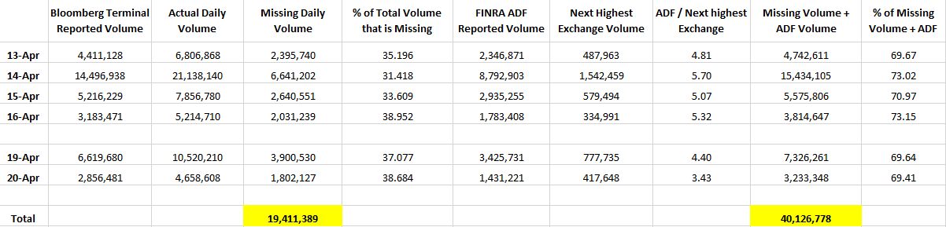
Data from Bloomberg vs Actual Daily Volume. So many missing bananas...
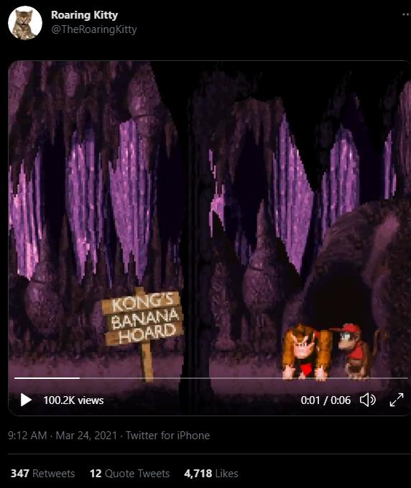
Missing bananas? 3/24 Tweet from DFV (sorry for the Play icon)
DFV Tweet from 3/24

4/22 will be Wild after green reversal?? Had to include it...
DFV Tweet from 4/9
Thanks again to u/Ravada for the daily Bloomberg Terminal drops. All Bloomberg images were taken
from his posts.
Bloomberg Data (just look at the middle of the screen for FINRA ADF and Total Volume):
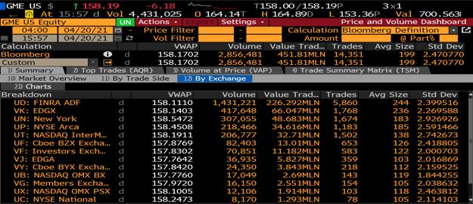
4/20 - 1,802,127 missing bananas + 1,431,221 through ADF = 69.4% of daily volume
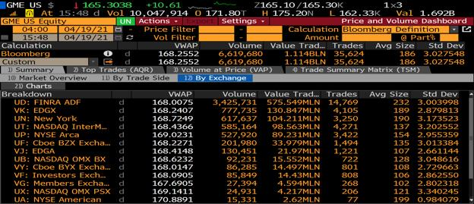
4/19 - 3,900,530 missing bananas + 3,425,731 through ADF = 69.6% of daily volume
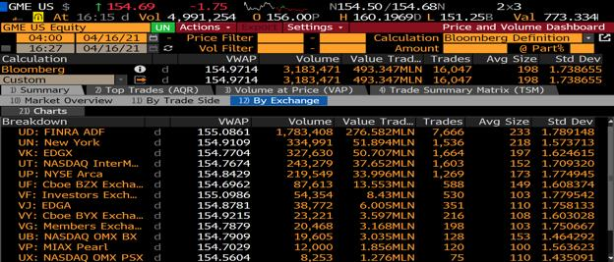
4/16 - 2,031,239 missing bananas + 1,783,408 through ADF = 73.1% daily volume
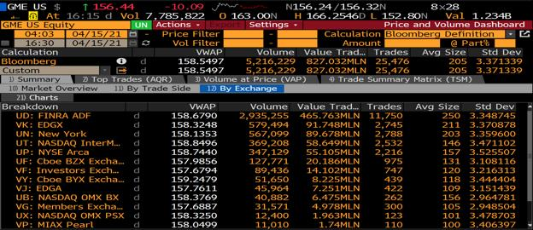
4/15 - 2,640,551 missing bananas + 2,935,255 through ADF = 70.9% daily volume
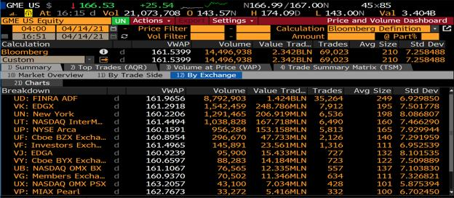
4/14 - 6,641,202 missing bananas + 8,792,903 through ADF = 73.0% daily volume
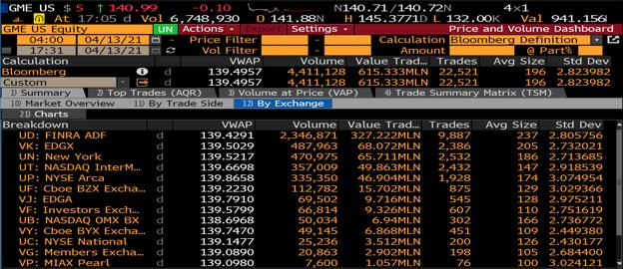
4/13 - 2,395,740 missing bananas + 2,346,871 through ADF = 69.6% daily volume
Edit 1: Daily GME Volume
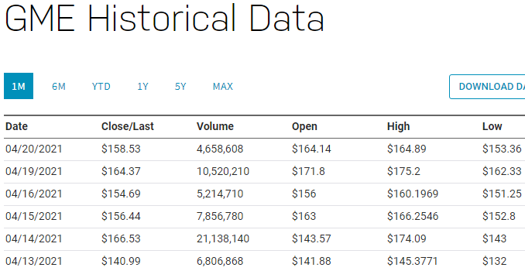
Source: nasdaq.com. Why is the actual daily volume so much different than reported Bloomberg volume? Where are the missing
bananas?
Edit 2: Edited the Excel sheet to reflect the Nasdaq daily volume (I had used a different source, which
had slightly different Total Volume data).
The total missing bananas increased from 19,285,389 to 19,411,389. Also edited the missing banana
data for each Bloomberg terminal to reflect Nasdaq. Thanks u/2008UniGrad
Edit 3: Added Bloomberg Terminal from 4/21 (below) and added updated Excel sheet to reflect 4/21
data (also below). Updated total missing bananas to reflect 4/21 data.
Total missing bananas for last 7 trading days = 20,798,855 bananas
Total missing bananas + ADF for last 7 trading days = 42,644,089 bananas
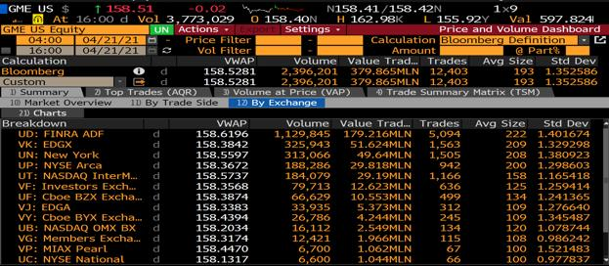
4/21 - 1,387,466 missing bananas + 1,129,845 through ADF = 66.5% daily volume
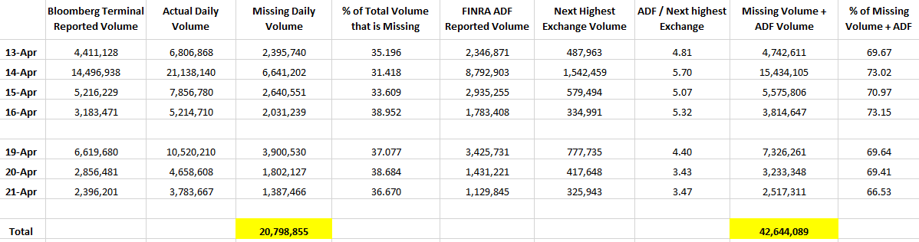
Data from Bloomberg vs Actual Daily Volume. Added 4/21 data to running total from last 7 trading days.
Back to Table of Contents
Citadel has hostages: explaining why the
MOASS is taking so long, how the January
spike was stopped, Robinhood's motives for
the trading halt, and the mysterious silence of
the SEC
DD 👨‍🔬
TA;DR: The January MOASS is delayed because Citadel took hostages. They figured out how to ensure
that others would be squeezed before they were. January 28th is the day Robinhood was required to
deliver some of the GME shares Citadel owed to its customers, so they halted trading. They halted
trading because their relationship with Citadel turned them into a hostage. The MOASS waits until new
regulations ensure the hostages are safe...
TL;DR: Citadel wasn’t going to be squeezed in January, Robinhood was. Citadel took hostages and
figured out how to ensure that others were squeezed before they were. Robinhood halted trading after
GME was on the threshold list for 35 days. After 35 days of failures to deliver, a broker becomes
responsible for delivering the security to their customer. The MOASS is taking so long because Citadel
managed to figure out how to make their short position other people's problem. This is why Citadel
seems to have so many people protecting it and willing to lie for it: they’ve spent six months figuring out
how to ensure it’s actually Citadel that gets squeezed. This is why there is an unusual cooperation
between parties we wouldn’t expect to be able to keep this secret for this long. Not even the SEC can
address this directly, Citadel figured out how to take everyone hostage. The past six months have been a
negotiation to figure out how to deliver our tendies.
Theory: Robinhood halted trading the day they became liable for delivery of the GME shares
Citadel sold to their customers
I think Robinhood halted trading because they were required to purchase GME shares to deliver their
customers' past orders. Look at this requirement from SHO § 242.203 (b2):
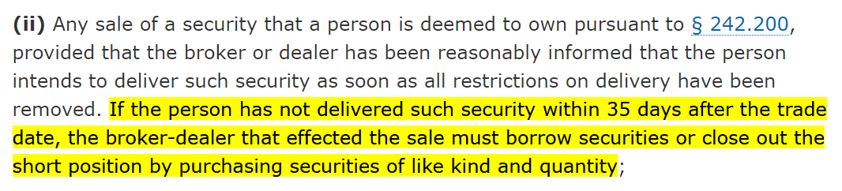
If a Robinhood customer buys shares that are cleared by Citadel Securities, their delivery is not a
problem for Robinhood unless it takes longer than 35 days. Once a security has taken longer than 35 days
to be delivered, Robinhood is responsible for delivering it to their customer. Citadel still has to deliver
the security too, but they deliver to Robinhood. So, the chain of obligation goes like this:
1. Your broker/dealer owes you the security they sold you
2. The market maker owes your broker the security they sold to the broker
3. The seller of the security owes the market maker the security they sold to the market
maker
The key point is that your broker is the one who owes you the shares you buy. If someone else fails to
deliver those shares, it’s your broker's problem (although they have some ability to make this into your
problem, there were too many GME shares owed to avoid their SHO obligations).
(Expanded explanation, boring - you should skip)
So, if I want to sell a share on the market (strictly hypothetical, I’ve never actually tried selling), then I do
not owe the sold share directly to the buyer of that share. I send my sell order into the market via my
broker and they send that off to the market center where the order is executed by a market maker. I sell
my share to the market maker executing the trade. The market maker then sells that share to the broker
of whichever ape has brought it and the broker then sells that share to the buyer. Assuming this goes
smoothly, my share ends up in the account of the buyer. However, technically speaking, I do not owe the
security to the buyer. I owe the security to the market maker, who owes it to the broker, who owes it to
the buyer. So, if something goes wrong, and I fail to deliver that share, I have not defaulted on my sale to
the buyer, I have defaulted on my sale to the market maker executing the trade. That market maker still
owes the share to the buyer's broker, regardless of my failure.
(End of skippable content)
I suspect that Citadel had been failing to deliver GME shares to Robinhood for an extended period, which
is why Robinhood halted buying. Their primary motive was not to help Citadel, but to protect
themselves from Citadel. After 35 days of failure, Robinhood has to buy the shares they expected Citadel
to deliver for their customers. Effectively, due to Citadel’s failures to deliver, Robinhood had inherited
Citadel’s short position. Citadel owed Robinhood and Robinhood owed their customers. I should clarify
that, in this scenario, Citadel still owes Robinhood the shares at some point, but Robinhood has to
deliver them to their customers now. At first, Robinhood didn’t care that Citadel owed shares to their
customers, until it went on for too long and Robinhood was on the hook to deliver.
Proof: the timing lines up
For this to be true, you would expect there to be a relationship between when Robinhood halted trading
and the 35 day threshold. If you look at my recent post on the relationship between the threshold
security list and the January price spike you’ll see that GME was on the threshold list for 39 consecutive
settlement days, from early December to early February. Robinhood halted trading on January 28, which
is day 35 of this 39 day streak. The trading halt aligns with when the obligation for Robinhood to deliver
kicks in. As soon as the undelivered shares became Robinhood’s problem, trading was halted. Frankly, I
would have expected them to halt trading earlier than the final moment, day 35, but perhaps waiting
until the last moment will allow them some legal defense in the court cases to come?
Proof: the weird cost basis after transfer
A number of users pointed out that their purchase prices and dates were incorrectly reported when
transferring from Robinhood to other brokers. I suspect this is because Robinhood initially sold their
users the shares based on delivery promises made by Citadel that Citadel then failed to fulfil. So, after 35
days, Robinhood had to fulfil them instead. My guess is that this process was an absolute mess because it
required Robinhood to at least appear to be purchasing GME shares from someone otherthan Citadel,
which is rather awkward when Citadel is a designated market maker for GME on all major exchanges.
The transaction dates and prices are wrong because the trade that was eventually settled for your GME
shares was not the same trade you sent to your broker - that trade failed and Robinhood had to redo it
after 35+ days.
This might help explain why my analysis of the 605 data found that the proportion of GME order
executions done through NASDAQ spikes in February, despite being almost non-existent prior to Feb
2021. If Robinhood needs to buy-up GME without going directly through Citadel, they’ll need to get
inventive and perhaps even use over the counter purchases. So, go to a market center that has very little
history of executing GME orders - NASDAQ. It’s possible that Robinhood borrowed/brought GME from a
variety of places to cover for the clusterfuck Citadel dumped them with, and then allocated those GME
shares that actually got delivered to customers that transferred. If you had a massive shambles of shares
like this, it might manifest in an inaccurate and messy purchase history for your customers.
Proof: others halted trading too
Robinhood wasn’t the only one that halted trading. It’s difficult, but not impossible, for Citadel to have
orchestrated this behind the scenes. It’s much easier to explain this seemingly organized trading halt by
pointing out that the brokers who halted trading only halted trading when they themselves became
obligated to deliver the shares in question. This is why they halted trading after the price had already
been spiking - my guess is that Citadel was putting on pressure behind the scenes too, but I don’t think
it’s a coincidence that trading didn’t actually halt until the time arrived that the brokers themselves were
threatened with delivery obligations.
Context and discussion: saving Citadel
Notice that my theory does not do Robinhood any favors - this is not a defense of them or their actions. I
suspect, as was claimed during the congressional hearings, the trading halt was the main reason the
January spike ended. If my theory is correct, it’s likely that the ending of the January spike saved Citadel.
This claim is nothing new. What I think my theory adds to the discussion is a better explanation of why
Robinhood and others did this. Remember, the buying halt was a disaster for Robinhood! They were
dragged in front of congress, their reputation is in tatters, and they’re bleeding customers. Halting
buying was not a good play. My guess is that they knew it would be a disaster and did it anyway. I think
that this is why they waited right up until day 35 of GME’s run on the threshold list - they didn’t help
Citadel until the only other option was delivering the undeliverable. In January, those who halted trading
were slated to be the first victims of the MOASS.
Further implications: MOASS is so slow because Citadel has hostages
I suspect that the implications of what almost happened to Robinhood in January are why we’re seeing
some of the recent regulation changes (‘clarifications’). I think that it was Robinhood and not Citadel that
was squeezed in the January spike. Citadel is a market maker with its own market center, it has privileges
and exemptions that make it quite resilient (as we’ve found out over the past six months). Robinhood
does not have the same level of protection from its exposures, once the 35 day settlement mark passed,
they had to deliver shares. It was the brokers that needed to buy shares from the 28th onwards:
Citadel’s failures to deliver were, in the short term at least, the brokers' problem. For all we know,
Citadel didn’t cover any of the deliveries that finally got GME off the threshold list at the beginning of
February and managed to force the brokers to do it for them. If they were willing to abuse the market
enough, perhaps via abuse of NASDAQ in February as my previously linked post discusses, Citadel might
have even used the brokers need to deliver as a way of expanding their short position substantially
while ‘technically’ resolving the failures to deliver (kicking the can down the road to another day). I
guess there is no better ally than one who has to pay your debt if you go under…
So, if my theory is correct, January almost saw Citadel’s failures result in someone else getting squeezed!
Perhaps this is why the trading halt became the focus of the congressional hearings. Maybe this is why
the DTCC has focused so many of their new regulations on clarifying what happens if positions need to
be forcibly closed. January might have demonstrated that a market center, such as Citadel Securities,
could contrive a scenario where they force someone else to be squeezed by their short position!
In my post examining the February gamma, I argue that the bizarre market activity near the end of
February was a failed attempt to begin the MOASS. If my theory that Robinhood, not Citadel, was being
forced to deliver in January is correct, I don’t think it’s any surprise that attempts to begin the MOASS
have been prevented since January. The regulations required updating to prevent Citadel from forcing
others to be squeezed before they were. If I am correct, Citadel was holding everyone hostage. The
embodiment of too big to fail: not just because of the havoc their sudden demise would cause, but
because they wouldn’t be squeezed until after the squeezing of all the smaller parties caught in the
impossibly convoluted web of failures to deliver and rehypothecation that Citadel shat into the market. Lots
of entities were exposed to the squeeze, and Citadel was setup to be hit last.
The MOASS can’t launch until the hostages are safe. It needs to be Citadel that’s squeezed. Otherwise, the
squeeze might wreak havoc on the market with no guarantee that the one responsible dies too. There
was no choice but to wait. Meanwhile, Citadel is a huge market center with substantial political clout and
presence in the regulators themselves. So, setting up the regulations for the MOASS took time. It was
urgent, but those involved were regulating against one of their own.
I think this offers a compelling explanation for what we’ve been living through over the last six months
because it attributes a strong motive to the parties involved to remain silent. Explaining why this
debacle has lasted six months is very difficult. It’s an absolute disaster and we haven't even heard
anything from the SEC. What could justify this level of cooperation to keep lips tight, just to delay the
inevitable? Why such slow action as the problem gets bigger? My guess is that Citadel has hostages and
it’s taking a lot of careful work behind the scenes to figure out how to be sure that Citadel is the one that
takes the fall. With everyone's hands tied and the need for secrecy so high, the job takes time.
As a disgusting parting thought, I should mention that, if I’m right, my theory predicts that those
responsible will suffer only minimal punishment. I suspect it’s taken six months because they’ve needed
at least some cooperation from Citadel to sort this out. If this is true, my guess is that Citadel spent
February trying to get out of their predicament and refused to cooperate with attempts to arrange the
MOASS that will kill them. The February gamma might have been other parties preventing Citadel’s
efforts to make the situation worse and forcing Citadel to come to the negotiating table. During the early
months we saw market activity that indicated whales were fighting each other. I think this was Citadel
trying to escape their own trap and whales preventing them, knowing it was too dangerous to let Citadel
make things worse while it held the system hostage. Notice that this explains why, relatively speaking,
the GME activity calmed slightly as this dragged on: Citadel was forced to the negotiating table and has
been helping plan and regulate its own destruction. I suspect the payment for this cooperation will be
those involved getting off lightly, because the alternative would be to have the MOASS without them
releasing the hostages. Unfortunately, if I’m right, we’ll see those responsible living in Florida after this
is over. Bankrupt and embarrassed, but more comfortable than the plebs.
Obvious but crucial disclaimer: I am a random on the internet spinning yarns about a conspiracy
theory. As I was posting this thread, I decided to literally wear a tinfoil hat. Anyone reading this
should understand my tinfoil attire to mean that I am not competent enough to be offering any
advice or taken seriously. Readers must carefully examine any claims made here independently
and not regard my words as authoritative.
Thank you to u/RoutineYesterday267 for a post that led to me writing this
Back to Table of Contents

